Similarity Modeling 1&2

Task 1: Find Kermit in the Muppet Show.

Task 2: Find Mrs. Piggy in the Muppet Show.

Students:

Fabian Stiedl, Mnr.: 01029117

Alexander Kuroll, Mnr.: 01029114

Project:

This project contains four machine learning algorithms in the following files.

1. Random-Forest for image classification: **RandomForest.ipynb (SIMM 1)**
2. Random-Forest for audio classification: **AudioForest.ipynb (SIMM 1)**
3. DeepLearning for image classification : **DeepMrsPiggy.ipynb (SIMM 2)**
4. DeepLearning for audio classification: **AudioPlotDeepMrsPiggy.ipynb (SIMM 2)**

Additionally these files pre-process the Muppet-Show episodes:

1. Extracting frame-data for image classification: **Extractor.ipynb**
2. Generate Ground Truth based on **GT_AllShows.csv: GenerateGroundTruth.ipynb**
3. Generating Train/Val/Test Splits for algorithms: **GenerateTrainValSplits.ipynb**

How-to setup for training:

* Step 0: Download and extract from GitHub.
* Step 1: Place Muppet episodes into ./AllShows directory.
* Step 2: Run **Extractor.ipynb** notebook in order to create frames.
  + There should be 1500 frames extracted per episode, totaling 4500 frames.
  + The audio wav files for training and testing are also extracted from the episodes.
* Step 3: Run **GenerateGroundTruth.ipynb** notebook in order to split into Yes/No folders.
* Step 4: Run **GenerateTrainValSplits.ipynb** notebook in order to split ground truth into train/val/test splits.
* Step 5: Run one of the machine learning algorithm notebook files. The notebooks are marked with headers.

For testing skip the training bits in the notebook files.

Dependencies: numpy, tensorflow, keras, opencv-python, scikit-learn, librosa, matplotlib, jupyter, IPython, h5py, pandas.

Time-Sheet Alexander:

Attended all lectures. (16h)  
2019/10/16   15-19h   Plan, read and talk about lecture and task  
2019/10/17 18-20h Create Git Repository and begin task  
2020/01/06 15-19h Extract first frames, set up python repository and jupyter notebooks  
2020/01/07 19-22h Labeling Data (Show 2, Half of Show 3)  
2020/01/10 12-20h First Random Forest implementation done  
2020/01/15 14-19h DeepLearning tests and first results with Keras  
2020/01/18 14-18h Added Audio Recognition for Random Forest & Deep Learning  
2020/01/19 15-20h Read up on Audio Recognition for Random Forest, Roc-curves, audio re-annotate  
2020/01/20 13-21h Finish up Project, Write Read.me, Set up for hand-in

Time-Sheet Fabian:

Attended all lectures. (16h)  
2019/10/16   15-19h   Plan, read and talk about lecture and task  
2019/10/17 18-20h Create Git Repository and begin task  
2020/01/06 15-19h Extract first frames, set up python repository and jupyter notebooks  
2020/01/07 19-22h Labeling Data (Show 1, Half of Show 3)  
2020/01/10 12-20h First Random Forest implementation done  
2020/01/15 14-19h DeepLearning tests and first results with Keras  
2020/01/18 14-18h Added Audio Recognition for Random Forest & Deep Learning  
2020/01/19 15-20h Read up on Audio Recognition for Deep Learning, Roc-curves, audio re-annotate  
2020/01/20 13-21h Finish up Project, Write Read.me, Set up for hand-in

ROC-Curves:

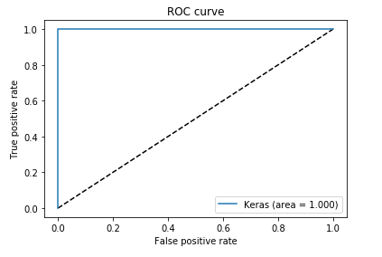

Figure 1: Audio-DeepLearning for MrsPiggy

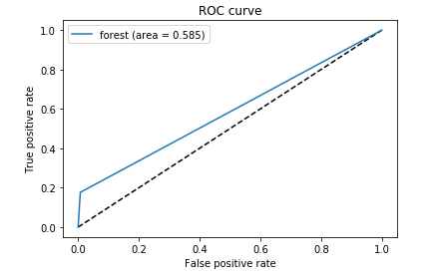

Figure 2: Audio-DeepLearning for MrsPiggy

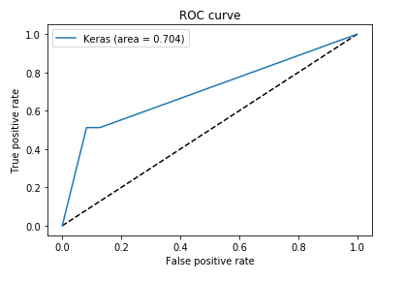

Figure 3: DeepLearning for MrsPiggy

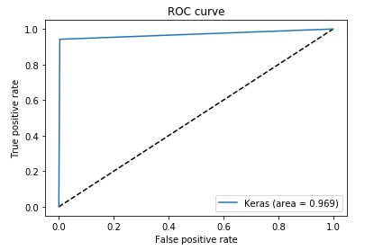

Figure 4: RandomForest for Kermit