Action Plan Phase 2 Notes

ADMIN VIEW

* Required Proof Docs (Red Box) remove the upload file buttons and check mark boxes. This will only be a static image with a link to <https://www.secureclientaccess.com/> for clients to click and upload their proof docs to our CRM.
  + Send Reminder Button within Red Required Proof Docs Box will trigger an email to be sent to the Client and will cc: Referring Party and TruPath Admin (Exhibit 1 Email)
* Check Boxes to be added beneath current score 1) Vantage, 2) Lender, 3) MyFico.
  + IF the Vantage Box is checked, the following disclosure will appear underneath the static disclosure that already exists underneath the gauge graphic:
    - *A VantageScore is not your actual mortgage score. TruPath™ does not guarantee qualification based on action plan completion without a mid score from a licensed Loan Officer or from [www.MyFico.com](http://www.MyFico.com).*
  + IF the Lender or MyFico boxes are checked, nothing additional will happen and the above disclosure will not appear.
* Yellow “Take Advantage of Your Client Access Library” box - the verbiage of this box should be changed to read as follows:
* Add Green “ Your Action Plan” and Purple “Additional Responsibilities” boxes to the design of the action plan as static images beneath the yellow box: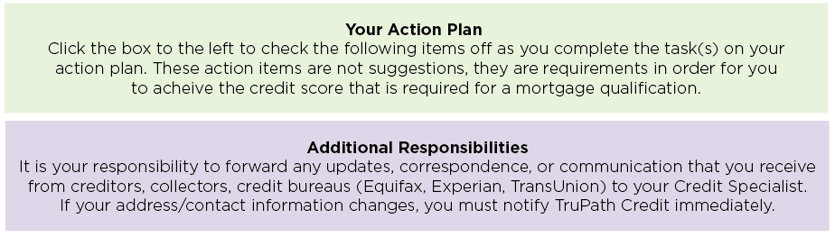
* Add a thin line separator between each section of the action plan.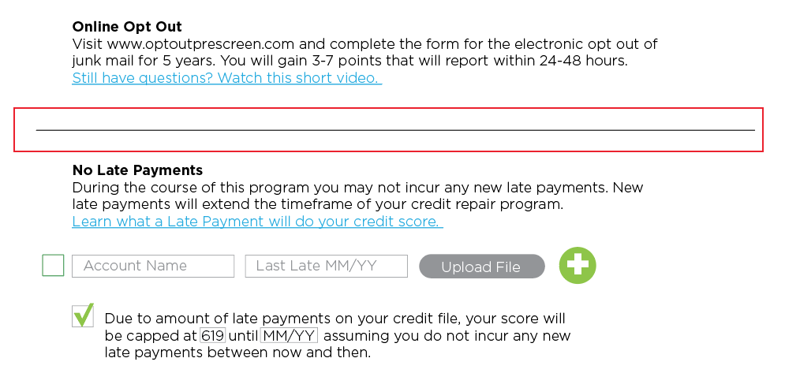
* Add a box to the left of each account in the admin view (No Late Payments, Public Records, Collection Accounts, Existing Revolving and New Revolving sections) so that admin can approve items without the client having to click it first. Please create a secondary popup measure to confirm that the admin wants to make the change to avoid any accidental mistakes.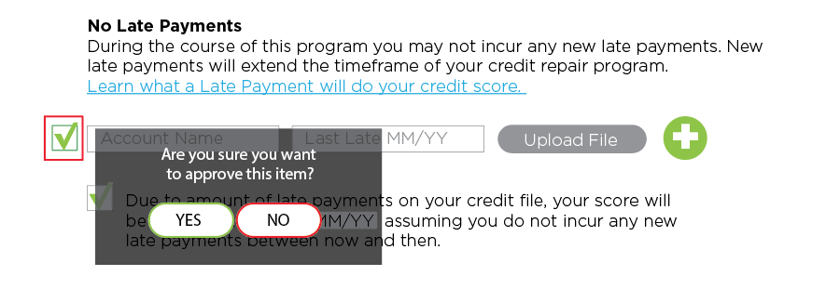
* Remove the “Upload File” button from the No Inquiries section of the action plan. We have no need for clients to upload a file in this section.
* Add a Total Balance Box to the Public Records section that calculates the total of all the Public Record accounts entered.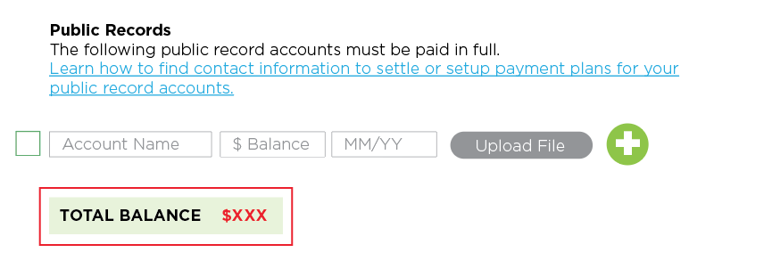
* Add Balance Boxes to the Collection Accounts Section:
  + **Non-Medical** (accounts where there are no check marks).
  + **Medical** (accounts where there is only a blue check mark).
  + **Pay at Closing** (accounts where there is a red check mark or red and blue check mark - if there is a red check mark, it will always be in the Pay at Closing section).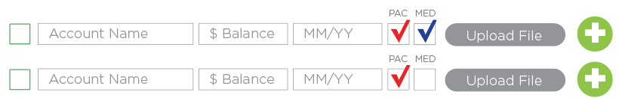
  + **Total Balance** (will total everything listed in Non-Medical, Medical and Pay at Closing).

- Client view, if the MED box is checked, then the account should be listed in all blue, just like the account is listed in all red currently when PAC is checked.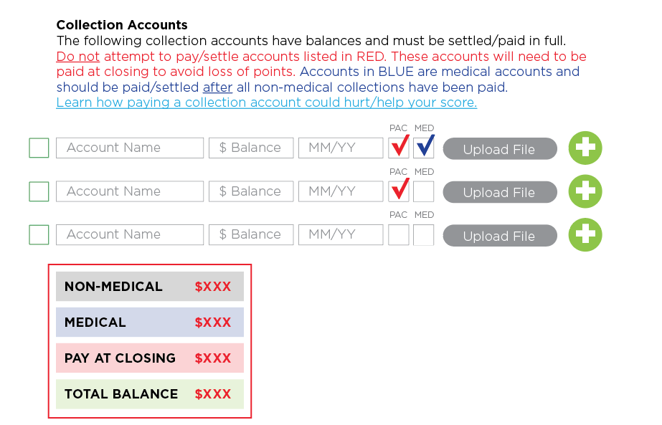

* “+Add New Account Name” dropdown options to be added for all “Account Name” fields (Late Payments, Public Records, Collections and Existing Revolving and New Revolving). Rather than having to type account names over and over again we can have a dropdown of Account Names that have already been added or we can have the option to add a new Account Name.
* Change the order of Existing Revolving and New Revolving. Existing Revolving should be above New Revolving section.
* All boxes within the action plan that require a dollar amount should automatically include a dollar sign “$” when we begin typing in the box. (Limit, Balance, Pay to)
* All “Pay to” boxes (Existing Revolving and New Revolving) should automatically calculate as 6% or whatever number is listed in the Limit box.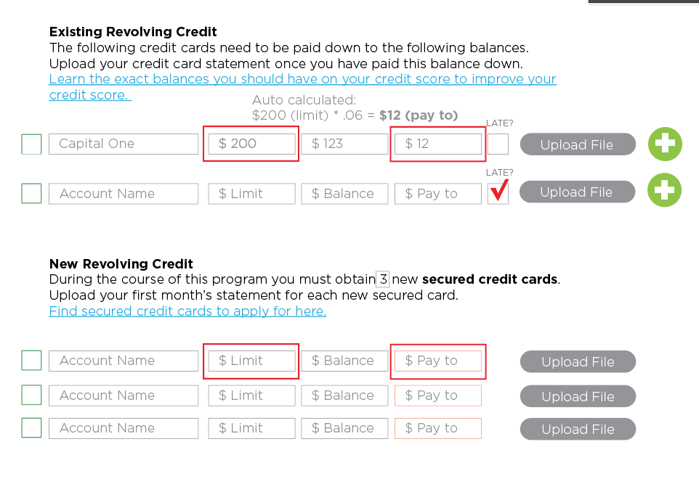
* Add new link to “Find secured credit cards to apply for here” under New Revolving Section. **<https://www.trupathclient.com/>**
* Understood by Client section: Verbiage has changed.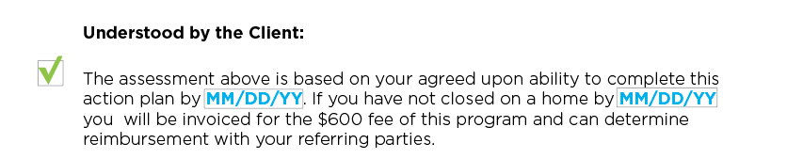
  + 2 dates listed in box above should automatically calculated as follows:
    - Date 1: Date listed in Est. Credit Ready box. (in Client Vitals Section).
    - Date 2: Date listed in Est. Closing box. (in Client Vitals Section).
    - EXAMPLE:
      * 6MS = 06/01/18 + 6 Months = 12/01/18 (DATE 1)
      * 12/01/18 = 3 Months = 03/01/19 (DATE 2)
    - Client view of “Understood by Client Section” - acceptance check box should be moved beneath: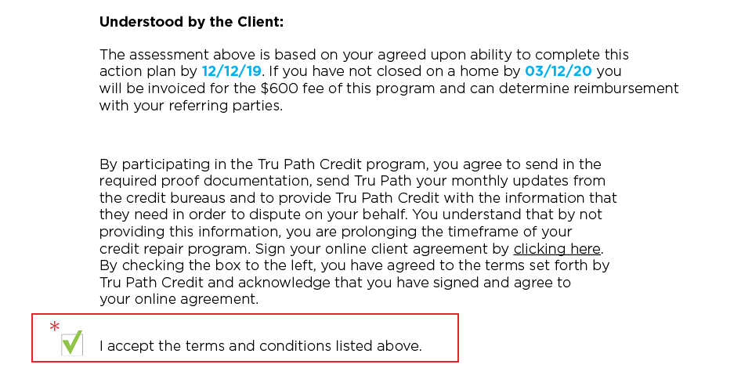
* Referring Party Section
  + Verbiage in this paragraph has changed: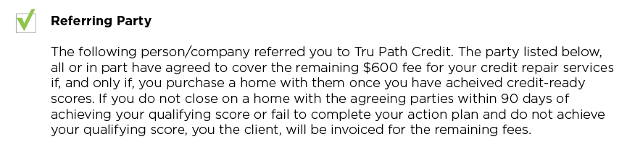
  + Create backend file with Referring Party contact information so that when the name is entered, the Company, phone number and email are auto-populated.
  + Don’t make all fields for referring parties required.
  + In admin view only, add a check box next to each referring party which will select who the update gets sent to. If check mark is not selected next to a referring party, they will not receive the update when the “Send Update to Referring Party” button is clicked. (Please add a select all option to check all referring party boxes when we want to send the update to all referring parties).
  + As of right now the formatting does not hold when we send updates to the referring party. Please make sure that the formatting stays exactly how we type it when the email is sent to the referring party.
  + Any notes sent in referring party note box should be added to internal notes with a timestamp.
  + Referring Party Client Update Weekly Report: a report for each referring party and all of the clients associated with them should be generated and sent as an attachment in an email sent to the respective referring party on a weekly basis. Exhibit 6 email to referring party - Exhibit 7 weekly report of all referring party’s clients.
* Client Vitals Section (This section is only visible to the admin):
  + Add Boxes for:
    - Beginning Score
    - Qualifying Score
    - Action Plan Review (Date)
    - 6 Mo. Disputes Start (Date)
    - Est. Credit-Ready (Date) = 6 Mo. Disputes Start Date + 6 Months
    - Est. Closing (Date) = Est. Credit-Ready Date + 3 Months
    - Weekly Report Notes (300 characters max allowed in this box).
  + Add Buttons for:
    - Resend Login Details (when clicked: triggers time stamp in internal notes and Exhibit 2 email to client)
      * Resend Login Details button should also be an icon on the main dashboard list of clients as an option as well.
    - Audits Sent (when clicked: triggers time stamp in internal notes section)
    - Contact Attempt (when clicked: triggers time stamp in internal notes and Exhibit 3 email to referring parties).
    - RP Alert (when clicked: triggers time stamp in internal notes and Exhibit 4 email to referring parties with cc: Client).
    - Proof Docs (when clicked: triggers time stamp in internal notes and Exhibit 1 email to client with cc: Referring Parties).
    - Credit Ready ( when clicked: triggers time stamp in internal notes and Exhibit 5 email to Client and Referring Parties).
  + Action Plan Update Buttons
    - **Update:** this button only updates the action plan, but does not send an email update to the clients.
    - **Client Update:** this button updates the action plan and sends an email update to the clients.
    - **Publish/Unpublish:** When this button is clicked, the action plan is unpublished and cannot be accessed by the client. The action plan still exists and can be re-published at a later date if the Admin chooses to do so. IT DOES NOT DELETE THE ACTION PLAN. (Yakin - we discussed a different method of achieving this same outcome during our call where we remove the button from the bottom of the action plan and use it as an icon on the main dashboard - please do what you feel is best for your programming).