Environmental Monitoring Station (DHT11, i used DHT22 as 11 was not available)
https://wokwi.com/projects/468719260625217537

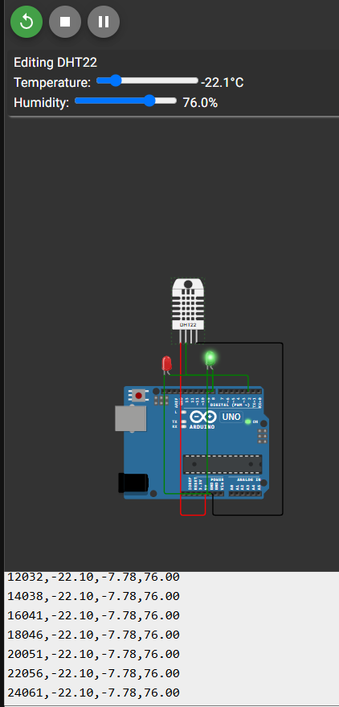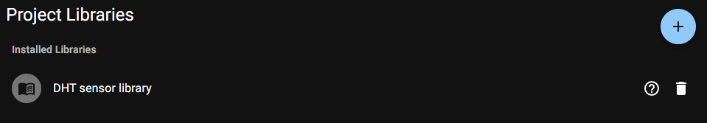
Sample_reading CSV added in GITHUB

Ultrasonic_Parking: https://www.tinkercad.com/things/jKOoCIrddrq-ultrasonic-parking?sharecode=T6j-D1s5A5DPLifpXVHbqV3WdEZHgQpaP7Z6UqTRlZI

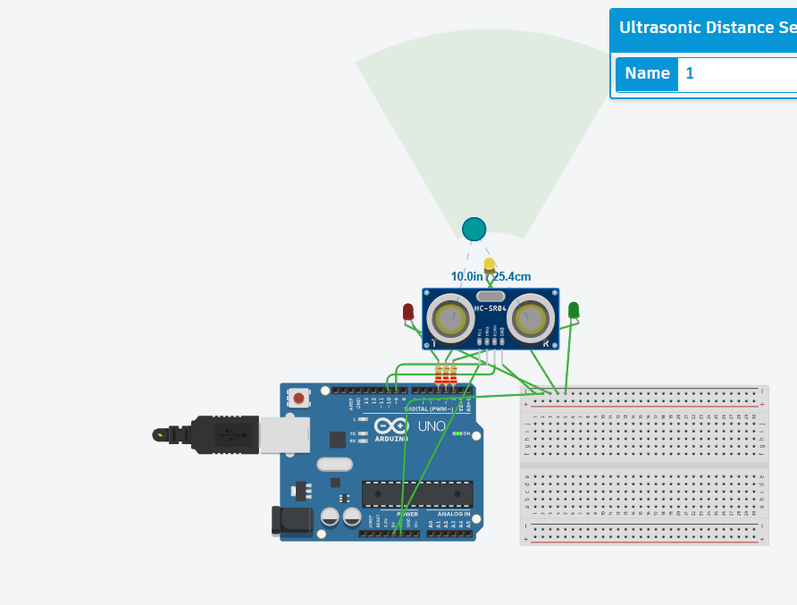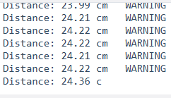

Smart Street Light:
https://www.tinkercad.com/things/hHHdiFLl4n7-smart-street-light?sharecode=rtsrkfvEYftDgTMWHQkPmhDreR2qIHpKlBD7wsqqm6A

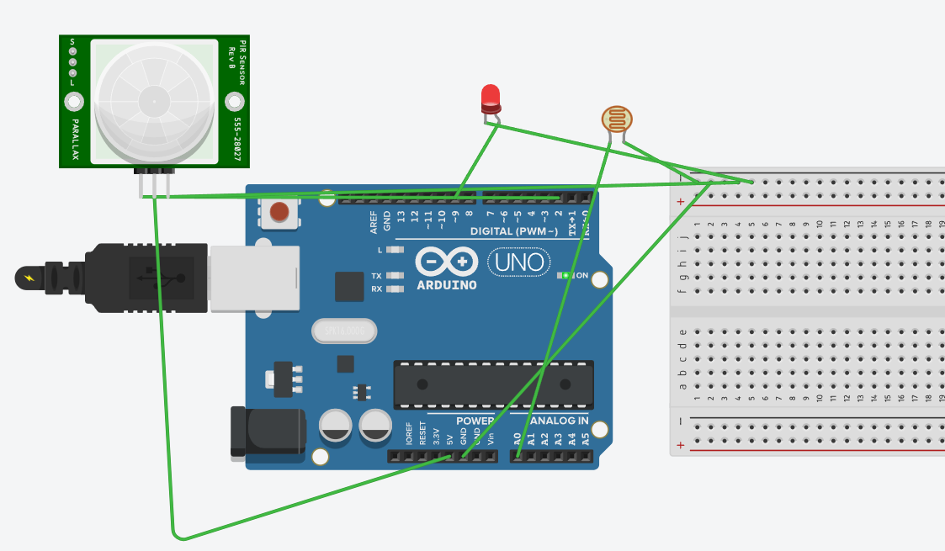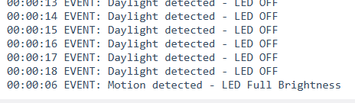

Multi_sensor Data logging:
https://wokwi.com/projects/468723259977277441

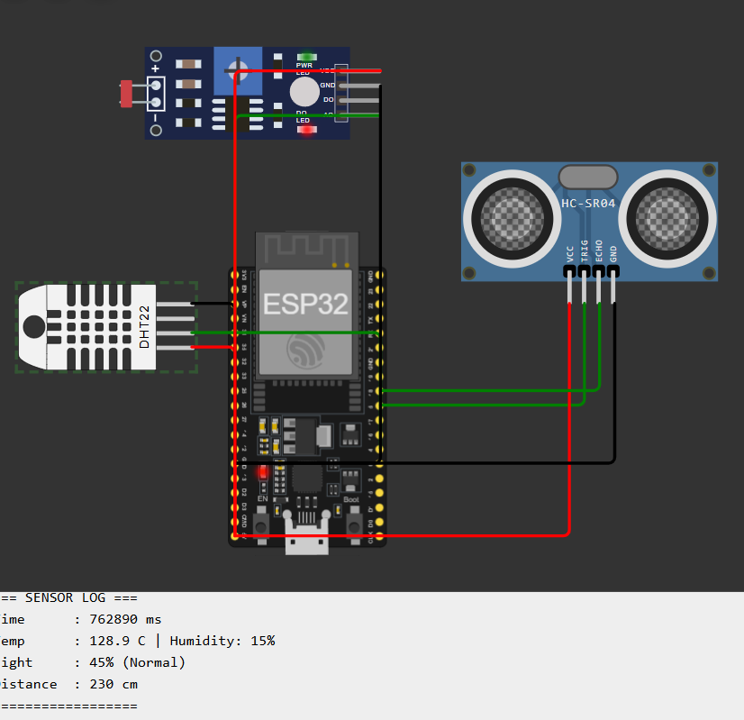

SG90 Servo motor: https://www.tinkercad.com/things/1YdyuPYSNgA-servo-motor-sweep?sharecode=W9POcIZvdDSERj43yPLMnnmDr0IeXmhmAbYNAzX9Tl4

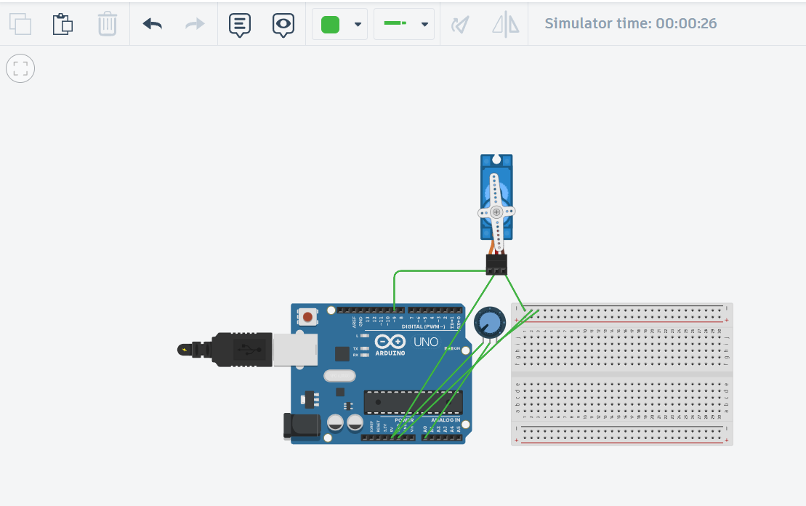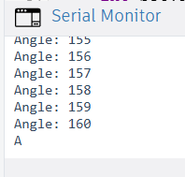

DC motor: https://www.tinkercad.com/things/6jmMCLdW1SJ-dc-motor?sharecode=FdxbjvNmOg2xbsP5thYSYlOfcwGRhQFBQ2hcpAInv2A

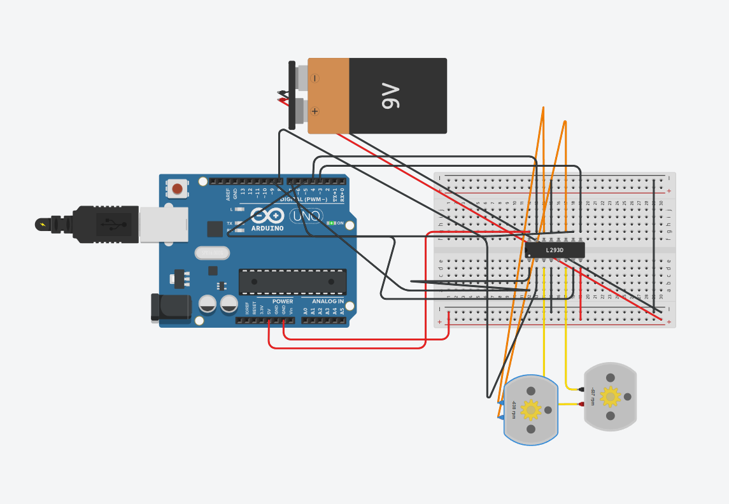

Relay:
https://wokwi.com/projects/468725527617503233

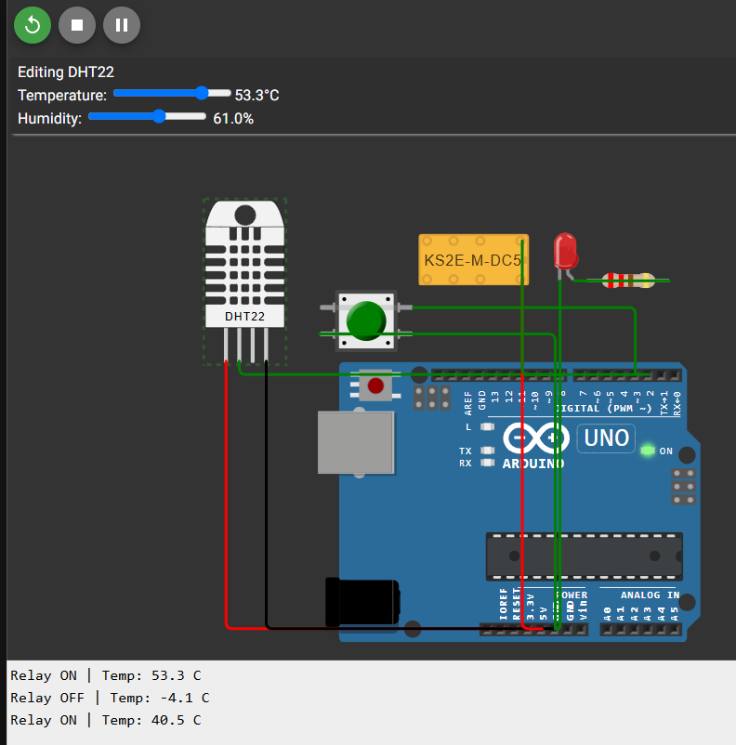

Keypad+LCD:
https://www.tinkercad.com/things/kbEluPtUWon-keypadlcd?sharecode=_Eztf63d8z0twk6YV5eontP9QSl4WPXWp5q5Fsdv5t0

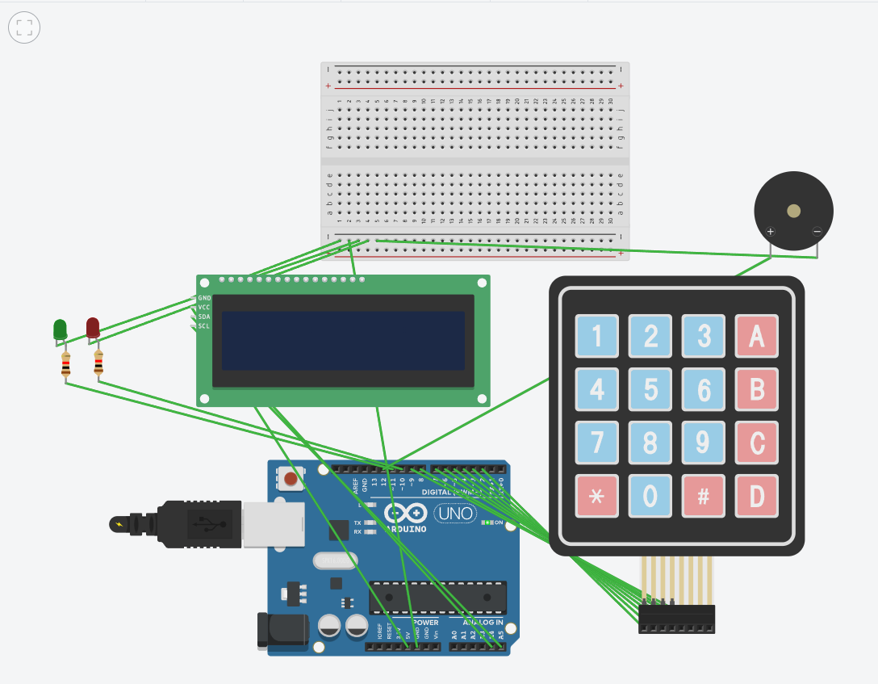

Sensor calibration means adjusting a sensor so that it gives correct and accurate readings. It is important in IoT systems because wrong sensor values can lead to incorrect decisions and poor system performance.
Two-point calibration method:
- First, place the soil moisture sensor in dry soil and note the sensor value (Dry value).
- Then place the sensor in fully wet soil and note the sensor value (Wet value).
- Use these two values to map any future sensor reading into a 0–100% moisture percentage.
This method makes the soil moisture readings more accurate and reliable.

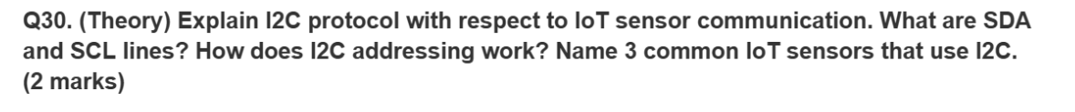

I2C (Inter-Integrated Circuit) is a communication protocol used to connect a microcontroller with multiple sensors using only 2 wires.
- SDA (Serial Data Line): Used to transfer data between the microcontroller and sensors.
- SCL (Serial Clock Line): Provides the clock signal to synchronize data transfer.
I2C Addressing:
Each I2C device has a unique address. The master (Arduino/ESP32) sends the address of the required sensor, and only that sensor responds while the others ignore the communication.
Examples of I2C IoT Sensors:
- BMP280 (Temperature & Pressure Sensor)
- MPU6050 (Accelerometer & Gyroscope)
- BH1750 (Light Intensity Sensor)

