|  |
| --- |
| Dorian.com |
| Dorian is the world’s largest network of freelance music producers from amateur to professional. |
| Dorian is a place to find quality music for your project and a place to share your creativity with the world. Dorian believes in simplicity and transparency. Clients should not have to worry about licensing issues when looking for talent. All producers on Dorian use the same license for their music. Dorian aims to provide a place where music is first and the producer-client interaction is as painless as possible. |
| PersonasProspective Producer, Orfea LeBlanc, age 31 Orfea started producing music at the age of 14, building her skills and learning new techniques along the way. She is fully employed as a professional violinist and is looking for a way to make some extra money off her creative outlet. A site with a friendly atmosphere without any barriers to entry is what she is looking for. Orfea is very talented and is willing to produce multiple genres of music. Prospective Employer, William Steinmann, age 48 The founder of a small video game company, Steinmann Studios. He has a small group of full-time developers but turns to freelancers for creative work to keep content original and unique. He strives for quality in his games and does not believe in producing cheap click-bait titles. He is looking for a place which will consistently deliver him the content he desires for many years to come. |
| Comparative Sites  Fiverr – www.fiverr.com  Melody Nest - www.melodynest.com |

# Wireframes

## Home Page

## Home Page Wireframe

## Login Page

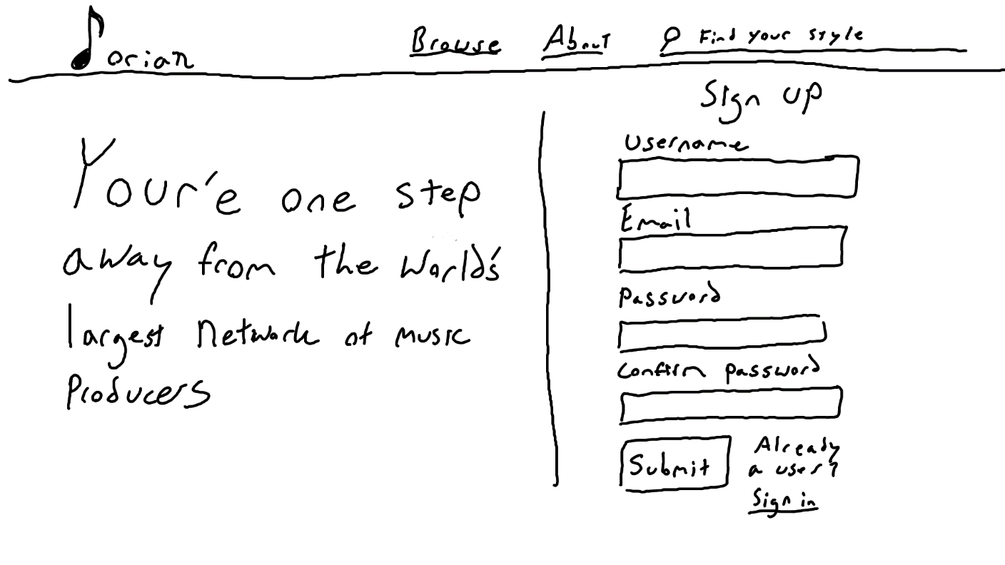

# Comps

## Home Page

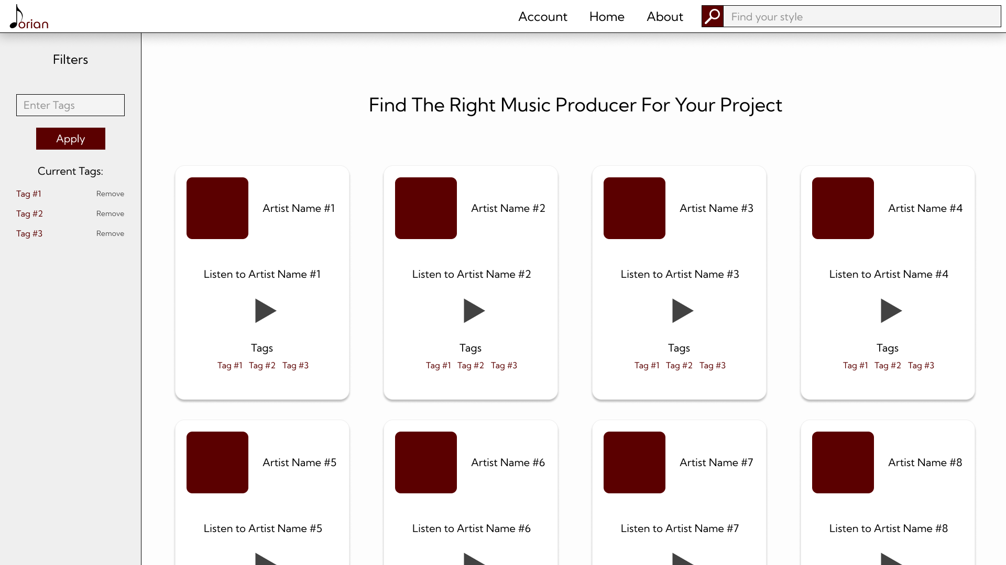

## Login Screen

