**Right Point**

**PROJECT CHARTER**

Revision History

|  |  |  |  |
| --- | --- | --- | --- |
| Date | Version | Modification | Modifier |
| 01/08/2017 | 1.0 | Plan created |  |
| 14/11/2021 | 2.0 | Updated | Zac, Rory and Tarsha |
| 16/02/2022 | 2.1 | Updated | Elan Sithirasenan |
|  |  |  |  |
|  |  |  |  |
|  |  |  |  |
|  |  |  |  |

## INTRODUCTION

## 1.1 PURPOSE OF PROJECT CHARTER

The purpose of this document is to provide an understanding of this project’s objectives, scope, time and budget plus the responsibilities of the team members.

Quarter to half page

## 2. PROJECT AND PRODUCT OVERVIEW

After completing an audit of the security policy at RightPoint the new Chief Security Officer (CIO) discovered that the organization lacks an updated incident response plan and believes it would be beneficial to conduct an incident response team exercise (IRTx).

Quarter to half page

# 3. Justification

RightPoint’s current security posture and procedures are simplistic, and the company’s new chief security officer has previously identified that their policies and procedures are inadequate for their current needs.

Half page

# 4. Scope

## 4.1 objectives

The objectives are as follows:

List in dot points

### 4.2 High-Level requirements

The high-level requirements are as follows:

List in dot points

### 4.3 Major Deliverables

**The major deliverables are as follows.**

List in dot points

### 4.4 Boundaries

The IRTx will run for four hours and be monitored by the Purple Team. If any security flaws are found each member of the developing team will be bound by a non-disclosure agreement (NDA).

# 5. Duration

## 5.1 Timeline

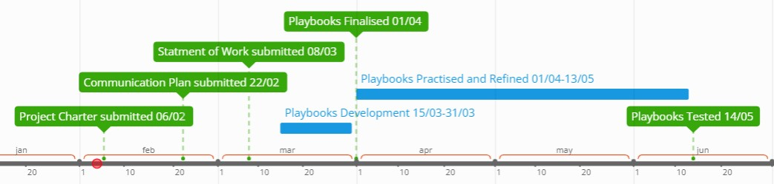

## 5.2 Milestones

The table below lists milestones and their estimated completion dates.

|  |  |
| --- | --- |
| **Milestone** | **Estimated completion time**  **frame** |
|  |  |
|  |  |
|  |  |

# 6. Budget Estimate

## 6.1 Funding source

The Red, Blue and Purple playbooks are being developed as part of a student project for certificate IV in cyber security at TAFE Coomera.

## 6.2 Estimate

This section provides a summary of estimated spending to meet objectives and deadlines described in this project charter. This summery of spending is preliminary and reflects costs for the entire investment lifecycle. It is intended to present probable funding requirements and assist in budgeting acquisition.

Complete table

|  |  |  |  |  |  |
| --- | --- | --- | --- | --- | --- |
| **Budget Item** | **Month1** | **Month 2** | **Month 3** | **Month 4** | **Total** |
|  |  |  |  |  |  |
|  |  |  |  |  |  |

# 7. ASSUMPTIONS, CONSTRAINTS AND RISKS

* 1. **Assumptions:**

List in dot points

**7.2 Constraints:**

* **Time constraints:**
* **Resource constraints:**
* **Technical constraints:**

**7.3 Risks:**

List in dot points

# Roles and Responsibilities

|  |  |  |
| --- | --- | --- |
| **Name** | **Project Role** | **Responsibilities** |
| ~~Teacher~~ | ~~Project sponsor~~ | ~~Function as the liaison between projects team, and the client RightPoint. This member aims to provide guidance and resource allocation for this project, in addition to any other project that they are overseeing.~~ |
| ~~Student 1~~ | ~~Project manager~~ | ~~Oversee the daily function and performance of the project. They are to ensure that each stage of the project is completed to the standard and timings required to ensure that the project is completed as intended and within the scope the client and project sponsor has requested. The project manager is responsible for liaising with the project sponsor as required during the conduct of this project.~~ |
| ~~Student 2~~ | ~~Blue team lead~~ | ~~The blue team technical lead is responsible for overseeing the creation, testing and auditing of the blue team playbooks that will be generated within this project. This member is to work with the blue team technical writer to generate these documents. As the team leader, this member is to ensure that these are done within the times outlined in the project schedule. The team leader is to liaise with the project manager throughout the conduct of this project.~~ |
| ~~Student 3~~ | ~~Red team lead~~ | ~~The red team technical lead is responsible for overseeing the creation, testing and auditing of the red team playbooks that will be generated within this project. This member is to work with the red team technical writer to generate these documents. As the team leader, this member is to ensure that these are done within the times outlined in the project schedule. The team leader is to liaise with the project manager throughout the conduct of this project.~~ |
| ~~Student 4~~ | ~~Blue team~~ | ~~The blue team technical write is responsible for helping create, test and audit the blue team playbooks. This member is to work with the blue team technical lead to ensure these documents are completed to the standard outlined in the projects scope, and within the timeframe dictated by the project schedule.~~ |
| ~~Student 5~~ | ~~Red team~~ | ~~The red team technical write is responsible for helping create, test and audit the red team playbooks. This member is to work with the red team technical lead to ensure these documents are completed to the standard outlined in the projects scope, and within the timeframe dictated by the project schedule.~~ |