ASSIGNMENT BIGDATA
- What are the characteristics of Hadoop?
Ans: Characteristics of Hadoop are:
1.Open-Source Software:
- Hadoop is an open-source project developed by the
Apache software foundation.
- It’s free to use, modify, and distribute, which makes
it popular for research and industry applications.
2.Framework:
- Means everything that you will need to develop and
Execute and application is provided-programs, tools,
Etc.
3.Distributed:
- Divides and stores data across multiple computers.
- Hadoop uses the Hadoop Distributed File System (HDFS) to store data.
- Data is split into blocks and stored across multiple
machines(nodes).
4.Massive Storage:
- Stores colossal amounts of data across nodes of
low-cost commodity hardware.
5.Faster processing:
- Large amounts of data is processed in parallel,
yielding quick response.
- Hadoop uses the MapReduce programming model to process data in parallel across nodes.
- Tasks are divided and run on different parts of data, increasing speed and efficiency.

- Explain YARN Architecture?
Ans: YARN Architecture:
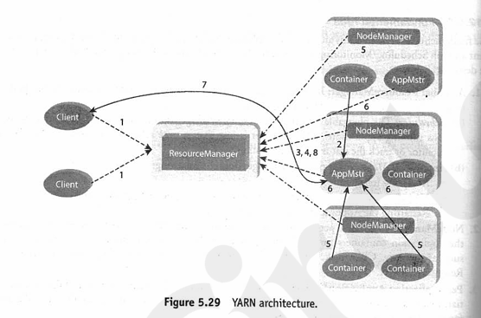
1.The steps involved in YARN Architecture are as follows:

- A client program submits the application which includes
the necessary specifications to launch the application-
specific ApplicationMaster itself.
- The ResourceManager launches the ApplicationMaster by assigning some container.
- The ApplicationMaster, on boot-up, register with Resource Manager. This helps the client program to query the ResourceManager directly for the details.
- During the normal course, ApplicationMaster negotiates appropriate resource container via the resource-request protocol.
- On succesfull container allocations, the ApplicationMaster launches the container by providing the container launch specification to the NodeManager.
- The NodeManager executes the application code and provides necessary information such as progress, status, etc. to it’s ApplicationMaster via an application-specific protocol.
- During the application execution, the client that submitted the job directly communicates with the ApplicationMaster to get status, progress updates, etc. via an application-specific protocol.
- Once the application has been processed completely, ApplicationMaster derigesters with the ResourceManager and shuts down, allowing its own container to be repurposed.

- What are the drawbacks of RDBMS compare with Hadoop?
Ans:
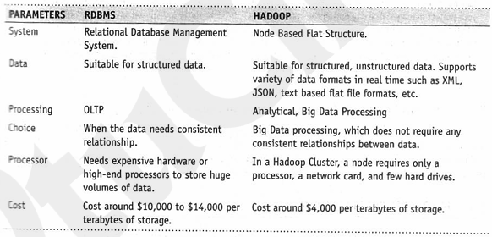
- Explain HDFS Briefly?
Ans: HDFS(HADOOP DISTRIBUTED FILE SYSTEM)
Some key points of HDFS are as follows:
- Storage component of Hadoop.
- Distributed File System.
- Modeled after Google File System.
- Optimized for high throughput .
- You can replicate a file for a configured number of times, which is tolerant in terms of both software and hardware.
- Re-replicate data blocks automatically on nodes that have failed.
- You can realize the power of HDFS when you perform read or write on large field .
- Sites on top of native file system such as ex3 and exf4.
HDFS DAEMONS:
1.NAME NODE:
- HDFS breaks large file into smaller pieces called blocks. Name Node uses a rack ID to identify Data Nodes in the rack.
- A rack is a collection of Data Nodes within in the cluster. Name Node keeps tracks of blocks of a file as it is placed on various data nodes.
- Name Node manages file-related operations, its main job is managing the File System Namespace.
- A file system namespace is collection of files in the cluster.
- File system namespace includes mapping of blocks no file, file properties and is stored in a file called FsImage.
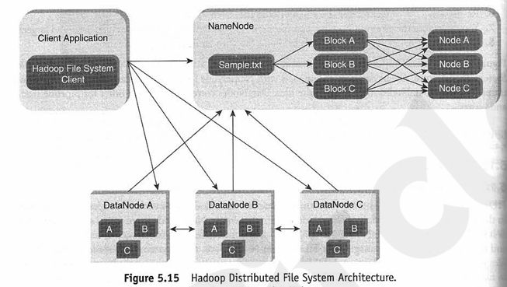

2.DataNode:
- There are multiple DataNode per cluster. During Pipeline read and write DataNodes communicate with each other.
- A DataNode also continuously sends “heartbeat” message to NameNode to ensure the connectivity between the NameNode and DataNode.
3.Secondary NameNode:
- The secondary NameNode takes a snapshots of HDFS metadata at intervals specified in the Hadoop configuration.
- It is better to run NameNode and Secondary NameNode on different machine. In case of failure of the NameNode, the Secondary NameNode can be configured manually to bring up the cluster.

- Explain the different commands which are used in Hadoop?
Ans: The commands used in Hadoop:
- Objective: To get the list of directories and files at the root of HDFS.
Act: hadoop fs -ls /
- Objective: To get the list of complete directories and files of HDFS.
Act: hadoop fs -ls -R /
- Objective: To create a directory in HDFS.
Act: hadoop fs -mkdir /sample
- Objective: To copy a file from local file system to HDFS.
Act: hadoop fs -put /root/sample/test.txt/sample/test.txt
- Objective: To copy a file from HDFS to local file system.
Act:
hadoop fs -get /sample/test.txt/root/sample/testsample.txt
- Objective: To copy a file from Hadoop system to HDFS via
copyFromLocal command.
Act:
hadoop fs -copyFromLocal/root/sample/test.txt/sample/testsample.txt
- Objective: To copy a file from Hadoop file system to local file system via copyToLocal command .
Act:
hadoop fs -copyToLocal/sample/test.txt/root/sample/testsample.txt

- Objective: To display the contents of an HDFS file on console.
Act: hadoop fs -cat /sample/test.txt

- Objective: To copy a file from one directory to another on HDFS.
Act: hadoop fs -cp /sample/test.txt/sample1
10)Object: To remove a directory from HDFS.
Act: hadoop fs-rm-r /sample1

6) What is the use of Nosql in Hadoop architecture?
Ans:

