A
Report on
Web Development
using
HTML and CSS only
First Term Assessment for Computing Group
(2017)

The University of Northhampton

Submitted to : Submitted by:
The University of Northhampton Badal Shrestha
UN ID=17421494
Summary
This report is about he project of CSY1018 module. This project is assigned by the University of Northhampton UK to student of year 1 2017AD. In this project student has to create a their own personal web page just by using HTML tags and CSS. This page contain home page, bio, cv and contact page. Bio page contain short biography, Cv page contain the personal detail and course work and Contact page contain the static form.
Table of Content
SN | Heading | Page No
1 | Introduction | 1
2 | Sketches (Computer, Tablet and Mobile view)  Sketch 1  sketch 2  Sketch 3 | 2  2  3  4
3 | Designs  Wireframes (Computer, Tablet and Mobile View)  Home page Wireframes of Desktop View  Home page Wireframes of Tablet view and Mobile view  Bio page Wireframes of Desktop View  Bio page Wireframes of Tablet view and Mobile view  CV page Wireframes of Desktop View  CV page Wireframes of Tablet view and Mobile view  Contact page Wireframes of Desktop View  Contact page Wireframes of Tablet view and Mobile view | 5 - 12  5  5  6  7  8  9  10  11  12
4 | Prototype | 13
5 | My own Image | 14
6 | Model of Good Practice  Page load speed  Navigation | 14  14  14
7 | Weekly Progress of Report  Week 1-3  Week 3-4  Week 4-5  Week 5-6  Week 6-7  Week 7-8 | 15 - 25  15  16  17  17  18 - 21  22 - 25
9 | Validation Check  HTML page Validation check  CSS Validation | 26 – 29  26 - 27  28 – 29
10 | Conclusion | 30
11 | Reference | 31

Introduction
Before getting started with my project , I have done some research on Internet. I looked out various portfolio website and took some idea from there site and I make my own. I found that lot of the website are formed by automatically code generating software like Bootstrap and Dream weaver but information provided to me tells we can't use such kind of software so I have used only text editor Atom software to create my website. Before creating my site I sketch model of my website in paper and start making changes for making wire frame I used wire frame sketcher software. This make easier and faster for me. The website from which I get idea to create my website were:
- http://joel.sh/about
- https://themeforest.net/item/sam-martin-personal-vcard-resume-wordpress-theme/17958872

Sketches (Computer, Tablet and Mobile)
Sketch1:
This is my first sketch of computer and mobile view, it has logo at the top and navigation bar just below it and it has main content at the center of navigation and footer.
The mobile view are similar and it is simple and its structure is same as desktop view logo at the top navigation just below it and main content at center of navigation and footer.
Merits: Simple layout and all content were included.
Demerits: Web page doesn’t looks good and navigation content was difficult to see in Tablet and mobile view.
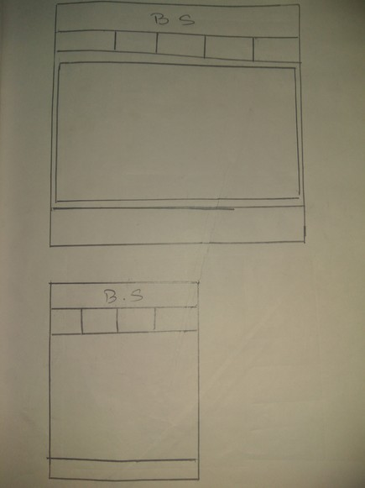
Sketch 2:
It is completely different from the firs sketch it has navigation at left side with full height of body, ti has logo at top right and main content is at center of logo and footer.
The tablet and mobile view is similar to first sketch.
Merits: Empty space was occupied and web page looks good than previous one.
Demerits: In mobile view navigation content wasn’t proper aligned.
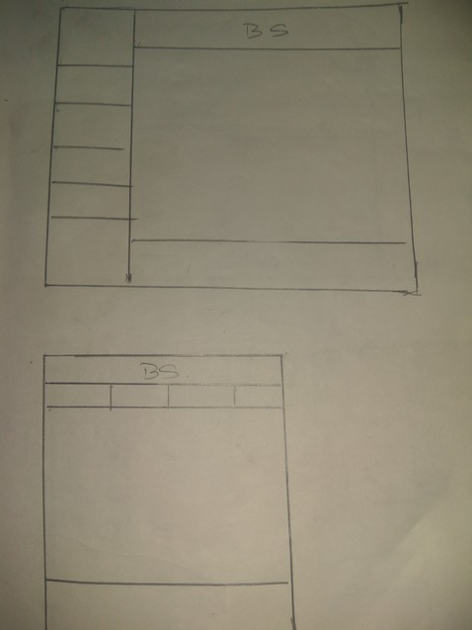
Sketch 3:
The sketch 3 is little bit similar to sketch 2 only the position of navigation and logo was changed.
The tablet and mobile view is different, Hamburger button is placed to show navigation content. Navigation content will only shows if Hamburger button is pressed.
This is my final layout of my web page were I will use this as frame and update it according to its needs to make attractive web page.
Merits: Web page looks more attractive and easy to navigate.
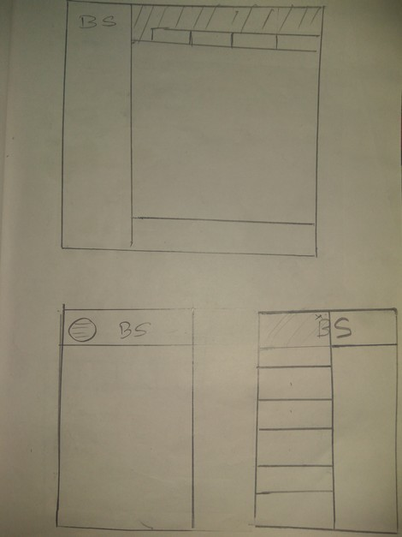
Demerit: In Mobile view navigation process is lengthy.
Designs
Wireframes: (Desktop, Tablet and Mobile)
Home page wireframe of Desktop view:
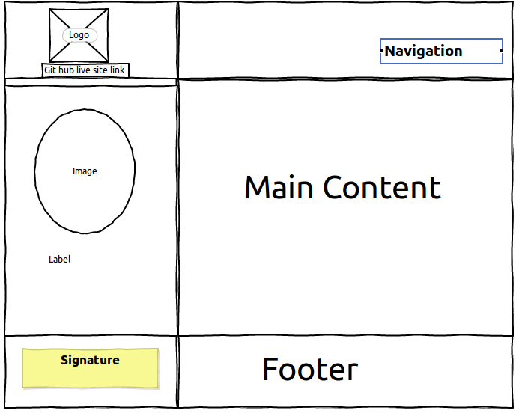
My home page will be simple and easy to use. I will add icon of home, bio , cv and contact in navigation panel so it will easy to navigate through out the system, icon color will be yellow and background will be black. I will add my logo at top left corner. I will add my name bellow the logo if it is hover size and color will change and if it is clicked it display Git hub live site page in same page. I will add my circular image in left part if it is hover border will appear and size will changed, if it is clicked that image will display in that page. I will add my signature in signature part. In footer I will add my social media link and Git hub repository link. In tablet view will main part in 2 different part. I will put my image at right side main content at left side. In mobile view I will put image at top and main content below it. I will put Hamburger button to access navigation in both mobile view and tablet view. Logo will at the top and footer will be at bottom.
Rest of the pages will have the same design only the main content will change and all the pages will have black as background color and yellow as a text color.
Home page wireframe of Tablet view and Mobile view:
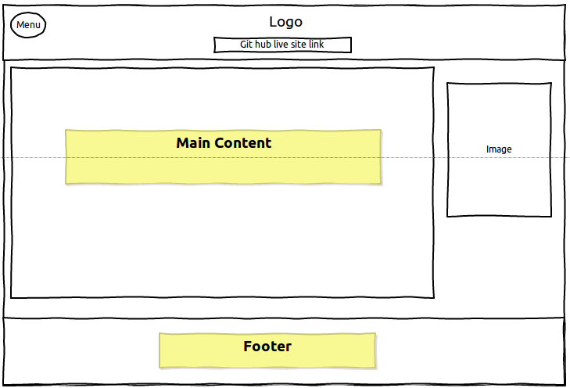
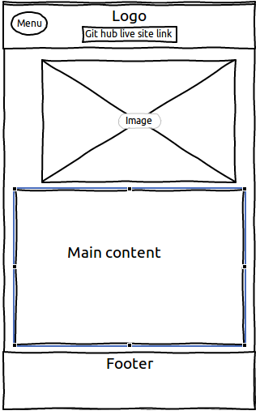
Bio page wireframe of Desktop view:
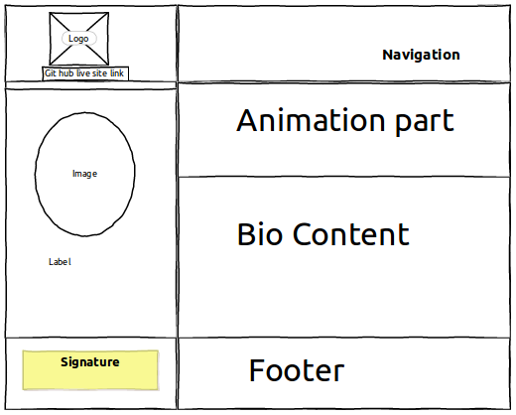
All the part will be same as home page expect the main content. I will divide main content in two different part. I will put an animation in top part and bio content in second part. In second part I will write about my shelf.
Bio page of wireframe of Tablet view and Mobile view:
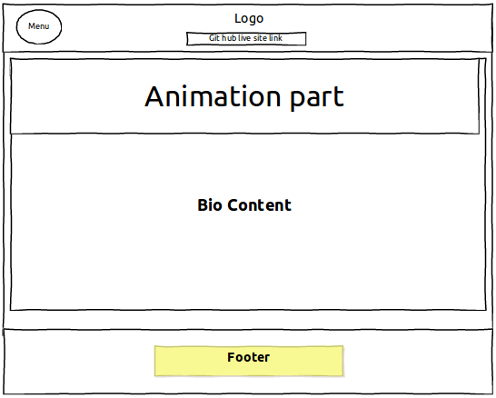
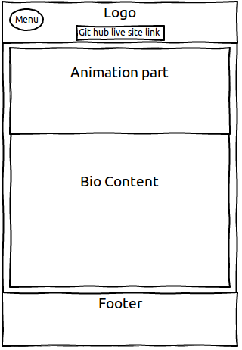
CV page wireframe of desktop view:
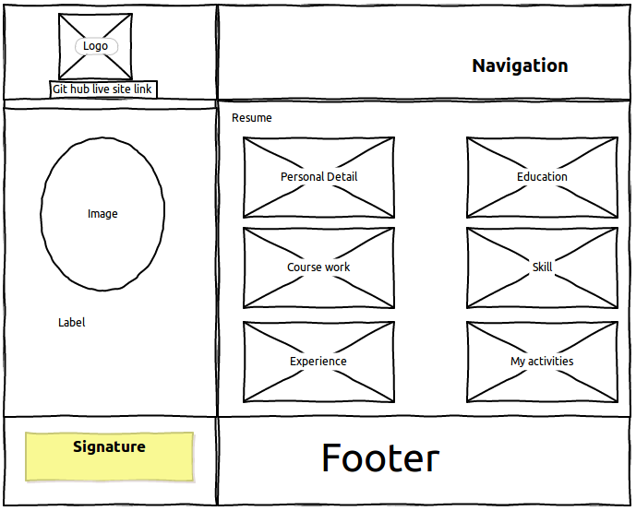
The CV page will be simple I will use six boxes to show my curriculum vitae. Tablet view is similar to desktop view. In mobile view I will make structure of human body to show my resume.
CV page wireframe of Tablet view and Mobile view:
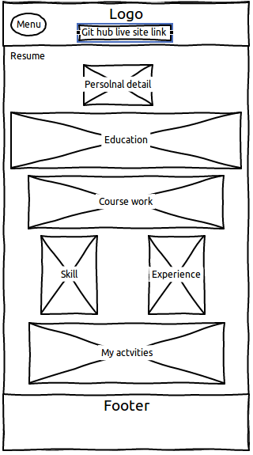
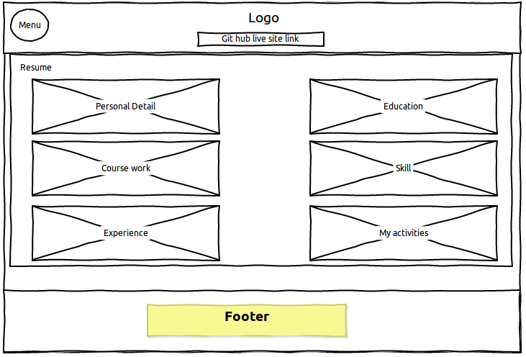
Contact page wireframe of desktop view:
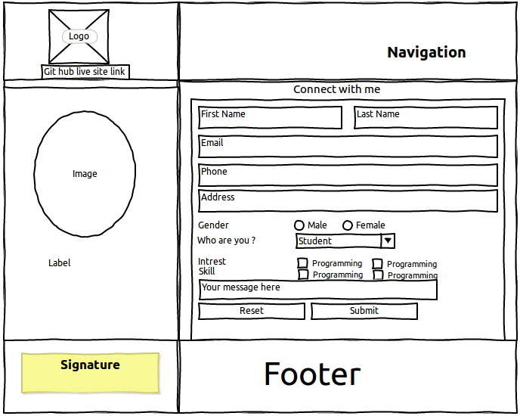
In contact page I will just put simple contact form in main part. By filling this form people can send me a email. I want my contact from focused so I will have yellow color as border. To make contact from attractive I will put transition on check box if it clicked inside shadow will appear and background color will changes to red. If mouse is pointed over submit and reset text size and color will increase and change to yellow and box background will changes to red.

Contact page wireframe of Tablet view and Mobile view:
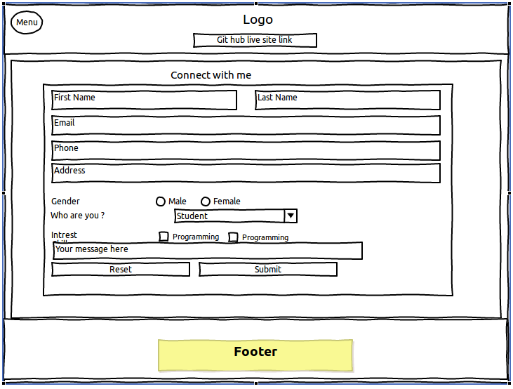
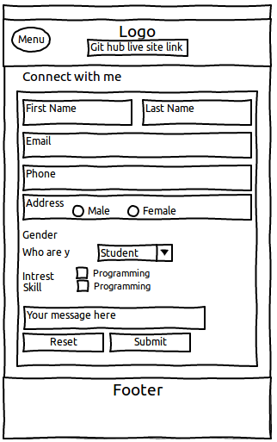
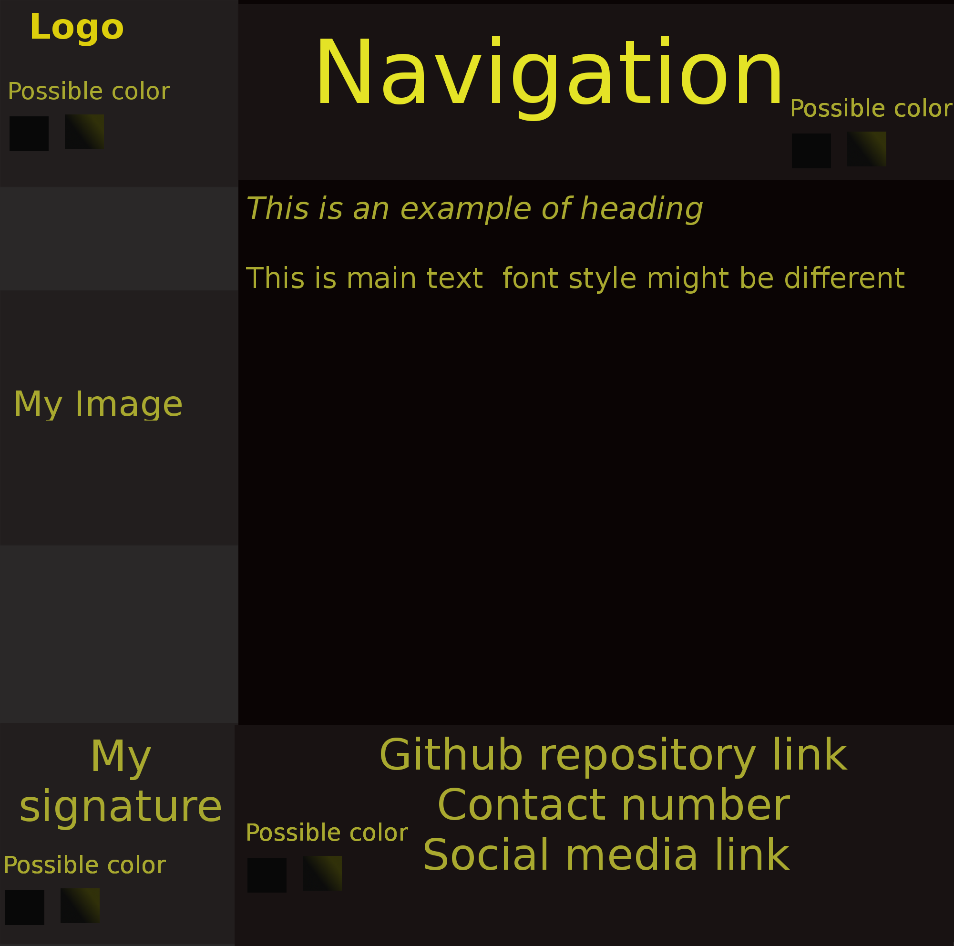
Prototype
Style Tile
My own image

This is my logo and I have create it by my shelf. The quality of image is good which is easily display in the bowser. It is so simple and easy to understand what it means. BS- My symbol.

Model of Good Practice
Page load speed
In Internet speed is the main component. To make web page load various good practice can be implement. I check web page speed at pingdom.com . It shows my page load 590s and it is 96% faster than other tested site.

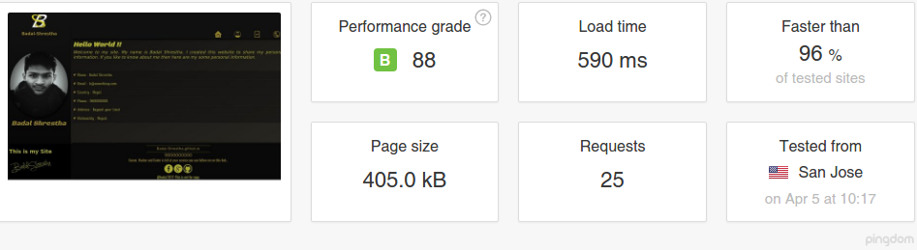
Navigation
Navigation system is a important part of website. Navigation system should not to complicated. It should be simple and easy to navigate. It should be easily visible, at top side it easily visible and easy to navigate
Weekly progress of Project

Week 1-3

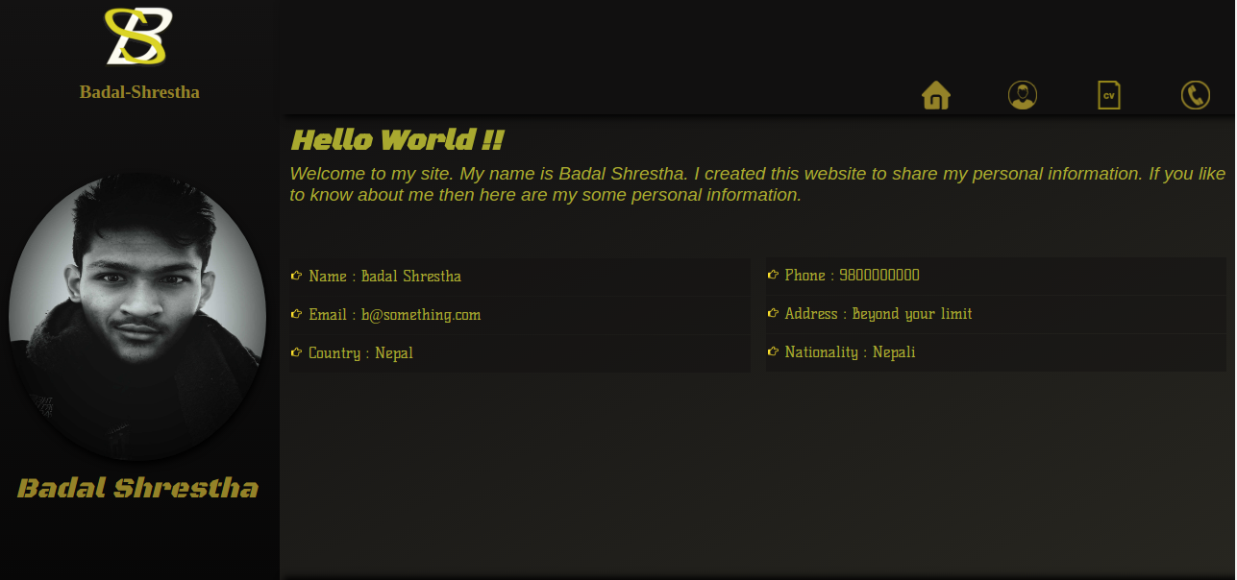
In first 3 weeks I create my home page and bio page. I put animation on so that logo image will change for infinite time. I put hover effect in navigation If navigation item is hover icon will move up and respective text will just appear bellow the icon.
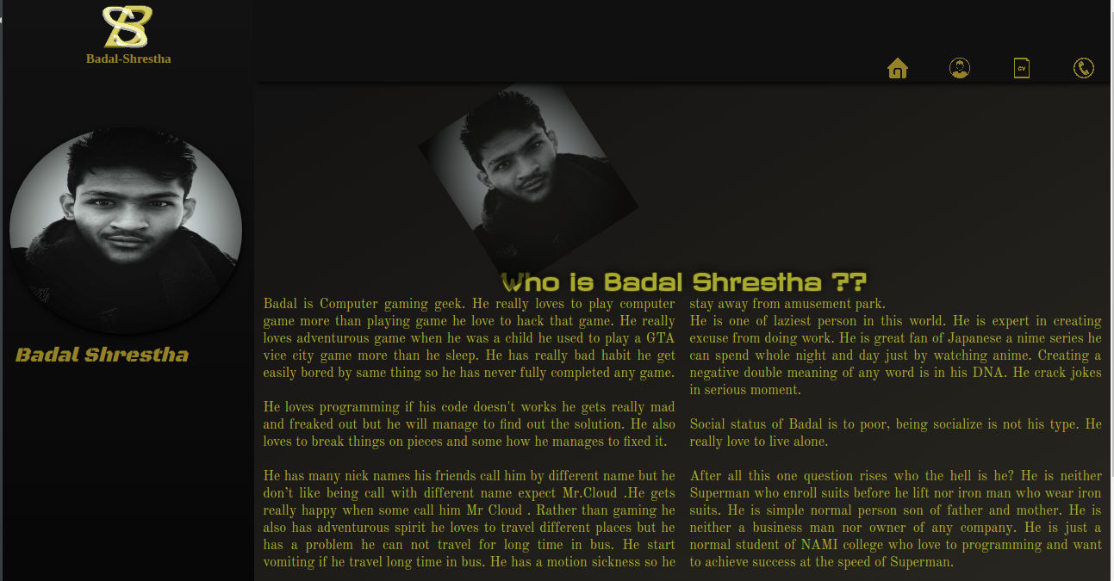
In bio I put animation on my image it will rotate and move for infinite time. In main content I use flex property column and I create two column to write about my shelf.
Week 3-4

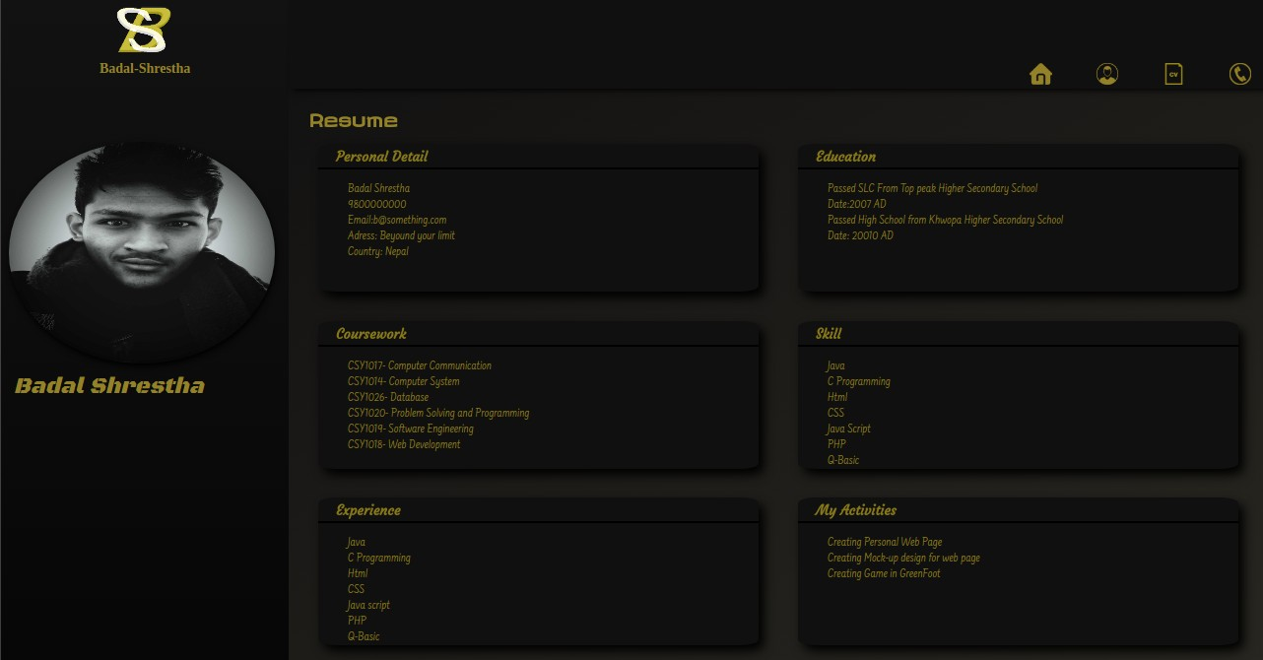
From week 3-4 I create my cv page and contact from. I optimize all image and reduce the page site. I put box shadow and create 3d effect.
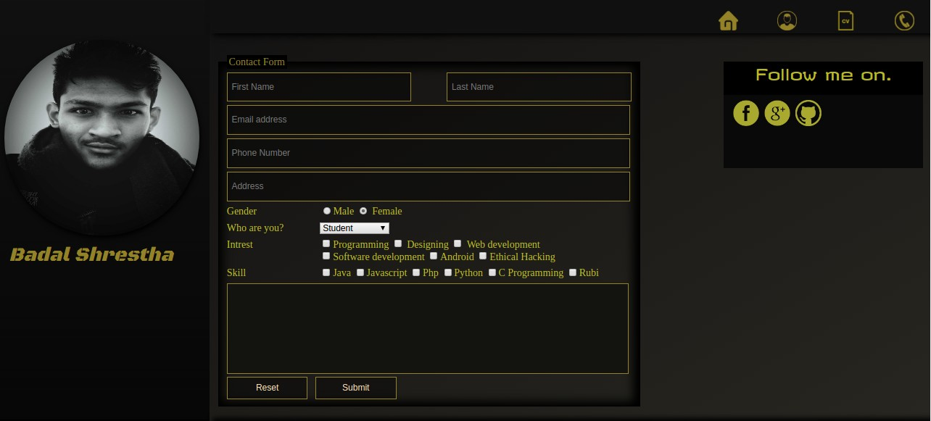
I put after click effect in contact from. If any text box is clicked it background and border color will change.

Week 4-5

Between week 4-5 I create footer. I put my signature , social media link git hub repository link. I put animation on border.

Week 5-6
In week 5-6 I put text color and Google font .

Week 6-7
In week 6-7 I create tablet view of all pages. I put hamburger icon. Here are the prototype:
Home page Tablet view.
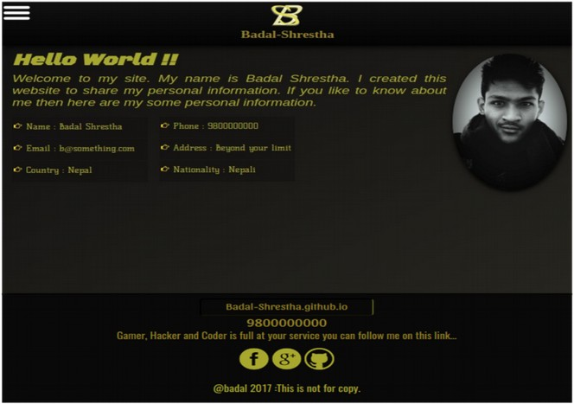

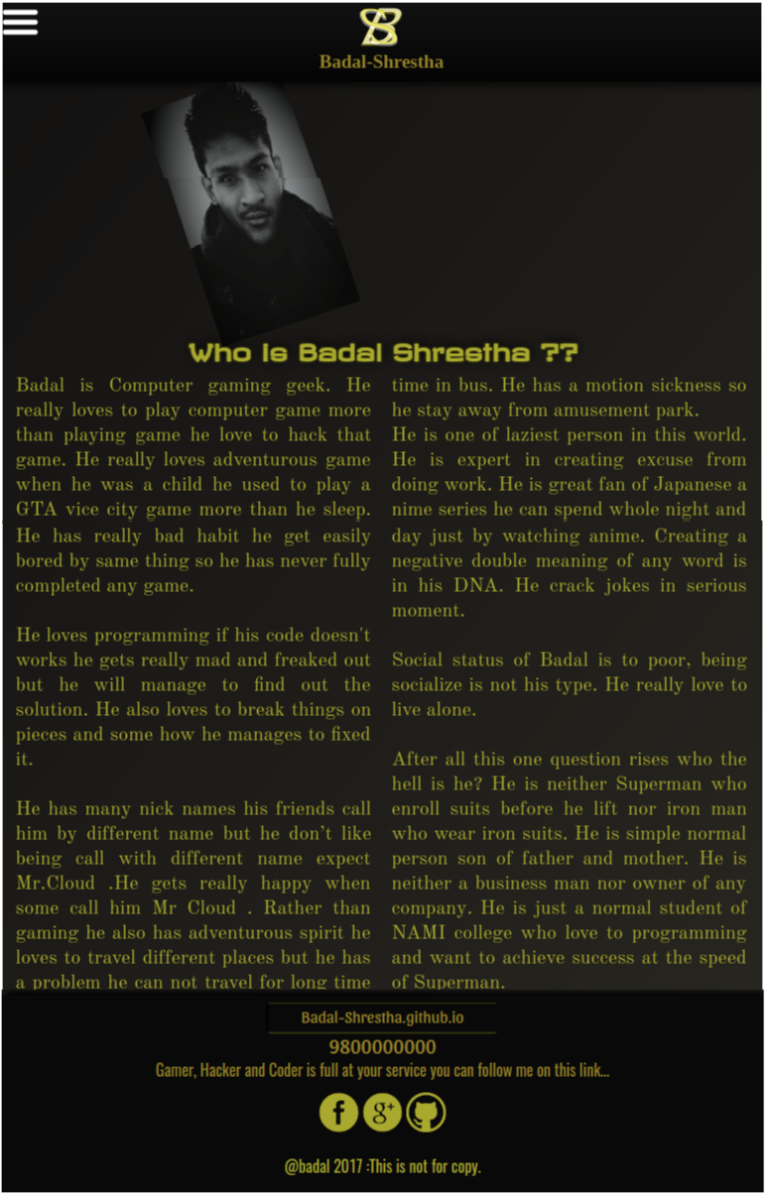
Bio page tablet view.
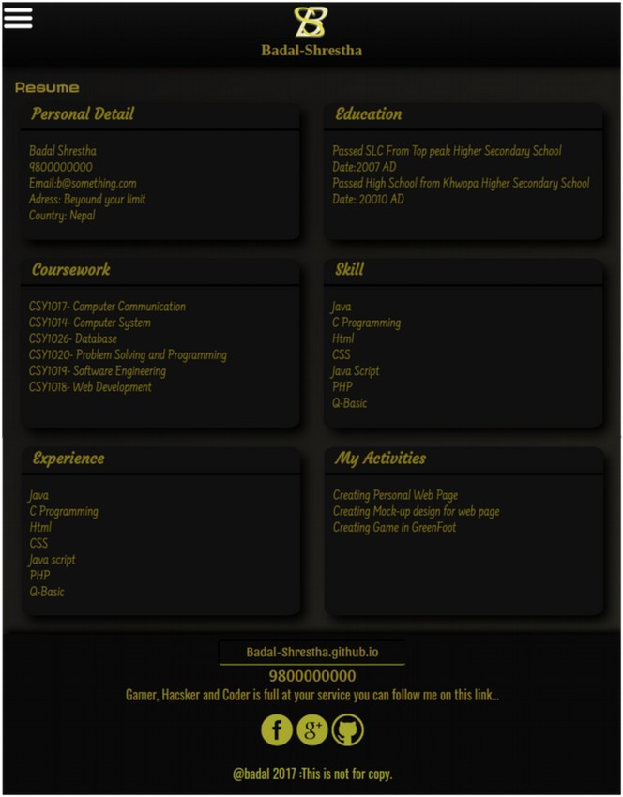
CV page tablet view
Contact page tablet view.
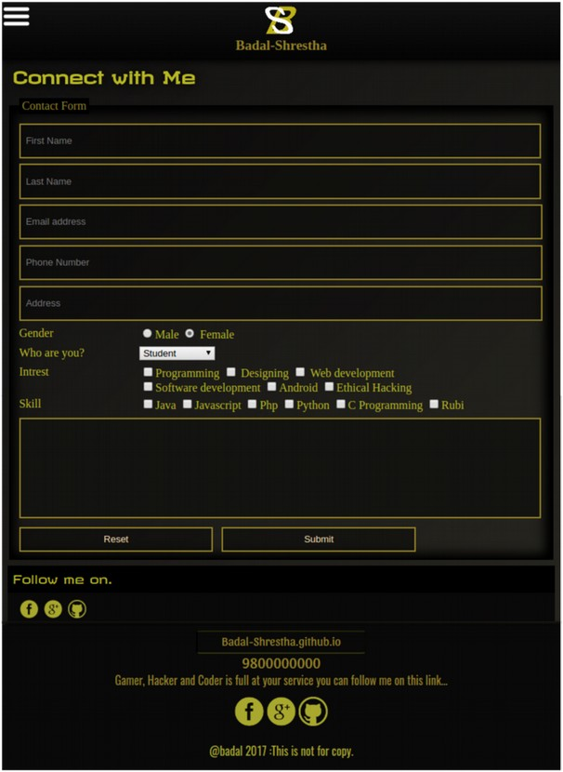
Week 7-8
In week 7-8 I create Mobile view of all pages.
Home page Mobile view.
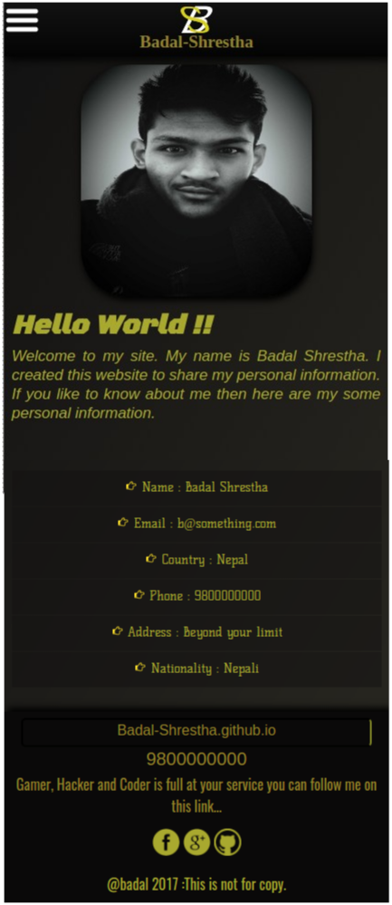
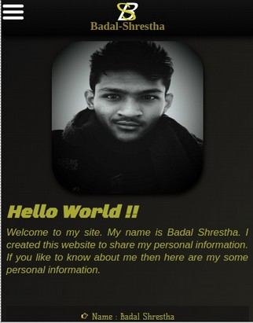
Full page layout
Mobile View

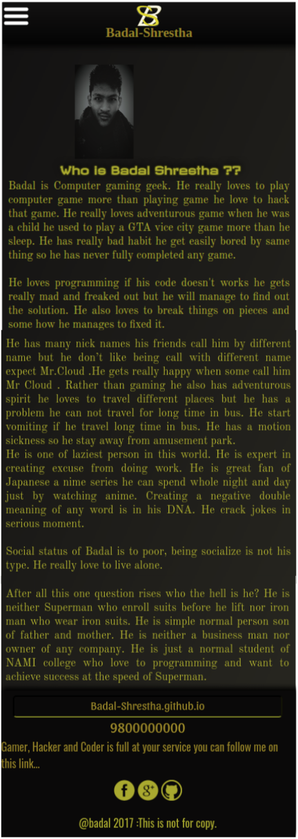
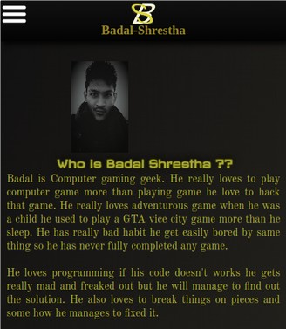
Bio page Mobile view
Full page layout
Mobile View
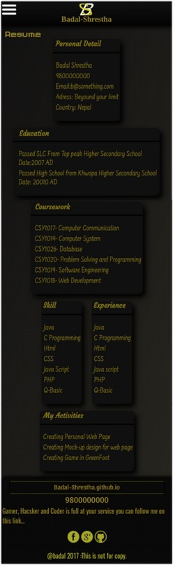
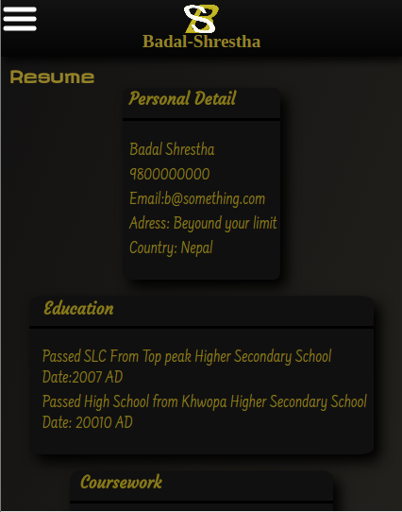
CV page Mobile view
Full page layout
Mobile View
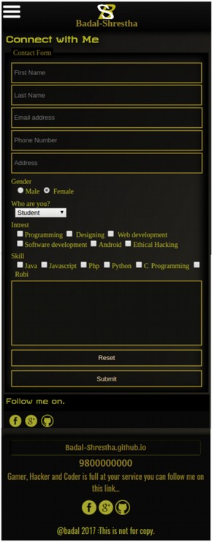
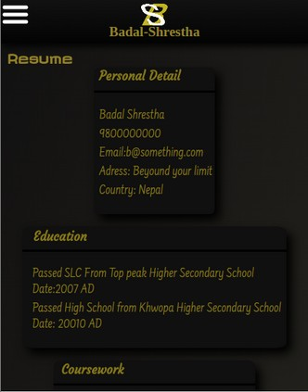
Contact page Mobile view
Full page layout
Mobile View
Validation check
HTML page validation
To make sure that I have use HTML 5 tags, I run the test on W3 validation successfully all my pages makes through that test without any error and warring expect bio.html . Here are the result.
Index page HTML validation check result.
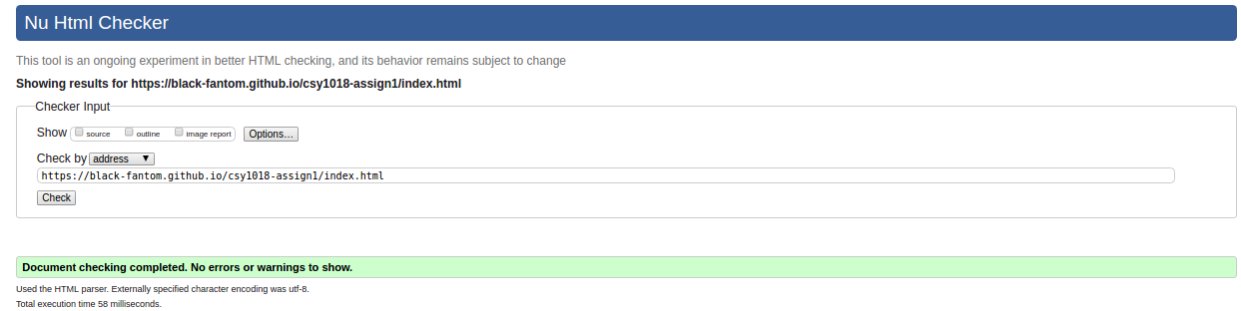
CV page HTML validation check result.
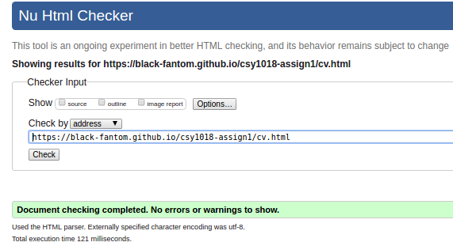
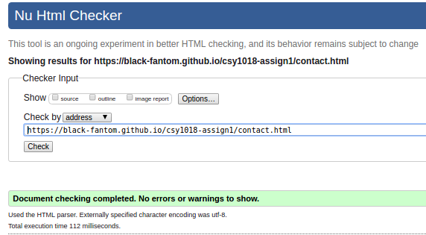
Contact page HTML validation check result.

Bio page HTML validation check result.
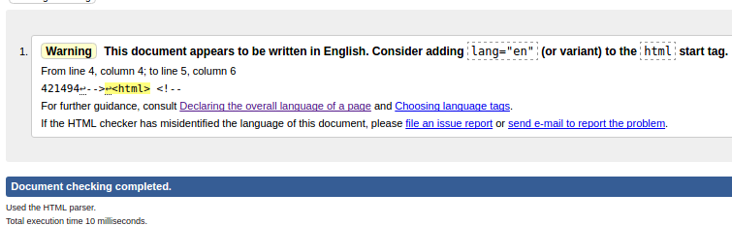
In Bio HTML it shows warring which I was not able to understand .
CSS Validation
To make sure my page has proper CSS tags I run a test through https://jigsaw.w3.org/css-validator/
. Successfully all pages pass through it with out any error. Here are some of the results
Index page CSS validation check result.
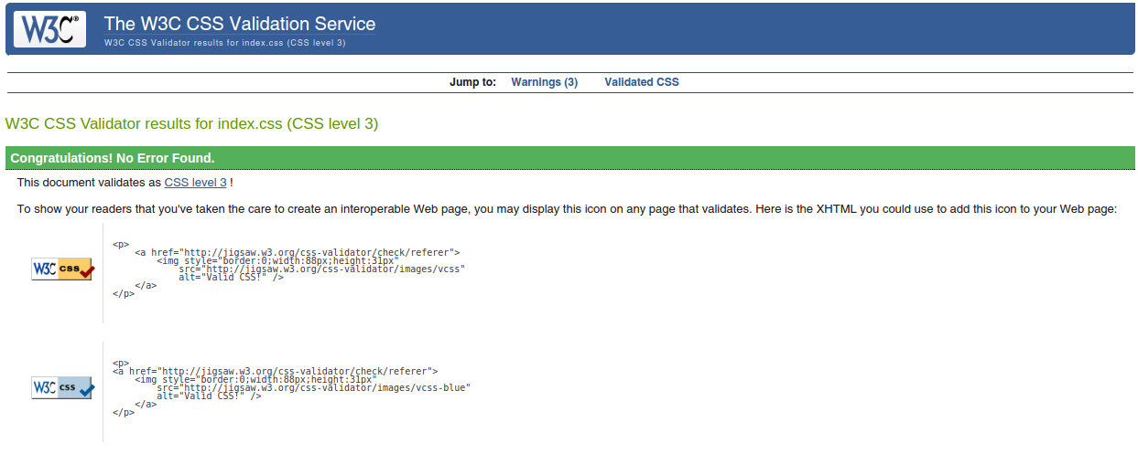
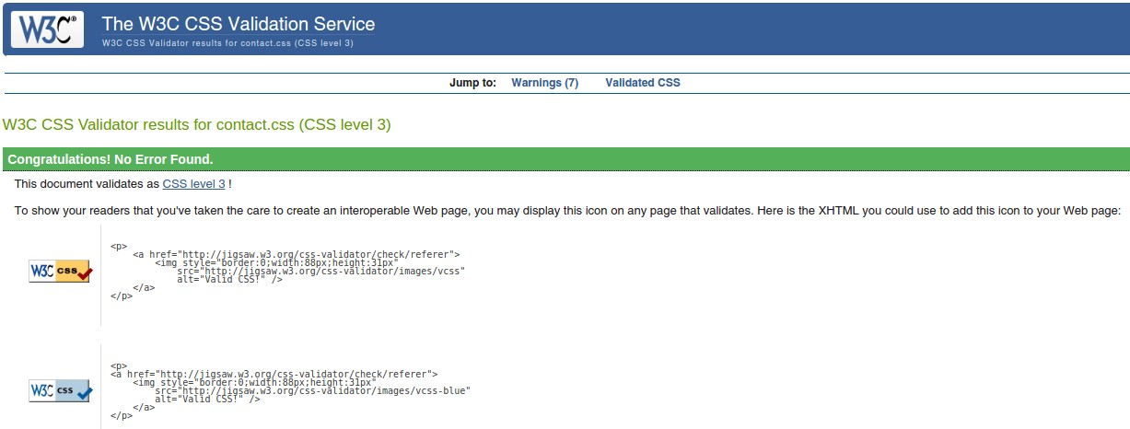
CV page CSS validation check result.
Contact page CSS validation check result.
Bio page CSS validation check result.
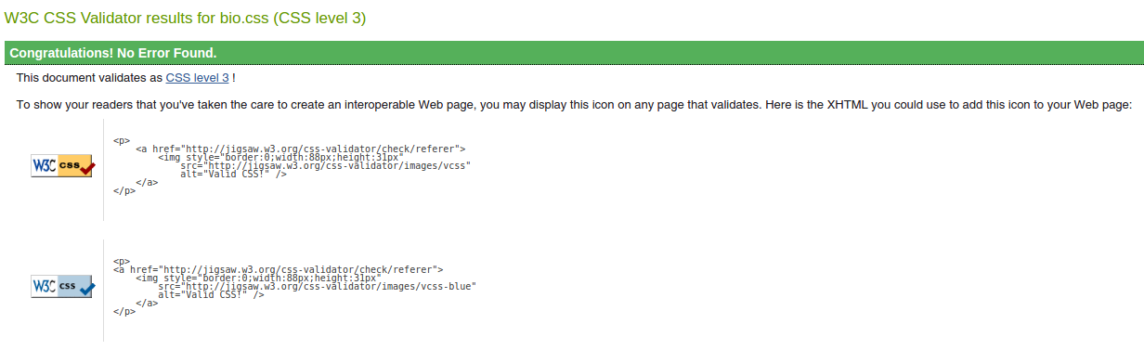

Conclusion
After 8weeks of hard work, a number of practice and good evaluation I finally created my personal website with HTML5 and CSS3. First of all, I created a number of sketch diagrams that I first planned in my mind and then created in my notebook. Then, I selected one that would be suitable for me then I created wireframe for that diagrams which gave me a clear idea how to write codes for my website. Then, I started my coding part which took me a long time as I was going through my plans and patiently writing all the codes to make it a good one. I even took some ideas from some of the websites and added them in my websites too. I have mentioned all the help that I took from other websites in the reference section. It was a very good experience as I learn a lot during the process of creating my personal website. Things taught in the classes and ideas mentioned in the study slides got more clear and I got a very clear understanding of HTML5 and CSS3. So, with all this I would like to conclude that I gave it a best shot to create my personal website.
This page could have make more attractive by using more material design and animation. The from can be made more dynamic by using Java script.
Reference
- Joel.2015.About Joel. [ONLINE] Available at: https://www.joel.sh/about [ Accessed 21 March 2017 ]
- CSS Tutorial. 1999 . CSS Tutorial. [ONLINE] Available at: https://www.w3schools.com/css/default.asp . [Accessed 30 March 2017].
- Online Signature.in .2001. Make your Own Signature Online. [ONLINE] Available at: http://www.onlinesignature.in/ [Accessed 1 April 2017].
- Iconfinder. 2017.Home icons. [ONLINE] Available at: https://www.iconfinder.com/search/?q=home . [ Accessed 22 March 2017].
- CSS Tricks.2007.CSS|CSS-tricks. [ONLINE] Available at: https://css-tricks.com/snippets/css/ [Accessed on 23 March 2017].
- Stack overflow. 2008. Can I have an onclick effect in CSS. [ONLINE] Available at: http://stackoverflow.com/questions/13630229/can-i-have-an-onclick-effect-in-css. [Accessed 31 March 2017]]

