PROJECT REPORT

Chess Openings as Contagion
Submitted by
[Student name(s) and register number(s)]
Under the guidance of
[Guide name]
[Designation]
[Department]
[Institution]
[Place]
[Submission month and year]

1 Abstract
This project examines whether players begin using a chess opening after encountering it in games against other players, and whether exposure from several distinct opponents provides additional reinforcement. A temporal player network was built from a cached slice of Lichess games recorded in January 2016. The analysis tracks the first use of each opening and colour by a player, constructs exposure trials with a full 14 day follow up, and compares adoption patterns with shuffled game times, rating and activity matched controls, and held out prediction. The corrected sample contains 249,505 games, 6,881 players, and 214,317 complete trials. The observed adoption rate rises across the distinct opponent buckets, but the observed to shuffled rate ratio falls from 1.084 at one opponent to 0.959 at six or more. This supports a simple contagion pattern in this sample, without clear evidence of reinforcement from additional distinct opponents. Matched exposed players show a 2.55 percentage point higher adoption rate than controls. These findings are observational and do not establish that an encounter caused adoption.

2 Introduction
An opening is the initial sequence of moves that sets the direction of a chess game. Players can learn openings from study, broadcasts, and their own games, including games against opponents who choose a line they have not used before. Public game records make this last route unusually visible: the same record identifies the two players, the opening, their colours, and the time of play [1].
The social network analysis question is whether the pattern of these encounters predicts later first use. In simple contagion, one meaningful contact may be enough to change behaviour. In complex contagion, additional independent sources provide reinforcement; the structure among exposing neighbours can matter as much as the number of encounters [2, 3]. This project applies that distinction to opening choice over a player interaction network.
The game record gives a precise timestamp for an encounter and for first observed use, but it does not reveal intent or private study. Players choose opponents and openings, and some openings become popular for reasons outside the network. The analysis therefore tests temporal associations and uses several comparison designs to assess whether a rising raw curve is more than a by-product of activity and popularity [4].

3 Problem Statement and Objectives
The problem is to determine whether an opening's first observed use is associated with prior exposure through opponents, and whether several distinct exposing opponents predict adoption beyond repeated encounters with the same opponent. A rising unadjusted adoption curve alone cannot answer this because highly active players both meet more opponents and try more openings.
Objective 1. Build a time ordered player interaction network and define opening behaviour by ECO code and player colour.
Objective 2. Measure exposure count, distinct exposers, structural diversity, and first subsequent use within a common 14 day window.
Objective 3. Compare the observed adoption curve with shuffled game times and rating and activity matched controls.
Objective 4. Assess whether exposure and network features improve held out prediction, and present the results in an explorable interface.

4 Methodology
The study uses the January 2016 Lichess standard rated game archive [1]. The current results were computed from a cached parsed slice, rather than from a fresh archive parse. Both players in a retained game had ratings from 1800 to 2200; the game was Blitz, Rapid, or Classical; and its ECO code was among the 40 most frequent after filtering. Players with fewer than 20 games in the slice were excluded.

4.1 Temporal network and behaviour
Each player is a node and each game creates a time stamped interaction between its players. An opening behaviour is the pair (ECO code, colour). In a game, the White player performs the White behaviour and exposes the Black player to it; the Black player likewise performs and exposes the White player to the Black behaviour. Adoption is a player's first observed performance of that same pair. This definition separates playing an opening from merely facing it.
For a player still at risk of first use, each exposure creates a trial. The variables are k, the cumulative number of exposure events; d, the number of distinct exposing opponents; and sd, the number of connected components among those opponents using only interactions already present at the trial time. The outcome is first use within 14 days after exposure. A trial is retained only when the full 14 day follow up fits inside the observation period, regardless of its outcome.
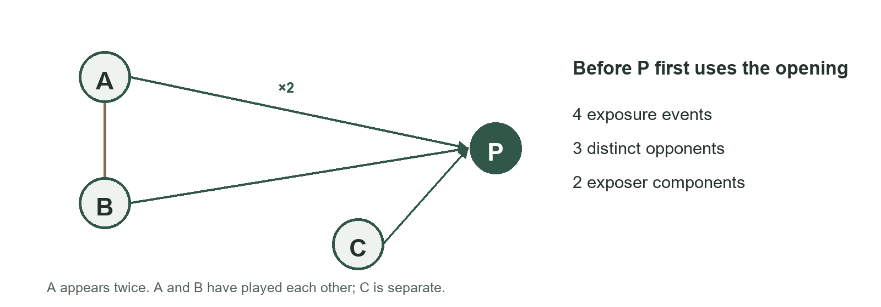
Figure 1. Conceptual example of exposure count, distinct opponents and structural diversity. This diagram illustrates the definitions and is not sampled game data.

4.2 Analysis and comparison design
The main curve groups complete trials by d and reports the percentage followed by first use. The decisive reinforcement check holds k fixed while comparing d, because a person with more distinct opponents may simply have had more total encounters. The timestamp shuffled reference permutes game times and repeats the trial construction 20 times. It preserves much of the sample's activity and opening mix while breaking the observed event order; it is a reference, not a randomized treatment.
At an exposed spell's first encounter, a matched control had not yet played or encountered the target behaviour. Matching uses rating within 50 points and prior game activity within 25 percent. A 400 replicate Poisson bootstrap clusters by player on both sides of each pair. A separate prediction check compares background features, repertoire proximity, and exposure/network features, with entire player opening colour spells held out together.
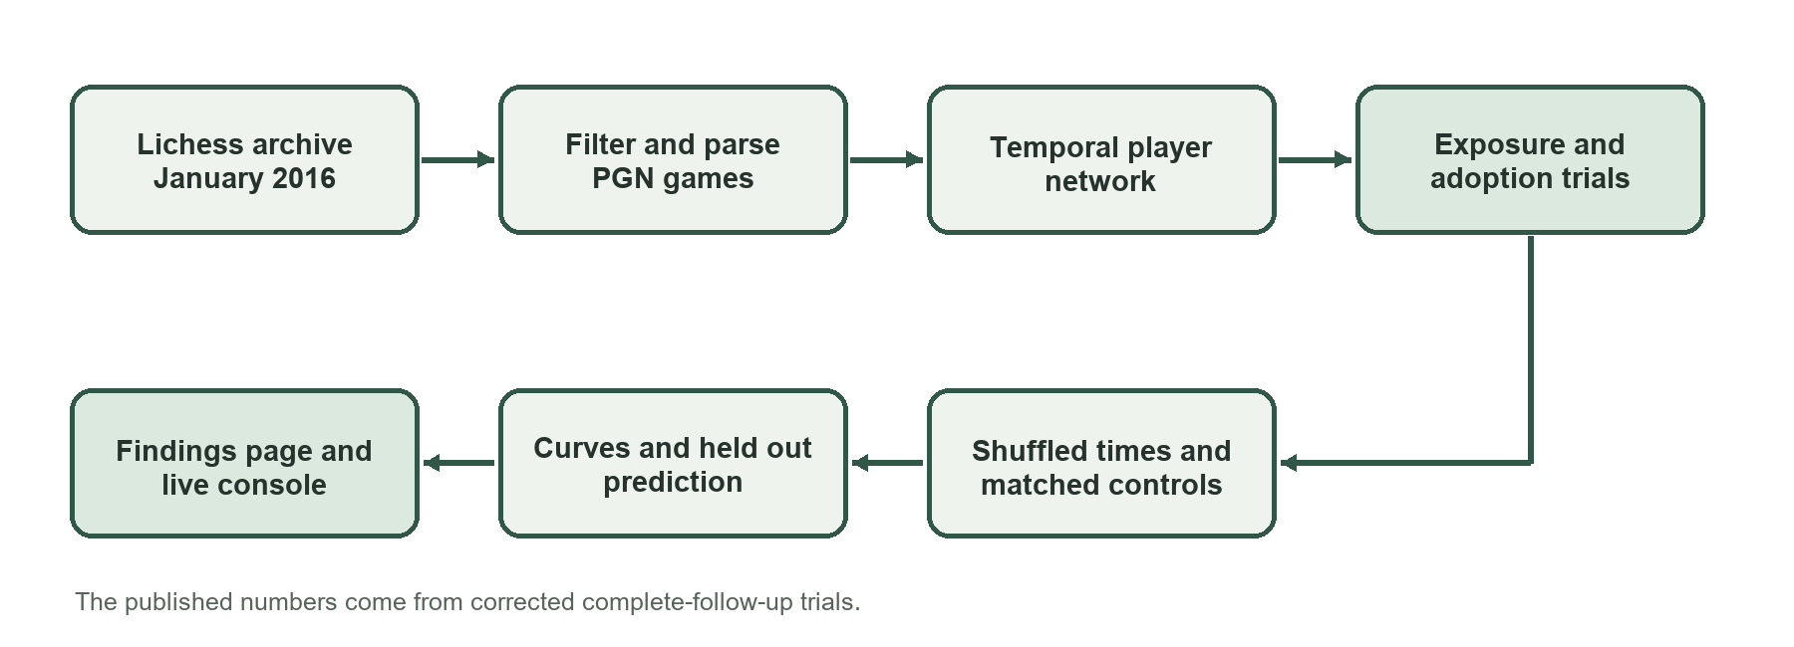
Figure 2. Implemented analysis workflow from archived games to corrected findings and interfaces.

5 Implementation
The project is implemented in Python. The parser streams PGN or compressed PGN and writes a compact Parquet game table. Downstream modules work from that table, so the analysis does not repeatedly read the archive. Pandas and PyArrow manage event tables; NetworkX provides network measures; SciPy and scikit learn support statistics and prediction; Matplotlib generates figures; and python chess validates moves in the live board.

5.1 Main components
The implementation keeps sample and measurement decisions in one configuration module. A pipeline runner then executes parsing, exposure trials, network analysis, null comparisons, curve and verdict, matching, prediction, and visualization. The server exposes a live console and a linked findings page. The findings page reads the corrected report and allows opening and colour filters, counts, descriptive intervals, and CSV or SVG exports.
The principal modules have distinct responsibilities: parse.py reads and filters the games; events.py constructs the exposure and adoption trials; structure.py and curve.py summarize the network and adoption pattern; nulls.py and matching.py run the two comparisons; and predict.py and animate.py produce the predictive check and diffusion views. This separation makes it possible to rerun a stage without altering the definitions used elsewhere.

5.2 Validation and reproducibility
The published results are stored in results/report.json with supporting CSV tables. The test suite contains 26 passing tests that cover event timing, complete follow up, risk set matching, grouped holdout and verdict safeguards. A verification script rebuilds the core January trial, curve, null and matching metrics from the cached slice. It does not reparse the original archive or refit the predictive models.
The live console can stream an archive or use a cached parsed slice, display stage progress, and replay saved run events after a page reload. The public findings page is generated from the report data. Both interfaces are presentation layers over the analysis code; the values discussed below come from the corrected January results, not from a visual simulation.

6 Results and Discussion
After filtering, the January slice contains 249,505 games among 6,881 players using 40 ECO codes. The interaction graph has 173,944 edges. Requiring a complete 14 day observation window leaves 214,317 exposure trials. Of these, 30,011 trial rows are positive, a 14.00 percent rate. A single eventual first use can contribute to several earlier trial rows, so this rate is a trial level measure rather than the proportion of unique players who adopted.
Measure | Corrected January result
Retained games | 249,505
Players | 6,881
Complete exposure trials | 214,317
Positive trial rows | 30,011
Matched exposed control pairs | 56,459

6.1 Exposure diversity and shuffled time
The observed 14 day adoption rate is 13.56 percent after one distinct exposer and 16.01 percent after six or more. Viewed alone, that increase might appear to support reinforcement. The shuffled time mean also rises, from 12.50 to 16.68 percent. Consequently the observed to reference ratio declines from 1.084 to 0.959, and the fixed k comparison shows no clear separation by d. The sample therefore shows a simple contagion pattern, with an early exposure association and no clear additional reinforcement.
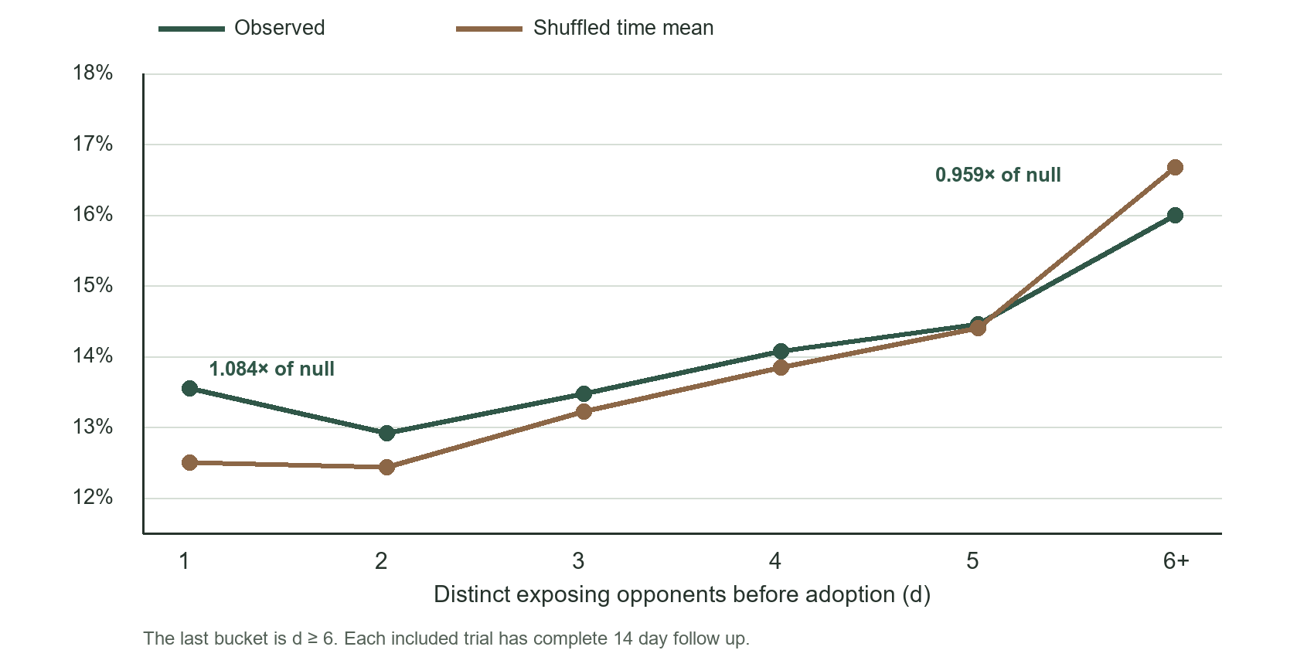
Figure 3. Observed and 20 shuffle mean adoption rates by distinct exposing opponents. Source: results/report.json. These repeated trial rows do not provide independent player level confidence intervals.

6.2 Matched and predictive checks
Among 56,459 matched pairs, the exposed adoption rate is 12.97 percent and the control rate is 10.42 percent, a difference of 2.55 percentage points. The descriptive 95 percent player cluster bootstrap interval is 1.82 to 3.13 points. About 16.16 percent of controls encounter the target behaviour during follow up. Rating and activity are closely balanced on average, although matching does not remove unmeasured differences in repertoire, opponent choice or motivation.
Held out AUC is 0.595 using opening popularity, rating and activity; 0.608 after adding repertoire proximity; and 0.633 with exposure and network features. This shows incremental predictive value in the evaluated data. Training AUCs are substantially higher than test AUCs, so the models overfit; their performance is not evidence that network exposure caused first use.
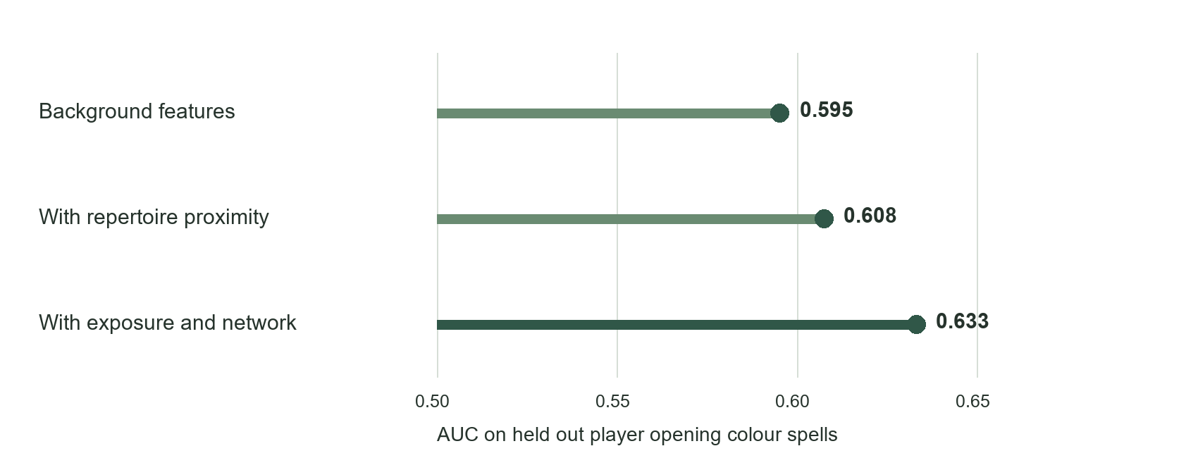
Figure 4. Predictive discrimination on held out player opening colour spells. AUC values come from the corrected report data; higher is better, with 0.5 representing chance.

6.3 Network context and limitations
The graph contains five detected communities and has mean degree 50.56. About 72.07 percent of recorded pre adoption exposures lie within communities. Players classed as early adopters have mean degree 84.29, compared with 60.77 for other players. These descriptive network summaries show where the recorded behaviour occurs; they do not establish a route of transmission.
This is a single month and rating band. The 20 shuffled replicates are useful as a reference mean but too few for precise tail probabilities. Repeated trials within a player behaviour spell can make trial level uncertainty look too narrow. A one row per spell sensitivity check preserves the declining lift pattern, but used only three shuffles. The original PGN has not been freshly reparsed after a parser fix, and a second month has not been replicated because the archive connection failed certificate validation. Existing historical robustness tables predate the corrected follow up rule and are not treated as current evidence.

7 Conclusion and Future Scope
The project produced a reproducible pipeline that turns chess games into a temporal player network, defines observable opening exposure and first use, and presents corrected findings through a live console and a static report page. In the current January sample, the raw adoption curve rises with the number of distinct exposing opponents, but its excess over a shuffled time reference does not. The evidence is most consistent with a simple contagion pattern and gives no clear support for reinforcement from additional distinct opponents. The matched difference and held out AUC add useful descriptive checks, while remaining observational.
The next step is to reparse the source PGN over a trusted connection and repeat the full analysis for at least one independent month. After that, the corrected follow up rule should be applied to alternative opening definitions and outcome windows, with more null replicates and player level uncertainty. A longer observation period would also help distinguish new first use from behaviour learned before the archive begins. Any stronger causal claim would require a design that better addresses opponent selection, private study and changing opening popularity.

8 References
[1] Lichess, “Open Database,” https://database.lichess.org/ (accessed 28 October 2026).
[2] D. Centola, “The spread of behavior in an online social network experiment,” Science, vol. 329, no. 5996, pp. 1194–1197, 2010. doi: 10.1126/science.1185231.
[3] J. Ugander, L. Backstrom, C. Marlow, and J. Kleinberg, “Structural diversity in social contagion,” Proceedings of the National Academy of Sciences, vol. 109, no. 16, pp. 5962–5966, 2012. doi: 10.1073/pnas.1116502109.
[4] S. Aral, L. Muchnik, and A. Sundararajan, “Distinguishing influence-based contagion from homophily-driven diffusion in dynamic networks,” Proceedings of the National Academy of Sciences, vol. 106, no. 51, pp. 21544–21549, 2009. doi: 10.1073/pnas.0908800106.

