BARBARIAN

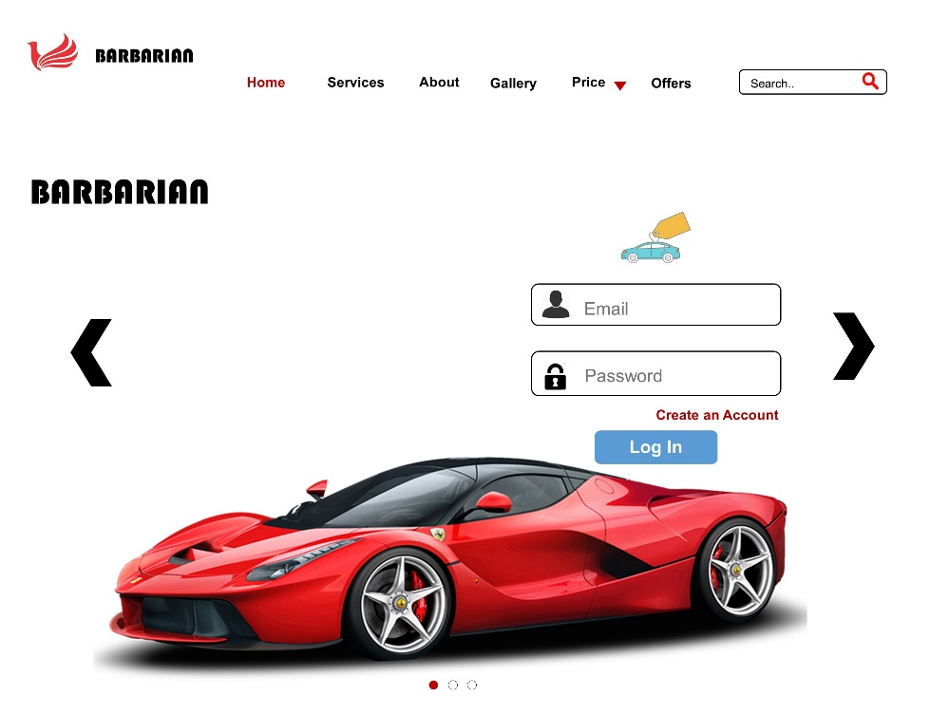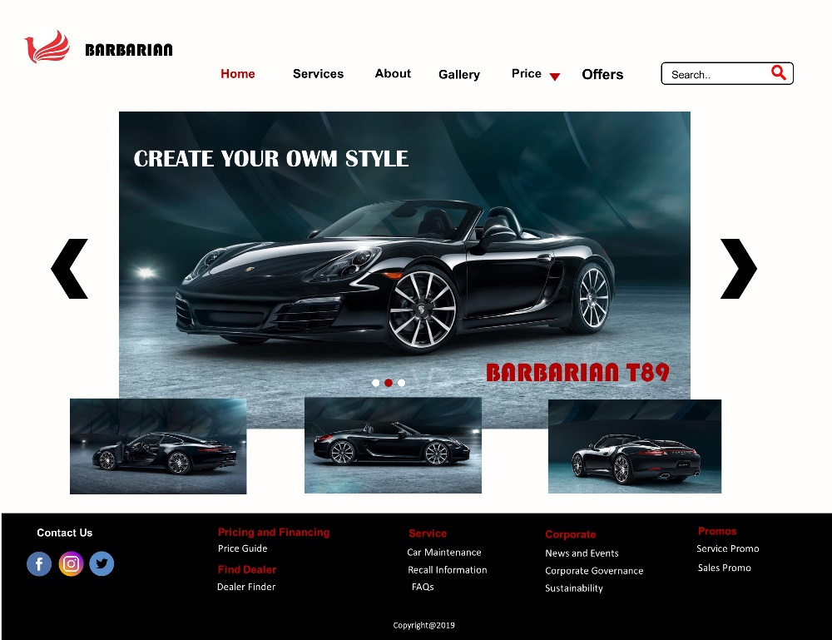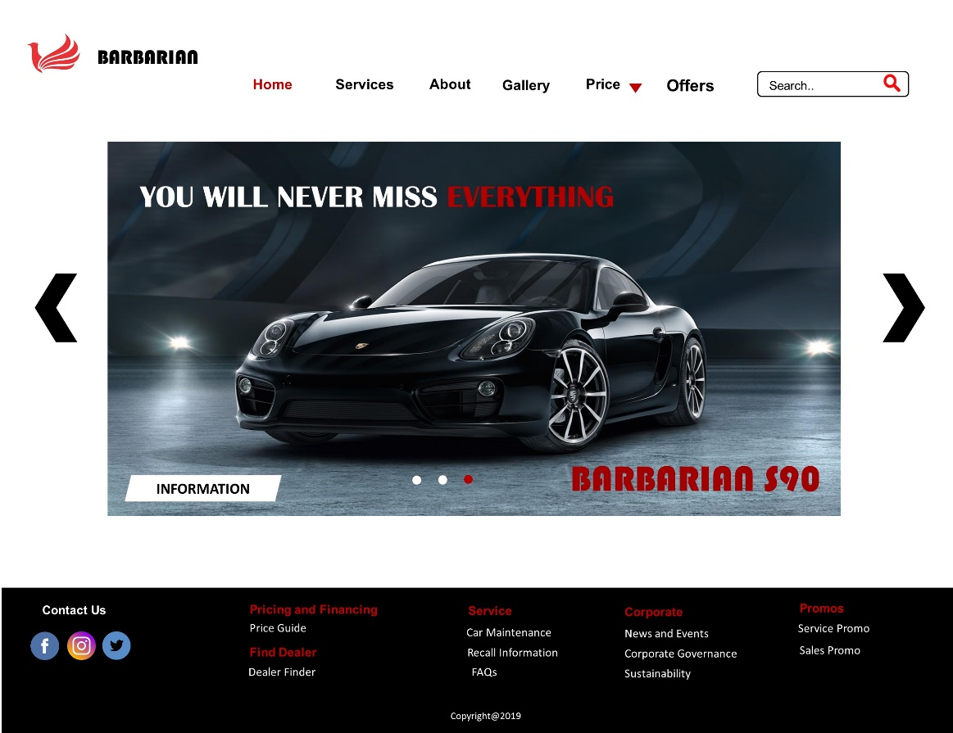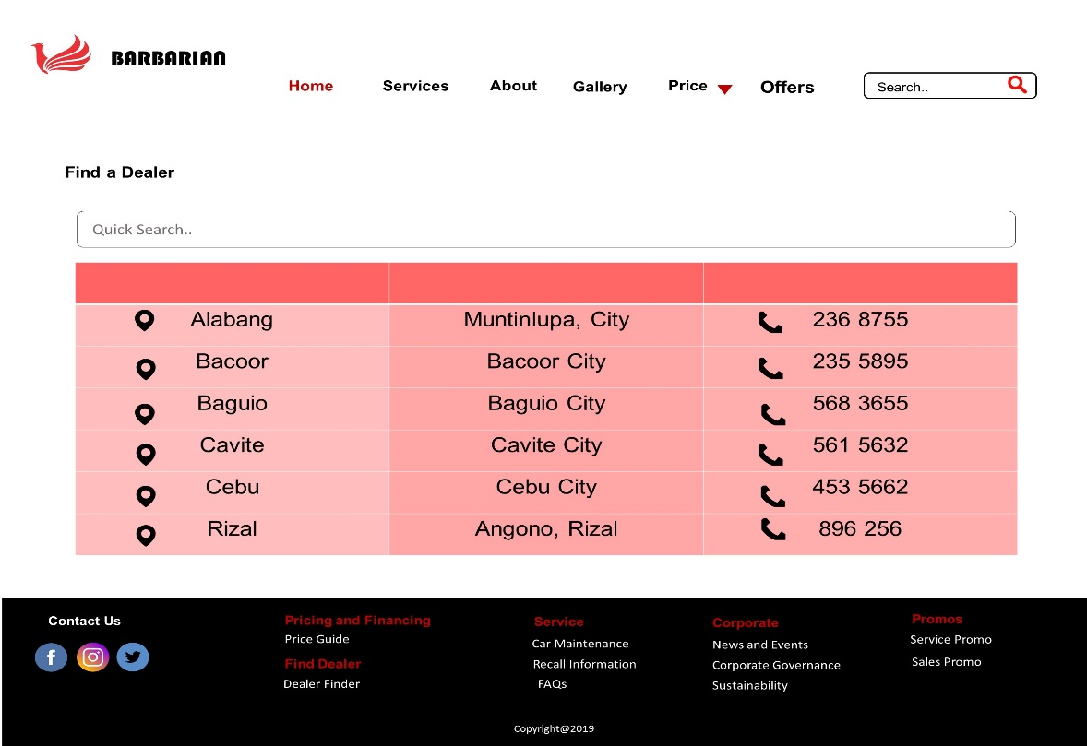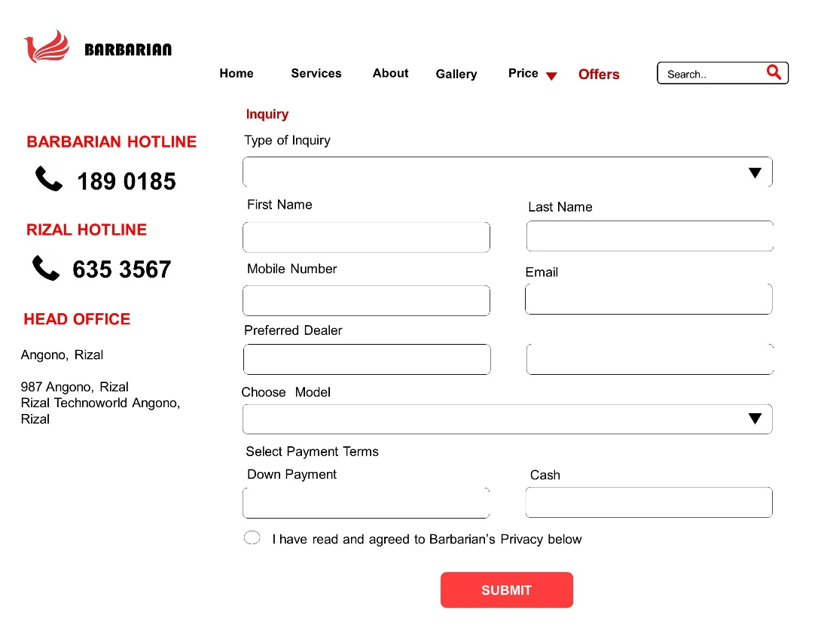

**HCI PRINCIPLES and GUIDELINES**

In the first home page I put header/Navigation Menu, User Interface, Footer

* Home, services, about, gallery, price, offers, and also search bar to easily use/find the needs of the user, this header help the users to easily recognize the buttons and features of the website and it also avoid memory load. The header is clear and properly alignment for the users.
* This user interface” know the User” help the user to secured their accounts specially their private information. The user interface is presentable and readable for the users.
* This footer is a great place to catch the user’s attention and guide them deeper into the website and reach the bottom of the page. And it also has a contact information of the website and Privacy policy to ensure the users that the website is safe and secured.
* Reduce memory task some other users can’t remember some features or buttons of the website; this reduce memory load help the user to easily find their task.
* Remind Users is to give them a confirmation about their private information's or remind them the actions they do before confirming it.