Brain Tumor Type Classification
Assignment 01 — Machine Learning

Part A: Data understanding and preprocessing
This section describes every transformation applied to the raw dataset before any model training took place. All preprocessing objects (imputers, encoder, scaler) are fitted exclusively on the training split to prevent data leakage.

A.1 Dataset Overview
Property | Value
Total records | 9,000
Total columns | 28 (27 features + 1 target)
Target variable | tumor_type (Glioma / Meningioma / Pituitary)
Numeric features | 13 (continuous)
Binary features | 5 (0 / 1 flags)
Ordinal feature | 1 (edema_grade: 0-3)
Nominal categorical | 5 (genetic_marker_status, tumor_location, smoking_status, region, ethnicity)
Dropped column | patient_id (non-informative identifier)

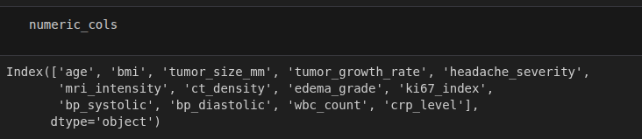
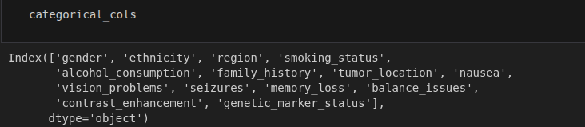

2. Value Handling
- All missing value markers were converted to a consistent NaN representation to ensure
proper processing. The number of missing values in each column was then checked to
identify incomplete data.
- Some numeric columns were initially loaded as text because they contained string-based
missing value markers. These columns were converted to the appropriate numeric data
type after replacing the invalid values with NaN.
- Missing values in numeric features were imputed using the median, while missing values in
categorical features were imputed using the most frequent category (mode). The imputers
were fitted only on the training data to prevent data leakage and ensure that information
from the validation and test sets did not influence the training process.

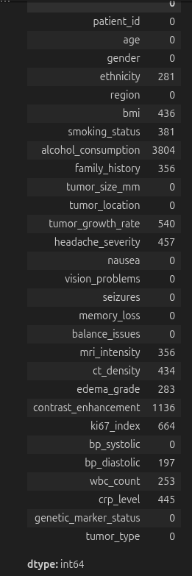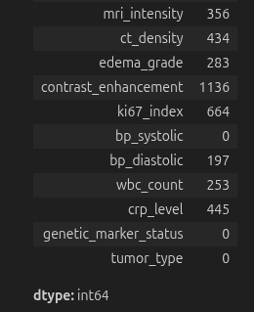
The dataset contains missing values in both numeric and categorical columns. Two separate SimpleImputer objects were fitted on the training set and serialised as .pkl files:

Imputer | Strategy | Columns affected | Artifact
Numeric Imputer | median | 13 continuous columns (age, bmi, tumor_size_mm, …) | numeric_imputer.pkl
Categorical Imputer | most_frequent | Categorical columns (before OHE) | categorical_imputer.pkl
Median imputation was chosen for numeric columns because it is robust to outliers that may be present in clinical measurements such as tumor size or blood-pressure readings.

3. Train / Validation / Test Split
Data was partitioned before any preprocessing to ensure no information leaks from the test or validation sets into the fitted transformers.
Split | Ratio | Samples | Purpose
Training | 70 % | 6,300 | Fit all preprocessing objects and model weights
Validation | 15 % | 1,350 | Hyper-parameter tuning & early-stopping monitor
Test | 15 % | 1,350 | Final unbiased performance evaluation
random_state=42 was used throughout for full reproducibility.

Encoding and scaling

Binary & Ordinal Features
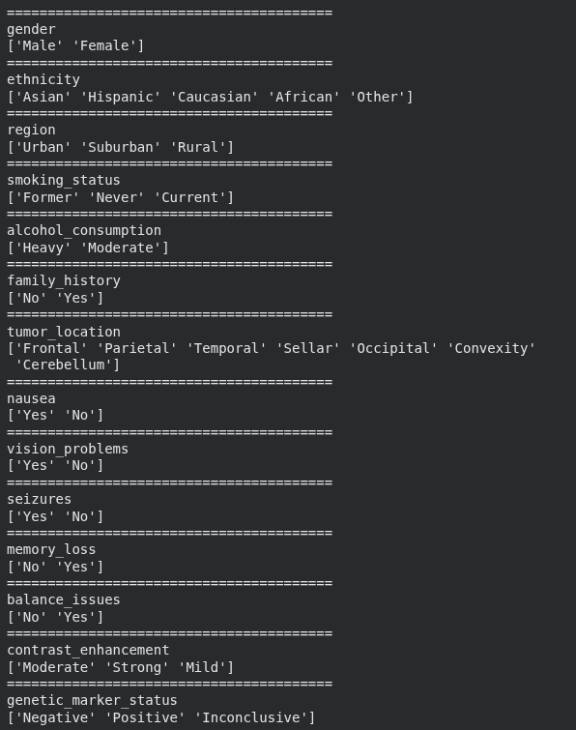
- 8 features (gender, alcohol_consumption,nausea,vision_problems,memory_loss,balance_issues family_history, seizures) encoded as 0/1 integers.
- edema_grade encodes an ordered clinical severity scale (0 = None, 1 = Mild, 2 = Moderate, 3 = Severe). It is retained as an integer so that the ordinal relationship is preserved and is excluded from the StandardScaler (see A.6) because its discrete 0-3 range is already compact and meaningful. Headache_severity ,contrast_enhancement are already a Ordinal ones

One-Hot Encoding (Nominal Categoricals)
Five nominal categorical features were encoded with scikit-learn's OneHotEncoder (handle_unknown='ignore', drop=None). This produced 19 binary indicator columns:

Original Column | Unique Values | OHE Columns Generated
genetic_marker_status | 3 (Inconclusive, Negative, Positive) | 3
tumor_location | 7 (Cerebellum, Convexity, Frontal, …) | 7
smoking_status | 3 (Current, Former, Never) | 3
region | 3 (Rural, Suburban, Urban) | 3
ethnicity | 5 (African, Asian, Caucasian, Hispanic, Other) | 5

Total feature columns after OHE: 43 (24 numeric/binary + 19 OHE).

Feature Scaling (StandardScaler)
Twelve continuous numeric features were z-score normalised using StandardScaler (mean=0, std=1), fitted on the training split only:
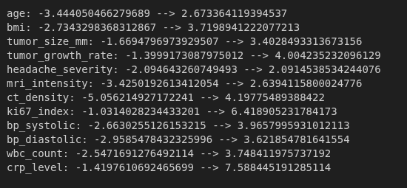
edema_grade and the binary 0/1 features were intentionally excluded from scaling to preserve their semantic meaning.

Target Label Encoding
The target column tumor_type (string) was encoded to integers using scikit-learn's LabelEncoder (alphabetical order):
Integer Label | Tumor Class
0 | Glioma
1 | Meningioma
2 | Pituitary

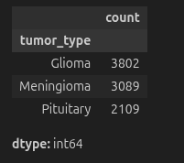

Step 4 – Class Balance
- The class distribution was examined by counting the number of samples in each tumour
class. The dataset is slightly imbalanced, as some classes contain more samples than
others.
- Class imbalance can affect training by causing the model to favour the majority class,
resulting in poorer learning for minority classes. During evaluation, overall accuracy may
appear high even if the model performs poorly on underrepresented classes. A common
technique to reduce this issue is to use class weights during model training.
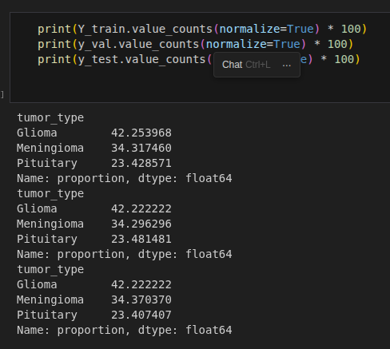

Part B: Model design : Neural Network Architecture
A Feed-Forward Neural Network (Multi-Layer Perceptron) was designed for 3-class classification of brain tumor types. Regularisation techniques were incorporated to address observed over-fitting in an earlier baseline model.

B.1 Layer-by-Layer Summary
A feed-forward neural network was designed for the brain tumour classification task. The
input layer contains the same number of units as the preprocessed input features. The
network consists of two hidden layers with 64 and 32 neurons, respectively, followed by an
output layer with 3 neurons, representing the three tumour classes. Dropout (0.3) and L2
regularization were applied to reduce overfitting.

The ReLU activation function was used in the hidden layers because it efficiently learns
non-linear patterns. The output layer uses the Softmax activation function to produce the
probability for each of the three classes. The number of output neurons is determined by
the number of target classes.

The model was compiled using the Adam optimizer and Sparse Categorical Crossentropy
loss function. This loss function is appropriate because the target labels were encoded as
integer values in Part A, Step 3, making it suitable for multi-class classification.

# | Layer Type | Units / Config | Parameters | Purpose
1 | Input | 43 features | — | Receives preprocessed feature vector
2 | Dense (Hidden 1) | 64 units, ReLU,  L2 λ=0.001 | 2,816 | Primary feature learning
3 | BatchNorm | 64 | 256 | Normalise activations → faster convergence
4 | Dropout | rate = 0.30 | 0 | 30 % neuron drop → regularisation
5 | Dense (Hidden 2) | 32 units, ReLU,  L2 λ=0.001 | 2,080 | Higher-order feature combinations
6 | BatchNorm | 32 | 128 | Normalise activations
7 | Dropout | rate = 0.20 | 0 | 20 % neuron drop → regularisation
8 | Dense (Output) | 3 units, Softmax | 99 | Class probability distribution
Total parameters: 5,379 (5,187 trainable + 192 non-trainable via BatchNorm).
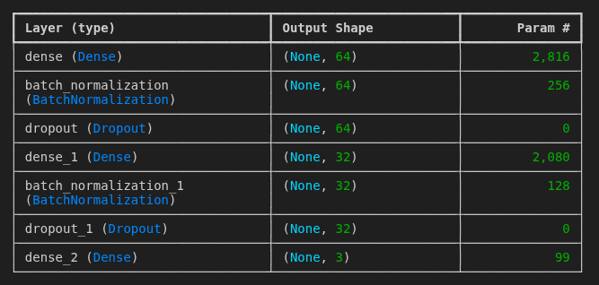

Step 2 – Regularisation
- To reduce overfitting, the model uses Dropout (0.3), L2 weight regularization, and Early
Stopping. Overfitting occurs when the model learns the training data too closely, resulting
in poor performance on unseen data. Dropout randomly disables a fraction of neurons
during training, L2 regularization discourages excessively large weights, and Early Stopping
stops training when the validation performance no longer improves. Together, these
techniques improve the model's ability to generalise.

- The final model architecture was verified using the model summary, which reports the
network structure and the total number of trainable parameters.
EarlyStopping
Parameter | Value
monitor | val_loss
patience | 8 epochs
restore_best_weights | True
Effect | Training stopped at epoch 26 and reverted to the best checkpoint
ReduceLROnPlateau
Parameter | Value
monitor | val_loss
factor | 0.5 (halves the learning rate)
patience | 4 epochs
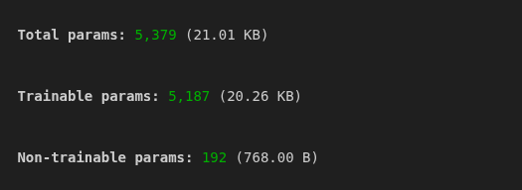

Part C: Data splitting, training, and tuning

Step 2 - Training & Validation Curves

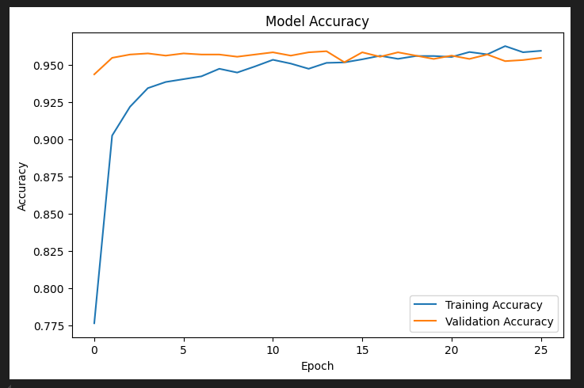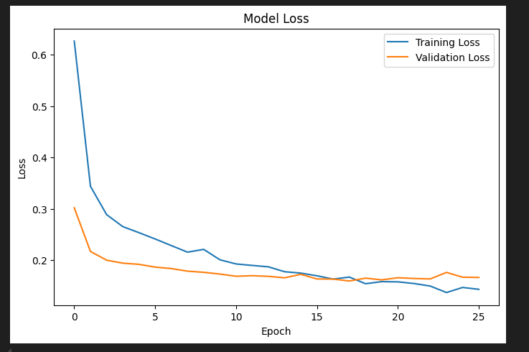

Accuracy Curve
Training accuracy increased rapidly from approximately 77.6% in the first epoch to around 96.0% by the final epoch. Validation accuracy remained consistently high throughout training, fluctuating between 95.4% and 96.0%, and closely followed the training accuracy after the initial epochs. The close alignment of the two curves, with only minor fluctuations, indicates good model generalisation and suggests that overfitting was effectively controlled.
Loss Curve
Training loss decreased substantially from approximately 0.63 at the first epoch to around 0.14 by the final epoch, demonstrating steady learning throughout training. Validation loss also declined rapidly during the early epochs, stabilising between 0.16 and 0.18 for the remainder of training. The small gap between the training and validation loss curves, together with their stable convergence, indicates that the model achieved good generalisation without significant overfitting. Minor fluctuations observed in the validation loss during the later epochs are typical and do not indicate instability.

C.1 Hyperparameter tuning.
Hyperparameter | Value | Rationale
Optimizer | Adam | Adaptive learning rates; robust default for deep nets
Learning rate | 1e-3 (initial) | Standard Adam default; reduced automatically by callback
Loss function | Sparse Categorical Crossentropy | Compatible with integer class labels; standard for multi-class
Metric | Accuracy | Primary tracking metric during training
Max epochs | 50 | Upper bound; EarlyStopping prevents unnecessary epochs
Batch size | 32 (Keras default) | Good balance between gradient noise and memory

Training Results (Final Epoch Metrics)
Metric | Training Set | Validation Set
Accuracy | 95.95 % | 95.48 %
Loss | 0.1429 | 0.1661
The small gap between training and validation accuracy confirms that the regularisation techniques (Dropout + L2 + BatchNorm) successfully mitigated the over-fitting observed in the un-regularised baseline model.

Part D: Model Evaluation & Results

D.1 Test-Set Performance
Metric | Value
Test Accuracy | 96.07 %
Test Loss | 0.1643
Test Samples | 1,350 (15 % of 9,000)

D.2 Per-Class Classification Report
The following metrics were computed on the held-out test set using sklearn.metrics.classification_report:
Glioma (0)
Meningioma (1)
Pituitary (2)
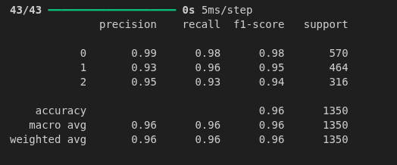
Glioma achieves the highest F1-score (0.98), benefiting from its larger support (570 samples). Meningioma and Pituitary achieve F1 = 0.94, reflecting balanced precision–recall trade-offs

D.3 Confusion Matrix
The confusion matrix below (generated with sklearn.metrics.ConfusionMatrixDisplay) shows the predicted vs. actual class assignments on the 1,350-sample test set:
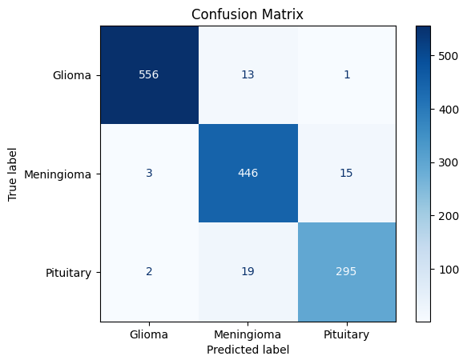
Actual \ Predicted | Glioma (0) | Meningioma (1) | Pituitary (2)
Glioma (0) | 556 ✓ | 13 | 1
Meningioma (1) | 3 | 446 ✓ | 15
Pituitary (2) | 2 | 19 | 295 ✓

Key observations:
• Glioma → correctly predicted 556/570 (97 % recall).
• Meningioma → 3 misclassified as Glioma; 15 as Pituitary.
• Pituitary → 19 misclassified as Meningioma, which is the most common error pair. These two tumour types share some overlapping imaging features, which may explain the confusion.

Step 1 – Baseline Comparison
A Random Forest classifier was trained using the same training, validation, and test splits
as the neural network. The performance of both models was compared using the held-out
test set.

Feature Importance Analysis
A Random Forest Classifier was used to evaluate the importance of each feature in predicting brain tumor types. As shown in Figure X, tumor growth rate (0.2191) was identified as the most influential feature, followed by the Ki-67 index (0.1669), tumor location (Sellar) (0.1246), and tumor size (0.1014). Other relevant features, including age, MRI intensity, edema grade, vision problems, and seizures, also contributed to the model's predictions. These results indicate that tumor characteristics and imaging-related features play a dominant role in achieving accurate classification.

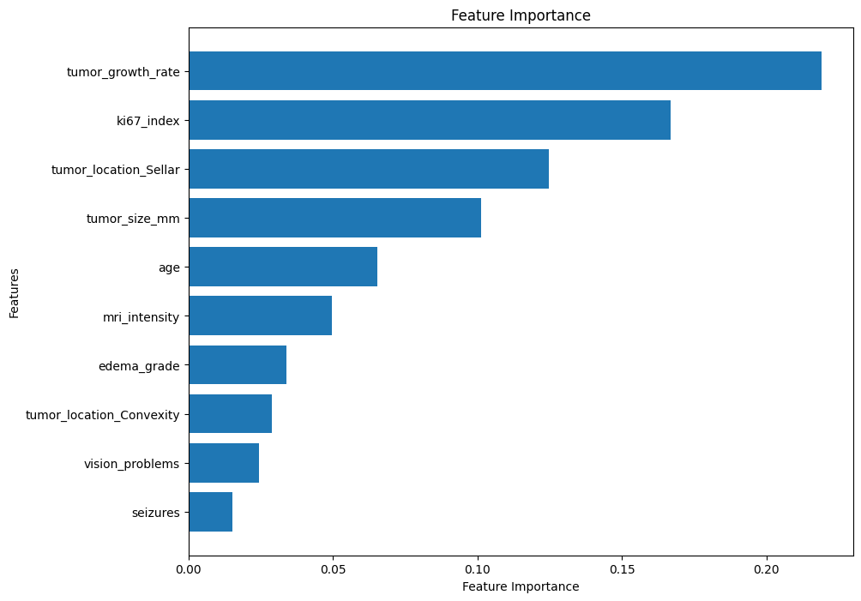
Step 3 – Limitations and Ethics
- One limitation of this model is that it was evaluated using only a single dataset. Its
performance on data collected from other hospitals or populations has not been verified. A
second limitation is that the model occasionally confuses Meningioma and Pituitary
tumours, as shown by the confusion matrix, indicating that some tumour classes remain
difficult to distinguish.
- A major risk of deploying this model in a real clinical setting is that an incorrect prediction
could lead to an inappropriate diagnosis or treatment decision. Therefore, the model
should be used only as a clinical decision support tool rather than a replacement for
medical professionals. Before deployment, the model should be validated on independent
clinical datasets and all predictions should be reviewed by qualified clinicians.

Appendix A – Academic Integrity Statement
Generative AI (ChatGPT) was used as an auxiliary learning and writing support tool during the completion of this assignment. Its use was limited to obtaining explanations, improving code understanding, and enhancing the presentation of the report. Specifically, ChatGPT was used to:
- Clarify Python programming errors and recommend debugging techniques.
- Provide explanations of machine learning concepts, including neural networks, feature scaling, encoding, and model evaluation.
- Assist with implementing data visualisation, such as accuracy/loss curves, confusion matrices, and feature importance graphs.
- Suggest improvements to the structure, grammar, and readability of the report.
The dataset preparation, feature engineering, model development, training, hyperparameter selection, performance evaluation, and interpretation of results were carried out independently by the author. All generated code and explanations were reviewed, modified where necessary, tested, and verified before being included in the final submission.

Example Prompts Used
- "How can I preprocess categorical and numerical features for a neural network using Scikit-learn?"
- "Help me generate training and validation accuracy and loss plots from my model history."
- "Explain the performance metrics obtained from my confusion matrix and classification report."
- "How can I calculate and visualise feature importance using a Random Forest model?"
- "Improve the academic writing of this report section without changing its meaning."
- "Why is my validation accuracy fluctuating, and how can I reduce overfitting?"

