Stored Cross-Site Scripting (CWE-79)
App: 04_stored_xss — a guestbook server.
The flaw: clients post a message; the server stores it verbatim and serves it to every viewer. It never validates or escapes the text, so <script>...</script> is stored as-is and runs in the browser of anyone who views the guestbook.
Analogy: a public noticeboard where the staff pin whatever note you hand them, word for word — including a note rigged to shout in the face of everyone who later reads the board.

1. How the vulnerable app works
The post handler stores the raw text; list hands it back to everyone:
# server.py — inside the "post" handler
text = msg.get("text", "")
MESSAGES.append(text) # THE BUG: stored verbatim — no validation, no escaping
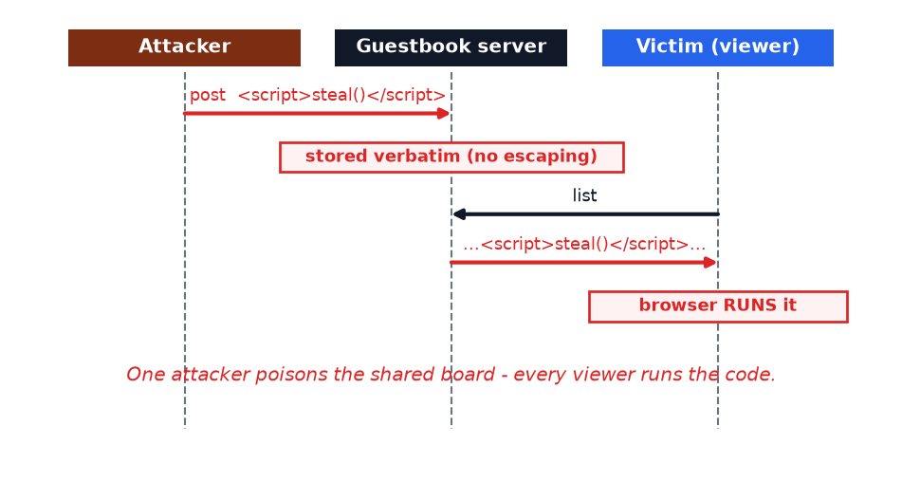
One attacker poisons the shared guestbook; every later viewer runs the attacker's code.

2. How Legilimens is used against it
Unlike app #2 (which changed a value in flight), here Legilimens injects a whole message the client never sent — using the Repeater to send a crafted post straight to the server.
Analogy: in app #2 Legilimens forged a number on your receipt; here it slips an extra, booby-trapped note into the mailbag before it reaches the noticeboard.
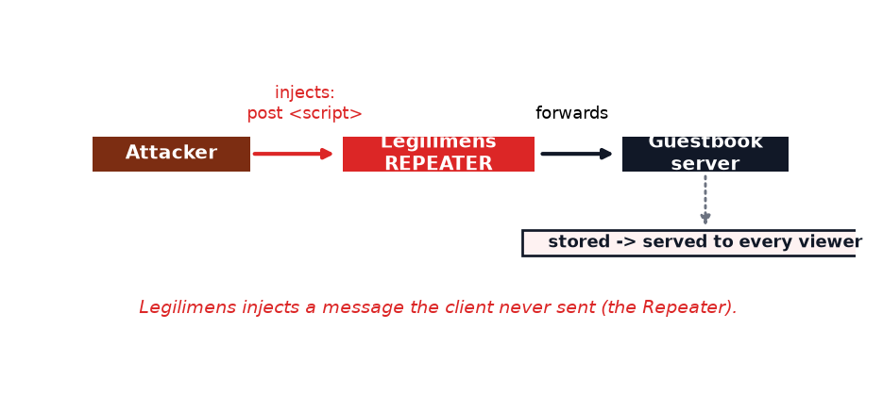
Under the hood the Repeater drops a datagram into the live session, as the client:
# proxy.py — the Repeater injects a datagram into the live session (as the client)
session.upstream.send_datagram(payload.encode()) # payload = the attacker's script post
Run a client so a session is live, then use the UI's Repeater -> TO SERVER with:
{"cmd":"post","text":"<script>LEGILIMENS_INJECTED</script>"}
Honest note: the script only executes when a UI renders the guestbook as HTML (e.g. via innerHTML). The server storing raw markup is the root cause — that's what this app proves.

3. How to make app-4 secure
Validate and escape on the way in. Then rendering it later is harmless.
# server.py — the fix (commented next to the bug)
import html
text = str(msg.get("text", ""))[:280] # length limit
text = html.escape(text) # <script> -> &lt;script&gt;
MESSAGES.append(text)
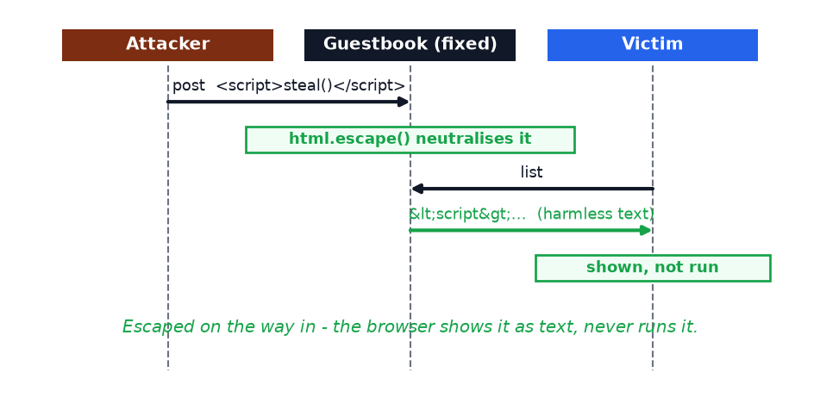
Escaped input is stored and shown as plain text — never executed:
Message posted | Vulnerable app | Fixed app
hello | stored, shown as text | stored, shown as text
<script>steal()</script> | stored raw -> RUNS in viewers | escaped -> harmless text

Takeaway
Never store or serve untrusted input unvalidated. Validate and escape on the way in (length limits, allow-lists, html.escape) and escape on the way out when rendering. Treat every byte from a client as hostile — a secure transport carries the attacker's <script> just as faithfully as a real message.

