Sensitive Data Exposure (CWE-200)
App: 03_secret_leak — a leaderboard server.
The flaw: asked for the leaderboard, the server sends back its whole internal user record for every player — email, session_token, role — instead of just name and score.
Analogy: you ask the front desk for the guest list, and they hand you a printout with everyone's name plus room number, credit card, and passport. You only needed names.

1. How the vulnerable app works
The handler serializes the full internal record straight to the client:
# server.py — inside the "leaderboard" handler
board = {"type": "leaderboard", "players": USERS} # THE BUG: USERS has email/session_token/role
self._http.send_datagram(stream_id=event.stream_id, data=json.dumps(board).encode())
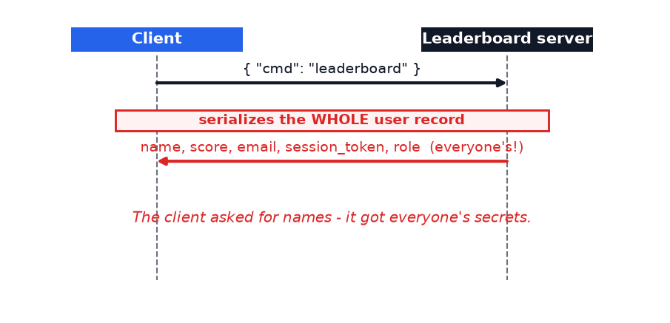
The client only needed names and scores — it received everyone's private fields too.

2. How Legilimens is used against it
This is the passive-detection side. You set no tamper rule and intercept nothing — you just capture. The moment the leaky reply flows through, Legilimens auto-flags it SUSPICIOUS because it spots keywords like session_token, token, and secret.
Analogy: in app #1 Legilimens was the security camera (watched), in app #2 the forger (attacked). Here it is the metal detector — it beeps by itself when something that shouldn't be there passes through.
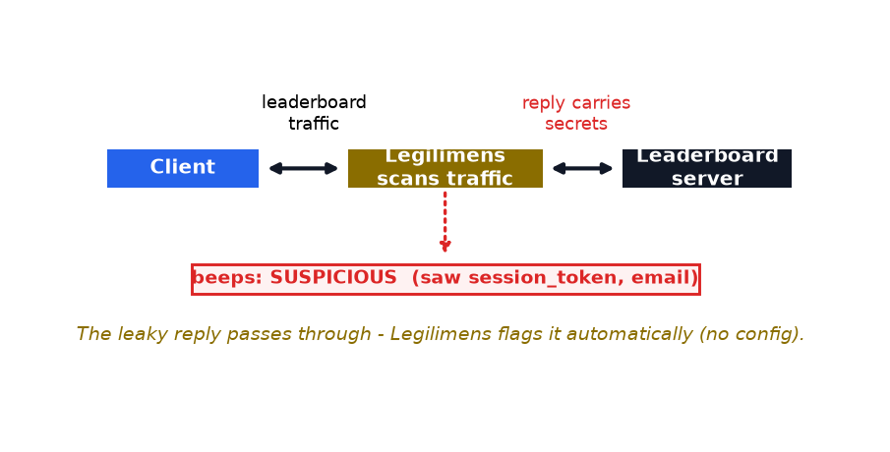
The flag is automatic — every message is scanned as it passes:
# proxy.py — Legilimens flags any payload with secret-like keywords, on its own
flag = "suspicious" if is_suspicious(payload) else "normal"
# is_suspicious() checks for: session_token, token, password, secret, api_key, ...
What you see: the reply row is flagged SUSPICIOUS and the counter climbs on its own. The tool surfaced the leak just by watching — no configuration.
Run it yourself (client through the proxy; no tamper/intercept needed):
.venv\Scripts\python.exe vuln_apps\03_secret_leak\client.py --port 4433

3. How to make app-3 secure
Send only a public projection — the fields the client actually needs. Keep the rest server-side.
# server.py — the fix (commented next to the bug)
public = [{"name": u["name"], "score": u["score"]} for u in USERS]
board = {"type": "leaderboard", "players": public} # no email / token / role
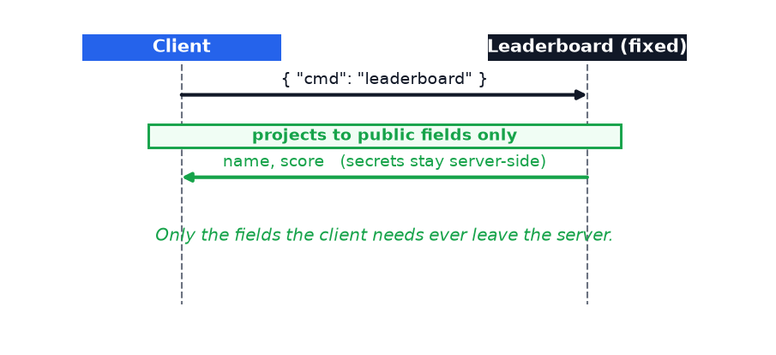
Now only the public fields ever leave the server:
Field the server holds | Vulnerable app | Fixed app
name, score | sent | sent
email | LEAKED | kept server-side
session_token | LEAKED | kept server-side
role | LEAKED | kept server-side

Takeaway
Never serialize your internal model to the client. Send only the fields it needs; keep tokens, PII, and roles on the server. Encryption protects the payload in transit — it does nothing about what you choose to put in that payload. A secure transport carrying secrets is still a leak.

