No Rate Limiting / Brute-Force (CWE-307)
App: 05_no_rate_limit — a vault pin-pad.
The flaw: a client sends a 4-digit PIN guess and the server says right or wrong — and it answers every guess instantly, with no per-client limit and no lockout. A client can try all 10,000 combinations in seconds and brute-force the secret.
Analogy: a padlock you can try keys on as fast as you like, forever. Your phone locks after a few wrong PINs; this door lets you try 10,000 in a row without blinking.

1. How the vulnerable app works
Each guess is checked and answered — the attempt is counted, but never limited:
# server.py — inside the "guess" handler
self._attempts += 1 # counted, but nothing caps it <- THE BUG
pin = str(msg.get("pin", ""))
reply = {"result": "correct"} if pin == SECRET_PIN else {"result": "wrong"}
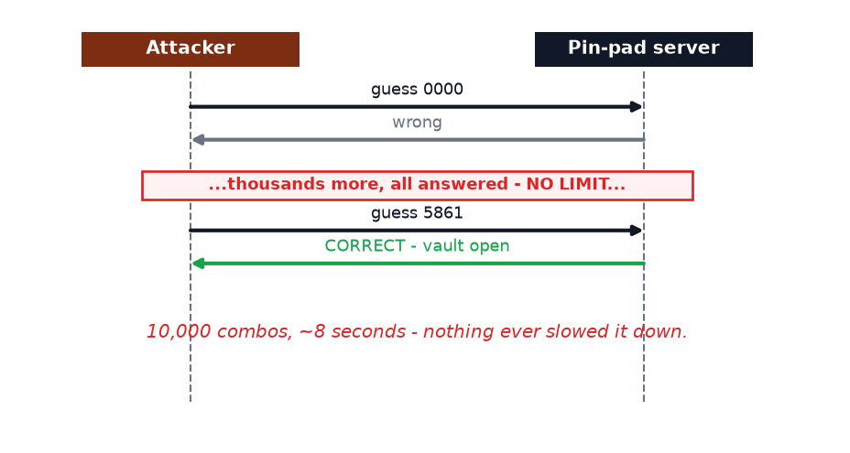
A 4-digit PIN has only 10,000 possibilities — trivial to exhaust when nothing slows you down.

2. How Legilimens is used against it
Here Legilimens is the watcher of a flood: the brute-force streams through the proxy and every guess lands in the traffic log, so you see the attack happening. Its Attack Simulator (QUIC-flooding / QUIC-loris) can also pile on a connection-level DoS.
Analogy: app #4 slipped one booby-trapped note in; here Legilimens is the CCTV watching someone try every key on the lock — and it can jam the door itself too.
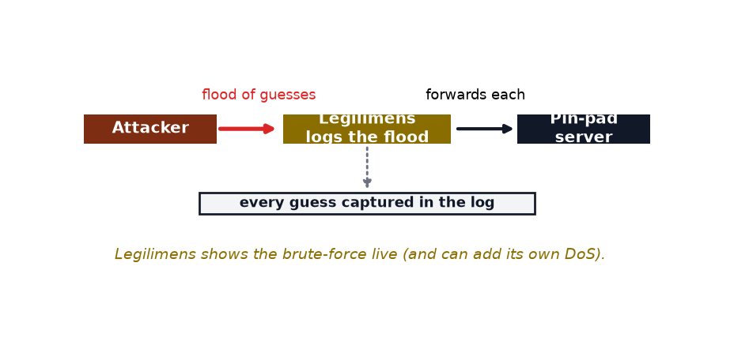
Nothing special is configured — the normal per-message logging captures the whole flood:
# proxy.py — every datagram (each brute-force guess) is logged as it passes through
await broadcast_async(make_event(direction="incoming", etype="datagram", payload=payload, ...))
Run the brute-forcer through the proxy and watch the log fill with guesses:
.venv\Scripts\python.exe vuln_apps\05_no_rate_limit\client.py --port 4433

3. How to make app-5 secure
Throttle per client and lock out after repeated failures.
# server.py — the fix (commented next to the bug)
import time
self._recent = [t for t in self._recent if time.time() - t < 60]
if len(self._recent) >= 5: # max 5 guesses per minute
reply = {"result": "rate_limited", "retry_after": 60}
...send and return...
self._recent.append(time.time())
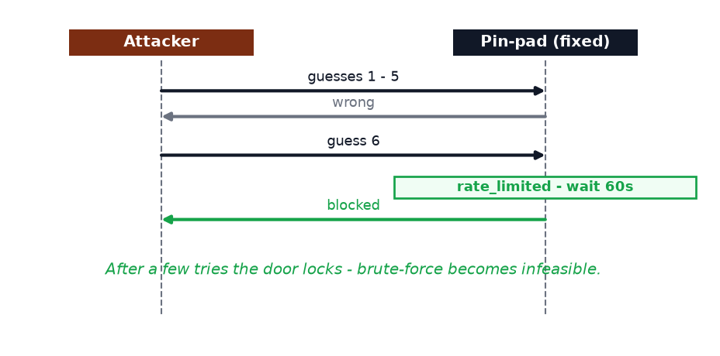
A few tries and the door locks — the brute-force dies:
 | Vulnerable app | Fixed app
Guesses allowed | unlimited | ~5, then locked out
Time to crack a 4-digit PIN | ~8 seconds | infeasible

Takeaway
Rate-limit anything an attacker can repeat: logins, PIN/OTP checks, password resets, API calls. Throttle per client and lock out after repeated failures. The short PIN is not the bug — a 4-digit PIN is fine with a “5 tries then wait” rule. The bug is the missing limit.

