Missing Authentication (CWE-306)
App: 01_no_auth — a tiny WebTransport “vault” that serves a private account balance.
The flaw: it asks for a token, then never checks it. Anyone gets in.
Analogy: a bank vault with a guard who says “ID please?”, glances away, and opens the door for everyone — even people holding no ID at all. The lock exists; nobody uses it.

1. How the vulnerable app works
The vault reads the token off the connection request and then just… opens the door.
# server.py — inside the CONNECT handler
token = parse_qs(urlparse(path).query).get("token", [None])[0]
# THE BUG: token is read above, then never checked — every connect gets 200 OK.
self._http.send_headers(stream_id=event.stream_id, headers=[(b":status", b"200")])
self._sessions.add(event.stream_id) # session is now live
Once the session is open, it hands the private balance to whoever asks:
if cmd == "balance":
self._http.send_datagram(stream_id=event.stream_id,
data=json.dumps(ACCOUNT).encode())
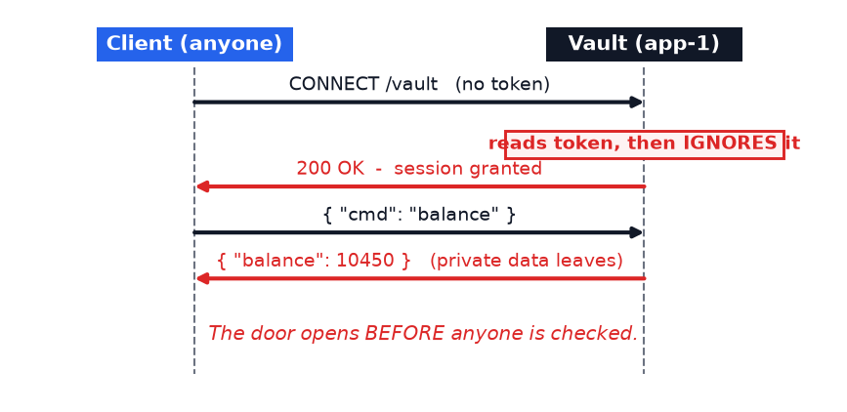
The whole problem: the door opens before anyone is checked.

2. How Legilimens is used against it
Legilimens is a wiretap. It sits between the client and the vault, forwards everything so the app still works, and records every message so you can prove what happened.
Analogy: a security camera in the hallway. It doesn’t change the guard’s behaviour — it just films the stranger walking in empty-handed and walking out with the cash.
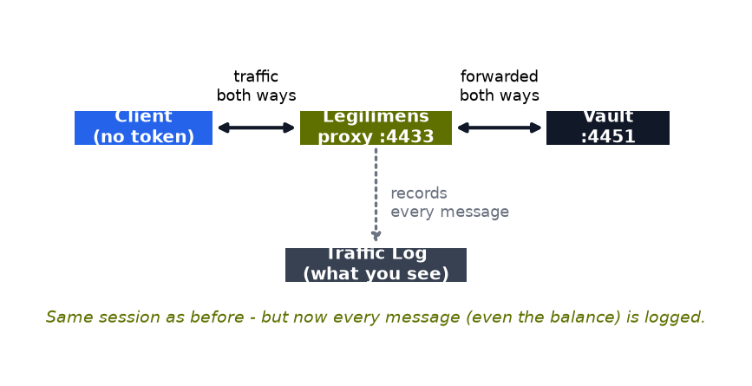
Under the hood it accepts the client, bridges to the real vault, and logs each message with a colour-coded flag:
# proxy.py — every message that passes through is captured for the log
await broadcast_async(make_event(
direction="incoming", etype="datagram",
payload=payload,
flag="suspicious" if is_suspicious(payload) else "normal", # auto-classified
))
What you see in the log: a "Session … connected via /vault" row with no credential, then the balance flowing back. That row is the proof the vault let a stranger read private data.
Run it yourself (client goes through the proxy on :4433):
.venv\Scripts\python.exe vuln_apps\01_no_auth\client.py --port 4433

3. How to make app-1 secure
Check the token before opening the session. Missing or wrong token → 401, and stop.
# server.py — the fix (already sitting commented-out next to the bug)
token = parse_qs(urlparse(path).query).get("token", [None])[0]
if token not in VALID_TOKENS: # the guard actually looks
self._http.send_headers(stream_id=event.stream_id,
headers=[(b":status", b"401")])
self.transmit()
return # door stays shut
# only valid tokens reach this line
self._http.send_headers(stream_id=event.stream_id, headers=[(b":status", b"200")])
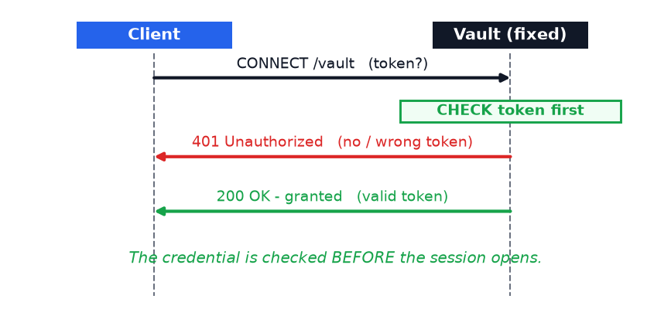
Re-running the three clients through Legilimens shows the difference plainly:
Client sends | Vulnerable app | Fixed app
no token | 200 — GRANTED | 401 — rejected
wrong-token | 200 — GRANTED | 401 — rejected
tok-hermione-granger | 200 — GRANTED | 200 — GRANTED

Takeaway
WebTransport (like HTTPS) gives you an encrypted channel, not an authorised one. Encryption proves nobody eavesdropped; it says nothing about who is on the other end. Always authenticate the CONNECT and reject the session when the credential is missing or invalid — don’t open the door and hope the caller behaves.

