Trusting the Client (CWE-602)
App: 02_trust_client — a coin-wallet game server.
The flaw: the client says how many coins it collected, and the server adds that number to the balance — it trusts a value the client fully controls.
Analogy: a shop where you fill in your own receipt. You write “paid: $1,000,000” and the cashier files it without checking the till. Whatever you claim, they believe.

1. How the vulnerable app works
When the client reports a “collect”, the server adds the client’s own number to the balance:
# server.py — inside the "collect" handler
amount = int(msg.get("amount", 0))
self.balance += amount # THE BUG: the client's number is trusted as truth
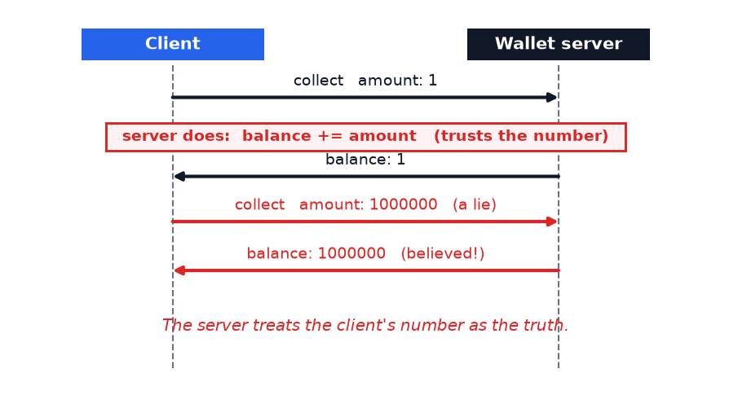
Any client can lie — send a huge amount and the balance jumps. The server never questions it.

2. How Legilimens is used against it
This is where Legilimens does more than watch — it uses its Tamper feature to rewrite a value as the message passes through, so even an honest client’s traffic arrives forged.
Analogy: in app #1 Legilimens was the security camera — it only filmed. Here it is the forger who intercepts your receipt in the mail and changes the number before it reaches the shop.
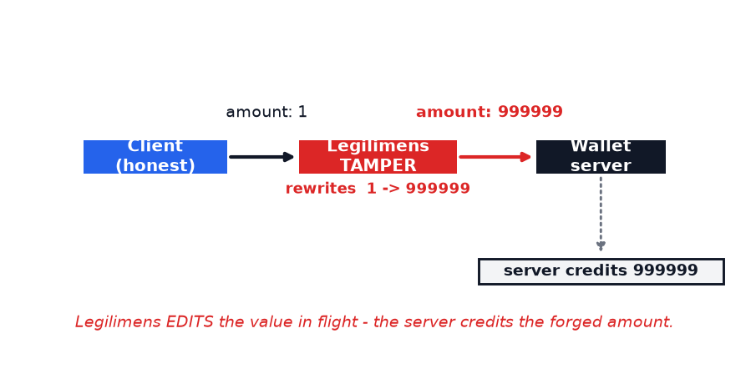
The proxy applies the tamper rule (field “amount” → 999999) to the datagram before forwarding it upstream:
# proxy.py — the Tamper feature rewrites the chosen field as the message passes through
tampered, payload = tamper_payload(raw) # rule: amount -> 999999
self.upstream.send_datagram(payload.encode()) # the SERVER receives the forged value
What you see: the honest client claims 1, but the server replies "credited": 999999. Legilimens changed the coin count in flight and the server trusted it.
Run it yourself (honest client through the proxy, with the amount tamper rule on):
.venv\Scripts\python.exe vuln_apps\02_trust_client\client.py --port 4433

3. How to make app-2 secure
Let the server decide the reward. The client’s number becomes irrelevant — the server owns the balance.
# server.py — the fix (commented next to the bug)
COIN_PER_COLLECT = 1
self.balance += COIN_PER_COLLECT # ignore msg["amount"] entirely
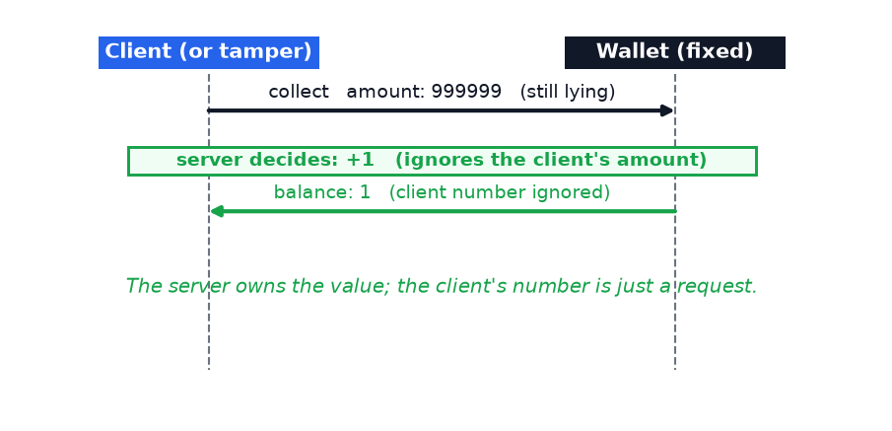
Now it makes no difference whether the client is honest, cheating, or tampered:
Client sends | Vulnerable app | Fixed app
collect amount:1 (honest) | +1 | +1
collect amount:1000000 (cheat) | +1000000 | +1
amount:1 tampered → 999999 | +999999 | +1

Takeaway
Never trust client-supplied values for state the server owns — money, score, inventory, permissions. A value from the client is a request, not a fact. The server must compute or verify authoritative state itself; encryption and even authentication don’t help if you then believe whatever the authenticated client tells you.

