|  |  |
| --- | --- |
| **Folder Name** | **Description** |
| View | In this folder you will add MVC views which can be HTML , Razor or Webform pages. |
| Model | In this folder you will add model classes. Models are simple .NET classes which provides data and probably also contain validations. So in this folder you will add Customer class, Supplier class etc. |
| Controller | In this folder you will add controller and controllers can have actions. This guy is responsible for taking the request from the end user, invoking the appropriate actions, creating object of the model and then tieing up the view and model together to send the results as response. |
| **Other folders** |  |
| Script | Here you add your javascript files. You will find Jquery and angular javascript files by default as they are included by visual studio itself. |
| App_Start | Before the MVC application comes live it need lot of objects to be activated and initialized. For example routing , bundling and minification components etc. You do not need to worry about this folder at this moment we will be discussing about each objects later. For example routing is explained in MVC day 2 , bundling is explained in Day 5 and so on. So relax and do not think about this folder at this moment. |
| Content | This folder has CSS(Cascading style sheet) which gives a uniform look and feel for your project. |
| App_Data | App_Data is for file based data store. Normally developers use RDBMS like SQL Server, oracle etc but some time people use XML, txt files to store data. So this folder is created when you store data in files. |
| Fonts | In case you fonts which you are using in your web application you can put them here. |

Scaffolding is a technique in which the MVC template helps to auto-generate CRUD code. CRUD stands for create, read, update and delete.

The advantage of creating a strong typed view is you can now get the properties of the class in the view by typing the model and “.” as shown in the below figure.

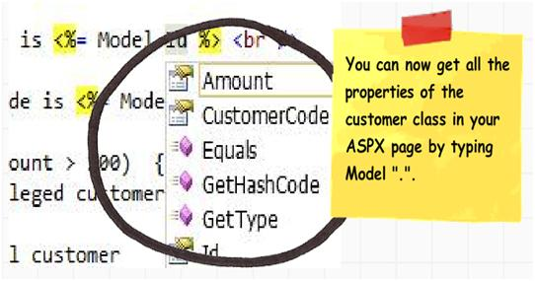

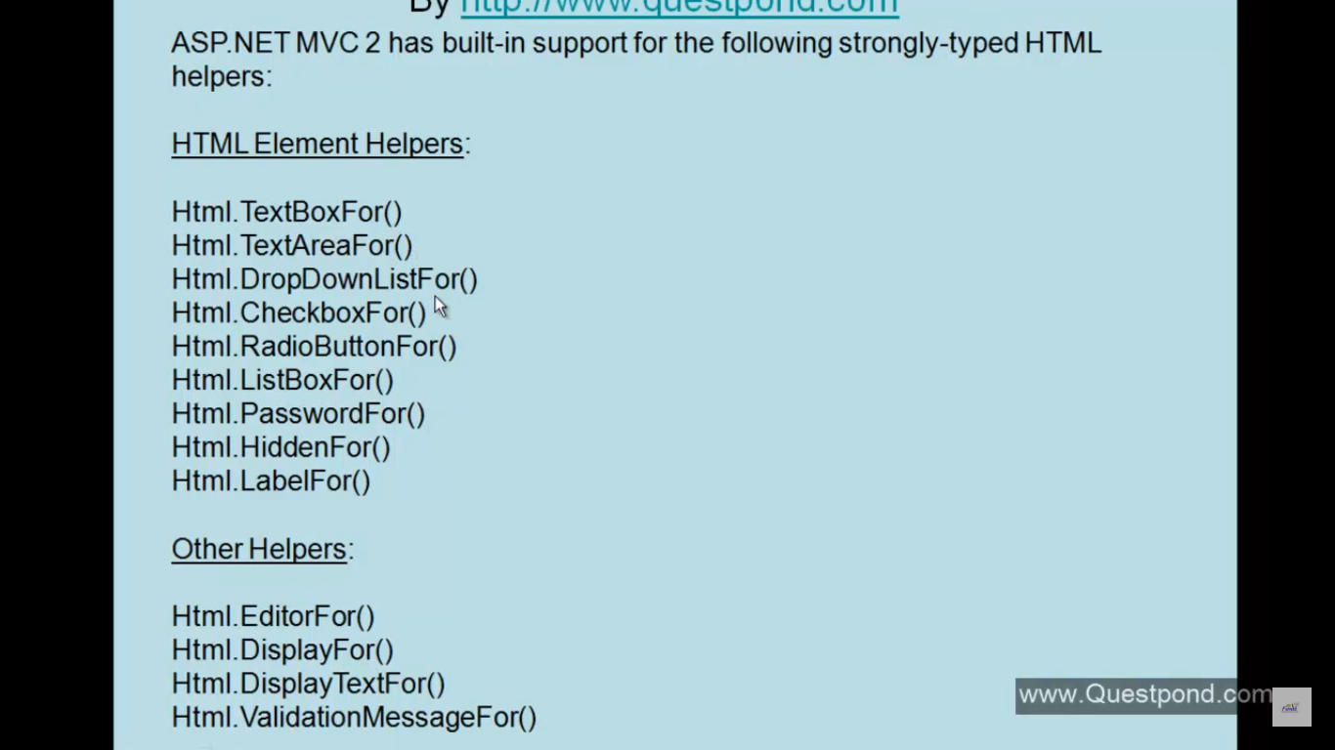

@Styles.Render(“~/content/css”);

