Pending

1. Nav
   1. Blue theme + nav like Abhinitee India 🡪 Done.
   2. Slogan (We mold the future) 🡪 Done
   3. Padding in menu-name 🡪 Done
   4. Abhinitee plast india pvt. Ltd.
      1. Font new-roman 🡪 Done
2. Home page
   1. Slider
      1. Slider - Animation same to same Abhinitee.
      2. Remove contact numbers from slider.
   2. Product
      1. Remove paint-shop, powder-coating 🡪 Done.
   3. Change images with company t-shirt (harsh will provide)
   4. Why to choose us
      1. Image (Whats app) 🡪 Done
   5. Numbers
      1. Remove powder coating tools, painting tools 🡪 Done.
      2. Add 7+ bi-metallic barrel machine, 7+ eight zone HRS controller 🡪 Done.
      3. Tool design 🡪 tool room (click redirect) 🡪 Done.
   6. Buddy tam
      1. Jitendra, Amit, …, Vidula 🡪 Done
         1. Jitu CEO Nahi Hain 🡪 Done
      2. Photos 🡪 Done
   7. Client
      1. Slider like Abhinitee 🡪 Acchanahi lagega kyo ki slider ke liye zyada images chahia
      2. The metal company, Mother son, Minda Rika, ~~JPM, JNS, MRS~~
3. New section: Tool-room
   1. VMC (img > slide-page : 32), 🡪 Done
   2. Wire Cut (img > slide-page : 33), 🡪 Done
   3. EDM (img > slide-page : 34), 🡪 Done
   4. Design (img > slide-page : 36- 1st image ), 🡪 Done
   5. Core (img > slide-page : 21) 🡪 Done
   6. cavity (img > slide-page : 21) , 🡪 Done
4. New section: Facilities
   * 1. Tool room section
        1. 3 images
        2. Description
     2. Facilitries (spell)
        1. 3 images
        2. With built-up area of 8000 Sq.ft our state-of-the-art Moulding shop consists of comprehensive range of 7 Injection moulding machines from 50 Ton to 250 Ton capacity. This also includes special purpose vertical Injection Moulding machines with rotary table as well as single sliding bed suitable for insert moulding, Terminal moulding & Over moulding applications.
        3. 3 images
     3. Infrastructure

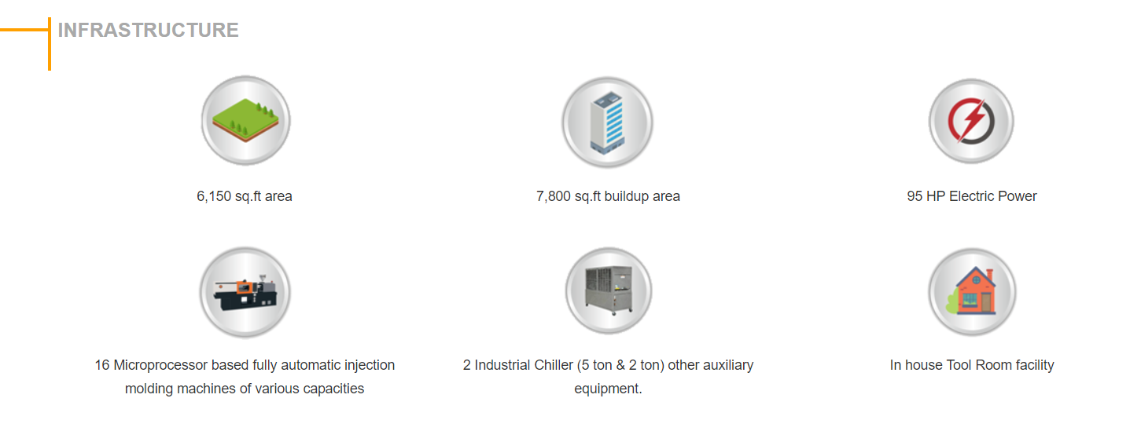

* + - 1. 3rd image 100 hp power
      2. 4th image 7+ Milacron machines 50 to 250 tons of capacity
      3. 5th image remove
  1. Rename section to infrastructure.
     1. Machines(whats app)
        1. Apane pass 7 50 se 250 tone ki machine hain milicrone ki
     2. Compressor (whats app)
     3. Air comp - Cooling tower (whats app)
     4. Assembly (No Image)
     5. Weigsting-scale (whats app)
     6. Quality-section (Google se quality ka image)

1. Contact us:
   1. Menu Spelling 🡪 Done
   2. Number & Email: Jitu & Amit([marketing@abhiniteeplast.com](mailto:marketing@abhiniteeplast.com), [abhiniteeplastIndia@gmail.com](mailto:abhiniteeplastIndia@gmail.com) ) 🡪 Done
   3. Address -> Plot No - PAP B-16, M.I.D.C. Chakan, Phase IV , Opp Mahindra & Mahindra Gate No -10 ,Pune-411501, Maharastra,India. 🡪 Done
2. Domain email
   1. Find costing per email: 🡪 Done
3. About us
   1. Remove our expertise. 🡪 Done
   2. Who we are image change. 🡪 Done
   3. Add About our MANAGING DIRECTOR (All) 🡪 Done
      1. Amit Sali ko abhi angutha chap hi rehne do 🡪 Done
4. Products
   1. <http://localhost:5173/src/assets/product-images/product-2.webp> 🡪 Done But Ghatiya lag rha hain
5. Gellary
   1. Remove entire section 🡪 Done

Abhinitee

1. Nav
   1. Abhinitee-india (new romans font)
   2. Logo 🡪 golden to blue
2. Home
   1. Team
      1. Jitendra 🡪 remove CEO
      2. Mangesh
      3. Nitin
      4. Harish
      5. Vidhula 🡪 last
      6. Paramjeet Singh remove from team
3. Contatect US
   1. Say hello
      1. Remove all mails
      2. Jitu 🡪 remove ceo
      3. Mango
      4. Keep mails empty
   2. Remove all mails
4. About
   1. Change photo (Vmc)
   2. About our MANAGING DIRECTOR (ALL)
      1. Remove age
      2. Remove aireas of specialization
      3. Change achievement(wp me harsh ne photo bheja hain 2 bar)