

Artificial Intelligence (AI) in Robotics
PDE3802
Assessment 1- Report

Student ID | Name | Contribution | Signature
M00992809 | Aisha Marire | 100%
M00975543 | Mark Kipokola | 100% | 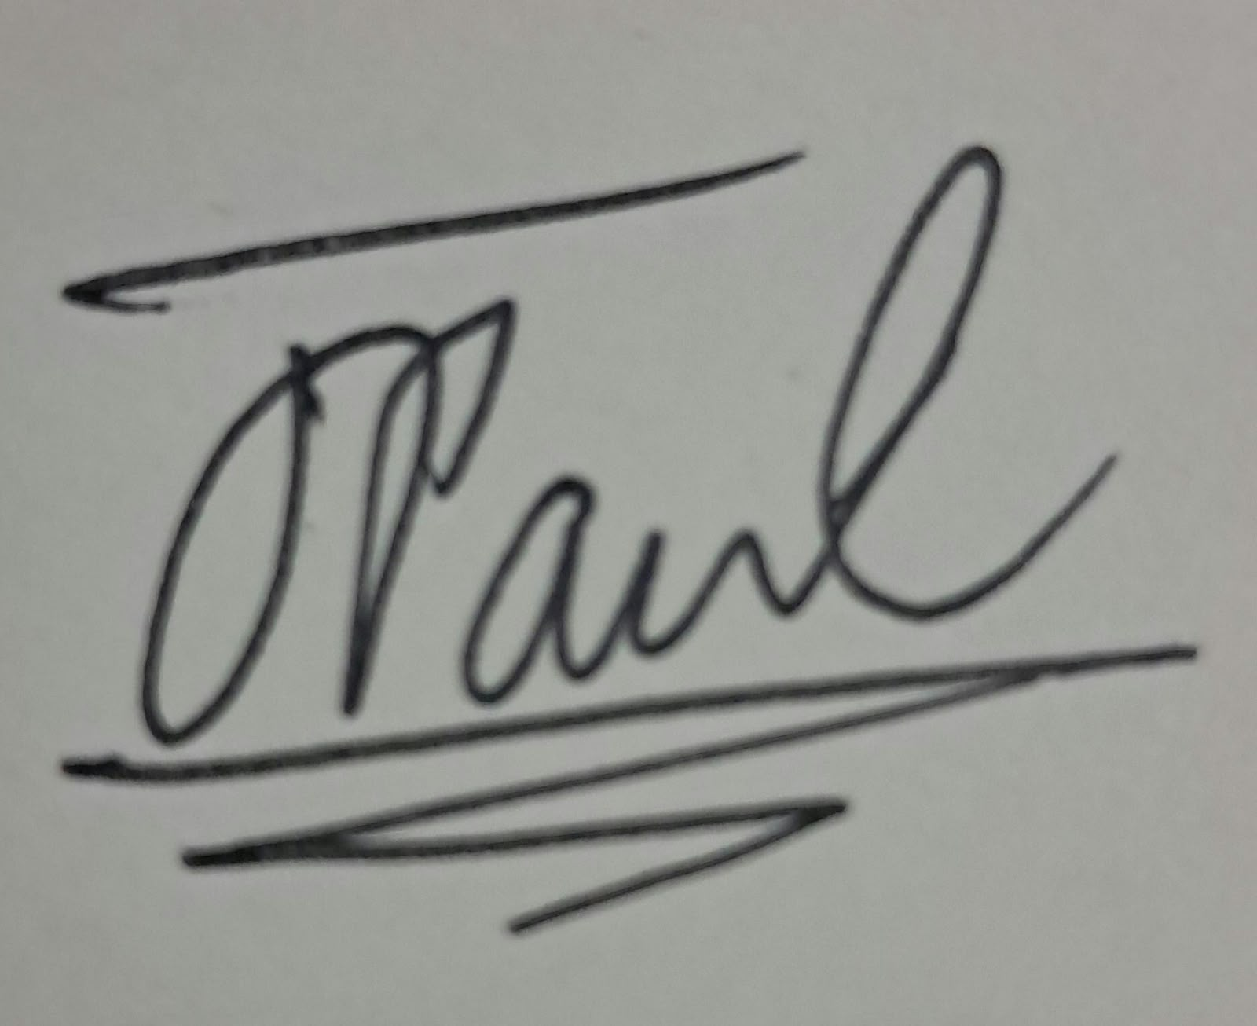
M00982779 | Orekoya Oluwagbohunmi Oluwasemiloore | 100% | 

Lecturer: Nivede Issur
Due date: 06/11/2026
Table of contents
1. Mission and Task 2
2. Required Skills 2
3. Hardware Components 3
4. Software Architecture 3
5. Dataset and Model Plan 3
6. Risk and Safety 4
7. Budget and Bill of Materials (BOM) 5
8 Reference list 5
Appendix A: Tables 7
Table A1. The ten classes and how OfficeBot handles each 7
Table A2. Skills the input, output and success criterion of each 8
Table A3. Delivery stages, what each adds and where it runs 8
Table A4. Sensors: the job of each, why it was chosen and the alternatives considered 9
Table A5. Actuators: the job of each, why it was chosen and the alternative 10
Table A6. Processing units; the job of each, why it was chosen and the alternative considered 11
Table A7. Bill of materials for the minimum and reference tiers (rough estimates, USD) 12
Table A8. Scoring of the alternatives (1 = poor, 5 = best) 13
Table A9. Error budget for grasping at 0.6 m 13
Table A10. Software and what each tool is used for 14
Table A11. Augmentation settings (training split only) 14
Table A12. Evaluation methods: what each shows and why we use it 15
Table A13. Safety measures 15
Appendix B: Figures 17
Figure B1. OfficeBot task sequence from the start state to the end state 17
Figure B2. OfficeBot software architecture: ROS 2 topics and actions on each flow 18

1. Mission and Task
OfficeBot patrols an open-plan office, finds out-of-place items (ten classes) and puts them back. There is no time limit on an action once it starts. Light items go to a fixed zone, and items it should not move are reported (see Table A1).
Task sequence. Each patrol follows seven steps:
- Start: the robot wakes at its dock and checks that it knows its position on the map.
- Patrol: it drives to the next zone, skipping occupied desks for now.
- Recognition: the camera finds an out-of-place item and the classifier names it.
- Manipulation: if the item is light and safe to move, the arm picks it up.
- Navigation: the robot drives to the fixed zone and puts the item down.
- Report: it logs what it moved and sends an alert about anything it should not move or could not move.
- End: when the patrol is finished, it returns to the dock and waits for the next one.
Figure B1 shows this sequence from the start state to the end state.
Autonomy and priorities. OfficeBot repeats a sense→plan→act loop. If a task cannot be finished (the item is unreachable, a grasp fails or the situation is unclear), it sends an alert. If AMCL (adaptive Monte Carlo localisation, which matches LiDAR scans to the map) loses the robot’s position, the robot stops, rotates in place to relocalise, then sends an alert and waits. Its priorities are:
- empty desks and floors;
- occupied desks, which are skipped and revisited later, because the robot never reaches over a person;
- items that must not be moved, which are reported and left alone.
Occupancy comes from the “person” class of a pretrained YOLO26n model (Jocher and Qiu, 2026), run at a low rate near desks. No data about people is stored.
Paradigm. The design is hybrid deliberative-reactive (Murphy, 2019). A planning layer (task manager and global planner) orders the tasks, and a fast layer (collision monitor and local controller) can override it within milliseconds. Confidence scores decide whether each action goes ahead (see Figure b1).

2. Required Skills
The robot’s main job is to pick up out-of-place items, put them down in the right place and organise the work. It needs six skills: perception, object recognition, localisation, navigation, manipulation (picking up and putting down) and task organisation. Table A2 gives the input, output and success criterion of each skill.
The work is delivered in three stages. Stage A finds items and sends alerts. Stage B adds picking up mugs that the wrist camera confirms are empty. Stage C adds patrols that visit messy zones more often. The Part B classifier is tested on a Raspberry Pi 4 (target: at least 5 frames per second, or FPS, at 224 to 320 px), although the full robot uses a Jetson (see Table A3).

3. Hardware Components
The design centers on the camera. The main camera runs the detector on the device, the LiDAR handles mapping and navigation, and the Jetson coordinates everything.
Table A4 lists the sensors, Table A5 lists the actuators and Table A6 lists the processing units. Each table gives the job of the part; the reason we chose it and the alternatives we considered. Prices are rough estimates and are in Table A7, and Table A8 scores the alternatives.
Depth limits. The OAK 4 D’s minimum depth is about 35 cm at 400P and 70 cm at 800P (Luxonis, 2025), so 400P is used near desks. Depth is trusted for grasping only within about 0.6 m, where 2% error is 1.2 cm. Table A9 combines the errors.
Mounting. The OAK 4 D sits on a 1.0 to 1.2 m mast, tilted down 20 to 30 degrees. Items far from the desk edge trigger an alert instead of a stretch. Depth uses standard filters, and the D Pro projector helps on blank desks. Colour uses 50 Hz anti-banding and capped exposure. If glare is measured, a polariser goes over the RGB lens only, never the stereo pair.

4. Software Architecture
Figure B2 shows the modules with the ROS 2 topics and actions on each flow. The planning side is the task manager and Nav2’s global planner. The fast side is the local controller, collision monitor and safety layer.
Table A10 lists the software we use. These tools are widely used, free and well documented, so every team member can learn and use them. Wheel encoders and the IMU estimate movement, AMCL corrects drift using the LiDAR map, and AprilTag markers (Olson, 2011) at the kitchenette and dock reset any drift that remains.

5. Dataset and Model Plan
Classes and data. The data covers the ten classes in Table A1, and hard negatives (pens, cables and cup-like objects) are added to the detector scenes only, because every classifier folder becomes a class. The target is 200 photos per class (minimum 150), taken with a phone and the OAK camera in varied lighting, backgrounds, angles, distances and occlusion. The classifier uses one item per image, and the detector uses scenes with several items. Labels are folder names, and boxes come from CVAT or Roboflow in YOLO format. The 70/15/15 split is made by capture session (files are named sNN_xxxx), so near-duplicate photos cannot leak into the test set. Because whole sessions go to one split, this gives roughly 300 test images (30 per class) at 200 per class, but only roughly 225 (22 per class) at 150. With so few images, per-class results are indicative only. Augmentation includes flips, scale, colour jitter (hue, saturation and brightness) and RandAugment, which adds small rotations and contrast changes (see Table A11).
Model choice. We use two models from one family. The detector finds items in the full camera image, and the classifier then checks a cropped image of one item, for example to decide whether a mug is empty. The models are:
- Detector: YOLO26n, fine-tuned on our ten classes and hard negatives. It runs on the OAK 4 D.
- Classifier: YOLO26n-cls, fine-tuned from ImageNet weights and exported to NCNN or ONNX. It runs on the Jetson, with the Pi 4 as a benchmark. YOLO11n-cls is trained as well, and we keep the model with the higher Macro-F1 that reaches 5 FPS.
The reasons are:
- YOLO26n is more accurate and cheaper than the earlier nano models, YOLOv8n and YOLO11n (Jocher, Chaurasia and Qiu, 2023; Jocher and Qiu, 2024, 2026).
- A single-stage detector returns boxes and classes in one pass, which keeps it fast (Redmon et al., 2016).
- Nano models are small enough for the camera chip and the Pi 4.
- Pretrained weights let about 200 photos per class be enough.
- One toolkit (Ultralytics) handles training, testing and exporting, so the whole team only must learn one workflow.
Evaluation. All layers are fine-tuned for about 50 epochs at 224 px, with early stopping (patience of 10 epochs) on the validation set. The methods are listed in Table A12, with the reason for each.
Because the split is by capture session, the test set contains sessions the model has never seen. A single temperature is fitted on the validation set (never the test set) to calibrate the confidence scores, and predictions below a minimum confidence are reported as unsure. The threshold is highest for empty mugs. If a spill costs ten times more than an alert, the robot needs over 90% confidence. Calibration is checked on the test set with the expected calibration error (ECE), but confidence scores can still be over-confident, so the load cell gives a second check after lifting.
Pass mark for the Part B classifier: at least 5 FPS on the Pi 4 at both 224 px and 320 px, using the candidate model with the higher Macro-F1 that also reaches this speed.

6. Risk and Safety
The safety layer sits between Nav2/MoveIt and the motors, so no planner or model output can bypass it. It applies ISO 13482 (ISO, 2014) by analogy, because that standard covers personal care robots and OfficeBot is an office robot. For the arm, it uses the limits of ISO/TS 15066 (ISO, 2016), which is written for collaborative robots.
- Stop: A latching emergency stop, wired through a dual-channel safety relay, cuts motor and arm power in hardware. A software /estop and a heartbeat watchdog back it up.
- Speed and distance: Base speed is 0.3 m/s, and 0.15 m/s within 1.5 m of a person. The stopping distance is 0.3^2/(2 x 0.5) + 0.3 x 0.2 = 0.15 m, half the 0.3 m threshold. The robot slows at 1.0 m and stops at 0.3 m from objects and 0.5 m from people, using a collision monitor on /scan. Bumpers stop it immediately. The arm moves only while the base is stopped, with limited joint speed and gripper force.
- Tip-over: As an example, an 18 kg base, an 8 kg arm and lift, and a 1 kg payload at 0.6 m put the combined center of mass 0.11 m forward of center, against a 0.25 m support edge. At a center-of-mass height of 0.5 m, the base tips above about 0.28 g, compared with 0.05 g when braking. Ballast and the speed limit keep this margin. CAD values will replace these figures.
- Payload and privacy: Only light items are carried, and a mug that is not empty or is uncertain is never carried. No images of people are stored. A light and sound cue shows when the robot is working, and first tests take place in a cleared area (see Table A13).
Limitations. Transparent bottles defeat stereo depth, and shiny mugs make it worse, so the robot uses a table-plane prior plus the detection box, with an alert if they disagree. Small items (stapler, mouse) are hard to detect from far away. Judging whether an opaque mug is empty is the weakest perception step. The data comes from one office, and sustained Jetson load is untested.

7. Budget and Bill of Materials (BOM)
See Table A7. The earlier 2,000 USD target was self-imposed, and the brief asks only for a realistic BOM with a target. The reference tier costs about 6,000 USD, mainly because of the arm, lift and gripper. A minimum viable tier of about 1,680 USD keeps perception and navigation but limits manipulation to empty mugs. The extra cost buys on-camera inference, close-range depth, a 1 kg payload, a lift axis that reaches desks, floor and shelf, and a standards-based safety chain.

8 Reference list
ISO (2014) ISO 13482:2014 Robots and robotic devices - Safety requirements for personal care robots. Geneva: International Organization for Standardization.
ISO (2016) ISO/TS 15066:2016 Robots and robotic devices - Collaborative robots. Geneva: International Organization for Standardization.
Jocher, G., Chaurasia, A. and Qiu, J. (2023) Ultralytics YOLOv8. Available at: https://docs.ultralytics.com/models/yolov8/ (Accessed: 27 October 2026).
Jocher, G. and Qiu, J. (2024) Ultralytics YOLO11. Available at: https://docs.ultralytics.com/models/yolo11 (Accessed: 27 October 2026).
Jocher, G. and Qiu, J. (2026) Ultralytics YOLO26. Available at: https://docs.ultralytics.com/models/yolo26/ (Accessed: 27 October 2026).
Luxonis (2025) OAK 4 series. Available at: https://www.luxonis.com/oak4 (Accessed: 27 October 2026).
Macenski, S., Foote, T., Gerkey, B., Lalancette, C. and Woodall, W. (2022) ‘Robot Operating System 2: design, architecture, and uses in the wild’, Science Robotics, 7(66), article eabm6074.
Macenski, S. and Jambrecic, I. (2021) ‘SLAM Toolbox: SLAM for the dynamic world’, Journal of Open Source Software, 6(61), article 2783.
Macenski, S., Martin, F., White, R. and Ginés Clavero, J. (2020) ‘The Marathon 2: a navigation system’, in Proceedings of the IEEE/RSJ International Conference on Intelligent Robots and Systems. IEEE, pp. 2718 - 2725.
Murphy, R.R. (2019) Introduction to AI robotics. 2nd edn. Cambridge, MA: MIT Press.
Olson, E. (2011) ‘AprilTag: a robust and flexible visual fiducial system’, in Proceedings of the IEEE International Conference on Robotics and Automation. IEEE, pp. 3400-3407.
Redmon, J., Divvala, S., Girshick, R. and Farhadi, A. (2016) ‘You only look once: unified, real-time object detection’, in Proceedings of the IEEE Conference on Computer Vision and Pattern Recognition. IEEE, pp. 779-788.

Appendix A: Tables

Table A1. The ten classes and how OfficeBot handles each
Class | Action | Destination | Condition
Mug | Move | Kitchenette zone | Only if empty; confidence over 0.9 and load cell check after lifting. Not empty or uncertain: alert, never carry
Bottle | Move | Fixed zone | Light enough for the 1 kg payload. Transparent bottles use the table-plane prior; alert if far from the desk edge
Mouse | Move | Fixed zone | Small item: detect at close range; alert if far from the desk edge
Stapler | Move | Fixed zone | Small item: detect at close range; alert if far from the desk edge
Book | Move | Fixed zone | Move only if the load cell reads under the 1 kg payload otherwise; alert
Notebook | Move | Fixed zone | Move only if the load cell reads under the 1 kg payload otherwise; alert
Phone | Report only | Left in place | Personal and valuable; alert, do not touch
Laptop | Report only | Left in place | Too heavy and valuable; alert, do not touch
Wallet | Report only | Left in place | Personal and valuable; alert, do not touch
Keys | Report only | Left in place | Personal and valuable; alert, do not touch
Hard negatives (pens, cables, cup-like objects) are not classes: they are in the data, so the model learns to ignore them.

Table A2. Skills the input, output and success criterion of each
Skill | Input | Output | Success criteria
Perception | Colour images and stereo depth from the OAK 4 D; person detection near desks | Boxes, classes and depth for each item; whether a desk is occupied | Detector mAP@0.5 of at least 0.80 on the test set; depth error under 2% below 4m (Luxonis, 2025)
Object recognition | Cropped images of one item | Class and confidence | Macro-F1 at least 0.85 on unseen sessions; an empty mug is accepted only above 0.9 confidence
Localization | Wheel encoder, IMU, LiDAR scan and map | Robot position on the map | Position error below 10 cm
Navigation | Goal position, map and Lidar scan | Velocity commands along a collision-free route | Reaches the goal within 0.15 m with no contact; stops at 0.3 m from objects and 0.5 m from people
Manipulation | Item class, 3D position of its box (within 0.6m) and wrist camera view | Arm, lift and gripper commands | Item picked up and put down in the fixed zone/ kitchenette zone in at least 8 of 10 trials; no mug carried unless empty
Task organisation | Detected items with class, confidence, occupancy and zone | Next item to tidy or an alert | Follows the priority order; occupied desks are skipped and revisited

Table A3. Delivery stages, what each adds and where it runs
Stage | What it adds | Runs on | Done when
Part B classifier test | Classifier benchmark (YOLO26n-cls and YOLO11n-cls compared) | Raspberry Pi 4 (test only) | At least 5 FPS at 224 and 320 px; Macro-F1 at least 0.85
Stage A | Finds items and sends alerts | OAK 4 D (detector); Jetson (ROS 2, Nav2, task manager) | Detector mAP@0.5 at least 0.80; position error under 10cm
Stage B | Picks up mugs the wrist camera confirms are empty | Jetson, plus arm, lift, gripper, load cell and wrist camera | At least 8 of 10 pick-and-place trials; no mug carried unless empty
Stage C | Patrols that visit messy zones more often | Jetson (task manager) | Follows the priority order, messy zones revisited more often

Table A4. Sensors: the job of each, why it was chosen and the alternatives considered
Sensor | Job | Why this device | Alternatives considered
Luxonis OAK 4 D (main camera, on mast) | Colour image, stereo depth and on-board YOLO | Combines camera, depth and an AI chip in one unit, so there are fewer parts to wire and program. Depth error is under 2% below 4 m (Luxonis, 2025) | Intel RealSense D455: good depth and wide ROS 2 support, but no on-board AI, so Jetson would run all detection. Plain RGB camera: cheapest, but gives no depth
Wrist camera (RGB) | Final approach and checking whether a mug are empty | Gives a close view that the mast camera cannot | Second OAK unit; adds depth and AI, but costs more and is heavier on the arm. Mast camera only: no extra part, but it cannot see the item during the final approach
2D LiDAR | Mapping, localisation and obstacle detection | Works in any lighting and is well supported by Nav2 and SLAM Toolbox | 3D LiDAR; see more of the room, but costs much more and needs more compute. Depth camera only; cheap, but its narrow view makes mapping harder
IMU | Turning and tilt | Corrects wheel-only estimates of heading | Wheel encoders only; no extra part, but heading drifts when the wheels slip. Higher-grade IMU: less drift, but costs more for little gain indoors
Wheel encoders | Distance travelled | Cheap and standard for odometry | Visual odometry from the camera; no encoders needed, but it uses more compute and struggles on blank walls
AprilTag markers (kitchenette and dock) | Reset position error at known spots | Printed tags cost almost nothing, and the camera can read them (Olson, 2011) | QR codes: easy to make, bit less reliable at an angle or distance. No markers: nothing to print, but only the LiDAR map would then correct drift
Load cell (in gripper) | Weight after lifting | A second check that a mug is empty | Gripper motor current; no extra part, but less accurate for light loads
Bumper | Contact | Immediate stop if all else fails | LiDAR and ultrasonic sensors only; no contact switch, but they can miss low thin objects

Table A5. Actuators: the job of each, why it was chosen and the alternative
Actuator | Job | Why this choice | Alternatives considered
Two drive motors (differential drive) | Move the base | Simple and can turn on the spot in tight offices | Mecanum wheels; move sideways but cost more and are harder to control. Skid-steer: rugged, but the wheels scrub on carpet
SO-ARM-class arm (minimum tier; larger arm in reference tier) | Reach and carry | Low cost and light | Larger 6-axis arm: more payload and reach but several times the cost
Lift axis (about 0.3 to 0.8m) | Move the arm up and down | Let’s one arm reach desks, floor and shelf | Longer arm without a lift: simpler but heavier and harder to keep stable
Wrist servo | Fine alignment | Needed because the base can only be positioned to within about 0.15 m of an item and the wrist closes the remaining gap | More precise base position; would remove the need for the servo, but is hard to achieve on carpet
Gripper with limited force | Hold items | Safe for light items | Suction cup: simple for flat items. But poor on mugs with handles

Table A6. Processing units; the job of each, why it was chosen and the alternative considered
Unit | Job | Why this choice | Alternative considered
NVIDIA Jetson (main computer) | Runs ROS 2, Nav2, the task manager and the classifier | Runs Linux and ROS 2 well and has a GPU for AI | Raspberry Pi; cheap and low power, but too slow to run Nav2 and perception together. Intel NUC; fast CPU and easy x86 software, but no AI- focused GPU and higher power use
OAK 4 D on-board chip | Runs the YOLO26n detector | Keeps the heavy image work off the Jetson | Running the detector on the Jetson; few parts to connect, but it takes compute from navigation
Raspberry Pi 4 (test only) | Benchmark for the classifier | Shows the model is light enough for low-cost hardware | Testing on a NUC instead; faster, but it would not show whether the model suits low-cost hardware

Table A7. Bill of materials for the minimum and reference tiers (rough estimates, USD)
Item | Minimum tier | Reference tier | Notes
Main camera | 60 | 950 | Minimum: plain RGB camera. Reference; OAK 4 D Pro class
Wrist camera (RGB) | 40 | 40 | USB camera on the wrist
2D LiDAR | 100 | 200 | Budget vs better range class
IMU | 20 | 40
Drive base (motors, encoders, wheels, caster, chassis, drivers) | 325 | 350 | Differential drive
Arm | 300 | 2,200 | Minimum: SO-ARM class. Reference; larger 6-axis arm
Lift axis | - | 300 | Reference tier only
Gripper with load cell | - | 150 | Minimum tier; gripper from arm kit motor-current check
Bumper | 20 | 50 | -
Main computer (Jetson class) | 250 | 280 | -
Raspberry Pi 4 (classifier benchmark) | 60 | 60 | Test only
Battery and power | 120 | 180 | -
Safety chain (latching e-stop, safety relay, watchdog) | 40 | 120 | Standards-based chain in reference tier
Mast, brackets and ballast | 60 | 75 | -
AprilTag markers (printed) | 5 | 5 | Kitchenette and dock
Subtotal | 1,400 | 5,000
Cabling, small parts and contingency (20%) | 280 | 1,000
Total | 1,680 | 6,000

Table A8. Scoring of the alternatives (1 = poor, 5 = best)
Decision | Option | Task fit (35%) | Cost (25%) | ROS 2 support (20%) | Integration (20%) | Weighted score
Main camera | Luxonis OAK 4 D | 5 | 3 | 4 | 5 | 4.30 (chosen)
 | Intel RealSense D455 | 4 | 3 | 5 | 3 | 3.75
 | Plain RGB camera | 1 | 5 | 5 | 2 | 3.00
Main computer | NVIDIA Jetson | 5 | 3 | 5 | 4 | 4.30 (chosen)
 | Raspberry Pi | 2 | 5 | 4 | 2 | 3.15
 | Intel NUC | 3 | 2 | 5 | 3 | 3.15
Arm | SO-ARM class | 3 | 5 | 3 | 4 | 3.70 (chosen)
 | Larger 6 axis arm | 5 | 1 | 4 | 3 | 3.40
Drive base | Differential drive | 4 | 5 | 5 | 5 | 4.65 (chosen)
 | Mecanum wheels | 4 | 3 | 4 | 2 | 3.35
 | Skisteer | 2 | 4 | 4 | 4 | 3.30
Scores are the team’s judgement from the reasons in tables A4 and A6. Cost scores a cheaper option higher. The larger arm fits the task better but loses on cost, so it appears only in the reference tier.

Table A9. Error budget for grasping at 0.6 m
Error source | Size | Basis
Stereo depth at 0.6 m | 1.2 cm | 2% of 0.6 m (Luxonis, 2025)
Stereo depth at 4 m (for comparison) | 8.0 cm | 2% of 4 m: why depth is not trusted for grasping beyond around 0.6m
Hand-eye calibration | 0.5 cm | Assumed; to be measured
Detection box center | 0.5 cm | Assumed; to be measured on the test set
Arm repeatability | 0.5 cm | Assumed for an SO-ARM class arm; check the datasheet
Combined (root sum of squares of the four grasp-range errors) | 1.5 cm | Square root of 1.2^2 +0.5^2 +0.5^2 + 0.5^2
Worst case | 2.7 cm | Sum of the four grasp-range errors
Allowed grasp error | About 2 cm | Design target: the wrist camera and wrist servo close the remaining gap

Table A10. Software and what each tool is used for
Software | Use
ROS 2 Jazzy (Macenski et al., 2022) | Connects all modules
Nav2 (Macenski et al., 2020) | Route planning and driving
SLAM Toolbox (Macenski and Jambrecic, 2021) | Building the map
Ultralytics YOLO | Training, testing and exporting models
CVAT or Roboflow | Labeling photos
OpenCV, NumPy and Matplotlib | Reading images, metrics and plots

Table A11. Augmentation settings (training split only)
Augmentation | Starting setting | Why
Horizontal flip | 50% of images | Items appear on either side of the desk; no vertical flip because items stand upright
RandAugment | Default magnitudes | Adds small rotations and contrast changes; items are rarely placed perfectly straight
Scale | Up to 30% | Covers different camera distances
Brightness | About 40% | Window light and dim corners
Hue and saturation | Hue up to 1.5%, saturation up to 50% | Different lamps and glossy or matt surfaces

Table A12. Evaluation methods: what each shows and why we use it
Method | What it shows | Why we use it
Test accuracy | Share of correct answers, with a Wilson 95% confidence interval | Simple overall score; the interval shows the uncertainty from so few images
Per-class precision and recall | Mistakes for each class, with Wilson 95% intervals | A wrong “empty mug” call causes spill, so each class must be checked
Macro-F1 | Average score across classes | Treat small and large classes equally
Confusion matrix | Which classes get mixed up | Expected confusions are mouse and phone, book and notebook, and mug and bottle
Calibration (ECE, NLL and reliability diagram) | Whether confidence matches accuracy, before and after temperature scaling | A wrong “empty mug” call causes a spill, so confidence must be trustworthy; the temperature is fitted on validation only
mAP@0.5 and mAP@0.5:0.95 (detector) | Box accuracy | Standard detector scores built into Ultralytics
FPS on the Pi 4 at 224 and 320 px | Median and 95th-percentile latency and FPS (model and preprocessing; camera capture not included) | The robot needs real-time results
Robustness test | Dim light, rotation, clutter, occlusion | Offices are not perfect lab scenes

Table A13. Safety measures
Hazard | Measure | Limit or check
Unwanted motion | Latching emergency stop on dual channel safety relay; software /estop; heartbeat watchdog | Cuts motor and arm power in hardware
Collision with people or objects | Collision monitor on /scan; bumper | Base 0.3 m/s, 0.15 m/s within 1.5 m of a person; slow at 1.0 m; stop at 0.3 m (objects) and 0.5 m (people); stopping distance 0.15m
Arm contact | Arm moves only while the base is stopped | Limited joint speed and gripper force (ISO/TS 15066 limits)
Tip-over | Ballast and speed limit | Example: tips above about 0.28 g vs 0.05 g when braking; replace with CAD values
Dropped or spilled load | Only light items carried; load cell second check | Mug carried only if empty with over 0.9 confidence; uncertain or not empty is never carried
Lost position | Stop, rotate in place to relocalise, alert and wait | AMCL position error alert; AprilTags reset drift
Bad depth on glass or shiny objects | Table plane prior plus detection box | Alert if the two disagree
Privacy | Person class used only to detect occupied desks | No images of people stored; low detection rate near desks
People nearby | Light and sound cue while working; first test in a cleared area | ISO 13482 applied by analogy; ISO/TS 15066 for the arm

Appendix B: Figures

Figure B1. OfficeBot task sequence from the start state to the end state
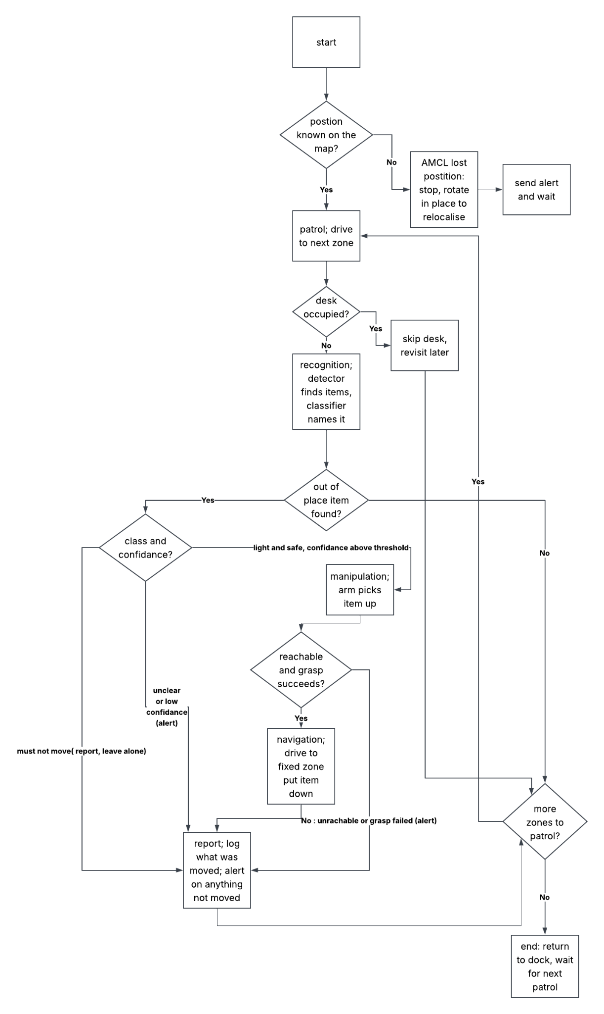

Figure B2. OfficeBot software architecture: ROS 2 topics and actions on each flow


