Mobile Application to Improve Mental Health of Persons with Dementia

Nimesh Mendis
Department of Computer Science and Software Engineering
University of Bedfordshire
SLIITA, Colombo, Sri Lanka
nimeshmendis1997@gmail.com
Vibhavi Attigala
Department of Computer Science and Software Engineering
University of Bedfordshire
SLIITA, Colombo, Sri Lanka
vibhavi.a@sliit.lk

Abstract—This electronic document is a “live” template. The various components of your paper [title, text, heads, etc.] are already defined on the style sheet, as illustrated by the portions given in this document Music and videos, according to caregiver anecdotes, play a key role for members of the family diagnosed with Dementia. A widely used mobile interface can be used by dementia patients to display favorite music and family photos through apps created in collaboration with geriatric facilities. Anecdotal evidence suggests that when a mobile computer played their favorite music, nonverbal late-stage dementia patients were stimulated. In addition to offering hard-core evidence for proving improved cognitive ability with technology, there is an unmet demand in geriatric facilities for exciting dementia patients. To improve the quality of living for the cognitively disabled, technology will help close the divide between patients and workers. This research looks into how technology affects people with dementia's cognitive functioning and quality of life. Over the duration of Alzheimer's or dementia, cognition decreases dramatically, leading most patients to be wary of caregivers and, as a result, to be institutionalized. Caregivers are often asked to concentrate their efforts on alleviating the agitation or pain experienced by Alzheimer's disease or dementia patients. Technology instruments such as iPods, cell phones, and laptops have been found to help stimulate people with dementia in studies. This research focuses on cutting-edge technologies such as cell phones, iPods, and tablets, which are widely available and easy to use and can not only help assess the level of dementia but also offer stimulus to improve cognitive ability. The aim of this study is to see whether specially designed applications and current assistive technologies can help older adults with Alzheimer's or other dementia-related disorders reduce their symptoms and enhance their memory. The article delves into the application's characteristics and functionalities, as well as the research and logic behind the system's case. The paper further looks at the event's outcome, as well as the benefits, feedback, and potential work for the application and its users. The article emphasizes the artefact's effectiveness and how it accomplishes its goals and priorities. The researcher discovered that the chatbot has a better success rate of accuracy, with in the range of 80-90 percent of accuracy showed 60 percent success rate out of general responses. This importance demonstrates that, in order to achieve a higher accuracy score, the chatbot must also be accurate. The accuracy of the chatbot and enhancing the available features in the mobile healthcare application, also the researcher planning to add new features to the system, as a future work.
Keywords- Dementia, Counselling, Application, Alzheimer’s, Relaxation Methods, Music, Artificial Intelligence, Machine Learning

Introduction
The proposed project is to develop a mobile application for people with Dementia and Alzheimer's. Dementia is recognized as one of the growing social health problems among older people in society. This is not a problem for the individual concerned, but it causes stress to the family members, neighbors, friends, and others who are involved in supporting a person with Dementia. Dementia is caused by abnormal brain changes, damage to or loss of never cells and their connection in the brain and communication problems, a change in personality, and a reduce ability to carry out daily activities such as washing or dressing. Depending on the area of the brain that is affected, they may face experiences in short term or long-term memory loss. It may lead to physical malfunctioning and disability too. Simply the drugs do not use for these people to improve their mental stability but if the patient is risk of harming themselves or others, they must seek medical attention to take drugs. Otherwise, doctors recommending for music sessions and sound therapies.
Since this is a modern era there is a strong relationship between human and information & communication technology. By using information technology, it can develop solution applications. This proposed project will help people with dementia maintain and improve mental functions. Since persons with Dementia have difficulties in concentrating, their span of attention is low, and they project irregular behaviors. Due to this reason, the caretakers find it difficult to handle them. Here the researcher can build their attention through calm sounds such as water flowing, the sound of birds, playing soothing music to calm them down, and have a conversation about that sound and what they heard. From the beginning by studying the patient’s behavior and output, the researcher can get to know his or her likes, dislikes and interest to develop a successful application to improve their concentration and span of attention. For that, the researcher needs to provide activities to remember things, ask questions about their past and what they remember without giving any sort of pressure or stress to the patient. By using attractive colors to the user interface, the system can draw the patient’s attention to the device.

Literature review
All the areas required for the research of this proposed topic is covered in this literature review. What is Dementia, what causes of Dementia, impact of people with Dementia, what are the medical treatment that doctors’ preferring and how mobile application is helpful to recover their memory for it is discussed under this chapter Market research was carried out in the aid of pointing out the importance of this research. The latter part of this literature review concentrates on the similar systems which are critically evaluated. For the similar systems researcher decided to choose Android and iOS applications which most users are using these two operating systems around the world.

What is Dementia?
Dementia is a loss of mental functions that is severe enough to affect your daily activities or routines and functions such as memory, language skills, visual recognition, problem solving, trouble with everyday tasks, ability to focus and pay attention.

Recovery memory using mobile application
Versatile applications are programming programs living on a compact gadget, for example, a cell phone, watch, or tablet. Favorable circumstances of application innovation for treatment conveyance incorporate its straightforward entry to data, the capacity to convey home practice activities, for example, sound chronicles, capacity to send notices and updates, and potential to catch dynamic and aloof use criticism. Applications may house data accessible for disconnected use, interface with sites, or both. Applications with data accessible disconnected might be obviously appropriate for the conveyance of treatments that give standard home practice practices so parental figures do not have to associate with the web each time they wish to utilize them [1].
The utilization of the Internet is quickly expanding around the world, including among more seasoned grown-ups, and can possibly be a powerful method of conveying mediations to help family guardians of individuals with dementia all through the providing care measure [2]. A few ongoing meta-examinations of Randomized Controlled Trials (RCTs) on Internet mediations for more youthful objective gatherings with side effects of gloom or tension have indicated that these intercessions can possibly be (cost)effective [3]. From the purpose of view of family guardians themselves, Internet backing may have some preferences contrasted with vis-à-vis uphold. Individuals can partake in a web course at the time that is generally appropriate for them; they do not have to head bent a medical aid proficient, which spares time; and Internet backing can be simpler for them to acknowledge see able of the shame related with searching for help from an expert (emotional wellness) care supplier [4]. Be that as it may, until now, results from RCTs on Internet mediations to decrease the mental manifestations of guardians of individuals with dementia are still scant [2].
In this unique situation, the help of innovation offers a lot of potentials and can improve the personal satisfaction of individuals with dementia and their casual guardians [5]. Late activities in smart gadgets (i.e., smartphones, versatile workstations, tablets, and so on) have made portable applications a promising hotspot for connecting with individuals in medical services [6], especially persons with disabilities with high medical service’s needs [7]. Researchers demonstrated that persons with disabilities can utilize touchscreen gadgets effectively, and this innovation can give a wide scope of advantages to them and their guardians. It makes a significant open door for engineers to convey an important application by adding drawing in exercises for such individuals to carry on with their life more autonomously [8].

How Mobile Application Helping for Dementia
Dementia is one of the most difficult diseases in older adults, affecting not just the people who have the disease but also their nonprofessional or informal caregivers. It is a dynamic condition characterized by a gradual loss of cognitive abilities such as understanding, recalling, and reasoning [9]. Further mentioning that the use of technologies to help people with dementia and their informal caregivers has a lot of promise and can increase their quality of life.
According to research, there is no treatment for this fatal illness. However, by improving the patient's quality of life and offering a cure for strengthening the patient's cognitive capacity, the disease's development can be delayed [10]. Further journal state one potential remedy is to encourage the patient to use his or her smartphone. Smartphones are important for Alzheimer's patients' families because they assist them in carrying out their daily lives by sending them updates on a regular basis. Furthermore, journal says the smartphone aids the caregiver in providing adequate treatment to the patient by retrieving the patient's GPS position via Geotagging. Photographs can be used as a way to help patients recall their loved ones.

How Artificial Intelligence Helping for Dementia
Artificial Intelligence is reshaping the world of computational services and user engagement in a variety of ways. Huge amounts of data are becoming useful for feeding intelligent systems that analyze, understand, and offer insights, as well as assisting decision support systems. Machine learning and the application of algorithms are critical for extracting functionality, reasoning over gathered data to make it usable and preventive, and revealing findings that add to our understanding of structures and processes.
Dementia impairs a person's capacity to perform everyday tasks when he or she becomes overwhelmed and forgets the order of steps to follow. The current approach is for the client to be constantly supervised and assisted by a caregiver who uses audible instructions or cues. Further in his article he proposes that this condition may be changed by using a computerized device that tracks progress and sends out necessary updates. His proposed system was a prototype called COACH. This device utilizes artificial intelligence to track a person, learn from their behavior, and issue pre-recorded cues with differing levels of information. The device was created with the help of a computer and a video camera that monitored the user invisibly. Preliminary experiments with participants who simulated confused actions while washing their hands revealed that the system was 95% successful in executing its functions.

Machine Learning for Dementia
Early detection may postpone or prolong the onset of dementia, which is the most common degenerative condition in seniors [11]. In this research, they used machine learning methods to propose a two-layer model inspired by the approach used in dementia care centers for early dementia diagnosis.
There is currently no successful cure for dementia that will delay or hinder its development. The importance of focusing on the disease's early stages, prompt diagnosis, and delay cannot be overstated. Dementia is diagnosed clinically based on a patient's and family's extensive psychiatric records, a neurological assessment, and neuropsychological evaluations. To rule out any causes of dementia, additional examinations such as hematology, CT, and MRI should be done [11].
The exponential growth in the availability of digital records has necessitated advancements in automated text classification. Machine learning (ML) algorithms can ‘learn' from data: for example, an ML method can be trained on a collection of features obtained from written texts belonging to known categories and learn to differentiate between them. In recent years, neuroimaging combined with computer-assisted algorithms has made significant progress in solving this issue. The use of machine learning algorithms for neuroimaging is largely responsible for the effectiveness of these methods [11].

Existing Health care Application for Dementia
Smartphone’s advancements are ideal for medical services intercessions since they incorporate various capacities, for example, Internet access, portable media transmission, sensors, warnings, and the capacity to introduce applications that are clinically engaged Indeed, versatile innovations have been demonstrated to be a viable way to deal with wellbeing observing for grown-ups with changing ongoing ailments [12]. the survey additionally revealed that advanced mobile phone applications have been appeared to help persistent consideration in psychological wellness settings for conditions including psychosis/schizophrenia, despondency, bipolar confusion, and substance misuse. Such innovations have demonstrated adequacy in checking tolerant symptomology, encouraging patient self-administration, screening patients for melancholy, and giving a subordinate to talk treatment. Cell phones likewise have shown to be possibly helpful for evaluating psychological capacity in more established grown-ups [13] also, conveying customized memory treatment [14] and, the early examination is as of now looking at the utilization of cell phone innovations for correspondence treatment in people with neurological issues [14] and to assist with security observing for more seasoned grown-ups [14].
Under given existing Android an iOS applications, the researcher personally downloaded from Google Play Store and iOS App Store and the researcher got user experience from each application and plan to discussed pros and cons as a summary under the conclusion section final part of this literature review.

Methodology
The methodology chapter of this thesis discusses the methods used to tackle the case, and the event methodology that was used. The segment further discusses how data and information is gathered and analyzed. The instruments used to design the artefact correctly will be included in this segment.
Selecting which approach to be ideal for the chosen project to be built is crucial, since it will affect the project's overall results. Despite the fact that the application is cantered in a very straightforward relation to its customers, flexibility, and most importantly, specializing in the project's requirements, the use of Agile Scrum technique has now been finalized, this system will be beneficial to the project. The technique enables a requirement analysis at the outset of each sprint, allowing for small changes while ensuring stability and making appropriate modifications during the testing process. Figure 1 explains the agile scrum technique is described by the characteristics mentioned below.
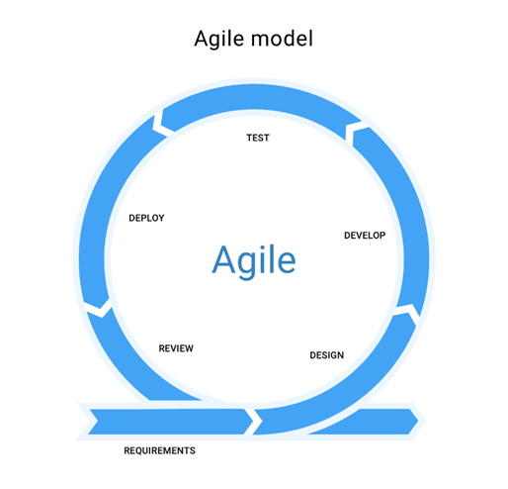
Figure 1 - Agile Methodology Phases

Planning and Analysis
The foundation of every good project is system planning. Each system requires a method for implementation and development. The look process was followed by a thorough examination of the data technology advances that were needed. The artefact's definition was snatched after a thorough examination of numerous documents and publications written in the manner of web articles, books, and reports.
After that, it was checked to see if the chosen subject was feasible. The underlying issue that was discovered was the need to organize the topic. Since digitalization is advancing at a rapid pace, it was important to reintroduce an upgrade to the system software. As a result, it was necessary to examine a variety of themes, which led to the discovery of many areas. The bulk of the study topics would be much more powerful and accomplished within the time limit, while the others would not face almost as many challenges.
The development of the project proposal, which was followed by this precise interpretation and a brief description of the artefact, clearly outlined the system's aims and priorities, as well as a feasible approach for completing the work.
In order to meet the needs of the system's intended audience, thorough implementation analysis and collection of all significant criteria, apart from project design and development, was required in order for the project proposal to be accepted. As a result, the tools that would best complement the project's personality must be chosen, and the decision was made to use the Android Studio IDE.
Planning is the secret to any good system, and careful planning was essential to ensure that the new system was delivered on schedule. A work breakdown structure (WBS) and Gantt map were developed to simplify and streamline the look process.
The WBS was used to break down the overall system's configuration into smaller functions. The overall framework was split into five major roles to develop the WBS for the proposed scheme.

- Planning - The task entailed conducting a feasibility analysis to better understand the new system's design and how it could be implemented. According to above work breakdown structure initial data gathering, feasibility analysis and background data gathering are the tasks included in the planning section. The researcher must properly fine tune with the functions of the proposed system before steps into next levels

- Requirement Gathering - The aim of the study was to achieve a greater understanding of the proposed system's context, and the final result was a literature review. According to the above work breakdown structure examples for this section is mainly primary data gathering where conducting market research where providing questionnaires to research relating parties in order to collect their ideas and experiences and secondary data gathering where collecting data and information from secondary sources such as journals, reports posted in Google Scholar database or IEEE Xplore database or any other websites. Further details explain under below next chapters.

- Design - The task entailed reviewing the specifications and deciding on a system design to go forward with. Diagrams of functional flow, use case, sequence, and data model were created during this project. According to the above work breakdown structure designing the wireframes and designing the user interfaces are the tasks which are done in design phase. Further details explain under next sub chapters.

- Implementation - During this project, implementation was done using sprints according to the Software Development Life Cycle model chosen. According to the work breakdown structure the researcher needs to divide the whole development parts into small parts which are called sprints. Each sprint represents a function which is related to the proposed system. After end of every sprint, we need to test the sprint before we step into the next sprint.

- Testing - A research was performed to decide when and how the system could be tested, and the testing was carried out accordingly.

Requirement Gathering
Requirement gathering may be described as the process of learning about the desires and needs of the target audience through analysis. During the need and collection process, significant and contributing analysis was required to determine the subject's adequacy. A market survey was performed, and this project's research papers were used.
The two popular methods for combat operations were a literature analysis and an industry survey on emerging platforms. For the literature review, the IEEE Xplore database and the Google Scholar database were both useful and accurate resources. The framework has incorporated the most recommended and crucial features, taking into account the most recent years of publications within the last eight years and gathering data to maintain a qualitative up to date analysis area and to examine widely regarded knowledge and requirements needed by the application. The goals for this approach and, as a result, the additional changes that need to be made, can be checked in a later section.

Testing and evaluation
The focus of this part of the thesis is on machine evaluation as queries. The material would emphasize device checking and ensure that the system runs smoothly for all users.
This segment will demonstrate the system's training as well as feedback from users. While testing the software was the last step in the SDLC, it was a significant accomplishment that showed the software's success or failure after all of the effort and dedication. And perhaps the system's usefulness is shown by ensuring that it is configured in compliance with the requirements. The finalized facets of the project would be tested by unit testing at the outset of each sprint, followed by integration testing before the device components are complete, and then final acceptance testing by the intended group during the final sprint.

Testing
After completing each sprint, the developer tests each sprint. Before releasing the final system. The developer proceeds the unit testing, system testing and acceptance testing. Test was conducted front end and back end separately. It is important to check the accuracy of the system as well as check the accuracy of the most important of the system. It is the chatbot which is developer implemented in the system. After conducting a questionnaire, users provide a feedback the researcher discovered that the chatbot has a better success rate of accuracy, with in the range of 80-90 percent of accuracy showed 60 percent success rate out of general responses. Following equation shows the accuracy level of the chatbot

Accuracy = (TP + TN) / (TP + TN + FP + FN) * 100

Above equation measuring the accuracy using the confusion matrix. By substituting values nearly 60% accuracy from the chatbot Figure 2 depicts the figures how results allocating after the testing.
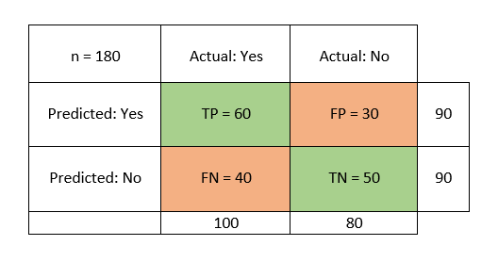
Figure 2 - Confusion Matrix

But in chatbot definite it should have a 99% accuracy rate. Because back-end developer used the neural language processing where the developer feed the knowledge as intents as json objects.

Evaluation
This is also another part of the implementation phase, and at the completion of each sprint, the system will be evaluated. This technique guarantees that all of the necessary specifications are fulfilled, as well as that the system is free of errors. Since the way of evaluating whether or not a project is a success is by assessment. As a result, the draft application addresses consumer acceptance explicitly. It was necessary to do a business analysis of existing solutions, including their complexities and shortcomings, in order to determine the features that current systems do not offer and the features that the community needs in a creative approach.

Functional Evaluation
For the program to be functional, all of the system's functions must work properly. The system's functions are assessed using the parameters described below.

- The user has the option of opening a new account.
The application requires the user to build a personal account, after which the user will log in using valid credentials.

- Application understands the user
Application provides the chatbot function where user can ask anything from the Demibot to clarify their doubts

- Application educates the user about Dementia
Application provides researched facts to get an idea about Dementia and gain knowledge to take care of their loved ones

- Provide Reminders and Tasks feature
Application provides users to save their Reminders and to-do lists inside application along itself. User get notification until they completing the task.

Performance Evaluation
The system's overall efficiency is also assessed. The user interface is enhanced by high-performance software. The system's performance was assessed using the following criteria.

- Responsiveness
All of the interfaces load in 1–1.5 seconds on average, which is a reasonable sensitive pace.

- Security
Only the user has access to the user's sensitive details. As a result, the information is well protected. To access the dashboard results, the user must first log into the device.

- Usability
The user can easily understand the flow of the program interfaces. The desired functionalities can be conveniently navigated by the user.

- Mobility
The device can be accessed from anywhere using a smartphone since it is a mobile application. To use the device, the user does not need to be in a certain area.

- Availability
Since the majority of the operations are offline, the device is accessible to the customer 24 hours a day, seven days a week
- Maintainability
Since the framework is designed module wise, adding a new feature to the application is easy.

Results and discussion
This section of the study explains the overall machine functionalities using references and diagrams to aid comprehension. Furthermore, it explicitly shows the efficiency, precision, strength and weakness, and operating challenges encountered during the implementation process, as well as how these obstacles were theoretically fixed to accomplish the goal and goals set out at the outset, as well as the customer criteria, to create a successful framework that meets the requirements. This section's main goal was to provide a quick rundown of all of the project's features and functionality., as well as to portray the importance of each one. Mainly for understanding the “Dementia Care” health care application system. Mainly, the “Dementia Care” interfaces were design using fragments in order to reduce the weight of the application and also it minimizes the size of the application. As a result, each software application was created in a way that was both interesting and interactive in order to increase the rate of versatility and productivity.

Functions
Once the application is installed on the device after successful installation user needs to enter LOGIN details in the login screen to use the features of the application further. When the log in button is pressed after the initialization process is complete, it will begin to authenticate the information entered in order to verify the user. Since the code is built on Firebase, it requires Firebase authentication. The user will be routed to the main page as soon as they log in. The customer is then granted permission to use all of the application's features and functions. Figure 3 shows the snapshots of the Login and Registration interfaces.
If the user hasn't already done so, REGISTER by filling out the required information and logging in with an email address and other user required information provided in Register interface. When you click the sign-up button on the login tab, the sign-up page will appear, and you can register by clicking the CREATE ACCOUNT option. The new user will be authenticated as the Firebase verification is being processed, and the information will be saved of the cloud store in the Firebase database as a result of the active registration of the new user. After successful registration Firebase Realtime database provide a unique id to each user.
Once the successful registered user login to the system while entering the user login details in login interface and click sign in button. Before sign in to the system user needs to check the tick in REMEMBER ME because in here the researcher used the shared preference method to remember the user. In shared preference it saves the login session once the user login to the system. Once the user login to the system, if the application closes user does not need to enter user login details once again in login interface in order to login to the system application. Login session is saved in Firebase authentication until the user logout from the system.

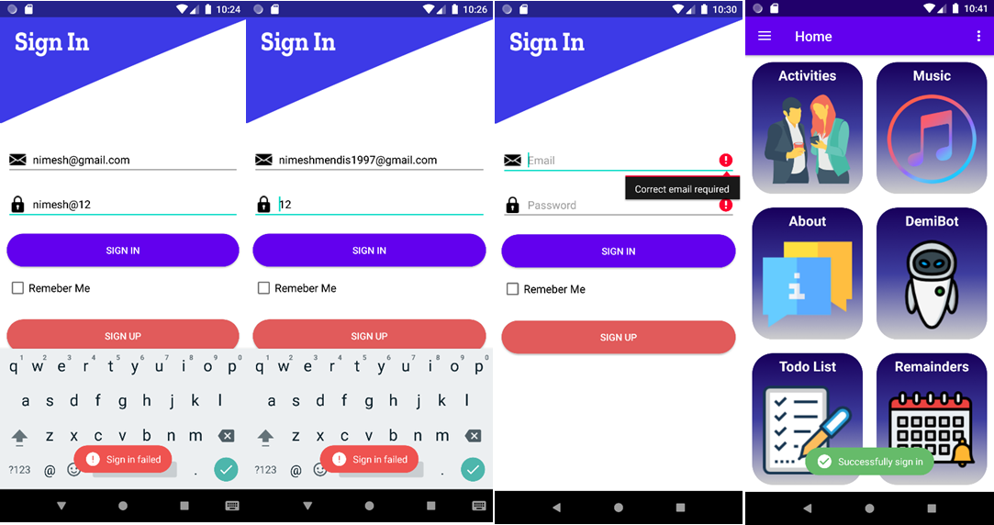
Figure 3 - Login and Registration Interfaces

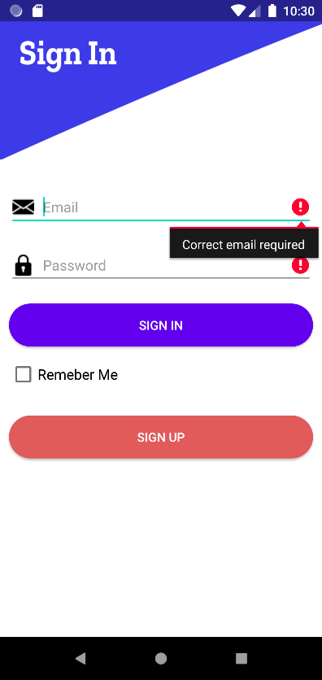
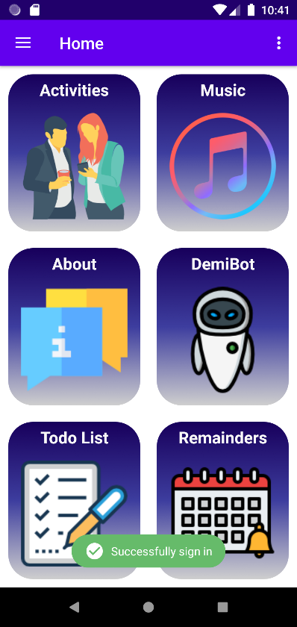
After entering to the system user directly entering to the dashboard, dashboard displays several interfaces where user can access to those interfaces. Figure 4 show that the user can able to do activities such as MEMORY RECALL ACTIVITY and RECOGNIZE OBJECTS ACTIVITY, first in memory recall activity there are three levels user has to complete from level 1 to level 3 increased easy to hard. Also, inside each levels number of circles increase. User needs to click on START NEW GAME in order to start the game. Once the user starts the level one by clicking start new game. Number zero will display inside one of the circles and disappear within seconds. User needs to identify the circle where the zero was displayed in which circle. If the user was able to identify the correct circle where it was displayed the game will getting little bit harder and it will be displaying the number of zeros will be increases and user needs to select all the circles where zeros were appeared. After completing the level system will displaying a successful completion message with a victory animation. The researcher wants to show that the user is a winner, by looking at the winning message user needs feels that user can go through with his mental illness and gradually user builds his/her self-confidence. Next activity is RECOGNIZE OBJECTS ACTIVITY, when we talk about objects, we can use anything including colors, same methods used for memory recall activity. But in this activity user needs to identify the colors and choose the correct color in a given period of time.

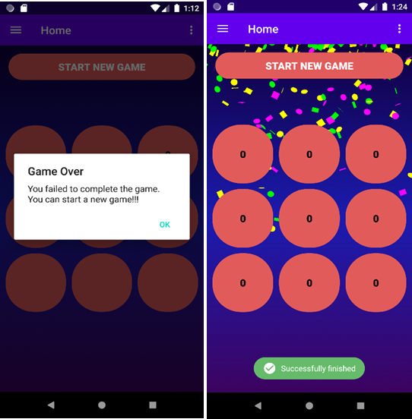
Figure 4 - Memory Recall game

Figure 5 shows the DEMIBOT feature in the application. It is the chatbot where user can have a chat with the chatbot to get information. This is the important function where this is the research component of this project. Demibot design using Python language separately design and integrated to the system.
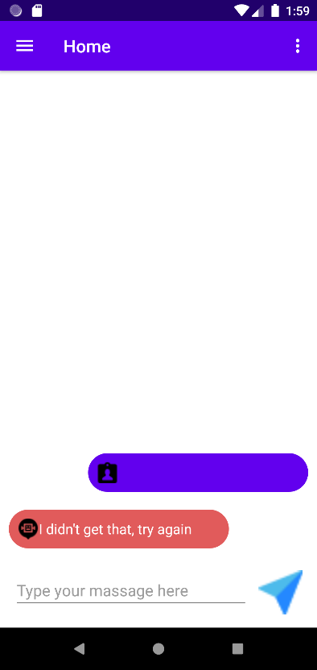
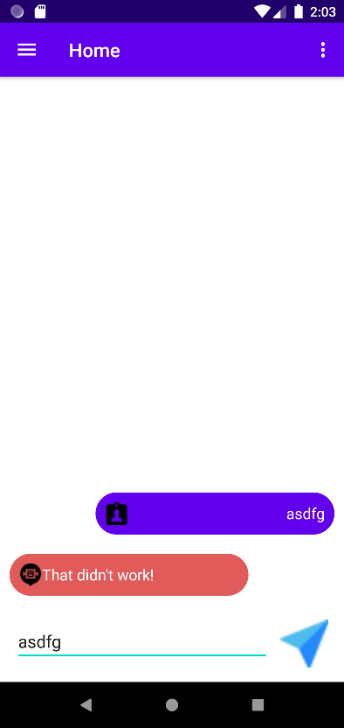
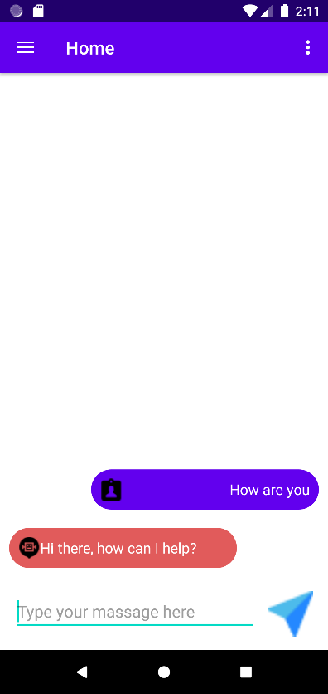
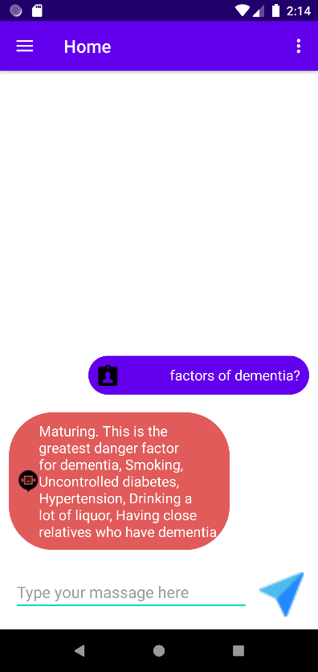
Figure 5 - Chatbot Interface

System provides users to save their To-Do list by clicking ADD TASK. Figure 6 show the user needs to enter task topic and also task description in add task interface. After clicking on SUBMIT button popup will appear whether that user needs to add another task or not. If the user wants to add another task user needs to select yes after that system will re-direct to the task adding interface. User can update the existing task by clicking pencil icon showing in the task. Also, user can delete or remove the task by clicking on green color tick icon by marking the task as completing. After completing the task, task will delete from the list and as well as from the database. All the to-do list tasks saving under the unique id which was provided by the user registration under that user id system will provides another unique task id.
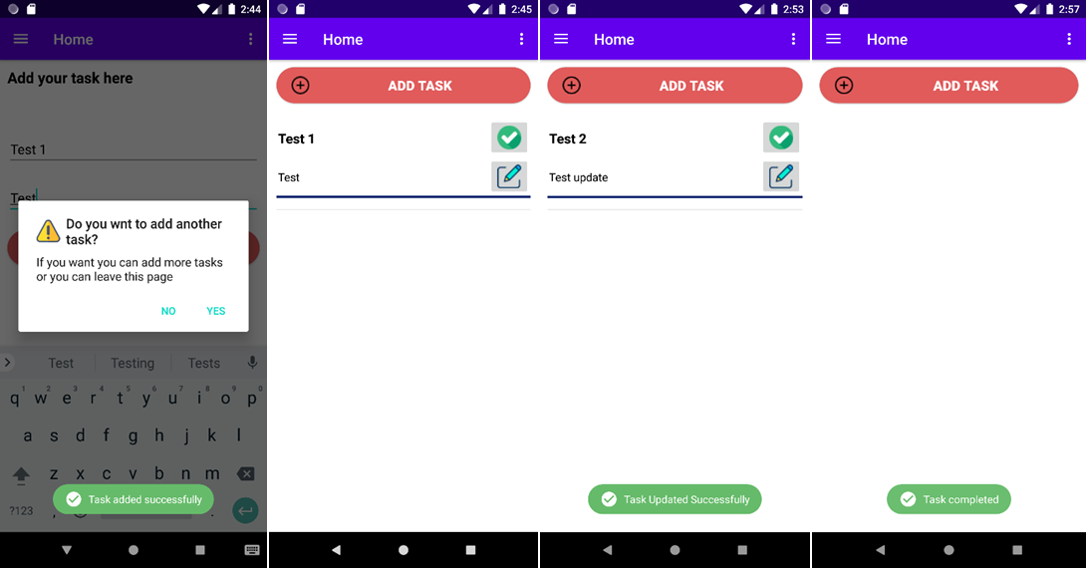
Figure 6 - To-do Interface

Finally figure 7 describes the Reminders interface. System provides Reminder function where users can store their reminders. User needs to click on plus icon below in the Reminder interface. System will be directing to an interface where user can add Reminders. User can add reminders in two ways, either typing the message or user can enter a voice message in order to input the message. After entering the message user needs select the time and select the date. After selecting user needs to click done. Soon after done saving notification of the reminder will appear on the notification panel which cannot clear until the reminder is completing or deleting the reminder. User can also delete or update the notification by long clicking on the reminder and popup will appear whether to update it or delete the reminder.

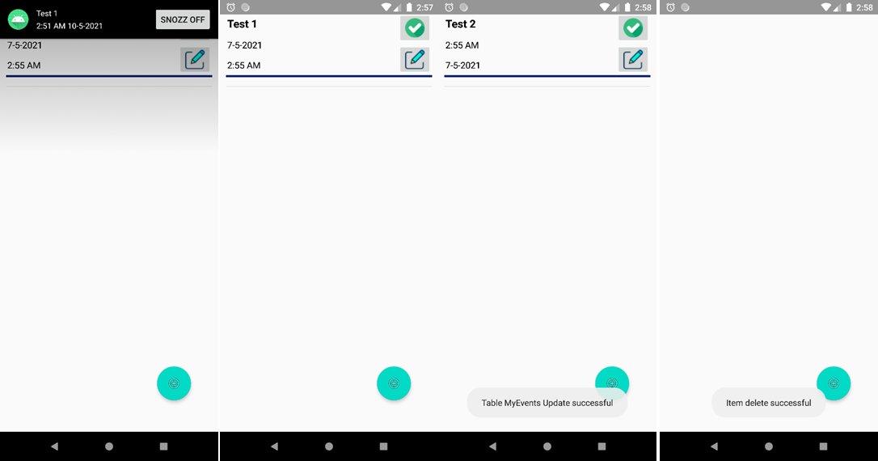
Figure 7 - Reminder Interface

Accuracy and Reliability of the System
DEMENTIA CARE application’s accuracy and dependability are determined by deciding when it meets its goals and achieves its goal. After being evaluated, the application should yield the desired outcomes and perform as expected. The program should be assessed in terms of its intent and whether or not this purpose is fulfilled, as well as whether or not the consumers are able to meet the goal of using it. DEMENTIA CARE is a health-care app, and it has to make sure that the whole app is built with the consumer in mind, so that they can benefit from it and get the most out of it. The accuracy of the program refers to the accuracy of the content it produces; for example, chatbot can react quickly to anything the user types. The program would need to be tested further to see if it performs as intended. The program must be able to ensure a reasonable level of reliability. DEMENTIA CARE application total functionality is rated at 75%. The success rate is determined by voice input, which is used in conjunction with the Reminder feature.
Following the development of each feature, the application would be tested. Additional sprint-by-sprint monitoring will be carried out. The researcher would monitor the overall functionality of the program using a manual testing application. Once the program has been completed, it is retested to see if it is still functional and free of glitches and errors.

Conclusion
Today people who are taking care of the persons with Dementia face lot of difficulties to how to look after their loved ones in situation like this. Due to increase of the Dementia problem care-takers or family members has to have an idea about. Non-pharmacological dementia treatment places a strain on caregivers who are caring for a patient with this lifelong illness. Caregivers are often called in to support their caregivers with everyday operations. They are, however, recommended to foster practical independence. Functional independence in persons with Dementia is enhanced and caregiver burden is reduced when a discrete tracking system is used. In this Thesis report discusses a method that uses smartphone apps to increase the efficiency of dementia patients' care. Mainly Dementia is related about the people who are have less brain functionalities and the researcher have to find any solution in technological side.
Since the evolution of technology there is no serious issue to find a solution application for Dementia. Since every user have a mobile application in their hands it is easy to develop a mobile application.
Dementia care health care application system provide users technologically advanced features as well as it provides users to have an idea about what is Dementia. Also, the application provides users to helping to recover their memory up to certain extent using a memory recall activity.
“DEMENTIA CARE” is a health care mobile application which is run on Android platform, the “Demibot” is the artificial intelligence chatbot plays a major role inside the application. User can have chat with bot and get help. “DEMENTIA CARE” application is unique from other applications because of this challenging component. Other than this feature there are features where helps user to recover their memory by recalling. As well as system provides music player which developed inside the application. Also provides song playlist which suitable for the user. All the songs which have been selected by the researcher are slow beat and mind soothing music. Additionally, the researcher adds features such as to-do list and reminder. User can be able to store their to-do activity tasks and reminders for their easy use.
The "DEMENTIA CARE" scheme was divided into stages in this thesis, which was then analyzed and depicted to emphasize the system's importance. It was created after extensive study into memory recall behavior, as well as an in-built music player and an AI chatbot. The planned project was designed and developed according to a comprehensive schedule. This contributed to the DEMENTIA CARE system's stable growth, which enabled it to meet its priorities and targets on time. Consumers will profit from this successful DEMENTIA CARE system by this system in their hectic lifestyle, which continues to overlook such problems and find solutions.

Acknowledgment
At the outset of this paper, I'd like to thank the University of Bedfordshire for allowing me to participate in this degree pathway.
Next, I would like to express my sincere appreciation to Dr. Enjie Liu and Dr. Gayana Fernando for all of the course materials and guidelines given in this module. Next, I would like to express my gratitude to Mr. Vibhavi Attigala, my research supervisor, for leading me every step of the way and assisting me in effectively completing my research from the beginning. Next, I'd like to express my gratitude to Dr. Tess Crosbie for the session she gave us on day one of this module.
Next, I would like to express my gratitude to Google and Google Scholar for assisting me in locating the research papers and other documentation needed for my research. Next, I would like to express my gratitude to all of the contributors to Stack Overflow, GitHub, the Google Android Developers forum, and the official Google Android Developers YouTube channel, from whom I got invaluable assistance in creating the mobile application.
I would like to thank one of my university undergraduate friend Mr. Dilshan Madhushanka who gave me help to develop chatbot using Python language and backend development of the chatbot.
Then, I would like to express my gratitude to my parents and sister for assisting me in completing this study in such a short amount of time.
Finally, I am overcome with gratitude to those who have driven and shown me the way to achieving all of the research goals by overcoming the obstacles.

References

- Sikder, A.T., Yang, F.C., Schafer, R., Dowling, G.A., Traeger, L. and Jain, F.A., 2019. Mentalizing imagery therapy mobile app to enhance the mood of family dementia caregivers: feasibility and limited efficacy testing. JMIR aging, 2(1), p.e12850.
- Brooke, J., 2016. Caring for patients with dementia. Nursing in Practice, 89, pp.68-71.
- Halbach, T., Solheim, I., Ytrehus, S. and Schulz, T., 2018. A Mobile application for supporting dementia relatives: a case study. Studies in health technology and informatics, 256, pp.839-846.
- Blom, M.M., Zarit, S.H., Zwaaftink, R.B.G., Cuijpers, P. and Pot, A.M., 2015. Effectiveness of an Internet intervention for family caregivers of people with dementia: results of a randomized controlled trial. PloS one, 10(2), p.e0116622.
- Anderson, J.G., Rose, K.M. and Taylor, A.G., 2016. A descriptive study of the nutrition-related concerns of caregivers of persons with dementia. Journal of Aging Research and Clinical Practice, 5(1), pp.1-6.
- Yousaf, K., Mehmood, Z., Saba, T., Rehman, A., Munshi, A.M., Alharbey, R. and Rashid, M., 2019. Mobile-health applications for the efficient delivery of health care facility to people with dementia (PwD) and support to their carers: a survey. BioMed research international, 2019.
- Y. Yorozu, M. Hirano, K. Oka, and Y. Tagawa, “Electron spectroscopy studies on magneto-optical media and plastic substrate interface,” ASME Transl. J. Magn. Japan, vol. 2, pp. 740–741, August 1987 [Digests 9th Annual Conf. Magnetics Japan, p. 301, 1982].
- Imtiaz, D., Khan, A. and Seelye, A., 2018. A mobile multimedia reminiscence therapy application to reduce behavioral and psychological symptoms in persons with Alzheimer’s. Journal of healthcare engineering, 2018.
- Zwingmann, I., Michalowsky, B., Esser, A., Kaczynski, A., Monsees, J., Keller, A., Hertel, J., Wucherer, D., Thyrian, J.R., Eichler, T. and Kilimann, I., 2019. Identifying unmet needs of family dementia caregivers: results of the baseline assessment of a cluster-randomized controlled intervention trial. Journal of Alzheimer's Disease, 67(2), pp.527-539.
- O'Connor, E., Farrow, M. and Hatherly, C., 2014. Randomized comparison of mobile and web-tools to provide dementia risk reduction education: use, engagement and participant satisfaction. JMIR Mental Health, 1(1), p.e4.
- Anderson, J.G., Rose, K.M. and Taylor, A.G., 2016. A descriptive study of the nutrition-related concerns of caregivers of persons with dementia. Journal of Aging Research and Clinical Practice, 5(1), pp.1-6.
- Hardinge, M., Rutter, H., Velardo, C., Shah, S.A., Williams, V., Tarassenko, L. and Farmer, A., 2015. Using a mobile health application to support self-management in chronic obstructive pulmonary disease: a six-month cohort study. BMC medical informatics and decision making, 15(1), pp.1-10.
[13] Brown, E.L., Ruggiano, N., Li, J., Clarke, P.J., Kay, E.S. and Hristidis, V., 2019. Smartphone-based health technologies for dementia care: opportunities, challenges, and current practices. Journal of Applied Gerontology, 38(1), pp.73-91.
[14] Zhang, H., Zheng, Z., Xu, S., Dai, W., Ho, Q., Liang, X., Hu, Z., Wei, J., Xie, P. and Xing, E.P., 2017. Poseidon: An efficient communication architecture for distributed deep learning on {GPU} clusters. In 2017 {USENIX} Annual Technical Conference ({USENIX}{ATC} 17) (pp. 181-193).

Authors’ background

Your Name | Title* | Research Field | Personal website
Nimesh Mendis | Student |  | Nimesh Mendis (LinkedIn)
Vibhavi Attigala | Lecturer |  | Vibhavi Attigala (LinkedIn)
*This form helps us to understand your paper better, the form itself will not be published.

*Title can be chosen from: master student, Phd candidate, assistant professor, lecture, senior lecture, associate professor, full professor

