

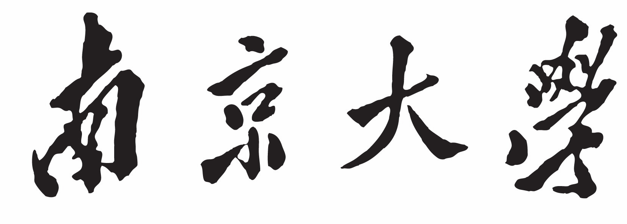

**本 科 毕 业 设 计**

院 系 计算机科学与技术系

专 业 计算机科学与技术

题 目基于K匿名及差分隐私的定域功能性影像隐私保护

年 级 2013级 学 号 131220124

学生姓名 肖鹏

指导老师 华景煜 职 称 讲师

论文提交日期 2017.05.22

$${H\left(P\right)=\left[h\left(x_{1}\right),h\left(x_{2}\right),…,h\left(x_{n}\right)\right]}^{1}$$

$$h\left(x_{i}\right)=\frac{S\left(x_{i}\right)}{\sum_{j}{S\left(x_{j}\right)}}$$

$${ d\left(H_{1,}H_{2}\right)=\frac{\sum_{1}{(H_{1}\left(I\right)-\overline{H_{1}})(H_{2}\left(I\right)-\overline{H_{2}})}}{\sqrt{\sum_{1}{{(H_{1}\left(I\right)-\overline{H_{1}})}^{2}}}\sum_{2}{{(H_{2}\left(I\right)-\overline{H_{2}})}^{2}}}}^{}$$

参考文献[27]

[1] Elaine Newton，Latanya Sweeney，Bradley Malin:Preserving Privacy by De-identifying Facial Images. [C]March 2003 CMU-CS-03-119 School of Computer Science Carnegie Mellon University Pittsburgh, PA 15213-3890[27]

[2]Suriyon TANSURIYAVONG，Shin-ichi HANAKI:Privacy protection by concealing persons in circumstantial video image. [C][Workshop on Perceptive User Interfaces](http://xueshu.baidu.com/usercenter/data/journal?cmd=jump&wd=confuri%3A%28ec1cde5a645e01db%29%20Workshop%20on%20Perceptive%20User%20Interfaces&tn=SE_baiduxueshu_c1gjeupa&ie=utf-8&sc_f_para=sc_hilight%3Dpublish&sort=sc_cited), 2002:1-4

[3] Lam Tran，Deguang Kong, Hongxia Jin，Ji Liu. Privacy-CNH: A Framework to Detect Photo Privacy with Convolutional Neural Network Using Hierarchical Features [C].AAAI 2016: 1317-1323

[4] Jihun Hamm:Minimax Filter: Learning to Preserve Privacy from Inference Attacks. [C]CoRR abs/1610.03577 (2016)

[5] Reza Shokri, Marco Stronati, Vitaly Shmatikov:Membership Inference Attacks against Machine Learning Models. [C]CoRR abs/1610.05820 (2016)

[6] S Süsstrunk，R Buckley，S Swen：Standard RGB Color Spaces；［C］Color & Imaging Conference, 1999, 7:127-134(8)

[7] 刘益新，郭依正：灰度直方图特征提取的Matlab实现［J］；《电脑知识与技术》, 2009, 5(32):9032-9034

[8] C Dwork：Differential Privacy: A Survey of Results［C］；Theory & Applications of Models of Computation, International Conference, Tamc, Xian, China, April, 2008, 4978:1-19

[9] ME Nergiz，C Clifton：Thoughts on k-anonymization［J］《Data & Knowledge Engineering》, 2006, 63(3):622-645

[10] H Schreier，JJ Orteu，MA Sutton：Image Correlation for Shape, Motion and Deformation Measurements［J］；Springer US, 2009:565-600

[11] MD Franzen：Chi-square［J］；Springer New York, 2011:559-559

[12] McMorris，R F：Topics in intersection graph theory［C］；SIAM,, 1999

[13] T Jebara，RI Kondor：Bhattacharyya Expected Likelihood Kernels ［C］；Conference on Computational Learning Theory & Kernel Machines 2003, 2777:57-71

[14] 李月龙，封举富：基于最小扭曲变换的正面人脸图像合成［J］；《计算机辅助设计与图形学学报》, 2011, 23(6):1085-1090

[15] Suman Jana, Arvind Narayanan, Vitaly Shmatikov:A Scanner Darkly: Protecting User Privacy from Perceptual Applications. ［C］IEEE Symposium on Security and Privacy 2013: 349-363

[16] Cynthia Dwork, Kunal Talwar, Abhradeep Thakurta, Li Zhang:Analyze gauss: optimal bounds for privacy-preserving principal component analysis. ［C］STOC 2014: 11-20

[17] Martín Abadi, Andy Chu, Ian J. Goodfellow, H. Brendan McMahan, Ilya Mironov, Kunal Talwar, Li Zhang:Deep Learning with Differential Privacy.［C］ ACM Conference on Computer and Communications Security 2016: 308-318

[18] Yining Wang, Yu-Xiang Wang, Aarti Singh:A Deterministic Analysis of Noisy Sparse Subspace Clustering for Dimensionality-reduced Data.［C］ ICML 2015: 1422-1431

[19] Kevin W. Bowyer:Face recognition technology: security versus privacy. ［C］IEEE Technol. Soc. Mag. 23(1): 9-19 (2004)

[20] Tom A. M. Kevenaar, Geert Jan Schrijen, Michiel van der Veen, Anton H. M. Akkermans, Fei Zuo:Face Recognition with Renewable and Privacy Preserving Binary Templates.［C］ AutoID 2005: 21-26

[21] Ahmad-Reza Sadeghi, Thomas Schneider, Immo Wehrenberg:Efficient Privacy-Preserving Face Recognition.［C］ ICISC 2009: 229-244

[22] Charu C. Aggarwal, Philip S. Yu:A General Survey of Privacy-Preserving Data Mining Models and Algorithms. ［C］Privacy-Preserving Data Mining 2008: 11-52

[23] Luminita Vasiu:Biometric Recognition - Security and Privacy Concerns. ［C］ ICETE (Invited Speakers) 2004: 3

[24] Moo-Ryong Ra, Ramesh Govindan, Antonio Ortega:P3: Toward Privacy-Preserving Photo Sharing.［C］ NSDI 2013: 515-528

[25] Zekeriya Erkin, Martin Franz, Jorge Guajardo, Stefan Katzenbeisser, Inald Lagendijk, Tomas Toft:Privacy-Preserving Face Recognition.［C］Privacy Enhancing Technologies 2009: 235-253

[26] 石香灵：隐私保护模型研究［D］；《重庆大学》, doi：10.7666/d.y1666001:2009

[27] 任向民：基于K-匿名的隐私保护方法研究［D］；《哈尔滨工程大学》:2012

[28]Ninghui Li, Min Lyu, Dong Su, Weining Yang:Differential Privacy: From Theory to Practice. Synthesis Lectures on Information Security, Privacy, & Trust, Morgan & Claypool Publishers 2016, pp. 1-138