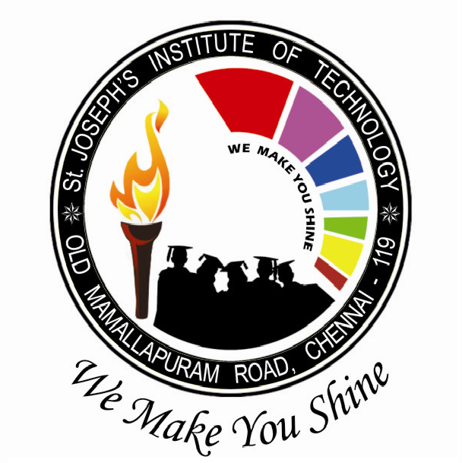
St. JOSEPH’S INSTITUTE OF TECHNOLOGY
Department of Information Technology
Circular
The Management, Principal and staff members congratulate the following Information Technology students who participated and won various events in Intra-Departmental Technical symposium.
EVENT NAME | STUDENT NAME | YEAR | PLACE | PRIZE AMT
Technical Quiz | Shwetha.S  Harshapriya.G | III IT | I | 750
Technical Quiz | Karthikeyan K R  Joseph Lionel Faber | III IT | II | 600
Technical Quiz | Ankith S - Aravind A  &  Garry Kevin E P  Harish B | IV IT  &  II IT | III | 400
Reverse Coding | Ankith S - Aravind A | IV IT | I | 750
Reverse Coding | Karthikeyan K R  Joseph Lionel Faber | III IT | II | 600
Reverse Coding | Kumaraguru G  Amalesh Fernando J T  &  Varshini S - Afros fathima | III IT  &  IV IT | III | 400
Guessmate  (Connexions) | Dinesh A & team | III IT | I | 750
Guessmate  (Connexions) | Pavithra.K & team | IV IT | II | 600
Guessmate  (Connexions) | Gowshik A & team | II IT | III | 400
AD-ZAP | Subhiksha.S & team | IV IT | I | 750
AD-ZAP | Harish B & team | II IT | II | 600
AD-ZAP | Gokul.R & team | III IT | III | 400
Model Presentation | Logeshwar T - Syed Jafer  &  Thigavathi J - ,Jeyalakshmi | II IT | I | 1250
Model Presentation | Madhan Sivavel  Gowtham Krishna | IV IT | II | 1000
Model Presentation | Abinaya devi - Jasmine S  &  Hema G N - Rini Sharon | III IT  &  IV IT | III | 750

MANAGING DIRECTOR

