**B-Sides Seattle 2018 Badge**

For code, schematic, and this guide, visit:

<https://github.com/BlackLodgeResearch/bsides_2018_badge>

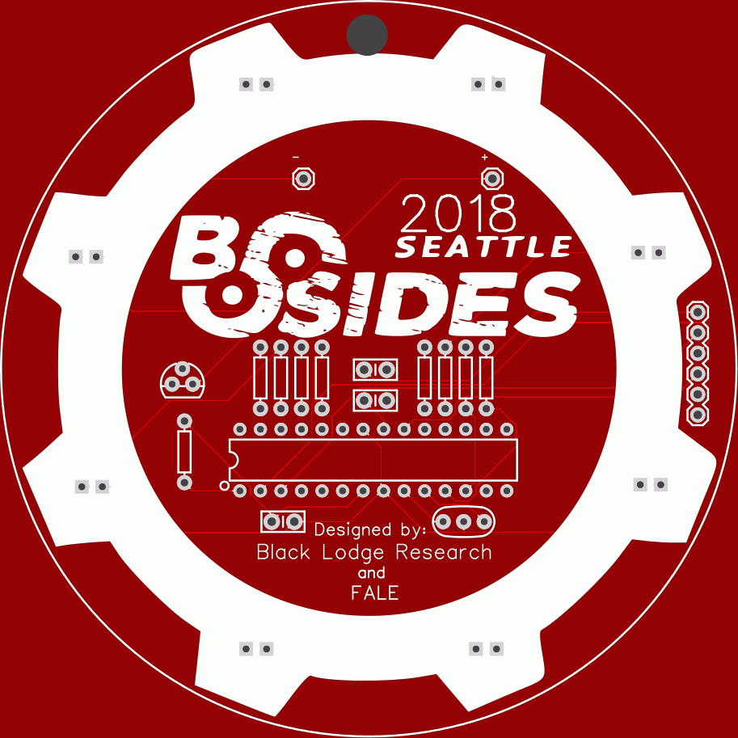

This badge is rather simple in its layout and execution, as it was designed and built in a haze of cold medicine and tight deadlines. Initial design and layout were done by Black Lodge Research (<https://www.blacklodgeresearch.org/>), with a great deal of help and guidance from folks from FALE (<http://lockfale.com/>).

If you haven’t heard of us, Black Lodge Research is your local Redmond, WA hacker space. Come check us out on our Thursday Open Hack Nights, our monthly talks, or many events we host.

BUILD GUIDE

Your parts baggie consists of the following badge components:

1. 8 1k Ohm Resistors
2. 1 10k Ohm Resistor
3. 1 Voltage Regulator
4. 3 0.1µf Capacitors
5. 8 Red LEDs
6. 1 16Mhz Crystal Resonator
7. 1 6-pin Header
8. 1 3-AAA Battery Holder
9. 1 28-pin Socket
10. 1 ATMEGA328p-pu Microcontroller

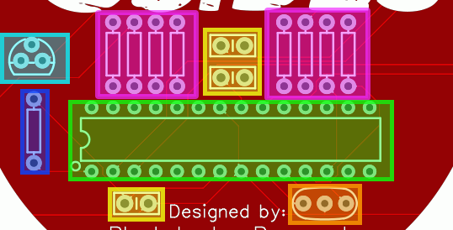

Steps:

1. Bend the legs of the 8 1kΩ resistors to fit and solder them to the areas highlighted above in MAGENTA. Resistors have no predetermined direction, so they can go in either way.
   1. The same can be done for the 10kΩ resistor, highlighted in BLUE.
2. Solder the LEDs to the outer white ring (not pictured). LEDs are directional and the longer “leg” is always the positive (for single color LEDs). In this configuration, the positive is in the LEFT hole for every LED when the badge is upright.
3. Insert the socket, highlighted in GREEN above, being careful to note the direction of the notch on the left, ensuring this corresponds with the notch present on the socket.
4. Insert the capacitors, highlighted in YELLOW and solder them in. All three are the same value, and they are non-directional, like the resistors.
5. Next, insert the crystal, highlighted in ORANGE above and solder it in. Like the resistors, this has no direction, and can go in either way it will fit.
6. Place the headers, not pictured above, on the far right of the badge and solder them in. They have no specific orientation.
7. The last piece on the front is the voltage regulator, which is highlighted in LIGHT BLUE above. This piece is inserted in a somewhat odd configuration, which does not follow the image on the board.
   1. With the flat portion facing you, the pins are as follows:
      1. Left most is **GROUND**, and goes in the top most hole of the triangle shape
      2. The center is **VOLTAGE IN** and goes in the bottom right hole
      3. The right pin is **VOLTAGE OUT** and goes in the bottom left
   2. Bend the pins slightly to fit the configuration noted, and solder it in
8. Finally, the battery holder is placed on the back of the badge. Bend the pins outward at 90-degree angles so the battery holder sits flush to the back and solder the pins from the front of the badge.
9. Carefully bend the pins on the ATMEGA328P Controller slightly, so they are perpendicular to the controller itself. Making sure to align the “notch” of the socket to the similar mark on the controller, gently press it into the socket.

**IMPORTANT:** Batteries must be placed in the holder in the opposite direction indicated. Positive to negative, and vice-versa.