In the name of Allah

Analysis of electrical energy systems (1)

Ali Sadeghian 400101464

Amir Hossein Naghdi 400102169

Lecturer:

Dr. Haji pour

project subject:

Simulation with Power-World software

**Part I:**

**1.Analysis by Gauss-Seidel method in Power-World:**

The circuit is drawn as follows:

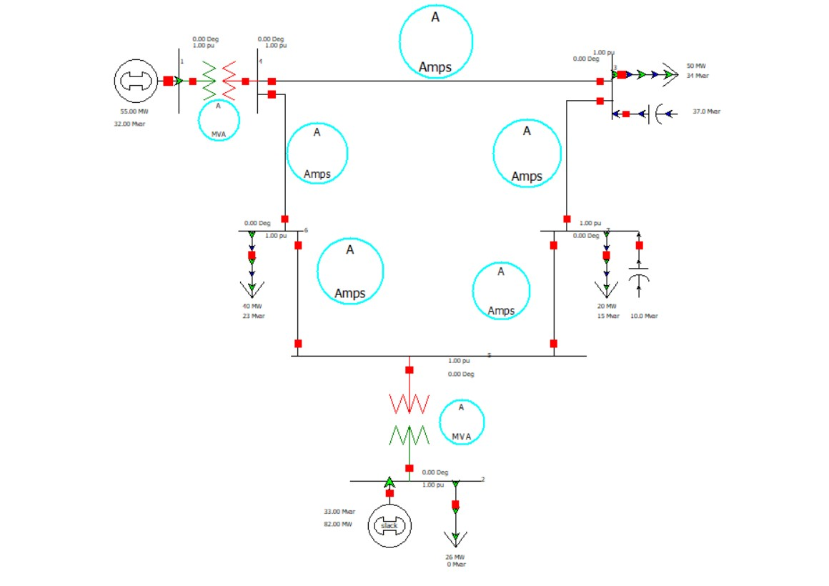

Now we solve the circuit with Gauss-seidel method. First, we activate the Do Only One Iteration check box according to the request of the question.

For the four Iterations, the bus voltage is as follows:

Iteration (0)

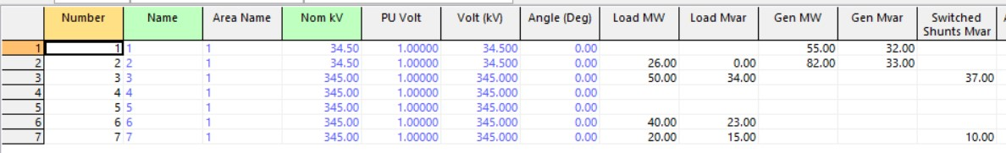

Iteration (1)

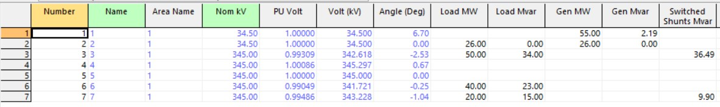

Iteration (2)

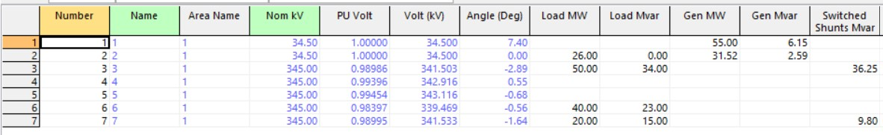

Iteration (3)

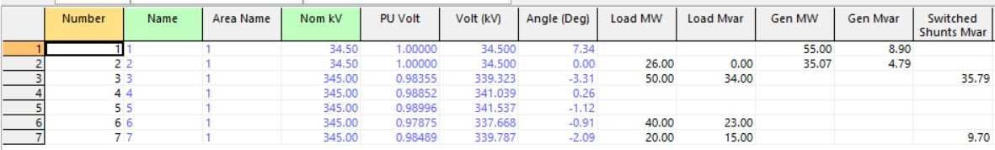

Iteration (4)

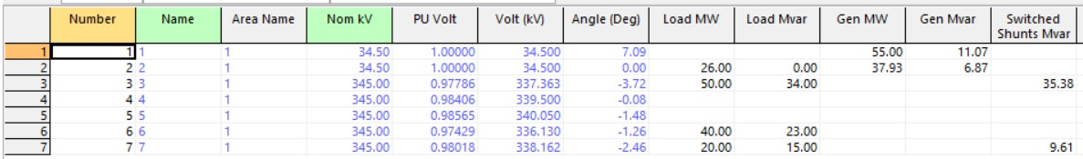

The voltages are converging.

Now, according to the first question, we set the iteration number to 100. And we run the program.

The following image shows the voltages and angles of the buses after 100 iterations: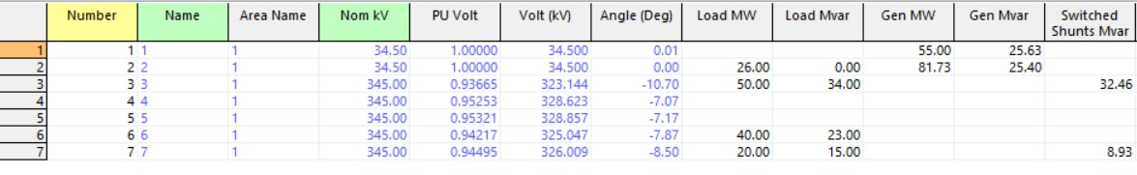

Mismatch in the bosses after these 100 iterations is as follows: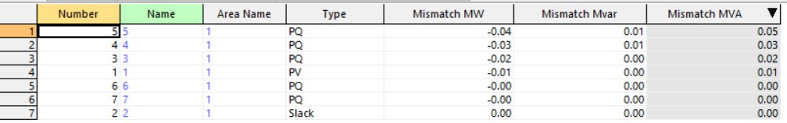

**2.Analysis by Newton-Raphson method in Power World**

For the four Iterations of solving with this method, the bus voltage is as follows:

Iteration (0)



Iteration (1)

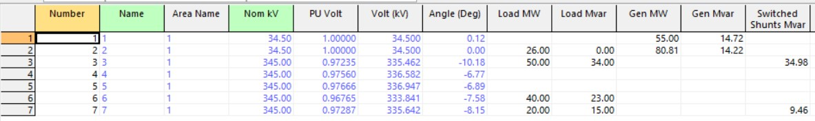

Iteration (2)

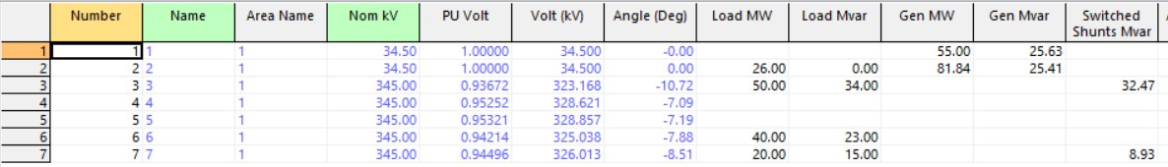

Iteration (3)

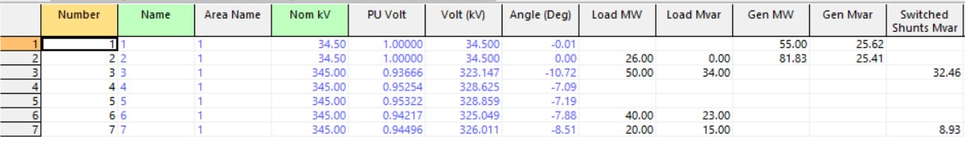

Iteration (4)

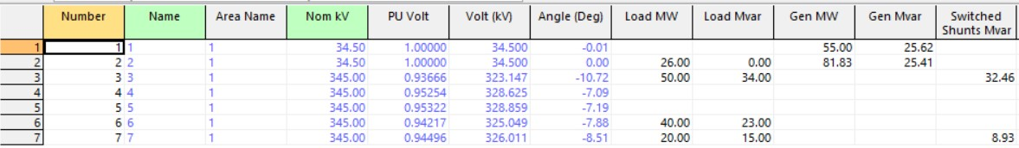

The voltages are converging.

Now, according to the first question, we set the iteration number to 100. And we run the program.

The following image shows the voltages and angles of the buses after 100 iterations: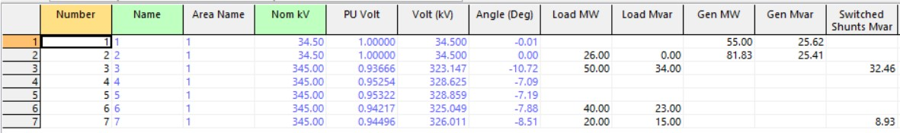

The Jacobian matrix is ​​as follows: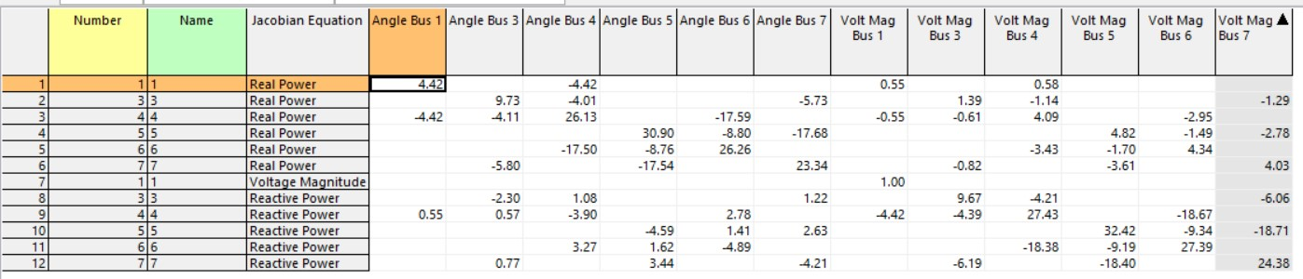

Mismatch in the bosses after these 100 iterations is as follows: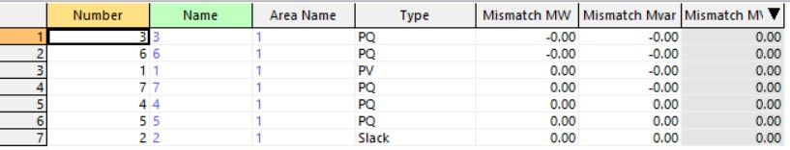

**3. Voltage limitation**

According to the image below, three basses pass this limit: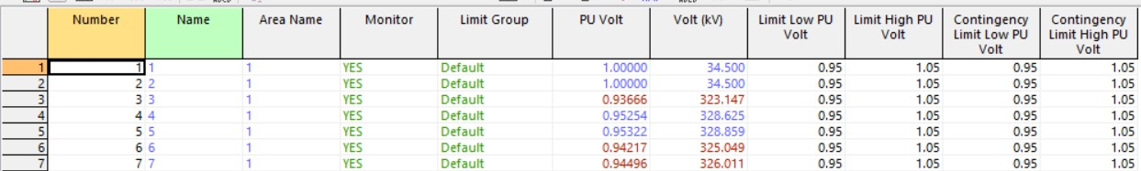

حال خازن باس 3 را از مدار خارج می کنیم:

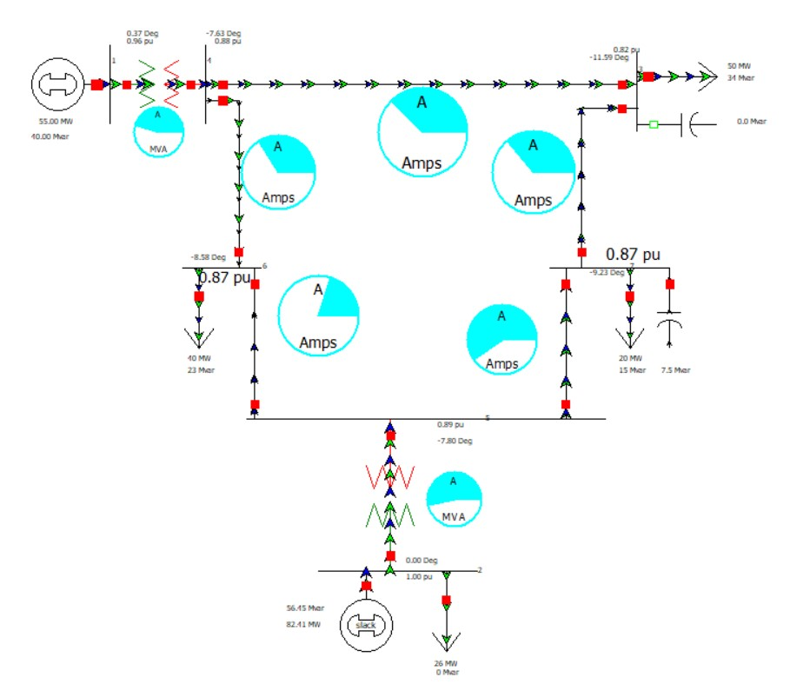

The bus voltage values ​​before removing the capacitor are as follows:

After removing the capacitor: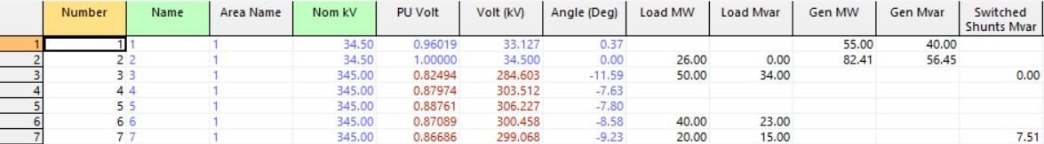

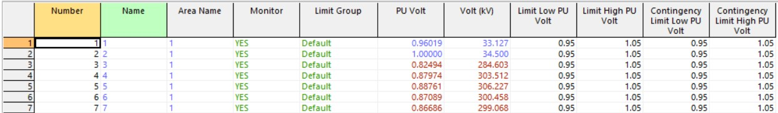

The cause of this phenomenon is the reduction of reactive power production in Bus 3, which causes the transfer of reactive power on the transmission line. As a result, the transmission current on the line increases and causes the voltage on the line to drop.

The losses of the system before removing this capacitor bank are as follows: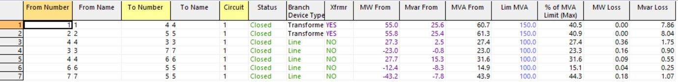

Amount of loss after disconnecting the capacitor bank: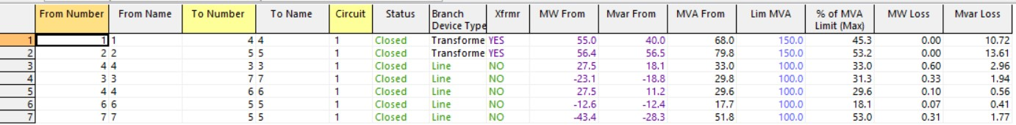

**4.Changing the transformer tab**

By trial and error, we found out that with reactive power of 40MVar, we cannot increase the voltage of bus 3 more than 0.9943 pu.

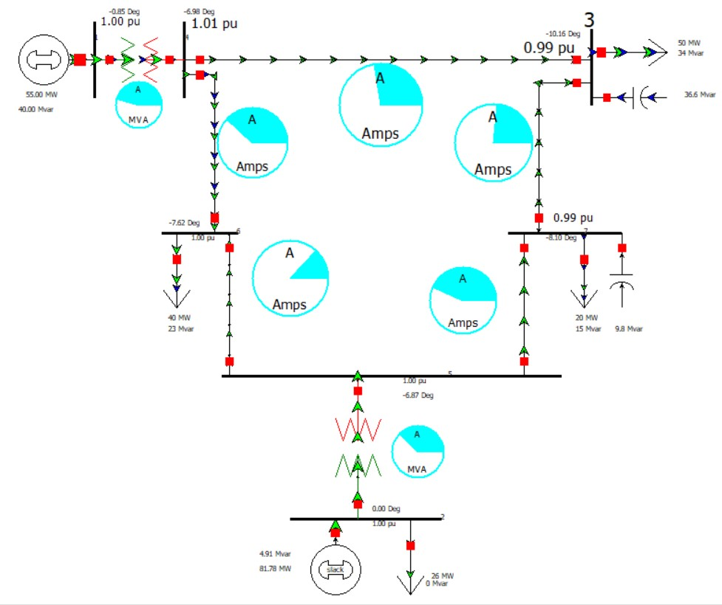

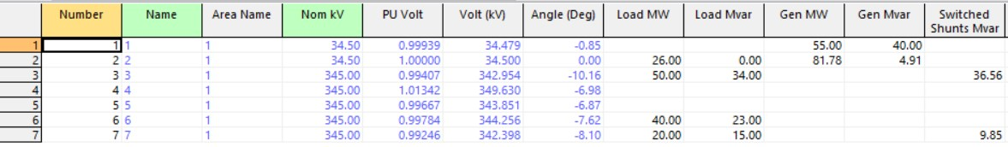

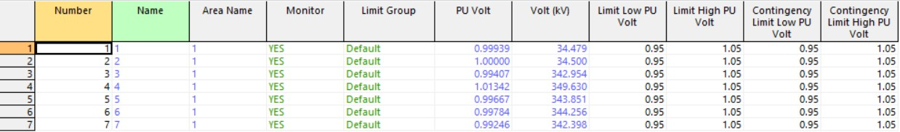

With a tab of 0.9, all voltages are within 5%, but the voltage of bus 3 has not reached the desired value.

Now, with a small change in the bus 1 generator (by increasing the reactive power production), we were able to bring the voltage of bus 3 to one unit with 0.9 tab.

.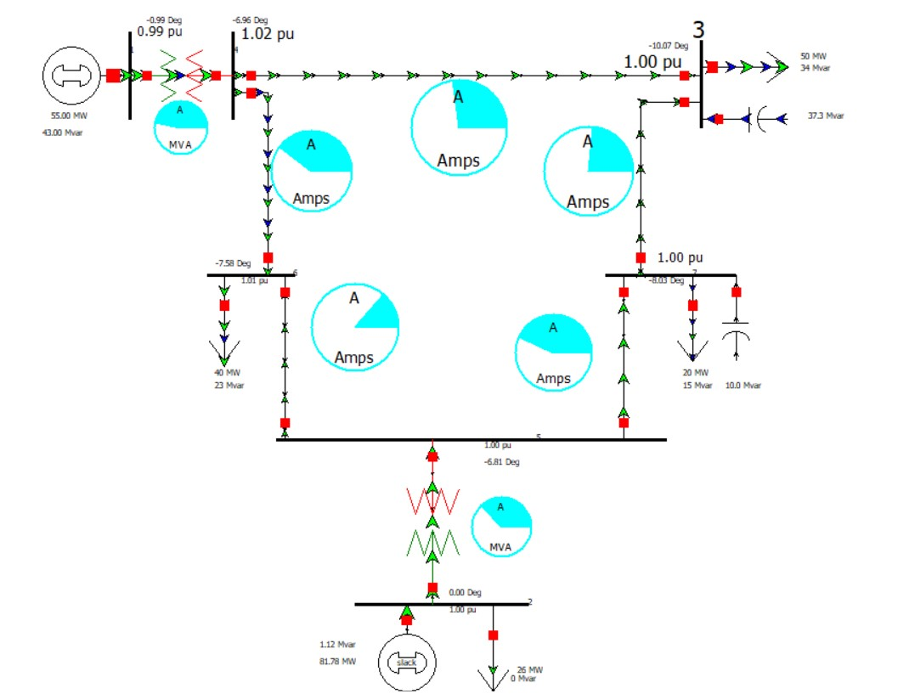

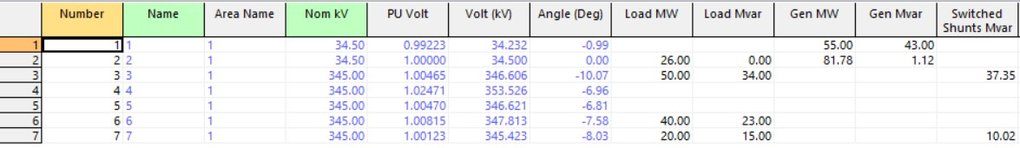

**5.Adding a transformer to bus 1-4**

Schematic of the circuit and power values ​​of the transformers in the case of the transformer being the same:

: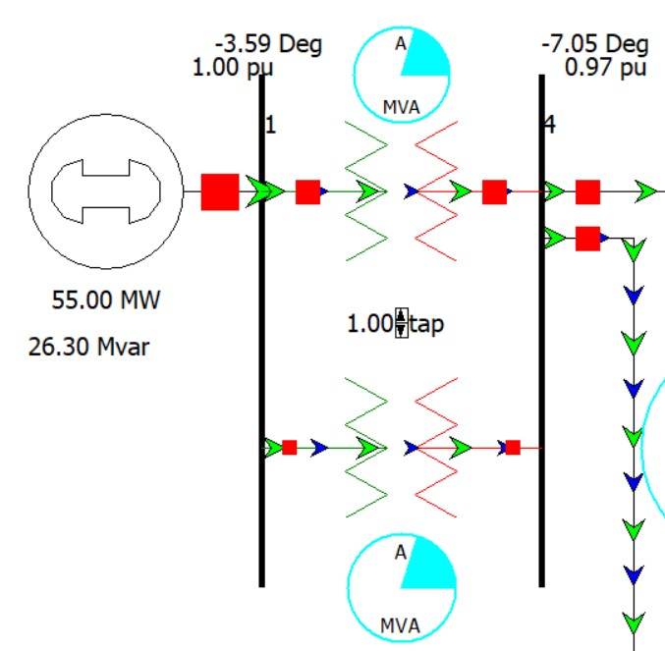

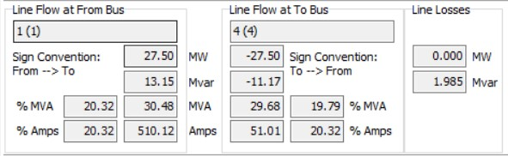

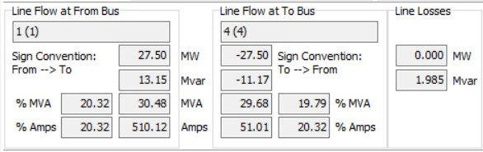

In the case that the reactance of the second transformer is twice the first:

: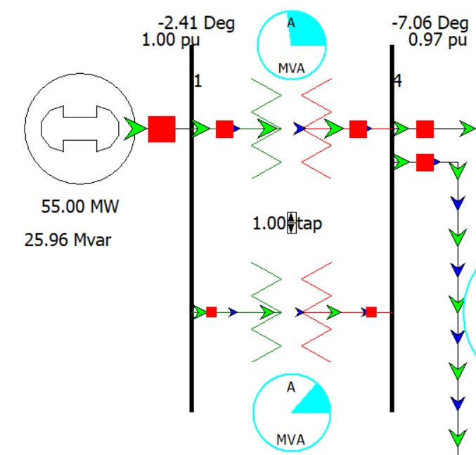

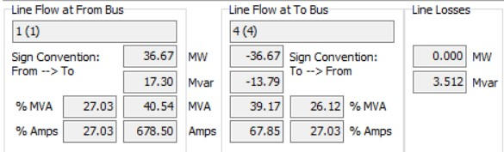

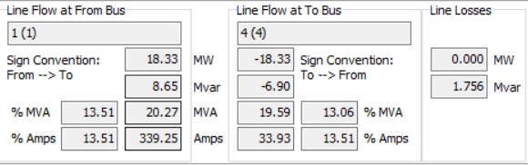

**6.Transmission line exit accident (3-4)**

We try to stabilize the network by reducing the reactive and real power consumption in bus 3:

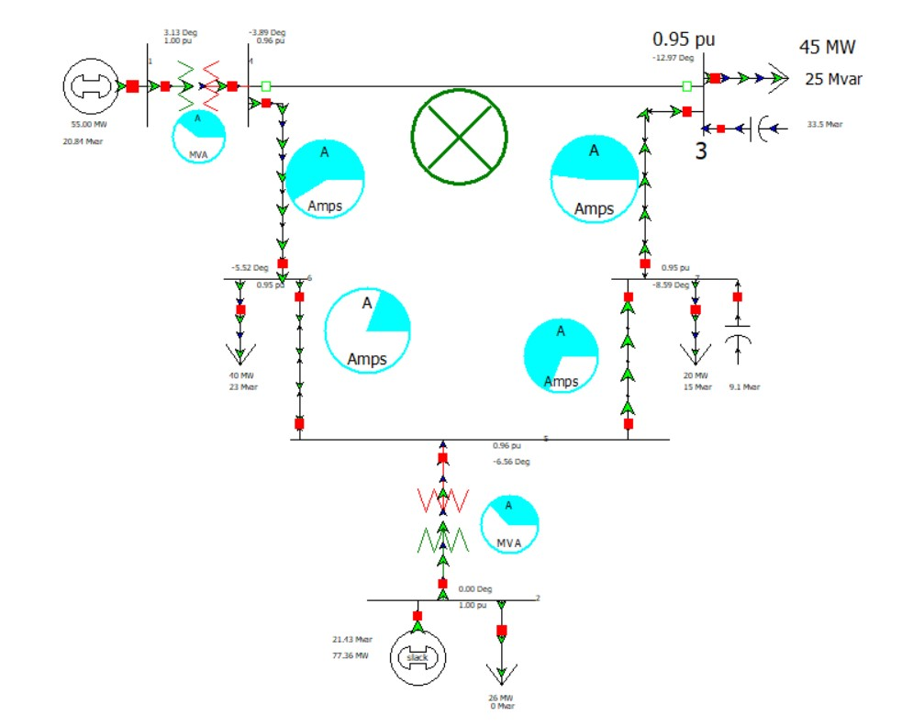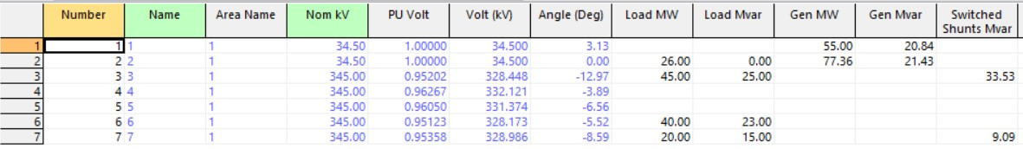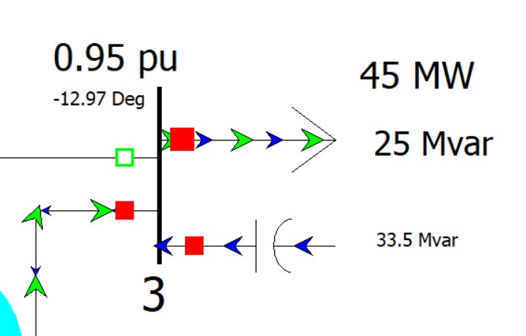

As we can see, by reducing the power consumption in bus 3, the transmission current on the line has decreased, and as a result, we see a lower voltage drop.

**7.New transmission line**

The new circuit with the addition of a new line will look like this: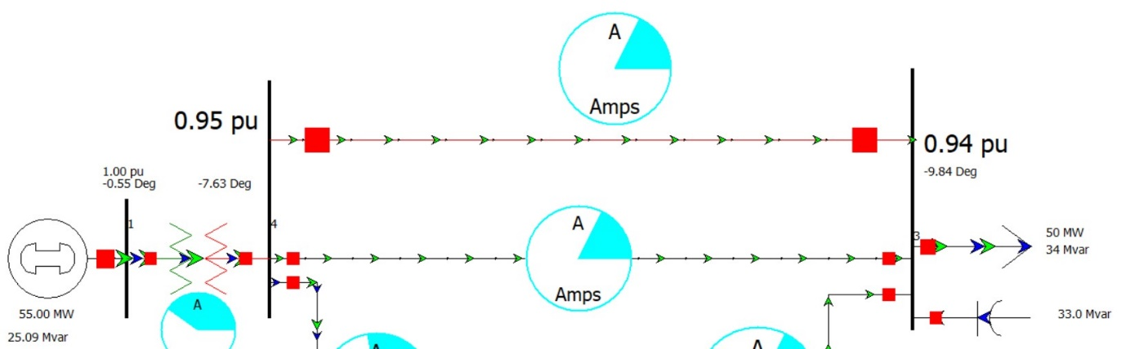

تلفات با خط انتقال موازی:

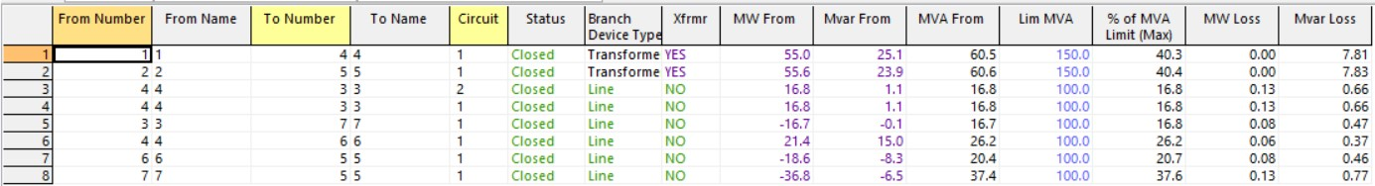

تلفات بی خط موازی:

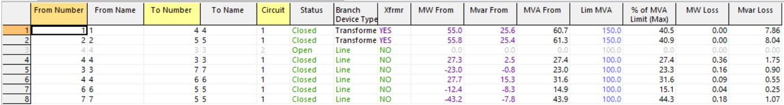

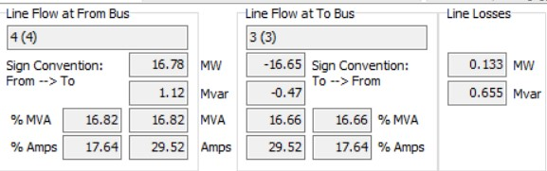

.

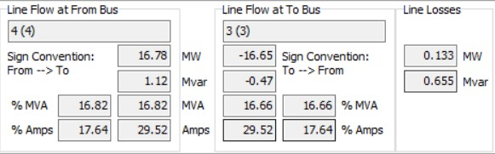

**Part II:**

The purpose of this section is to review the Convergence Analysis section in Power-World software.

First, we see a general picture of the work done in the software:



Answer to part a:

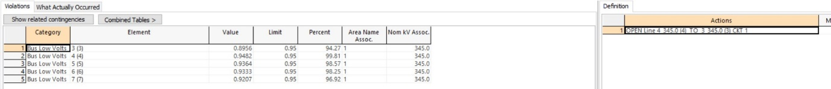

According to the figure, the problem created for our distribution system if the communication line between buses 3 and 4 is cut, the voltage level of all buses will be reduced. which is not acceptable according to our limitations.

To solve this problem, we must use the deterministic load method, which was reviewed in the first part of the project.

Answer to part b:



According to the figure, by removing this line, the entire system becomes unstable and fails (Blackout).

Answer to part c:

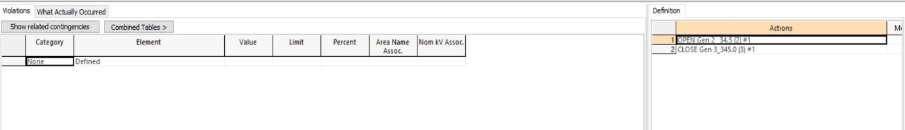

As you can see in the picture above, there is no problem with the system.

**Part III:**

1. **What are the advantages of the Gauss-Seidel method and the Newton-Raphson method respectively?**

The Gauss-Seidel and Newton-Raphson methods are iterative techniques used to solve systems of nonlinear algebraic equations, which commonly arise in power flow analysis in electrical engineering. Each method has its own set of advantages:

**Gauss-Seidel Method Advantages:**

1. **Simplicity:**

The Gauss-Seidel method is relatively simple to understand and implement. Its algorithm is straightforward, making it accessible for those new to power systems analysis.

2. **Memory Efficiency**:

It requires less memory storage because it updates the solution immediately and does not store the Jacobian matrix or its inverse, which can be significant in large systems.

3. **Computational Efficiency for Small Systems**:

For small to moderately sized systems, the Gauss-Seidel method can be computationally efficient, especially if the system is well-conditioned and the solution is close to the initial guess.

4. **Incremental Improvement**:

Each iteration naturally improves on the approximation of the solution, which allows for the evaluation of convergence after each sweep through the equations.

**Newton-Raphson Method Advantages:**

1. **Fast Convergence**:

The Newton-Raphson method generally has quadratic convergence, which means it can achieve high accuracy with fewer iterations compared to linear convergence methods like Gauss-Seidel, especially as the solution approximation gets closer to the actual values.

2. **Robustness**:

It can handle a wider range of problems, including those with less than ideal initial guesses or those with heavier non-linear characteristics.

3. **Scalability**:

Better suited to large-scale power system analysis due to its consistent convergence properties, regardless of system size, when compared to linear iterative methods.

4. **Efficiency with Sparse Matrix Techniques**:

When implemented with sparse matrix techniques, the Newton-Raphson method can be highly efficient as it exploits the sparsity of the Jacobian matrix in large power systems.

5. **Accommodating Complex Systems**:

It can easily accommodate changes in the system, such as the addition of new lines or generators, and still perform with consistent reliability.

Both methods are foundational to numerical analysis and optimization in power system engineering, and their relative advantages often dictate their use depending on the specific requirements and characteristics of the system under study.

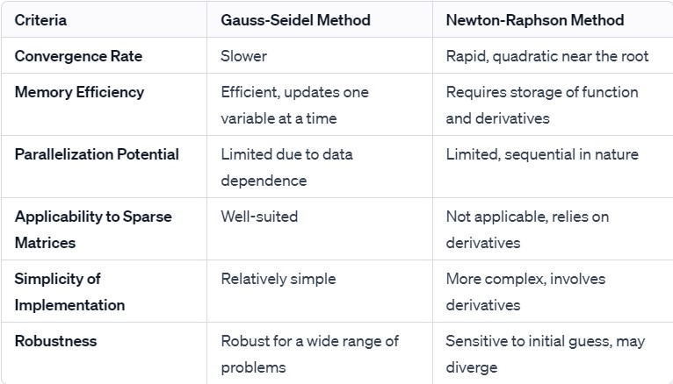

**2-Comment on the effects of presence of enough shunt capacitors in power system operation.**

Shunt capacitors in a power system mainly have the following effects:

1. **Voltage Regulation**: They help maintain voltage levels, especially over long transmission distances where voltage drops may occur.

2. **Power Factor Improvement**: They provide reactive power support, thereby improving the system's power factor, which leads to decreased reactive power demand and enhances overall system efficiency.

3. **Loss Reduction**: By sourcing reactive power locally, shunt capacitors reduce current in the lines, decreasing I^2R losses.

4. **Increased Capacity**: They enable existing lines to carry additional loads by reducing the current needed for the same amount of power, thus avoiding potential overloading.

5. **System Stability**: Shunt capacitors can offer reactive power to support system voltage during disturbances, aiding in system stability.

It is important to manage shunt capacitors correctly to prevent overvoltages and resonance issues.

**3-Comment on the data required for optimum power flow analysis in this software.**

1-Number of buses

2-active and reactive produced or generated power in each bus

3-shunt admittance and shunt capacitive reactance value for each bus

4-connection path between each two buses.

5-Length of each line.

6-impedance of each line and Charging MVAR for each line

**Other parameters can affect on analysis:**

1-maximum power flow of each line (in this project was 100MVA)

2-Participation Factor for each Generator

3-Insert a transmission line to increase the level of power flow in each line.

4-build a spare generator to ensure the safety of system in harmful conditions.

5-Cutting loads in special conditions to stabilize the voltage level of each bus.

**4-Comment on the possible ways to improve reliability and resilience of system operation.**

To enhance the reliability and resilience of a power system, consider the following strategies:

1. **Infrastructure Hardening**: Upgrade and reinforce physical structures to withstand adverse conditions.

2. **Redundancy**: Implement N-1 contingency planning and install backup systems for critical assets.

3. **Advanced Monitoring**: Use real-time monitoring and control systems for improved situational awareness.

4**. Smart Grid Technologies**: Adopt smart switches and automated systems for self-healing operations.

5. **Distributed Energy Resources**: Integrate renewables and storage to diversify and decentralize the energy supply.

6. **Maintenance and Management**: Conduct regular maintenance and prioritize investments based on asset criticality.

7. **Cybersecurity**: Strengthen defenses against digital threats to operational technology.

8. **Simulation Tools**: Utilize predictive analytics and perform drills for emergency preparedness.

9. **Flexible Power Flow Control**: Implement FACTS and HVDC for dynamic power flow management.

10. **Training and Culture**: Improve staff training and foster a culture emphasizing resilience.

Balancing these approaches can lead to a power system that's better equipped to prevent disruptions and recover from them swiftly.