TradeMirror
Desktop-first trading psychology dashboard • development pipeline • build brief for Claude Code
Primary goal | Build a stunning desktop app first, with a clean path to a later web version.
Recommended stack | Tauri + React + TypeScript + Vite + Tailwind + SQLite + Drizzle ORM
Business intent | Professional enough to sell later as a polished product.
Important note | Use the reference image for layout and mood, but do not ship a near-copy of another company's exact branding or design details.

1. Best stack choice
Use one shared frontend for both desktop and web. Wrap it in Tauri for desktop now. Later, reuse the same React app as a browser app with only a thin web-specific layer.
Layer | Pick | Why it fits | What Claude Code should own
Desktop shell | Tauri | Small, fast desktop wrapper around a web UI; good fit for desktop now and shared UI later. | Windowing, folder picker, splash screens, file access, packaging
Frontend UI | React + TypeScript | Component-based UI makes a panel-heavy dashboard much easier to build and maintain. | All screens, reusable cards, theme system, forms
Build tool | Vite | Fast local development and clean React setup. | Scaffold, dev scripts, builds
Styling | Tailwind CSS | Best way to match a high-end custom dashboard quickly without heavy CSS work. | Design tokens, spacing, glass panels, responsive layout
Database | SQLite | Simple local database for a desktop-first app. | Local storage, migrations, seeded demo data
Database layer | Drizzle ORM | Keeps schema organized and makes later migration easier. | Schema, queries, migrations, typed data access
Charts | Recharts | Good fit for dashboard line and pie charts in React. | Balance curve, account distribution, P&L visuals

Why this is the best fit for you
• You only build one real UI, not two separate apps.
• Claude Code can move quickly because the stack is common and dashboard-friendly.
• SQLite keeps setup simple for your first project.
• You can later add a cloud database and web login without rebuilding the whole product.
• The visual style in your reference image is much easier to reproduce with React + Tailwind than with a traditional desktop-only toolkit.
2. Product structure
Build the first release as 8 main areas.
Area | MVP definition
Dashboard Home | Account balance, today's P&L, avg win, avg loss, win rate, market session, live clock, dynamic theme, quote strip.
Trade Log | Manual trade entry with technical fields, stats fields, notes, emotions, mistakes, lessons, screenshots, tags.
Calendar View | Shows daily P&L and number of trades. Clicking a day opens the day's trades and journal.
Risk Calculator | Position size, risk amount, stop distance, target, reward/risk, account selector.
Equity Curve | Line graph of account balance over time, filtered by account and date range.
Portfolio Distribution | Pie or donut chart showing account distribution across Robinhood, OANDA, FTMO, E8, and others.
Inspiration Panel | Connect to a local desktop folder and rotate images for psychology support.
Fatigue Timer | Configurable countdown. When it ends, show a full-screen warning overlay that can be dismissed.

3. Data model Claude should build first
• users: kept simple now; one local user profile for desktop MVP
• accounts: name, broker/firm, starting balance, current balance, daily target, account type, active flag
• trades: account_id, date/time, ticker/instrument, side, setup, entry, stop, target, size, fees, result, screenshots, notes
• trade_journal: emotions before, emotions after, mistakes, lessons, confidence, discipline score
• daily_stats: account_id, day, total_pnl, trade_count, avg_win, avg_loss, win_rate
• quotes: quote text, author, category, active flag
• inspiration_folders: local path, active flag
• fatigue_settings: duration_minutes, enabled, bypass_count
• theme_rules: thresholds for green, yellow, red states
4. UI rules that matter
• Dark glassmorphism style like the reference image: soft glow, rounded cards, thin borders, deep shadows, low-noise background.
• Dynamic psychology color system: green when target hit, yellow when positive but below target, red when negative.
• One visual language only: same radius, same spacing, same chart look, same glow logic everywhere.
• Motion should be subtle: hover lift, slow pulse for live market, soft fade for panel changes, never flashy.
• Support keyboard-first data entry in the trade log because this will be used daily.
• Always design for future web layout, even while building the desktop app first.
5. Build order
Phase | Deliverable
Phase 1 - Foundation | Set up repo, stack, theme tokens, app shell, sidebar, dashboard layout, demo data.
Phase 2 - Core data | Create SQLite schema, migrations, account selector, trade entry form, list view, daily stats calculation.
Phase 3 - Psychology features | Dynamic P&L color logic, quotes, inspiration folder picker, fatigue timer overlay.
Phase 4 - Analytics | Calendar, equity curve, donut chart, summary cards, filters.
Phase 5 - Polish | Animations, empty states, settings, onboarding, error handling, desktop packaging.
Phase 6 - Sellable prep | Brand cleanup, legal text, export/import backup, installer, update path, web-readiness review.

6. What to postpone on purpose
• Do not build broker API integrations in version 1.
• Do not build cloud sync in version 1.
• Do not build multi-user accounts in version 1.
• Do not build mobile in version 1.
• Do not build advanced AI coaching in version 1.
• Keep version 1 local, fast, beautiful, and reliable.
7. Start-to-finish workflow with ChatGPT and Claude Code
• Use ChatGPT for product thinking, screen planning, naming, copy, database ideas, and review.
• Use Claude Code for actual implementation, file creation, refactoring, bug fixing, and step-by-step building.
• Keep one master project brief in the repo so Claude always works from the same vision.
• Have Claude finish one thin vertical slice at a time: UI + data + behavior for one feature before moving on.
• After every phase, ask ChatGPT to critique usability and psychology impact before continuing.
8. Claude Code handoff brief
Copy the markdown file that comes with this document into Claude Code before building. It gives Claude a full project brief, stack decision, feature list, build order, and strict design rules.
9. First action step
Your first move: have Claude Code scaffold the desktop shell and static UI only. No database yet. The goal of week 1 is to create a pixel-strong dashboard shell that matches the mood, spacing, and panel layout of your reference image using fake data.
• Set up Tauri + React + TypeScript + Vite + Tailwind.
• Build the sidebar and dashboard shell.
• Create reusable panel/card components.
• Mock the key panels: stats cards, balance chart, account distribution chart, market session card, quote card, trade log preview, calendar preview, fatigue timer preview.
• Implement dynamic green/yellow/red theme switching using mock P&L values.
• Only after the shell looks great should Claude add real data storage.
10. Appendix - design guardrails for a sellable product
• Do not ship someone else's logo, app name, icons, or exact copy layout if you plan to sell it.
• Use the reference image as inspiration for atmosphere, not as a 1:1 clone.
• Own the visual identity: custom logo, unique panel spacing, custom icon choices, unique wording.
• Add export/import backups early enough that users feel safe trusting the app with their journal data.
• A local-first app needs clear backup language and a simple restore flow.

Reference image used for style direction
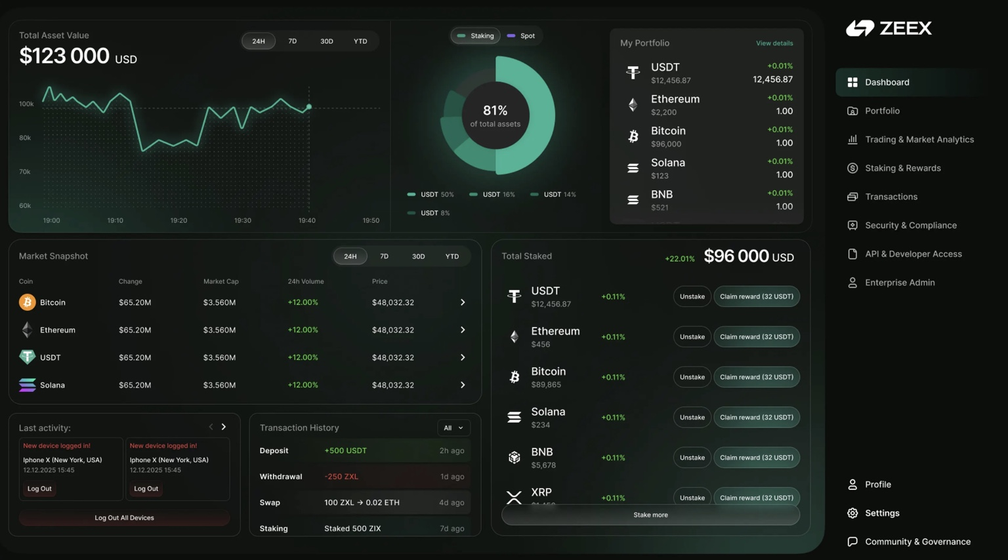
Reference layout and visual mood only - not for direct cloning in a sellable product.

