**Hamster Roulette**

**1. Abstract**

Two hamsters on hamster wheel, see who lasts longer while trying to make the other fall off, with LAN P2P versus option.

**2. Inspiration**

<http://youtu.be/aVJSFeSic84?list=FLsbmHyzRrtbPtpajR0peFRA>

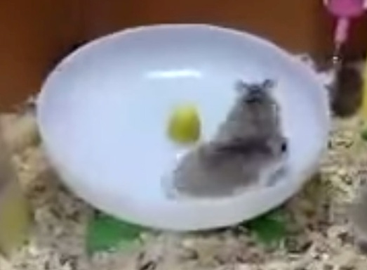

**3. Art Style**

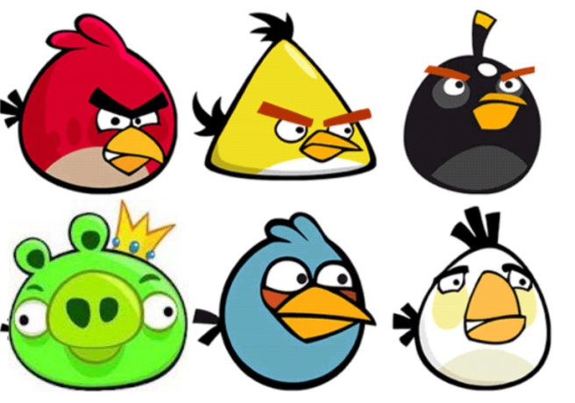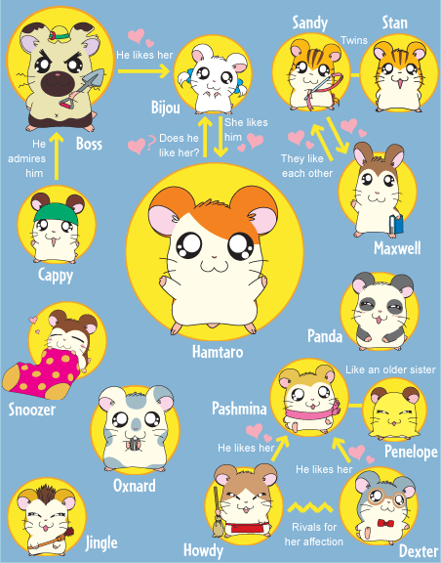

**4. Gameplay**

Play as a hamster on the hamster wheel/plate running, while trying to attack and defend against the other hamster; win by making the other hamster fall off.

1. VS AI  
   - Easy, Normal, Hard difficulties  
    *Differences: AI attack rate and timings, AI defend success rates, skill sets  
   - Player (as player 1) could choose both own character and the AI character to play against before starting the round.
2. VS LAN  
   - For phones on the same local network (Wifi), with the same version of the game  
   - Host phone as player 1, guest phone as player 2  
   *How To host/find games: similar system as L4D  
   - Host and Guest can choose characters after connected and before game round begins and also after each round is over.  
   **\*Important! Different versions of game can not connect**

*Player 1 gets on the hamster wheel/spinner first. The order of getting on the wheel does not affect the outcome.  
**Player automatically assumes Player 1 role if against AI

**Game Play Mechanisms:**

1. Tutorial  
   In-game Tutorial

0b. Pause Button  
 To pause game

1. Hamster Modes:  
 - Running  
 Running is an action starts automatically by the game. Unless triggered by a   
 (possible) skill, running speed is a constant.

- Spinning  
 A temporary mode when a player loses all HP. Players has **limited amount of   
 time (5~10sec maybe, could be longer with Level up)** to recover back into Running, Otherwise would go to the Falling mode.  
 *After a successful recover, player would recover 1/3 HP, but Skill Cool Down   
 will all need to restart from zero.  
 **Recover action consumes MP and also needs timing like a defensive action  
 Not enough MP = no recovery action  
 MP still regenerates in Spinning Mode, but there is no HP stat.  
 \*\*\***Big Twist!** The Spinner would continuously launches a “hurdle attack”   
 against the Runner. The Runner would need to defend against it, but the   
 defensive actions would not consume MP as usual.

- Falling  
 Most of the time Falling = Fail, except the character with unique recovery   
 skill(s)  
 → a possible unique skill:  
 Hard to maneuver (time the tab), but if successful, player goes straight   
 back to Running mode, as if recovered from Spinning Mode  
 ~ hard to time the tab, very short available time limit  
 ~ No MP necessary to launch the skill

- Fail  
 The round ends, resulting a winner and a loser, or a draw.

2. Attack  
 ~ Purpose: Reduce Opponent’s HP  
 Consumes MP  
 *In general:  
 I. Can not attack spinner/faller  
 II. Damage HP only

- possible unique attacks:  
 → steal HP / MP / Both  
 → attack spinner  
 ~ damaging MP or prolong recover CD

→ powerful, hard-to-defend, long CD, large MP consuming strike  
 → weak, easy-to-defend, short CD. Small MP consuming “annoying” attack.  
 → Time bomb  
 -\***SUPER/CHARGED attack:**  
 ~ Devastating HP damage to the Opponent if succeeding.  
 Significant HP damage to Opponent even with good defense.  
 ~ Charging by attacking the opponent with all non-charged attack skills  
 Successful attack = large charge  
 Defended attack = small charge  
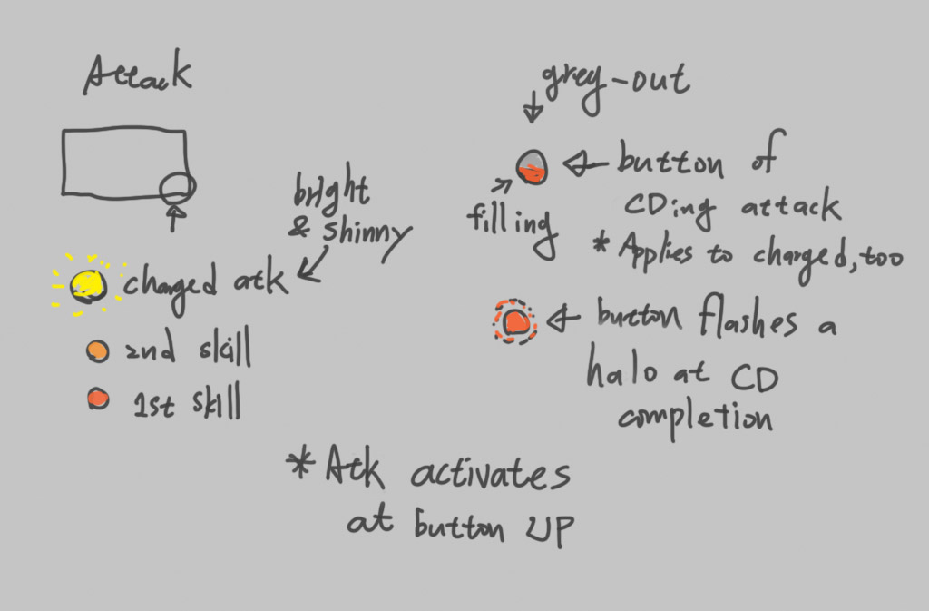

3. Defense  
 ~ Purpose: Counter Opponent’s attacks  
 Use less MP than the Basic Attack (1/2 ~ 1/3 less)  
 Still consumes MP even Opponent is not attacking  
 *In general, one defense mechanism against all attacks,  
 but the timing area on circle would change based on defense skill Lv and

Opponent’s attack types.  
 **Good and Regular defensive timing:  
 Good – no hp loss, kind of like a “dodge.”  
 Regular – with hp loss (very small)

- possible unique defensive mechanisms:  
 → Reflect damage back to attacker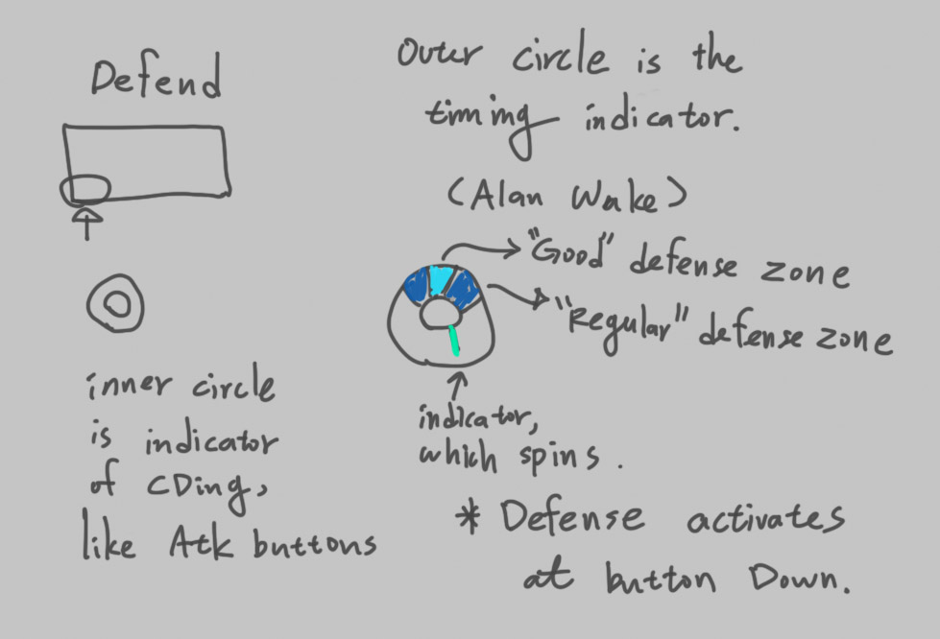

**\*Above graph needs to be modified**  
  
4. Attack Points:  
 ~ Purpose: To prevent only defending but no attacking, due to the reason  
 less MP is consumed by defensive action.  
  
5. Time Limit:  
 ~ Limited time to infinity, as game/LAN host setting option

5. Win / Lose / Draw  
 ~ Three ways to generate a winner and a loser:  
 1. One player Falls off the wheel while the other stays on in Running mode.  
 2. Times up, both players still in Running mode, the player with higher attack   
 points win  
 3. Times up, one player in Running mode, the other in Spinning mode  
 ~ Two ways to Draw:  
 1. Both players Fall of the wheel, regardless who falls first.  
 2. Times up, both players have the same attack points and both in Running   
 mode

**4a. Leveling / Skills** ~ Levels affect the following Stats:  
 1. HP  
 2. MP  
 3. Attack multiplier (increases damage to HP and/or MP)  
 4. Skill/Recovery Cool Down (CD) rate  
 5. Number of skills  
 6. HP/MP regenerate rates

- Harder difficulties give more EXP for each **win**  
 - All characters shares common basic attack and defense skills  
 - Leveling increases HP and MP and reduce skill cool down rates  
 Max level: 5  
 HP/MP regeneration   
 * All same-level characters have the same HP/MP and regeneration rates, unless   
 affected by unique skills  
 Skills:  
 *Bettering first common attack and defense skills at Lv2  
 *Learn 2nd common attack skill at Lv3  
 *Bettering 2nd common attack skill at Lv4  
 *Learn unique attack or defense skill at Lv5

**4b. Achievements** - Level based  
 - Skill unlock based  
 - Character based  
 - Playground based  
 - Gameplay statistics based

**4c. Unlock Features** - New Skills  
 *5 hamsters each has a unique attack or defense skill, unlockable at Lv 5.  
 - New hamsters  
 * 4 unlockable, two “obviously” boy-like, two “obviously” girl-like.  
 - New playgrounds  
 * 4 unlockable playgrounds, come with each new character unlock

**4d. Monetization**

- After each round ends, display an interstitial ad.  
 *Currently have no intention for in-game purchases

**5. Game Flow Chart**

**6. Feature List**

**7. Asset List**

Codes

3D models

Textures

UI (sprites)

Sounds

**8. KickStarter / Funraising**

- Maybe to raise fund for possible music, art, coding, marketing, and other expenses  
- Campaign timing:  
 A playable game prototype is complete:

Prototype content:  
 1. The first hamster  
 2 .The first stage  
 3. Single player mode (against AI)  
 *LAN mode optional  
 4. All gameplay mechanisms are in place (even though they will be adjusted for   
 balance in the future).  
 *Tutorial and Pause can be excluded.