Information Integration and
Analytic Data Processing 2025/2026
Project Report

Designing a Domain-Specific Information Retrieval System
Using a Data Warehouse

Group 03
Student Number | Student Name
54346 | Pedro Fanica
66661 | Iaroslav Sagan
66662 | Anna Maksymchuk
66663 | Mariia Samosudova

Project Goal
The ELIQSIR project aims to build an end-to-end Information Retrieval (IR) system for the biomedical domain to accelerate drug discovery. Beyond search, the system is architected as a curated feature store to support future Machine Learning pipelines (e.g., drug-target affinity prediction).
The project executes three core phases:
- Centralized Data Warehouse: A custom ETL pipeline extracts and harmonizes data from UniProt, ChEMBL, PDBe, and PubMed into a cloud-hosted AWS RDS Data Warehouse (Temporal Star Schema).
- Multi-Tier IR Engine: Relational data is flattened into an enriched document corpus. The system evaluates classical lexical models (Boolean, TF-IDF, BM25) against an advanced Neural Semantic Search layer (all-MiniLM-L6-v2 + FAISS) to rank scientific literature.
- Interactive Evaluation: A real-time Jupyter UI Playground allows researchers to run head-to-head model comparisons, proving the neural engine's ability to successfully fetch the most relevant information.
Phase 1: Data Selection and Data Warehouse Construction
Step 1: Domain Selection & Dataset Identification
Domain: Biomedical Research and Pharmacology (Target-Compound Interaction Analysis).
Motivation: Biomedical knowledge is heavily fragmented. This system integrates structured biochemical metrics (e.g., IC50 from ChEMBL) with unstructured literature (PubMed) to accelerate drug discovery. The curated Data Warehouse can act as a robust feature store for training downstream Machine Learning models (e.g., predicting drug-target affinity).
Target Users: Bioinformaticians, pharmacologists, and clinical researchers.
Supported Queries: Ranges from strict technical entity matching ("EGFR kinase inhibitors") to broad semantic discovery ("novel treatments for hypertension").
Dataset Matrix
The foundational data is sourced from four distinct, highly curated biomedical databases:
Feature | UniProtKB (Swiss-Prot) | ChEMBL (v36) | PDBe | NCBI PubMed
Source & Access Method | UniProt REST API (/stream endpoint) | Local SQLite DB (chembl_36.db) via SQL | PDBe Graph API (/best_structures/) | NCBI Entrez API (E-utilities) via Bio.Entrez
Data Format | TSV / JSON | Relational / Parquet Cache | JSON | XML
Purpose | Provides a curated foundation for human biological targets and ML sequence features. | Provides chemical metadata and quantitative experimental bioactivity metrics. | Connects linear protein sequences to their physical 3D high-resolution conformations. | Primary textual corpus for the Information Retrieval and lexical and semantic search engines.
Key Attributes (ETL Targets) | uniprot_id, protein_name, gene_names, sequence, sequence_length, protein_families | drug_chembl_id, molecule_type, molecular_weight, canonical_smiles, standard_value, pchembl_value | pdb_id, resolution, coverage, unp_start, unp_end, experimental methods | pubmed_id, article_title, abstract, journal, authors, and 5 lifecycle dates
Statistics / Volume | ~20,400 reviewed human entries | ~6.4 million raw bioactivity records | Dynamic 1-to-Many mapping for the ~20k targets | ~36,351 scientific articles
Specific Data Issues | Pagination limits required stream-loading directly into Pandas. | Massive volume risks OOM errors; contains "grey" literature lacking article IDs. | One-to-Many explosion (one protein mapped to hundreds of models). | Strict API rate limits; missing abstracts in editorials/notes.
Relational Linkage | Base biological key (uniprot_id). Links to ChEMBL & PDBe. | Links to UniProt (targets) and provides pubmed_id for Literature. | Linked via uniprot_id. | Linked to bioactivity facts via pubmed_id.

Data Quality Issues & Integration Plan
To harmonize these sources into a Temporal Star Schema, we resolved critical data quality bottlenecks during the ETL phase:
- Grey Literature (Orphan Records): ~66.8% of ChEMBL records (4.3M) lack PubMed IDs (mostly patents).
Integration Logic: Applied Logical Partitioning. The DWH intentionally retains all records for complete structural analytics, but the IR pipeline utilizes a dynamic filter (WHERE pubmed_id IS NOT NULL) to index only verifiable academic literature.
- Temporal Uncertainty: Legacy PubMed XMLs frequently lack exact publication dates.
Integration Logic: Missing or unparseable temporal data was explicitly imputed with a default surrogate anchor key (19000101) to guarantee 100% referential integrity without SQL errors.
- API Volatility & Rate Limits: Network extraction of 36K+ XMLs triggered severe NCBI API rejections.
Integration Logic: Implemented adaptive batching (batch_size=200), exponential backoff (time.sleep), and strict try/except blocks to bypass corrupted payloads without halting execution.
- Cartesian Duplication Risk: Mapping multiple compounds to single articles naturally introduces extreme duplication.
Integration Logic: Aggressive in-memory deduplication via Pandas. To bypass heavy ORM overhead and prevent SQL aggregation errors, cleaned data was exported as flat CSVs for direct, high-performance bulk insertion into AWS RDS.
Step 2: Dimensional Modeling
Architecture Overview
Deployed on AWS RDS (MySQL), the ELIQSIR Data Warehouse utilizes a Temporal Star Schema. It enforces strict 1-to-Many referential integrity between central facts and conformed dimensions, optimizing query execution plans for complex analytical aggregations. This dimensional topology serves as the structured foundation to materialize the flat JSONL document corpus ingested by the downstream Information Retrieval (IR) engine.
The Fact Table (fact_bioactivity)
- Grain: A single bioactivity measurement (e.g., IC₅₀ or K_{i} value) from a discrete scientific assay.
- Measures: Quantitative metrics (standard_value, pchembl_value, confidence_score) and unit types.
- Foreign Keys (FK): Acts as the central bridge resolving 1-to-Many relationships with all contextual dimensions.
- Temporal Precision: Employs a date_precision flag (Exact, Month, Year) for partial dates. Completely missing temporal data is resolved using a default surrogate anchor key (19000101) to enforce referential integrity without triggering SQL NULL errors.
The Contextual Dimensions
All dimensions utilize integer Surrogate Keys (PK) to isolate the warehouse architecture from source-system natural key mutations:
- dim_protein (Biological Targets): Human proteome attributes (sequence, sequence_length, protein_families). Natural Key: uniprot_id.
- dim_drug (Chemical Compounds): Structural metadata (canonical_smiles, standard_inchi_key) and physiochemical properties (molecular_weight, molecule_type). Natural Key: chembl_id.
- dim_structure (3D Conformations): High-resolution physical mappings, storing resolution and experimental methods. Natural Key: pdb_id.
- dim_article (Literature Context): Textual metadata powering the IR corpus (article_title, journal, abstract, authors). Natural Key: pubmed_id.
- dim_date (Data-Driven & Role-Playing): A dynamic, storage-optimized temporal dimension containing only dates present in the fact table. It utilizes an integer YYYYMMDD key to concurrently serve six chronological roles per fact record: publication, received, revised, accepted, epub, and ppub.
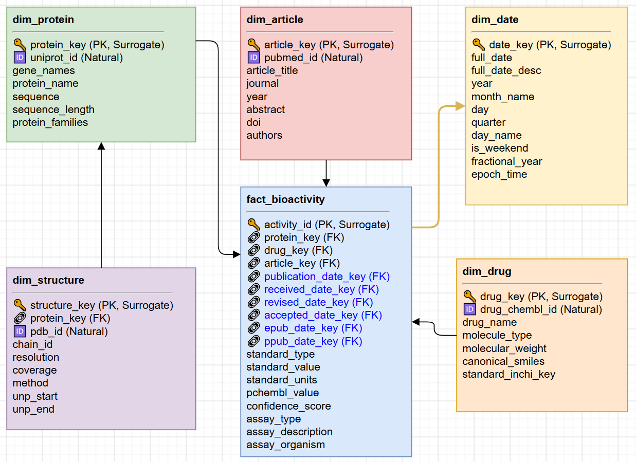
Step 3: The ETL & Enrichment Pipeline
The ETL pipeline orchestrates the ingestion, transformation, and temporal enrichment of fragmented biochemical data into the centralized AWS RDS Data Warehouse.
1. Extraction Layer
Data was sourced via four dedicated API/Database clients and serialized into immutable raw CSV files to ensure reproducibility:
- UniProt (REST API): Streamed human proteome features (sequence, families).
- ChEMBL (SQLite/Parquet): Leveraged local Parquet caching for high-performance extraction of bioactivity metrics (IC₅₀, K_{i}) and drug metadata (SMILES).
- PDBe (Graph API): Fetched high-resolution 3D structural parameters.
- PubMed (NCBI E-utilities): Extracted literature metadata and full XML abstracts via Bio.Entrez.
Pipeline Output: 4 decoupled sets of immutable raw .csv and .json artifacts.
2. Transformation Layer
In-memory transformations were executed via Pandas, applying non-destructive cleaning and relational formatting:
- Type Safety & Coercion: Strings were cast to strict numerics (e.g., Float64 for molecular weights, nullable Int64 for years). String artifacts were sanitized, and missing data was preserved as pd.NA for native SQL NULL translation.
- Dimensional Mapping: Natural string identifiers were mapped to optimized integer surrogate keys. Raw dates were formatted to YYYYMMDD integers, injecting the 19000101 default anchor to safely initialize missing temporal parameters.
Pipeline Output: Relational, type-safe, and dimensionally mapped "clean" CSV files, formatted strictly to match the target SQL schemas.
3. Loading Layer Appendix A: DWH Initial Loading Results
To maximize I/O throughput, the custom WarehouseLoader intentionally bypassed heavy ORM layers (like SQLAlchemy) in favor of native mysql.connector:
- Idempotent Chunked Upserts: Data was streamed in strict memory chunks (chunksize=10000) using parameterized cursor.executemany() with ON DUPLICATE KEY UPDATE logic.
- Constraint Enforcement: Dimension tables were populated strictly before the central fact_bioactivity table to guarantee referential integrity at the database level.
Pipeline Output: A fully functional AWS RDS Data Warehouse populated with core dimensions and a central fact table (e.g., 36,000+ articles, 12,000+ compounds).
4. Temporal Enrichment Appendix B: Post-Enrichment Integrity & Structural Gap Analysis
To bridge bibliographic data with temporal analytics, the pipeline harvested the complete 5-point publication lifecycle (Received, Revised, Accepted, e-Pub, p-Pub):
- Adaptive API Throttling: PubMed IDs were processed in dense batches (batch_size=200) with exponential backoff to strictly respect NCBI rate limits (3 requests/sec).
- Two-Phase Staging Load: Utilized an ELT (Extract, Load, Transform) approach. Data was first written to a volatile staging table (stg_article_dates_enrichment) via a Truncate-and-Load pattern. A high-performance SQL UPDATE-JOIN then propagated the surrogate temporal keys directly into the fact table.
Pipeline Output: 6 enriched role-playing temporal keys integrated directly into the dimension tables, enabling deep lifecycle latency analytics (e.g., measuring peer-review duration).
5. Post-Load Optimization
To prevent heavy CPU spikes and index-thrashing during massive bulk inserts, strategic B-Tree indexing was deployed strictly post-load:
- Join Optimization: Indices on foreign keys (idx_fact_article, idx_fact_drug) and role-playing temporal keys (idx_fact_pub_date) successfully shifted retrieval complexity from O(N) (Full Table Scans) to O(log N).
Pipeline Output: A highly performant, query-ready Data Warehouse optimized for sub-second analytical read operations.
Technology Stack
- Orchestration & Compute: Python 3, Pandas (vectorized transformations, downcasting).
- Extraction: Biopython (Bio.Entrez), Parquet (local caching).
- Database I/O: MySQL Connector (connection pooling, bulk cursor execution).
- Infrastructure: AWS RDS MySQL (Cloud Data Warehouse).
Phase 2: Information Retrieval System
In this phase, we transform the relational Data Warehouse into a flat, searchable document corpus. We implement, optimize, and evaluate multiple retrieval models, transitioning from classical lexical matching to advanced dense semantic search.
Step 4: Extract Searchable Documents
Document Schema Structure Appendix C: DWH to JSONL Data Lineage
The final JSONL structure strictly separates machine-readable IDs, searchable text, and numerical ranking metrics to prevent text-index pollution:
- natural_keys: Arrays of strings (e.g., pubmed_id, uniprot_ids) enabling exact-match filtering for scientists searching by registry IDs.
- metadata: Structured context for UI rendering and hard filtering (e.g., publication year, structure methods).
- search_corpus: The unified, deduplicated flat text string ingested by the Vectorizer.
- metrics: Aggregated float values reserved for Hybrid Search sorting. Includes max_confidence (0-9 scale indicating target assignment certainty) and avg_pchembl (the continuous arithmetic mean of biological potency metrics like IC₅₀ or K_{i}).
Field Weighting & Natural Language Prefixing
Because downstream lexical models ingest a single flattened string per JSONL line, we engineered weights directly into the text corpus structure using pure Information Retrieval mathematics rather than artificial keyword stuffing:
Weight Tier | Document Fields | Implementation Strategy | Rationale
Multiplier (x2) | article_title | Explicit Duplication. The title string is concatenated twice at the beginning of the search_corpus. | A match in the title is a significantly stronger signal of relevance than a match buried in the abstract.
High Value (IDF Boost) | Extracted Entities (Target:, Compound:, Measurement:) | Semantic Grouping & Deduplication. Included exactly once per unique term alongside a natural language prefix (e.g., "Target: EGFR"). | By removing duplicate spam via Python set(), we allow the algorithm's natural Inverse Document Frequency (IDF) to assign massive weight to rare, specific terms.
Base (x1) | abstract, assay_description | Single Inclusion. Appended at the end of the text block. | Provides the necessary vocabulary for broad keyword matching without overpowering dense biological entities.

Step 5: Text Representation and Preprocessing
1. The Preprocessing Pipeline
- Tokenization: Utilized compiled Regex to systematically strip non-alphanumeric noise while maintaining consistent spacing for compound biochemical strings.
- Stopword Filtering: Applied standard English stop-words to eliminate linguistic noise. Domain-specific terms (e.g., "study", "assay", "inhibitor") were explicitly retained; the system relies on downstream Inverse Document Frequency (IDF) mechanics to penalize these naturally.
- Lemmatization: Deployed a WordNet Lemmatizer wrapped in a Python Least Recently Used (LRU) cache. This guaranteed that highly repetitive biological variations (e.g., "kinases" vs. "kinase") were mapped to their exact morphological roots at O(1) lookup speed, drastically reducing processing time.
2. Vocabulary Pruning
The indexer captures both Unigrams and Bigrams (ngram_range = (1, 2)). To optimize matrix sparsity and constrain RAM usage, strict document frequency boundaries were enforced:
- min_df=2: Eliminated isolated typos, unique protein hashes, and OCR errors.
- max_df=0.85: Automatically pruned ubiquitous academic boilerplate that appears in over 85% of documents.
3. Sparse Matrix Generation & Serialization
To bypass heavy computation during query execution, the preprocessed corpus was vectorized into three mathematically optimized artifacts and serialized to disk via joblib:
- Boolean Index (BoW): Stored in Compressed Sparse Column (CSC) format, specifically chosen to optimize high-speed column-wise Boolean intersection (AND/OR) queries.
- TF-IDF Matrix: Stored in Compressed Sparse Row (CSR) format, which is mathematically optimized for fast dot-product and cosine similarity calculations.
- Pre-compiled BM25 Engine: Instead of calculating document length normalization metrics at query-time, the entire BM25Okapi probabilistic engine was pre-computed and serialized.
Step 6: Implement Retrieval Models
We implemented and compared three distinct retrieval models, progressing from strict exact-matching to advanced probabilistic ranking:
- Strict Boolean Retrieval (Sparse AND): A baseline model returning unordered sets of documents containing exact token matches via fast CSC matrix operations.
- Vector Space Model (TF-IDF): Represents queries and documents as sparse vectors in high-dimensional space, ranking them via Cosine Similarity.
- BM25 (Okapi): A probabilistic model that improves upon TF-IDF by introducing term frequency saturation (via hyperparameter k₁) and dynamic document length normalization (via hyperparameter b).
Step 7: Baseline Evaluation (TREC Pooling) Appendix D: Complete Benchmark Query Sets
Evaluation was conducted using the TREC Pooling methodology. The Top-20 results from three baseline models across 5 queries (q1 – q5) were merged, deduplicated, and blinded to establish an unbiased Ground Truth (QRELS) via AI-assisted and human validation.
The quantitative results below represent the mean benchmark performance across these 5 queries at a strict retrieval depth of k=10.
Mean Quantitative Results @K=10
Algorithm | Precision@10 | Recall@10 | F1@10 | nDCG@10 | MAP@10
BM25 (Okapi) | 0.72 | 0.6 | 0.345 | 0.473 | 0.299
TF-IDF | 0.2 | 0.378 | 0.257 | 0.286 | 0.161
Boolean (AND) | 0.05 | 0.083 | 0.062 | 0.077 | 0.037

Lexical Benchmark Insights (Analysis of Q1–Q5) Appendix E: Lexical Search Engines Evaluation Results & Comparison
An in-depth analysis of these queries revealed critical behavioral traits of classical lexical models:
- Boolean Failure (MAP = 0.037): Strict intersection logic ruthlessly discards valid synonyms, proving the extreme brittleness of exact-matching algorithms in medical literature.
- Precision Parity: On highly specific entity queries (e.g., q1: EGFR), both BM25 and TF-IDF achieved perfect precision (P@10 = 1.0) by successfully leveraging IDF weights for rare domain nomenclature.
- The Recall Ceiling: Despite perfect precision, Recall is mathematically capped by the k=10 depth constraint. If the Ground Truth contains >10 relevant articles (e.g., 40 in q2), a strict Top-10 output fundamentally cannot exceed a Recall of 0.25.

Step 8: Learning to Rank or Neural Retrieval
To break through the Recall ceiling and the Vocabulary Mismatch problem, we implemented an Embedding-based Semantic Search layer powered by the all-MiniLM-L6-v2 transformer model and FAISS vector indexing.
Results: Neural Search achieved a 11.2% improvement in nDCG@10 over BM25, effectively bridging the vocabulary gap (e.g., mapping "hypertension" to "high blood pressure").
A/B Benchmark Design (Balanced Query Set) Appendix D: Complete Benchmark Query Sets
To perform head-to-head comparison between our best lexical model (BM25) and the Neural Indexer, we developed a new Balanced Query Set (bq1-bq6):
- Lexical/Technical Queries (bq1-bq3): Focus on exact matches for protein targets and experimental methods.
- Semantic/Meaningful Queries (bq4-bq6): Natural language descriptions where authors' scientific terminology varies.
A dedicated Ground Truth was established for this set using AI-assisted review of pooled candidate results.
Mean Lexical vs. Semantic Performance (@K=10)
Mean Metric | BM25 (Lexical) | Neural (Semantic) | Improvement
Precision@10 | 0.733 | 0.8 | +9.10%
Recall@10 | 0.376 | 0.358 | -4.80%
nDCG@10 | 0.74 | 0.823 | +11.20%
MAP@10 | 0.298 | 0.319 | +7.00%

Key Findings & Semantic Insights Appendix F: Semantic vs Lexical Search Engines Evaluation Results
- Vocabulary Gap Bridged: Neural achieved perfect nDCG (1.000) on query bq4 ("high blood pressure"), successfully retrieving "hypertension" literature where BM25 failed severely (nDCG = 0.228).
- Lexical Robustness vs. Semantic Smoothing: BM25 dominated highly specific chemical queries (bq6: Recall 0.778 vs Neural 0.333), as the Neural model occasionally over-generalized ("smoothed") rare technical terms.
- Superior Ranking: The Neural model’s overall +11.2% nDCG improvement proves its capacity to push contextually relevant matches into the absolute top positions.
K-Cutoff Optimization (Grid Search) Appendix G: Retrieval Depth K-Grid Heatmaps
A Grid Search analysis (K in [5, 100]) was conducted to identify the mathematical "sweet spot":
- Precision Collapse: Deep retrieval degrades precision exponentially (BM25 P@K drops from 0.818 at K= to 0.208 at $K=100).
- The F1-Score Peak: Both standalone models achieve their absolute harmonic mean peak exactly at K=20 (BM25 F1 = 0.606; Neural F1 = 0.590).
- Architectural Decision: K=20 was established as the optimal baseline threshold to maximize relevant discovery while preventing computational noise.
The Hybrid Engine Breakthrough (Reciprocal Rank Fusion)
To neutralize the lexical vulnerability to synonymy and the neural vulnerability to semantic smoothing, we implemented a Hybrid Search Engine merging both pipelines via Reciprocal Rank Fusion (RRF, k=60). This yielded state-of-the-art retrieval dynamics:
- Top-Tier Dominance (nDCG@5 = 0.896): Fusing exactness with dense context successfully pushed the most relevant documents to the very top, outperforming both Neural (0.847) and BM25 (0.820).
- Zero-Loss Recall (Recall@100 = 1): The Hybrid ensemble completely shattered the recall ceiling, successfully retrieving 100% of the Ground Truth documents at deep depth - a feat impossible for either standalone model.
Final System Comparison (At Optimal Depth K=20)
To summarize the architectural evolution of the ELIQSIR retrieval engine, the table below compares the three core methodologies at the established baseline threshold of K=20.
Mean Metric (@K=20) | BM25 (Lexical Baseline) | Neural (Semantic Search) | Hybrid Search (RRF Ensemble)
Precision | 0.764 | 0.683 | 0.625
Recall | 0.561 | 0.569 | 0.555
F1-Score | 0.606 | 0.59 | 0.552
nDCG | 0.829 | 0.789 | 0.778
MAP | 0.46 | 0.5 | 0.476

While the standalone BM25 model mathematically peaks in F1-score exactly at K=20, the Hybrid model fundamentally reshapes the ranking curve via Reciprocal Rank Fusion (RRF):
- Top-5 Dominance: RRF enforces consensus between lexical and semantic pipelines, pushing universally relevant documents to the absolute top. This yields an unmatched, state-of-the-art nDCG@5 of 0.896 (vs BM25's 0.820).
- The K=20 Penalty: Documents retrieved by only a single pipeline are mathematically penalized and pushed deeper. This causes a temporary, isolated dip in raw intersection metrics exactly at the K=20 mark.
- Zero-Loss Recall: By K=100, the Hybrid model completely shatters the lexical recall ceiling, successfully retrieving 100% of the Ground Truth (Recall = 1.000).
Conclusion: The Hybrid ensemble is the superior production system. It trades a minor mid-curve mathematical dip (K=20) for maximum immediate relevance for the end-user (Top-5) and absolute literature coverage for deep scientific research (Top-100).

BONUS: Interactive Search Playground
Engineered a Jupyter-based search lab for real-time model comparison, featuring dynamic PubMed/DOI hyperlinking for immediate source literature validation.
To run it please follow the instruction below
Step 1: Data Preparation
To run the interface, you need the cached semantic indexes and the searchable text corpus.
- Download the data archive from this link
- Extract the archive into a data folder at the root of the project. Your folder structure should look exactly like this:
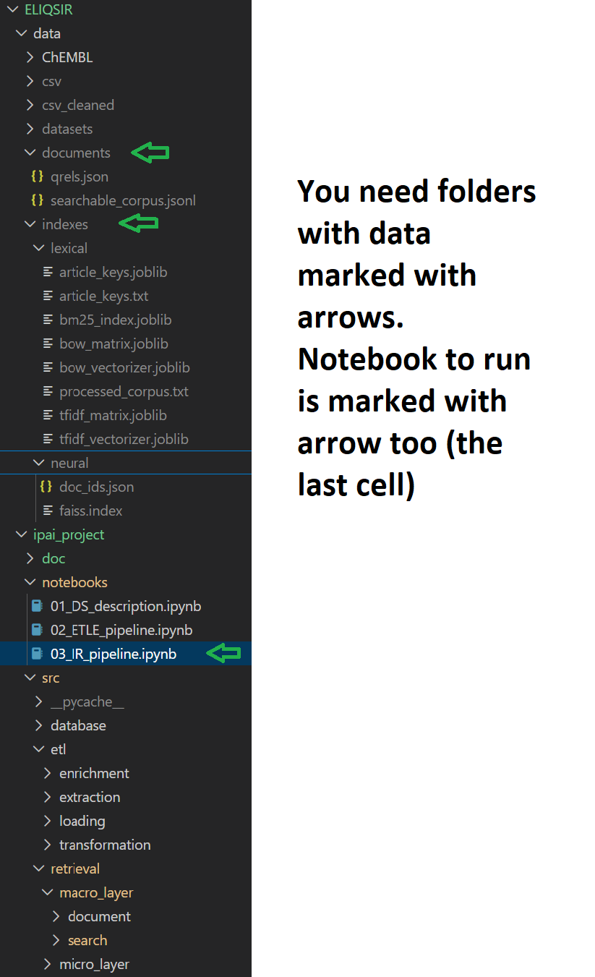
Note: If you are using Jupyter Lab, ensure the ipywidgets extension is enabled.
Step 2: Launch the Playground
- Open the notebook notebooks/IR_pipeline.ipynb.
- Scroll down to the "Playground” section (or locate the final execution cell).
- Run the cell. It features built-in smart path resolution, so you do not need to manually configure any environment variables (like DATA_DIR).

Step 3: Enjoy!
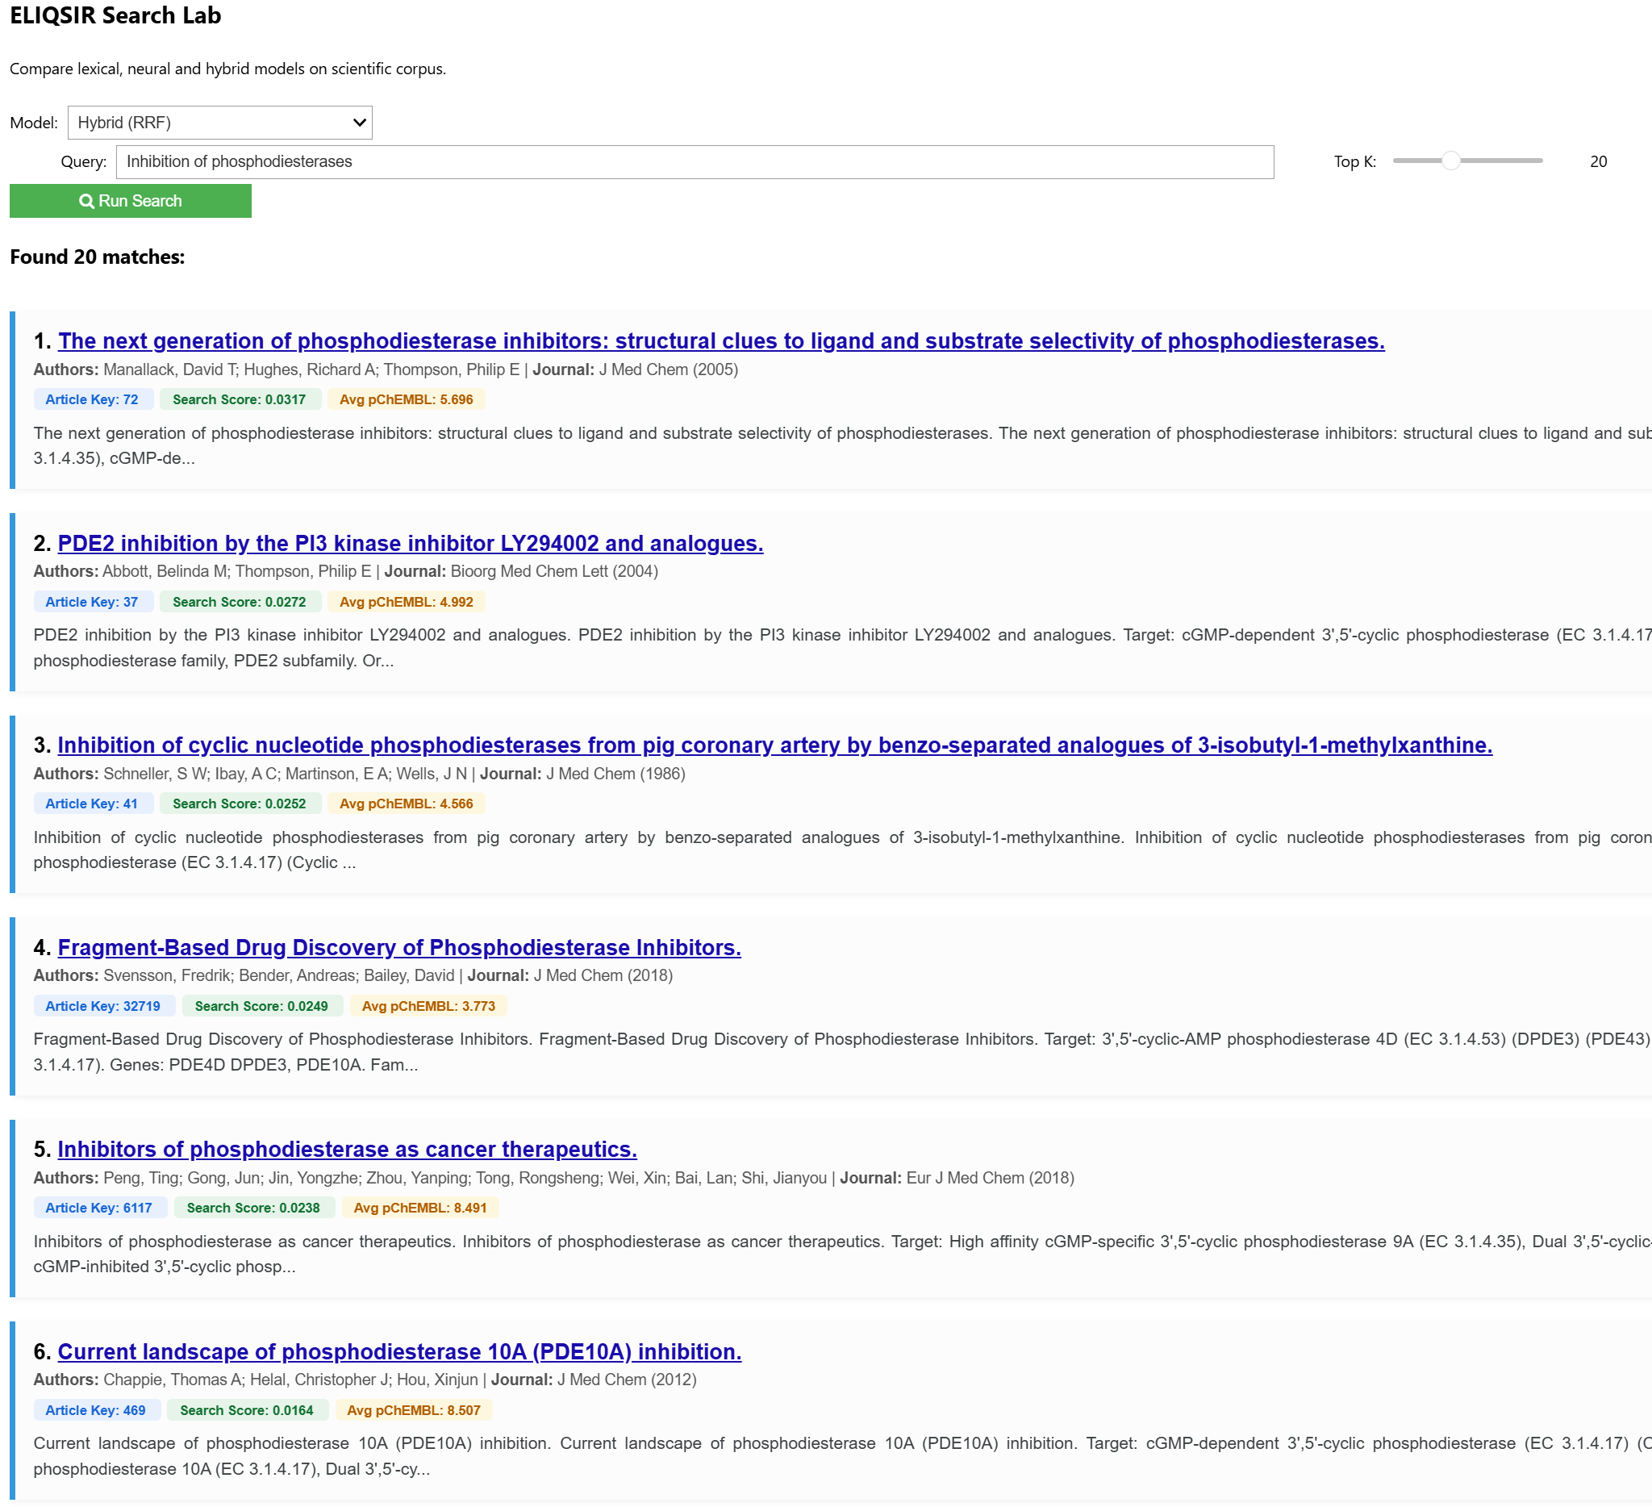
Appendix A: DWH Initial Loading Results
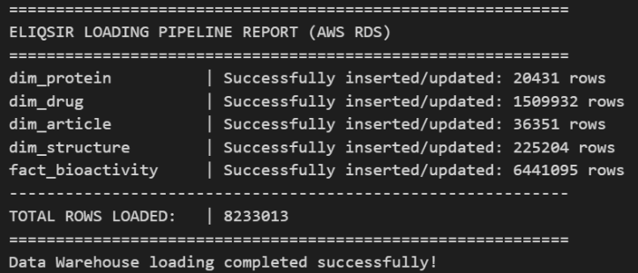
Appendix B: Post-Enrichment Integrity & Structural Gap Analysis
1. Strategic Data Segmentation: An audit of the enriched data revealed a strict structural partition based on data provenance. Exactly 66.81% (4.3M rows) of the fact records represent patents and industrial technical reports lacking a valid PMID, intentionally left untouched. The remaining 33.19% (2.14M rows) representing peer-reviewed academic literature achieved a 100% temporal enrichment rate.
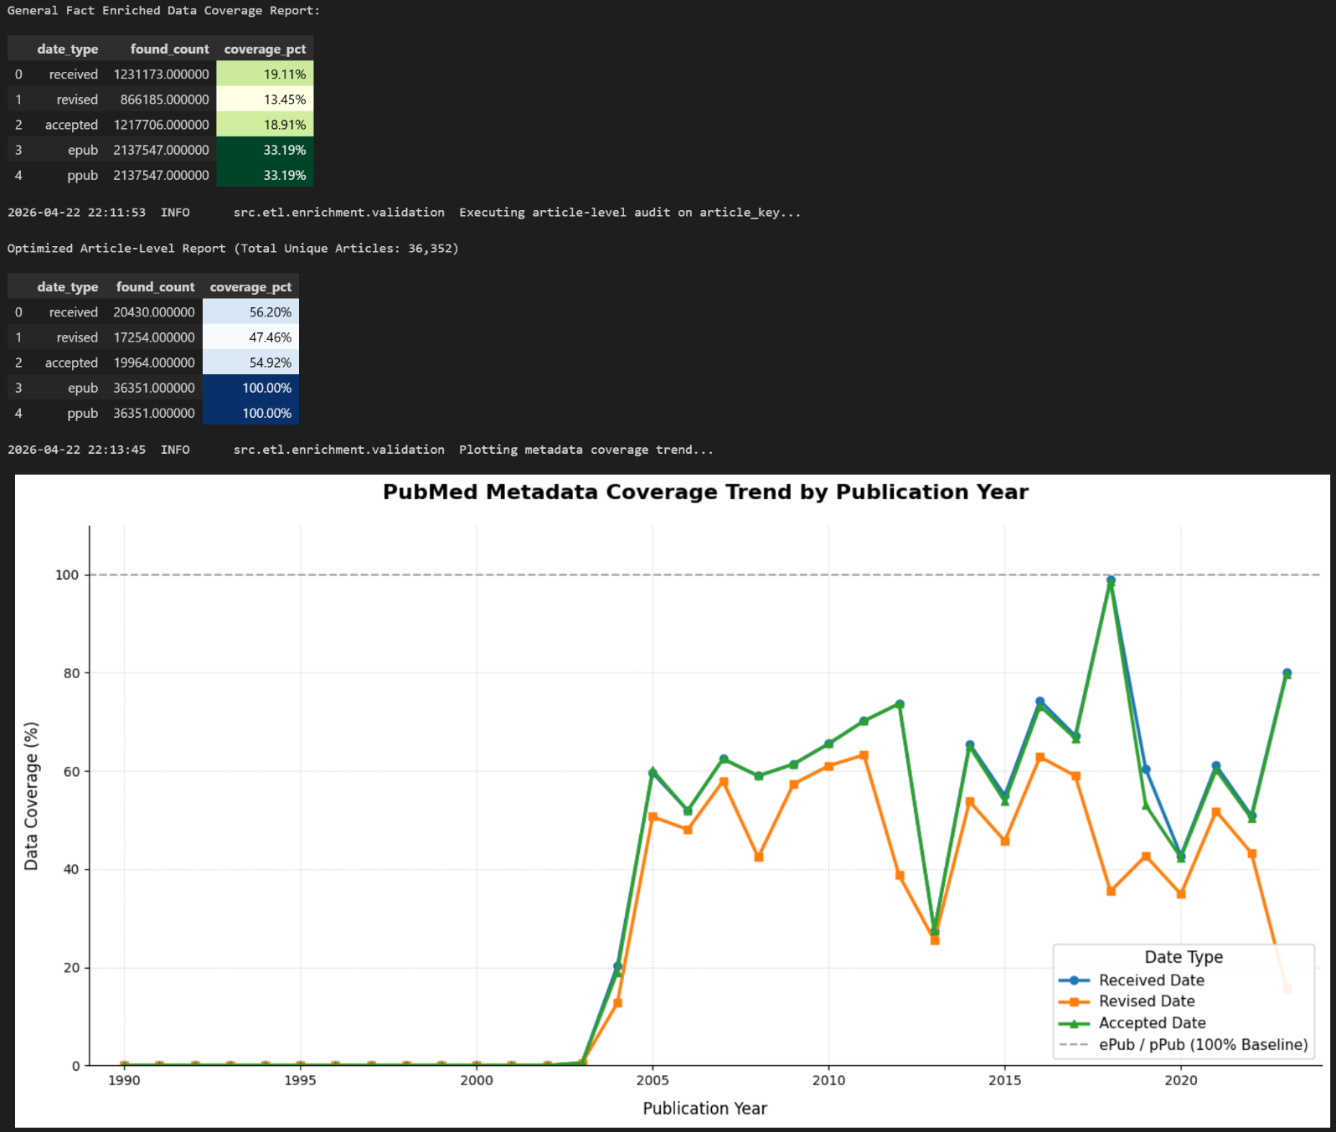
2. Storage Compression & Integrity Metrics: The dynamic Role-Playing Star Schema demonstrated massive storage compression. The automated integrity tests (src.etl.enrichment.validation) confirmed:
- 100% Coverage & Referential Integrity: Zero orphan dates exist in the facts, and zero unused dates exist in the dimension.
- Macro Compression: A highly compact dim_date table of exactly 8,690 unique physical rows successfully supports over 10,920,992 individual foreign key references across the warehouse, significantly reducing AWS RDS storage footprint.
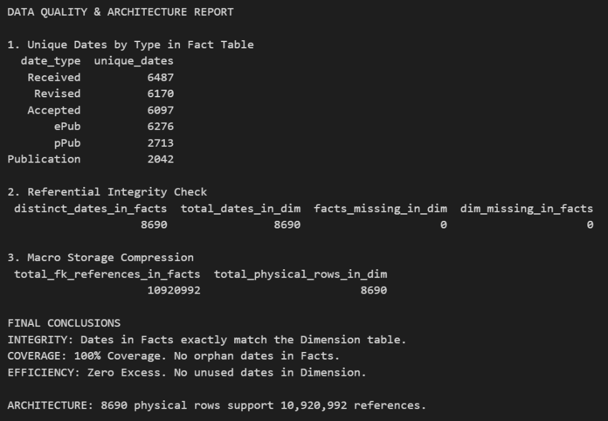
Appendix C: DWH to JSONL Data Lineage
To transform the relational Data Warehouse into a flat, mathematically optimized document corpus, the pipeline utilizes a strict schema separating machine-readable identifiers, searchable text, and continuous numerical features.
DWH to JSONL Traceability Matrix
To ensure full data provenance, this matrix maps every field from the DWH to its destination in the JSONL document. High-value categorical fields employ Dual Routing: they are stored as exact arrays in metadata for UI filtering, and as natural-language prefixed strings in search_corpus for lexical matching.
DWH Source Table | Source Column | Target JSON Node | Format / Transformation
dim_article | pubmed_id | natural_keys.pubmed_id | Exact String
 | year | metadata.year | Integer
 | article_title | metadata.title | String
 |  | search_corpus | Concatenated (x2 multiplier)
 | journal | metadata.journal | String
 |  | search_corpus | Prefix: "Journal: {x}"
 | abstract | search_corpus | String
 |  |  | Appended to end
dim_drug | drug_chembl_id | natural_keys.chembl_ids | Unique Array
 | drug_name | search_corpus | Prefix: "Compound: {x}"
 | molecule_type | metadata.scientific_context.molecule_types | Unique Array
 |  | search_corpus | Prefix: "Type: {x}"
dim_protein | uniprot_id | natural_keys.uniprot_ids | Unique Array
 | protein_name | search_corpus | Prefix: "Target: {x}"
 | gene_names | search_corpus | Prefix: "Genes: {x}"
dim_structure | pdb_id | natural_keys.pdb_ids | Unique Array
 | method | metadata.scientific_context.structure_methods | Unique Array
 |  | search_corpus | Prefix: "Structure method: {x}"
fact_bioactivity | standard_type | metadata.scientific_context.measurement_types | Unique Array
 |  | search_corpus | Prefix: "Measurement: {x}"
 | confidence_score | metrics.max_confidence | Aggregate: MAX()
 | pchembl_value | metrics.avg_pchembl | Aggregate: MEAN()
 | *_date_key | metadata.lifecycle_dates.* | In-memory mapping with dim_date

Metrics Aggregation Strategy
Because scientific publications report multiple bioassays, experiment-level facts are aggregated into document-level continuous variables during the Pandas groupby phase. These metrics are strictly isolated from the text corpus to serve as numerical features for future Learning to Rank layers and hybrid search sorting:
- max_confidence: Derived from the ChEMBL confidence score (0-9). The pipeline extracts the maximum value across all linked assays (max(row['confidence_score'])). A score of 9 indicates direct, highly verified single-protein target assignment.
- avg_pchembl: The standardized negative logarithm of molar concentration (e.g., IC₅₀, K_{d}, K_{i}). The pipeline calculates the arithmetic mean of all pChEMBL values within the article (pd.Series.mean()), providing a continuous mathematical representation of general biological potency.

Appendix D: Complete Benchmark Query Sets
This section provides the complete lists of benchmark queries used during the evaluation of the lexical baseline engines (Step 7) and the head-to-head Neural A/B testing (Step 8).
Baseline Evaluation Query Set (q1–q5)
These 5 complex biomedical queries were designed to evaluate the core entity extraction, metadata prefixing, and relational mapping of the classical retrieval models (Boolean, TF-IDF, and BM25):
QID | Query Text | Evaluation Rationale / Target Context
q1 | EGFR kinase inhibitors in Homo sapiens | Tests extraction of specific protein targets and organism constraints.
q2 | X-ray crystal structure of protein-ligand complexes | Tests the Structure method prefix and physical conformation matching.
q3 | Cyclic nucleotide phosphodiesterase family inhibitors | Tests the Family metadata prefix and broad biological class retrieval.
q4 | Potency of Imatinib mesylate measured by IC50 or Ki | Tests correlation between a specific drug entity and quantitative assay metrics.
q5 | Small molecule antagonists for GPCR targets | Tests multi-entity filtering using Type: Small molecule and Target prefixes.

Balanced Neural A/B Test Query Set (bq1–bq6)
This dedicated subset was structured to evaluate the system's ability to bridge the Vocabulary Mismatch problem by comparing the exact-matching BM25 baseline against the all-MiniLM-L6-v2 dense vector model.
The set is deliberately split into two categories: strict lexical constraints (to test index precision) and semantic intent (to test vector comprehension).
QID | Query Text | Category | Evaluation Rationale / Target Context
bq1 | EGFR kinase inhibitors in Homo sapiens | Lexical | Tests strict keyword precision for explicit nomenclature, protein targets, and organism constraints.
bq2 | potency of Imatinib mesylate measured by IC50 or Ki | Lexical | Tests correlation between a specific drug entity and quantitative assay metrics.
bq3 | X-ray crystal structure of protein-ligand complexes | Lexical | Tests exact matching for specialized experimental structure methods.
bq4 | novel treatments for high blood pressure without side effects | Semantic | Tests the model's ability to map colloquial natural language expressions to scientific terminology (e.g., "hypertension", adverse events).
bq5 | drugs that can shrink breast tumors in triple negative cases | Semantic | Tests broad natural language understanding of abstract clinical context and medical intent (mapping to "triple-negative breast cancer").
bq6 | mechanism of resistance to platinum-based chemotherapy | Semantic | Tests the neural model's "lexical robustness" - its ability to retain exact technical specificity without over-smoothing.

Appendix E: Lexical Search Engines Evaluation Results & Comparison
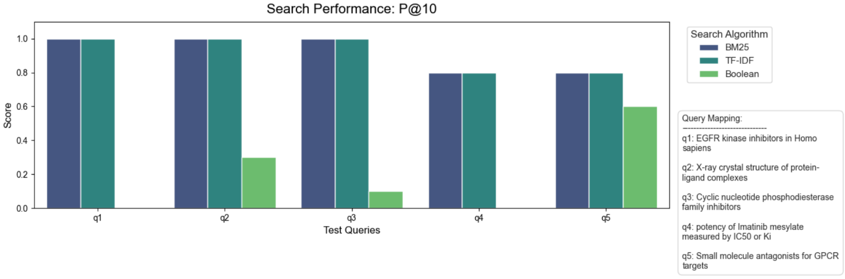
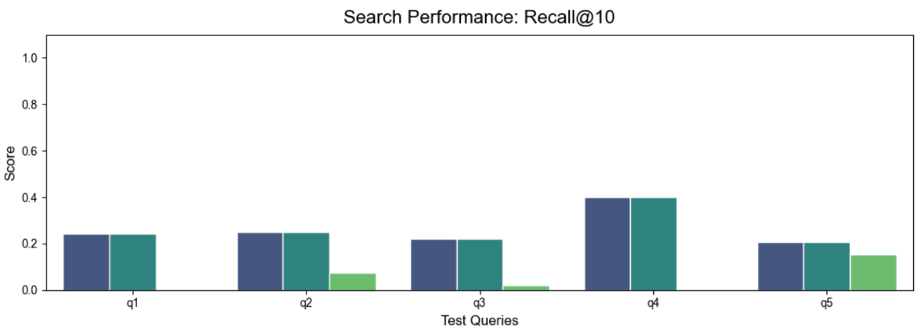
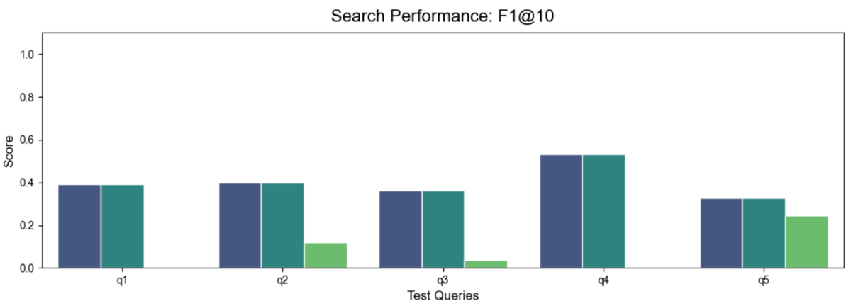
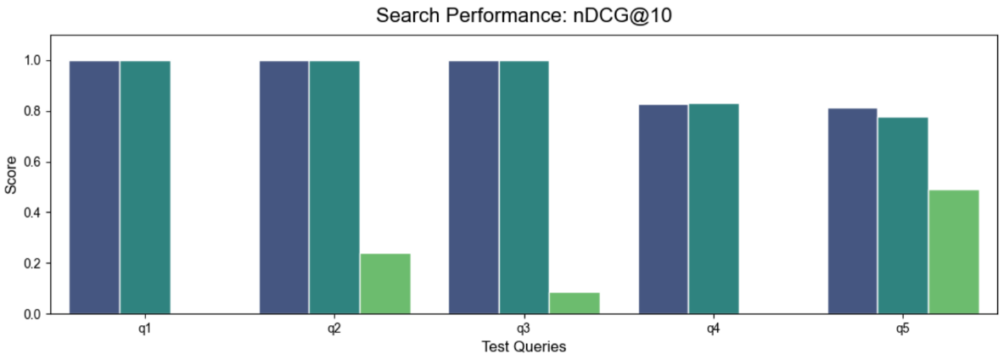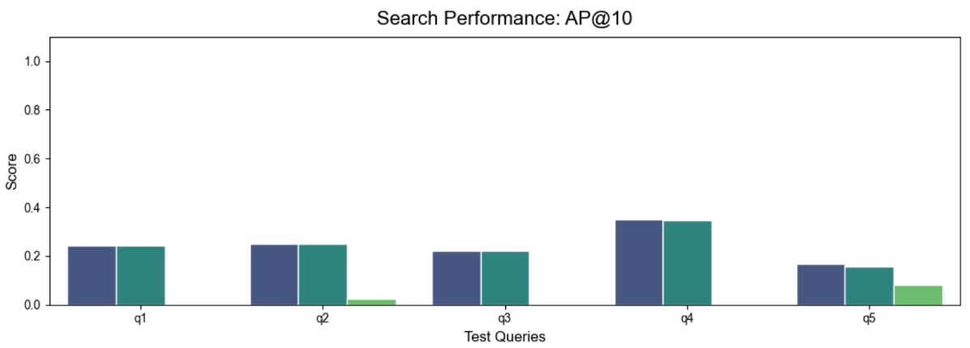
Appendix F: Semantic vs Lexical Search Engines Evaluation Results
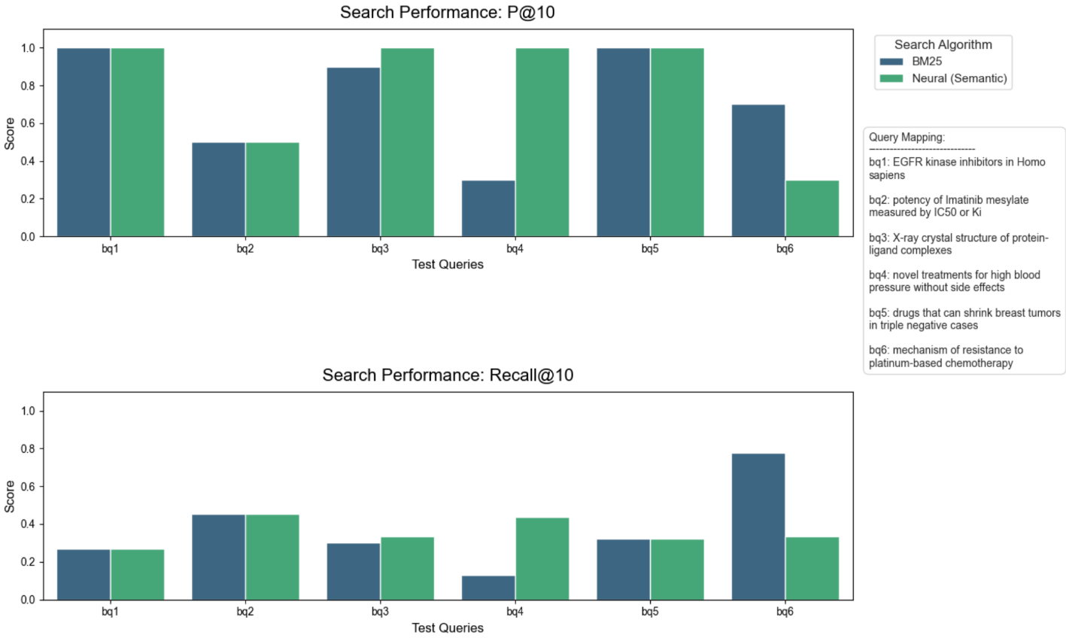
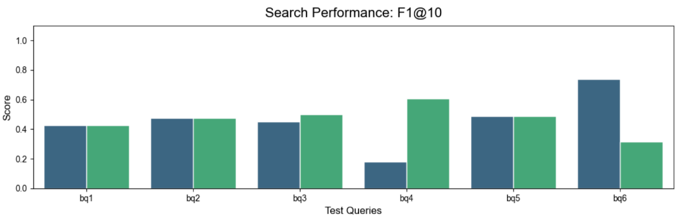

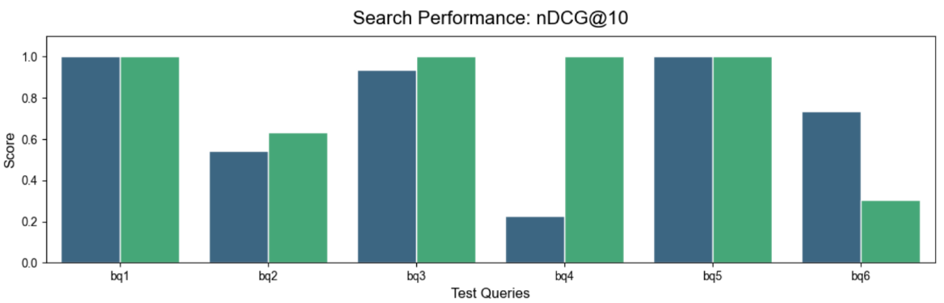
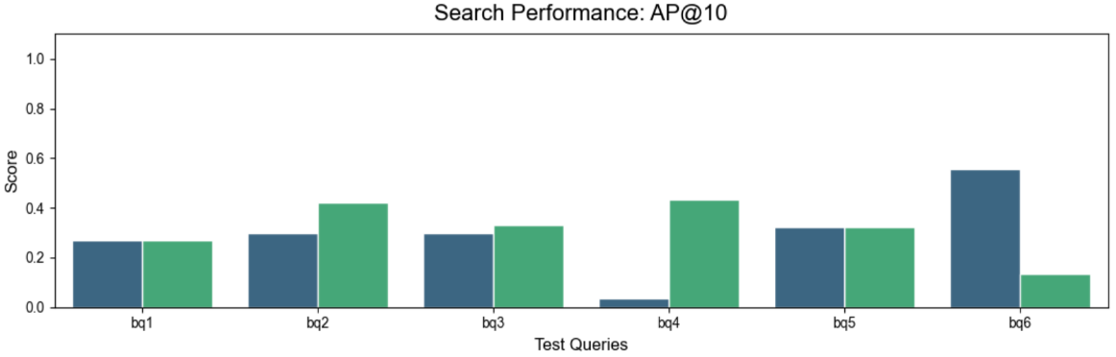

Appendix G: Retrieval Depth (K-Grid) Optimization & Hybrid Search Heatmaps

