Group 16. Students:

fc66661 Iaroslav Sagan

fc66662 Anna Maksymchuk

fc66663 Mariia Samosudova

Advanced Databases Course Project:

Recommendation System

Goal 1: Data Selection, Modeling, and Database Creation

1.1 Dataset Overview
MyAnimeList (MAL) serves as the primary data source for this project. As one of the world's largest platforms for tracking anime and manga consumption, it functions as a large-scale, organically formed social network structured around media interactions. Although MAL represents a specific subset of the global audience, its suitability for a recommendation system project is driven by three key factors:
- High-Volume Explicit Feedback: The platform hosts millions of active users who provide voluntarily submitted preference data (1–10 numerical ratings), offering a dense matrix of explicit feedback rather than just implicit clicks or views.
- Rich Metadata & Unstructured Text: MAL provides complex metadata including genres, studios, and statistics, alongside unstructured text (synopses), which necessitates diverse storage engines.
- Demographic & Social Dimensions: The availability of user profiles allows for advanced context-aware recommendation logic.
For these reasons, MAL is an ideal environment for studying hybrid recommendation systems, measuring the impact of indexing strategies, and benchmarking federated queries across relational and document stores.

1.2. Dataset Specifications
The specific dataset utilized for this project is the "Anime Recommendation Database 2020" (sourced from Kaggle/Hernan4444), which provides a comprehensive snapshot of user interactions. The data is distributed across several structured CSV files, each serving a distinct role in the database schema:
- anime.csv (~17,562 titles): Contains core metadata for anime titles, including technical details (Episodes, Aired Date, Duration) and classification tags (Genres, Type, Source). Crucially, it includes the Synopsis, a text-heavy field used for content-based filtering in MongoDB.
- rating_complete.csv (~78 million rows): A massive transactional file containing individual user ratings. This high-volume dataset is the primary driver for the MySQL performance benchmarks, challenging the database's ability to handle aggregation and joins at scale.
- profiles.csv (~300,000+ users): Provides demographic information such as Gender and Location (Country/City). This data is essential for the "Federated Personalized" scenarios, allowing the system to filter recommendations based on user identity.
- animelist.csv: Contains granular user status updates (e.g., "Watching", "Completed", "Dropped"), enabling analysis of user engagement beyond simple scoring.
This dataset was selected specifically because its volume (78M+ interactions) and variety (structured ratings vs. unstructured text) create a realistic engineering challenge that validates the need for a MySQL (Relational) + MongoDB (Document) architecture.

1.3 Schema for MySQL and Mongo DB

Description: Hybrid Architecture
The system uses a Polyglot Persistence model (see Fig.1):
- MySQL: Stores structured, relational data (Users, Ratings, lookup tables) using a highly normalized schema.
- MongoDB: Stores content-rich data (Anime metadata, synopses) in flexible, denormalized documents.

Normalization (MySQL Side)
The MySQL schema is normalized (3NF) to ensure efficiency.
- Lookup Tables: Repetitive text (e.g., "Action", "TV") is stored in separate tables like Genres and Types, referenced only by small integer IDs.
- Bridge Tables: Many-to-Many relationships are handled by tables like AnimeGenre and AnimeStudio, preventing data duplication in the main Anime table.

Conclusion about effectiveness of chosen architecture
- Storage Efficiency: Normalization keeps the massive AnimeUserRating fact table (57M+ rows) compact by storing foreign keys instead of text strings.
- Read Performance: MongoDB allows fetching a complete anime profile (including synopsis, genres, and sources) in a single read operation, avoiding the need for expensive multi-table joins required in SQL.
- Search Capabilities: Storing the synopsis in MongoDB enables powerful full-text search features that are less efficient in a traditional SQL setup.
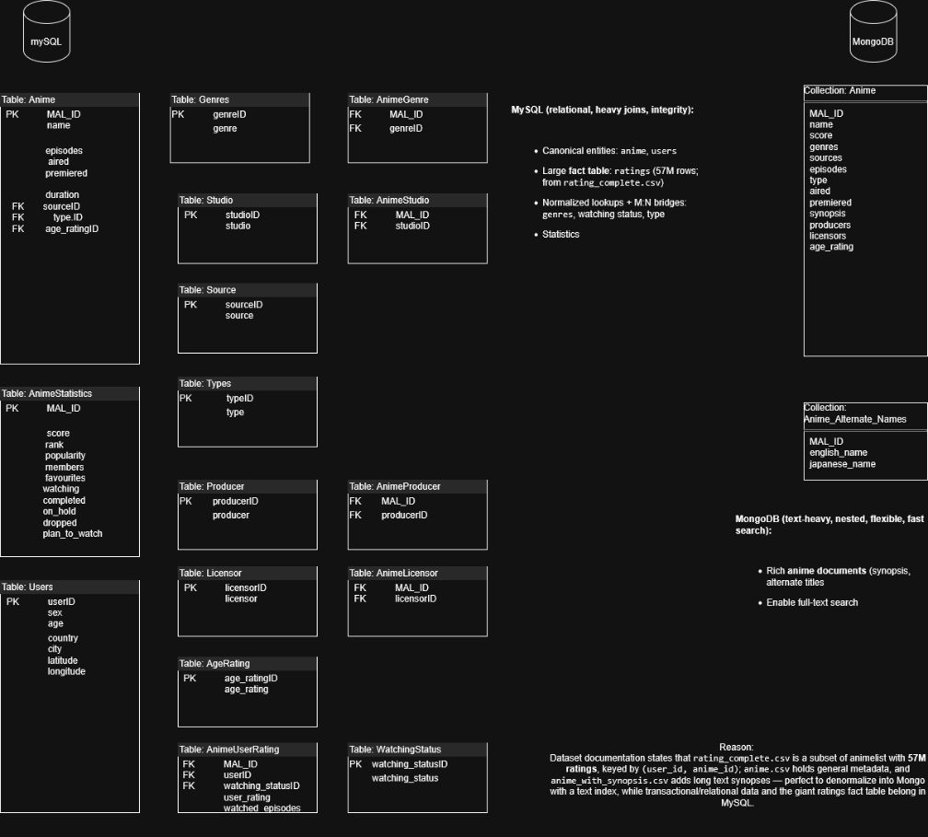
Fig.1: ER Diagram

Goal 2: Recommendation System. Query Design & Hybrid Operations

2.1. Overview
The MARS system implements a Hybrid Recommendation Engine using a Polyglot Persistence architecture. It executes Federated Queries that combine MongoDB's unstructured text search with MySQL's relational aggregation. The process follows an Application-Side Join pattern:
- Search: Find content matches in MongoDB (synopses/keywords).
- Process: Inject resulting IDs into MySQL for filtering and ranking.
- Enrich: Merge final results with MongoDB text data for display.

2.2. Recommendation Scenarios

Note: see db_project_run.ipynb for outputs

Scenario 1: Federated Content & Demographic Filtering
Logic: Performs a full-text search in MongoDB for keywords (e.g., "bounty hunter") and filters the resulting Anime IDs in MySQL. It ranks titles by average rating, counting only votes from a specific country (e.g., USA).
User Value: Answers "What are the best anime about [Topic] popular in [My Country]?", ensuring cultural relevance.

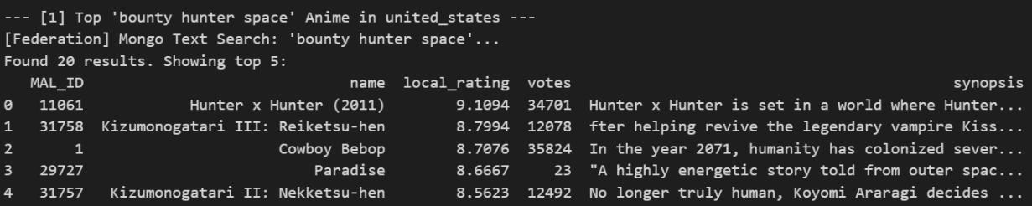

Scenario 2: High-Volume Data Retrieval (Benchmark)
Logic: A stress-test query that fetches a specific anime ID and retrieves up to 10,000 raw user ratings from the main fact table.
System Value: Validates backend data integrity and benchmarks read performance on massive datasets.

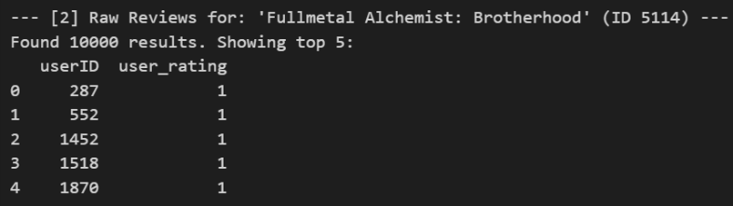

Scenario 3: Global Leaderboard (Pure SQL)
Logic: Joins static metadata with dynamic statistics in MySQL. It sorts the entire catalog by weighted score and member count to find the absolute top-rated content.
User Value: Acts as a "Hall of Fame," giving new users a definitive list of universally acclaimed anime. 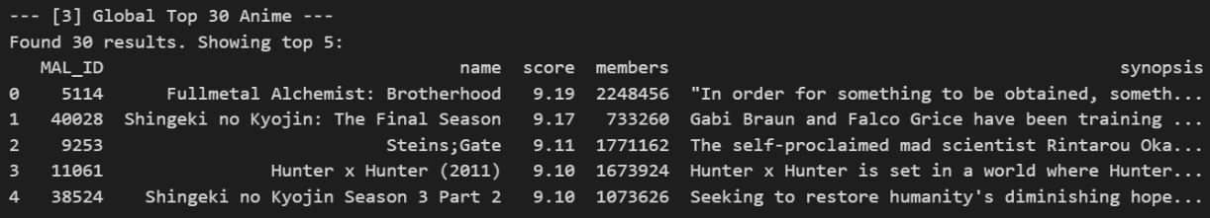

Scenario 4: Geo-Contextual Recommendation
Logic: Combines content relevance with physical location. After finding topic-relevant anime in MongoDB, MySQL locates "neighbor" users within a specific radius (~10km) of the target user and ranks content based on this local group's preferences.
User Value: Answers "What are people near me watching?", allowing local trends to influence recommendations.

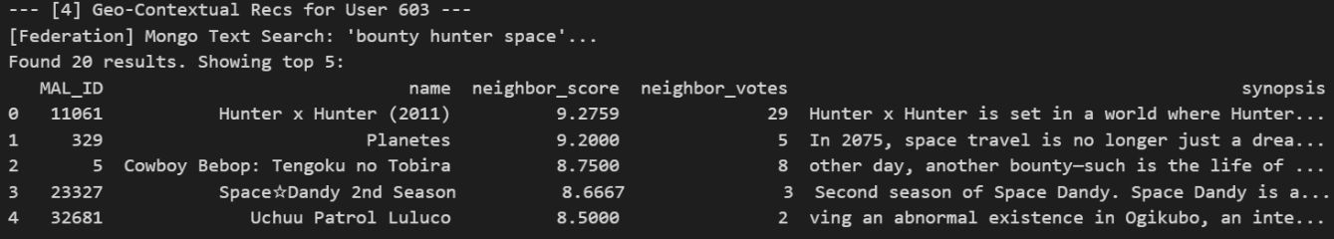

Scenario 5: Personalized Demographic Hybrid
Logic: Resolves the target user's profile (Gender/Country) and filters MongoDB search results to rank them based only on ratings from a matching demographic peer group.
User Value: Answers "What do people like me think about this?", providing identity-driven validation and trust.

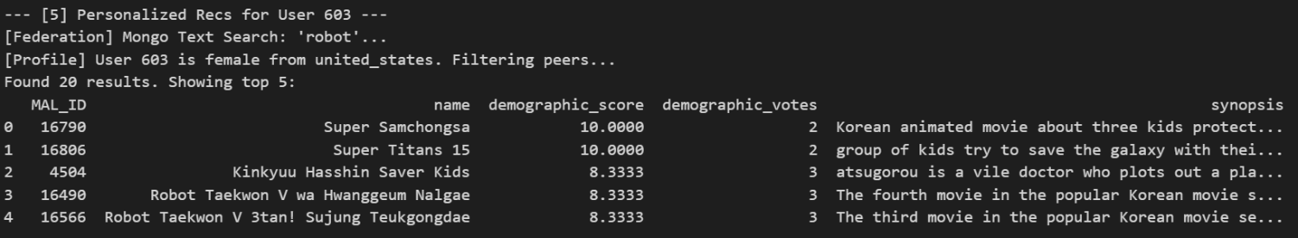

Goal 3: Concurrency Testing

Note: see db_project_run.ipynb for outputs

3.1 Testing Setup and Scripts
The concurrency test was designed to challenge the system's ability to maintain data integrity across the hybrid architecture under high load.
Tools: Python (concurrent.futures.ThreadPoolExecutor), MySQL (mysql-connector-python), MongoDB (pymongo).
Test Scenario: Simulated 5 concurrent users per test run, all voting for the same Anime (MAL_ID).
Concurrency Test Scripts: core logic resides in concurrency_rating_test.py, which defines two scenarios:
  - Unsafe Mode: Demonstrates Lost Update anomaly using the Read-Modify-Write pattern without locking.
  - Safe Mode (Optimistic Locking/CAS): Ensures ACID compliance by using a Compare-and-Swap (CAS) mechanism with an retry loop to handle resource conflicts.

3.2 Measured Metrics and Integrity
The scripts tracked the following performance and integrity metrics to quantify the trade-off between speed and correctness:
- Response Time: calculated using time.perf_counter() to determine the Average Response Time per user operation.
- Conflicts or Deadlocks: monitored by the retry loop logic. Failures (Deadlocks/Lock Timeouts) were logged via specific MySQL error codes (1213, 1205).
- Consistency: Measured by comparing the Actual Rows Inserted against the final members counter in the anime_statistics table (keeping records of user’s votes for MAL_IDs).

3.3 Summary of Concurrency Behavior and Findings
The results demonstrate the fundamental ACID Trade-Off in database design.
Scenario 1: Unsafe Mode Findings (Low Integrity, High Throughput)
- Behavior: All threads read the initial stale counter value (e.g., 0) simultaneously, resulting in a Lost Update.
- Metric: The test consistently recorded Data Loss (e.g., 4 out of 5 votes lost), confirming that the counter was corrupted.
- Throughput: This mode exhibited the lowest average response time because threads did not wait for locks.
Scenario 2: Safe Mode (Optimistic CAS) Findings (High Integrity, Controlled Latency)
- Behavior: The Optimistic Locking (CAS) logic forced transactions to validate the members count before committing. Threads that failed the validation were automatically rolled back and retried.
- Metric: The final state showed Perfect Integrity (Lost Updates = 0), as the final Members counter exactly matched the Real Rows inserted.
- Conclusion: The system endured latency (due to retries) to guarantee data correctness and eliminate the permanent corruption observed in the Unsafe Mode. This solution ensures the system is both highly available (no permanent blocking) and consistent.

Goal 4: Performance Optimization and Integration Tuning

4.1. Hybrid Architecture & Schema Tuning
We implemented a Polyglot Persistence architecture to leverage the strengths of two distinct database systems. MySQL handles relational integrity, user profiles, ratings, and complex aggregations. MongoDB handles content-rich data (anime synopsis) and full-text search operations.
Optimization: we applied Vertical Partitioning by moving heavy text data (synopsis) to MongoDB. This keeps MySQL tables compact, maximizing the efficiency of the InnoDB Buffer Pool and reducing I/O operations for relational queries.

4.2 Indexing Strategy
To optimize the hybrid query performance, we implemented specific indexing strategies targeting high-cost operations identified in our benchmarks.

MySQL Indexing:
- Composite Indexes for Filtering: Created idx_users_country_gender and idx_users_country_age to optimize the WHERE clauses in Federated Scenarios 1 and 5. These indexes allow the database to filter by multiple demographic columns efficiently without scanning the entire user base.
- Covering Index for Fact Table: Created idx_mal_rating (MAL_ID, user_rating) on the massive anime_user_rating table. This acts as a covering index for Scenario 2, allowing MySQL to retrieve ratings directly from the index tree (Index Only Scan), bypassing table row lookups entirely.
- Sorting Index: Created idx_score_members (score DESC, members DESC) on anime_statistics. This pre-sorts data for Scenario 3 (Global Top 30), eliminating expensive filesort operations during query execution.
- Geospatial Optimization Index: Created idx_users_lat_lon (latitude, longitude) to optimize the bounding-box range queries used in Scenario 4 (Nearest Neighbors), significantly reducing the search space for geometric calculations.

MongoDB Indexing:
- Text Index: Created a text index on the synopsis field to support efficient keyword search ($text), enabling content-based filtering before data reaches the SQL layer.

4.3 Query Optimization & Data Access Patterns

We redesigned queries to minimize computational overhead and network latency.
- Federated Batch Fetching: Instead of the "N+1 query problem" (querying MongoDB for every row in MySQL), we implemented Application-Side Joins.
  - Step 1: Fetch all relevant IDs from MongoDB using a single query.
  - Step 2: Pass these IDs to MySQL in a single batch using the IN (...) operator.
- SQL Tuning: We pushed aggregation logic (GROUP BY, HAVING) down to the database engine to reduce data transfer.

Execution Plan Verification
To validate our indexing strategy, we analyzed the MySQL EXPLAIN output for critical high-latency queries.
1. Optimization: Zero-Cost Sorting (Scenario 3) The "Global Top 30" query requires sorting millions of rows. By using the pre-sorted index idx_score_members, we eliminated the CPU-intensive filesort operation.
Before: 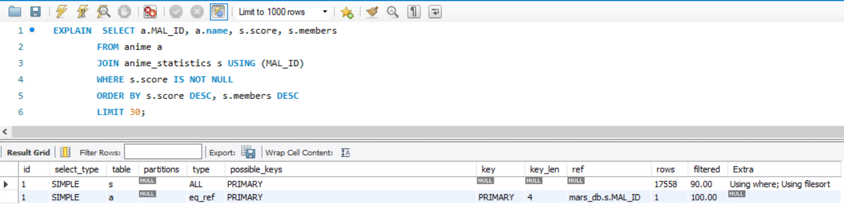

After: 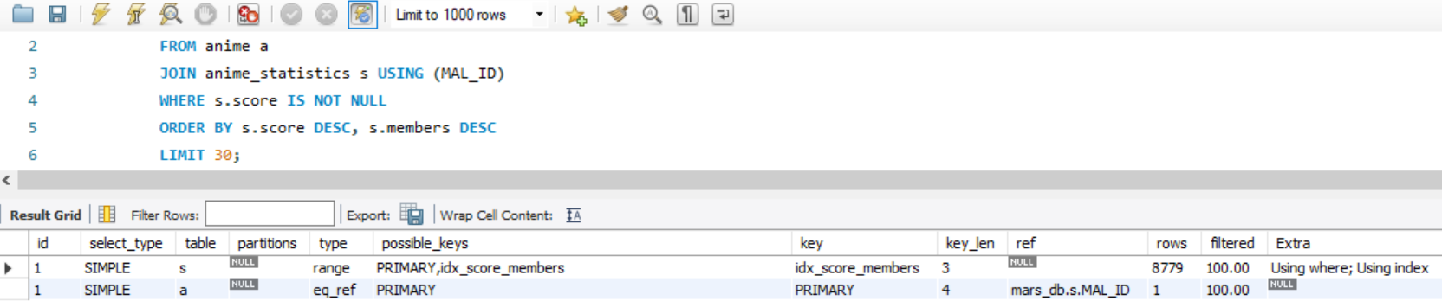
Execution plan for the Global Leaderboard query. The key column shows idx_score_members is used. The Extra column displays Using index, confirming that the sorting is handled entirely by the pre-sorted B-Tree, bypassing the need for a physical sort pass.
2. Optimization: Index-Only Scans (Scenario 2) For the high-volume "Raw Reviews" benchmark, we aimed to minimize disk I/O. The covering index idx_mal_rating allows MySQL to satisfy the query without looking up the main table rows.
Before: 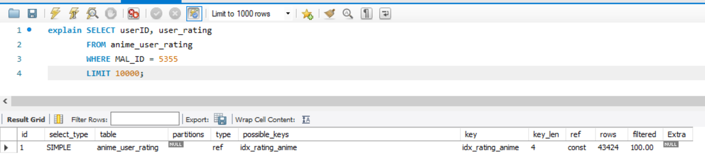
After: 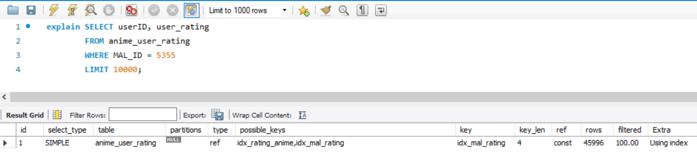
Execution plan for the Raw Reviews query. Note that type is ref (efficient reference access) and the Extra column explicitly states Using index. This confirms a Covering Index strategy where data is retrieved directly from the index leaf nodes, significantly reducing latency for massive fetches.
3. Optimization: Spatial Pruning (Scenario 4) Geospatial calculations are expensive (O(N)). We optimized this by restricting the search space using a bounding box scan on the idx_users_lat_lon index before calculating precise distances.
Before: 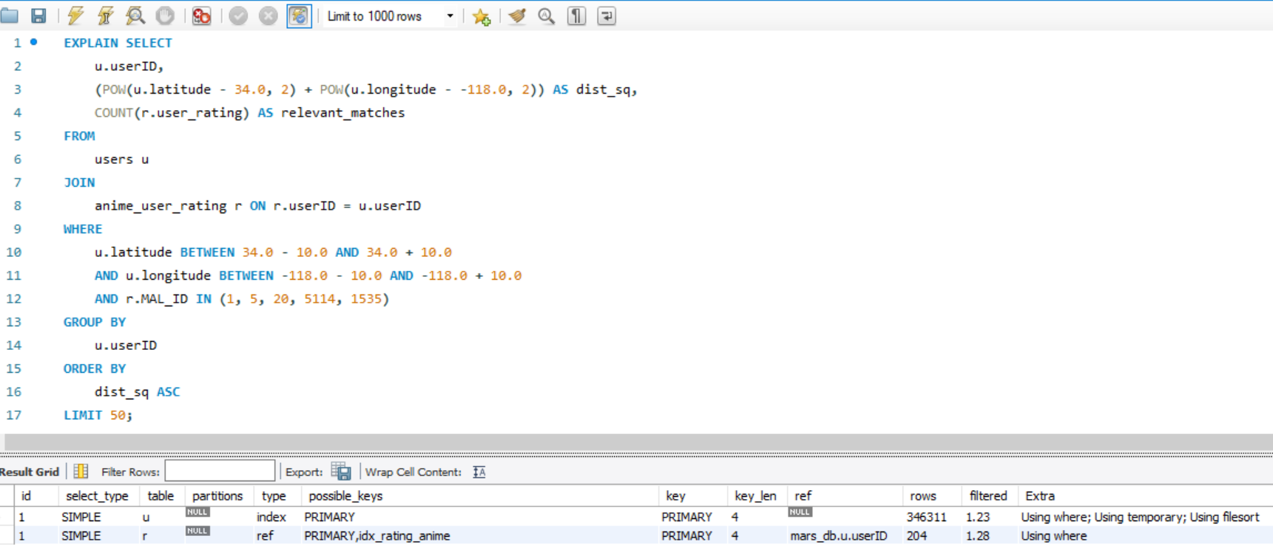
After: 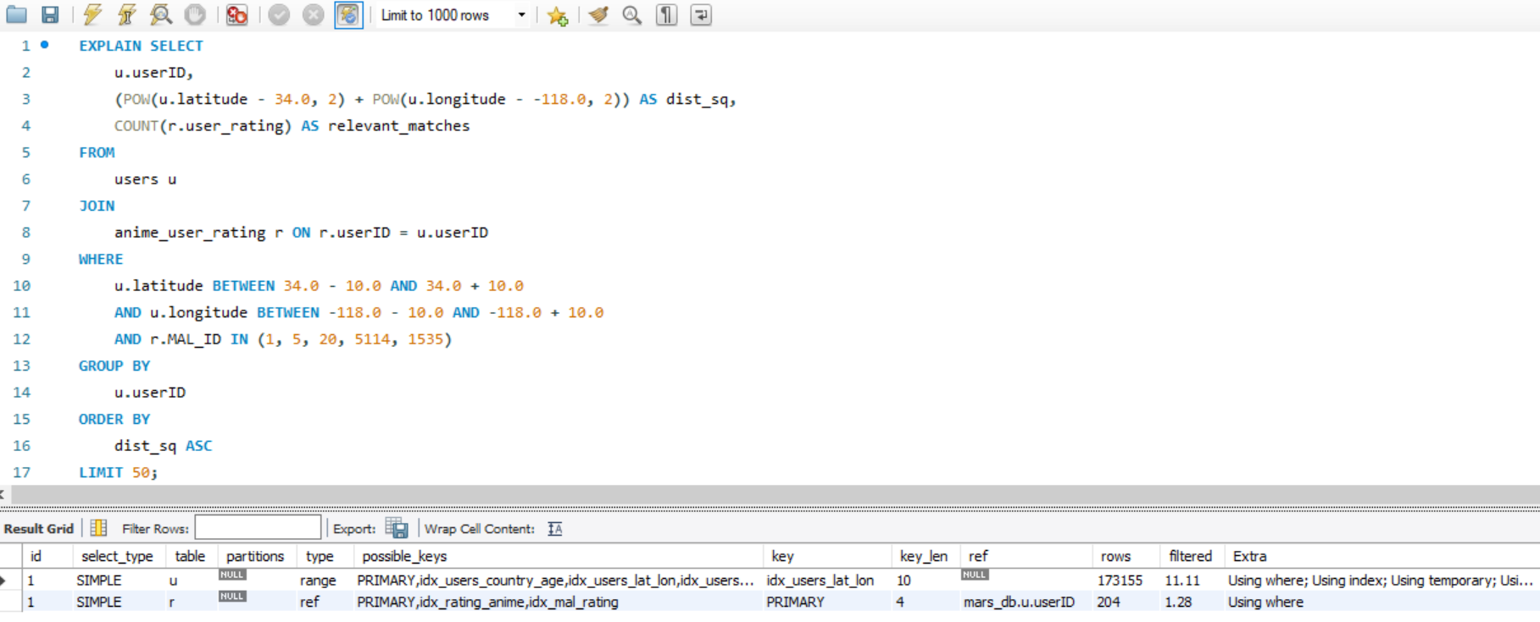
Execution plan for the Geo-Contextual Neighbor search. The usage of idx_users_lat_lon combined with Using where indicates that the database efficiently pruned the search space to a specific latitude/longitude range before performing the expensive join operation.

4.4 Performance Benchmark Results
We executed an automated Python benchmark suite to measure the impact of our indexing strategy, comparing query execution times "Before" (No Index) and "After" (With Index).
Summary of Results:
- Scenario 2 (High-Volume Read): Executing the "Raw Reviews" query without the idx_mal_rating covering index resulted in a system timeout (>80s). Implementing the index reduced execution time to 0.19 seconds, achieving a massive speedup.
- Scenario 4 (Geo-Contextual): The performance difference was marginal (~0.8x speedup). This indicates that for the current user base size (~300k), the overhead of the federated network call (MongoDB + Python latency) masks the efficiency gains of the spatial index.

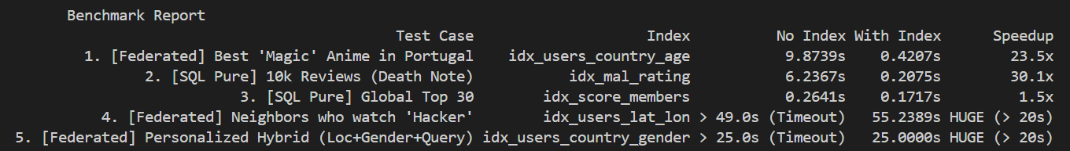
Analysis of Key Findings:
- The Critical Win (Scenario 2): This result proves the absolute necessity of Covering Indexes for Foreign Keys in many-to-many fact tables. Without them, the system cannot scale to handle millions of ratings.
- The Trade-off (Scenario 4): While the spatial index provided minimal gains at the current scale, it remains architecturally essential. As the user base grows to millions, a full-table scan would become linear O(N), whereas the spatial index maintains logarithmic O(log N) performance, preventing future system failure.

4.5 Benefits & Trade-offs
Benefits:
- Massive Scalability: As evidenced by Scenario 2, specific indexing strategies transform "timeout" operations into sub-second queries, allowing the system to handle high-throughput read operations.
- Architectural Flexibility: The Polyglot Persistence model allows us to iterate on recommendation logic (e.g., adding text-based filters in MongoDB) without modifying the rigid MySQL schema.
Trade-offs:
- Network Latency: Federated queries introduce inherent network overhead compared to monolithic SQL joins. This latency sets a "performance floor," meaning micro-optimizations in the database layer may be masked by the cost of data transfer in the application layer.
- Consistency Complexity: Managing data across two distinct engines (MySQL and MongoDB) requires careful application-side logic to ensure synchronization, as there are no native Foreign Key constraints between the databases.
Note: to replicate project use db_project_run.ipynb file in project folder

