|  |  |  |
| --- | --- | --- |
| **Problem Chosen** B | **2020 MCM/ICM Summary Sheet** | **Team Control Number** 2010265 |

**Sandcastle erosion simulation based on cellular automaton**

**Summary**

This paper aims at building a more lasting sandcastle, and research the conditions of sand breaking away from sand castle under the influence of rain and waves. We establish a three-dimensional cellular automaton for the simulation of the erosion process, and find out the optimal three-dimensional shape for a sandcastle, as well as the optimum sand-to-water mixture proportion.

Aiming at requirement 1, this paper divides the erosion process into two stages. The first stage is the direct impact of waves on sandcastle, and the second stage is the influence of backflow. In the first stage, we compare the starting speed  and wave speed  to judge whether the sand falls off. In the second stage, the sand **separation** probability is calculated from the sand distribution. Then, we consider a sand as a cube cell, and formulate the rules of cellular state change. After that, we simulate the erosion process of the sandcastles in different shapes by using 3d cellular automaton. We find that a better 3d shape has a smooth surface and its wave-facing part is taper. And we give a specific result for a particular case.

**Aiming at requirement 2, this paper establishes a sand-water combination microscopic structure model, and finds that the sand castle is the most stable when the sand grains are surrounded exactly by water molecules. Based on the principle of geometry, we calculate the volume ratio**  **of sand and water. And then we figure out that the optimal sand and water mixing ratio is 6.46:1.**

**For requirement 3, this paper calculates the ratio of the energy**  **of rain and waves. We establish the mixed wave-rain erosion model. We increase the separation probability**  **of sand cells in the open air to simulate the process of rainwater erosion. We find that the optimal 3d shape obtained previously has a shorter duration now. By adjusting the height, we conclude that the best three-dimensional shape of the sand castle is a higher semi-ellipsoid.**

**In view of requirement 4, this paper considers to dig a ditch and build a defensive wall around the sandcastle. In addition, the sand can be mixed with shells or pebbles Finally, this paper analyzes the advantages, disadvantages and sensitivity of the model, and puts forward the extended application of the model.We also wrote an article for the magazine about our model.**

****Keywords:** 3D cellular automaton, mix-erosion model, erosion proceed simulation**

**Contents**

[1. Analysis of the Problem 1](#_Toc10567)

[2. Assumption：](#_Toc10553) 1

[3. Symbols 2](#_Toc20258)

[4. Model and solution 2](#_Toc10911)

[4.1 Model for requirement 1 2](#_Toc13610)

[4.2 Requirement 2 1](#_Toc22564)2

[4.3 Requirement 3 1](#_Toc5613)4

[5. Sensitivity analysis 1](#_Toc31105)8

[6. Advantages and disadvantages 1](#_Toc17643)8

## Analysis of the Problem

****Requirement 1****

**We need to build a model to determine the optimal 3d shape of the sandcastle to make it last the longest under the influence of waves. Regardless of the sandcastle's location on the beach, its proximity to the sea, the amount of sand and the ratio of water to sand. First analyze how waves affect sand castles, and then explore the durability of sand castles of different shapes.**

****Requirement 2****

**Without using other materials, use the model to determine the optimal sand-water mixing ratio of the sand. It is necessary to establish a model to describe the influence of sand-to-water mixing ratio on sandcastle durability, so as to find the optimal ratio.**

****Requirement 3****

**Analyze the change of the optimal sandcastle shape obtained in requirement 1 under the mixed erosion of rain and waves, and judge whether the optimal sandcastle shape changes.Need to add the effect of rain water in the front wave erosion model.**

****Requirement 4****

**Consider other ways to extend the time when sandcastle lasting on the beach, mainly about the sandcastle itself and the external environment.**

****Requirement 5****

**Write a magazine article to introduce our model to non-professional readers.**

## Assumption：

Suppose the bottom of the sandcastle is horizontal. Generally, the beach slope does not exceed 5°, and its sine value is about 0.087. It can be considered that the beach is nearly horizontal, and then the bottom of the sand castle is horizontal.

Suppose the waves only affect the front, left and right sides. The top of the sandcastle is also affected. But the back and the bottom of the sandcastle is not affected by the waves. [Observationally](javascript:;), when a sandcastle is large enough, a wave crash has little effect on its backside and underside.

The effect of rain and sea water on the sand castle can be ignored. That’s because the contact time between seawater and rain water and the sand castle surface is relatively short, and the rain water infiltration into the sand castle is negligible compared with the volume of the entire sandcastle.

## Symbols

|  |  |  |
| --- | --- | --- |
| **Definition** | **Description** | **Unit** |
|  | **The minimum wave speed at which sand is removed from position** | **m/s** |
|  | **The speed of the waves patting on the sandcastle** | **m/s** |
|  | **The height of offshore waves** | **cm** |
|  | **Average offshore depth** | **cm** |
|  | **The probability that a piece of sand leave its original place due to the influence of the surrounding sand** |  |
|  | **，the influence coefficient of different positions on the central cell** |  |
|  | **Volume ratio of sand to water** |  |
|  | **Mass ratio of sand to water** |  |
|  | **The wavelength of an offshore wave** | **m** |
|  | **The speed at which rain falls on the sandcastle** | **m/s** |

## Model and solution

### Model for requirement 1

#### Establishment

In order to determine the best 3-dimensional geometric shape of sand castle and make it last the longest period of time under the impact of waves and tides, this paper establishes the erosion model of sand castle caused by waves, simulates the erosion process of sand castle with different 3-dimensional shapes under the same conditions, and finds the characteristics of the sand castle which lasts the longest period of time.

Every time the waves hit the sandcastle, some sand will be carried away. This paper divides each impact into two stages. The first stage is that the waves come from the sea and hit the sandcastle directly. The direct impact from the waves will make part of the sand directly in contact with the waves break away from its original position. The second stage is after the waves fall, part of the seawater flow back, will once again make part of the sand drop from the sand castle. At the same time, it will make part of the sand go back to the sand castle. As shown in the figure 1, the gray part represents the sand castle, and the orange part in the first stage represents the sand that was directly hit by the waves and left its original position. In the second stage, the seawater returns. The red part represents the backflow of seawater, and the green part represents the [sedimentation](D:/Program%20Files/Dict/8.5.1.0/resultui/html/index.html" \l "/javascript:;) of sand carried by seawater.

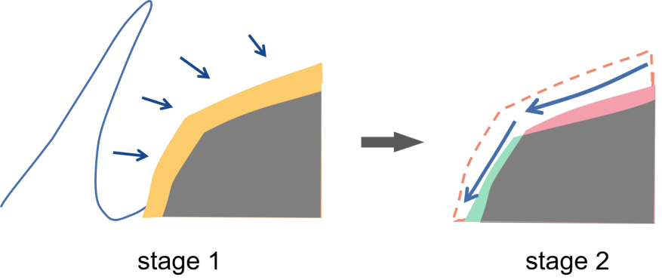

**Figure 1.** two stage of the wave hit

In this paper, a three-dimensional cellular automaton is used to simulate sand castle erosion. Corresponding to the above two stages, the sand castle erosion model contains two main processes. The first step is to find the sand directly hit by the waves and compare the starting speed ****and wave speed ****; The second step is to determine the probability of sand being washed away by the sea based on the distribution of sand around the cell.

Each grain of sand is placed in a three-dimensional cubic cell, and let****represent the state of the cell. The value is assigned as follows

****

We discretize the time. Each wave impact is considered as a moment. At each moment, we determine whether sand cells will be lost in the impact.

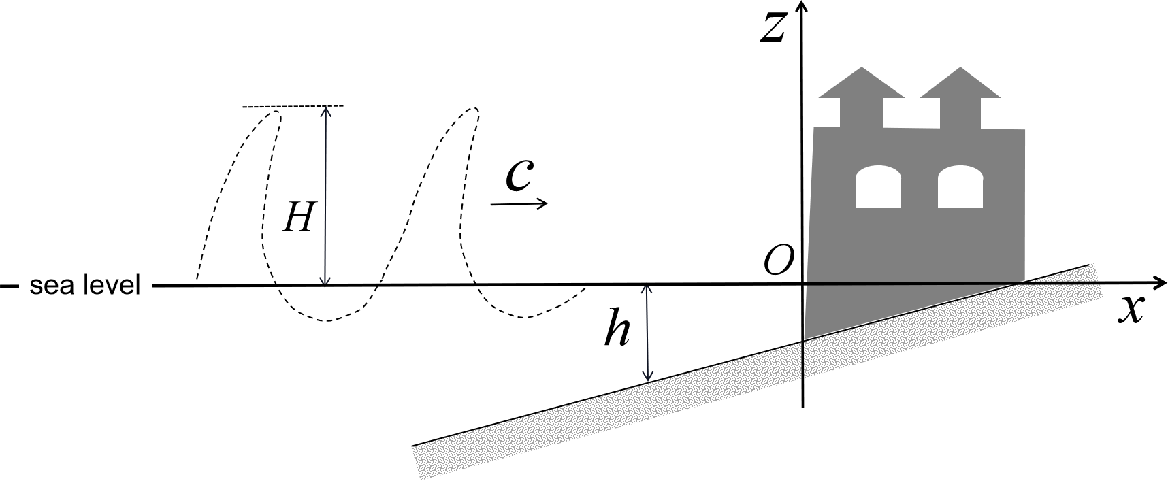

**Figure 2**. Sand castle and wave motion

Taking the point closest to the sea at the bottom of the sandcastle as the origin of coordinates, we establish a rectangular coordinate system as shown in the figure 2. For a point on the sandcastle, its coordinates are expressed in terms of ****. Below we will give the concrete content of sand castle erosion model

1. Determine whether the sand will leave its original position by comparing the starting speed ****of the sand with the speed of the wave ****.

Referring to literature, the starting speed **** refers to the minimum wave speed required to make the sand in contact with the sea wave move from the original position on the sandcastle. Only when the speed of the waves hitting the sand **** is greater than or equal to the starting speed ****, the sand will be out of its original position.

The starting speed **** of sand at a certain point on the sand castle can be calculated by the following formula

****

where **** denotes the starting speed of sand, and **** is the bulk density of sand, that is, the heap density of sand, with a value of 1.54 ****.

**** is the bulk density of water, namely the density of seawater, which can be calculated as 1.048 ****.

**** is the particle diameter of sand. According to the data, it can be found that the particle size of sea sand ranges from 2.2 mm to 2.6mm, and we take the mean value 2.4mm as the value of the variable.

**** is the dry density of the deposit, **** is the stable dry density of the deposit, its value is about 1.6 ****, generally **** can take the value 0.85.

**** is the kinematic viscosity coefficient of seawater, which is **1.55×106**.

**** is the thickness of film water, more precisely the thickness of water molecules adsorbed on the surface of sand particles. It is considered that the value can be **0.213×10-4cm** under the same waterto-sand proportion.

**** is the gravitational acceleration, approximately 9.8 ****.

**** is the influence coefficient of sediment concentration, which is given by the following formula



where **** is the sediment concentration by volume. Without considering the sediment content of seawater, **** can take the value 1. **** denotes the height of the water above the sea level. We assume ****.

With the method of calculating the starting speed ****of sand, it is also necessary to calculate the speed **** of the waves at each point on the sand castle. The wave crest in the offshore area will become increasingly sharp and steep, and the waveform of the isolated wave is similar to it. We consider this as the basis for wave modeling and movement, the horizontal velocity **** and the vertical velocity **** at any point **** can be calculated as follows [3]

****

where **** is the height from the sea level to the top of the wave crest. **** is the offshore sea depth, which can be uniformly valued at 10cm. According to the vector sum rule shown in figure 3, the expression of wave velocity **** at the **** point is ****.

**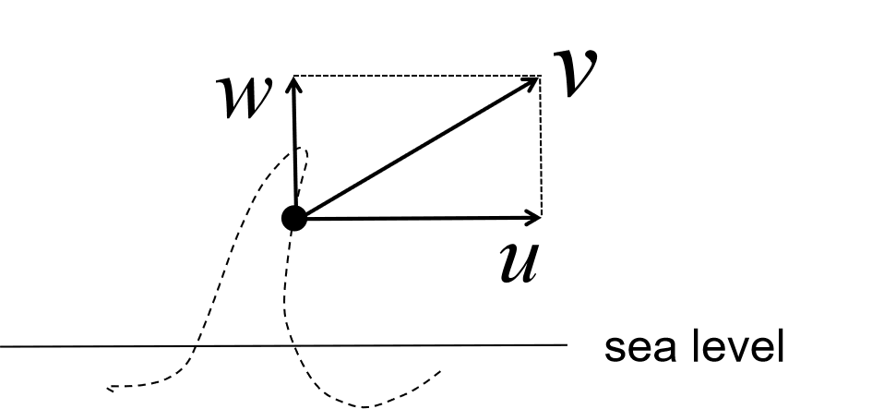**

**Figure 3.** Velocity composition diagram

Above is the calculation method of **** and ****. Each time the waves hit the sand castle, we find the sand cell hit by the waves, and the position of its center point is denoted as ****. By comparing the value of **** and ****, it is only when ****, that the sand cells here are considered to have been washed away by the sea.

2. We use the cellular automaton to simulate the probability of sand being washed away by seawater

With each wave, in addition to the sand carried away by the direct impact, the backflow of seawater also causes some sand to be lost. Therefore, this paper decides to use probability to describe this uncertain process. According to the distribution of sand in the cubic range of 3×3×3 around the sand cell, we determine the loss probability of the sand cell in the central position, so as to simulate the erosion of the actual seawater backflow process.

**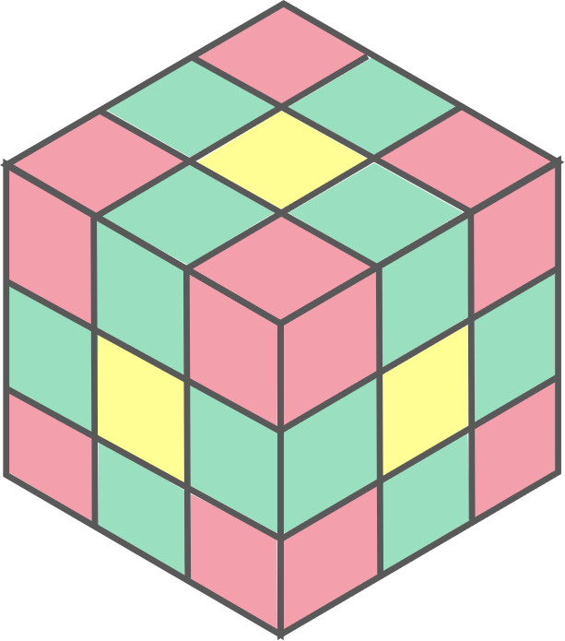**

**Figure 4.** Cellular decomposition diagram

**As shown in the figure 4, in the range of 3×3×3 with a sand cell as the center, there are a total of 27 cube cells, 26 in addition to the sand cell itself. The 26 cells can be divided into three categories, the yellow, green and red ones in the figure 4. Take the yellow cell as an example. They are in direct contact with the sand cell in the center, with a distance of 1**

|  |  |  |  |
| --- | --- | --- | --- |
| ****Color**** | ****Distance from the center**** | ****Number**** | ****Location**** |
| **Yellow** | **1** | **6** | **The center of each face of the cube** |
| **Green** |  | **12** | **Edges of the cube** |
| **Red** |  | **8** | **Corners of the cube** |

****Chart 1.** Meaning for the color of the cube**

**The state  of each of the 26 cells determines the probability of loss for the sand cell at the central location. Suppose the probability of sand cell loss at the central position is , and the expression is as follow**

****

**Where  represents the sum of state  quantities of 6 yellow cells. For example, when 5 of the 6 yellow cells contain sand and 1 does not, then .  and  represents the number of sand in the green and red cells respectively.**

**, and  respectively represent the influence coefficients of yellow, green and red cells on the central cell. As the closer the sand is, the greater the adhesive force is, the following relation exists between the influence coefficients**

****

**On the whole, the more sand there is in the 26 cells around the sand cell, the lower the loss probability is.**

#### Sand erosion model algorithm based on cellular automaton

**In addition to considering the direct impact of waves and the sand loss caused by seawater backflow, it is also necessary to consider the falling of the sand because of gravity, which also has an impact on the overall shape of sand castle. A simple and practical rule that can be considered is that when the state value of the cell directly below the sand cell is 0, which means there is no sand, the position of the cell is considered to drop vertically until the state value of the cell below is 1.**

**We use the three-dimensional cellular automaton to simulate the sand erosion process. Each sand particle was put into a cube cell, and the state value of the cell changed from 1 to 0, which represented the sand loss at the corresponding position. The time is discretized and each wave impact is considered as a cycle, in which the change of each sand cell is considered. Each cycle is divided into the following three steps**

* A certain direction is defined as the impact direction of the wave. If one side of the cube sand cell faces this direction, we calculate the starting speed **** and the speed of the wave **** against it. If the inequality **** is satisfied, the state value of the cell changes from 1 to 0.
* **The loss probability  of each sand cell is calculated according to the equation, and the state value of the cell changes from 1 to 0 according to the probability .**
* **Starting from the top layer, if the state value of the cell directly below the sand cell is 0, then exchange the state value of the two cells.**

**The above two processes correspond to the two stages of the wave impact on the sand castle. And the framework of the sand castle erosion model is obtained, as shown in figure 5**

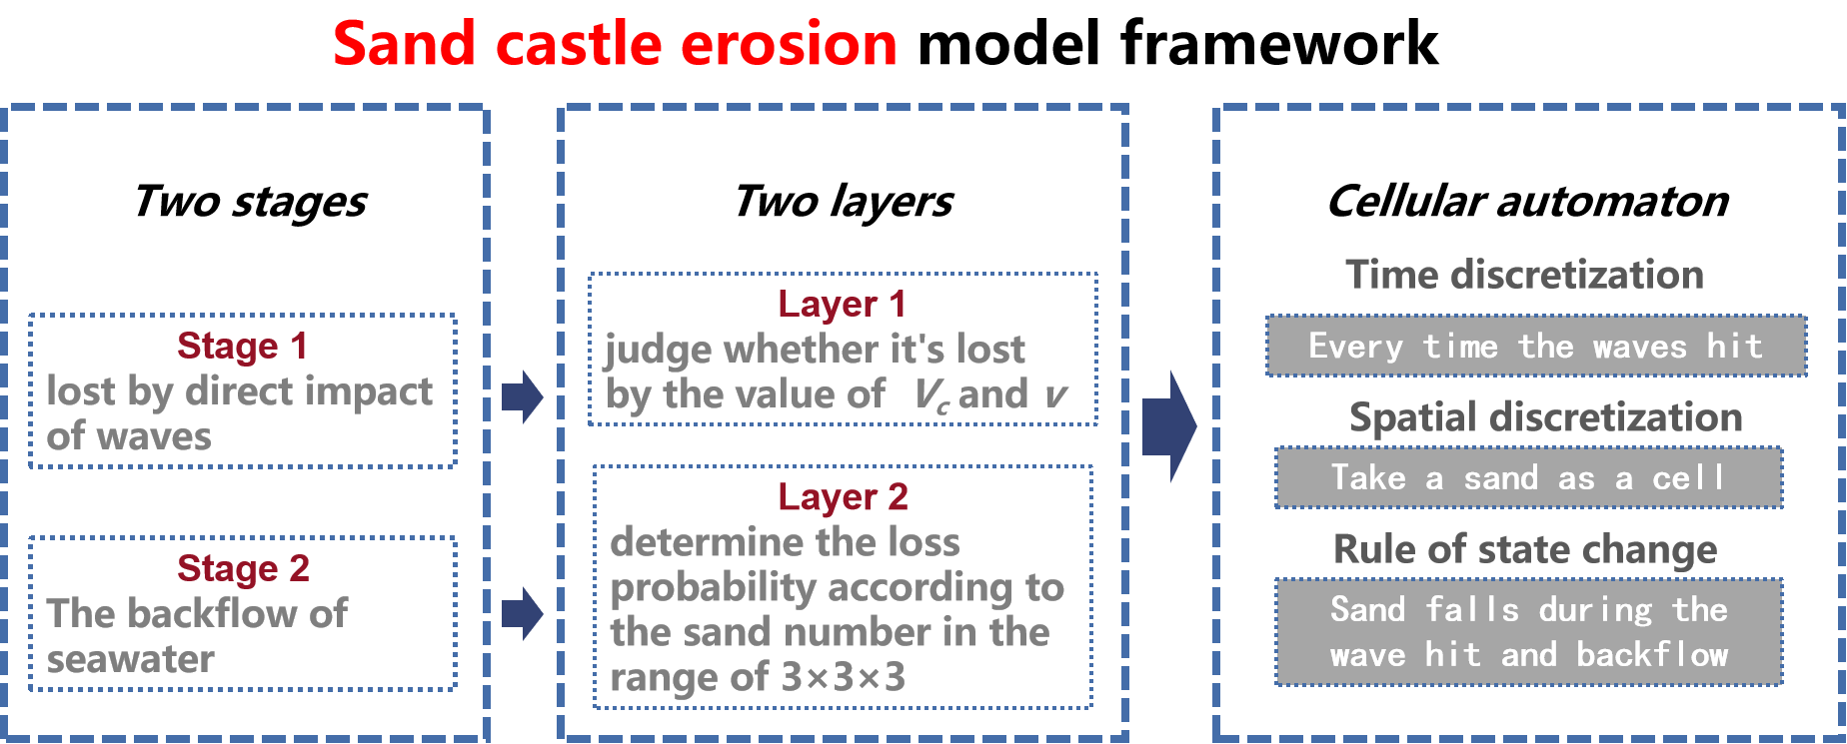

**Figure 5.** Comprehensive analysis of sand castle erosion model

**Based on the above sand castle erosion model, the cellular automaton is used to simulate the variation of each sand castle for sand castles with different 3-dementional shapes containing the same amount of sand.**

#### Results and analysis of sand castle erosion model

**Based on the above sand castle erosion model, the cellular automaton is used to simulate the variation of each sand castle for sand castles with different 3-dementional shapes containing the same amount of sand. It should be noted that due to the random factors caused by probability in the rules for the change of cellular state, the following experimental results are all obtained by averaging after 10 times of simulation.**

**During our fellow research, we set the wave height  as 30cm and the average offshore sea depth  as 10cm. The influence coefficients in the probability formula are respectively ,  and .**

1. **The comparison between erosion process of cube and that of cylinder**

**We compare the erosion process of the sand castle in the shape of cube and cylinder with the same volume. The specific parameters of the models are shown in the following table.**

|  |  |  |  |
| --- | --- | --- | --- |
| Shape | Height(cm) | Side of length or diameter(cm） | Volume(cm³) |
| Cube | 30 | 30 | 27000 |
| Cylinder | 31 | 31 | 26597 |

****Chart 2.** Model specification chart**

**The residual quantity change diagram of the cube and the cylinder sand castle is obtained as follows, where the vertical coordinate represents the proportion of the remaining sand in the original total sand, and the horizontal coordinate represents the number of waves hitting.**

|  |  |
| --- | --- |
| **正方体和圆柱体1** | **Figure_1 (2)** |
| **Figure 6.** Remaining ratio of the cube and the cylinder | **Figure 7.** Decrement of the cube and the cylinder |

**This paper holds that the sand castle is destroyed when the sand surplus is less than 30%. As can be seen from the figure, the cube sandcastle was destroyed after the 22nd wave impact, and the cylindrical sandcastle was destroyed after the 19th wave impact.**

**Corresponding to figure 6, we get the amount of sand lost each time the cube and cylinder sandcastle hit by waves as shown in the figure above. As can be seen from the figure, after the first 30 waves, the cube lost more sand each time than cylindrical sand castle. The three-dimensional image of the two simulation erosion process is given below, and the seawater impact direction is the state ↗**

|  |  |  |  |
| --- | --- | --- | --- |
| **Figure_31** | **Figure_36** | **Figure_325** | **Figure_335** |
| ****A-1**** | ****A-2**** | ****A-3**** | ****A-4**** |
| ****initcylinder**** | ****Figure_69**** | ****Figure_510**** | ****Figure_532**** |
| ****B-1**** | ****B-2**** | ****B-3**** | ****B-4**** |
| **Figure 8.** Three-dimensional erosion models of cubes and cylinders | | | |

**From the 3d simulation image, it can be seen that compared with the cylindrical sand castle with rounded smooth sides, the cube has a tendency of de-angulation. From the evolution rules of cellular automaton, the sand density around the sand cell at the edges and corners is lower, so it is easier to be lost, which also reflects the agreement between the model and the actual process.**

**It can be concluded that, at the same height and volume, the cylindrical sand castle with sleek bottoms is more durable in the waves.**

**Then we consider oval cylindrical sand castles with the bottom of different shapes. We simulate the erosion process of a series of elliptical cylindrical sand castles by keeping the same bottom area and changing the length of the ellipse axis on the bottom. We consider the parameters  and  the same as above, and the sand castle volume is still 27000cm³. The half-axis length of the bottom ellipse is shown in the following table**

|  |  |  |  |  |  |  |  |  |  |  |
| --- | --- | --- | --- | --- | --- | --- | --- | --- | --- | --- |
| a(cm) | 11 | 13 | 15 | 18 | 19 | 21 | 23 | 25 | 27 | 29 |
| b(cm) | 30 | 25 | 22 | 18 | 17 | 16 | 14 | 13 | 12 | 11 |

****Chart 3.** Parameters of different ellipse**

**Where the half axis b refers to the half axis of the ellipse protruding toward the sea, and the half axis a is the half axis perpendicular to it.**

**The change in the surplus of sand is shown in figure 9**

**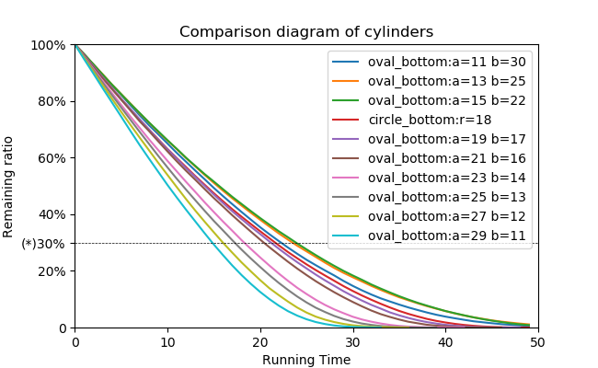**

**Figure 9.** Remaining ratio of the different elliptic cylinder

**It can be seen that the duration of an elliptic cylinder is better than that of the cylinder and other elliptic cylinders if the part protruding toward the sea is more taper, but if it is too taper, the duration will be reduced instead. The relationship between the duration and the length of the ellipse can be seen more clearly in the figure 10**

**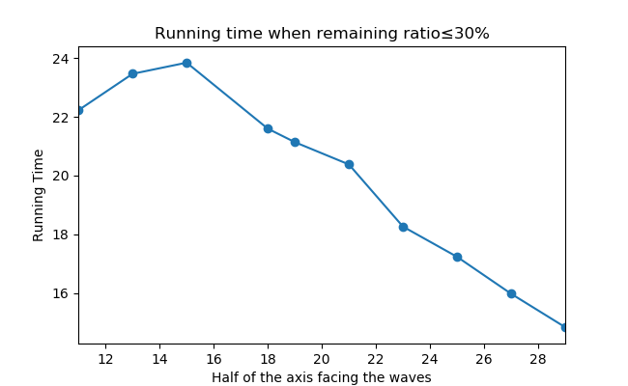**

**Figure 10.** Remaining ratio of the different elliptic cylinder

**Finally, under the condition that the nearshore wave height is 30cm, the average depth of the sea is 10cm, the sand castle volume is 27000cm3 and other parameters are all the same, we get the conclude that the best 3d shape of the sand castle is a semi-ellipsoid with a long half axis of 30cm, a short half axis of 21cm and a high height of 25cm, and its short half axis points to the waves.**

### Requirement 2

**Determine the best sand-to-water mixture proportion for the castle foundation without using other materials. First of all, we should know how the sand-water mixing ratio affects the structure of sandcastle. According to the literature** [5]**, the water in wet sand will form a liquid bridge between sand particles. Due to the surface tension of the liquid, the liquid bridge will make the sand particles bond. This adhesive force allows wet sand to be built in a certain shape, rather than forming a natural cone like dry sand.The liquid bridge between the sand particles is shown in the figure 11**

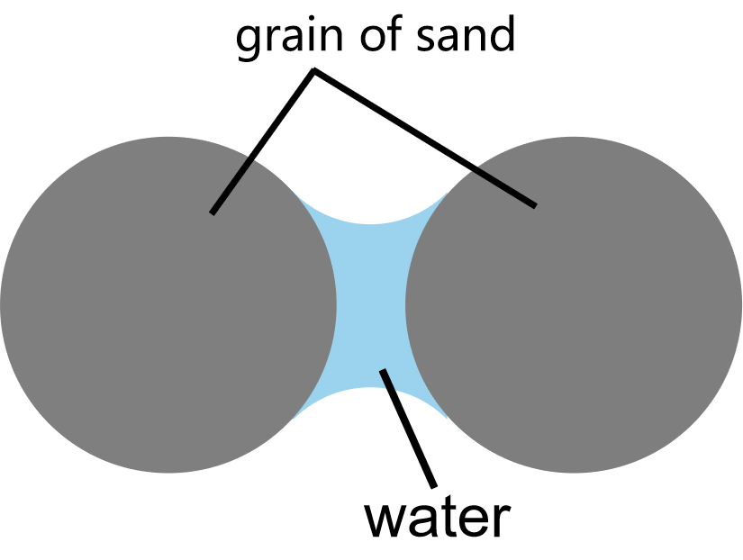

**Figure 11.** Sand water analysis

**According to literature**[4]**, when the water content in sand reaches the plastic limit, the sand grain is surrounded by water, and the adhesive force is the largest. As shown in figure 12-a. After that, the increase of water content only removes the gas between the grains, but does not affect the connection form between the grains. When the water content is lower than the plastic limit, the cohesion between grains is very weak.**

|  |  |
| --- | --- |
| 问题二9a | 问题二9b |
| **Figure 12-a** | **Figure 12-b** |

**Therefore, we believe that when the water content reaches the plastic limit, the corresponding** sand-to-water mixture proportion for the castle foundation is the best.

First, we calculate the ratio of the volume of sand grains to the volume of water in a three-dimensional sand pile when the number of sand grains is very large. It can be considered that the air mass between the sand grains is approximately a sphere. Suppose the radius of the sand grain sphere is  and the radius of the air sphere is , the following equation can be easily obtained



**Suppose the cube containing 8 spherical sand grains is a Grid. In such a Grid, there are 8 spherical sand grains and 1 spherical air, and the rest is water. When eight such grids form a large cube, there are 64 grains of sand inside, with 27 spheres of air among them. Following this pattern, we draw the following conclusions:**

**When**  **Grids constitute a large cube, it contains**  **grains of sand,**  **spheres of air, and the rest is water. Suppose under the macroscopic measurement, the volume of each sphere of sand is** **, the volume of each sphere of air is** **,** **and**  **can be considered large enough, we can obtain the calculation formula**



**where**  **which denotes the ratio of sand particles to water volume in the sand pile**

**And the optimal sand-water ratio**  **is calculated as**



**where**  **is the density of sand, which is** 3.5g/cm3**, and**  **is** **the density of seawater, which is 1.04g/cm3. Ultimately, we calculate that the mass ratio of sand to water is 6.46:1.**

### Requirement 3

#### 4.3.1 Establishment

**Now we need to consider the effect of rain on the sand castle, determine how the best 3-dementional shape of the sand castle in requirement1 is affected by the rain, and judge whether it is still the best 3-dementional shape of the sand castle.**

**The main effect of rain on a sandcastle is to destroy its structure and remove the sand from the castle. But there are two differences between rain and ocean waves. Firstly, approximately we assume that the rain is continuous falling on the sand castle. Secondly, the rain mainly affects the top of the sandcastle, and its drop point is determined randomly.**

**The action of waves is periodic, and there is a time interval between two adjacent actions. So we can calculate the energy**  **of waves flapping on the sand castle and the kinetic energy of rain**  **falling on the surface of the sand castle respectively during each period, and compare the impact of waves and rain on the sand castle.**

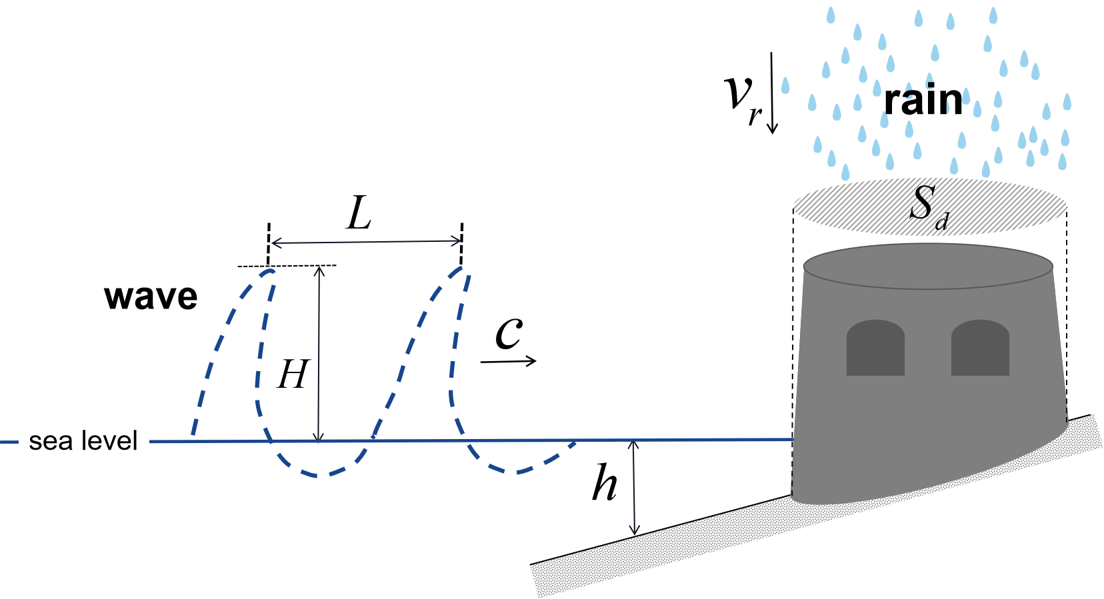

**Figure 13.** wave-rainfall mixed model

**As shown in figure 13, the wavelength of offshore waves is** **, the wave speed is** **, the distance from the crest to the sea level is** **, and the average water depth near the coast is** **. The horizontal cross-sectional area of the bottom of the sandcastle is** **, and the dripping velocity of the rain is** **. And the wave energy of an offshore wave can be calculated by**



**Each period**  **is the time interval of two waves lapping, and the calculation method is**



where the wave velocity is [11]



**Precipitation intensity**  **refers to the amount of rainfall per unit time, usually in mm/h.**  **denotes the total mass of rain water dropping on the sand castle in one period,**  **is the density of rain water. According to the kinetic energy formula, the kinetic energy**  **of rain water dripping on the surface of the sand castle in one period is**



**The influence coefficient**  **of rain relative to waves on sand castle can be definedas the ratio of the kinetic energy of rain falling and energy of waves during one cycle, and calculated by**



**On the basis of the sand castle erosion model proposed in requirement 1, we expand the original two layers of sand loss to three. On the basis of the original two layers (direct impact of seawater and sand loss caused by backflow), we add the third layer, in which the rain drops cause sand loss. We show the sequence of each level’s actions within a cycle in figure 14**

**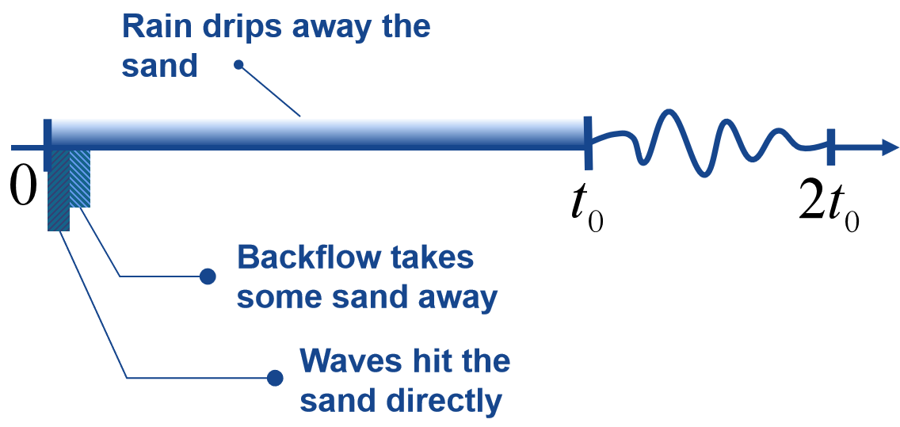**

**Figure 14.** Action time diagram of each layer

**It can be seen that the rain falls throughout the whole cycle. Compared with this, when the wavelength of sea wave is long enough, the length of the action time of the wave is much less than the length of the whole cycle. Based on this, this paper consider the effect of rain and seawater separately.**

**Still, we use 3d cellular automaton simulate the erosion process of sand castle. At each discrete moment, we firstly simulate the sand loss caused by the impact of waves and backflow according to the original erosion rule. This is followed by an additional step to simulate the sand loss caused by rain fall, which adds new rules for cellular state changes in cellular automata as follows.**

* During each cycle, we record  which denotes the number of sand cells lost due to the direct impact of waves.
* Find and record all sand cell whose state value is 0 (that is, there is no sand) directly above, which is called open sand cell, and the number of such sand cell is marked as .
* Calculate the value  according to the following formula. When , the state value of each open sand cell changes from 1 to 0 according to the probability. When , the state value of each open sand cell changes from 1 to 0 according to the probability  and the state value of  cell directly below the cell changes to 0.



#### 4.3.2 Simulation results and analysis of rain-wave sand castle erosion model

**The rain-wave sand castle erosion model constructed above is used to simulate the erosion of the sand castle with the best 3d shape obtained in requirement 1.**

### Requirement 4

**In addition to changing the three-dimensional shape of the sandcastle, there are two ways to make it durable. One is to dig ditches and build walls around the castle, which can withstand the waves and prevent some of the sand from escaping. The second is to add pebbles and shells to the sand to improve the strength of sandcastle itself.**

## Sensitivity analysis

**This paper uses probability to describe the disappearance process of some sand. In the stage of seawater reflux, the probability of sand disappearance  is related to the influence coefficient . So we adjust the value of . The other conditions are the same as in requirement 1. A total of five influence coefficients were used. In addition to the previous values, there are the following four:**

|  |  |  |  |  |
| --- | --- | --- | --- | --- |
| ****parameter**** | ****Test 1**** | ****Test2**** | ****Test 3**** | ****Test 4**** |
|  | **16** | **20** | **16** | **16** |
|  | **4** | **4** | **6** | **2** |
|  | **1** | **1** | **2** | **1** |

****Chart 4.** Parameters of sensitivity analysis**

**The change of residual quantity of the cube sandcastle with side length of 30cm corresponding to the five influence coefficients is shown in figure 15. It can be seen that the curves in the figure almost coincide with other lines. Therefore, it can be considered that when the relationship between the influence coefficient satisfy , it has little impact on the whole sandcastle erosion process. From this point, the stability of the model is strong.**

**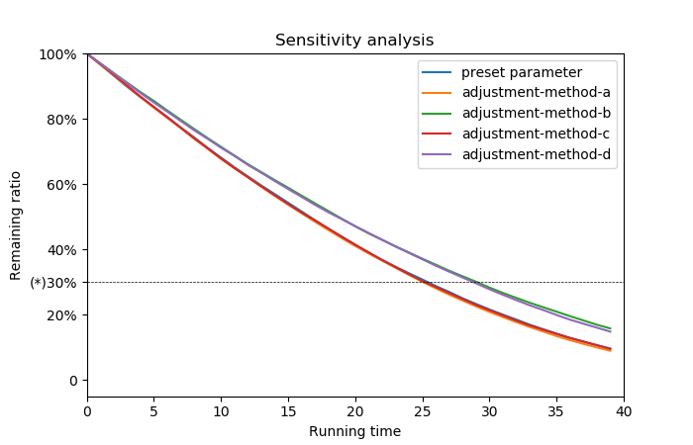**

**Figure 15.** Results of the **sensitivity analysis**

## Advantages and disadvantages

**Advantages:**

1. In this paper, we use the method of combining principle analysis and probability simulation, and successfully avoid the consideration of some complex motions, which can not only simplify the model but also fit the reality to a large extent.
2. When determining the best sand castle shape, we determine the characteristics of the best 3d shape step by step through the comparison among cubes, cylinders and hemispheres.

**Disadvantages:**

Using cellular automaton to simulate sand castle erosion may lead to the problem of insufficient accuracy.

## Promotion and improvement of the model

The erosion of the sandcastle by the waves is divided into two stages, which can actually be divided more detailed, such as adding the process of seawater flooding onto the sandcastle. That will absolutely help to improve the authenticity of the model.

A sand castle collapsing under the impact of too much seawater is also worth a considering.

The model proposed in this paper can be improved and applied to the evolution of river embankment and the control of soil erosion.

## Reference

1. **Hongwu Zhang, Hailei Bu. On the starting velocity formula of sediment [C] / / proceedings of the 8th national symposium on basic sediment theory research. Nanjing: Hohai University Press, 2011:400-407**
2. **Hongwu Zhang, Jiye Ma, Junhua Zhang, et al. River bridge design [M]. Beijing: China Building Materials Industry Press, 1993.**
3. **Jun Chen. Research on Simulation of Waves in Shallow Water[D]. Wuhan university of technology, 2011.**
4. **Xianli Xing, Tonglu Li, Kunlun Ju, Yukai Fu, Yu Xi. Experimental study on strength parameters of unsaturated loess [J]. Journal of Engineering Geology, 2015,23 (02) : 252-259.**
5. **J´erˆome Duriez , Sacha Duverger, Richard Wan. A Micromechanic , µUnsat , Approach for Wet Granular Soils.**

****How to Build a Strong Sandcastle****

**As you walk along the beach, enjoying the golden beach and the warm wind, have you ever noticed the sandcastles on the beach? They are in different style and different size, carrying the childlike of kids and dreams of adults, but ultimately unable to escape from the fate of being washed away by the waves. However, we can confidently tell you that there is a way to make your sandcastle weatherproof and enduring.**

**In fact, we have built a mathematical model to find the most enduring sandcastle shape in theory. First of all, the waves mainly affect the sandcastle through the frontal impact. We calculate the impact effect on the sandcastle according to the wave velocity. Second, the backflow of the water that hits the beach also carries away some of the sand. This process is too complicated to study it thoroughly. But fortunately, we can describe this process in terms of probability. With the above two parts, we can use cellular automaton to simulate the disappearance of sandcastle under the impact of waves.**

**Through constant comparison and adjustment, we found that the most durable sandcastle shape should have such characteristics. It has a smooth surface without edges and corners, and a sharp and thin shape of part facing the waves. If it's too hard for you to understand, you can imagine a rocket or a bullet in the head. And that’s exactly the best shape to build a sandcastle. Finally, we determined that a semi-ellipsoid sand castles could last the longest containing the same amount of sand, not forgetting that you need the thinner side facing the sea. But be careful not to build the front of the sandcastle too sharp, which can be sometimes just the opposite.**

**Things can change when it rains, and the falling water can wash over the top of the castle. To make your castle last longer, we suggest you stack it higher so that it doesn't drop off quickly in the rain.**

**In addition, we've all had the experience that sand is too dry to stack up, so adding the right amount of water to the sand can help you shape the castle, because the liquid changes the forces between the sand. Our recommended ratio of sand to water is 6:1 or 7:1. If you can pick up shells or pebbles on the beach, all the better, mixing them with the sand will make the castle stronger. Of course, you can also build strong defenses or moats for your sand castles. That will be cool.**

**Now, take your ideas to the beach and make your sand castle impregnable!**