Лаба 3.1.3

* 1. 30 шаровы = 25.03

M_1 = 0.834 g

* 1. = 18.6 mm

2r * 21= 123.7 mm

r = 2.95 mm

r_max \approx 21.55 mm

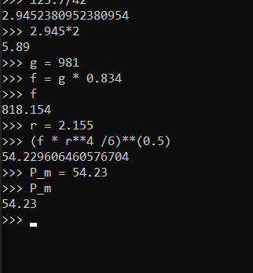

* 1. B_rem = 6340 G

260.29g

194.93g

M_s = 455.22 g

P_m = 91.4 CGS

2.1 5 колебаний кольца – 54 секунды

2.2

|  |  |  |  |  |  |  |  |  |  |
| --- | --- | --- | --- | --- | --- | --- | --- | --- | --- |
| 3 | 4 | 5 | 6 | 7 | 8 | 9 | 10 | 11 | 12 |
| 20 | 15 | 10 | 10 | 10 | 5 | 5 | 5 | 5 | 5 |
| 18.24 | 18.61 | 16.46 | 19.08 | 23.36 | 14.04 | 15.47 | 16.67 | 17.58 | 19.79 |
| 18.34 | 18.94 | 16.51 | 19.22 | 23.25 | 14.01 | 15.09 | 17.08 | 17.24 | 19.43 |
| 18.40 | 19.10 | 16.32 | 18.94 | 23.03 | 14.12 | 15.11 | 16.44 | 17.35 | 19.96 |

3.

|  |  |  |  |  |  |  |
| --- | --- | --- | --- | --- | --- | --- |
| 12 | 10 | 8 | 6 | 4 |  |  |
| 5 | 4 | 3 | 2 | 1 |  |  |
| 1+4 | +1 | +1+2-3 | +1+2-4 | +1+2-4 |  |  |

Диаметр 0.26 0.26 0.27

L1 = 16.9 cm

L2 = 18.0 cm

L3 = 6.5 cm

L4 = 9.0 cm