5/13/2026
Ali Ahsan
Cyberstaer
Task Report
C2 FRAMEWORKS & PHISHING INFRASTRUCTURE



CyberStar RED TEAMING
INTERSHIP TASK REPORT

Name | Ali Ahsan
Roll No | CSI-B1-427
Internship Program | Cybersecurity Red Teaming
Task Title | C2 FRAMEWORKS & PHISHING INFRASTRUCTURE
Instructor | Umar Niaz

Content:
Task 01-Sliver C2 Framework Deployment
Task 02-Payload Weaponization Techniques
Task 03-GoPhish Phishing Infrastructure
Task 04-Email Security & SMTP Analysis
Findings and Technical Observations
Security Recommendations

Summary:
Modern cybersecurity threats have become increasingly advanced, involving phishing infrastructures, malicious document weaponization, social engineering, and encrypted Command & Control (C2) communications. Attackers commonly use phishing platforms, spoofed domains, macro-enabled files, and deceptive payload delivery techniques to gain unauthorized access into organizations. These attacks are often managed through centralized C2 infrastructures capable of handling remote communication and command execution.
This internship laboratory was designed to provide practical exposure to these techniques within a safe and isolated virtual environment while emphasizing defensive concepts such as email authentication, domain protection, infrastructure monitoring, and user awareness. The laboratory environment consisted of a Kali Linux virtual machine and a Windows virtual machine communicating through an isolated Host-Only network architecture.

Task 01-Sliver C2 Framework Deployment

Introduction to Command & Control Frameworks:
A Command & Control framework is a centralized management system used to maintain communication between operators and compromised systems known as implants or agents. Modern C2 frameworks allow encrypted communication, payload management, remote command execution, multi-session handling, and beacon tracking across multiple systems simultaneously. The Sliver framework was selected for this exercise because of its modern architecture, opensource nature, and support for multiple communication protocols including HTTP, HTTPS, DNS, and Mutual TLS.
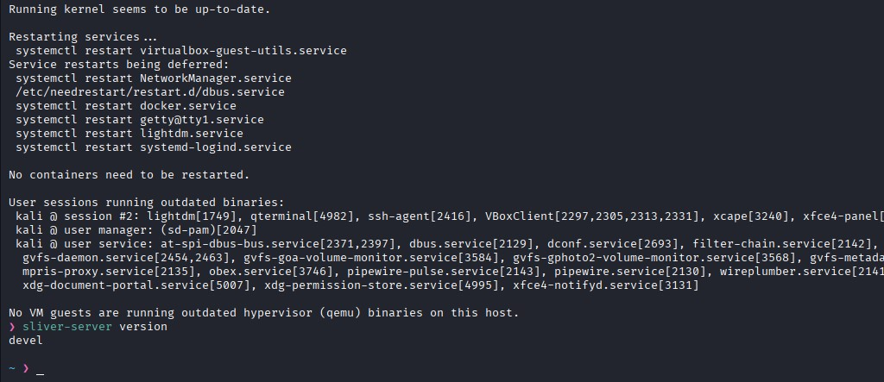

Sliver Installation and Integration:
The Sliver framework was installed successfully on the Kali Linux virtual machine environment. During installation, both client and server binaries were downloaded alongside local configuration files and certificate directories. Several operational issues emerged during initial deployment due to executable permission problems and missing binary accessibility through the Linux system path. Troubleshooting involved manually identifying the server binary, assigning executable permissions, and creating symbolic links inside /usr/local/bin/.
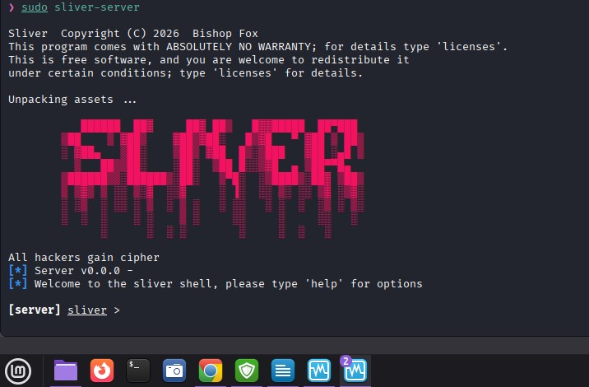

Network Architecture Configuration:
A Host-Only Adapter network configuration was implemented to ensure isolated communication between the Kali Linux machine and the Windows target machine. Connectivity validation was performed successfully using ICMP ping requests between both virtual machines.

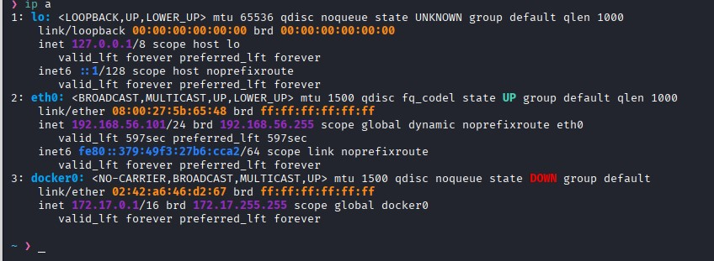

Service Stabilization and Troubleshooting:
The Sliver systemd service initially failed repeatedly due to malformed service configuration syntax inside the Linux service definition file. The issue originated from an incorrect execution path configuration which prevented the operating system from locating the Sliver executable.
The service file was corrected manually before reloading the Linux daemon using
sudo systemctl daemon-reload

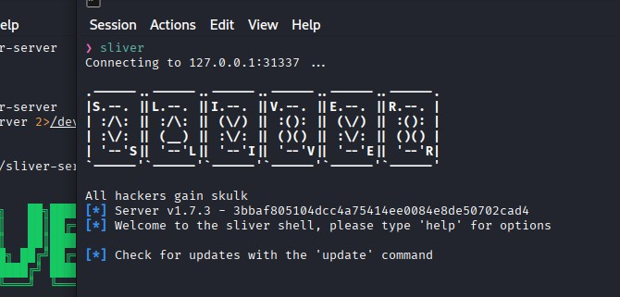

Listener Configuration:
An HTTP listener was configured on TCP port 8080 to simulate inbound implant communication. The listener successfully initialized and appeared inside the Sliver jobs management console, confirming operational readiness. This listener represented the communication endpoint through which implants would establish outbound beacon communication in real-world attack scenarios.

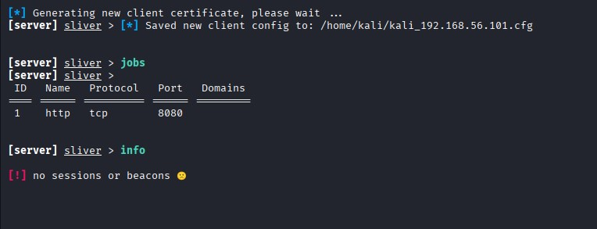

Operator Creation:
An operator profile was generated using the Sliver framework to simulate authenticated multi-user management capabilities. The framework initially returned an error because permissions were not specified during operator generation. This issue was resolved by assigning full permissions. A valid operator configuration file was subsequently generated successfully.
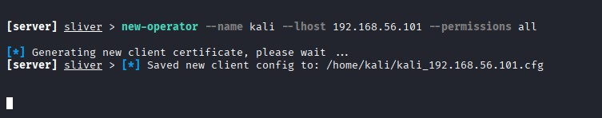

Operational Workflow and Observations:
Following listener deployment and operator creation, the Sliver environment transitioned into operational readiness mode. The framework supported
- Beacon communication
- Session handling
- Remote command execution
- Multi-session management
- Encrypted HTTP communications
No external implants were deployed because the objective of the exercise focused primarily on infrastructure deployment and listener validation inside a controlled environment. Several troubleshooting experiences improved understanding of Linux services, permissions, daemon configuration, and network management.

Task 02-Payload Weaponization Techniques:

Introduction to Payload Weaponization
Weaponization refers to the process of converting ordinary file formats into payload delivery mechanisms capable of executing unauthorized commands or malicious operations. Modern attackers commonly weaponize business documents, shortcut files, archives, and browser- based payloads to bypass user suspicion and security controls.
Microsoft Word VBA Macro Simulation:
A macro-enabled Microsoft Word document (.docm) was created to simulate how attackers embed VBA scripts inside business documents. The VBA editor was opened successfully inside Microsoft Word, and a module was created containing the AutoOpen () function. This function automatically triggers execution whenever the document is opened. The exercise demonstrated how attackers abuse trusted business documents to trigger automated execution behavior.
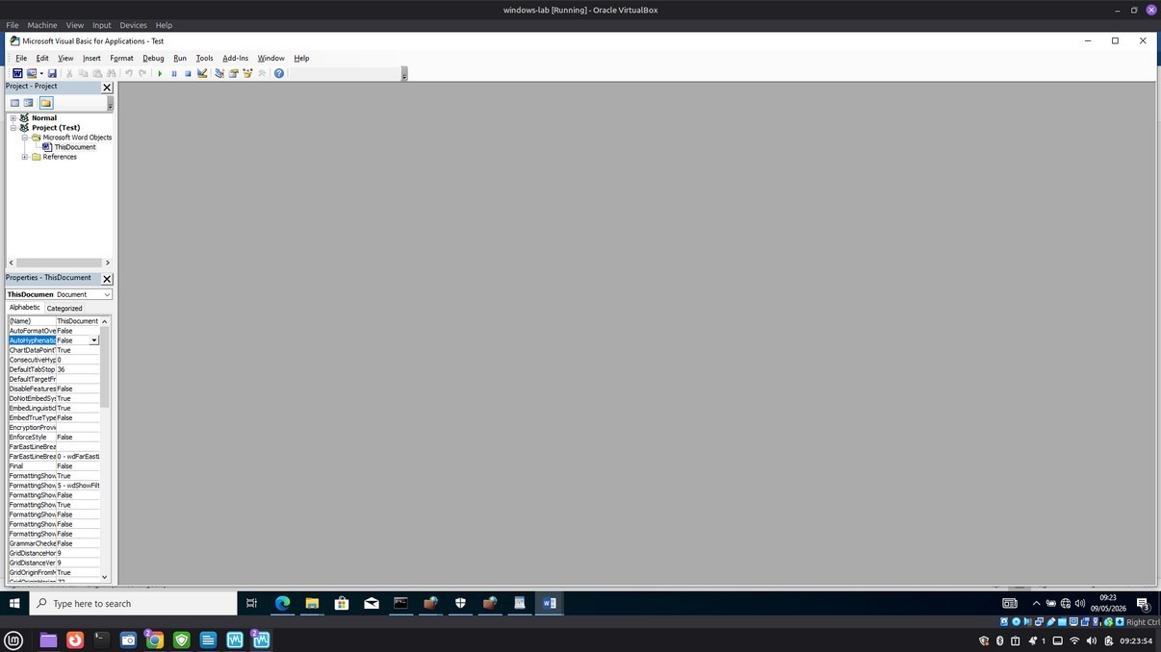

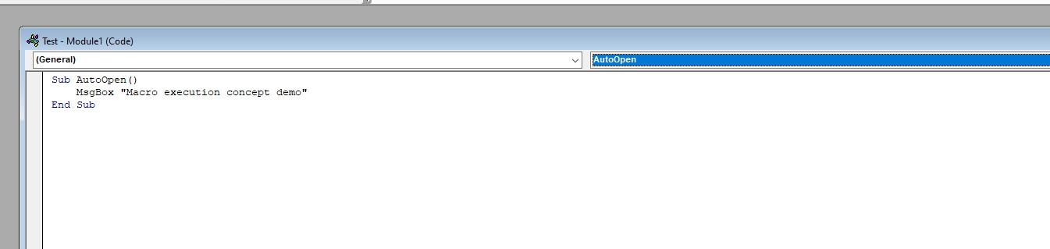

LNK Shortcut-Based Execution Simulation:
Windows shortcut files (.LNK) were analyzed as alternative execution mechanisms capable of triggering commands while appearing harmless to users. Shortcut generation was performed using both graphical and command-line methodologies. This exercise demonstrated how attackers abuse native Windows functionality to conceal command execution behind legitimate-looking shortcuts.
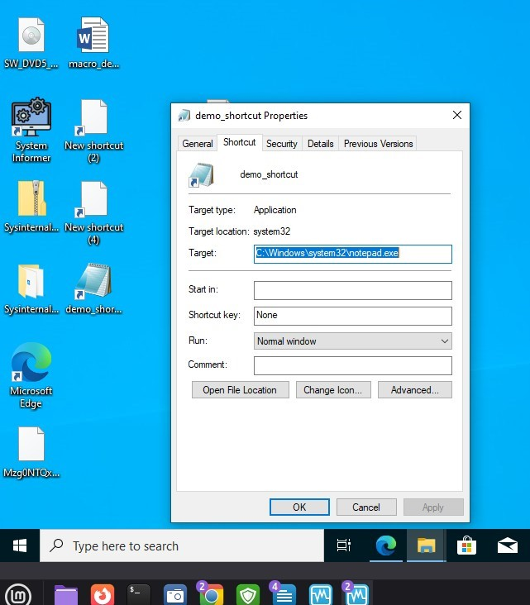

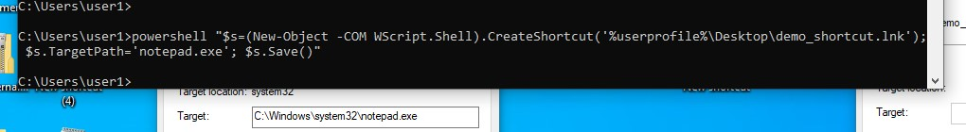

HTML Smuggling Conceptual Model:
HTML smuggling is a modern payload delivery technique where malicious content is encoded directly inside HTML and JavaScript. When opened inside a browser, the embedded script reconstructs the payload locally on the victim’s system. This technique is highly dangerous because the payload assembly occurs client-side, bypassing many traditional email security filters. The exercise focused on understanding the operational concept and structure of HTML smuggling methodologies.

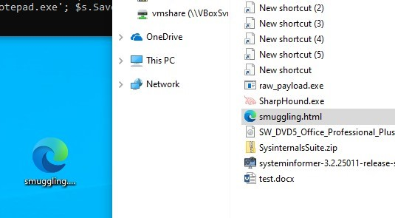

Security Implications:
The weaponization techniques explored during this exercise demonstrated how attackers exploit trusted business file formats and native operating system features to bypass user suspicion. These techniques reinforce the importance of
- Endpoint protection systems
- Macro restriction policies
- Email attachment filtering
- User awareness training
- Browser security controls
- Application whitelisting
Task 03-GoPhish Phishing Infrastructure

Overview of Phishing Infrastructure:
GoPhish is an open-source phishing simulation framework used to design, deploy, and monitor phishing campaigns inside controlled environments. The platform provides campaign analytics, email tracking, landing page management, and user interaction monitoring.
Installation and Initialization:
GoPhish was installed successfully within the Kali Linux environment and launched using the local HTTPS administrative interface.
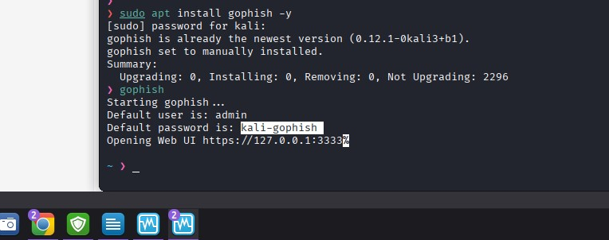

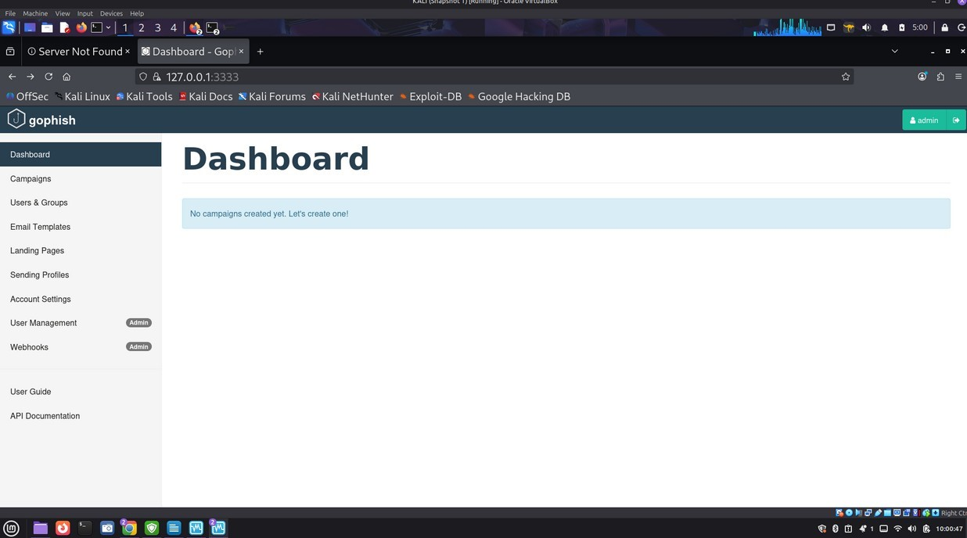

Dashboard Architecture and Metrics Interpretation:
The GoPhish dashboard provided centralized visibility into campaign statistics including
- Email delivery status
- Open rates
- User submissions
- SMTP delivery logs
- Click tracking
This dashboard simulated how organizations and red teams monitor phishing campaign performance metrics.
Email Template Engineering:
A phishing email template was designed using social engineering principles including urgency, professionalism, and authority simulation. The objective was to create a realistic email capable of mimicking legitimate organizational communication.

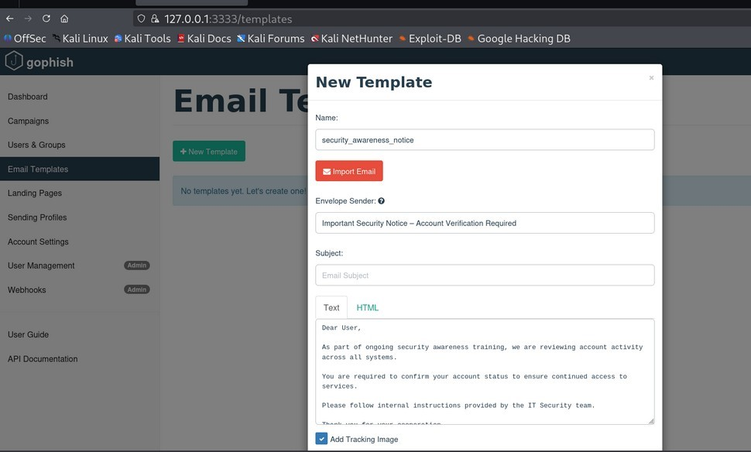

Landing Page Design and User Interaction Flow:
A phishing landing page was configured to simulate a credential collection portal. The page represented a cloned authentication interface designed to imitate legitimate login systems commonly targeted during phishing attacks.
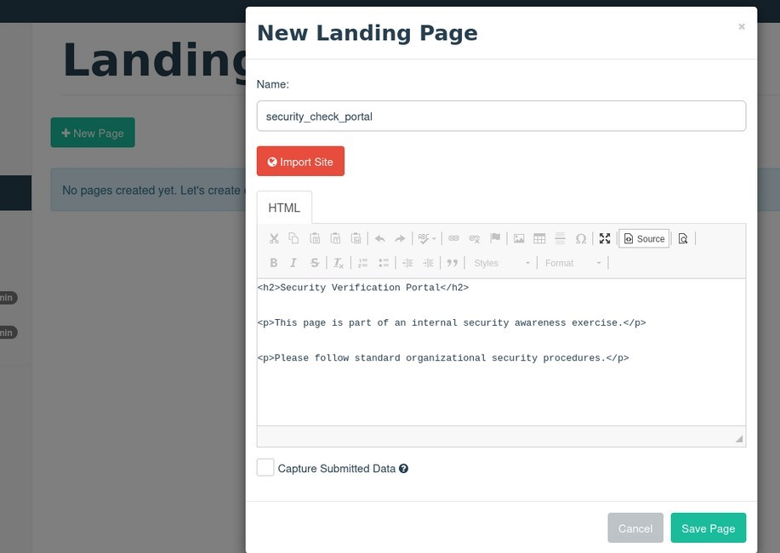

Campaign Execution and Monitoring:
- A phishing campaign was launched successfully by integrating
- Email template
- Landing page
- Target group
- Sending profile
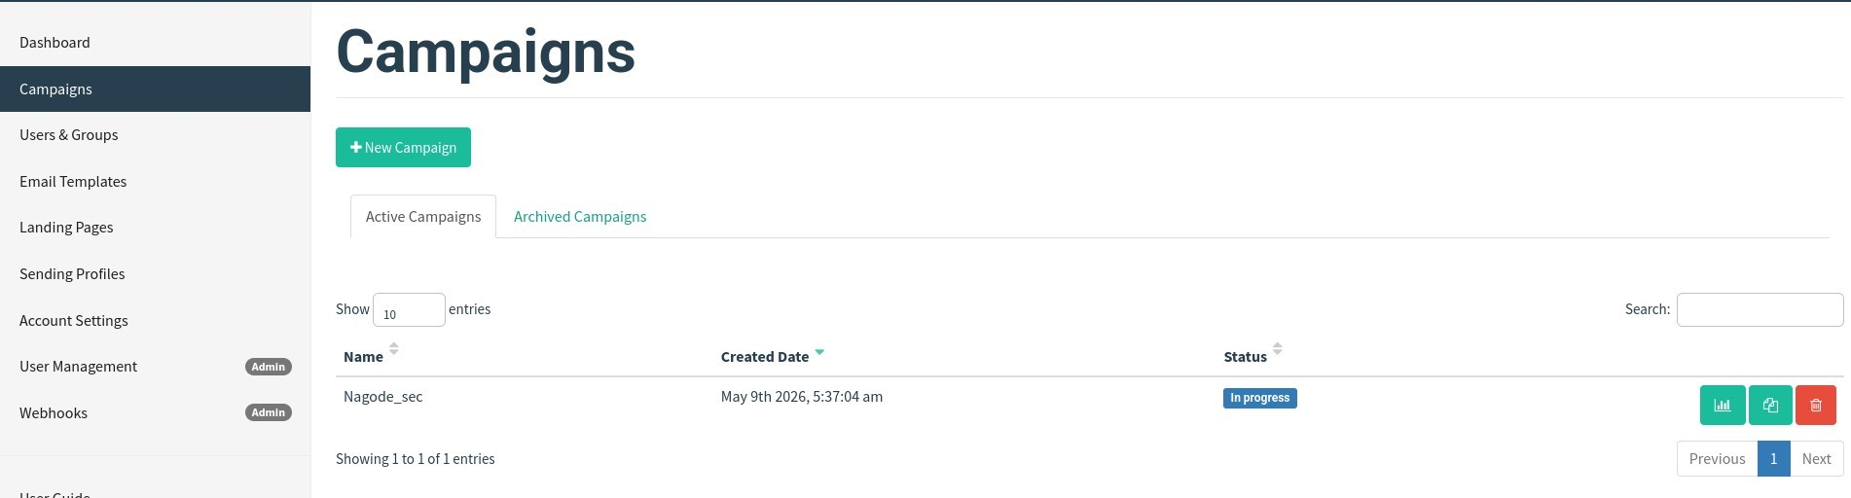

Results Analysis and Interpretation:
During campaign execution, SMTP delivery errors occurred because no active Mail Transfer Agent (MTA) was configured within the isolated lab environment. Despite delivery limitations, the exercise successfully demonstrated the full phishing workflow lifecycle including template creation, landing page management, campaign deployment, and analytics monitoring.
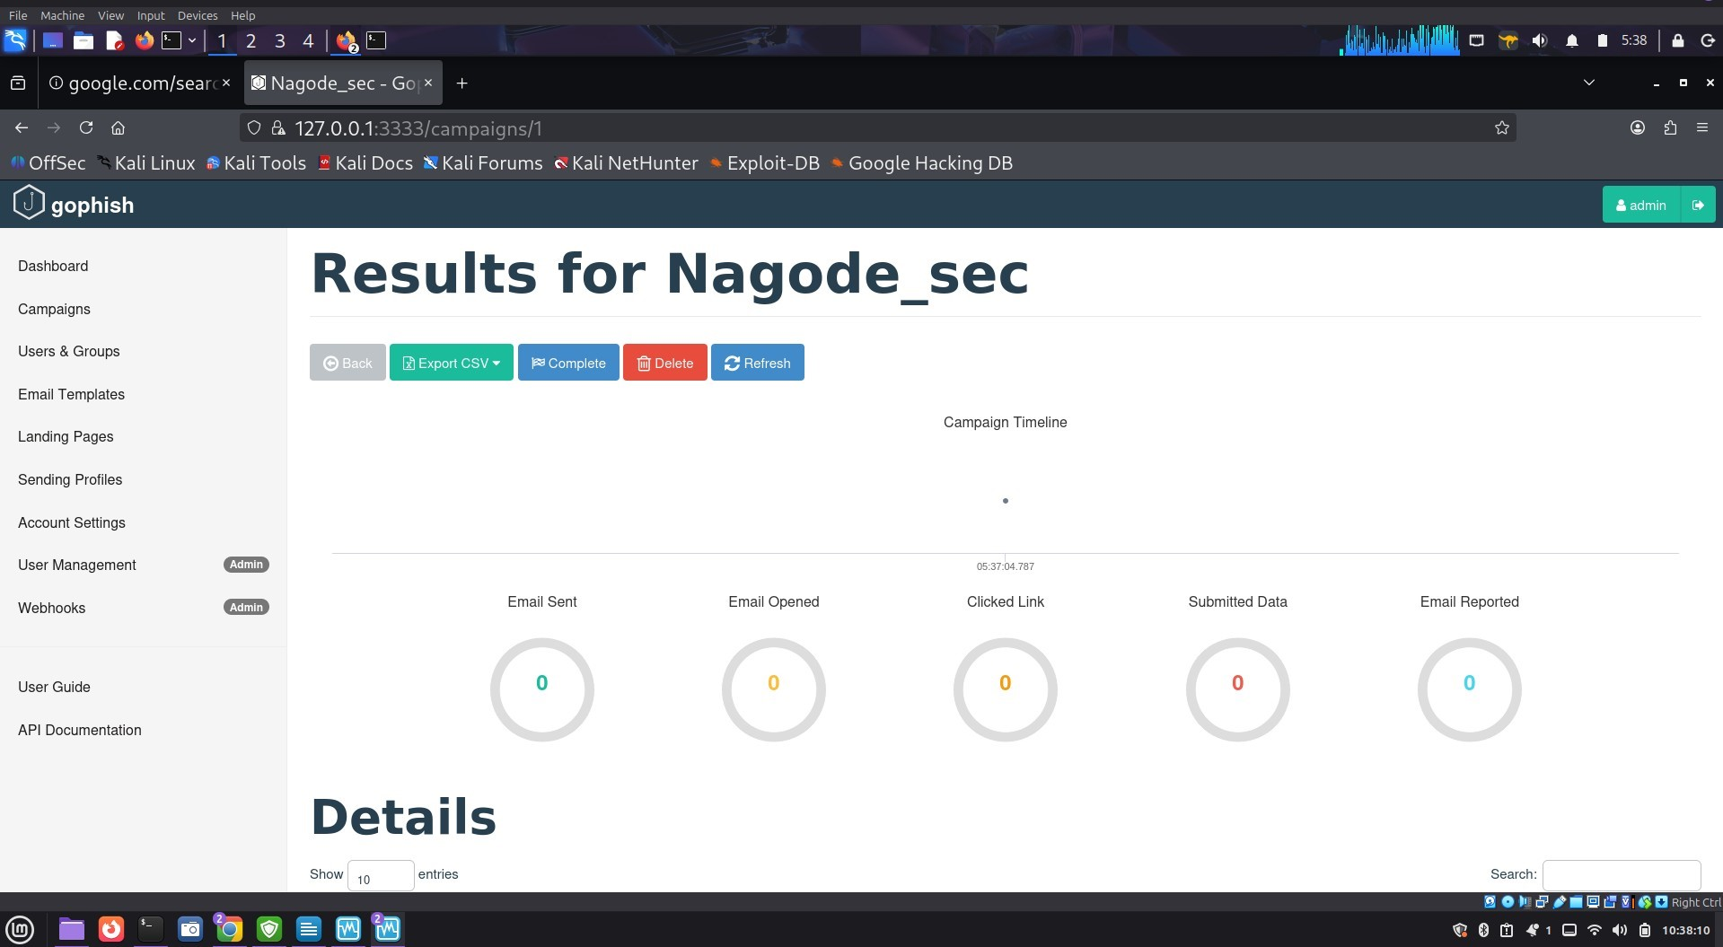

Limitations Observed in the Laboratory Environment:
Several operational limitations were identified
- Absence of external SMTP relay services
- No public email delivery capability
- Isolated laboratory restrictions
- Limited outbound communication infrastructure

Task 04-Email Security & SMTP Analysis

SMTP Communication Fundamentals:
Simple Mail Transfer Protocol (SMTP) is the standard protocol responsible for email transmission between servers. SMTP operates using a push-based communication model typically over TCP port 25. Understanding SMTP behavior is critical for both phishing operations and defensive email security analysis.
Sender Policy Framework (SPF):
SPF is an email authentication mechanism that validates whether a sending mail server is authorized to send emails on behalf of a specific domain. SPF reduces email spoofing by restricting unauthorized mail server usage.
DomainKeys Identified Mail (DKIM):
DKIM provides cryptographic email verification through digital signatures embedded inside email headers. This mechanism ensures message integrity and validates that email content was not modified during transmission.
DMARC Enforcement Policies:
DMARC combines SPF and DKIM validation results to enforce organizational policies regarding suspicious or unauthorized emails. DMARC policies may include
- None
- Quarantine
- Reject
These policies significantly reduce phishing abuse and email spoofing attacks.
Swaks SMTP Diagnostics and Testing:
Swaks was used to simulate SMTP communication and diagnose email delivery functionality. Connection attempts to localhost port 25 failed because no active Mail Transfer Agent existed inside the laboratory environment. This demonstrated the dependency relationship between SMTP services and email delivery infrastructure.
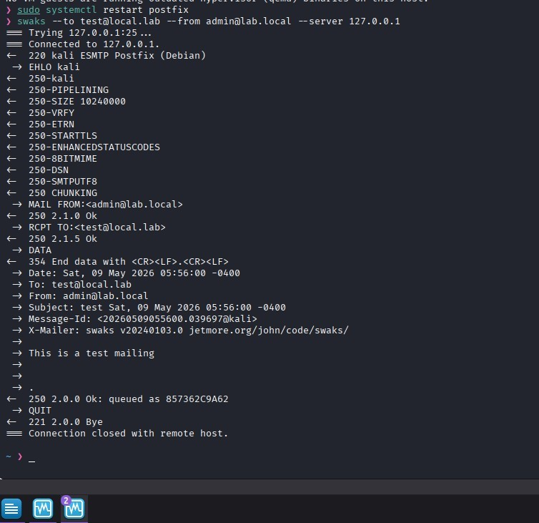

Typosquatting and Domain Impersonation:
Typosquatting is a deceptive attack methodology where attackers register domains closely resembling legitimate websites.
Examples include:
- goggle.com
- googlle.com
- go0gle.com
Attackers exploit typing mistakes, visual similarity, and user trust to redirect victims
Homograph Attacks and Unicode Abuse:
Homograph attacks extend typosquatting techniques using Unicode characters from different languages that visually resemble standard English characters. Examples include replacing Latin letters with visually identical Cyrillic or Greek characters. These attacks are extremely dangerous because malicious domains may appear visually identical to legitimate websites.

Defensive Security Recommendations:
To defend against phishing and domain impersonation attacks, organizations should implement
- SPF, DKIM, and DMARC policies
- Domain monitoring systems
- Email filtering infrastructure
- Endpoint protection solutions
- User awareness training
- Browser anti-spoofing protections
- Multi-factor authentication systems

TECHNICAL OBSERVATIONS:
The laboratory exercise demonstrated that
- Modern C2 frameworks require stable network and service configurations
- Linux permission management plays a critical role in infrastructure deployment
- Phishing infrastructures depend heavily on SMTP relay availability
- Macro-enabled documents remain highly abused attack vectors
- HTML smuggling techniques can bypass traditional email filters
- Email authentication mechanisms significantly reduce spoofing risks
- Domain impersonation attacks remain effective against unaware users

SECURITY RECOMMENDATIONS:
Organizations should
- Enforce strong email authentication policies
- Disable unnecessary Office macros
- Conduct regular phishing awareness training
- Monitor suspicious domain registrations
- Implement endpoint detection systems
- Restrict unauthorized script execution
- Deploy secure email gateways
- Use multi-factor authentication

