Chapter I

THE PROBLEM AND ITS BACKGROUND

Introduction
Weather nowadays has become more unpredictable because of the sudden changes due to global warming. In the study conducted by Anastasia M. (2023), she said that weather forecasting is essential to our daily lives, influencing areas such as agriculture, transportation, construction, energy production, and emergency management. Disasters are now more active than before thus monitoring this kind of events is a must to consider lessening the likeliness of high casualty rates.
For this study, to address the existing challenges on the performance of Luisiana's Municipal Disaster Risk Reduction and Management Office (MDRRMO), the researchers will construct a Real-Time Municipal Disaster Risk Reduction Information Management Web System to enhance public service efficiency of MDRRMO. A Real-time Information Management System enables end users to create, protect, read, update and delete data in a database. The area of Luisiana, Laguna is located at high altitude which is prone to disasters like landslides and though the place is in high land, other areas still experience other disasters that affect the residents. This leads us to conduct a study in the Municipal Disaster Risk Reduction and Management Office to identify and further lessen the burdens of their work. Our main purpose in this study is to have a user-friendly and accessible platform for disseminating disaster preparedness information, statistics, and emergency incident reporting in Luisiana, Laguna which limits community awareness and participation in disaster risk reduction efforts. This research can also discuss what are the realities and challenges to the functions of Luisiana's Municipal Hall.
The Municipality of Luisiana, Laguna, like many other municipalities, faces challenges in disaster risk reduction and management due to fragmented communication, lack of centralized data, and limited access to accurate and timely information. These issues hinder effective disaster preparedness, response, and recovery. To address these challenges, the Online Municipal Disaster Risk Reduction and Management Information Management System (MDRRMIS) will be developed. This system will provide a centralized database and an online platform to streamline disaster management processes, enhance communication, and empower the community by improving access to disaster-related resources and information.

Background of the Study
According to Radtke et al. (2018), the Philippines is the third most at-risk country in the world. The country's geographic location makes it prone to disasters; on average, 20 typhoons occur there each year (Information on Disaster Risk Reduction of the Member Countries, n.d.). Typhoons are a common occurrence in the Philippines, with the most affected areas being in the center and eastern part of the country. Because the locals are accustomed to these occurrences, little preparation is made.
In this modern day, technology is gradually rising up and most of our municipalities. The Municipality of Luisiana, Laguna recognizes the need to modernize its public service delivery to improve efficiency, transparency, and accessibility for its constituents. In accordance with Sakthivel's article, N. (2024), titled Weather Forecasting, emphasizes how important weather forecasting is for a variety of aspects of human existence, including organizing outdoor activities, transportation, agriculture, and disaster preparedness. Accurate forecasts reduce the impact of extreme weather events, increasing public safety and preparedness. Weather forecasting helps people make informed decisions by providing important meteorological information like temperature, wind speed, and humidity. The integration of sophisticated technologies, such as machine learning and high-performance computing, has substantially enhanced the reliability of these projections, making them more actionable and valuable for society.

Scope and Delimitation of the Project
The primary goal of the study is to create an Online Municipal Disaster Risk Reduction and Management Information Management System (MDRRMIS) for the Municipality of Lusiana, Laguna. The respondents for this study were seventeen (17) workers from the MDRRM, twenty-three (23) barangay captains, and one-hundred-sixty (160) coming from the community members, which makes it a total of 200 respondents in the Municipality of Luisiana, Laguna. They will be assessed to collect information with regards to the disaster events in different areas and their current situation.
The MDRRMIS will cover the following:
- Municipal DRRM Office (MDRRMO): Overall management of the system, data analysis, tracking of users (admin, brgy. coordinators, and community users) activities through audit-logs, and resource allocation.
- Barangay DRRM Coordinators: Use the platform for confirming reports, find nearest barangay hall/evacuation center, contact office of MDRRM and its community, upload reports on community engagements, resource tracking, and community support.
- Community Members: Access disaster-related information, report incidents, contact the MDRRM office, identify news and statistics related to incidents happening in the municipality, and submit comments with regards to the website.
- Integration of disaster-related statistics for local government planning and decision-making.

Statement of the Problem
The challenge of effectively coordinating disaster preparedness and response efforts in Luisiana, Laguna is compounded by the lack of a shared information platform among key stakeholders. The lack of a user-friendly and accessible platform for disseminating disaster preparedness information and statistics in Luisiana, Laguna limits community awareness and participation in disaster risk reduction efforts. This research proposes the development of a web-based system to improve information sharing and promote community resilience.
Specifically, it sought to answer the following:
- Effectiveness of MDRRM’s method of communication channels with barangays before and after hazards are in terms of;
  - . Public speakers;
  - . Messenger App; and
  - . Walk-ins.
- What is the status of MDRRMO’s community awareness and participation in terms of:
2.1. Public Access to Information;
2.2. Limited Community Engagement; and
2.3. Disseminating Targeted Information.
3. Effectiveness of the proposed website on providing a comprehensive information on disaster preparedness and awareness in terms of:
3.1. Data Statistics;
3.2. Hazard Maps; and
3.3. Incident Reporting.
4. Does the system fulfill the MDRRM’s gap on assuring that residents acquire comprehensive understanding on disaster risk reduction and awareness of information on hazards happening in the areas?
Hypothesis of the Study
The implementation of the MDRRMIS significantly improves disaster preparedness, community awareness, and response coordination in the Municipality of Luisiana, Laguna.
These hypotheses will be tested through a comprehensive evaluation of the system’s effectiveness in enhancing data-driven decision-making, information dissemination, and community participation in disaster risk reduction and management efforts.
Theoretical Framework
The development of the Online Municipal Disaster Risk Reduction and Management Information System (MDRRMIS) is anchored in established theories that support disaster preparedness, effective communication, and information system integration. The Disaster Risk Reduction (DRR) Theory, as outlined by the United Nations Office for Disaster Risk Reduction (UNDRR, 2019), emphasizes proactive measures such as risk assessment, preparedness, and early warning systems to minimize disaster impact. This theory supports the study’s goal of establishing a centralized database, improving real-time monitoring, and enhancing community resilience through an accessible online platform.
Additionally, the Crisis Communication Theory by Coombs (2007) highlights the significance of effective information dissemination before, during, and after a crisis. MDRRMO’s current communication channels—public speakers, messaging apps, and walk-ins—have limitations in reaching a wider audience. By integrating a real-time online portal, the proposed system aims to enhance disaster communication, ensuring that critical information reaches stakeholders efficiently and in a timely manner.
The Information Systems Theory by Alter (1999) supports the role of technology in improving decision-making and organizational efficiency. The proposed MDRRMIS incorporates data analytics, structured reporting tools, and public access to disaster-related information, addressing existing gaps in community engagement and risk awareness. By leveraging these theoretical foundations, the system enhances disaster preparedness, response coordination, and data-driven decision-making, ultimately strengthening the resilience of the Municipality of Luisiana, Laguna.

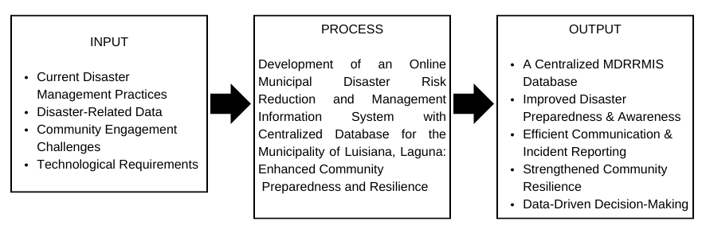
Conceptual Framework
Figure 1. Conceptual Framework of the Online Municipal Disaster Risk Reduction and Management Information System (MDRRMIS) Using the Input-Process-Output Model
The Figure 1 shows the conceptual framework of the Online Municipal Disaster Risk Reduction and Management Information System (MDRRMIS) using the input-process-output (IPO) model which will serves as the foundation for developing the Online Municipal Disaster Risk Reduction and Management Information System (MDRRMIS). This model outlines how disaster-related data and system functionalities are structured to improve preparedness, response coordination, and community resilience.

Objectives of the Study
- To establish a centralized database for managing disaster-related data and resources.
- To provide real-time tools for disaster monitoring, incident reporting, and response coordination.
- To enhance community engagement and awareness through an accessible online portal for disaster preparedness resources.
- To improve data-driven decision-making with analytics and reporting tools for municipal DRRM planning.
- To strengthen disaster resilience by fostering timely and effective coordination among the MDRRMO, barangay DRRM coordinators, and the community.

Significance of the Study
The result of this study (MDRRMIS) will benefit the following:
MDRRMO. This study can contribute to the department itself by improving efficiency in disaster management operations and resource allocation.
Barangay DDRM Coordinators. The result of this study will help by enabling faster and more effective response to disasters.
Community Members. It would be beneficial to residents as the study will help them increase their access to critical information and resources during disaster.
Local Government. This study will help them by providing accurate data for planning, budgeting, and policy development to enhance disaster resilience.
Future Researchers. The data gathered in this study can serve as a source of information for further research on creating web-based information management systems, offering avenues for future studies to improve and develop a full functioning and real-time web-based information mana.
Definition of Terms
MDRRMO. Acronym for Municipal Disaster Risk Reduction and Management Office. It is a municipal department/office tasked to monitor disaster events, emergencies, and monitor CCTVs around the municipal's town plaza.
Disaster. It is a serious disruption to the functioning of a community or society, causing widespread human, material, economic, or environmental losses that exceed the ability of the affected area to cope using its own resources.
Hazard. It is a source or a situation with the potential for harm or damage in terms of human injury or ill-health, damage to property, damage to the environment, or a combination of these.
Risk. The likelihood or probability that a person will be harmed that will cause damage or injury.
Planning. The proactive process of developing strategies and procedures to prepare for, respond to, and recover from potential disasters.
Communication Channel. The specific medium or method used to deliver important information to affected populations during an emergency.

CHAPTER II
REVIEW OF RELATED LITERATURE
Foreign Literature & Studies
Disaster
Based on the study of Wawomeo (2022), he defines disaster as a disruptive event that has a threat with our lives and livelihoods due to natural or human factors, leading to casualties, environmental damage, and loss of property, emphasizing community vulnerability and preparedness. Experiencing disaster creates trauma normally if the disaster results in a total loss of a family. Additionally, there are different kinds of disasters which according to Kale and Oka (2022), in their study titled "Disaster Management: A Review” this negative event that impacts human population are earthquakes, floods, conflicts, health epidemics, or industrial accidents.
In the article written by Chandrappa and Das (2021) they assert that a disaster is a major disruption that happens quickly, it is likely to have far-reaching effects, which affects a larger number of people than an emergency. In addition, according to the article created by Cui et al. (2021), the likelihood of disasters due to earth processes and climate change is growing. Climate-related changes in the frequency and severity of catastrophes also have an impact on other kinds of disasters. Compound, cascading, and extra-large disasters will still happen. The likelihood of a disaster is growing as it becomes harder to forecast their intensity.
In conclusion, disasters are major disruptions with swift onset and significant effects, impacting more people than typical emergencies. As the causes and effects of these disasters can vary greatly, classification is crucial for creating focused planning and response plans (Chandrappa and Das, 2021).
Disaster Preparedness
According to Figg's study (2023), disaster preparedness entails teaching and preparing people to deal efficiently with crises and catastrophes. Furthermore, he highlights that disaster preparedness involves community preparation and educated engagement to lessen the effects of calamities.
According to the research conducted by Ciottone and Keim (2023), disaster preparedness encompasses several crucial actions meant to guarantee readiness for any situation. Risk assessment, resource allocation, training, and communication tactics are important. Maintaining service continuity, safeguarding public health, and guaranteeing quick response times are the fundamental goals of health care. In order to create comprehensive plans that meet the particular difficulties presented by diverse disaster types, government agencies, healthcare providers, and the community must work together. This is necessary for effective disaster preparedness.
According to Toyosawa et al.'s study from 2024, there are four motivational categories that affect disaster preparedness. These motivating categories include introjection of societal norms, avoidance of bad effect, other-oriented motivation, and personal significance. These incentives were found to positively correspond with several forms of preparedness, including autonomous, household, and continuous preparedness. Gaining insight into these drivers can aid in the creation of practical plans to improve community and individual preparedness practices.
In conclusion, disaster preparedness is a multifaceted approach that combines education, community involvement, and strategic planning. By recognizing the various factors that motivate individuals and communities, stakeholders can develop tailored strategies that not only enhance readiness but also foster a culture of resilience. Ultimately, a collaborative effort among all sectors is essential to ensure that communities are well-equipped to face the challenges posed by disasters.
Data Analytics
According to Rakhonde et al. (2024), data analytics is essential to disaster management because it uses big data techniques to forecast severe weather, evaluate risks, and improve response plans, which ultimately reduces economic losses and improves preparedness for natural disasters and agricultural events. In addition, modern technological advancements lead to a more efficient way of life by creating machines that can analyze or predict certain hazardous events.
According to Kamoji et al. (2023), data analytics on disasters entails analyzing social media data, especially from platforms like Twitter, to categorize information about resource availability and needs during catastrophic events. Deep learning and natural language processing techniques are used for effective analysis. In fact, social media platforms have revolutionized disaster management by facilitating effective communication, information sharing, and collaboration among stakeholders. These technologies give authorities, disaster management professionals, and at-risk communities the ability to gather information and deliver life-saving messages more quickly and efficiently (Social Media in Disasters - PrepareCenter, 2024).
In the study "Assessing long-term impacts of disaster using predictive data analytics for effective decision support" by Mishra (2023) emphasizes how data analytics on disasters uses a variety of datasets and machine learning techniques to assess both short-term and long-term impacts, guiding emergency management and policy decisions. Effective forecasts and suggestions for aiding disaster victims and their communities are made possible by it.
In summary, data analytics plays a crucial role in disaster management by utilizing big data techniques to predict severe weather, assess risks, and enhance response strategies. The use of machine learning techniques to assess both short-term and long-term impacts leads to more effective for disaster-affected populations.
Information Management Web System
Based on the article published by Sarusu et al. (2024) entitled, “Sistem Informasi Manajemen Data Penduduk Berbasis Website”, the study highlights information management web system allows real-time data processing, reduces human error, and facilitates public participation in managing demographic information through a user-friendly online platform.

Local Literature & Studies
Our realities are shaped by disaster. In the study created by Bonifacio, G. T., & Epe, R. B. (2023), the study states that growing up in the Philippines allowed us to witness the devastation caused by natural catastrophes, which has a lasting impact on our conscience. In fact, the Philippines’ location in the Pacific Ring of Fire makes it a country prone to earthquakes, while its tropical climate makes it vulnerable to typhoons (Alcayna et al et al 2016).
According to the study "Relief Operations among Selected Typhoon Disasters in the Philippines: A Work Plan for Disaster Relief Management" by Krista et al. (2023), a disaster is defined as a major adverse event that interferes with regular operations and impacts people, property, and the environment. A National Disaster Risk Reduction and Management Plan is also in place in the Philippines, with a focus on readiness, response, and recovery in order to successfully lessen these effects. Plans are as important as taking care of ourselves during a disaster. Having plans in mind keeps us away from having high casualties.
In conclusion, the realities of living in a disaster-prone country like the Philippines underscore the importance of preparedness and effective management strategies. By understanding the risks and having well-structured plans in place, communities can better navigate the challenges posed by natural calamities, ultimately leading to a more resilient society.

Feasibility Study
This study evaluates the feasibility of implementing a comprehensive web-based information management system for Municipality of Luisiana, Laguna, prompted by citizen and official concerns regarding the disaster preparedness and awareness on hazards that occur in areas of the municipality. By examining technical, economic, operational, and logical aspects, the study aims to determine the project's viability and potential to streamline departmental services. Furthermore, this analysis explores the potential benefits and challenges of implementation, providing a foundation for informed decision-making and highlighting key factors critical to successful project execution.
Technical
From a technical standpoint, the study will assess the availability and suitability of hardware, software, and network infrastructure to support the proposed system. This includes evaluating database solutions, server capacity, cybersecurity measures, and compatibility with existing municipal systems.
Operational
This section assesses the operational feasibility of the proposed Information Management System within the operations of Luisiana Municipality's department as well as its residents. The evaluation will focus on the system's integration with current workflows, analyzing staff training requirements, potential implementation disruptions, and impacts on daily operations. It will also assess staff adaptability and their ability to effectively utilize the new system to determine if the project is operationally viable.
Economic
A thorough cost-benefit analysis is carried out, considering the continuing maintenance cost, and initial development expenditures.
Cost Estimates: ₱ 2,500.00
Development Costs: Estimated ₱ 0.00 - ₱ 2,500.00
Operational Costs: ₱ 1,200.00
- Domain: Estimated ₱ 600.00
- Web Hosting: ₱ 200 per month (3 months) = ₱ 600.00
Funding Sources:
- Members Allowance
The purpose of this part is to make the financial effects of installing the Municipality risk reduction information management system as transparent as possible. To clearly indicate whether to move forward with the project based on its economic feasibility, the findings will highlight if running the system is financially sound and in line with the municipality's economic objectives.
Logical
The logical feasibility of a data management system in Luisiana hinges on its ability to solve the problem of inefficient knowledge with hazards that occur in different parts of barangays as well as monitoring the risks of it, a concern of both citizens and officials. The study will assess if the system's functionalities directly correlate with desired improvements in information delivery, transparency, and efficiency.
Importance of Project
The reporting of incidents and the dissemination of past incident statistics are currently conducted through platforms such as Messenger and Facebook. However, the establishment of a more comprehensive communication and learning system would significantly enhance public awareness of local events. Furthermore, this approach will provide valuable insights into the benefits of implementing a web-based information management system within the framework of local government. Such a system is expected to improve the effectiveness, transparency, and citizen-centric focus of the public service delivery system in Luisiana, Laguna.
This research study is significant as it directly addresses the pressing need for enhanced service delivery and information management within the Municipality of Luisiana. The implementation of an information management web system has the potential to increase staff productivity, streamline processes, enhance public satisfaction, and promote good governance. Ultimately, this contemporary approach aims to benefit the entire community of Luisiana, Laguna, by improving the efficacy and efficiency of municipal operations while fostering a more transparent, accountable, and citizen-centered government.

CHAPTER III

PROJECT METHODOLOGY
This section of the research study focuses on the methods used and procedures performed during the development and implementation of the user-friendly and accessible platform for disseminating disaster preparedness information and statistics websites. Specifically, it includes the research design, locale and population of the study, data collection methods, project design, and time frame plan.
Research Design
This study aimed to assess the importance of a user-friendly and accessible platform for the Luisiana MDRRM to disseminate disaster preparedness information and statistics. A mixed-methods approach, incorporating both quantitative and qualitative research designs, was employed to achieve this objective.
This study employs a mixed-methods approach. Quantitative analysis, using PageSpeed Insights, systematically measures and evaluates the website's efficiency through performance metrics. Complementing this, qualitative research, via survey questionnaires, gathers evidence-based insights into the website's effectiveness for both MDRRM representatives and municipal residents, exploring user and administrative experience and satisfaction.

Problem Identification
Luisiana, Laguna is a highly elevated place which measures 1155 ft. (352 m) above sea level. The town is known as Little Baguio of Laguna and is known for its cold climate and mostly rainy weather. Due to abnormal weather, Municipal Disaster Risk Reduction (MDRRM) experiences countless challenges with helping residents avoid hazards that occur from it. The MDRRM’s objective is to help residents be prepared and aware of unforeseeable hazards that occur from each of their areas, depending on the area’s topography. Also, the goal of this study is to empower residents to tell their own stories in public to know the events happening in their area. This will lead residents to be more aware of hazards.

Locale and Population of the Study
The respondent for this study consists of twelve (12) MDRRMO Staff, twenty-three (23) Barangay Coordinators and one-hundred-sixty (160) Community Members who reside in Luisiana, Laguna. Utilizing Stratified Random Sampling (SRS) ensures that barangay captains, MDRRM office participants, and general participants are proportionally and equitably represented, thereby enhancing the reliability and generalizability of the findings.
Table 1. Respondents of the Study.
Strata | No. of Participants
MDRRMO Staff | 17
Barangay Coordinators | 23
Community Members | 160
Total | 200

Table 1 illustrates the study’s participants. There are a total of two-hundred (200) participants, with one-hundred-sixty (160) participants coming from community members all-over the Luisiana, a total of twenty-three (23) barangay coordinators, and seventeen (17) staffs coming from the office of Municipal Disaster Risk Reduction (MDRRM).

Statistical Treatment of Data
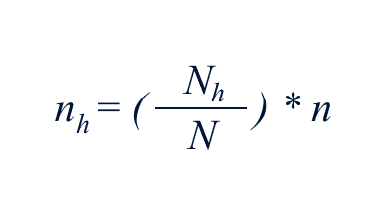
This study employed the stratified random sampling technique to ensure proportional and equitable representation of barangay captains, participants from the Municipal Disaster Risk Reduction and Management (MDRRM) office, and general participants. This approach enhances the reliability of the data and the generalizability of the findings by effectively capturing the unique characteristics of each subgroup. Additionally, the sample was allocated proportionately across all strata based on their actual population sizes, utilizing the following formula.

Where:
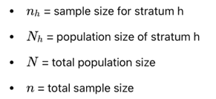
Data Collection Analysis
This section outlines the various techniques employed to gather essential information for the development of the Municipal Disaster Risk Reduction and Management (MDRRM) information management website. It details the processes involved in client surveys and the operational methods utilized by the researchers. Additionally, this section provides a comprehensive overview of the data collection methods employed, including surveys, questionnaires, and both online and library research, which were instrumental in gathering the necessary data and information.
Library Research
The researchers utilized the main library of PHINMA Union College of Laguna to gather insights and relevant studies pertinent to the development of the information management website. They reviewed previous research that served as a foundational reference for the current study's format. Furthermore, related studies, among others, were also examined to enhance the research further. The materials and resources collected were found to be valuable for both documentation and project development.
Online Research
In this study, the researcher considered gathering relevant topics/references on the web. With the use of browsing relevant information from articles and studies, the researchers acquire further knowledge about information management websites. Foreign and even local studies and articles were utilized, which helped the researcher to grasp the gaps this capstone project still needs to fill.
Surveys and Interviews
The MDRRM workers, barangay captains, and residents of Luisiana, Laguna were subjected to answer surveys/interviews for this study. The Barangay captains and residents will be the basis to assess MDDRM’s website user experience and satisfaction, while the MDRRM’s workers answered surveys and questionnaires will provide the basis to assess the admin experience and satisfaction.
Both the survey questionnaires include questions which evaluate the MDRRM’s operation and, the website. Questions which regards to MDRRM’s method of using mediums as communication panel (Public Speakers, Messenger App, Phone Calls, and Walk-ins), status of awareness and participation of the community in Luisiana (Public Access to Information, Limited Community Engagement, and Disseminating Targeted Information), website’s effectiveness on providing comprehensive information on disaster preparedness and awareness (Data Analytics, Hazard Map, Risk Reduction Planning, and Communication Channel).
Using the Likert Scale, respondents will be asked to rate their level of agreement with the given statements for evaluation, rating from strongly disagree to strongly agree. The researcher will use a weighted mean to categorize the respondents’ comprehension level and evaluate MDRRM’s website’s overall effectiveness. The weighted mean is comparable to the arithmetic mean, the most common type of averaging, in that each data item contributes equally to the total average.
Where: WA = n = N / (1 + Ne2)
WA - Weighted Mean.
TNR - Total number of respondents.
SD - Strongly Disagree.
D - Disagree.
N - Neither.
A - Agree.
SA - Strongly Agree.
Table 2. Five-Point Likert Scale Method
Scale | Description | Verbal Interpretation
1 | 1.00 - 1.49 | Strongly Disagree (SD)
2 | 1.50 - 2.49 | Disagree (D)
3 | 2.50 - 3.49 | Neutral (N)
4 | 3.50 - 4.49 | Agree (A)
5 | 4.50 - 5.00 | Strongly Agree (SA)
Table 2 outlines the evaluation methodology, which will be analyzed through the Five-Point Likert Scale. The responses to each question across all survey instruments will be aggregated and employed to evaluate both user and administrator experiences, as well as their levels of satisfaction.
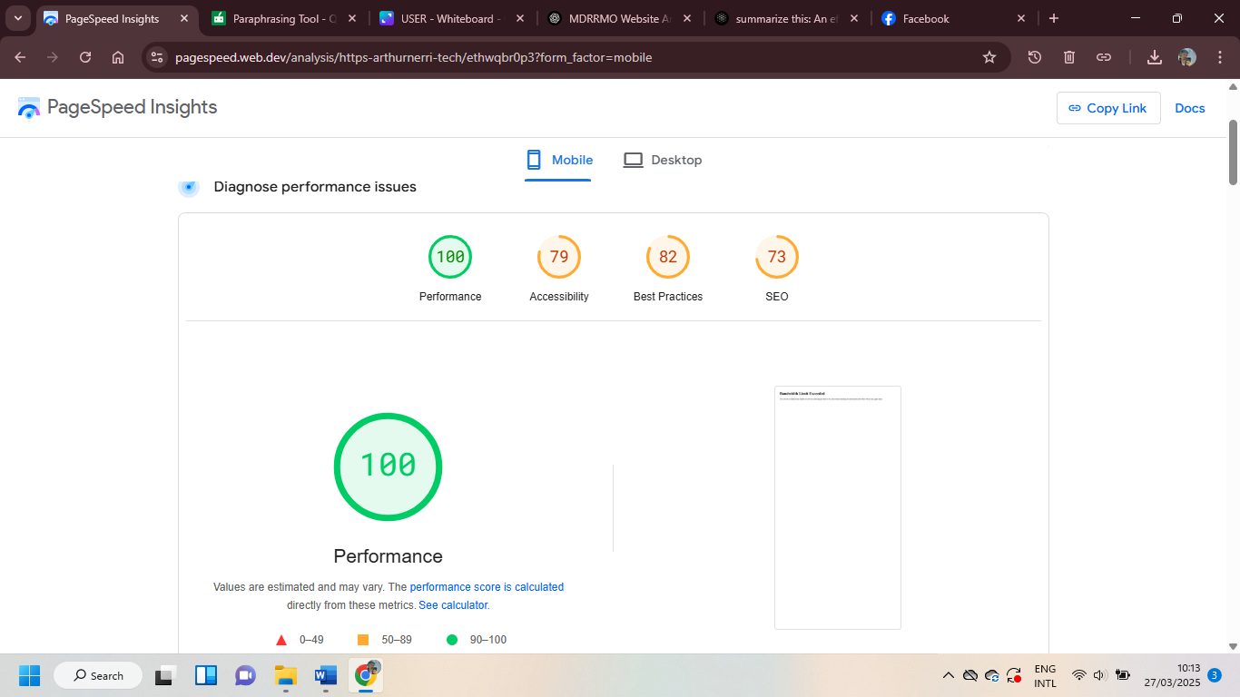
System Evaluation

Figure 2. PageSpeed System Evaluation
Figure 2 show the evaluation of the website MDRRMIS. The PageSpeed Insights report in the image evaluates the performance of the website on mobile devices. The website achieves a perfect 100/100 performance score, indicating fast loading times and optimal efficiency. However, there are areas for improvement in Accessibility (79/100), Best Practices (82/100), and SEO (73/100). These scores suggest the need for enhancements in accessibility features, adherence to web development best practices, and search engine optimization. The insights provided can help developers refine the website to ensure a better user experience across all metrics.
Project design
This project aims to benefit the community by providing real-time updates regarding emergencies and resources for those impacted. Essential features will encompass interactive maps, resource inventory, analytics, an incident reporting system, current news updates, warning system and a communication engagement portal for disseminating critical alerts and announcements. The design will emphasize user-friendliness and accessibility to guarantee that essential information is effectively communicated to all residents.
SOFTWARE DEVELOPMENT MODEL
In software development, it is hard to choose the right development model. It is crucial to ensure that the project progresses smoothly and meets the goals of the system. In this study, the agile model is used as the software development approach in developing document tracking systems. The Agile model follows an iterative and flexible process, allowing continuous improvements based on feedback. Agile methodology is an iterative and flexible approach to software development, during each sprint, teams develop, test, and review a small part of the product, gathering feedback to make continuous improvements. The process emphasizes collaboration, adaptability, and delivering functional software frequently, allowing for changes based on customer feedback throughout the development cycle.
REQUIREMENT GATHERING AND ANALYSIS
Assessing the community's vulnerabilities to natural and man-made hazards, inventorying available resources (personnel, equipment, and finances), evaluating the capabilities of the staff and volunteers, and identifying gaps in knowledge or training. It also includes reviewing current disaster management plans, communication and early warning systems, and assessing legal and financial aspects. Engaging with local communities and stakeholders is key to understanding their needs, while also prioritizing resource allocation and identifying areas for improvement to enhance the effectiveness of disaster preparedness and response strategies.
Construction of Website
- Programming Language
The information management web system designed for the Management of Disaster Risk Reduction and Management (MDRRM) provides an innovative platform for communicating disaster-related incidents in the users' respective locations. This website addresses the requirements for disaster analytics and incorporates interactive features, thereby offering a seamless and user-friendly experience.
The technological framework of the MDRRMO website comprises a combination of programming languages and database systems. PHP (Hypertext Preprocessor) is employed to facilitate the dynamic and interactive components of the site. CSS (Cascading Style Sheets) is utilized for styling purposes, enhancing the visual aesthetics and ensuring a consistent design throughout the website. MySQL functions as a robust database management system, overseeing critical operations such as user account management, administrative account management, and various interactive features. Additionally, JavaScript, a versatile programming language integral to web development, enhances interactivity and enables the incorporation of dynamic content.
- Outline Planning
The proposed website for the Management of Disaster Risk Reduction and Management (MDRRM) represents a comprehensive and multifaceted information management system. It is specifically designed to deliver a smooth user experience while simultaneously ensuring transparency and providing valuable insights into its operational processes.
Login Page: This serves as the primary access point for registered users, who are required to enter their email address and password to gain entry to their accounts.
Registration Page: This section allows new users to establish their accounts by submitting essential information, including their username, password, and designated roles. Completing this process enables them to become official users of the website.
Home Page: This page is the main hub of the website featuring the spotlight of the web system on the latest news, events, and reports. It serves as the gateway for the users to store, manage, and organize a document.
Infographics: This page provides information on emergency protocols like awareness about earthquake preparedness, fire safety, flood, etc.
Understand Disaster: This page also provides the definition of all the disasters that may occur, helping the users to properly understand the disaster.
News: This page will show the latest news updates. You can also report an incident in the incident report page, and it will be directed to the news once you submit your report.
Statistics Page: This feature will show the data collected of the users like latest news updates, incident report, etc.
Municipal Map Page: It is an additional feature that you can view all the evacuation centers or nearest center in your area. It also has a real-time comprehensive map that you can monitor the wind pressure for predicting severe weather conditions, including typhoons, storms, and sudden weather changes.
Report Page: This is one of the main features of the system, in this page you can report your incident encountered containing the location, reporter’s name, residence, incident type, description, report time, and image. In this page all the users and admin are allowed to report an incident.
About Page: Here, users can gain into the website’s duty. It provides background information for users on why this website is beneficial for managing data.
Contact Page: Specially for the contact page, this will show the users where to contact or to get in touch with the site's administrators for any questions.
Resource Inventory Page: In this page, the admin can monitor disaster response equipment and relief supplies.
PLANNING AND DESIGN
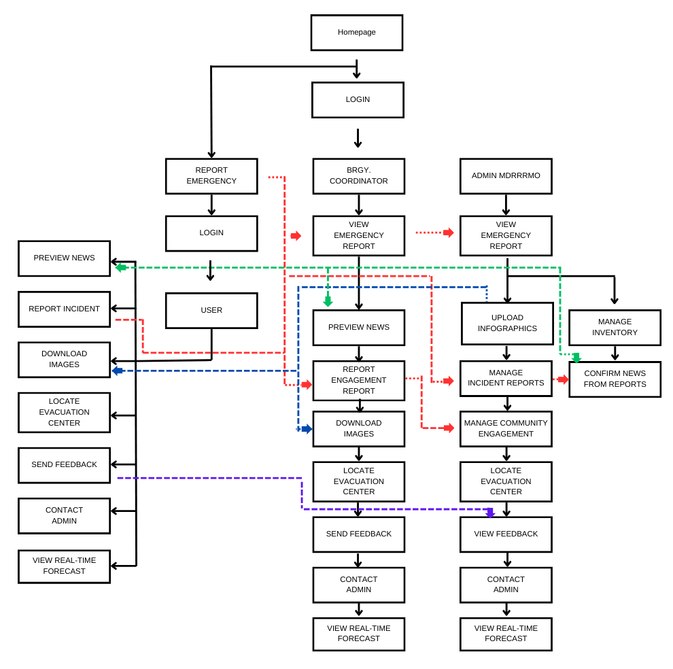
System Architecture and Design

Figure 3. System Architecture and Design of MDRRMIS
Figure 3 show the system architecture and design of the proposed system entitled, “Development of an Online Municipal Disaster Risk Reduction and Management Information System with Centralized Database for the Municipality of Luisiana, Laguna: Enhanced Community Preparedness and Resilience”. This system architecture provides a structured and efficient disaster risk management platform, ensuring real-time communication, accurate reporting, and informed decision-making. The design integrates user accessibility with administrative oversight to enhance disaster response capabilities at the municipal level.
Database Design
This database is structured to support disaster management, inventory tracking, incident reporting, and user engagement through well-defined tables. User roles are managed via the User, Admin, and MainAdmin tables, ensuring secure access. System transparency is maintained through Audit_Logs, while Notifications keep users informed of important updates.
Resource tracking is handled by the Inventory table, which monitors item availability, condition, and suppliers. Incident management is facilitated through the Reports table, logging user-submitted reports with descriptions, locations, and statuses. Community outreach efforts are recorded in the Community_Engagement table, supporting disaster preparedness initiatives.
To improve services, the Feedback table collects user ratings and messages, while the Upload1 table ensures proper storage of uploaded images. This integrated database design enhances efficiency, accountability, and responsiveness in disaster risk reduction and resource management.
User Interface (UI) Design
The user interface (UI) design of the Municipal Disaster Risk Reduction and Management Office (MDRRMO) website features a formal and professional aesthetic, utilizing a color scheme of red, black, and white to convey urgency. The bold typography ensures accessibility for all users, including those with visual impairments.
The landing page has a minimalist design with a significant background image representing a landmark in Luisiana, Laguna, and prominently displays the official logo and title “Ligtas Luisiana.” Two key call-to-action buttons, “Report Accident” (highlighted in red) and “Homepage,” facilitate user engagement. The footer includes a brief description of the MDRRMO’s mission, emphasizing its role in disaster preparedness.
The primary interface features a structured layout with a navigation bar categorizing sections such as “Home,” “Infographics,” “Understand Disaster,” “Municipal Map,” and “Statistics.” Login and sign-up buttons are conveniently located at the top-right corner. The hero section includes a dynamic image of a rescue operation and a call-to-action button, “Learn More About Our Initiatives.”
From a user experience (UX) perspective, the website prioritizes accessibility with high-contrast colors and large text. It is designed to be responsive across various devices. Key call-to-action elements are strategically placed for quick access in emergencies. Suggested enhancements for usability include design consistency, interactive elements, breadcrumb navigation, and multilingual support to better serve the community.
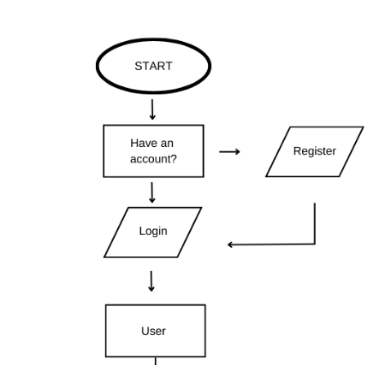
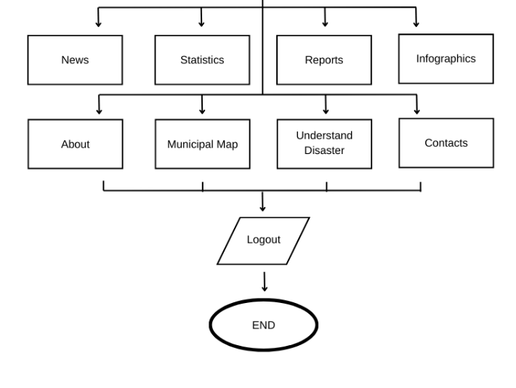
NAVIGATION STRUCTURE

Figure 4. User Navigation Flow Chart
Step 1. Users are seamlessly guided to the welcome page where they can go to login.
Step 2. The login credentials entered by the users are validated in MySQL database, and upon successful authentication, they are directed to the user dashboard.
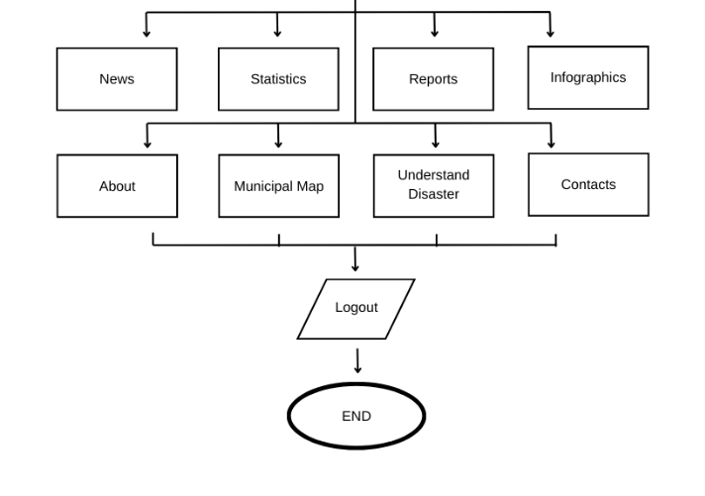
Step 3. After verifying their login credentials in the MySQL database, users can smoothly navigate the website’s features.

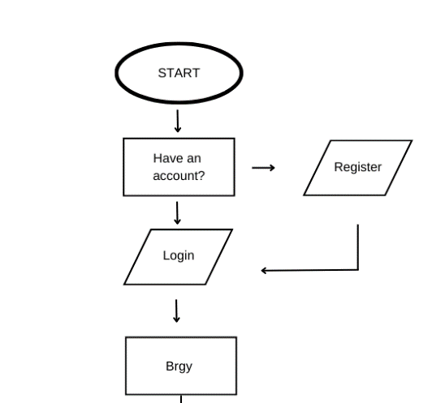

Figure 5. Brgy. Coordinators Navigation
Step 1. Upon inputting login credentials, the website validates the administrator’s access in the MySQL database, ensuring that only authorized personnel gain entry to the website’s dashboard.
Step 2. Once their identity is verified within the MySQL database, administrators gain the ability to seamlessly navigate and explore the website’s features and capabilities.
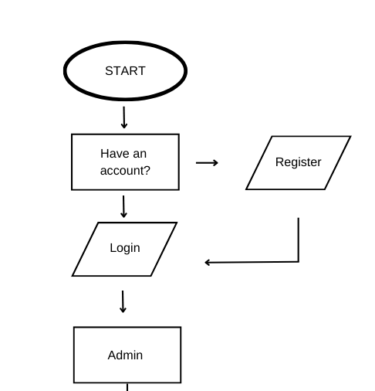
Step 3. Brgy. Coordinators possess the capability to upload, search, and manage all the features.
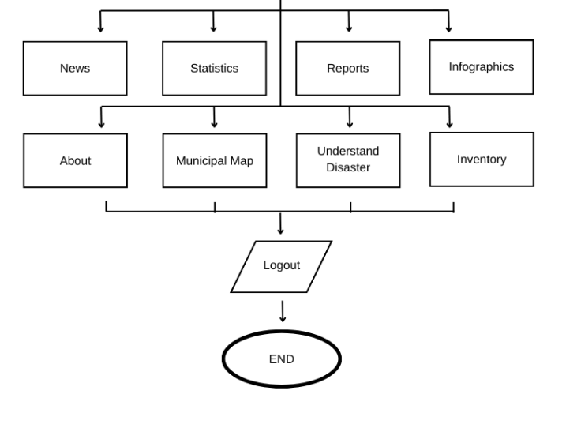

Figure 6. Admin Navigation
Step 1. Upon inputting login credentials, the website validates the administrator’s access in the MySQL database, ensuring that only authorized personnel gain entry to the website’s dashboard.
Step 2. Once their identity is verified within the MySQL database, administrators gain the ability to seamlessly navigate and explore the website’s features and capabilities.
Step 3. Administrators possess the capability to upload, search, and manage all the features.
TIME FRAME PLAN
This timeline presents the structured development process for the Disaster Risk Reduction and Management (DRRM) website. The project follows a systematic approach, beginning with requirement analysis and system design, followed by database and back-end development, front-end integration, testing, and deployment. The final phase includes training for MDRRMO staff and barangay coordinators to ensure effective system utilization. Each stage is designed to enhance the website’s functionality, usability, and reliability in supporting disaster preparedness and response efforts. The detailed timeline is as follows:
Development of Timeline:
- Week 1-2: Requirement analysis and system architecture design.
- Week 3-4: Database schema development and back-end API creation.
- Week 5-6: Front-end design and integration with back-end APIs.
- Week 7: System Testing, debugging, and optimization.
- Week 8: Deployment and training of MDRRMO staff and barangay coordinators.
EXISTING SYSTEM
The Municipal Disaster Risk Reduction and Management Office (MDRRMO) currently utilizes conventional communication channels, primarily phone calls and Messenger, for receiving emergency reports from the public. When an emergency arises, concerned individuals must either contact the MDRRMO hotline or send a message via Messenger to relay critical information. Upon receiving a report, designated personnel manually document and assess the incident before mobilizing the appropriate response teams.
This system facilitates direct communication between citizens and disaster response personnel, but it presents several operational limitations. The manual nature of data collection and verification increases the likelihood of delays, miscommunication, and inconsistencies in report documentation. Furthermore, the absence of a centralized database for systematically storing, retrieving, and analyzing past emergency reports hinders the ability to track trends, assess response efficiency, and enhance long-term disaster preparedness strategies. These limitations underscore the need for a more structured, automated system that optimizes emergency reporting, improves response coordination, and strengthens disaster management capabilities.
DATABASE DESIGN
Database Design, according to Martha (2024), is a critical process in the development of systems that manage and utilize data effectively. It involves creating a structured schema that organizes data in a way that supports the specific needs of applications and users. This process is essential for ensuring that data can be efficiently collected, stored, processed, and managed, ultimately facilitating the extraction of meaningful insights for decision-making.
To explore the concept of a database, one must understand the necessary data. Data, which are not only facts, are details about the topic under consideration. Along with being familiar with key technologies, a thorough study of data in connection to databases is conducted, as follows:
- Fields: A part of the database system that contains transactions. It also includes the most precise information on the crucial data that a system requires.
- Record: A list of corresponding areas within a database system.
- Table: a collection of relevant records allocated specifically to set one apart from another.
- Database: A compilation of related tables in a system.
Also, according to Pulungan (2023), An Entity Relationship (ER) refers to a conceptual framework used in database design to illustrate the relationships between data entities. It serves as a foundational model that helps in structuring and organizing data effectively. The Entity-Relationship Diagram (ERD) is a key tool in this process, representing entities, their attributes, and the relationships among them. This overview leads to a deeper exploration of its components and applications, using its three constructions, the following shows:
- Entity: A person, place, object, or concept that is recognized as a separate unit.
- Relationship: Relationship between the several forms of entities that might be expressed differently.
- Attribute: A defined property or attribute of an entity.
Maintaining data integrity, efficiency, and scalability requires properly designing relational databases by turning E-R diagrams into well-defined tables and recording them with a data dictionary. This procedure guarantees logical data organization, removes redundancy through normalization, and uses main and foreign keys to enforce consistency. In addition to boosting security and access control, a well-structured database improves query efficiency, enabling quicker and more effective data retrieval. A data dictionary also acts as a thorough reference, making it easier for developers and stakeholders to comprehend the database structure, facilitating maintenance, and guaranteeing smooth cooperation. Better decision-making, enhanced system performance, and long-term database sustainability are the ultimate results of this strategy.
Listed below are the data dictionary of the database for this capstone project:
Table 3. Users Table
Field Name | Data Type | Length | Key | Description
id | int | auto_increment | p | Unique Users ID
username | varchar | 50 |  | username
email | varchar | 100 |  | email
password | varchar | 255 |  | users password
created_at | timestamp |  |  | users role
Table 4. Main Admin Table
Field Name | Data Type | Length | Key | Description
id | int | auto_increment | p | main admin’s identifier
username | varchar | 50 |  | admin’s username
email | varchar | 50 |  | email
password | varchar | 255 |  | admin’s password
created_at | timestamp
Table 5. Incident Reports Table
Field Name | Data Type | Length | Key | Description
id | int | auto_increment | p | identifier
incident_type | varchar | 255 |  | incident type
location | varchar | 255 |  | location
description | text |  |  | description
pdf_file | varchar | 255 |  | file
image_file | varchar | 255 |  | image file
date_reported | timestamp
Table 6. Inventory
Field Name | Data Type | Length | Key | Description
id | int | auto_increment | p | identifier
item_name | varchar | 255 |  | item name
category | varchar | 50 |  | category
expiry_date | date
description | text |  |  | description
brand_model | varchar | 255 |  | brand
serial_number | varchar | 100 |  | serial number
date_acquired | date |  |  | date acquired
supplier | varchar | 255 |  | supplier
item_condition | enum |  |  | condition
status | enum |  |  | status
created_at | timestamp |  |  | time item added
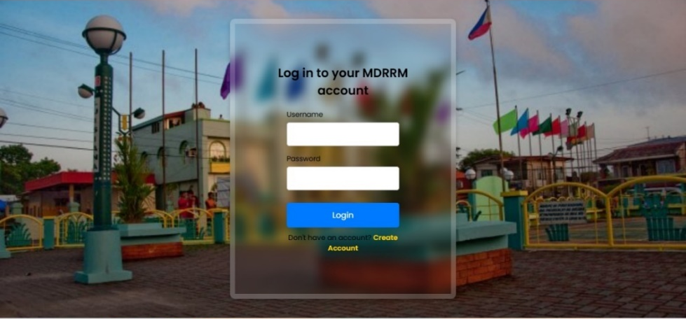
Table 7. Reports
Field Name | Data Type | Length | Key | Description
id | int | auto_increment | p | identifier
name | varchar | 100 |  | username
contact | varchar | 50 |  | contact
residence | varchar | 100 |  | residence
incident_type | varchar | 50 |  | incident type
location | varchar | 255 |  | location
description | varchar | 255 |  | description
report_time | timestamp
status | enum |  |  | status
image_file | varchar | 255 |  | image
Table 8. Community Engagement Table
Field Name | Data Type | Length | Key | Description
id | int | auto_increment | p | identifier
officer_in_charge | varchar | 100 |  | officer in charge name
population | int | 11 |  | population
attendees | int | 11 |  | attendees
engagement_type | varchar | 50 |  | engagement type activity
location | varchar | 255 |  | location
description | varchar | 255 |  | description
image_file | varchar | 255 |  | image
report_time | timestamp
Table 9. Audit Logs Table
Field Name | Data Type | Length | Key | Description
id | int | auto_increment | p | identifier
username | varchar | 255 |  | username
role | varchar | 50 |  | user role
action | varchar | 255 |  | user action
timestamp | timestamp

Table 10. Feedback
Field Name | Data Type | Length | Key | Description
Id | Int | auto_increment |  | Identifier
Name | Varchar | 255 |  | Feedback Name
Rating | Int | 11 |  | Feedback Rating
Message | Text |  |  | Feedback Message
Submitted_at | Timestamp |  |  | Feedback  submitted
Table 11. Notifications
Field Name | Data Type | Length | Key | Description
Id | Int | Auto_increment |  | Identifier
Message | Varchar | 255 |  | Notification Message
Status | Enum(‘unread’, ‘read’) |  |  | Notifications Status
Created_at | Timestamp |  |  | Notifications Create

Table 12. Upload1
Field Name | Data Type | Length | Key | Description
Id | Int | Auto_increment |  | Identifier
Category | Varchar | 50 |  | Upload Category
Image_path | Varchar | 255 |  | Upload image path

Design of Tables in Database
MainAdmin
User
Admin
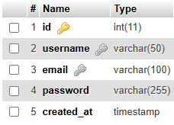
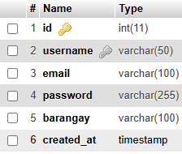
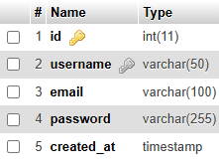
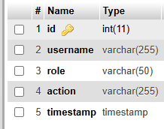
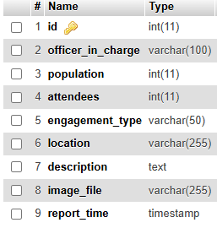
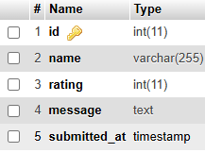
Community_Engagement
Feedback
Audit_Logs

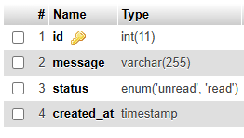
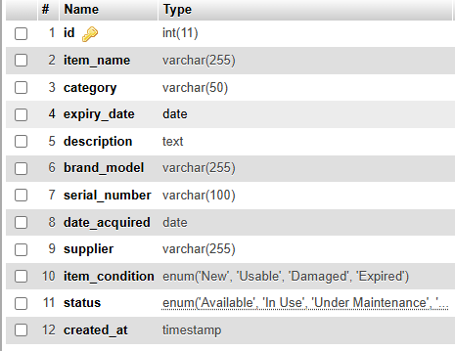
Notifications
Inventory

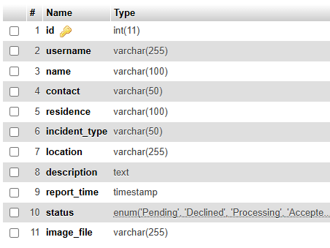
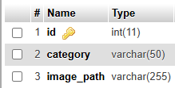
Reports
Upload1

Figure 7. Design of Tables in MDRRMO Database

PREFERRED TECHNOLOGIES ADMIN AND USER INTERFACE
Visual Studio Code
A lightweight yet robust source code editor, Visual Studio Code offers integrated support for JavaScript and boasts a comprehensive ecosystem of extensions for various other languages and runtimes, including PHP, CSS, and HTML. These programming languages were predominantly utilized in the development of the information management system website for the Municipal Disaster Risk Reduction and Management Office (MDRRMO).
PHP
As noted in the journal by Uzayr (2022), PHP is employed for the development of dynamically generated web pages and functions on the backend of websites, managing tasks such as data collection, processing, and database administration. Its straightforward syntax renders it accessible to beginners, while its dynamic typing provides flexibility in feature development. Commonly referred to as Hypertext Preprocessor, PHP is utilized across various web servers and can be executed via a simple command line on multiple browsers. This programming language is capable of connecting and synchronizing with all types of databases, both relational and non-relational. For instance, MySQL serves as a key database with which PHP can interface, playing a vital role in the development of MDRRM’s website.
CSS
Cascading Style Sheets (CSS) is a stylesheet language that defines the presentation and visual formatting of HTML content on a web server. By separating content from design, CSS enhances the maintainability and flexibility of web pages, allowing developers to implement consistent styling across multiple pages efficiently. Furthermore, CSS supports responsive design techniques, enabling web applications to adapt seamlessly to different screen sizes and devices, thereby improving user experience and accessibility.
JavaScript
JavaScript enhances user interactivity by allowing for real-time updates and responsive design features, which are critical for engaging users and improving their overall experience. Additionally, JavaScript supports various frameworks and libraries, such as React and Angular, which streamline the development process and enable the creation of complex web applications. Its compatibility with both client-side and server-side environments further underscores its significance in modern web development, making it a foundational technology for creating interactive and user-friendly online platforms.
HTML
HTML (HyperText Markup Language) is essential in any web-based project as it provides the fundamental structure for web pages. It defines how content is organized using elements such as headings, paragraphs, lists, tables, and sections, ensuring a clear and well-structured layout. Since HTML is a standardized language, it ensures compatibility across different web browsers, allowing websites to be displayed consistently.
MySQL
The integration of MySQL as the database management system for the Municipal Disaster Risk Reduction and Management Office (MDRRMO) offers numerous advantages in handling emergency reports, disaster mapping, and inventory management. One of the primary benefits of MySQL is its ability to centralize and organize data efficiently.
Software Design, Systems, and Process (UI Design)
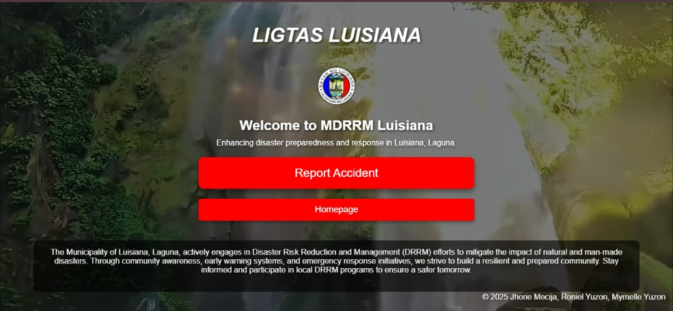

Figure 8. Welcome Page

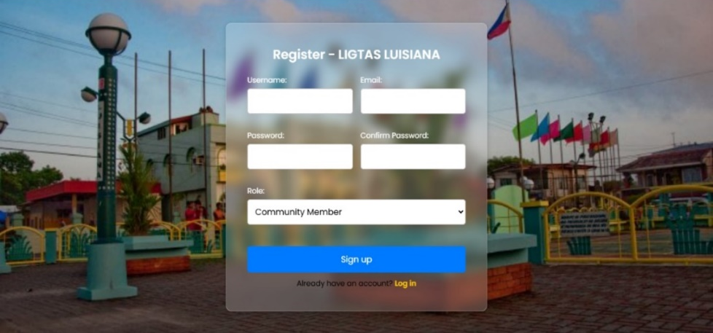
Figure 9. Login Page

Figure 10. Register Page
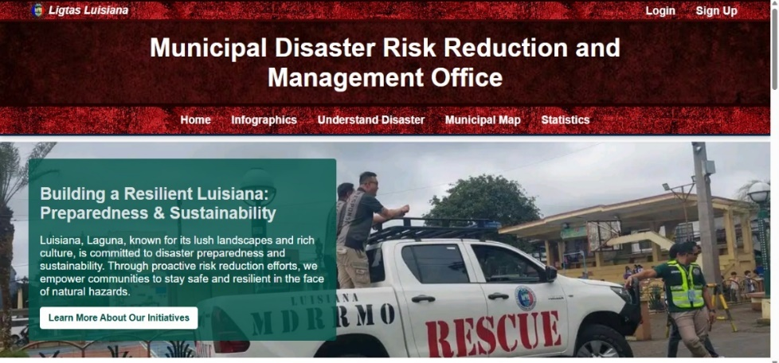

Figure 11. Dashboard Page

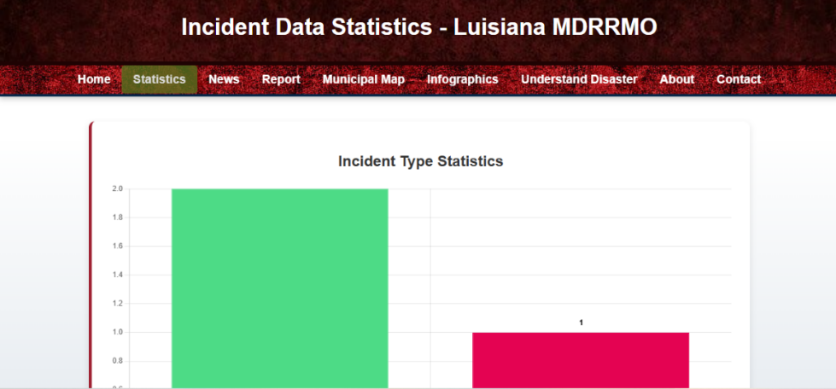

Figure 12. Statistics Page

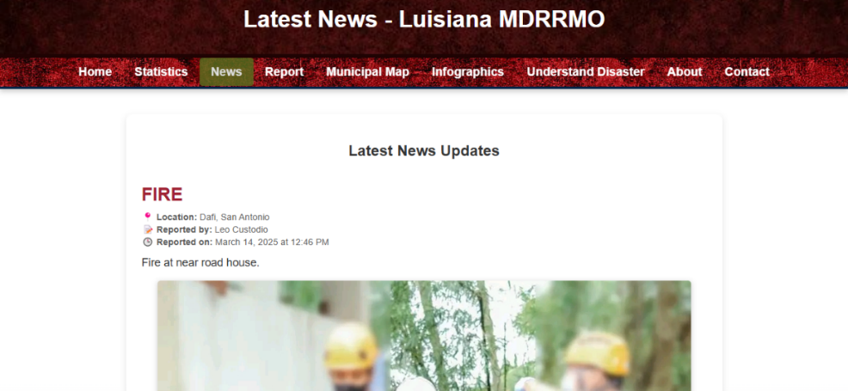

Figure 13. News Page

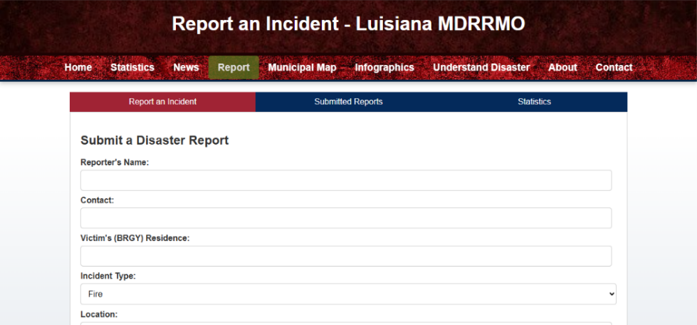

Figure 14. Reporting Page

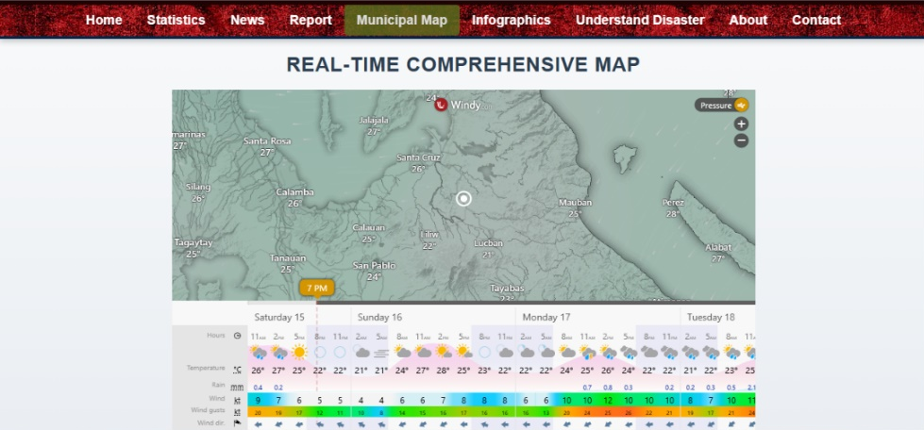

Figure 15. Disaster Map Page

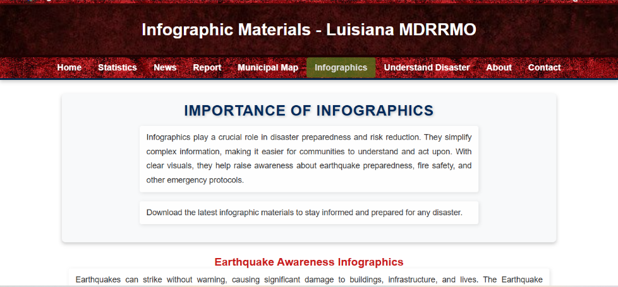

Figure 16. Infographics Page
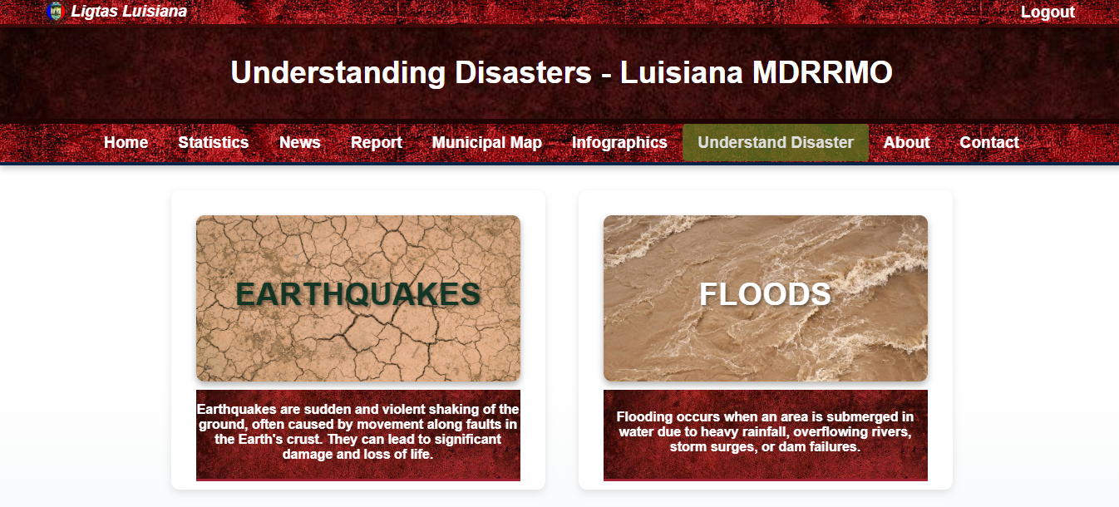
Figure 17. Learning Page

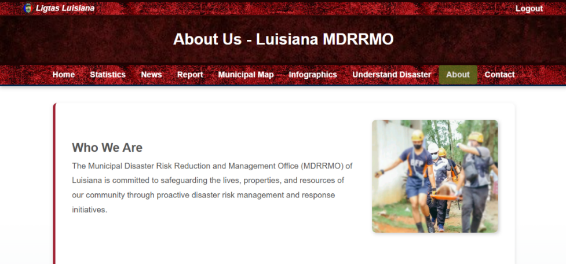

Figure 18. About Page

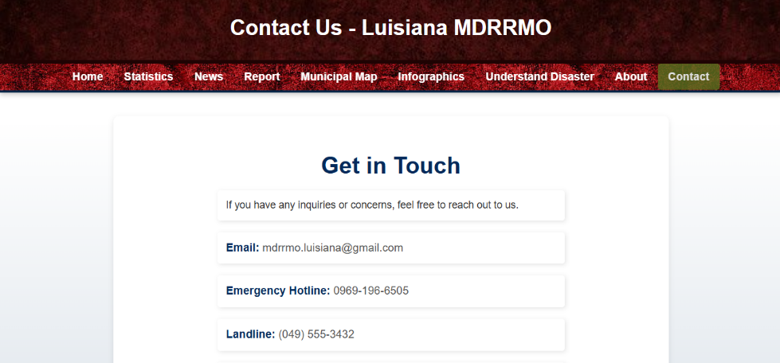

Figure 19. Contact Page

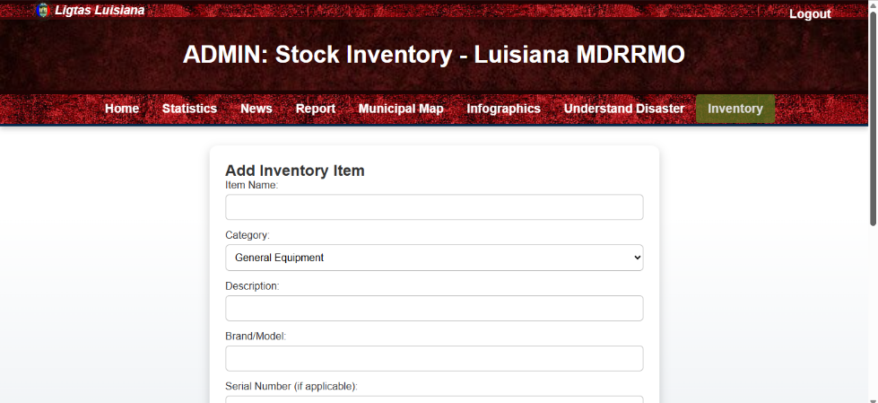

Figure 20. Admin Inventory Page

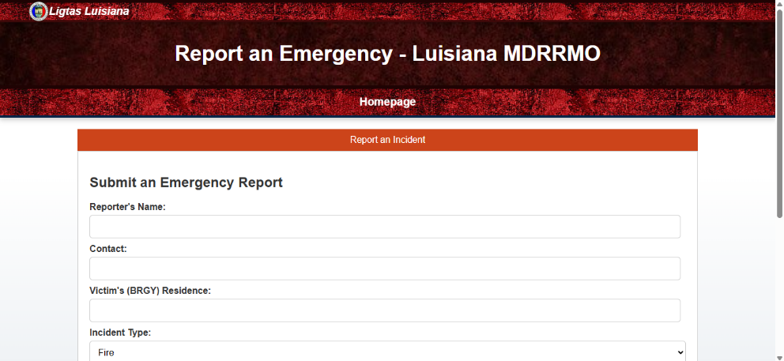

Figure 21. Emergency Reporting

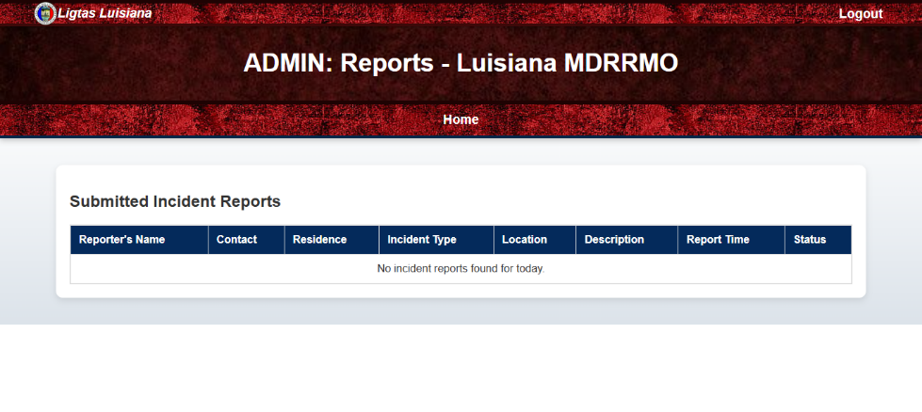

Figure 22. Admin Emergency Report Viewing

Chapter IV

Presentation of Results
This section of the research study provides an overview of the data obtained from the User and Admin Web Experience and Satisfaction Survey Questionnaire and its thorough analysis upon the implementation of an online municipal disaster risk reduction and management information system. Moreover, this chapter provides a comprehensive analysis of the performance of the Municipal Disaster Risk Reduction and Management Office itself.

User Experience and Satisfaction
To further analyze the situation encountered by our community and also our barangay coordinators with regards to the use of different forms of communication channel, the researchers provide a specific survey questionnaire to identify factors on the situation. The survey questionnaire utilizes the Likert Scale Method on each of the questions. Data obtained will be analyzed through computing the weighted mean of each Likert Scale. This analysis will demonstrate the respondents’ level of agreement with the given statements for evaluation and will be the basis to assess MDRRM’s website user experience and satisfaction.
Effectiveness of MDRRM’s method of communication channels with barangays and community before and after hazards in terms of Public Speakers.
Below are the results obtained from the user, brgy. coordinators, and members of MDRRM experience of communication channels within barangays and community before and after hazards in terms of public speakers.
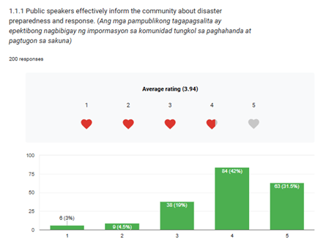

Figure 23 Effectiveness of MDRRM’s method of communication channels with barangays before and after hazards in terms of Speakers educating community on disaster readiness.
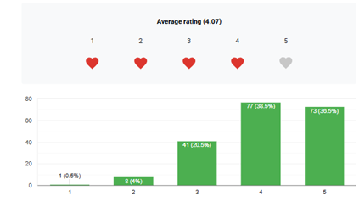
Figure 23 shows that most respondents agree with the effectiveness of MDRRM’s method of communication with its constituents before and after hazard. Using the Likert Scale Method, the computed weighted mean is 3.94 with an Agree (A) remarks which shows that the community and brgy. coordinators receive help with the use of their current communication channel

Figure 24 Effectiveness of MDRRM’s method of communication channels with barangays before and after hazards in terms of clear public announcements.
Figure 24 shows that most respondents agree with the effectiveness of MDRRM’s method of communication with public announcements. Using the Likert Scale Method, the computed weighted mean is 4.07 with an Agree (A) remarks which shows that the community and brgy. coordinators understand public announcement from the MDRRM with the use of their current communication channel.
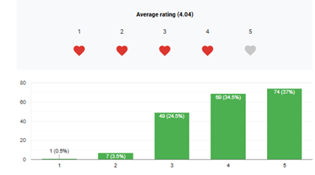
Figure 25 Effectiveness of MDRRM’s method of communication channels with barangays before and after hazards in terms of the announcements being timely and widespread.
Figure 25 shows that most respondents agree with the effectiveness of MDRRM’s method of communication where constituents received announcements timely and widespread. Using the Likert Scale Method, the computed weighted mean is 4.04 with an Agree (A) remarks which shows that the community and brgy. coordinators receive announcement in a timely and widespread way from the MDRRM with the use of their current communication channel.

Effectiveness of MDRRM’s method of communication channels with barangays and community before and after hazards in terms of use of Messenger Application as medium for communicating with MDRRMO.
Below are the results obtained from the user, brgy. coordinators, and members of MDRRM experience of communication channels within barangays and community before and after hazards in terms of using Messenger App as medium for communicating incidents.
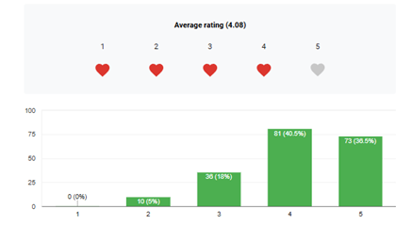
Figure 26 Effectiveness of MDRRM’s method of communication channels with barangays before and after hazards in terms of MDRRMO utilizing Messenger for alerts.
Figure 26 shows that most respondents agree with the effectiveness of MDRRM’s method of communication where MDRRMO utilize Messenger for alerts. Using the Likert Scale Method, the computed weighted mean is 4.06 with an Agree (A) remarks which shows that the community and brgy. coordinators accept how MDRRMO utilize Messenger for alerting its constituents.
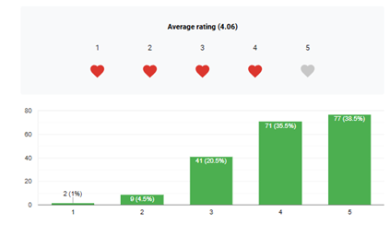
Figure 27 Effectiveness of MDRRM’s method of communication channels with barangays before and after hazards in terms of MDRRMO using Messenger for ensuring timely outreach.
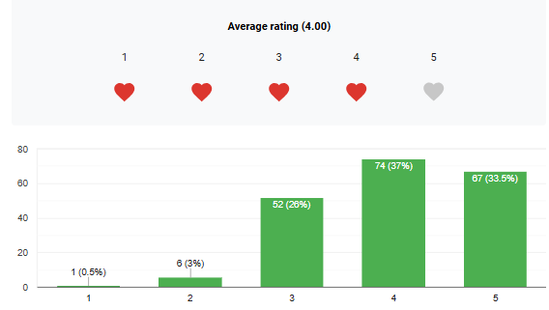
Figure 27 shows that most respondents agree with the effectiveness of MDRRM’s method of communication where MDRRMO use Messenger for ensuring timely outreach. Using the Likert Scale Method, the computed weighted mean is 4.08 with an Agree (A) remarks which shows that the community and brgy. coordinators accept how MDRRMO using Messenger for ensuring timely outreach.
Figure 28 Effectiveness of MDRRM’s method of communication channels with barangays before and after hazards in terms of the Community engaging with MDRRMO’s Messenger alerts.
Figure 28 shows that most respondents agree with the effectiveness of MDRRM’s method of communication where Community engages with MDRRMO’s Messenger alerts. Using the Likert Scale Method, the computed weighted mean is 4.00 with an Agree (A) remarks which shows that the community and brgy. coordinators engage with MDRRMO’s Messenger alerts with the use of their current communication channel.

Effectiveness of MDRRM’s method of communication channels with barangays and community before and after hazards in terms Walking-in the office.
Below are the results obtained from the user, brgy. coordinators, and members of MDRRM experience of communication channels within barangays and community before and after hazards in terms of going to office to convey situations.
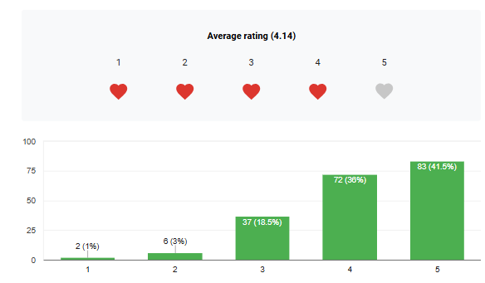

Figure 29 Effectiveness of MDRRM’s method of communication channels with barangays before and after hazards in terms of MDRRMO welcoming walk-in inquiries.
Figure 29 shows that most respondents agree with the effectiveness of MDRRM’s method of communication where Community engages with MDRRMO with walk-in inquiries. Using the Likert Scale Method, the computed weighted mean is 4.14 with an Agree (A) remarks which shows that the community and brgy. coordinators are welcomed to the office of MDRRMO to report or gather information.

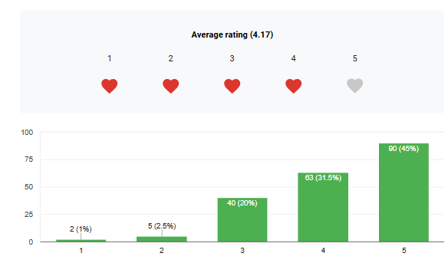

Figure 30 Effectiveness of MDRRM’s method of communication channels with barangays before and after hazards in terms of MDRRMO’s Staff efficiently handling walk-in inquiries.
Figure 30 shows that most respondents agree with the effectiveness of MDRRM’s method of communication where MDRRMO’s Staff efficiently handles walk-in inquiries. Using the Likert Scale Method, the computed weighted mean is 4.17 with an Agree (A) remarks which shows that the community and brgy. coordinators are welcomed to the office of MDRRMO to report or gather information.
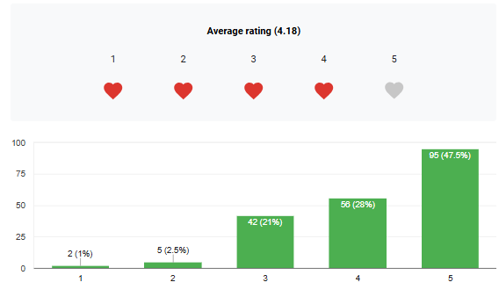

Figure 31 Effectiveness of MDRRM’s method of communication channels with barangays before and after hazards in terms of Walk-in consultations enhance preparedness.
Figure 31 shows that most respondents agree with the effectiveness of MDRRM’s method of communication where MDRRMO’s Staff efficiently handles walk-in inquiries and provide consultation with the community to enhance hazard preparedness. Using the Likert Scale Method, the computed weighted mean is 4.18 with an Agree (A) remarks which shows that the community and brgy. coordinators are welcomed to the office of MDRRMO for consultation to enhance hazard preparedness.

Status of MDRRM’s community awareness and participation in terms of Public Access to Information.
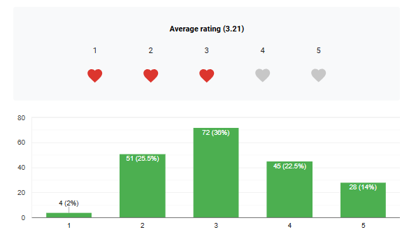
Below are the results obtained from the user, brgy. coordinators, and members of MDRRM about the status of their community awareness and participation in terms of community’s public access to information regarding hazards.

Figure 32 Status of MDRRM’s community awareness and participation in terms of community’s public access to information.
Figure 32 shows that most respondents agree with the MDRRM’s community awareness and participation in terms of community’s public access to information. Using the Likert Scale Method, the computed weighted mean is 3.21 with a Neutral (N) remark which shows that some of community and brgy. Coordinators have access to public information. This may vary depending on the location of their house where the officials are finding it hard to reach the place.
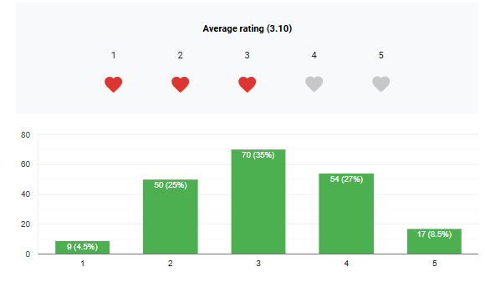

Figure 33 Status of MDRRM’s community awareness and participation in terms of availability of disaster materials like brochures, posters, and online resources are easily accessible.
Figure 33 shows that most respondents agree with the MDRRM’s community awareness and participation in terms of availability of disaster materials like brochures, posters, and online resources are easily accessible. Using the Likert Scale Method, the computed weighted mean is 3.10 with a Neutral (N) remark which shows that some of community and brgy. Coordinators don’t have any resources/ materials to begin with. Thus, the need for online materials that can help the community to be prepared from hazard is a must.
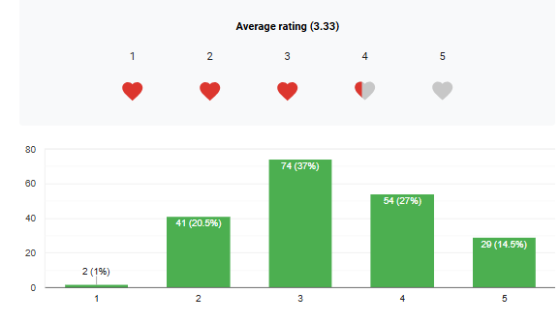

Figure 34 Status of MDRRM’s community awareness and participation in terms of community easily accessing emergency contacts and plans.
Figure 34 shows that most respondents agree with the MDRRM’s community awareness and participation in terms of community easily accessing emergency contacts and plans. Using the Likert Scale Method, the computed weighted mean is 3.33 with a Neutral (N) remark which shows that some of the community and brgy. Coordinators don’t have any access with the emergency contacts and plans. Thus, the need for knowledge for emergency contacts and plans is needed to lessen the risk of accidents that may occur during a hazard.
Status of MDRRM’s community awareness and participation in terms of Limited Community Engagement
Below are the results obtained from the user, brgy. coordinators, and members of MDRRM about the status of their community awareness and participation in terms of community’s limited engagement on activities done by Municipal Risk Reduction and Management Office (MDRRMO).
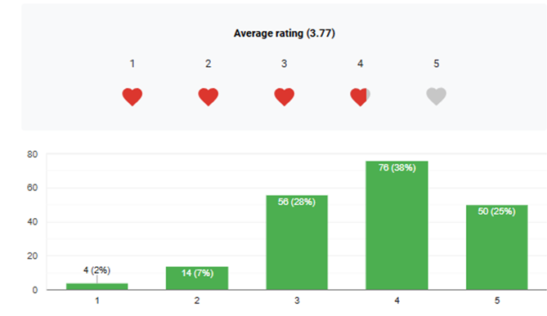

Figure 35 Status of MDRRM’s community awareness and participation in terms of community actively participates in preparedness programs.
Figure 35 shows that most respondents agree with the MDRRM’s community awareness and participation in terms of community actively participates in preparedness programs. Using the Likert Scale Method, the computed weighted mean is 3.77 with a Neutral (N) remark which shows that some of the community and brgy. Coordinators can’t attend community preparedness programs. Thus, the need for alternative way of teaching community how to prepared in times of hazard is a must.
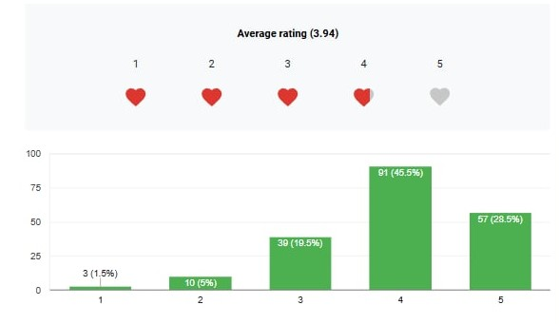

Figure 36 status of MDRRM’s community awareness and participation in terms of enough training sessions or seminars on disaster risk reduction.
Figure 36 shows that most respondents (74%) agree that there are enough training sessions or seminars on disaster risk reduction, with an average rating of 3.94. While 19.5% remain neutral, only 6.5% feel the training is insufficient. This suggests that MDRRM’s efforts are generally effective, but there is room for improvement in accessibility and awareness. To enhance participation, outreach efforts should be strengthened, and feedback should be gathered to improve training effectiveness.
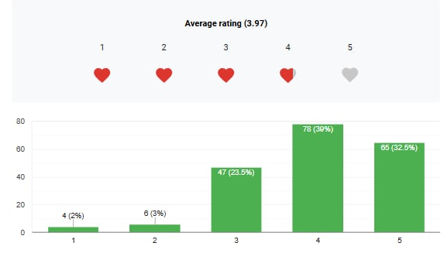
Figure 37 Status of MDRRM’s community awareness and participation in terms of lack of interest or awareness hinders community engagement in disaster preparedness.
Figure 37 shows that many people believe a lack of interest or awareness affects community participation in disaster preparedness, with an average rating of 3.97. Most respondents (71.5%) agree, while 23.5% are neutral, and only 5% disagree. This means that more efforts are needed to raise awareness and encourage people to take part in disaster preparedness activities through education and community programs.

Effectiveness of MDRRM’s in terms of disseminating targeted information.
Below are the results obtained from the user, brgy. coordinators, and members of MDRRM’s about the effectiveness of MDRRM’s in terms of disseminating targeted information done by Municipal Risk Reduction and Management Office (MDRRMO).

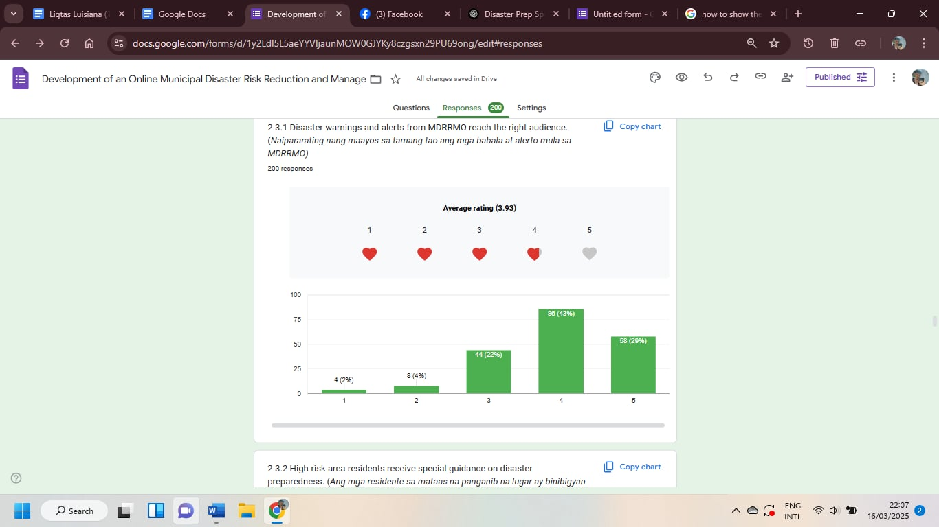
Figure 38 Effectiveness of MDRRM’s disseminating targeted information in terms of sending disaster warnings and alerts to the right audience.
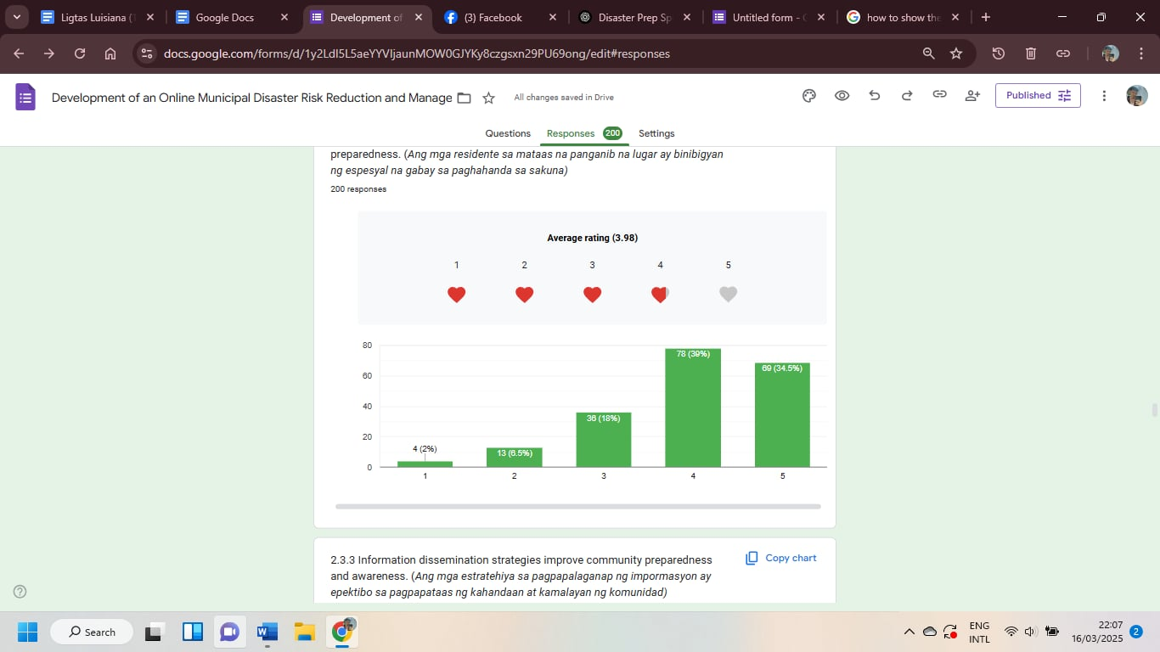
Figure 38 shows that most respondents believe MDRRM’s effectively delivers disaster warnings and alerts to the right audience, with an average rating of 3.93. A majority (72%) rated it 4 or 5, while 22% remain neutral, and only 6% disagree. This suggests that while the system is generally effective, further improvements in communication methods can help ensure that alerts reach all community members more efficiently.
Figure 39 Effectiveness of MDRRM’s disseminating targeted information in terms of giving special guidance on disaster preparedness to the high-risk residential area.
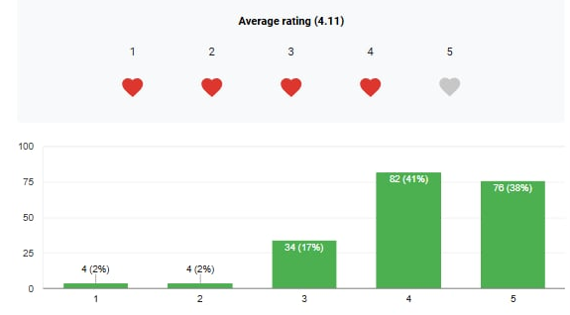
Figure 39 shows that MDRRM's efforts to provide special guidance on disaster preparedness to high-risk areas are generally effective, with an average rating of 3.98. A majority (73.5%) rated it 4 or 5, while 18% remain neutral, and only 10.5% disagree. This indicates that while many residents in high-risk areas receive proper guidance, further improvements can ensure more comprehensive disaster preparedness.

Figure 40 Effectiveness of MDRRM’s disseminating targeted information in terms of improving the community awareness and preparedness.
Figure 40 shows the effectiveness of MDRRM’s in sharing disaster preparedness information with the community, receiving an average rating of 4.11. The majority (79%) find it effective, with 41% rating it 4 and 38% rating it 5, while 17% feel neutral. Only 4% believe it is not effective. This indicates that while MDRRM’s information dissemination is generally successful, improvements can be made in reaching the small percentage of residents who feel uninformed or less prepared, possibly by enhancing accessibility, using multiple communication channels, or providing more localized and detailed guidance.
Effectiveness of the proposed website on providing comprehensive information on disaster preparedness and awareness in terms of Data Statistics.
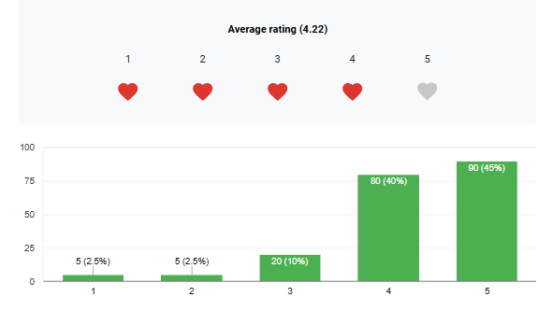
Below are the results obtained from the user, brgy. coordinators, and members of MDRRM about the effectiveness of the proposed website on providing comprehensive information on disaster preparedness and awareness in terms of Data Statistics.

Figure 41 Effectiveness of the proposed website on providing comprehensive information on disaster preparedness and awareness in terms of delivering accurately, updated disaster data.
Figure 41 shows that most respondents agree with the proposed website being effective on providing comprehensive information on disaster preparedness and awareness in terms of website delivers accurate, updated disaster data. Using the Likert Scale Method, the computed weighted mean is 4.22 with a Agree (A) remark which shows that the community and brgy. Coordinators ensures that the website delivers accurate, and updated disaster data.
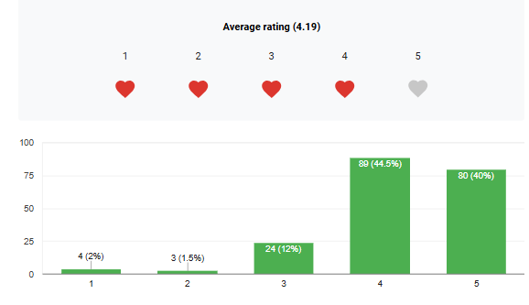

Figure 42 Effectiveness of the proposed website on providing comprehensive information on disaster preparedness and awareness in terms of statistics being clearly presented.
Figure 42 shows that most respondents agree with the proposed website being effective on providing comprehensive information on disaster preparedness and awareness in terms of website’s statistics being clearly presented. Using the Likert Scale Method, the computed weighted mean is 4.19 with an Agree (A) remark which shows that the community and brgy. Coordinators tells that the proposed website’s statistics are clearly presented.
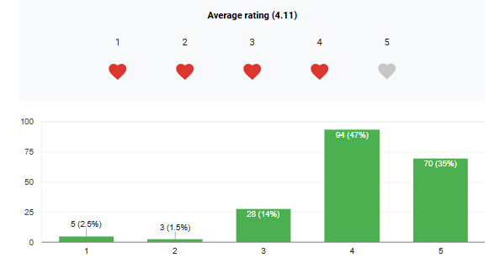
Figure 43 Effectiveness of the proposed website on providing comprehensive information on disaster preparedness and awareness in terms of data aids in understanding trends and preparedness.
Figure 43 shows that most respondents agree with the proposed website being effective on providing comprehensive information on disaster preparedness and awareness in terms of data aids in understanding trends and preparedness. Using the Likert Scale Method, the computed weighted mean is 4.11 with an Agree (A) remark which shows that the community and brgy. Coordinators tells that the proposed website’s data, aids in understanding trends and preparedness.
Effectiveness of the proposed website on providing comprehensive information on disaster preparedness and awareness in terms Hazard Maps.
Below are the results obtained from the user, brgy. coordinators, and members of MDRRM about the effectiveness of the proposed website on providing comprehensive information on disaster preparedness and awareness in terms of implemented hazard maps.
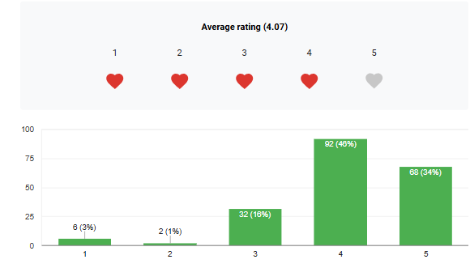

Figure 44 Effectiveness of the proposed website on providing comprehensive information on disaster preparedness and awareness in terms of website offering clear, detailed hazard maps.
Figure 44 shows that most respondents agree with the proposed website being effective on providing comprehensive information on disaster preparedness and awareness in terms of website offering clear, detailed hazard maps. Using the Likert Scale Method, the computed weighted mean is 4.07 with an Agree (A) remark which shows that the community and brgy. Coordinators tells that the proposed website offers clear, and detailed hazard maps.

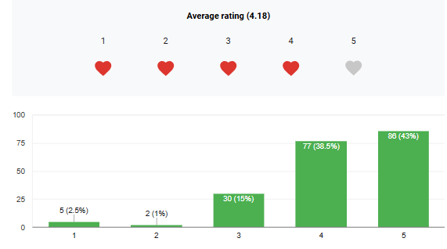
Figure 45 Effectiveness of the proposed website on providing comprehensive information on disaster preparedness and awareness in terms of Maps are interactive and user-friendly.
Figure 45 shows that most respondents agree with the proposed website being effective on providing comprehensive information on disaster preparedness and awareness in terms of Maps are interactive and user-friendly. Using the Likert Scale Method, the computed weighted mean is 4.18 with an Agree (A) remark which shows that the community and brgy. Coordinators tells that the proposed website shows interactive and user-friendly.
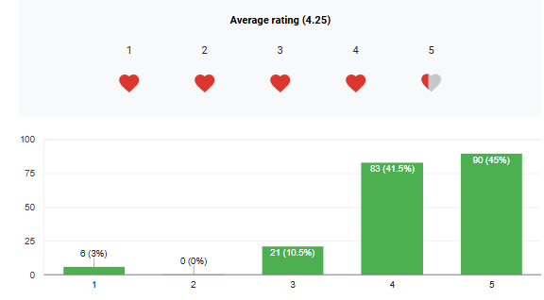
Figure 46 Effectiveness of the proposed website on providing comprehensive information on disaster preparedness and awareness in terms of Hazard maps enhance awareness and preparedness.
Figure 46 shows that most respondents agree with the proposed website being effective on providing comprehensive information on disaster preparedness and awareness in terms of Hazard maps which enhance awareness and preparedness. Using the Likert Scale Method, the computed weighted mean is 4.25 with an Agree (A) remark which shows that the community and brgy. Coordinators tells that the map implemented on the website can enhance awareness and preparedness from hazards.
Effectiveness of the proposed website on providing comprehensive information on disaster preparedness and awareness in terms of Incident Reporting.
Below are the results obtained from the user, brgy. coordinators, and members of MDRRM about the effectiveness of the proposed website on providing comprehensive information on disaster preparedness and awareness in terms of incident reporting.
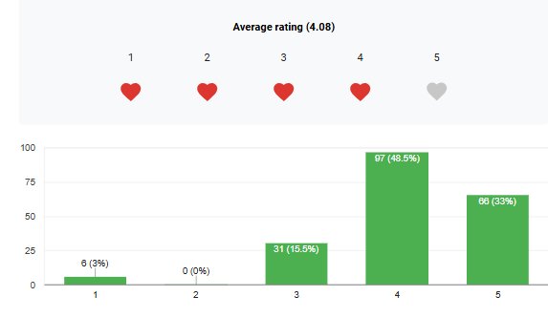

Figure 47 Effectiveness of the proposed website on providing comprehensive information on disaster preparedness and awareness in terms of website offering a user-friendly disaster reporting platform.
Figure 47 shows that most respondents agree with the proposed website being effective on providing comprehensive information on disaster preparedness and awareness in terms of website offering a user-friendly disaster reporting platform. Using the Likert Scale Method, the computed weighted mean is 4.08 with an Agree (A) remark which shows that the community and brgy. Coordinators tells that the website offers a user-friendly disaster reporting platform.
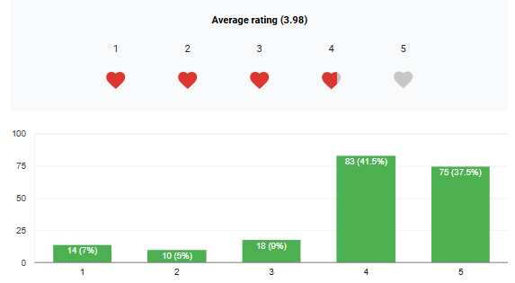

Figure 48 Effectiveness of the proposed website on providing comprehensive information on disaster preparedness and awareness in terms of users’ accessibility to upload images, descriptions, and priorities.
Figure 48 shows that most respondents agree with the proposed website being effective on providing comprehensive information on disaster preparedness and awareness in terms of accessibility of users to upload images, descriptions, and priorities. Using the Likert Scale Method, the computed weighted mean is 3.98 with an Agree (A) remark which shows that the community and brgy. Coordinators tells that the website allows the user to upload reports with specific actions.
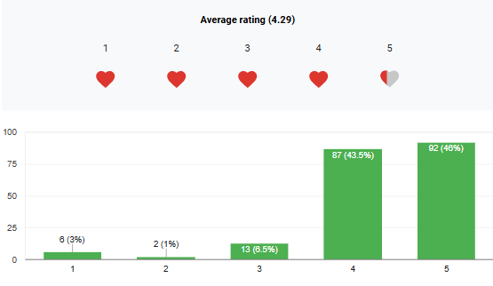

Figure 49 Effectiveness of the proposed website on providing comprehensive information on disaster preparedness and awareness in terms of website verifies and filters reports to prevent misinformation.
Figure 49 shows that most respondents agree with the proposed website being effective on providing comprehensive information on disaster preparedness and awareness in terms of website verifying and filtering reports to prevent misinformation. Using the Likert Scale Method, the computed weighted mean is 4.29 with an Agree (A) remark which shows that the community and brgy. Coordinators tells that there’s an authorization rule for reporting incident before it was published.
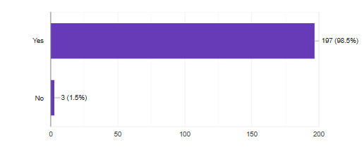
Figure 50 System’s fulfillment on the MDRRM’s gap on assuring that residents acquire comprehensive understanding on disaster risk reduction and awareness of information on hazards happening in the areas.
Figure 50 shows that most respondents agree with the proposed website being fulfillment on the MDRRM’s gap on assuring that residents acquire comprehensive understanding on disaster risk reduction and awareness of information on hazards happening in the areas. Using the Comparative Analysis Method, the results showed that the website fulfils the gap needed for the MDRRMO to enhance their public efficiency with a total of 197 individual who says yes, the website shows an acceptable outcome.
Website’s Performance Metrics and Responsive Contentns for Multiple Devices
The effectiveness and user-friendliness of the MDRRMO website rely on its responsiveness and performance, which are evaluated through factors like page load time, server response time, accessibility, security, and user engagement. The desktop version loads in about 1.5 seconds, while the mobile version takes around 2.3 seconds. Optimization techniques, including caching, minimized CSS/JS, and image compression, have been applied to improve speed, with an average server response time of 400ms aided by a Content Delivery Network (CDN) and server-side caching. The desktop version features a grid layout and wide navigation, while the tablet version has a compressed navigation structure and flexible content grid. The mobile version utilizes a hamburger menu and stack-based content layout for better readability and touch-friendly interactions.

Chapter V
CONCLUSION and RECOMMENDATION
With the considerations brought about by the design construction and testing, the researchers have summarized and gathered the following findings, conclusions and recommendations.
Conclusion
This capstone project aimed to develop and implement an online Municipal Disaster Risk Reduction and Management information system for the Municipality of Luisiana, Laguna. System for managing and centralized database that will decrease the laborious tasks. This system has been made user-friendly for easy accessibility of the users. Database management and programming languages form the foundation of the system - PHP (Hypertext Processor), HTML (Hypertext Markup Language), CSS (Cascading Style Sheets), MySQL and Javascript.
The results from both the Main Admin and User Web Experience and Satisfaction Questionnaire show a strong agreement regarding the functionality, usability, and efficiency of the Municipal Disaster Risk Reduction and Management information System for the Municipality of Luisiana, Laguna. Both Admins and Users expressed high satisfaction with the system's ability to manage file uploads, downloads, and division-specific access. Admins highlighted the system's ease of use in managing files and controlling access to different divisions, while Users appreciated the simplicity and reliability of the report accident and view the maps.
Furthermore, both Main Admins and Users appreciated the system's overall efficiency, maintainability, and dependability, notably its ability to assure seamless document management and user access. The system's design and functionality also contributed to a great user experience, with ease of use and speed being critical to satisfaction. The system's capabilities were viewed as a significant step toward improving internal operations and streamlining access to critical documents across departments. In terms of performance indicators, the system was highly efficient, particularly in terms of accessibility. However, like other systems, it encountered difficulties in several areas, such as initial load times. While these issues were minor, they do identify opportunities for future development.
Recommendations
For future researchers. conduct an expanded study to determine the possible content that needs to be added on the website to make it more reliable. Develop more appropriate commands to make the website more interactive in terms of layout, buttons and overall design. Prioritize the functionality of the website to enhance the functionality of MDRRMO for enhancing public service efficiency.
For the community. To further improve MDRRM’s incidence resilience, don’t hesitate to report incidents in your area. This will help not just the residents on your area but also everyone who lives in the Municipality.
For the MDRRMO. The use of these systems can enhance the management’s work. By creating a space for community to understand the events happening in the areas, it is a must to have this kind of websites.

SOURCE CODES
arthurnerritech_user_system.sql
-- phpMyAdmin SQL Dump
-- version 5.2.1
-- https://www.phpmyadmin.net/
--
-- Host: 127.0.0.1
-- Generation Time: Mar 14, 2025 at 06:38 PM
-- Server version: 10.4.32-MariaDB
-- PHP Version: 8.1.25

SET SQL_MODE = "NO_AUTO_VALUE_ON_ZERO";
START TRANSACTION;
SET time_zone = "+00:00";

/*!40101 SET @OLD_CHARACTER_SET_CLIENT=@@CHARACTER_SET_CLIENT */;
/*!40101 SET @OLD_CHARACTER_SET_RESULTS=@@CHARACTER_SET_RESULTS */;
/*!40101 SET @OLD_COLLATION_CONNECTION=@@COLLATION_CONNECTION */;
/*!40101 SET NAMES utf8mb4 */;

--
-- Database: `arthurnerritech_user_system`
--

-- --------------------------------------------------------

--
-- Table structure for table `admins`
--

CREATE TABLE `admins` (
`id` int(11) NOT NULL,
`username` varchar(50) NOT NULL,
`email` varchar(100) NOT NULL,
`password` varchar(255) NOT NULL,
`barangay` varchar(100) NOT NULL,
`created_at` timestamp NOT NULL DEFAULT current_timestamp()
) ENGINE=InnoDB DEFAULT CHARSET=utf8mb4 COLLATE=utf8mb4_general_ci;

--
-- Dumping data for table `admins`
--

INSERT INTO `admins` (`id`, `username`, `email`, `password`, `barangay`, `created_at`) VALUES
(2, 'rovic', 'rovic@gmail.com', '$2y$10$Ojkl/sTw2jikAgh1WRbbKeKIJa7XYjlskndRIltBO0HFW7CIbnsU2', 'San Salvador', '2025-03-07 12:44:00');

-- --------------------------------------------------------

--
-- Table structure for table `audit_logs`
--

CREATE TABLE `audit_logs` (
`id` int(11) NOT NULL,
`username` varchar(255) NOT NULL,
`role` varchar(50) NOT NULL,
`action` varchar(255) NOT NULL,
`timestamp` timestamp NOT NULL DEFAULT current_timestamp()
) ENGINE=InnoDB DEFAULT CHARSET=utf8mb4 COLLATE=utf8mb4_general_ci;

--
-- Dumping data for table `audit_logs`
--

INSERT INTO `audit_logs` (`id`, `username`, `role`, `action`, `timestamp`) VALUES
(1, 'lian', 'mainAdmins', 'User logged in', '2025-03-07 13:31:57'),
(2, 'rovic', 'admins', 'User logged in', '2025-03-07 13:32:38'),
(3, 'lian', 'mainAdmins', 'User logged in', '2025-03-07 13:32:46'),
(4, 'lian', 'mainAdmins', 'User logged out', '2025-03-07 13:33:42'),
(5, 'lian', 'mainAdmins', 'User logged in', '2025-03-07 13:34:05'),
--
-- Table structure for table `community_engagement`
--
CREATE TABLE `community_engagement` (
`id` int(11) NOT NULL,
`officer_in_charge` varchar(100) NOT NULL,
`population` int(11) NOT NULL,
`attendees` int(11) NOT NULL,
`engagement_type` varchar(50) NOT NULL,
`location` varchar(255) NOT NULL,
`description` text NOT NULL,
`image_file` varchar(255) DEFAULT NULL,
`report_time` timestamp NOT NULL DEFAULT current_timestamp()
) ENGINE=InnoDB DEFAULT CHARSET=utf8mb4 COLLATE=utf8mb4_general_ci;
-- Dumping data for table `community_engagement`
--
INSERT INTO `community_engagement` (`id`, `officer_in_charge`, `population`, `attendees`, `engagement_type`, `location`, `description`, `image_file`, `report_time`) VALUES
(1, 'Obib', 233, 0, 'Cleanup Drive', 'San Juan', 'dfgdg', NULL, '2025-03-14 17:33:25'),
(2, 'baldonado', 233, 0, 'Cleanup Drive', 'San Juan', 'adasda', NULL, '2025-03-14 17:33:47');
--
-- Table structure for table `incident_reports`
--
CREATE TABLE `incident_reports` (
`id` int(11) NOT NULL,
`incident_type` varchar(255) NOT NULL,
`location` varchar(255) NOT NULL,
`description` text NOT NULL,
`pdf_file` varchar(255) DEFAULT NULL,
`image_file` varchar(255) DEFAULT NULL,
`date_reported` timestamp NOT NULL DEFAULT current_timestamp()
) ENGINE=InnoDB DEFAULT CHARSET=utf8mb4 COLLATE=utf8mb4_general_ci;

-- Dumping data for table `incident_reports`
INSERT INTO `incident_reports` (`id`, `incident_type`, `location`, `description`, `pdf_file`, `image_file`, `date_reported`) VALUES
(1, 'Accident', 'luisiana', 'xdvsdf', NULL, '1741967230_22.jpg', '2025-03-14 15:47:10');

-- Table structure for table `inventory`
--
CREATE TABLE `inventory` (
`id` int(11) NOT NULL,
`item_name` varchar(255) NOT NULL,
`category` varchar(50) NOT NULL,
`expiry_date` date DEFAULT NULL,
`description` text NOT NULL,
`brand_model` varchar(255) DEFAULT NULL,
`serial_number` varchar(100) DEFAULT NULL,
`date_acquired` date NOT NULL,
`supplier` varchar(255) NOT NULL,
`item_condition` enum('New','Usable','Damaged','Expired') NOT NULL,
`status` enum('Available','In Use','Under Maintenance','Disposed') NOT NULL,
`created_at` timestamp NOT NULL DEFAULT current_timestamp()
) ENGINE=InnoDB DEFAULT CHARSET=utf8mb4 COLLATE=utf8mb4_general_ci;
--
-- Table structure for table `mainadmins`
--
CREATE TABLE `mainadmins` (
`id` int(11) NOT NULL,
`username` varchar(50) NOT NULL,
`email` varchar(100) NOT NULL,
`password` varchar(255) NOT NULL,
`created_at` timestamp NOT NULL DEFAULT current_timestamp()
) ENGINE=InnoDB DEFAULT CHARSET=utf8mb4 COLLATE=utf8mb4_general_ci;
--
-- Dumping data for table `mainadmins`
--
INSERT INTO `mainadmins` (`id`, `username`, `email`, `password`, `created_at`) VALUES
(1, 'jhe', 'jhe@gmail.com', '$2y$10$RCiwlpI3QHUyLwxLvYlMdOQM0wP9nmtLGXWcYMlktgGoXEOGuPbyu', '2025-03-10 11:36:56'),
(2, 'obib', 'obib@gmail.com', '$2y$10$ESkiKda/R66ilbZbALUWLOUEeLj8LGBOg900KbUZ7m68HJ7XnSWhK', '2025-03-13 11:11:13');
--
-- Table structure for table `reports`
--
CREATE TABLE `reports` (
`id` int(11) NOT NULL,
`name` varchar(100) NOT NULL,
`contact` varchar(50) NOT NULL,
`residence` varchar(100) NOT NULL,
`incident_type` varchar(50) NOT NULL,
`location` varchar(255) NOT NULL,
`description` text NOT NULL,
`report_time` timestamp NOT NULL DEFAULT current_timestamp(),
`status` enum('Pending','Declined','Processing','Accepted') DEFAULT 'Pending',
`image_file` varchar(255) DEFAULT NULL
) ENGINE=InnoDB DEFAULT CHARSET=utf8mb4 COLLATE=utf8mb4_general_ci;

-- Dumping data for table `reports`
INSERT INTO `reports` (`id`, `name`, `contact`, `residence`, `incident_type`, `location`, `description`, `report_time`, `status`, `image_file`) VALUES
(1, 'James Izel Gallardo', '09918980287', 'Santo Tomas', 'Accident', 'Mabini Street, Zone 6', 'Motor Vehicle vs Dog - Leading to unstable control of driver on his motorcycle.', '2025-03-07 16:24:50', 'Accepted', NULL),
(2, 'Lian', '0943317496', 'San Juan', 'Accident', 'San Roque', 'Slippery road on side', '2025-03-10 04:11:53', 'Accepted', '1741973770_fir3.jpg');
--
-- Table structure for table `users`
CREATE TABLE `users` (
`id` int(11) NOT NULL,
`username` varchar(50) NOT NULL,
`email` varchar(100) NOT NULL,
`password` varchar(255) NOT NULL,
`created_at` timestamp NOT NULL DEFAULT current_timestamp()
) ENGINE=InnoDB DEFAULT CHARSET=utf8mb4 COLLATE=utf8mb4_general_ci;

--
-- Dumping data for table `users`
--
INSERT INTO `users` (`id`, `username`, `email`, `password`, `created_at`) VALUES
(2, 'manjares', 'manjares@gmail.com', '$2y$10$ZhI6xwgqBilwoUwFjV8zkOsfbXOjcAdJqKGO5lpkQLu.ICc945fw6', '2025-03-07 12:45:10'),
(3, 'leo', 'leo@gmail.com', '$2y$10$XRpQwga5Iv0kPw0j0HQ3qunc7o/yTBbUYhO/MHEHyGi50Y049e4oe', '2025-03-10 11:25:08');
--
-- Indexes for dumped tables
--
--
-- Indexes for table `admins`
--
ALTER TABLE `admins`
ADD PRIMARY KEY (`id`),
ADD UNIQUE KEY `username` (`username`);
--
-- Indexes for table `audit_logs`
--
ALTER TABLE `audit_logs`
ADD PRIMARY KEY (`id`);

--
-- Indexes for table `community_engagement`
--
ALTER TABLE `community_engagement`
ADD PRIMARY KEY (`id`);

--
-- Indexes for table `incident_reports`
--
ALTER TABLE `incident_reports`
ADD PRIMARY KEY (`id`);

--
-- Indexes for table `inventory`
--
ALTER TABLE `inventory`
ADD PRIMARY KEY (`id`);

--
-- Indexes for table `mainadmins`
--
ALTER TABLE `mainadmins`
ADD PRIMARY KEY (`id`),
ADD UNIQUE KEY `username` (`username`),
ADD UNIQUE KEY `email` (`email`);

--
-- Indexes for table `reports`
--
ALTER TABLE `reports`
ADD PRIMARY KEY (`id`);

--
-- Indexes for table `users`
--
ALTER TABLE `users`
ADD PRIMARY KEY (`id`),
ADD UNIQUE KEY `username` (`username`);

--
-- AUTO_INCREMENT for dumped tables
--

--
-- AUTO_INCREMENT for table `admins`
--
ALTER TABLE `admins`
MODIFY `id` int(11) NOT NULL AUTO_INCREMENT, AUTO_INCREMENT=3;

--
-- AUTO_INCREMENT for table `audit_logs`
--
ALTER TABLE `audit_logs`
MODIFY `id` int(11) NOT NULL AUTO_INCREMENT, AUTO_INCREMENT=69;

--
-- AUTO_INCREMENT for table `community_engagement`
--
ALTER TABLE `community_engagement`
MODIFY `id` int(11) NOT NULL AUTO_INCREMENT, AUTO_INCREMENT=3;

--
-- AUTO_INCREMENT for table `incident_reports`
--
ALTER TABLE `incident_reports`
MODIFY `id` int(11) NOT NULL AUTO_INCREMENT, AUTO_INCREMENT=2;

--
-- AUTO_INCREMENT for table `inventory`
--
ALTER TABLE `inventory`
MODIFY `id` int(11) NOT NULL AUTO_INCREMENT, AUTO_INCREMENT=3;

--
-- AUTO_INCREMENT for table `mainadmins`
--
ALTER TABLE `mainadmins`
MODIFY `id` int(11) NOT NULL AUTO_INCREMENT, AUTO_INCREMENT=3;

--
-- AUTO_INCREMENT for table `reports`
--
ALTER TABLE `reports`
MODIFY `id` int(11) NOT NULL AUTO_INCREMENT, AUTO_INCREMENT=8;

--
-- AUTO_INCREMENT for table `users`
--
ALTER TABLE `users`
MODIFY `id` int(11) NOT NULL AUTO_INCREMENT, AUTO_INCREMENT=4;
COMMIT;

/*!40101 SET CHARACTER_SET_CLIENT=@OLD_CHARACTER_SET_CLIENT */;
/*!40101 SET CHARACTER_SET_RESULTS=@OLD_CHARACTER_SET_RESULTS */;
/*!40101 SET COLLATION_CONNECTION=@OLD_COLLATION_CONNECTION */;

Index.php
<!DOCTYPE html>
<html lang="en">
<head>
<meta charset="UTF-8">
<meta name="viewport" content="width=device-width, initial-scale=1.0">
<title>Welcome to MDRRM Luisiana</title>
<link rel="stylesheet" href="styles.css">
</head>
<style>
*{box-sizing:border-box;margin:0;padding:0;}
body{font-family:Arial,sans-serif;display:flex;flex-direction:column;justify-content:center;align-items:center;height:100vh;position:relative;padding:0;overflow:hidden;color:white;text-align:center;}
.video-background{position:absolute;top:0;left:0;width:100%;height:100%;object-fit:cover;z-index:-2;}
body::before{content:'';position:absolute;top:0;left:0;width:100%;height:100%;background-color:rgba(0,0,0,0.5);z-index:-1;}h2{font-style:italic;font-size:40px;margin-bottom:20px;text-shadow:2px 2px 5px rgba(0,0,0,0.7);z-index:1;}.container{width:90%;max-width:600px;padding:20px;border-radius:10px;text-align:center;position:relative;z-index:1;background:transparent;}.logo{width:100px;max-width:80px;margin-bottom:20px;}h1,p{color:white;text-shadow:2px 2px 5px rgba(0,0,0,0.7);}h1{font-size:28px;margin-bottom:10px;}p{font-size:16px;margin-bottom:20px;}.login-button{background-color:#ff0000;color:white;border:none;padding:12px 20px;font-size:18px;border-radius:5px;cursor:pointer;transition:0.3s;box-shadow:0 4px 6px rgba(0,0,0,0.3);width:100%;}.login-button:hover{background-color:#b30000;transform:scale(1.05);box-shadow:0 6px 10px rgba(0,0,0,0.5);}.description{margin-top:20px;font-size:16px;background:rgba(0,0,0,0.6);padding:15px;border-radius:10px;max-width:90%;z-index:1;}.credits{position:absolute;bottom:5px;right:15px;font-size:14px;color:#FFD700;z-index:1;}@media screen and (max-width:600px){h2{font-size:30px;}h1{font-size:24px;}p{font-size:14px;}.container{width:100%;max-width:90%;padding:15px;}.logo{max-width:70px;}.login-button{font-size:16px;padding:10px;}.description{font-size:14px;padding:10px;}.credits{font-size:12px;right:10px;}}

</style>
<body>
<video class="video-background" autoplay muted loop>
<source src="img/front.mp4" type="video/mp4">
</video>
<h2>LIGTAS LUISIANA</h2>
<div class="container">
<img src="img/logo1.png" alt="MDRRM Logo" class="logo">
<h1>Welcome to MDRRM Luisiana</h1>
<p>Enhancing disaster preparedness and response in Luisiana, Laguna.</p>
<a href="login.php"><button class="login-button">Get Started</button></a>
</div>
<div class="description">
<p>The Municipality of Luisiana, Laguna, actively engages in Disaster Risk Reduction and Management (DRRM) efforts to mitigate the impact of natural and man-made disasters. Through community awareness, early warning systems, and emergency response initiatives, we strive to build a resilient and prepared community. Stay informed and participate in local DRRM programs to ensure a safer tomorrow.</p>
</div>
<div class="credits">
<p>© 2025 Jhorie Mecija, Roniel Yuzon, Myrnelle Yuzon</p>
</div>
</body>
</html>

Homepage.php
<!DOCTYPE html>
<html lang="en">
<head>
<meta charset="UTF-8">
<meta name="viewport" content="width=device-width, initial-scale=1.0">
<title>Ligtas Lusiana</title>
<link href="https://fonts.googleapis.com/css2?family=Roboto:wght@300;400;700&display=swap" rel="stylesheet">
<style>
body{font-family:'Poppins',sans-serif;margin:0;padding:0;background:linear-gradient(180deg,#ffffff 30%,#dce3ea 100%);color:#333;}
header {background:url('img/677.jpeg') no-repeat center center/cover;height:140px;display:flex;align-items:center;justify-content:center;position:relative;color:#fff;text-align:center;}
header::before {content:'';position:absolute;top:0;left:0;right:0;bottom:0;background:rgba(0,0,0,0.5);}
header h1 {font-size:2.8em;position:relative;z-index:1;font-weight:bold;}
.upper nav{background-image:url('img/763.jpeg');padding:12px 0;position:sticky;top:0;height:30px;width:100%;z-index:1000;border-bottom:4px solid rgb(61,9,9);}
.upper .nav-links{flex-grow:1;padding-top:5px;padding-right:40px;display:flex;justify-content:right;}
.upper nav{background-color:#0f4979;padding:0;box-shadow:0 2px 5px rgba(0,0,0,0.3);display:flex;align-items:left;justify-content:space-between;}
.upper h2{font-size: 1.2em;color:#ffffff;font-style:italic;}
.logo-container{padding-left:50px;display:flex;align-items:center;}
.logoi{width:35px;height:auto;}
nav {background-image:url('img/763.jpeg');padding:12px 0;position:sticky;top:0;width:100%;z-index:1000;box-shadow:0px 4px 8px rgba(0,0,0,0.2);border-top:6px solid rgb(31,3,3);border-bottom:4px solid rgb(4,37,71);}
nav ul {display:flex;justify-content:center;list-style:none;padding:0;margin:0;}
nav a {color:white;font-size:1.2em;font-weight:bold;padding:12px 18px;text-decoration:none;transition:background 0.3s;}
nav a:hover {background:rgba(255,255,255,0.2);border-radius:5px;}
.dropdown{position:relative;display:inline-block;}
.dropdown-content{display:none;position:absolute;background-color:#f9f9f9;min-width:160px;box-shadow:0px 8px 16px 0px rgba(0,0,0,0.2);z-index:1;}
.dropdown-content a{color:black;padding:12px 16px;text-decoration:none;display:block;}
.dropdown-content a:hover{background-color:#f1f1f1;}
.dropdown:hover .dropdown-content{display:block;}
.introduction{display:flex;justify-content:center;align-items:center;padding:40px 20px;background:#f5f5f5;text-align:center;}
.container{max-width:800px;}
.introduction h2{font-size:2em;color:#0f4979;margin-bottom:10px;}
.introduction p{font-size:1.2em;color:#333;line-height:1.6;}
.featured-section {width: 100%;background: #fff;}
.featured-banner {background: url('img/22.jpg') no-repeat center center/cover;height:330px;position:relative;display:flex;align-items:center;justify-content:flex-start;text-align:left;padding:20px;border-top:10px solid rgb(255,255,255);padding-left:50px;}
.banner-content {max-width: 500px;background: rgba(0, 82, 72, 0.8);padding: 20px;color: white;border-radius: 5px;}
.banner-content h2 {font-size: 1.8em;margin-bottom: 10px;}
.banner-content p {font-size: 1.2em;margin-bottom: 15px;}
.btn {display: inline-block;background: white;color: #005248;padding: 10px 15px;font-weight: bold;text-decoration: none;border-radius: 5px;}
.btn:hover {background: #ddd;}
.latest-additions {padding: 40px 80px;text-align: center;}
.latest-additions h2 {font-size: 2em;margin-bottom: 20px;}
.grid-container {display: grid;grid-template-columns: repeat(auto-fit, minmax(200px, 1fr));gap: 20px;justify-content: center;}
.grid-item {background:rgb(255, 255, 255);padding: 10px;border-radius: 5px;text-align: center;}
.grid-item img {width: 100%;height: 150px;object-fit: cover;border-radius: 5px;}
.grid-item p {font-size: 1em;margin-top: 10px;color: #333;}
.info-container {display: flex;justify-content: space-between;align-items: flex-start;max-width: 1200px;margin: 40px auto;padding: 20px;background-color:rgb(255, 255, 255);border-radius: 10px;box-shadow: 0 4px 8px rgba(0, 0, 0, 0.1);}
.left-content {flex: 2;padding-right: 20px;}
.right-content {flex: 1;display: flex;flex-direction: column;align-items: flex-start;gap: 20px;}
.mission, .drr-activities, .contact-info, .share-buttons {background: white;padding: 15px;border-radius: 5px;box-shadow: 0 2px 5px rgba(0, 0, 0, 0.1);}
h2 {color:rgb(223, 226, 228);}
.latest-additions h2{color:rgba(0, 0, 0, 0.77);margin-bottom: 20px;}
.info-container h2{color:rgba(0, 0, 0, 0.77);margin-bottom: 20px;}
h3 {color: #005248;margin-bottom: 10px;}
a {color: #0073e6;text-decoration: none;}
a:hover {text-decoration: underline;}
.share-buttons .buttons {display: flex;gap: 10px;}
.share-btn {border: none;padding: 10px;border-radius: 5px;cursor: pointer;font-size: 16px;}
.facebook {background-color: #1877F2;color: white;}
.linkedin {background-color: #0077B5;color: white;}
.email {background-color: #34A853;color: white;}
.copy-link {background-color: #555;color: white;}
.video-container {background-color:rgb(70, 151, 151);color: white;padding: 40px;display: flex;justify-content: center;}
.video-content {display: flex;max-width: 1100px;width: 100%;align-items: center;gap: 20px;}
.video-text {flex: 1;}
.video-text h2 {font-size: 24px;font-weight: bold;margin-bottom: 10px;}
.video-text p {font-size: 16px;margin-bottom: 20px;}
.video-buttons button {background-color: transparent;border: 2px solid white;color: white;padding: 10px 15px;margin-right: 10px;cursor: pointer;}
.video-buttons button:hover {background-color: white;color: #005f5f;}
.video-frame {flex: 1;}
.video-frame iframe {width: 100%;}
.footer{position:fixed;width:98.5%;background:#333;color:white;text-align:center;padding:10px;}
.footer-container {background-image:url('img/763.jpeg');color: white;text-align: center;padding: 20px;font-size: 1em;}
.footer-top {margin-bottom: 10px;font-weight: bold;}
.footer-top p {color:}
.footer-links {margin: 10px 0;}
.footer-links a {color: #ffcc00;text-decoration: none;font-weight: bold;margin: 0 10px;}
.footer-links a:hover {text-decoration: underline;}
.footer-bottom {margin-top: 10px;font-size: 0.9em;}
.contact-section {background-image: url('img/hsa.jpg');background-size: cover;background-position: center;background-repeat: no-repeat;text-align: center;padding: 40px;margin-top: 20px;border-radius: 10px;box-shadow: 0px 4px 8px rgba(0, 0, 0, 0.2);border-bottom: 50px solid rgb(255, 255, 255);}
.contact-section h2 {font-size: 24px;font-weight: bold;color: #000;}
.contact-section p {font-size: 22px;font-weight: bold;color: #1565c0;}
.contact-btn {background: #ffeb3b;border: none;padding: 12px 20px;font-size: 16px;cursor: pointer;border-radius: 5px;}
.contact-btn:hover {background: #fdd835;}
@media (max-width: 768px) {.info-container {flex-direction: column;}.left-content, .right-content {width: 100%;padding: 0;}.video-content {flex-direction: column;text-align: center;}.video-frame {max-width: 100%;}.video-text {margin-bottom: 20px;}.video-buttons {display: flex;flex-direction: column;}.video-buttons button {display: block;width: 100%;margin-bottom: 10px;}.footer {padding: 12px;font-size: 0.9em;}.footer-container {padding: 15px;font-size: 0.9em;}.footer-links a {display: block;margin: 5px 0;}}
</style>
</head>
<body>
<div class="upper">
<nav>
<div class="logo-container">
<img src="img/logo1.png" alt="MDRRMO Logo" class="logoi">
<h2> Ligtas Luisiana </h2>
</div>
<div class="nav-links">
<ul>
<li><a href="login.php">Login</a></li>
<li><a href="register.php">Sign Up</a></li>
</ul>
</div>
</nav>
</div>

<header>
<h1>Municipal Disaster Risk Reduction and<br>Management Office</h1>
</header>

<nav>
<ul>
<li><a href="login.php">Home</a></li>
<li><a href="login.php">Infographics</a></li>
<li><a href="login.php">Understand Disaster</a></li>
<li><a href="login.php">Municipal Map</a></li>
<li><a href="login.php">Statistics</a></li>
</ul>
</nav>

<section class="featured-section">
<div class="featured-banner">
<div class="banner-content">
<h2>Building a Resilient Luisiana: Preparedness & Sustainability</h2>
<p>Luisiana, Laguna, known for its lush landscapes and rich culture, is committed to disaster preparedness and sustainability. Through proactive risk reduction efforts, we empower communities to stay safe and resilient in the face of natural hazards.</p>
<a href="login.php" class="btn">Learn More About Our Initiatives</a>
</div>
</div>
</section>

<div class="latest-additions">
<h2>Featured latest additions</h2>
<div class="grid-container">
<div class="grid-item"><img src="img/training.jpg" alt="Image 1"><p>Completion of Work Immersion of Students from LINHS</p></div>
<div class="grid-item"><img src="img/medical.jpg" alt="Image 2"><p>Iba and Laging Handa: Medical Assistance on Resident of San Roque</p></div>
<div class="grid-item"><img src="img/lamok.jpg" alt="Image 3"><p>Bawat Buhay Malaga: Dengue Fever Awareness and Prevention</p></div>
<div class="grid-item"><img src="img/award.jpg" alt="Image 4"><p>24th Gawad Kalasag Seal and Special Awards for DRRM and Humanitarian Assistance Awarding Ceremony for CALABARZON</p></div>
</div>
</div>
</section>

<div id="disaster_preparedness_video" class="video-container">
<div class="video-content">
<div class="video-text">
<h2>Discover Disaster Preparedness Status in the Philippines</h2>
<p>
Stay informed and prepared with the latest resources on disaster risk reduction.
Learn how to respond effectively in emergency situations.
</p>
<div class="video-buttons">
<button>Learn More</button>
</div>
</div>
<div class="video-frame">
<iframe
width="580"
height="330"
src="https://www.youtube.com/embed/ZROP1ZR3460"
frameborder="0"
allow="accelerometer; autoplay; clipboard-write; encrypted-media; gyroscope; picture-in-picture"
allowfullscreen>
</iframe>
</div>
</div>
</div>

<div class="info-container">
<div class="left-content">
<h2>Explore Further</h2>

<div class="mission">
<h3>Mission</h3>
<p>
The Municipal Disaster Risk Reduction and Management Office (MDRRMO) of Luisiana is dedicated to building a disaster-resilient community by enhancing preparedness, risk reduction, and recovery strategies. We aim to safeguard lives, property, and the environment through proactive measures, strong governance, and active community participation.
</p>
<p>
Our mission is to promote disaster awareness, provide timely emergency response, and implement sustainable solutions to mitigate the impact of natural and human-induced hazards in Luisiana, Laguna.
</p>
</div>

<div class="drr-activities">
<h3>DRR Activities</h3>
<p>
Luisiana MDRRMO conducts regular disaster preparedness training, early warning system updates, and emergency drills to strengthen community resilience. Our key activities include:
</p>
<ul>
<li><strong>Barangay Disaster Readiness Training</strong> - Capacity-building sessions for local emergency responders and residents.</li>
<li><strong>Flood and Landslide Risk Assessment</strong> - Monitoring high-risk areas to enhance preparedness measures.</li>
<li><strong>Tree Planting and Environmental Programs</strong> - Reforestation and watershed conservation to reduce disaster risks.</li>
<li><strong>Community-Based First Aid and Rescue Training</strong> - Equipping residents with life-saving skills.</li>
<li><strong>Emergency Response and Relief Operations</strong> - Rapid assistance for affected families during calamities.</li>
</ul>
<p>
We encourage all Luisianans to actively participate in disaster risk reduction programs and stay informed about safety protocols.
</p>
</div>
</div>

<div class="right-content">
<div class="contact-info">
<h3>Contact Information</h3>
<p><strong>Municipal Disaster Risk Reduction and Management Office (MDRRMO) Luisiana</strong></p>
<p>📍 Municipal Hall, Luisiana, Laguna</p>
<p>📞 Emergency Hotline: 0969-196-6505</p>
<p>📠 Landline: (049) 555-3432</p>
<p>📧 Email: <a href="mailto:mdrrmo.luisiana@gmail.com">mdrrmo.luisiana@gmail.com</a></p>
<p>📌 Facebook: <a href="https://www.facebook.com/luisiana.mdrrmo" target="_blank">@LuisianaMDRRMO</a></p>
</div>

<div class="share-buttons">
<h3>Share this</h3>
<div class="buttons">
<button class="share-btn facebook">🔵</button>
<button class="share-btn linkedin">🔗</button>
<button class="share-btn email">✉️</button>
<button class="share-btn copy-link">🔗</button>
</div>
</div>
</div>
</div>

<div class="contact-section">
<h2>Do you Have Concern or Recommendations?</h2>
<p>Let's Talk!</p>
<a href="login.php">
<button class="contact-btn">Contact Us</button>
</div>

<footer class="footer-container">
<div class="footer-top">
<p>Municipal Disaster Risk Reduction and Management Office</p>
<p>Your trusted source for disaster preparedness and response.</p>
</div>
<div class="footer-links">
<a href="login.php">Newsletter</a>
<a href="login.php">Submit Report</a>
<a href="login.php">About</a>
</div>
<div class="footer-bottom">
<p>© 2025 MDRRMO. All Rights Reserved.</p>
</div>
</footer>
<script>
document.addEventListener("DOMContentLoaded", function () {
const video = document.getElementById("disasterVideo");
const observer = new IntersectionObserver((entries) => {
entries.forEach(entry => {
if (entry.isIntersecting) {
video.play(); // Play when in view
} else {
video.pause(); // Pause when out of view
video.currentTime = 0; // Reset video to start
}
});
}, { threshold: 0.5 }); // Video must be 50% visible to trigger

observer.observe(video);
});
</script>
</body>
</html>

Login.php
<?php
include('config.php');
session_start();

if ($_SERVER['REQUEST_METHOD'] === 'POST') {
$username = trim($_POST['username']);
$password = $_POST['password'];

// Define tables to check
$tables = ["users", "admins", "mainAdmins"];
$user = null;
$role = null;

// Check all tables for the user
foreach ($tables as $table) {
$stmt = $conn->prepare("SELECT username, password FROM $table WHERE username = ?");
$stmt->bind_param("s", $username);
$stmt->execute();
$result = $stmt->get_result();

if ($result->num_rows === 1) {
$user = $result->fetch_assoc();
$role = $table; // Assign role based on table name
break;
}
}

if ($user && password_verify($password, $user['password'])) {
$_SESSION['username'] = $user['username'];
$_SESSION['role'] = $role;

// Log the login
$logStmt = $conn->prepare("INSERT INTO audit_logs (username, role, action) VALUES (?, ?, 'User logged in')");
$logStmt->bind_param("ss", $username, $role);
$logStmt->execute();

// Redirect based on role
if ($role === 'admins') {
header("Location: brgy_dashboard.php");
} elseif ($role === 'mainAdmins') {
header("Location: admin_dashboard.php");
} else {
header("Location: community_dashboard.php");
}
exit();
} else {
echo "<script>alert('Invalid username or password!'); window.history.back();</script>";
}
}
?>

<!DOCTYPE html>
<html lang="en">
<head>
<meta charset="UTF-8">
<meta name="viewport" content="width=device-width, initial-scale=1.0">
<title>Login - LIGTAS LUISIANA</title>
<link href="https://fonts.googleapis.com/css2?family=Poppins:wght@300;400;600&display=swap" rel="stylesheet">
<style>
*{box-sizing:border-box;margin:0;padding:0;font-family:'Poppins',sans-serif;}
body{display:flex;height:100vh;justify-content:center;align-items:center;background:url('img/has.jpg')no-repeat center/cover;}
.container{display:flex;max-width:600px;width:90%;background:rgba(255,255,255,0.02);backdrop-filter:blur(10px);border-radius:10px;box-shadow:0 4px 10px rgba(0,0,0,0.2);overflow:hidden;border:10px solid rgba(255,255,255,0.2);}
.left-section{flex:1;display:flex;justify-content:center;align-items:center;padding:50px;flex-direction:column;text-align:center;}
h2{font-size:24px;font-weight:600;margin-bottom:20px;}
.form-group{width:100%;margin-bottom:15px;text-align:left;}
label{display:block;font-size:14px;margin-bottom:5px;}
input{width:100%;padding:10px;border:1px solid #ccc;border-radius:5px;font-size:16px;}
.login-btn{width:100%;padding:12px;background:#007bff;border:none;color:white;font-size:16px;border-radius:5px;cursor:pointer;margin-top:10px;transition:background 0.3s;}
.login-btn:hover{background:#0056b3;}
.register-link{margin-top:10px;font-size:14px;}
.register-link a {color: #ffcc00;text-decoration: none;font-weight: 600;transition: color 0.3s, transform 0.2s;}
.register-link a:hover {color: #ffd633;text-decoration: underline;transform: scale(1.05);}
@media (min-width: 600px) {
.container {
max-width: 450px;
padding: 30px;
}
h2 {
font-size: 24px;
}
}
</style>
</head>
<body>
<div class="container">
<div class="left-section">
<h2>Log in to your MDRRM account</h2>
<form action="login.php" method="POST">
<div class="form-group">
<label for="username">Username</label>
<input type="text" id="username" name="username" required>
</div>
<div class="form-group">
<label for="password">Password</label>
<input type="password" id="password" name="password" required>
</div>
<button type="submit" class="login-btn">Login</button>
</form>
<p class="register-link">Don't have an account? <a href="register.php"><br>Create Account</br></a></p>
</div>
</div>
</body>
</html>

Register.php
<?php
include('config.php');
session_start();

if ($_SERVER['REQUEST_METHOD'] === 'POST') {
// Get and sanitize user input
$username = trim($_POST['username']);
$email = trim($_POST['email']);
$password = $_POST['password'];
$confirmPassword = $_POST['confirmPassword'];
$role = $_POST['role'];
$barangay = isset($_POST['barangay']) ? $_POST['barangay'] : null;

// Validate passwords match
if ($password !== $confirmPassword) {
die("<script>alert('Passwords do not match!'); window.history.back();</script>");
}

// Hash password
$hashedPassword = password_hash($password, PASSWORD_DEFAULT);

// Define table based on role
switch ($role) {
case 'user':
$table = "users";
break;
case 'admin':
$table = "admins";
break;
case 'mainAdmin':
$table = "mainAdmins";
break;
default:
die("<script>alert('Invalid role selected.'); window.history.back();</script>");
}

// Check if username already exists in any table
$stmt = $conn->prepare("SELECT username FROM users WHERE username = ?
UNION SELECT username FROM admins WHERE username = ?
UNION SELECT username FROM mainAdmins WHERE username = ?");
$stmt->bind_param("sss", $username, $username, $username);
$stmt->execute();
$stmt->store_result();

if ($stmt->num_rows > 0) {
echo "<script>alert('Username already taken!'); window.history.back();</script>";
} else {
// Insert user data into appropriate table
if ($role === "admin") {
$stmt = $conn->prepare("INSERT INTO admins (username, email, password, barangay) VALUES (?, ?, ?, ?)");
$stmt->bind_param("ssss", $username, $email, $hashedPassword, $barangay);
} else {
$stmt = $conn->prepare("INSERT INTO $table (username, email, password) VALUES (?, ?, ?)");
$stmt->bind_param("sss", $username, $email, $hashedPassword);
}

if ($stmt->execute()) {
// Log the registration
$logStmt = $conn->prepare("INSERT INTO audit_logs (username, role, action) VALUES (?, ?, 'User registered')");
$logStmt->bind_param("ss", $username, $role);
$logStmt->execute();

$_SESSION['username'] = $username;
$_SESSION['role'] = $role;

// Redirect based on role
if ($role === "mainAdmin") {
echo "<script>alert('Registration successful! Redirecting to Admin Dashboard.'); window.location.href='admin_dashboard.php';</script>";
} else {
echo "<script>alert('Registration successful! Redirecting to login.'); window.location.href='login.php';</script>";
}
} else {
echo "<script>alert('Error: " . $stmt->error . "');</script>";
}
}
$stmt->close();
}
?>

<!DOCTYPE html>
<html lang="en">
<head>
<meta charset="UTF-8">
<meta name="viewport" content="width=device-width, initial-scale=1.0">
<title>Register - LIGTAS LUISIANA</title>
<link href="https://fonts.googleapis.com/css2?family=Poppins:wght@300;400;600&display=swap" rel="stylesheet">
<style>
*{box-sizing:border-box;margin:0;padding:0;font-family:'Poppins',sans-serif;}
body{display:flex;height:100vh;justify-content:center;align-items:center;background:url('img/has.jpg') no-repeat center/cover;}
.register-container{width:100%;max-width:500px;background:rgba(255,255,255,0.2);padding:40px;border-radius:10px;box-shadow:0px 4px 10px rgba(0,0,0,0.2);backdrop-filter:blur(10px);text-align:center;border:1px solid rgba(255,255,255,0.3);}
h2{font-size:24px;font-weight:600;color:white;margin-bottom:20px;}
.form-group{width:100%;margin-bottom:15px;text-align:left;}
.form-container{display:grid;grid-template-columns:1fr 1fr;gap:15px;}
.full-width{grid-column:span 2;}
label{display:block;font-size:14px;color:white;margin-bottom:5px;}
input,select{width:100%;padding:10px;border:1px solid #ccc;border-radius:5px;font-size:16px;}
.submit-btn{width:100%;padding:12px;background:#007bff;border:none;color:white;font-size:16px;border-radius:5px;cursor:pointer;margin-top:10px;transition:background 0.3s;}
.submit-btn:hover{background:#0056b3;}
.login-link{margin-top:10px;font-size:14px;}
.login-link a{color:#ffcc00;text-decoration:none;font-weight:600;transition:color 0.3s,transform 0.2s;}
.login-link a:hover{color:#ffd633;text-decoration:underline;transform:scale(1.05);}
select[name="barangay"] {max-height: 150px;overflow-y: auto;display: block;width: 80%;padding: 5px;font-size: 14px;}
#barangay-container{display:none;}
</style>
<script>
function toggleBarangay() {
var role = document.getElementById("role").value;
var barangayContainer = document.getElementById("barangay-container");
barangayContainer.style.display = (role === "admin") ? "block" : "none";
}
</script>
</head>
<body>
<div class="register-container">
<h2>Register - LIGTAS LUISIANA</h2>
<form action="register.php" method="POST" class="form-container">
<div class="form-group"><label for="username">Username:</label><input type="text" name="username" required></div>
<div class="form-group"><label for="email">Email:</label><input type="email" name="email" required></div>
<div class="form-group"><label for="password">Password:</label><input type="password" name="password" required></div>
<div class="form-group"><label for="confirmPassword">Confirm Password:</label><input type="password" name="confirmPassword" required></div>

<!-- Role Selection -->
<div class="form-group full-width">
<label for="role">Role:</label>
<select name="role" id="role" required onchange="toggleBarangay()">
<option value="user">Community Member</option>
<option value="admin">Brgy. Coordinator</option>
<option value="mainAdmin">MDRRMO Staff</option>
</select>
</div>

<!-- Barangay Selection (Only for Admins) -->
<div class="form-group full-width" id="barangay-container">
<label for="barangay">Barangay:</label>
<select name="barangay">
<option value="Brgy 1">Brgy. Zone 1</option>
<option value="Brgy 2">Brgy. Zone 2</option>
<option value="Brgy 3">Brgy. Zone 3</option>
<option value="Brgy 4">Brgy. Zone 4</option>
<option value="Brgy 5">Brgy. Zone 5</option>
<option value="Brgy 6">Brgy. Zone 6</option>
<option value="Brgy 7">Brgy. Zone 7</option>
<option value="Brgy 8">Brgy. Zone 8</option>
<option value="San Buenaventura">San Buenaventura</option>
<option value="Santo Domingo">Santo Domingo</option>
<option value="Dela Paz">Dela Paz</option>
<option value="San Pablo">San Pablo</option>
<option value="San Juan">San Juan</option>
<option value="Santo Tomas">Santo Tomas</option>
<option value="San Luis">San Luis</option>
<option value="San Roque">San Roque</option>
<option value="San Isidro">San Isidro</option>
<option value="San Salvador">San Salvador</option>
<option value="San Antonio">San Antonio</option>
</select>
</div>

<button type="submit" class="submit-btn full-width">Sign up</button>
</form>
<p class="login-link">Already have an account? <a href="login.php">Log in</a></p>
</div>
</body>
</html>

Config.php
<?php
// Database connection settings
$servername = "localhost"; // Your database server
$username = "root"; // Your database username
$password = ""; // Your database password (usually empty for local XAMPP setup)
$dbname = "arthurnerritech_user_system"; // Your database name

// Create connection
$conn = new mysqli($servername, $username, $password, $dbname);

// Check connection
if ($conn->connect_error) {
die("Connection failed: " . $conn->connect_error);
}
?>

Logout.php
<?php
include('config.php');
session_start();

if (isset($_SESSION['username']) && isset($_SESSION['role'])) {
$username = $_SESSION['username'];
$role = $_SESSION['role'];

// Insert into audit logs for logout
$log_sql = "INSERT INTO audit_logs (username, role, action) VALUES ('$username', '$role', 'User logged out')";
$conn->query($log_sql);
}

// Destroy session and redirect to login
session_destroy();
header("Location: login.php");
exit();
?>

Update_status.php
<?php
require 'config.php';

if ($_SERVER["REQUEST_METHOD"] == "POST" && isset($_POST['id'], $_POST['status'])) {
$id = intval($_POST['id']);
$status = $_POST['status'];

// Ensure the status is valid
$valid_statuses = ['Pending', 'Declined', 'Processing', 'Accepted'];
if (!in_array($status, $valid_statuses)) {
echo "Invalid status selected.";
exit;
}

$stmt = $conn->prepare("UPDATE reports SET status = ? WHERE id = ?");
$stmt->bind_param("si", $status, $id);

if ($stmt->execute()) {
echo "Status updated successfully!";
} else {
echo "Failed to update status.";
}

$stmt->close();
$conn->close();
}
?>

Save_report1.php
<?php
require 'config.php';

if ($_SERVER["REQUEST_METHOD"] == "POST" && isset($_POST['id'])) {
$id = intval($_POST['id']);
$name = $_POST['name'];
$contact = $_POST['contact'];
$location = $_POST['location'];
$description = $_POST['description'];

// Check if an image is uploaded
if (!empty($_FILES["image_file"]["name"])) {
$target_dir = $_SERVER['DOCUMENT_ROOT'] . "/uploads/"; // Define upload directory

// Ensure upload directory exists
if (!is_dir($target_dir)) {
mkdir($target_dir, 0777, true);
}

// Process Image Upload
$image_name = time() . "_" . basename($_FILES["image_file"]["name"]);
$image_path = $target_dir . $image_name;
$image_type = strtolower(pathinfo($image_path, PATHINFO_EXTENSION));

// Validate image type
$allowed_types = ["jpg", "jpeg", "png", "gif"];
if (in_array($image_type, $allowed_types)) {
if (move_uploaded_file($_FILES["image_file"]["tmp_name"], $image_path)) {
chmod($image_path, 0644);

// Update report with new image file
$stmt = $conn->prepare("UPDATE reports SET name = ?, contact = ?, location = ?, description = ?, image_file = ? WHERE id = ?");
$stmt->bind_param("sssssi", $name, $contact, $location, $description, $image_name, $id);
} else {
die("Error uploading image file.");
}
} else {
echo "<script>alert('Only JPG, PNG, and GIF images are allowed!'); window.history.back();</script>";
exit();
}
} else {
// Update report without changing the image
$stmt = $conn->prepare("UPDATE reports SET name = ?, contact = ?, location = ?, description = ? WHERE id = ?");
$stmt->bind_param("ssssi", $name, $contact, $location, $description, $id);
}

// Execute update query
if ($stmt->execute()) {
echo "<script>alert('Report updated successfully!'); window.location.href='admin_report.php';</script>";
} else {
echo "<script>alert('Failed to update report. Please try again.'); window.history.back();</script>";
}

$stmt->close();
$conn->close();
}
?>

Save_report.php
<?php
session_start();
require 'config.php';

// Ensure only authorized users can update
if (!isset($_SESSION['user_id'])) {
die("Unauthorized access.");
}

// Validate and sanitize input
if ($_SERVER["REQUEST_METHOD"] == "POST") {
if (!isset($_POST['id']) || !is_numeric($_POST['id'])) {
die("Invalid report ID.");
}

$id = intval($_POST['id']);
$name = htmlspecialchars($_POST['name']);
$contact = htmlspecialchars($_POST['contact']);
$residence = htmlspecialchars($_POST['residence']);
$incident_type = htmlspecialchars($_POST['incident_type']);
$location = htmlspecialchars($_POST['location']);
$description = htmlspecialchars($_POST['description']);

// Get existing image filename
$stmt = $conn->prepare("SELECT image_file FROM reports WHERE id = ?");
$stmt->bind_param("i", $id);
$stmt->execute();
$stmt->bind_result($existing_image);
$stmt->fetch();
$stmt->close();

$image_name = $existing_image; // Default to the existing image

// Handle Image Upload if a new file is selected
if (!empty($_FILES["image_file"]["name"])) {
$target_dir = "uploads/";
if (!is_dir($target_dir)) {
mkdir($target_dir, 0777, true); // Create the directory if it doesn't exist
}

$image_name = time() . "_" . basename($_FILES["image_file"]["name"]); // Unique filename
$image_path = $target_dir . $image_name;
$image_type = strtolower(pathinfo($image_path, PATHINFO_EXTENSION));

// Allowed image types
$allowed_types = ["jpg", "jpeg", "png", "gif"];

if (in_array($image_type, $allowed_types)) {
if ($_FILES["image_file"]["size"] <= 2 * 1024 * 1024) { // Limit file size to 2MB
if (move_uploaded_file($_FILES["image_file"]["tmp_name"], $image_path)) {
// Remove old image if it exists
if (!empty($existing_image) && file_exists("uploads/" . $existing_image)) {
unlink("uploads/" . $existing_image);
}
} else {
echo "<script>alert('Error uploading image.'); window.history.back();</script>";
exit;
}
} else {
echo "<script>alert('Image file too large. Max 2MB allowed.'); window.history.back();</script>";
exit;
}
} else {
echo "<script>alert('Invalid file type. Only JPG, JPEG, PNG, and GIF allowed.'); window.history.back();</script>";
exit;
}
}

// Update the report in the database
$stmt = $conn->prepare("UPDATE reports SET name=?, contact=?, residence=?, incident_type=?, location=?, description=?, image_file=? WHERE id=?");
$stmt->bind_param("sssssssi", $name, $contact, $residence, $incident_type, $location, $description, $image_name, $id);

if ($stmt->execute()) {
echo "<script>alert('Report updated successfully!'); window.location.href='admin_report.php';</script>";
} else {
echo "<script>alert('Error updating report.'); window.history.back();</script>";
}

$stmt->close();
$conn->close();
}
?>

Save_location.php
<?php
include 'config.php'; // Ensure this connects to your database

$data = json_decode(file_get_contents("php://input"), true);
if (isset($data['latitude'], $data['longitude'], $data['description'])) {
$latitude = $data['latitude'];
$longitude = $data['longitude'];
$description = $data['description'];
$image_url = isset($data['image_url']) ? $data['image_url'] : '';

$stmt = $conn->prepare("INSERT INTO incident_reports (latitude, longitude, description, image_url) VALUES (?, ?, ?, ?)");
$stmt->bind_param("ddss", $latitude, $longitude, $description, $image_url);

if ($stmt->execute()) {
echo json_encode(["success" => true]);
} else {
echo json_encode(["success" => false, "error" => $stmt->error]);
}
$stmt->close();
} else {
echo json_encode(["success" => false, "error" => "Invalid input"]);
}
$conn->close();
?>

Process_inventory.php
<?php
require 'config.php'; // Include your database connection file

if ($_SERVER["REQUEST_METHOD"] == "POST") {
$item_name = $_POST['item_name'];
$category = $_POST['category'];
$description = $_POST['description'];
$brand_model = $_POST['brand_model'];
$serial_number = $_POST['serial_number'];
$date_acquired = $_POST['date_acquired'];
$supplier = $_POST['supplier'];
$condition = $_POST['condition'];
$status = $_POST['status'];
$expiry_date = isset($_POST['expiry_date']) ? $_POST['expiry_date'] : NULL;

// Prepare and execute the SQL query
$sql = "INSERT INTO inventory (item_name, category, description, brand_model, serial_number, date_acquired, supplier, item_condition, status, expiry_date)
VALUES (?, ?, ?, ?, ?, ?, ?, ?, ?, ?)";
$stmt = $conn->prepare($sql);
$stmt->bind_param("ssssssssss", $item_name, $category, $description, $brand_model, $serial_number, $date_acquired, $supplier, $condition, $status, $expiry_date);

if ($stmt->execute()) {
echo "<script>alert('Inventory item added successfully!'); window.location.href='admin_inventory.php';</script>";
} else {
echo "Error: " . $stmt->error;
}

$stmt->close();
$conn->close();
} else {
echo "Invalid request!";
}
?>
Edit_report.php
<?php
require 'config.php';

if (isset($_GET['id'])) {
$id = intval($_GET['id']);
$query = $conn->prepare("SELECT * FROM reports WHERE id = ?");
$query->bind_param("i", $id);
$query->execute();
$result = $query->get_result();

if ($result->num_rows > 0) {
$report = $result->fetch_assoc();
} else {
echo "<script>alert('Report not found!'); window.location.href='brgy_report.php';</script>";
exit;
}
} else {
echo "<script>alert('Invalid request!'); window.location.href='brgy_report.php';</script>";
exit;
}

if ($_SERVER["REQUEST_METHOD"] == "POST") {
$name = $_POST['name'];
$contact = $_POST['contact'];
$residence = $_POST['residence'];
$incident_type = $_POST['incident_type'];
$location = $_POST['location'];
$description = $_POST['description'];

// Handle Image Upload
$image_name = $report['image_file']; // Keep old image if no new upload
if (!empty($_FILES["image_file"]["name"])) {
$target_dir = "uploads/";
if (!is_dir($target_dir)) {
mkdir($target_dir, 0777, true);
}

$image_name = time() . "_" . basename($_FILES["image_file"]["name"]);
$image_path = $target_dir . $image_name;
$image_type = strtolower(pathinfo($image_path, PATHINFO_EXTENSION));

if (in_array($image_type, ["jpg", "jpeg", "png", "gif"])) {
move_uploaded_file($_FILES["image_file"]["tmp_name"], $image_path);
} else {
echo "<script>alert('Invalid image format! Please upload JPG, JPEG, PNG, or GIF.');</script>";
$image_name = $report['image_file']; // Retain old image
}
}

// Update query
$stmt = $conn->prepare("UPDATE reports SET name=?, contact=?, residence=?, incident_type=?, location=?, description=?, image_file=? WHERE id=?");
$stmt->bind_param("sssssssi", $name, $contact, $residence, $incident_type, $location, $description, $image_name, $id);

if ($stmt->execute()) {
echo "<script>alert('Report updated successfully!'); window.location.href='brgy_report.php';</script>";
} else {
echo "<script>alert('Error updating report. Please try again.');</script>";
}

$stmt->close();
$conn->close();
}
?>

<!DOCTYPE html>
<html lang="en">
<head>
<meta charset="UTF-8">
<meta name="viewport" content="width=device-width, initial-scale=1.0">
<title>Edit Report</title>
<style>
body {font-family: 'Poppins', sans-serif; margin: 0; padding: 0; background: linear-gradient(180deg, #ffffff 30%, #dce3ea 100%); color: #333;}
.container {max-width: 600px; margin: 40px auto; background: white; padding: 20px; border-radius: 10px; box-shadow: 0 4px 10px rgba(0, 0, 0, 0.1);}
label {font-weight: bold; display: block; margin-top: 10px;}
input, textarea, select {width: 100%; padding: 10px; margin-top: 5px; border: 1px solid #ccc; border-radius: 5px; font-size: 1em;}
button {display: block; width: 100%; background-color: #A02334; color: white; font-size: 1.2em; font-weight: bold; padding: 12px; border: none; border-radius: 5px; cursor: pointer; margin-top: 20px;}
button:hover {background-color: #750d20;}
.image-preview {margin-top: 10px; text-align: center;}
.image-preview img {max-width: 100%; height: auto; border-radius: 5px;}
</style>
</head>
<body>

<div class="container">
<h2>Edit Report</h2>
<form action="edit_report.php?id=<?php echo $id; ?>" method="POST" enctype="multipart/form-data">
<label for="name">Reporter's Name:</label>
<input type="text" name="name" value="<?php echo htmlspecialchars($report['name']); ?>" required>

<label for="contact">Contact:</label>
<input type="text" name="contact" value="<?php echo htmlspecialchars($report['contact']); ?>" required>

<label for="residence">Residence:</label>
<input type="text" name="residence" value="<?php echo htmlspecialchars($report['residence']); ?>" required>

<label for="incident_type">Incident Type:</label>
<input type="text" name="incident_type" value="<?php echo htmlspecialchars($report['incident_type']); ?>" required>

<label for="location">Location:</label>
<input type="text" name="location" value="<?php echo htmlspecialchars($report['location']); ?>" required>

<label for="description">Description:</label>
<textarea name="description" rows="4" required><?php echo htmlspecialchars($report['description']); ?></textarea>

<label for="image_file">Upload New Image (Optional):</label>
<input type="file" name="image_file" accept="image/*">

<?php if (!empty($report['image_file'])): ?>
<div class="image-preview">
<p>Current Image:</p>
<img src="uploads/<?php echo htmlspecialchars($report['image_file']); ?>" alt="Report Image">
</div>
<?php endif; ?>

<button type="submit">Update Report</button>
</form>
</div>

</body>
</html>

Edit_report1.php
<?php
require 'config.php';

if (!isset($_GET['id']) || !is_numeric($_GET['id'])) {
die("Invalid report ID.");
}

$id = intval($_GET['id']);

$stmt = $conn->prepare("SELECT * FROM reports WHERE id = ?");
$stmt->bind_param("i", $id);
$stmt->execute();
$result = $stmt->get_result();
$report = $result->fetch_assoc();
$stmt->close();

if (!$report) {
die("Report not found.");
}
?>

<!DOCTYPE html>
<html lang="en">
<head>
<meta charset="UTF-8">
<meta name="viewport" content="width=device-width, initial-scale=1.0">
<title>Edit Report</title>
<style>
body {font-family: 'Poppins', sans-serif; margin: 0; padding: 0; background: linear-gradient(180deg, #ffffff 30%, #dce3ea 100%); color: #333;}
.container {max-width: 600px; margin: 40px auto; background: white; padding: 30px; border-radius: 10px; box-shadow: 0 4px 10px rgba(0, 0, 0, 0.1);}
label {font-weight: bold; display: block; margin-top: 10px;}
input, textarea, select {width: 100%; padding: 10px; margin-top: 5px; border: 1px solid #ccc; border-radius: 5px; font-size: 1em;}
button {display: block; width: 100%; background-color: #A02334; color: white; font-size: 1.2em; font-weight: bold; padding: 12px; border: none; border-radius: 5px; cursor: pointer; margin-top: 20px;}
button:hover {background-color: #750d20;}
img {max-width: 100px; height: auto; margin-top: 10px;}
</style>
</head>
<body>

<div class="container">
<h2>Edit Incident Report</h2>
<form action="save_report1.php" method="POST" enctype="multipart/form-data">
<input type="hidden" name="id" value="<?= htmlspecialchars($report['id']) ?>">

<label for="name">Reporter's Name:</label>
<input type="text" name="name" value="<?= htmlspecialchars($report['name']) ?>" required>

<label for="contact">Contact:</label>
<input type="text" name="contact" value="<?= htmlspecialchars($report['contact']) ?>" required>

<label for="residence">Residence:</label>
<input type="text" name="residence" value="<?= htmlspecialchars($report['residence']) ?>" required>

<label for="incident_type">Incident Type:</label>
<input type="text" name="incident_type" value="<?= htmlspecialchars($report['incident_type']) ?>" required>

<label for="location">Location:</label>
<input type="text" name="location" value="<?= htmlspecialchars($report['location']) ?>" required>

<label for="description">Description:</label>
<textarea name="description" rows="4" required><?= htmlspecialchars($report['description']) ?></textarea>

<label for="image_file">Upload New Image (optional):</label>
<input type="file" name="image_file" accept="image/*">
<?php if (!empty($report['image_file'])): ?>
<p>Current Image:</p>
<img src="uploads/<?= htmlspecialchars($report['image_file']) ?>" alt="Incident Image">
<?php endif; ?>

<button type="submit">Save Changes</button>
</form>
</div>

</body>
</html>

Delete_report.php
<?php
require 'config.php';

if ($_SERVER["REQUEST_METHOD"] == "POST" && isset($_POST['id'])) {
$id = $_POST['id'];

// Prepare delete query
$stmt = $conn->prepare("DELETE FROM reports WHERE id = ?");
$stmt->bind_param("i", $id);

if ($stmt->execute()) {
echo "Report deleted successfully.";
} else {
echo "Error deleting report.";
}

$stmt->close();
$conn->close();
}
?>

Delete_engagement.php
<?php
require 'config.php';

if ($_SERVER["REQUEST_METHOD"] == "POST" && isset($_POST['id'])) {
$id = $_POST['id'];

// Prepare delete query
$stmt = $conn->prepare("DELETE FROM community_engagement WHERE id = ?");
$stmt->bind_param("i", $id);

if ($stmt->execute()) {
echo "Engagement report deleted successfully.";
} else {
echo "Error deleting engagement report.";
}

$stmt->close();
$conn->close();
}
?>
Map.css
/* General Layout */
body {
margin: 0;
padding: 0;
font-family: Arial, sans-serif;
display: flex;
flex-direction: column;
height: 100vh; /* Full height of the viewport */
box-sizing: border-box; /* Include padding and border in element's total width/height */
background-image: url('img/763.jpeg'); /* Background image for the entire page */
background-size: cover; /* Ensure the image covers the entire page */
background-position: center; /* Center the background image */
background-attachment: fixed; /* Fix the background while scrolling */
}

/* Upper Header */
.upper {
background: rgba(0, 0, 0, 0.5); /* Transparent overlay to allow readability */
padding: 13px 0; /* Space for the logo and text */
box-sizing: border-box;
text-align: center;
}
header {
position: relative;
height: 200px;
background-image: url('img/677.jpeg');
background-size: cover;
background-position: center;
color: #ffffff;
text-align: center;
overflow: hidden;
display: flex;
align-items: center;
justify-content: center;
transition: transform 0.5s ease;
}
header::before {
content: '';
position: absolute;
top: 0;
left: 0;
right: 0;
bottom: 0;
background: rgba(0, 0, 0, 0.3);
z-index: 1;
transition: background 0.5s ease;
}
header h1 {
font-size: 3em;
z-index: 2;
margin: 0;
transition: transform 0.5s ease;
font-style: italic;
}
header:hover {
transform: scale(1.05);
}
header:hover::before {
background: rgba(0, 0, 0, 0.5);
}
header:hover h1 {
transform: translateY(-10px);
}
nav {
background-image: url('img/763.jpeg');
padding: 10px 0;
box-shadow: 0 2px 5px rgba(0, 0, 0, 0.3);
}
nav ul {
list-style: none;
padding: 0;
margin: 0;
display: flex;
justify-content: center;
}
nav a {
color: white;
padding: 14px 20px;
text-decoration: none;
text-transform: uppercase;
transition: background-color 0.3s, transform 0.3s;
border-radius: 5px;
font-size: 1.2em; /* Increase the font size */
}
nav a:hover {
background-color: #0e2b42;
transform: translateY(-2px);
}
.dropdown {
position: relative;
display: inline-block;
}

.dropdown-content {
display: none;
position: absolute;
background-color: #f9f9f9;
min-width: 160px;
box-shadow: 0px 8px 16px 0px rgba(0, 0, 0, 0.2);
z-index: 1;
}

.dropdown-content a {
color: black;
padding: 12px 16px;
text-decoration: none;
display: block;
}

.dropdown-content a:hover {
background-color: #f1f1f1;
}

.dropdown:hover .dropdown-content {
display: block;
}

/* Map Layout */
.map-container {
display: flex;
flex: 1; /* Take up remaining space */
position: relative;
height: calc(100vh - 200px - 60px); /* Adjusted to avoid overlap with the header and navigation */
box-sizing: border-box; /* Ensure padding is included in the height calculation */
}

.map-side {
width: 200px; /* Fixed width for side containers */
background-color: rgb(100, 44, 44); /* Light background for visibility */
padding: 10px;
box-shadow: 0 2px 5px rgba(0, 0, 0, 0.3);
}

#map {
flex: 1; /* Take up remaining space */
height: 100%; /* Full height of the container */
}

/* Information Box */
.info {
padding: 6px 8px;
font: 14px/16px Arial, sans-serif;
background: white;
border-radius: 5px;
box-shadow: 0 0 15px rgba(0, 0, 0, 0.5);
position: absolute;
top: 20px; /* Adjusted to ensure it is visible */
right: 230px; /* Positioned to the right */
z-index: 1000;
}

/* Logo */
.logo-container {
padding-left: 500px;
display: flex;
align-items: center; /* Center the items vertically */
}

.logoi {
width: 50px; /* Set your desired width */
height: auto; /* Maintain aspect ratio */
}

/* Locate Button */
.leaflet-control-locate {
background-color: #007bff;
color: white;
border: none;
border-radius: 5px;
cursor: pointer;
padding: 10px;
z-index: 1000; /* Ensure it is above the map */
}

.leaflet-control-locate:hover {
background-color: #0056b3;
}

/* Upper Header Text */
.upper h2 {
color: #ffffff;
font-style: italic;
}

Community_view_news.php
<?php
require 'config.php';

// Fetch only reports that have been "Accepted"
$query = "SELECT id, name, location, incident_type, description, report_time, image_file
FROM reports
WHERE status = 'Accepted'
ORDER BY report_time DESC";
$result = $conn->query($query);
?>

<!DOCTYPE html>
<html lang="en">
<head>
<meta charset="UTF-8">
<meta name="viewport" content="width=device-width, initial-scale=1.0">
<title>Latest News Updates</title>
<style>
body {font-family:'Poppins',sans-serif;margin:0;padding:0;background:linear-gradient(180deg,#ffffff 30%,#dce3ea 100%);color:#333;}
header{background:url('img/677.jpeg') no-repeat center center/cover;height:110px;display:flex;align-items:center;justify-content:center;position:relative;color:#fff;text-align:center;transition:transform 0.4s ease,filter 0.4s ease;}
header::before{content:'';position:absolute;top:0;left:0;right:0;bottom:0;background:rgba(0,0,0,0.5);transition:background 0.4s ease;}
header:hover{transform:scale(1.01);}
header:hover::before{background:rgba(0,0,0,0.3);}
header h1{font-size:2.3em;position:relative;z-index:1;font-weight:bold;transition:transform 0.4s ease,text-shadow 0.4s ease;}
header:hover h1{transform:translateY(-10px) scale(1.05);text-shadow:0px 4px 10px rgba(255,255,255,0.8);}
.upper nav{background-image:url('img/763.jpeg');padding:12px 0;position:sticky;top:0;height:30px;width:100%;z-index:1000;border-bottom:4px solid rgb(61,9,9);}
.upper .nav-links{flex-grow:1;padding-top:5px;padding-right:40px;display:flex;justify-content:right;}
.upper nav{background-color:#0f4979;padding:0;box-shadow:0 2px 5px rgba(0,0,0,0.3);display:flex;align-items:left;justify-content:space-between;}
.upper h2{font-size: 1.2em;color:#ffffff;font-style:italic;}
.logo-container{padding-left:50px;display:flex;align-items:center;}
.logoi{width:35px;height:auto;}
nav {background-image:url('img/763.jpeg');padding:12px 0;position:sticky;top:0;width:100%;z-index:1000;box-shadow:0px 4px 8px rgba(0,0,0,0.2);border-top:6px solid rgb(31,3,3);border-bottom:4px solid rgb(4,37,71);}
nav ul {display:flex;justify-content:center;list-style:none;padding:0;margin:0;}
nav a {color:white;font-size:1.2em;font-weight:bold;padding:12px 18px;text-decoration:none;transition:background 0.3s;}
nav a:hover {background:rgba(255,255,255,0.2);border-radius:5px;}
nav a.active {background: rgba(88, 114, 31, 0.8); color: #ddd;font-weight: bold;border-radius: 5px;}
.container {
max-width: 900px;
margin: 40px auto;
background: white;
padding: 25px;
border-radius: 10px;
box-shadow: 0 4px 10px rgba(0, 0, 0, 0.1);
}
.news-item {
border-bottom: 2px solid #ddd;
padding: 20px 0;
}
.news-item:last-child {
border-bottom: none;
}
.news-title {
font-size: 1.8em;
font-weight: bold;
color: #A02334;
text-transform: uppercase;
margin-bottom: 8px;
}
.news-details {
font-size: 0.9em;
color: #555;
margin-bottom: 10px;
}
.news-description {
font-size: 1.1em;
color: #333;
line-height: 1.6;
margin-top: 10px;
}
.news-image {
display: block;
max-width: 100%;
height: auto;
margin: 15px auto;
border-radius: 5px;
box-shadow: 0 2px 8px rgba(0, 0, 0, 0.2);
}
.no-news {
text-align: center;
font-size: 1.2em;
color: #777;
padding: 20px;
}
.back-btn {
display: inline-block;
text-align: center;
text-decoration: none;
color: white;
background-color: #6c757d;
padding: 12px 20px;
border-radius: 5px;
font-size: 1.1em;
margin-top: 20px;
transition: background 0.3s ease;
}
.back-btn:hover {
background-color: #5a6268;
}
</style>
</head>
<body>
<div class="upper">
<nav>
<div class="logo-container">
<img src="img/logo1.png" alt="MDRRMO Logo" class="logoi">
<h2> Ligtas Luisiana </h2>
</div>
<div class="nav-links">
<ul>
<li><a href="login.php">Logout</a></li>
</ul>
</div>
</nav>
</div>

<header>
<h1>Latest News - Luisiana MDRRMO</h1>
</header>
<nav>
<ul>
<li><a href="community_dashboard.php">Home</a></li>
<li><a href="community_statistics.php">Statistics</a></li>
<li><a href="community_view_news.php" class="active">News</a></li>
<li><a href="community_report.php">Report</a></li>
<li><a href="community_map.php">Municipal Map</a></li>
<li><a href="community_materials.php">Infographics</a></li>
<li><a href="community_learn.php">Understand Disaster</a></li>
<li><a href="community_about.php">About</a></li>
<li><a href="community_contact.php">Contact</a></li>
</ul>
</nav>
<div class="container">
<h2 style="text-align: center; color: #333;">Latest News Updates</h2>

<?php if ($result->num_rows > 0): ?>
<?php while ($row = $result->fetch_assoc()): ?>
<div class="news-item">
<div class="news-title"><?php echo htmlspecialchars($row['incident_type']); ?></div>
<div class="news-details">
<strong>📍 Location:</strong> <?php echo htmlspecialchars($row['location']); ?><br>
<strong>📝 Reported by:</strong> <?php echo htmlspecialchars($row['name']); ?><br>
<strong>🕒 Reported on:</strong> <?php echo date("F j, Y \a\\t g:i A", strtotime($row['report_time'])); ?>
</div>
<div class="news-description">
<?php echo nl2br(htmlspecialchars($row['description'])); ?>
</div>
<?php if (!empty($row['image_file'])): ?>
<img class="news-image" src="uploads/<?php echo htmlspecialchars($row['image_file']); ?>" alt="Incident Image">
<?php endif; ?>
</div>
<?php endwhile; ?>
<?php else: ?>
<div class="no-news">🚫 No accepted reports available.</div>
<?php endif; ?>
</div>

</body>
</html>

Community_statistics.php
<?php
session_start(); // Start the session to access user data

// Include your database connection
require 'config.php'; // Ensure this file contains proper database connection setup

// Fetch incident type data from the database
$query = "SELECT incident_type, COUNT(*) as count FROM reports GROUP BY incident_type";
$result = mysqli_query($conn, $query);

$incident_types = [];
$incident_counts = [];
$colors = []; // Store different colors

// Generate random colors for each incident type
while ($row = mysqli_fetch_assoc($result)) {
$incident_types[] = $row['incident_type'];
$incident_counts[] = $row['count'];

// Generate a random color in hex format
$colors[] = sprintf('#%06X', mt_rand(0, 0xFFFFFF));
}
?>

<!DOCTYPE html>
<html lang="en">
<head>
<meta charset="UTF-8">
<meta name="viewport" content="width=device-width, initial-scale=1.0">
<title>Statistics - Ligtas Luisiana</title>
<script src="https://cdn.jsdelivr.net/npm/chart.js"></script>
<style>
body {font-family:'Poppins',sans-serif;margin:0;padding:0;background:linear-gradient(180deg,#ffffff 30%,#dce3ea 100%);color:#333;}
header{background:url('img/677.jpeg') no-repeat center center/cover;height:110px;display:flex;align-items:center;justify-content:center;position:relative;color:#fff;text-align:center;transition:transform 0.4s ease,filter 0.4s ease;}
header::before{content:'';position:absolute;top:0;left:0;right:0;bottom:0;background:rgba(0,0,0,0.5);transition:background 0.4s ease;}
header:hover{transform:scale(1.01);}
header:hover::before{background:rgba(0,0,0,0.3);}
header h1{font-size:2.3em;position:relative;z-index:1;font-weight:bold;transition:transform 0.4s ease,text-shadow 0.4s ease;}
header:hover h1{transform:translateY(-10px) scale(1.05);text-shadow:0px 4px 10px rgba(255,255,255,0.8);}
.upper nav{background-image:url('img/763.jpeg');padding:12px 0;position:sticky;top:0;height:30px;width:100%;z-index:1000;border-bottom:4px solid rgb(61,9,9);}
.upper .nav-links{flex-grow:1;padding-top:5px;padding-right:40px;display:flex;justify-content:right;}
.upper nav{background-color:#0f4979;padding:0;box-shadow:0 2px 5px rgba(0,0,0,0.3);display:flex;align-items:left;justify-content:space-between;}
.upper h2{font-size: 1.2em;color:#ffffff;font-style:italic;}
.logo-container{padding-left:50px;display:flex;align-items:center;}
.logoi{width:35px;height:auto;}
nav {background-image:url('img/763.jpeg');padding:12px 0;position:sticky;top:0;width:100%;z-index:1000;box-shadow:0px 4px 8px rgba(0,0,0,0.2);border-top:6px solid rgb(31,3,3);border-bottom:4px solid rgb(4,37,71);}
nav ul {display:flex;justify-content:center;list-style:none;padding:0;margin:0;}
nav a {color:white;font-size:1.2em;font-weight:bold;padding:12px 18px;text-decoration:none;transition:background 0.3s;}
nav a:hover {background:rgba(255,255,255,0.2);border-radius:5px;}
nav a.active {background: rgba(88, 114, 31, 0.8); color: #ddd;font-weight: bold;border-radius: 5px;} .container {
max-width: 1000px;
margin: 40px auto;
background: white;
padding: 30px;
border-radius: 10px;
box-shadow: 0 4px 10px rgba(0, 0, 0, 0.1);
border-left: 5px solid #A02334;
text-align: center;
}
canvas {
max-width: 100%;
width: 100%;
}
</style>
</head>
<body>
<div class="upper">
<nav>
<div class="logo-container">
<img src="img/logo1.png" alt="MDRRMO Logo" class="logoi">
<h2> Ligtas Luisiana </h2>
</div>
<div class="nav-links">
<ul>
<li><a href="login.php">Logout</a></li>
</ul>
</div>
</nav>
</div>

<header>
<h1>Incident Data Statistics - Luisiana MDRRMO</h1>
</header>
<nav>
<ul>
<li><a href="community_dashboard.php">Home</a></li>
<li><a href="community_statistics.php" class="active">Statistics</a></li>
<li><a href="community_view_news.php">News</a></li>
<li><a href="community_report.php">Report</a></li>
<li><a href="community_map.php">Municipal Map</a></li>
<li><a href="community_materials.php">Infographics</a></li>
<li><a href="community_learn.php">Understand Disaster</a></li>
<li><a href="community_about.php">About</a></li>
<li><a href="community_contact.php">Contact</a></li>
</ul>
</nav>

<div class="container">
<h2>Incident Type Statistics</h2>
<canvas id="incidentChart"></canvas>
</div>

<script src="https://cdn.jsdelivr.net/npm/chart.js"></script>
<script src="https://cdn.jsdelivr.net/npm/chartjs-plugin-datalabels"></script>

<script>
var ctx = document.getElementById('incidentChart').getContext('2d');
var incidentChart = new Chart(ctx, {
type: 'bar',
data: {
labels: <?php echo json_encode($incident_types); ?>,
datasets: [{
label: 'Number of Incidents',
data: <?php echo json_encode($incident_counts); ?>,
backgroundColor: <?php echo json_encode($colors); ?>,
borderColor: <?php echo json_encode($colors); ?>,
borderWidth: 1
}]
},
options: {
responsive: true,
plugins: {
legend: { display: false }, // Hide legend
datalabels: {
anchor: 'end',
align: 'top',
color: '#000',
font: { weight: 'bold' },
formatter: function(value) {
return value; // Display the count value
}
}
},
scales: {
y: {
beginAtZero: true
}
}
},
plugins: [ChartDataLabels] // Activate the plugin
});
</script>

</body>
</html>
Community_report.php
<?php
require 'config.php';

if ($_SERVER["REQUEST_METHOD"] == "POST") {
$name = $_POST['name'];
$contact = $_POST['contact'];
$residence = $_POST['residence'];
$incident_type = $_POST['incident_type'];
$location = $_POST['location'];
$description = $_POST['description'];

// Secure Query using Prepared Statements
$stmt = $conn->prepare("INSERT INTO reports (name, contact, residence, incident_type, location, description, report_time)
VALUES (?, ?, ?, ?, ?, ?, NOW())");
$stmt->bind_param("ssssss", $name, $contact, $residence, $incident_type, $location, $description);

if ($stmt->execute()) {
echo "<script>alert('Report submitted successfully!'); window.location.href='community_report.php';</script>";
} else {
echo "<script>alert('Error submitting report! Please try again.');</script>";
}

$stmt->close();
$conn->close();
}
?>

<!DOCTYPE html>
<html lang="en">
<head>
<meta charset="UTF-8">
<meta name="viewport" content="width=device-width, initial-scale=1.0">
<title>Report an Incident | Ligtas Luisiana</title>
<link rel="stylesheet" href="https://unpkg.com/leaflet/dist/leaflet.css" />
<style>
body {font-family: 'Poppins', sans-serif; margin: 0; padding: 0; background: linear-gradient(180deg, #ffffff 30%, #dce3ea 100%); color: #333;}
header{background:url('img/677.jpeg') no-repeat center center/cover;height:110px;display:flex;align-items:center;justify-content:center;position:relative;color:#fff;text-align:center;transition:transform 0.4s ease,filter 0.4s ease;}
header::before{content:'';position:absolute;top:0;left:0;right:0;bottom:0;background:rgba(0,0,0,0.5);transition:background 0.4s ease;}
header:hover{transform:scale(1.01);}
header:hover::before{background:rgba(0,0,0,0.3);}
header h1{font-size:2.3em;position:relative;z-index:1;font-weight:bold;transition:transform 0.4s ease,text-shadow 0.4s ease;}
header:hover h1{transform:translateY(-10px) scale(1.05);text-shadow:0px 4px 10px rgba(255,255,255,0.8);}
.upper nav{background-image:url('img/763.jpeg');padding:12px 0;position:sticky;top:0;height:30px;width:100%;z-index:1000;border-bottom:4px solid rgb(61,9,9);}
.upper .nav-links{flex-grow:1;padding-top:5px;padding-right:40px;display:flex;justify-content:right;}
.upper nav{background-color:#0f4979;padding:0;box-shadow:0 2px 5px rgba(0,0,0,0.3);display:flex;align-items:left;justify-content:space-between;}
.upper h2{font-size: 1.2em;color:#ffffff;font-style:italic;}
.logo-container{padding-left:50px;display:flex;align-items:center;}
.logoi{width:35px;height:auto;}
nav {background-image:url('img/763.jpeg');padding:12px 0;position:sticky;top:0;width:100%;z-index:1000;box-shadow:0px 4px 8px rgba(0,0,0,0.2);border-top:6px solid rgb(31,3,3);border-bottom:4px solid rgb(4,37,71);}
nav ul {display:flex;justify-content:center;list-style:none;padding:0;margin:0;}
nav a {color:white;font-size:1.2em;font-weight:bold;padding:12px 18px;text-decoration:none;transition:background 0.3s;}
nav a:hover {background:rgba(255,255,255,0.2);border-radius:5px;}
nav a.active {background: rgba(88, 114, 31, 0.8); color: #ddd;font-weight: bold;border-radius: 5px;}
.tab-container { width: 80%; margin: 20px auto; }
.tabs { display: flex; cursor: pointer; }
.tab { padding: 10px 20px; background: #042a5b; color: white; flex: 1; text-align: center; }
.tab.active { background: #A02334; }
.tab-content { display: none; padding: 20px; background: white; border: 1px solid #ccc; }
.tab-content.active { display: block; }
.container {max-width: 700px; margin: 40px auto; background: white; padding: 30px; border-radius: 10px; box-shadow: 0 4px 10px rgba(0, 0, 0, 0.1);}
label {font-weight: bold; display: block; margin-top: 10px;}
input, textarea {width: 97%; padding: 10px; margin-top: 5px; border: 1px solid #ccc; border-radius: 5px; font-size: 1em;}
select {width: 100%; padding: 10px; margin-top: 5px; border: 1px solid #ccc; border-radius: 5px; font-size: 1em;}
button {display: block; width: 100%; background-color: #A02334; color: white; font-size: 1.2em; font-weight: bold; padding: 12px; border: none; border-radius: 5px; cursor: pointer; margin-top: 20px;}
button:hover {background-color: #750d20;}
.table-container {max-width: 1100px; margin: 40px auto; background: white; padding: 20px; border-radius: 10px; box-shadow: 0 4px 10px rgba(0, 0, 0, 0.1);}
table {width: 100%; border-collapse: collapse; margin-top: 20px;}
th, td {border: 1px solid #ddd; padding: 10px; text-align: left;}
th {background-color: #042a5b; color: white;}
.footer {background: #042a5b; color: white; text-align: center; padding: 15px 0; margin-top: 40px; font-weight: bold; border-top: 5px solid #A02334;}
</style>
</head>
<body>
<div class="upper">
<nav>
<div class="logo-container">
<img src="img/logo1.png" alt="MDRRMO Logo" class="logoi">
<h2> Ligtas Luisiana </h2>
</div>
<div class="nav-links">
<ul>
<li><a href="login.php">Logout</a></li>
</ul>
</div>
</nav>
</div>

<header>
<h1>Report an Incident - Luisiana MDRRMO</h1>
</header>

<nav>
<ul>
<li><a href="community_dashboard.php">Home</a></li>
<li><a href="community_statistics.php">Statistics</a></li>
<li><a href="community_view_news.php">News</a></li>
<li><a href="community_report.php" class="active">Report</a></li>
<li><a href="community_map.php">Municipal Map</a></li>
<li><a href="community_materials.php">Infographics</a></li>
<li><a href="community_learn.php">Understand Disaster</a></li>
<li><a href="community_about.php">About</a></li>
<li><a href="community_contact.php">Contact</a></li>
</ul>
</nav>
<div class="tab-container">
<div class="tabs">
<div class="tab active" onclick="showTab('report')">Report an Incident</div>
<div class="tab" onclick="showTab('reports')">Submitted Reports</div>
<div class="tab" onclick="showTab('statistics')">Statistics</div>
</div>

<div id="report" class="tab-content active">
<h2>Submit a Disaster Report</h2>
<form action="community_report.php" method="POST">
<label for="name">Reporter's Name:</label>
<input type="text" name="name" required>

<label for="contact">Contact:</label>
<input type="text" name="contact" required>

<label for="residence">Victim's (BRGY) Residence:</label>
<input type="text" name="residence" required>

<label for="incident_type">Incident Type:</label>
<select name="incident_type" required>
<option value="Fire">Fire</option>
<option value="Flood">Flood</option>
<option value="Landslide">Landslide</option>
<option value="Accident">Road Accident</option>
<option value="Assistance">Medical Assistance</option>
</select>

<label for="location">Location:</label>
<input type="text" name="location" required>

<label for="description">Description:</label>
<textarea name="description" rows="4" required></textarea>

<button type="submit">Submit Report</button>
</form>
</div>

<div id="reports" class="tab-content">
<h2>Submitted Reports</h2>
<table border="1">
<tr>
<th>ID</th>
<th>Reporter's Name</th>
<th>Contact</th>
<th>Residence</th>
<th>Incident Type</th>
<th>Location</th>
<th>Description</th>
<th>Status</th> <!-- New Status Column -->
<th>Report Time</th>
</tr>
<?php
require 'config.php';
$result = $conn->query("SELECT * FROM reports ORDER BY report_time DESC");
if ($result->num_rows > 0) {
while ($row = $result->fetch_assoc()) {
// Color code the status for better visibility
$statusColor = match ($row['status']) {
'Pending' => 'orange',
'Processing' => 'blue',
'Accepted' => 'green',
'Declined' => 'red',
default => 'black',
};

echo "<tr>
<td>{$row['id']}</td>
<td>{$row['name']}</td>
<td>{$row['contact']}</td>
<td>{$row['residence']}</td>
<td>{$row['incident_type']}</td>
<td>{$row['location']}</td>
<td>{$row['description']}</td>
<td style='color: {$statusColor}; font-weight: bold;'>{$row['status']}</td> <!-- Display Status -->
<td>{$row['report_time']}</td>
</tr>";
}
} else {
echo "<tr><td colspan='9' style='text-align: center;'>No reports found.</td></tr>";
}
$conn->close();
?>
</table>
</div>

<div id="statistics" class="tab-content">
<h2>Incident Statistics</h2>
<div class="chart-container">
<canvas id="incidentChart"></canvas>
</div>
<?php
require 'config.php';
$stats = $conn->query("SELECT incident_type, COUNT(*) as count FROM reports GROUP BY incident_type");
$incident_types = [];
$incident_counts = [];
while ($row = $stats->fetch_assoc()) {
$incident_types[] = $row['incident_type'];
$incident_counts[] = $row['count'];
}
$conn->close();
?>
<script>
const ctx = document.getElementById('incidentChart').getContext('2d');
new Chart(ctx, {
type: 'pie',
data: {
labels: <?php echo json_encode($incident_types); ?>,
datasets: [{
data: <?php echo json_encode($incident_counts); ?>,
backgroundColor: ['#FF5733', '#33FF57', '#3357FF', '#FF33A8', '#FFA533'],
hoverOffset: 4
}]
}
});
</script>
</div>
</div>

<footer class="footer">
<p>&copy; 2025 MDRRMO Luisiana. All rights reserved.</p>
</footer>

</body>
<script>
function showTab(tabId) {
document.querySelectorAll('.tab-content').forEach(el => el.classList.remove('active'));
document.querySelectorAll('.tab').forEach(el => el.classList.remove('active'));
document.getElementById(tabId).classList.add('active');
event.target.classList.add('active');
}

</script>
</html>

Community_profile.php
<?php
// Start the session to track the logged-in user
session_start();

// Include the database connection (adjust the path if necessary)
include('config.php'); // Ensure this file contains the proper database connection

// Ensure the user is logged in
if (!isset($_SESSION['user_id'])) {
// Redirect to login page if not logged in
header("Location: login.php");
exit;
}

// Get the logged-in user's ID
$user_id = $_SESSION['user_id'];

// Fetch the user's data from the database
$query = "SELECT username, email FROM users WHERE id = ?";
$stmt = $conn->prepare($query);
$stmt->bind_param("i", $user_id);
$stmt->execute();
$stmt->bind_result($username, $email);
$stmt->fetch();
$stmt->close();

// Check if user data was found
if (!$username || !$email) {
echo "User data not found.";
exit;
}
?>

<!DOCTYPE html>
<html lang="en">
<head>
<meta charset="UTF-8">
<meta name="viewport" content="width=device-width, initial-scale=1.0">
<title>My Account | MDRRMO Luisiana</title>
<link href="https://fonts.googleapis.com/css2?family=Roboto:wght@300;400;700&display=swap" rel="stylesheet">
<style>
body {
font-family: 'Poppins', sans-serif;
margin: 0;
padding: 0;
background: linear-gradient(180deg, #ffffff 30%, #dce3ea 100%);
color: #333;
}
header {
background: url('img/677.jpeg') no-repeat center center/cover;
height: 140px;
display: flex;
align-items: center;
justify-content: center;
position: relative;
color: #fff;
text-align: center;
}
header::before {
content: '';
position: absolute;
top: 0;
left: 0;
right: 0;
bottom: 0;
background: rgba(0, 0, 0, 0.5);
}
header h1 {
font-size: 2.8em;
position: relative;
z-index: 1;
font-weight: bold;
}
nav {
background-image: url('img/763.jpeg');
padding: 12px 0;
position: sticky;
top: 0;
width: 100%;
z-index: 1000;
box-shadow: 0px 4px 8px rgba(0, 0, 0, 0.2);
border-top: 6px solid rgb(31, 3, 3);
border-bottom: 4px solid rgb(4, 37, 71); /* Blue separator line */
}
nav ul {
display: flex;
justify-content: center;
list-style: none;
padding: 0;
margin: 0;
}
nav a {
color: white;
font-size: 1.2em;
font-weight: bold;
padding: 12px 18px;
text-decoration: none;
transition: background 0.3s;
}
nav a:hover {
background: rgba(255, 255, 255, 0.2);
border-radius: 5px;
}
.logo-container {
display: flex;
align-items: center;
}
.logo {
height: 50px;
margin-right: 10px;
}
.logo-text {
color: white;
font-size: 0.8em;
font-weight: bold;
}
.nav-links {
flex-grow: 1;
display: flex;
justify-content: center;
}
nav ul {
list-style: none;
margin: 0;
padding: 0;
display: flex;
}
nav li {
margin: 0 20px;
}
nav a {
color: white;
text-decoration: none;
font-size: 1.2em;
font-weight: bold;
padding: 10px 15px;
transition: background 0.3s;
}
nav a:hover {
background: rgba(255, 255, 255, 0.2);
border-radius: 5px;
}
.profile-section {
max-width: 600px;
margin: 50px auto;
background: white;
padding: 30px;
border-radius: 10px;
box-shadow: 0 4px 10px rgba(0, 0, 0, 0.1);
text-align: center;
}
.profile-picture {
width: 120px;
height: 120px;
border-radius: 50%;
object-fit: cover;
margin-bottom: 20px;
}
.profile-info p {
font-size: 1.2em;
color: #555;
}
.edit-btn, .logout-btn {
display: inline-block;
padding: 10px 20px;
font-size: 1em;
font-weight: bold;
color: white;
background: #042a5b;
border: none;
border-radius: 5px;
cursor: pointer;
margin: 10px;
}
.edit-btn:hover, .logout-btn:hover {
background: #034081;
}
.footer {
background: #042a5b;
color: white;
text-align: center;
padding: 15px 0;
margin-top: 40px;
}
</style>
</head>
<body>
<nav>
<div class="logo-container">
<img src="img/logo1.png" alt="Logo" class="logo">
<span class="logo-text">MDRRM Luisiana</span>
</div>
<div class="nav-links">
<ul>
<li><a href="community_dashboard.php">Home</a></li>
<li><a href="community_materials.php">Learn</a></li>
<li><a href="community_statistics.php">Statistics</a></li>
<li><a href="community_map.php">Municipal Map</a></li>
<li><a href="community_about.php">About Us</a></li>
<li><a href="community_contact.php">Contact</a></li>
</ul>
</div>
</nav>

<div class="profile-section">
<img src="img/default-profile.png" alt="Profile Picture" class="profile-picture">
<div class="profile-info">
<p><strong>Name:</strong> <?php echo htmlspecialchars($username); ?></p>
<p><strong>Email:</strong> <?php echo htmlspecialchars($email); ?></p>
<p><strong>Role:</strong> Community Member</p> <!-- You can replace this with dynamic data if needed -->
</div>
<a href="update_user_info.php" class="edit-btn" style="display: inline-block; text-decoration: none;">Edit Profile</a>
<a href="logout.php" class="logout-btn">Logout</a>
</div>

<footer class="footer">
<p>&copy; 2025 MDRRMO Luisiana. All rights reserved.</p>
</footer>

</body>
</html>
Community_materials.php
<!DOCTYPE html>
<html lang="en">
<head>
<meta charset="UTF-8">
<meta name="viewport" content="width=device-width, initial-scale=1.0">
<title>Infographic Materials | Luisiana MDRRMO</title>
<link rel="stylesheet" href="https://unpkg.com/leaflet/dist/leaflet.css" />
<style>
* { box-sizing: border-box; margin: 0; padding: 0; }
body {font-family:'Poppins',sans-serif;margin:0;padding:0;background:linear-gradient(180deg,#ffffff 30%,#dce3ea 100%);color:#333;}
header{background:url('img/677.jpeg') no-repeat center center/cover;height:110px;display:flex;align-items:center;justify-content:center;position:relative;color:#fff;text-align:center;transition:transform 0.4s ease,filter 0.4s ease;}
header::before{content:'';position:absolute;top:0;left:0;right:0;bottom:0;background:rgba(0,0,0,0.5);transition:background 0.4s ease;}
header:hover{transform:scale(1.01);}
header:hover::before{background:rgba(0,0,0,0.3);}
header h1{font-size:2.3em;position:relative;z-index:1;font-weight:bold;transition:transform 0.4s ease,text-shadow 0.4s ease;}
header:hover h1{transform:translateY(-10px) scale(1.05);text-shadow:0px 4px 10px rgba(255,255,255,0.8);}
.upper nav{background-image:url('img/763.jpeg');padding:12px 0;position:sticky;top:0;height:40px;width:100%;z-index:1000;border-bottom:4px solid rgb(61,9,9);}
.upper .nav-links{flex-grow:1;padding-top:5px;padding-right:40px;display:flex;justify-content:right;}
.upper nav{background-color:#0f4979;padding:0;box-shadow:0 2px 5px rgba(0,0,0,0.3);display:flex;align-items:left;justify-content:space-between;}
.upper h2{font-size: 1.2em;color:#ffffff;font-style:italic;}
.logo-container{padding-left:50px;display:flex;align-items:center;}
.logoi{width:35px;height:auto;}
nav {background-image:url('img/763.jpeg');padding:12px 0;position:sticky;top:0;width:100%;z-index:1000;box-shadow:0px 4px 8px rgba(0,0,0,0.2);border-top:6px solid rgb(31,3,3);border-bottom:4px solid rgb(4,37,71);}
nav ul {display:flex;justify-content:center;list-style:none;padding:0;margin:0;}
nav a {color:white;font-size:1.2em;font-weight:bold;padding:12px 18px;text-decoration:none;transition:background 0.3s;}
nav a:hover {background:rgba(255,255,255,0.2);border-radius:5px;}
nav a.active {background: rgba(88, 114, 31, 0.8); color: #ddd;font-weight: bold;border-radius: 5px;}
p {font-size:1.1em;line-height:1.8;color:#333;text-align:justify;margin-left:150px;margin-right:150px;margin-bottom:20px;padding:10px 15px;background:rgba(255,255,255,0.8);border-radius:5px;box-shadow:2px 2px 8px rgba(0,0,0,0.1);}
.container {width:80%;margin:30px auto;padding:20px;background:#f8f9fa;border-radius:8px;box-shadow:0 4px 8px rgba(0,0,0,0.2);text-align:center;}
.container h2 {color:#042a5b;font-size:2em;font-weight:bold;text-transform:uppercase;text-shadow:2px 2px 5px rgba(0,0,0,0.2);margin-bottom:15px;letter-spacing:1px;}
.slider {width:100%;height:200px;overflow:hidden;margin-top:40px;mask-image:linear-gradient(to right,transparent,#000 10% 90%,transparent);}
.slider .list {display:flex;width:100%;min-width:calc(var(--width) * var(--quantity));position:relative;}
.slider .list .item{width:var(--width);height:var(--height);position:absolute;left:100%;animation:autoRun 10s linear infinite;transition:filter 0.5s;animation-delay:calc((10s / var(--quantity)) * (var(--position) - 1) - 10s)!important;}
.slider .list .item img {width:100%;height:100%;object-fit:cover;}
@keyframes autoRun{from{left:100%;}to{left:calc(var(--width) * -1);}}
.slider .item {position:relative;overflow:hidden;}
.slider .item img {width:100%;height:100%;object-fit:cover;transition:opacity 0.3s ease-in-out;}
.slider .item .hover-text {position:absolute;top:0;left:0;width:100%;height:100%;background:rgba(0,0,0,0.6);color:white;display:flex;align-items:center;justify-content:center;font-size:1.2em;font-weight:bold;opacity:0;visibility:hidden;transition:opacity 0.3s ease-in-out;}
.slider .item:hover .default {opacity:0.2;}
.slider .item:hover .hover-text {opacity:1;visibility:visible;}
.slider[reverse="true"] .item{animation:reversePlay 10s linear infinite;}
.dropbtn {background-color:#042a5b;color:white;padding:10px 15px;font-size:16px;border:none;cursor:pointer;border-radius:5px;}
.dropdown {position:relative;display:inline-block;}
.dropdown-content {display:none;position:absolute;background-color:white;min-width:200px;max-height:70px;overflow-y:auto;box-shadow:0px 4px 8px rgba(0,0,0,0.2);border-radius:5px;z-index:1;}
.dropdown-content a {color:black;padding:10px 15px;text-decoration:none;display:block;}
.dropdown-content a:hover {background-color:#ddd;}
.dropdown:hover .dropdown-content {display:block;}
@keyframes reversePlay{from{left: calc(var(--width) * -1);}to{left: 100%;}}
.footer {background: #042a5b; color: white; text-align: center; padding: 15px 0; margin-top: 20px; font-weight: bold; border-top: 5px solid #A02334;}
@media (max-width: 768px) {nav ul {flex-direction: column; align-items: center;} nav a {display: block; text-align: center; width: 100%;}}
</style>
</head>
<body>

<div class="upper">
<nav>
<div class="logo-container">
<img src="img/logo1.png" alt="MDRRMO Logo" class="logoi">
<h2> Ligtas Luisiana </h2>
</div>
<div class="nav-links">
<ul>
<li><a href="login.php">Logout</a></li>
</ul>
</div>
</nav>
</div>

<header>
<h1>Infographic Materials - Luisiana MDRRMO</h1>
</header>
<nav>
<ul>
<li><a href="community_dashboard.php">Home</a></li>
<li><a href="community_statistics.php">Statistics</a></li>
<li><a href="community_view_news.php">News</a></li>
<li><a href="community_report.php">Report</a></li>
<li><a href="community_map.php">Municipal Map</a></li>
<li><a href="community_materials.php" class="active">Infographics</a></li>
<li><a href="community_learn.php">Understand Disaster</a></li>
<li><a href="community_about.php">About</a></li>
<li><a href="community_contact.php">Contact</a></li>
</ul>
</nav>

<div class="container">
<h2>Importance of Infographics</h2>
<p>Infographics play a crucial role in disaster preparedness and risk reduction. They simplify complex information, making it easier for communities to understand and act upon. With clear visuals, they help raise awareness about earthquake preparedness, fire safety, and other emergency protocols.</p>
<p>Download the latest infographic materials to stay informed and prepared for any disaster.</p>
</div>
<h2 style="text-align: center; margin-top: 30px; color:rgb(202, 26, 26);">Earthquake Awareness Infographics</h2>
<p>Earthquakes can strike without warning, causing significant damage to buildings, infrastructure, and lives. The Earthquake Preparedness materials provide guidance on how to secure your home, create emergency kits, and develop family evacuation plans. It also educates individuals on what to do during an earthquake to reduce the risk of injury and save lives.</p>
<div class="slider" style="
--width: 200px;
--height: 200px;
--quantity: 9;
">
<div class="list">
<div class="item" style="--position: 1"><img class="default" src="img/earthquake.png" alt=""><div class="hover-text">Img No.1</div>
</div>
<div class="item" style="--position: 2"><img class="default" src="img/earthquake2.jpg" alt=""><div class="hover-text">Img No.2</div>
</div>
<div class="item" style="--position: 3"><img class="default" src="img/earthquake3.jpg" alt=""><div class="hover-text">Img No.3</div>
</div>
<div class="item" style="--position: 4"><img class="default" src="img/earthquake4.jpg" alt=""><div class="hover-text">Img No.4</div>
</div>
<div class="item" style="--position: 5"><img class="default" src="img/earthquake5.jpg" alt=""><div class="hover-text">Img No.5</div>
</div>
<div class="item" style="--position: 6"><img class="default" src="img/earthquake6.jpg" alt=""><div class="hover-text">Img No.6</div>
</div>
<div class="item" style="--position: 7"><img class="default" src="img/earthquake7.jpg" alt=""><div class="hover-text">Img No.7</div>
</div>
<div class="item" style="--position: 8"><img class="default" src="img/earthquake8.jpg" alt=""><div class="hover-text">Img No.8</div>
</div>
<div class="item" style="--position: 9"><img class="default" src="img/earthquake9.png" alt=""><div class="hover-text">Img No.9</div>
</div>
<div class="item" style="--position: 10"><img class="default" src="img/earthquake10.jpg" alt=""><div class="hover-text">Img No.10</div>
</div>
</div>
</div>
<div class="container" style="text-align: center; margin-top: 20px;">
<h2>Select the Image Number to Download</h2>
<div class="dropdown">
<button onclick="toggleDropdown()" class="dropbtn">Select Image to Download</button>
<div id="dropdown-content" class="dropdown-content">
<a href="img/earthquake.png" download>Image Number 1</a>
<a href="img/earthquake2.jpg" download>Image Number 2</a>
<a href="img/earthquake3.jpg" download>Image Number 3</a>
<a href="img/earthquake4.jpg" download>Image Number 4</a>
<a href="img/earthquake5.png" download>Image Number 5</a>
<a href="img/earthquake6.jpg" download>Image Number 6</a>
<a href="img/earthquake7.jpg" download>Image Number 7</a>
<a href="img/earthquake8.jpg" download>Image Number 8</a>
<a href="img/earthquake9.png" download>Image Number 9</a>
<a href="img/earthquake10.jpg" download>Image Number 10</a>
</div>
</div>
</div>

<h2 style="text-align: center; margin-top: 30px; color:rgb(202, 26, 26);">Fire Safety Infographics</h2>
<p>Fire safety materials emphasize prevention and safety measures to avoid fires in homes and public spaces. These resources focus on maintaining fire extinguishers, electrical safety, escape routes, and fire drills. Additionally, the materials offer specific guidelines for children to understand the risks and actions to take in case of fire.</p>
<div class="slider" reverse="true" style="
--width: 200px;
--height: 200px;
--quantity: 9;
">
<div class="list">
<div class="item" style="--position: 1"><img src="img/fire1.jpg" alt=""><div class="hover-text">Img No.1</div></div>
<div class="item" style="--position: 2"><img src="img/fire2.jpg" alt=""><div class="hover-text">Img No.2</div></div>
<div class="item" style="--position: 3"><img src="img/fire3.jpg" alt=""><div class="hover-text">Img No.3</div></div>
<div class="item" style="--position: 4"><img src="img/fire4.png" alt=""><div class="hover-text">Img No.4</div></div>
<div class="item" style="--position: 5"><img src="img/fire11.jpg" alt=""><div class="hover-text">Img No.5</div></div>
<div class="item" style="--position: 6"><img src="img/fire6.png" alt=""><div class="hover-text">Img No.6</div></div>
<div class="item" style="--position: 7"><img src="img/fire7.jpg" alt=""><div class="hover-text">Img No.7</div></div>
<div class="item" style="--position: 8"><img src="img/fire8.png" alt=""><div class="hover-text">Img No.8</div></div>
<div class="item" style="--position: 9"><img src="img/fire9.jpg" alt=""><div class="hover-text">Img No.9</div></div>
<div class="item" style="--position: 9"><img src="img/fire10.jpg" alt=""><div class="hover-text">Img No.10</div></div>
</div>
</div>
<div class="container" style="text-align: center; margin-top: 20px;">
<h2>Select the Image Number to Download</h2>
<div class="dropdown">
<button onclick="toggleDropdown()" class="dropbtn">Select Image to Download</button>
<div id="dropdown-content" class="dropdown-content">
<a href="img/fire1.jpg" download>Image Number 1</a>
<a href="img/fire2.jpg" download>Image Number 2</a>
<a href="img/fire3.jpg" download>Image Number 3</a>
<a href="img/fire4.png" download>Image Number 4</a>
<a href="img/fire11.jpg" download>Image Number 5</a>
<a href="img/fire6.png" download>Image Number 6</a>
<a href="img/fire7.jpg" download>Image Number 7</a>
<a href="img/fire8.png" download>Image Number 8</a>
<a href="img/fire9.png" download>Image Number 9</a>
<a href="img/fire10.jpg" download>Image Number 10</a>
</div>
</div>
</div>
</div>
</div>

<h2 style="text-align: center; margin-top: 30px; color:rgb(202, 26, 26);">Landslide Safety Infographics</h2>
<p>Landslides can occur after heavy rainfall or due to earthquakes, putting lives and property at risk. The Landslide Safety materials educate the public on recognizing the signs of a potential landslide and the necessary actions to take when a landslide occurs, such as evacuation routes and staying informed about weather conditions.</p>
<div class="slider" style="
--width: 200px;
--height: 200px;
--quantity: 9;
">
<div class="list">
<div class="item" style="--position: 1"><img class="default" src="img/landslidei.png" alt=""><div class="hover-text">Img No.1</div>
</div>
<div class="item" style="--position: 2"><img class="default" src="img/landslide1.jpg" alt=""><div class="hover-text">Img No.2</div>
</div>
<div class="item" style="--position: 3"><img class="default" src="img/landslide2.jpeg" alt=""><div class="hover-text">Img No.3</div>
</div>
<div class="item" style="--position: 4"><img class="default" src="img/landslide3.jpg" alt=""><div class="hover-text">Img No.4</div>
</div>
<div class="item" style="--position: 5"><img class="default" src="img/landslide4.jpg" alt=""><div class="hover-text">Img No.5</div>
</div>
<div class="item" style="--position: 6"><img class="default" src="img/landslide5.jpg" alt=""><div class="hover-text">Img No.6</div>
</div>
<div class="item" style="--position: 7"><img class="default" src="img/landslide6.jpg" alt=""><div class="hover-text">Img No.7</div>
</div>
<div class="item" style="--position: 8"><img class="default" src="img/landslide7.jpg" alt=""><div class="hover-text">Img No.8</div>
</div>
<div class="item" style="--position: 9"><img class="default" src="img/landslide8.jpg" alt=""><div class="hover-text">Img No.9</div>
</div>
<div class="item" style="--position: 10"><img class="default" src="img/landslide9.png" alt=""><div class="hover-text">Img No.10</div>
</div>
</div>
</div>
<div class="container" style="text-align: center; margin-top: 20px;">
<h2>Select the Image Number to Download</h2>
<div class="dropdown">
<button onclick="toggleDropdown()" class="dropbtn">Select Image to Download</button>
<div id="dropdown-content" class="dropdown-content">
<a href="img/landslidei.jpg" download>Image Number 1</a>
<a href="img/landslide1.jpg" download>Image Number 2</a>
<a href="img/landslide2.jpeg" download>Image Number 3</a>
<a href="img/landslide3.jpg" download>Image Number 4</a>
<a href="img/landslide4.jpg" download>Image Number 5</a>
<a href="img/landslide5.jpg" download>Image Number 6</a>
<a href="img/landslide6.jpg" download>Image Number 7</a>
<a href="img/landslide7.jpg" download>Image Number 8</a>
<a href="img/landslide8.jpg" download>Image Number 9</a>
<a href="img/lanadslide9.png" download>Image Number 10</a>
</div>
</div>
</div>

<h2 style="text-align: center; margin-top: 30px; color:rgb(202, 26, 26);">Flood Safety and Prevention Infographics</h2>
<p>Floods are among the most common natural disasters. The Flood Safety & Prevention materials provide essential knowledge on how to prepare for floods, including securing valuables, avoiding flood-prone areas, and creating a flood emergency plan. It also covers steps to take during and after a flood to stay safe and help others.</p>
<div class="slider" reverse="true" style="
--width: 200px;
--height: 200px;
--quantity: 9;
">
<div class="list">
<div class="item" style="--position: 1"><img src="img/flood1.png" alt=""><div class="hover-text">Img No.1</div></div>
<div class="item" style="--position: 2"><img src="img/flood2.png" alt=""><div class="hover-text">Img No.2</div></div>
<div class="item" style="--position: 3"><img src="img/flood3.png" alt=""><div class="hover-text">Img No.3</div></div>
<div class="item" style="--position: 4"><img src="img/flood4.png" alt=""><div class="hover-text">Img No.4</div></div>
<div class="item" style="--position: 5"><img src="img/flood5.png" alt=""><div class="hover-text">Img No.5</div></div>
<div class="item" style="--position: 6"><img src="img/flood6.jpg" alt=""><div class="hover-text">Img No.6</div></div>
<div class="item" style="--position: 7"><img src="img/flood7.jpg" alt=""><div class="hover-text">Img No.7</div></div>
<div class="item" style="--position: 8"><img src="img/flood8.png" alt=""><div class="hover-text">Img No.8</div></div>
<div class="item" style="--position: 9"><img src="img/flood9.png" alt=""><div class="hover-text">Img No.9</div></div>
<div class="item" style="--position: 9"><img src="img/flood10.png" alt=""><div class="hover-text">Img No.10</div></div>
</div>
</div>
<div class="container" style="text-align: center; margin-top: 20px;">
<h2>Select the Image Number to Download</h2>
<div class="dropdown">
<button onclick="toggleDropdown()" class="dropbtn">Select Image to Download</button>
<div id="dropdown-content" class="dropdown-content">
<a href="img/flood1.png" download>Image Number 1</a>
<a href="img/flood2.png" download>Image Number 2</a>
<a href="img/flood3.png" download>Image Number 3</a>
<a href="img/flood4.png" download>Image Number 4</a>
<a href="img/flood5.png" download>Image Number 5</a>
<a href="img/flood6.jpg" download>Image Number 6</a>
<a href="img/flood7.jpg" download>Image Number 7</a>
<a href="img/flood8.png" download>Image Number 8</a>
<a href="img/flood9.png" download>Image Number 9</a>
<a href="img/flood10.png" download>Image Number 10</a>
</div>
</div>
</div>
</div>
</div>
<h2 style="text-align: center; margin-top: 30px; color:rgb(202, 26, 26);">Drought Prevention Infographics</h2>
<p>Droughts can severely affect water supply, agriculture, and the overall ecosystem. The Drought Prevention materials focus on conserving water, efficient irrigation methods, and steps to take during dry spells. These resources offer practical tips for reducing water usage, especially in agriculture, and how to prepare communities for long-term drought conditions.</p>
<div class="slider" style="
--width: 200px;
--height: 200px;
--quantity: 9;
">
<div class="list">
<div class="item" style="--position: 1"><img class="default" src="img/drought1.jpg" alt=""><div class="hover-text">Img No.1</div>
</div>
<div class="item" style="--position: 2"><img class="default" src="img/drought2.jpg" alt=""><div class="hover-text">Img No.2</div>
</div>
<div class="item" style="--position: 3"><img class="default" src="img/drought3.png" alt=""><div class="hover-text">Img No.3</div>
</div>
<div class="item" style="--position: 4"><img class="default" src="img/drought4.png" alt=""><div class="hover-text">Img No.4</div>
</div>
<div class="item" style="--position: 5"><img class="default" src="img/drought5.png" alt=""><div class="hover-text">Img No.5</div>
</div>
<div class="item" style="--position: 6"><img class="default" src="img/drought6.png" alt=""><div class="hover-text">Img No.6</div>
</div>
<div class="item" style="--position: 7"><img class="default" src="img/drought7.jpg" alt=""><div class="hover-text">Img No.7</div>
</div>
<div class="item" style="--position: 8"><img class="default" src="img/drought8.png" alt=""><div class="hover-text">Img No.8</div>
</div>
<div class="item" style="--position: 9"><img class="default" src="img/drought9.png" alt=""><div class="hover-text">Img No.9</div>
</div>
<div class="item" style="--position: 10"><img class="default" src="img/drought10.png" alt=""><div class="hover-text">Img No.10</div>
</div>
</div>
</div>
<div class="container" style="text-align: center; margin-top: 20px;">
<h2>Select the Image Number to Download</h2>
<div class="dropdown">
<button onclick="toggleDropdown()" class="dropbtn">Select Image to Download</button>
<div id="dropdown-content" class="dropdown-content">
<a href="img/drought1.jpg" download>Image Number 1</a>
<a href="img/drought2.jpg" download>Image Number 2</a>
<a href="img/drought3.png" download>Image Number 3</a>
<a href="img/drought4.png" download>Image Number 4</a>
<a href="img/drought5.png" download>Image Number 5</a>
<a href="img/drought6.png" download>Image Number 6</a>
<a href="img/drought7.jpg" download>Image Number 7</a>
<a href="img/drought8.png" download>Image Number 8</a>
<a href="img/drought9.png" download>Image Number 9</a>
<a href="img/drought10.png" download>Image Number 10</a>
</div>
</div>
</div>

<footer class="footer">
&copy; 2025 Municipal Disaster Risk Reduction and Management Office - Luisiana, Laguna. All rights reserved.
</footer>
<script>
function toggleDropdown(id) {
var dropdown = document.getElementById(id);
dropdown.style.display = dropdown.style.display === "block" ? "none" : "block";
}

document.addEventListener("click", function(event) {
document.querySelectorAll(".dropdown-content").forEach(dropdown => {
if (!event.target.closest(".dropdown")) {
dropdown.style.display = "none";
}
});
});
document.addEventListener("click", function(event) {
var dropdown = document.getElementById("dropdown-content");
if (!event.target.matches('.dropbtn')) {
dropdown.style.display = "none";
}
});
</script>
</body>
</html>

Community_map.php
<!DOCTYPE html>
<html lang="en">
<head>
<meta charset="UTF-8">
<meta name="viewport" content="width=device-width, initial-scale=1.0">
<title>Municipal Disaster Map | Luisiana, Laguna</title>
<link rel="stylesheet" href="https://unpkg.com/leaflet/dist/leaflet.css" />
<style>
body {font-family:'Poppins',sans-serif;margin:0;padding:0;background:linear-gradient(180deg,#ffffff 30%,#dce3ea 100%);color:#333;}
header{background:url('img/677.jpeg') no-repeat center center/cover;height:110px;display:flex;align-items:center;justify-content:center;position:relative;color:#fff;text-align:center;transition:transform 0.4s ease,filter 0.4s ease;}
header::before{content:'';position:absolute;top:0;left:0;right:0;bottom:0;background:rgba(0,0,0,0.5);transition:background 0.4s ease;}
header:hover{transform:scale(1.01);}
header:hover::before{background:rgba(0,0,0,0.3);}
header h1{font-size:2.3em;position:relative;z-index:1;font-weight:bold;transition:transform 0.4s ease,text-shadow 0.4s ease;}
header:hover h1{transform:translateY(-10px) scale(1.05);text-shadow:0px 4px 10px rgba(255,255,255,0.8);}
.upper nav{background-image:url('img/763.jpeg');padding:12px 0;position:sticky;top:0;height:30px;width:100%;z-index:1000;border-bottom:4px solid rgb(61,9,9);}
.upper .nav-links{flex-grow:1;padding-top:5px;padding-right:40px;display:flex;justify-content:right;}
.upper nav{background-color:#0f4979;padding:0;box-shadow:0 2px 5px rgba(0,0,0,0.3);display:flex;align-items:left;justify-content:space-between;}
.upper h2{font-size: 1.2em;color:#ffffff;font-style:italic;}
.logo-container{padding-left:50px;display:flex;align-items:center;}
.logoi{width:35px;height:auto;}
nav {background-image:url('img/763.jpeg');padding:12px 0;position:sticky;top:0;width:100%;z-index:1000;box-shadow:0px 4px 8px rgba(0,0,0,0.2);border-top:6px solid rgb(31,3,3);border-bottom:4px solid rgb(4,37,71);}
nav ul {display:flex;justify-content:center;list-style:none;padding:0;margin:0;}
nav a {color:white;font-size:1.2em;font-weight:bold;padding:12px 18px;text-decoration:none;transition:background 0.3s;}
nav a:hover {background:rgba(255,255,255,0.2);border-radius:5px;}
nav a.active {background: rgba(88, 114, 31, 0.8); color: #ddd;font-weight: bold;border-radius: 5px;}
.evacuation-search-container {display: flex;flex-direction: column;align-items: center;justify-content: center;}
#barangaySearrch {flex: 1;padding: 12px;font-size: 1.1em;border: 2px solid #2c3e50;border-radius: 5px;outline: none;background-color: #f8f9fa;color: #333;font-weight: bold;text-align: center;min-width: 250px;}
.search-btn {padding: 10px 15px;font-size: 1.1em;font-weight: bold;color: white;background-color: #2c3e50;border: 2px solid #A02334;cursor: pointer;border-radius: 5px;transition: all 0.3s ease-in-out;}
.search-btn:hover {background-color: #A02334;color: white;}
.map-container {position: relative;height: 70vh;width: 85%;margin: 20px auto;border-radius: 10px;overflow: hidden;box-shadow: 0px 4px 10px rgba(0, 0, 0, 0.1);}
#map, #evacuation-map {width: 100%;height: 100%;touch-action: none;}
.leaflet-container {max-width: 100%;max-height: 100%;}
.contact-section {background-image: url('img/hsa.jpg');background-size: cover;background-position: center;background-repeat: no-repeat;text-align: center;padding: 40px;margin-top: 20px;border-radius: 10px;box-shadow: 0px 4px 8px rgba(0, 0, 0, 0.2);border-bottom: 50px solid rgb(255, 255, 255);}
.contact-section h2 {font-size: 24px;font-weight: bold;color: #000;}
.contact-section p {font-size: 22px;font-weight: bold;color: #1565c0;}
.contact-btn {background: #ffeb3b;border: none;padding: 12px 20px;font-size: 16px;cursor: pointer;border-radius: 5px;}
.contact-btn:hover {background: #fdd835;}
.footer {background: #042a5b;color: white;text-align: center;padding: 15px 0;margin-top: 20px;font-weight: bold;border-top: 5px solid #A02334;}
@media (max-width: 768px) {nav ul {flex-direction: column; align-items: center;} nav a {display: block;text-align: center;width: 100%;}.map-container {width: 95%;height: 60vh;}iframe {width: 100%;height: 300px;}}

</style>
</head>
<body>
<div class="upper">
<nav>
<div class="logo-container">
<img src="img/logo1.png" alt="MDRRMO Logo" class="logoi">
<h2> Ligtas Luisiana </h2>
</div>
<div class="nav-links">
<ul>
<li><a href="login.php">Logout</a></li>
</ul>
</div>
</nav>
</div>

<header>
<h1>Municipal Disaster Map - Luisiana MDRRMO</h1>
</header>
<nav>
<ul>
<li><a href="community_dashboard.php">Home</a></li>
<li><a href="community_statistics.php">Statistics</a></li>
<li><a href="community_view_news.php">News</a></li>
<li><a href="community_report.php">Report</a></li>
<li><a href="community_map.php" class="active">Municipal Map</a></li>
<li><a href="community_materials.php">Infographics</a></li>
<li><a href="community_learn.php">Understand Disaster</a></li>
<li><a href="community_about.php">About</a></li>
<li><a href="community_contact.php">Contact</a></li>
</ul>
</nav>

<div class="map-container">
<h2 style="text-align: center; margin-bottom: 20px; font-size: 1.8em; font-weight: bold; letter-spacing: 1px; text-transform: uppercase; color: #2c3e50;">
Evacuation Center Location Map
</h2>
<div style="display: flex; justify-content: center; width: 100%;">
<input type="text" id="barangaySearch" placeholder="Enter Barangay Name">
<button onclick="searchEvacuationCenter()" class="search-btn">Search</button>
</div>
<div id="evacuation-map" style="margin-top: 20px;"></div>
</div>
<div style="background: #f8f9fa; padding: 20px; border-radius: 10px; box-shadow: 0px 4px 10px rgba(0, 0, 0, 0.1); width: fit-content; max-width: 75%; margin: 20px auto;">
<p style="font-size: 1.1em; line-height: 1.6; color: #333; text-align: justify;">
Barangay Halls serve as designated evacuation centers during emergencies, providing immediate shelter
and assistance to affected residents. These facilities are strategically located within each barangay
to ensure accessibility and rapid response in times of disaster. Equipped with basic amenities and
supported by local officials and volunteers, Barangay Halls play a vital role in disaster preparedness,
coordination, and relief efforts.
</p>
<p style="font-size: 1.1em; line-height: 1.6; color: #333; text-align: justify;">
In the event of typhoons, floods, earthquakes, or other emergencies, residents are advised to proceed
to their respective Barangay Halls for safety and assistance. These centers facilitate the distribution
of relief goods, medical support, and emergency coordination with the Municipal Disaster Risk Reduction
and Management Office (MDRRMO). Strengthening barangay-level disaster preparedness ensures a safer and
more resilient community for everyone.
</p>
</div>

<h2 style="text-align: center; margin-top: 30px; margin-bottom: 20px; font-size: 1.8em; font-weight: bold; letter-spacing: 1px; text-transform: uppercase; color: #2c3e50;">
Real-Time Comprehensive Map
</h2>

<div style="display: flex; justify-content: center; margin-bottom: 20px;">
<iframe width="850" height="500"
src="https://embed.windy.com/embed2.html?lat=14.2008&lon=121.5047&detailLat=14.2008&detailLon=121.5047&zoom=10&level=surface&overlay=pressure&product=ecmwf&menu=&message=true&marker=true&calendar=now&pressure=true&type=map&location=coordinates&detail=true&metricWind=default&metricTemp=default&radarRange=-1"
frameborder="0">
</iframe>
</div>
<div class="wind-pressure-info">
<h3 style="text-align: center; color: #2c3e50;">Importance of Monitoring Wind Pressure</h3>
<p style="font-size: 1.1em; line-height: 1.6; color: #333; text-align: justify; max-width: 80%; margin: 0 auto; padding: 10px;">
Monitoring wind pressure is essential for predicting severe weather conditions, including typhoons, storms, and sudden weather changes.
It helps disaster management teams anticipate potential risks and take proactive measures to minimize damage and protect communities.
</p>
<p style="font-size: 1.1em; line-height: 1.6; color: #333; text-align: justify; max-width: 80%; margin: 10px auto; padding: 10px;">
Strong wind pressure differences can indicate approaching typhoons, while sudden drops in pressure may signal storms or heavy rainfall.
By tracking these changes in real time, emergency response teams can enhance preparedness efforts and issue timely warnings to residents in at-risk areas.
</p>
</div>

<div class="contact-section">
<h2>Do you Have Concern or Recommendations?</h2>
<p>Let's Talk!</p>
<a href="admin_contact.php">
<button class="contact-btn">Contact Us</button>
</div>

<footer class="footer">
&copy; 2025 Municipal Disaster Risk Reduction and Management Office - Luisiana, Laguna. All rights reserved.
</footer>

<script src="https://unpkg.com/leaflet/dist/leaflet.js"></script>
<script>
const evacuationMap = L.map('evacuation-map').setView([14.1976, 121.5431], 13);
L.tileLayer('https://{s}.tile.openstreetmap.org/{z}/{x}/{y}.png', {
maxZoom: 19,
attribution: '© OpenStreetMap contributors'
}).addTo(evacuationMap);

function searchEvacuationCenter() {
const barangayName = document.getElementById("barangaySearch").value.toLowerCase().trim();
evacuationMap.eachLayer(layer => {
if (layer instanceof L.Marker) {
evacuationMap.removeLayer(layer);
}
});

const foundCenters = evacuationCenters.filter(center => center.name.toLowerCase().includes(barangayName));

if (foundCenters.length === 0) {
alert("No nearby evacuation center found for this barangay.");
return;
}

let bounds = [];
foundCenters.forEach(center => {
const marker = L.marker([center.lat, center.lng]).addTo(evacuationMap)
.bindPopup(`<strong>${center.name}</strong><br><img src="${center.imageUrl}" width="150px">`).openPopup();
bounds.push([center.lat, center.lng]);
});

evacuationMap.fitBounds(bounds);
}

const evacuationCenters = [
{ name: 'Barangay Zone 1 Hall', lat: 14.184691, lng: 121.508660, imageUrl: 'img/zone1.jpg'},
{ name: 'Barangay Zone 2 Hall', lat: 14.183973, lng: 121.510310, imageUrl: 'img/zone2.jpg'},
{ name: 'Barangay Zone 3 Hall', lat: 14.183266, lng: 121.511459, imageUrl: 'img/zone3.jpg'},
{ name: 'Barangay Zone 4 Hall', lat: 14.183911, lng: 121.513364, imageUrl: 'img/zone4.jpg'},
{ name: 'Barangay Zone 5 Hall', lat: 14.185242, lng: 121.514323, imageUrl: 'img/zone5.jpg'},
{ name: 'Barangay Zone 6 Hall', lat: 14.185804, lng: 121.512498, imageUrl: 'img/zone6.jpg'},
{ name: 'Barangay Zone 7 Hall', lat: 14.185471, lng: 121.511151, imageUrl: 'img/zone7.jpg'},
{ name: 'Barangay Zone 8 Hall', lat: 14.186350, lng: 121.509914, imageUrl: 'img/zone8.jpg'},
{ name: 'Barangay Santo Tomas Hall', lat: 14.188157, lng: 121.518785, imageUrl: 'img/santotomas.jpg'},
{ name: 'Barangay San Juan Hall', lat: 14.189239, lng: 121.518968, imageUrl: 'img/sanjuan.jpg'},
{ name: 'Barangay San Pablo Hall', lat: 14.187564, lng: 121.529103, imageUrl: 'img/sanpablo.jpg'},
{ name: 'Barangay Dela Paz Hall', lat: 14.186667, lng: 121.536973, imageUrl: 'img/delapaz.jpg'},
{ name: 'Barangay Santo Domingo Hall', lat: 14.186652, lng: 121.536988, imageUrl: 'img/santodomingo.jpg'},
{ name: 'Barangay San Buenaventura Hall', lat: 14.193257, lng: 121.557347, imageUrl: 'img/sanbuenaventura.jpg'},
{ name: 'Barangay San Isidro Hall', lat: 14.182106, lng: 121.508894, imageUrl: 'img/sanisidro.jpg'},
{ name: 'Barangay San Pedro Hall', lat: 14.174372, lng: 121.525455, imageUrl: 'img/sanpedro.jpg'},
{ name: 'Barangay San Diego Hall', lat: 14.185533, lng: 121.505708, imageUrl: 'img/sandiego.jpg'},
{ name: 'Barangay San Luis Hall', lat: 14.170388, lng: 121.507532, imageUrl: 'img/sanluis.jpg'},
{ name: 'Barangay San Roque Hall', lat: 14.160157, lng: 121.507865, imageUrl: 'img/sanroque.jpg'},
{ name: 'Barangay San Antonio Hall', lat: 14.185872, lng: 121.506722, imageUrl: 'img/sanantonio.jpg'},
{ name: 'Barangay San Jose Hall', lat: 14.190979, lng: 121.511008, imageUrl: 'img/sanjos.jpg'},
{ name: 'Barangay San Salvador Hall', lat: 14.215015, lng: 121.491407, imageUrl: 'img/sansalvador.jpg'}
];
evacuationCenters.forEach(center => {
const marker = L.marker([center.lat, center.lng]).addTo(evacuationMap)
.bindPopup(`<strong>${center.name}</strong><br><button class='evacuation-btn' onclick='zoomToLocation(${center.lat}, ${center.lng})'>Go to Location</button>`);
});

function zoomToLocation(lat, lng) {
evacuationMap.setView([lat, lng], 16);
}
</script>
</body>
</html>

Community_learn.php
<!DOCTYPE html>
<html lang="en">
<head>
<meta charset="UTF-8">
<meta name="viewport" content="width=device-width, initial-scale=1.0">
<title>Learning Materials | MDRRMO Luisiana</title>
<link rel="stylesheet" href="https://unpkg.com/leaflet/dist/leaflet.css" />
<style>
* { box-sizing: border-box; margin: 0; padding: 0; }
body {font-family:'Poppins',sans-serif;margin:0;padding:0;background:linear-gradient(180deg,#ffffff 30%,#dce3ea 100%);color:#333;}
header{background:url('img/677.jpeg') no-repeat center center/cover;height:110px;display:flex;align-items:center;justify-content:center;position:relative;color:#fff;text-align:center;transition:transform 0.4s ease,filter 0.4s ease;}
header::before{content:'';position:absolute;top:0;left:0;right:0;bottom:0;background:rgba(0,0,0,0.5);transition:background 0.4s ease;}
header:hover{transform:scale(1.01);}
header:hover::before{background:rgba(0,0,0,0.3);}
header h1{font-size:2.3em;position:relative;z-index:1;font-weight:bold;transition:transform 0.4s ease,text-shadow 0.4s ease;}
header:hover h1{transform:translateY(-10px) scale(1.05);text-shadow:0px 4px 10px rgba(255,255,255,0.8);}
.upper nav{background-image:url('img/763.jpeg');padding:12px 0;position:sticky;top:0;height:40px;width:100%;z-index:1000;border-bottom:4px solid rgb(61,9,9);}
.upper .nav-links{flex-grow:1;padding-top:5px;padding-right:40px;display:flex;justify-content:right;}
.upper nav{background-color:#0f4979;padding:0;box-shadow:0 2px 5px rgba(0,0,0,0.3);display:flex;align-items:left;justify-content:space-between;}
.upper h2{font-size: 1.2em;color:#ffffff;font-style:italic;}
.logo-container{padding-left:50px;display:flex;align-items:center;}
.logoi{width:35px;height:auto;}
nav {background-image:url('img/763.jpeg');padding:12px 0;position:sticky;top:0;width:100%;z-index:1000;box-shadow:0px 4px 8px rgba(0,0,0,0.2);border-top:6px solid rgb(31,3,3);border-bottom:4px solid rgb(4,37,71);}
nav ul {display:flex;justify-content:center;list-style:none;padding:0;margin:0;}
nav a {color:white;font-size:1.2em;font-weight:bold;padding:12px 18px;text-decoration:none;transition:background 0.3s;}
nav a:hover {background:rgba(255,255,255,0.2);border-radius:5px;}
nav a.active {background: rgba(88, 114, 31, 0.8); color: #ddd;font-weight: bold;border-radius: 5px;}
.container-wrapper { display: flex; flex-wrap: wrap; justify-content: center; padding: 20px; gap: 20px; }
.container { perspective: 1000px; width: 450px; }
.container {
max-width: 1000px;
margin: 40px auto;
background: white;
padding: 30px;
border-radius: 10px;
box-shadow: 0 4px 10px rgba(0, 0, 0, 0.1);
text-align: center;
}
.container h2 {
font-size: 2.5em;
color: #042a5b;
margin-bottom: 20px;
}
.materials-section {
margin-bottom: 40px;
text-align: left;
}
.materials-section h3 {
font-size: 1.8em;
color: #A02334;
margin-bottom: 15px;
border-bottom: 2px solid #A02334;
padding-bottom: 5px;
}
.gallery {
background-color: #042a5b;
margin: 60px; height: 400px;
display: flex;
justify-self: center; align-items: center;
border-radius: 8px;
box-shadow: 12px, 45px, 45px, rgba(0, 0, 0, 0.6);
}
.container {
overflow: hidden;
height: 360px;
margin: 10px;
}
.container img{
cursor: pointer;
width: 100%;
height: 100%;
object-fit: cover;
transition: all 0.3s ease-out;
border: 1px solid #a5b1c2;
}
.container img:hover {
transform: scale(1.1);
}
.modal {
background-color: rgba(0, 0, 0, 0.8);
position: fixed;
margin: 60px;
top: 0;
left: 0;
width: 91%;
height: 400px;
border-radius: 8px;
opacity: 0;
pointer-events: none;
transition: opacity 0.3s ease-out;
}
.modal.open {
opacity: 1;
pointer-events: all;
}
.full-img {
position: absolute;
height: 75%;
top: 50%;
left: 50%;
transform: translate(-50%, -50%) scale(0.5);
border: 1px solid #a5b1c2;
transition: all 0.3s ease-out;
}
.full-img.open {
transform: translate(-50%, -50%) scale(1);
}
.modal p {
color: white;
font-size: 16px;
position: absolute;
bottom: 3%;
left: 50%;
transform: translate(-50%, -5%);
}
.footer {
background: #042a5b;
color: white;
text-align: center;
padding: 15px 0;
margin-top: 40px;
}
.flip-card { width: 100%; height: 200px; position: relative; transform-style: preserve-3d; transition: transform 0.6s; }
.flip-card-inner { position: absolute; width: 100%; height: 100%; backface-visibility: hidden; }
.flip-card-front1, .flip-card-back1 { position: absolute; width: 100%; height: 100%; border-radius: 10px; box-shadow: 0px 4px 8px rgba(0, 0, 0, 0.3); text-align: center; display: flex; align-items: center; justify-content: center; padding: 20px; }
.flip-card-front1 { background: url('img/dry.jpg'); background-size: cover; }
.flip-card-back1 { background: #555; transform: rotateY(180deg); }
.flip-card-front2, .flip-card-back2 { position: absolute; width: 100%; height: 100%; border-radius: 10px; box-shadow: 0px 4px 8px rgba(0, 0, 0, 0.3); text-align: center; display: flex; align-items: center; justify-content: center; padding: 20px; }
.flip-card-front2 { background: url('img/floods.jpg'); background-size: cover; }
.flip-card-back2 { background: #555; transform: rotateY(180deg); }
.flip-card-front3, .flip-card-back3 { position: absolute; width: 100%; height: 100%; border-radius: 10px; box-shadow: 0px 4px 8px rgba(0, 0, 0, 0.3); text-align: center; display: flex; align-items: center; justify-content: center; padding: 20px; }
.flip-card-front3 { background: url('img/typhooni.jpg'); background-size: cover; }
.flip-card-back3 { background: #555; transform: rotateY(180deg); }
.flip-card-front4, .flip-card-back4 { position: absolute; width: 100%; height: 100%; border-radius: 10px; box-shadow: 0px 4px 8px rgba(0, 0, 0, 0.3); text-align: center; display: flex; align-items: center; justify-content: center; padding: 20px; }
.flip-card-front4 { background: url('img/fir3.jpg'); background-size: cover; }
.flip-card-back4 { background: #555; transform: rotateY(180deg); }
.flip-card-front5, .flip-card-back5 { position: absolute; width: 100%; height: 100%; border-radius: 10px; box-shadow: 0px 4px 8px rgba(0, 0, 0, 0.3); text-align: center; display: flex; align-items: center; justify-content: center; padding: 20px; }
.flip-card-front5 { background: url('img/landslidei.jpg'); background-size: cover; }
.flip-card-back5 { background: #555; transform: rotateY(180deg); }
.flipped { transform: rotateY(180deg); }
.footer { background: #042a5b; color: white; text-align: center; padding: 15px 0; font-weight: bold; border-top: 5px solid #A02334; margin-top: 20px; }
.container-wrapper h2 { font-size: 2.4em; font-weight: bold; color: white; text-align: center; text-transform: uppercase; text-shadow: 2px 2px 4px rgba(0, 0, 0, 0.5); }
.container h2 { margin-bottom: 10px; }
.container .flip-card-front4 h2 { margin-bottom: 10px; color:rgb(255, 255, 255);}
.container .flip-card-front1 h2 { margin-bottom: 10px; color:rgba(7, 48, 32, 0.91);}
.container .flip-card-front3 h2 { margin-bottom: 10px; color:rgb(255, 34, 4);}
.container .flip-card-front5 h2 { margin-bottom: 10px; color:rgb(234, 255, 48);}

.description { font-size: 1.0em; font-weight: 600; color:rgb(0, 0, 0); text-align: center; margin-top: 10px; border-bottom: 3px solid #A02334; display: inline-block; padding-bottom: 5px;
background: url('img/677.jpeg') no-repeat center center/cover;
height: 110px;
display: flex;
align-items: center;
justify-content: center;
position: relative;
color: #fff;
text-align: center;
transition: transform 0.4s ease, filter 0.4s ease;
}
</style>
</head>
<body>
<div class="upper">
<nav>
<div class="logo-container">
<img src="img/logo1.png" alt="MDRRMO Logo" class="logoi">
<h2> Ligtas Luisiana </h2>
</div>
<div class="nav-links">
<ul>
<li><a href="login.php">Logout</a></li>
</ul>
</div>
</nav>
</div>

<header>
<h1>Understanding Disasters - Luisiana MDRRMO</h1>
</header>

<nav>
<ul>
<li><a href="community_dashboard.php">Home</a></li>
<li><a href="community_statistics.php">Statistics</a></li>
<li><a href="community_view_news.php">News</a></li>
<li><a href="community_report.php">Report</a></li>
<li><a href="community_map.php">Municipal Map</a></li>
<li><a href="community_materials.php">Infographics</a></li>
<li><a href="community_learn.php" class="active">Understand Disaster</a></li>
<li><a href="community_about.php">About</a></li>
<li><a href="community_contact.php">Contact</a></li>
</ul>
</nav>

<div class="container-wrapper">
<div class="container" onclick="flipCard(this)">
<div class="flip-card">
<div class="flip-card-inner flip-card-front1">
<h2>Earthquakes</h2>
</div>
<div class="flip-card-inner flip-card-back2">
<iframe width="100%" height="100%" src="https://www.youtube.com/embed/7uKXN_nllCc" frameborder="0" allowfullscreen></iframe>
</div>
</div>
<p class="description">Earthquakes are sudden and violent shaking of the ground, often caused by movement along faults in the Earth's crust. They can lead to significant damage and loss of life.</p>
</div>
<div class="container" onclick="flipCard(this)">
<div class="flip-card">
<div class="flip-card-inner flip-card-front2">
<h2>Floods</h2>
</div>
<div class="flip-card-inner flip-card-back2">
<iframe width="100%" height="100%" src="img/flood.mp4" frameborder="0" allowfullscreen></iframe>
</div>
</div>
<p class="description">Flooding occurs when an area is submerged in water due to heavy rainfall, overflowing rivers, storm surges, or dam failures.</p>
</div>
<div class="container" onclick="flipCard(this)">
<div class="flip-card">
<div class="flip-card-inner flip-card-front3">
<h2>Typhoons</h2>
</div>
<div class="flip-card-inner flip-card-back3">
<iframe width="100%" height="100%" src="img/typhoon.mp4" frameborder="0" allowfullscreen></iframe>
</div>
</div>
<p class="description">A typhoon is a powerful tropical cyclone that forms over warm ocean waters, bringing strong winds, heavy rain, and storm surges.s</p>
</div>
<div class="container" onclick="flipCard(this)">
<div class="flip-card">
<div class="flip-card-inner flip-card-front4">
<h2>Fire Safety</h2>
</div>
<div class="flip-card-inner flip-card-back4">
<iframe width="100%" height="100%" src="img/sunog.mp4" frameborder="0" allowfullscreen></iframe>
</div>
</div>
<p class="description">Fire safety refers to precautions taken to prevent fires, reduce fire hazards, and ensure a safe evacuation during emergencies.</p>
</div>
<div class="container" onclick="flipCard(this)">
<div class="flip-card">
<div class="flip-card-inner flip-card-front5">
<h2>Landslides</h2>
</div>
<div class="flip-card-inner flip-card-back5">
<iframe width="100%" height="100%" src="img/landslide.mp4" frameborder="0" allowfullscreen></iframe>
</div>
</div>
<p class="description">A landslide is the downward movement of rock, soil, or debris due to gravity, often triggered by heavy rainfall, earthquakes, or human activities like deforestation.</p>
</div>
</div>

<div class="footer">
&copy; 2025 MDRRMO Luisiana. All rights reserved.
</div>

<script>
function flipCard(card) {
let flipCard = card.querySelector('.flip-card');
let video = card.querySelector('iframe');

// Toggle the flipped state
flipCard.classList.toggle('flipped');

if (flipCard.classList.contains('flipped')) {
// Restore video source when flipped open
video.src = video.dataset.src;
} else {
// Remove source to stop video when flipped back
video.src = '';
}
}

// Store video source in data attribute to allow replay after closing
document.addEventListener("DOMContentLoaded", function() {
document.querySelectorAll('.flip-card iframe').forEach(video => {
video.dataset.src = video.src; // Save original video URL
video.src = ''; // Prevent auto-play before flipping
});
});
</script>

</body>
</html>

Community_edit_profile.php
<?php
session_start();
if (!isset($_SESSION['user_id'])) {
header("Location:login.php");
exit();
}
$user_id = $_SESSION['user_id'];
$username = isset($_SESSION['username']) ? $_SESSION['username'] : '';
$email = isset($_SESSION['email']) ? $_SESSION['email'] : '';
?>
<!DOCTYPE html>
<html lang="en">
<head>
<meta charset="UTF-8">
<meta name="viewport" content="width=device-width, initial-scale=1.0">
<title>Edit Profile | MDRRMO Luisiana</title>
<link href="https://fonts.googleapis.com/css2?family=Roboto:wght@300;400;700&display=swap" rel="stylesheet">
<style>
body {
font-family: 'Roboto', sans-serif;
margin: 0;
padding: 0;
background-color: #f4f4f4;
color: #333;
}
nav {
background-image: url('img/763.jpeg');
padding: 10px 20px;
display: flex;
align-items: center;
justify-content: space-between;
}
.logo-container {
display: flex;
align-items: center;
}
.logo {
height: 50px;
margin-right: 10px;
}
.logo-text {
color: white;
font-size: 0.8em;
font-weight: bold;
}
.nav-links {
flex-grow: 1;
display: flex;
justify-content: center;
}
nav ul {
list-style: none;
margin: 0;
padding: 0;
display: flex;
}
nav li {
margin: 0 20px;
}
nav a {
color: white;
text-decoration: none;
font-size: 1.2em;
font-weight: bold;
padding: 10px 15px;
transition: background 0.3s;
}
nav a:hover {
background: rgba(255, 255, 255, 0.2);
border-radius: 5px;
}
.edit-section {
max-width: 600px;
margin: 50px auto;
background: white;
padding: 30px;
border-radius: 10px;
box-shadow: 0 4px 10px rgba(0, 0, 0, 0.1);
text-align: center;
}
.edit-section input {
width: 100%;
padding: 10px;
margin: 10px 0;
border: 1px solid #ccc;
border-radius: 5px;
font-size: 1em;
}
.save-btn {
display: inline-block;
padding: 10px 20px;
font-size: 1em;
font-weight: bold;
color: white;
background: #042a5b;
border: none;
border-radius: 5px;
cursor: pointer;
}
.save-btn:hover {
background: #034081;
}
.footer {
background: #042a5b;
color: white;
text-align: center;
padding: 15px 0;
margin-top: 40px;
}
</style>
</head>
<body>
<nav>
<div class="logo-container">
<img src="img/logo1.png" alt="Logo" class="logo">
<span class="logo-text">MDRRM Luisiana</span>
</div>
<div class="nav-links">
<ul>
<li><a href="community_dashboard.php">Home</a></li>
<li><a href="community_materials.php">Learn</a></li>
<li><a href="community_statistics.php">Statistics</a></li>
<li><a href="community_map.php">Municipal Map</a></li>
<li><a href="community_about.php">About Us</a></li>
<li><a href="community_contact.php">Contact</a></li>
</ul>
</div>
</nav>

<div class="edit-section">
<h2>Edit Profile</h2>
<form action="update_profile.php" method="post">
<input type="hidden" name="user_id" value="<?php echo htmlspecialchars($user_id); ?>">
<input type="text" name="username" placeholder="Username" value="<?php echo htmlspecialchars($username); ?>" required>
<input type="email" name="email" placeholder="Email" value="<?php echo htmlspecialchars($email); ?>" required readonly>
<input type="password" name="password" placeholder="New Password">
<input type="password" name="confirm_password" placeholder="Confirm New Password">
<button type="submit" class="save-btn">Save Changes</button>
</form>
</div>

<footer class="footer">
<p>&copy; 2025 MDRRMO Luisiana. All rights reserved.</p>
</footer>

</body>
</html>

Community_dashboard.php
<!DOCTYPE html>
<html lang="en">
<head>
<meta charset="UTF-8">
<meta name="viewport" content="width=device-width, initial-scale=1.0">
<title>Ligtas Lusiana</title>
<link rel="stylesheet" href="https://unpkg.com/leaflet/dist/leaflet.css" />
<style>
body{font-family:'Poppins',sans-serif;margin:0;padding:0;background:linear-gradient(180deg,#ffffff 30%,#dce3ea 100%);color:#333;}
header{background:url('img/677.jpeg') no-repeat center center/cover;height:110px;display:flex;align-items:center;justify-content:center;position:relative;color:#fff;text-align:center;transition:transform 0.4s ease,filter 0.4s ease;}
header::before{content:'';position:absolute;top:0;left:0;right:0;bottom:0;background:rgba(0,0,0,0.5);transition:background 0.4s ease;}
header:hover{transform:scale(1.01);}
header:hover::before{background:rgba(0,0,0,0.3);}
header h1{font-size:2.3em;position:relative;z-index:1;font-weight:bold;transition:transform 0.4s ease,text-shadow 0.4s ease;}
header:hover h1{transform:translateY(-10px) scale(1.05);text-shadow:0px 4px 10px rgba(255,255,255,0.8);}
.upper nav{background-image:url('img/763.jpeg');padding:12px 0;position:sticky;top:0;height:30px;width:100%;z-index:1000;border-bottom:4px solid rgb(61,9,9);}
.upper .nav-links{flex-grow:1;padding-top:5px;padding-right:40px;display:flex;justify-content:right;}
.upper nav{background-color:#0f4979;padding:0;box-shadow:0 2px 5px rgba(0,0,0,0.3);display:flex;align-items:left;justify-content:space-between;}
.upper h2{font-size: 1.2em;color:#ffffff;font-style:italic;}
.logo-container{padding-left:50px;display:flex;align-items:center;}
.logoi{width:35px;height:auto;}
nav{background-image:url('img/763.jpeg');padding:12px 0;position:sticky;top:0;width:100%;z-index:1000;box-shadow:0px 4px 8px rgba(0,0,0,0.2);border-top:6px solid rgb(31,3,3);border-bottom:4px solid rgb(4,37,71);}
nav ul{display:flex;justify-content:center;list-style:none;padding:0;margin:0;}
nav a{color:white;font-size:1.2em;font-weight:bold;padding:12px 18px;text-decoration:none;transition:background 0.3s;}
nav a:hover{background:rgba(255,255,255,0.2);border-radius:5px;}
.dropdown{position:relative;display:inline-block;}
.dropdown-content{display:none;position:absolute;background-color:#f9f9f9;min-width:160px;box-shadow:0px 8px 16px 0px rgba(0,0,0,0.2);z-index:1;}
.dropdown-content a{color:black;padding:12px 16px;text-decoration:none;display:block;}
.dropdown-content a:hover{background-color:#f1f1f1;}
.dropdown:hover .dropdown-content{display:block;}
.container{max-width:800px;}
.introduction{display:flex;justify-content:center;align-items:center;padding:40px 20px;background:#f5f5f5;text-align:center;}
.introduction h2{font-size:2em;color:#0f4979;margin-bottom:10px;}
.introduction p{font-size:1.2em;color:#333;line-height:1.6;}
.featured-section {width: 100%;background: #fff;}
.featured-banner {background: url('img/22.jpg') no-repeat center center/cover;height:330px;position:relative;display:flex;align-items:center;justify-content:flex-start;text-align:left;padding:20px;border-top:10px solid rgb(255,255,255);padding-left:50px;}
.banner-content {max-width: 500px;background: rgba(0, 82, 72, 0.8);padding: 20px;color: white;border-radius: 5px;}
.banner-content h2 {font-size: 1.8em;margin-bottom: 10px;}
.banner-content p {font-size: 1.2em;margin-bottom: 15px;}
.btn {display: inline-block;background: white;color: #005248;padding: 10px 15px;font-weight: bold;text-decoration: none;border-radius: 5px;}
.btn:hover {background: #ddd;}
.latest-additions {padding: 40px 80px;text-align: center;}
.latest-additions h2 {font-size: 2em;margin-bottom: 20px;}
.grid-container {display: grid;grid-template-columns: repeat(auto-fit, minmax(200px, 1fr));gap: 20px;justify-content: center;}
.grid-item {background:rgb(255, 255, 255);padding: 10px;border-radius: 5px;text-align: center;}
.grid-item img {width: 100%;height: 150px;object-fit: cover;border-radius: 5px;}
.grid-item p {font-size: 1em;margin-top: 10px;color: #333;}
.info-container {display: flex;justify-content: space-between;align-items: flex-start;max-width: 1200px;margin: 40px auto;padding: 20px;background-color:rgb(255, 255, 255);border-radius: 10px;box-shadow: 0 4px 8px rgba(0, 0, 0, 0.1);}
.left-content {flex: 2;padding-right: 20px;}
.right-content {flex: 1;display: flex;flex-direction: column;align-items: flex-start;gap: 20px;}
.mission, .drr-activities, .contact-info, .share-buttons {background: white;padding: 15px;border-radius: 5px;box-shadow: 0 2px 5px rgba(0, 0, 0, 0.1);}
h2 {color:rgb(223, 226, 228);}
.latest-additions h2{color:rgba(0, 0, 0, 0.77);margin-bottom: 20px;}
.info-container h2{color:rgba(0, 0, 0, 0.77);margin-bottom: 20px;}
h3 {color: #005248;margin-bottom: 10px;}
a {color: #0073e6;text-decoration: none;}
a:hover {text-decoration: underline;}
.share-buttons .buttons {display: flex;gap: 10px;}
.share-btn {border: none;padding: 10px;border-radius: 5px;cursor: pointer;font-size: 16px;}
.facebook {background-color: #1877F2;color: white;}
.linkedin {background-color: #0077B5;color: white;}
.email {background-color: #34A853;color: white;}
.copy-link {background-color: #555;color: white;}
.video-container {background-color:rgb(70, 151, 151);color: white;padding: 40px;display: flex;justify-content: center;}
.video-content {display: flex;max-width: 1100px;width: 100%;align-items: center;gap: 20px;}
.video-text {flex: 1;}
.video-text h2 {font-size: 24px;font-weight: bold;margin-bottom: 10px;}
.video-text p {font-size: 16px;margin-bottom: 20px;}
.video-buttons button {background-color: transparent;border: 2px solid white;color: white;padding: 10px 15px;margin-right: 10px;cursor: pointer;}
.video-buttons button:hover {background-color: white;color: #005f5f;}
.video-frame {flex: 1;}
.video-frame iframe {width: 100%;}
.footer{position:fixed;width:98.5%;background:#333;color:white;text-align:center;padding:10px;}
.footer-container {background-image:url('img/763.jpeg');color: white;text-align: center;padding: 20px;font-size: 1em;}
.footer-top {margin-bottom: 10px;font-weight: bold;}
.footer-top p {color:}
.footer-links {margin: 10px 0;}
.footer-links a {color: #ffcc00;text-decoration: none;font-weight: bold;margin: 0 10px;}
.footer-links a:hover {text-decoration: underline;}
.footer-bottom {margin-top: 10px;font-size: 0.9em;}
.contact-section {background-image: url('img/hsa.jpg');background-size: cover;background-position: center;background-repeat: no-repeat;text-align: center;padding: 40px;margin-top: 20px;border-radius: 10px;box-shadow: 0px 4px 8px rgba(0, 0, 0, 0.2);border-bottom: 50px solid rgb(255, 255, 255);}
.contact-section h2 {font-size: 24px;font-weight: bold;color: #000;}
.contact-section p {font-size: 22px;font-weight: bold;color: #1565c0;}
.contact-btn {background: #ffeb3b;border: none;padding: 12px 20px;font-size: 16px;cursor: pointer;border-radius: 5px;}
.contact-btn:hover {background: #fdd835;}
@media (max-width: 768px) {.info-container {flex-direction: column;}.left-content, .right-content {width: 100%;padding: 0;}.video-content {flex-direction: column;text-align: center;}.video-frame {max-width: 100%;}.video-text {margin-bottom: 20px;}.video-buttons {display: flex;flex-direction: column;}.video-buttons button {display: block;width: 100%;margin-bottom: 10px;}.footer {padding: 12px;font-size: 0.9em;}.footer-container {padding: 15px;font-size: 0.9em;}.footer-links a {display: block;margin: 5px 0;}}
</style>
</head>
<body>
<div class="upper">
<nav>
<div class="logo-container">
<img src="img/logo1.png" alt="MDRRMO Logo" class="logoi">
<h2> Ligtas Luisiana </h2>
</div>
<div class="nav-links">
<ul>
<li><a href="login.php">Logout</a></li>
</ul>
</div>
</nav>
</div>

<header>
<h1>Municipal Disaster Risk Reduction and<br>Management Office</h1>
</header>

<nav>
<ul>
<li><a href="community_dashboard.php">Home</a></li>
<li><a href="community_statistics.php">Statistics</a></li>
<li><a href="community_view_news.php">News</a></li>
<li><a href="community_report.php">Report</a></li>
<li><a href="community_map.php">Municipal Map</a></li>
<li><a href="community_materials.php">Infographics</a></li>
<li><a href="community_learn.php">Understand Disaster</a></li>
<li><a href="community_about.php">About</a></li>
<li><a href="community_contact.php">Contact</a></li>
</ul>
</nav>

<section class="featured-section">
<div class="featured-banner">
<div class="banner-content">
<h2>Building a Resilient Luisiana: Preparedness & Sustainability</h2>
<p>Luisiana, Laguna, known for its lush landscapes and rich culture, is committed to disaster preparedness and sustainability. Through proactive risk reduction efforts, we empower communities to stay safe and resilient in the face of natural hazards.</p>
<a href="community_about.php" class="btn">Learn More About Our Initiatives</a>
</div>
</div>
</section>

<div class="latest-additions">
<h2>Featured latest additions</h2>
<div class="grid-container">
<div class="grid-item"><img src="img/training.jpg" alt="Image 1"><p>Completion of Work Immersion of Students from LINHS</p></div>
<div class="grid-item"><img src="img/medical.jpg" alt="Image 2"><p>Iba and Laging Handa: Medical Assistance on Resident of San Roque</p></div>
<div class="grid-item"><img src="img/lamok.jpg" alt="Image 3"><p>Bawat Buhay Malaga: Dengue Fever Awareness and Prevention</p></div>
<div class="grid-item"><img src="img/award.jpg" alt="Image 4"><p>24th Gawad Kalasag Seal and Special Awards for DRRM and Humanitarian Assistance Awarding Ceremony for CALABARZON</p></div>
</div>
</div>
</section>

<div id="disaster_preparedness_video" class="video-container">
<div class="video-content">
<div class="video-text">
<h2>Discover Disaster Preparedness Status in the Philippines</h2>
<p>
Stay informed and prepared with the latest resources on disaster risk reduction.
Learn how to respond effectively in emergency situations.
</p>
<div class="video-buttons">
<a href="https://psa.gov.ph/content/disaster-mitigation-posted-highest-drr-expenditure-php-10797-billion-2022" class="btn">Learn More</a>
</div>
</div>
<div class="video-frame">
<iframe
width="580"
height="330"
src="https://www.youtube.com/embed/ZROP1ZR3460"
frameborder="0"
allow="accelerometer; autoplay; clipboard-write; encrypted-media; gyroscope; picture-in-picture"
allowfullscreen>
</iframe>
</div>
</div>
</div>

<div class="info-container">
<div class="left-content">
<h2>Explore Further</h2>

<div class="mission">
<h3>Mission</h3>
<p>
The Municipal Disaster Risk Reduction and Management Office (MDRRMO) of Luisiana is dedicated to building a disaster-resilient community by enhancing preparedness, risk reduction, and recovery strategies. We aim to safeguard lives, property, and the environment through proactive measures, strong governance, and active community participation.
</p>
<p>
Our mission is to promote disaster awareness, provide timely emergency response, and implement sustainable solutions to mitigate the impact of natural and human-induced hazards in Luisiana, Laguna.
</p>
</div>

<div class="drr-activities">
<h3>DRR Activities</h3>
<p>
Luisiana MDRRMO conducts regular disaster preparedness training, early warning system updates, and emergency drills to strengthen community resilience. Our key activities include:
</p>
<ul>
<li><strong>Barangay Disaster Readiness Training</strong> - Capacity-building sessions for local emergency responders and residents.</li>
<li><strong>Flood and Landslide Risk Assessment</strong> - Monitoring high-risk areas to enhance preparedness measures.</li>
<li><strong>Tree Planting and Environmental Programs</strong> - Reforestation and watershed conservation to reduce disaster risks.</li>
<li><strong>Community-Based First Aid and Rescue Training</strong> - Equipping residents with life-saving skills.</li>
<li><strong>Emergency Response and Relief Operations</strong> - Rapid assistance for affected families during calamities.</li>
</ul>
<p>
We encourage all Luisianans to actively participate in disaster risk reduction programs and stay informed about safety protocols.
</p>
</div>
</div>

<div class="right-content">
<div class="contact-info">
<h3>Contact Information</h3>
<p><strong>Municipal Disaster Risk Reduction and Management Office (MDRRMO) Luisiana</strong></p>
<p>📍 Municipal Hall, Luisiana, Laguna</p>
<p>📞 Emergency Hotline: 0969-196-6505</p>
<p>📠 Landline: (049) 555-3432</p>
<p>📧 Email: <a href="mailto:mdrrmo.luisiana@gmail.com">mdrrmo.luisiana@gmail.com</a></p>
<p>📌 Facebook: <a href="https://www.facebook.com/luisiana.mdrrmo" target="_blank">@LuisianaMDRRMO</a></p>
</div>

<div class="share-buttons">
<h3>Share this</h3>
<div class="buttons">
<button class="share-btn facebook">🔵</button>
<button class="share-btn linkedin">🔗</button>
<button class="share-btn email">✉️</button>
<button class="share-btn copy-link">🔗</button>
</div>
</div>
</div>
</div>

<div class="contact-section">
<h2>Do you Have Concern or Recommendations?</h2>
<p>Let's Talk!</p>
<a href="community_contact.php">
<button class="contact-btn">Contact Us</button>
</div>

<footer class="footer-container">
<div class="footer-top">
<p>Municipal Disaster Risk Reduction and Management Office</p>
<p>Your trusted source for disaster preparedness and response.</p>
</div>
<div class="footer-links">
<a href="#">Newsletter</a>
<a href="#">Submit Report</a>
<a href="#">About</a>
</div>
<div class="footer-bottom">
<p>© 2025 MDRRMO. All Rights Reserved.</p>
</div>
</footer>
<script>
document.addEventListener("DOMContentLoaded", function () {
const video = document.getElementById("disasterVideo");
const observer = new IntersectionObserver((entries) => {
entries.forEach(entry => {
if (entry.isIntersecting) {
video.play(); // Play when in view
} else {
video.pause(); // Pause when out of view
video.currentTime = 0; // Reset video to start
}
});
}, { threshold: 0.5 }); // Video must be 50% visible to trigger

observer.observe(video);
});

function logAction(action) {
fetch('log_action.php', {
method: 'POST',
headers: { 'Content-Type': 'application/x-www-form-urlencoded' },
body: 'action=' + encodeURIComponent(action)
});
}

document.addEventListener('DOMContentLoaded', function() {
logAction('Visited Community Dashboard');

document.querySelectorAll('nav a').forEach(link => {
link.addEventListener('click', function() {
logAction('Navigated to ' + this.textContent);
});
});

document.querySelector('iframe').addEventListener('play', function() {
logAction('Played Disaster Preparedness Video');
});
});
</script>
</body>
</html>

Community_contact.php
<!DOCTYPE html>
<html lang="en">
<head>
<meta charset="UTF-8">
<meta name="viewport" content="width=device-width, initial-scale=1.0">
<title>Infographic Materials - Luisiana MDRRMO</title>
<link rel="stylesheet" href="https://unpkg.com/leaflet/dist/leaflet.css" />
<style>
body {font-family:'Poppins',sans-serif;margin:0;padding:0;background:linear-gradient(180deg,#ffffff 30%,#dce3ea 100%);color:#333;}
header{background:url('img/677.jpeg') no-repeat center center/cover;height:110px;display:flex;align-items:center;justify-content:center;position:relative;color:#fff;text-align:center;transition:transform 0.4s ease,filter 0.4s ease;}
header::before{content:'';position:absolute;top:0;left:0;right:0;bottom:0;background:rgba(0,0,0,0.5);transition:background 0.4s ease;}
header:hover{transform:scale(1.01);}
header:hover::before{background:rgba(0,0,0,0.3);}
header h1{font-size:2.3em;position:relative;z-index:1;font-weight:bold;transition:transform 0.4s ease,text-shadow 0.4s ease;}
header:hover h1{transform:translateY(-10px) scale(1.05);text-shadow:0px 4px 10px rgba(255,255,255,0.8);}
.upper nav{background-image:url('img/763.jpeg');padding:12px 0;position:sticky;top:0;height:30px;width:100%;z-index:1000;border-bottom:4px solid rgb(61,9,9);}
.upper .nav-links{flex-grow:1;padding-top:5px;padding-right:40px;display:flex;justify-content:right;}
.upper nav{background-color:#0f4979;padding:0;box-shadow:0 2px 5px rgba(0,0,0,0.3);display:flex;align-items:left;justify-content:space-between;}
.upper h2{font-size: 1.2em;color:#ffffff;font-style:italic;}
.logo-container{padding-left:50px;display:flex;align-items:center;}
.logoi{width:35px;height:auto;}
nav {background-image:url('img/763.jpeg');padding:12px 0;position:sticky;top:0;width:100%;z-index:1000;box-shadow:0px 4px 8px rgba(0,0,0,0.2);border-top:6px solid rgb(31,3,3);border-bottom:4px solid rgb(4,37,71);}
nav ul {display:flex;justify-content:center;list-style:none;padding:0;margin:0;}
nav a {color:white;font-size:1.2em;font-weight:bold;padding:12px 18px;text-decoration:none;transition:background 0.3s;}
nav a:hover {background:rgba(255,255,255,0.2);border-radius:5px;}
nav a.active {background: rgba(88, 114, 31, 0.8); color: #ddd;font-weight: bold;border-radius: 5px;}
p {font-size:1.1em;line-height:1.8;color:#333;text-align:justify;margin-left:150px;margin-right:150px;margin-bottom:20px;padding:10px 15px;background:rgba(255,255,255,0.8);border-radius:5px;box-shadow:2px 2px 8px rgba(0,0,0,0.1);}
.contact-section {max-width: 900px;margin: 40px auto;background: white;padding: 30px;border-radius: 10px;box-shadow: 0 4px 10px rgba(0, 0, 0, 0.1);text-align: center;}
.contact-section h2 {font-size: 2.5em;color: #042a5b;margin-bottom: 20px;}
.contact-info p {font-size: 1.2em; line-height: 1.8; color: #555;}
.contact-info strong { color: #042a5b; }
.footer {background: #042a5b; color: white; text-align: center; padding: 15px 0; margin-top: 20px; font-weight: bold; border-top: 5px solid #A02334;}
@media (max-width: 768px) {nav ul {flex-direction: column; align-items: center;} nav a {display: block; text-align: center; width: 100%;}}
</style>
</head>
<body>

<div class="upper">
<nav>
<div class="logo-container">
<img src="img/logo1.png" alt="MDRRMO Logo" class="logoi">
<h2> Ligtas Luisiana </h2>
</div>
<div class="nav-links">
<ul>
<li><a href="login.php">Logout</a></li>
</ul>
</div>
</nav>
</div>

<header>
<h1>Contact Us - Luisiana MDRRMO</h1>
</header>
<nav>
<ul>
<li><a href="community_dashboard.php">Home</a></li>
<li><a href="community_statistics.php">Statistics</a></li>
<li><a href="community_view_news.php">News</a></li>
<li><a href="community_report.php">Report</a></li>
<li><a href="community_map.php">Municipal Map</a></li>
<li><a href="community_materials.php">Infographics</a></li>
<li><a href="community_learn.php">Understand Disaster</a></li>
<li><a href="community_about.php">About</a></li>
<li><a href="community_contact.php" class="active">Contact</a></li>
</ul>
</nav>

<div class="contact-section">
<h2>Get in Touch</h2>
<p>If you have any inquiries or concerns, feel free to reach out to us.</p>
<div class="contact-info">
<p><strong>Email:</strong> mdrrmo.luisiana@gmail.com</p>
<p><strong>Emergency Hotline:</strong> 0969-196-6505</p>
<p><strong>Landline:</strong> (049) 555-3432</p>
<p><strong>Address:</strong> Municipal Hall, Luisiana, Laguna</p>
</div>
</div>

<footer class="footer">
&copy; 2025 Municipal Disaster Risk Reduction and Management Office - Luisiana, Laguna. All rights reserved.
</footer>
</body>
</html>

Community_about.php
<!DOCTYPE html>
<html lang="en">
<head>
<meta charset="UTF-8">
<meta name="viewport" content="width=device-width, initial-scale=1.0">
<title>About Us | MDRRMO Luisiana</title>
<link rel="stylesheet" href="https://unpkg.com/leaflet/dist/leaflet.css" />
<style>
* { box-sizing: border-box; margin: 0; padding: 0; }
body {font-family:'Poppins',sans-serif;margin:0;padding:0;background:linear-gradient(180deg,#ffffff 30%,#dce3ea 100%);color:#333;}
header{background:url('img/677.jpeg') no-repeat center center/cover;height:110px;display:flex;align-items:center;justify-content:center;position:relative;color:#fff;text-align:center;transition:transform 0.4s ease,filter 0.4s ease;}
header::before{content:'';position:absolute;top:0;left:0;right:0;bottom:0;background:rgba(0,0,0,0.5);transition:background 0.4s ease;}
header:hover{transform:scale(1.01);}
header:hover::before{background:rgba(0,0,0,0.3);}
header h1{font-size:2.3em;position:relative;z-index:1;font-weight:bold;transition:transform 0.4s ease,text-shadow 0.4s ease;}
header:hover h1{transform:translateY(-10px) scale(1.05);text-shadow:0px 4px 10px rgba(255,255,255,0.8);}
.upper nav{background-image:url('img/763.jpeg');padding:12px 0;position:sticky;top:0;height:40px;width:100%;z-index:1000;border-bottom:4px solid rgb(61,9,9);}
.upper .nav-links{flex-grow:1;padding-top:5px;padding-right:40px;display:flex;justify-content:right;}
.upper nav{background-color:#0f4979;padding:0;box-shadow:0 2px 5px rgba(0,0,0,0.3);display:flex;align-items:left;justify-content:space-between;}
.upper h2{font-size: 1.2em;color:#ffffff;font-style:italic;}
.logo-container{padding-left:50px;display:flex;align-items:center;}
.logoi{width:35px;height:auto;}
nav {background-image:url('img/763.jpeg');padding:12px 0;position:sticky;top:0;width:100%;z-index:1000;box-shadow:0px 4px 8px rgba(0,0,0,0.2);border-top:6px solid rgb(31,3,3);border-bottom:4px solid rgb(4,37,71);}
nav ul {display:flex;justify-content:center;list-style:none;padding:0;margin:0;}
nav a {color:white;font-size:1.2em;font-weight:bold;padding:12px 18px;text-decoration:none;transition:background 0.3s;}
nav a:hover {background:rgba(255,255,255,0.2);border-radius:5px;}
nav a.active {background: rgba(88, 114, 31, 0.8); color: #ddd;font-weight: bold;border-radius: 5px;}
.container {
max-width: 1100px;
margin: 40px auto;
background: white;
padding: 40px;
border-radius: 10px;
box-shadow: 0 4px 10px rgba(0, 0, 0, 0.1);
border-left: 6px solid #A02334;
}
.about-section {
display: flex;
align-items: center;
justify-content: space-between;
gap: 40px;
margin-bottom: 40px;
}
.about-text {
flex: 1;
font-size: 1.2em;
line-height: 1.8;
color: #555;
}
.about-image img {
width: 300px;
height: auto;
border-radius: 10px;
box-shadow: 3px 3px 8px rgba(0, 0, 0, 0.2);
}
.mission-section {
text-align: center;
padding: 30px;
background: #f8f9fa;
border-radius: 10px;
margin-top: 40px;
}
.footer {
background: #042a5b;
color: white;
text-align: center;
padding: 15px 0;
margin-top: 40px;
font-weight: bold;
border-top: 5px solid #A02334;
}
</style>
</head>
<body>
<div class="upper">
<nav>
<div class="logo-container">
<img src="img/logo1.png" alt="MDRRMO Logo" class="logoi">
<h2> Ligtas Luisiana </h2>
</div>
<div class="nav-links">
<ul>
<li><a href="login.php">Logout</a></li>
</ul>
</div>
</nav>
</div>

<header>
<h1>About Us - Luisiana MDRRMO</h1>
</header>

<nav>
<ul>
<li><a href="community_dashboard.php">Home</a></li>
<li><a href="community_statistics.php">Statistics</a></li>
<li><a href="community_view_news.php">News</a></li>
<li><a href="community_report.php">Report</a></li>
<li><a href="community_map.php">Municipal Map</a></li>
<li><a href="community_materials.php">Infographics</a></li>
<li><a href="community_learn.php">Understand Disaster</a></li>
<li><a href="community_about.php" class="active">About</a></li>
<li><a href="community_contact.php">Contact</a></li>
</ul>
</nav>

<div class="container">
<div class="about-section">
<div class="about-text">
<h2>Who We Are</h2>
<p>The Municipal Disaster Risk Reduction and Management Office (MDRRMO) of Luisiana is committed to safeguarding the lives, properties, and resources of our community through proactive disaster risk management and response initiatives.</p>
</div>
<div class="about-image">
<img src="img/accident.jpg" alt="MDRRMO Office">
</div>
</div>
</div>

<div class="container">
<div class="about-section">
<div class="about-image">
<img src="img/fire.jpg" alt="MDRRMO Team">
</div>
<div class="about-text">
<h2>Our Role</h2>
<p>We work closely with the local government, NGOs, and community stakeholders to ensure preparedness, quick response, and recovery efforts in the event of disasters. Our team is dedicated to creating a resilient and disaster-ready community.</p>
</div>
</div>
</div>

<div class="container">
<div class="about-section">
<div class="about-text">
<h2>Community Engagement</h2>
<p>We conduct regular training programs, drills, and awareness campaigns to educate residents on disaster preparedness, emergency response, and mitigation strategies.</p>
</div>
<div class="about-image">
<img src="img/hehes.jpg" alt="Disaster Training Program">
</div>
</div>
</div>

<div class="container mission-section">
<h2>Our Mission & Vision</h2>
<p><strong>Mission:</strong> To build a disaster-resilient community through effective planning, preparedness, and emergency response measures.</p>
<p><strong>Vision:</strong> A safe and resilient municipality where disasters have minimal impact on lives, properties, and livelihoods.</p>
</div>

<footer class="footer">
<p>&copy; 2025 MDRRMO Luisiana. All rights reserved.</p>
</footer>
</body>
</html>

font-size: 1em;
font-weight: bold;
color: white;
background: #042a5b;
border: none;
border-radius: 5px;
cursor: pointer;
margin: 10px;
}
.edit-btn:hover, .logout-btn:hover {
background: #034081;
}
.footer {
background: #042a5b;
color: white;
text-align: center;
padding: 15px 0;
margin-top: 40px;
}
</style>
</head>
<body>
<div class="upper">
<nav>
<div class="logo-container">
<img src="img/logo1.png" alt="MDRRMO Logo" class="logoi">
<h2> Ligtas Luisiana </h2>
</div>
<div class="nav-links">
<ul>
<li><a href="login.php">Logout</a></li>
</ul>
</div>
</nav>
</div>
<nav>
<div class="logo-container">
<img src="img/logo1.png" alt="Logo" class="logo">
<span class="logo-text">MDRRM Luisiana</span>
</div>
<div class="nav-links">
<ul>
<li><a href="admin_dashboard.php">Home</a></li>
<li><a href="admin_materials.php">Infographics</a></li>
<li><a href="admin_learn.php">Understand Disaster</a></li>
<li><a href="admin_map.php">Municipal Map</a></li>
<li><a href="admin_statistics.php">Incident Reports</a></li>
<li><a href="admin_about.php">About Us</a></li>
</ul>
</div>
</nav>

<div class="profile-section">
<img src="img/default-profile.png" alt="Profile Picture" class="profile-picture">
<div class="profile-info">
<p><strong>Name:</strong> John Doe</p>
<p><strong>Email:</strong> johndoe@example.com</p>
<p><strong>Role:</strong> Community Member</p>
</div>
<a href="update_user_info.php" class="edit-btn" style="display: inline-block; text-decoration: none;">Edit Profile</a>
<a href="login.php" class="login-btn">Logout</a>
</div>

<footer class="footer">
<p>&copy; 2025 MDRRMO Luisiana. All rights reserved.</p>
</footer>

</body>
</html>

Admin_materials.php
<!DOCTYPE html>
<html lang="en">
<head>
<meta charset="UTF-8">
<meta name="viewport" content="width=device-width, initial-scale=1.0">
<title>Infographic Materials - Luisiana MDRRMO</title>
<link rel="stylesheet" href="https://unpkg.com/leaflet/dist/leaflet.css" />
<style>
* { box-sizing: border-box; margin: 0; padding: 0; }
body {font-family:'Poppins',sans-serif;margin:0;padding:0;background:linear-gradient(180deg,#ffffff 30%,#dce3ea 100%);color:#333;}
header{background:url('img/677.jpeg') no-repeat center center/cover;height:110px;display:flex;align-items:center;justify-content:center;position:relative;color:#fff;text-align:center;transition:transform 0.4s ease,filter 0.4s ease;}
header::before{content:'';position:absolute;top:0;left:0;right:0;bottom:0;background:rgba(0,0,0,0.5);transition:background 0.4s ease;}
header:hover{transform:scale(1.01);}
header:hover::before{background:rgba(0,0,0,0.3);}
header h1{font-size:2.3em;position:relative;z-index:1;font-weight:bold;transition:transform 0.4s ease,text-shadow 0.4s ease;}
header:hover h1{transform:translateY(-10px) scale(1.05);text-shadow:0px 4px 10px rgba(255,255,255,0.8);}
.upper nav{background-image:url('img/763.jpeg');padding:12px 0;position:sticky;top:0;height:40px;width:100%;z-index:1000;border-bottom:4px solid rgb(61,9,9);}
.upper .nav-links{flex-grow:1;padding-top:5px;padding-right:40px;display:flex;justify-content:right;}
.upper nav{background-color:#0f4979;padding:0;box-shadow:0 2px 5px rgba(0,0,0,0.3);display:flex;align-items:left;justify-content:space-between;}
.upper h2{font-size: 1.2em;color:#ffffff;font-style:italic;}
.logo-container{padding-left:50px;display:flex;align-items:center;}
.logoi{width:35px;height:auto;}
nav {background-image:url('img/763.jpeg');padding:12px 0;position:sticky;top:0;width:100%;z-index:1000;box-shadow:0px 4px 8px rgba(0,0,0,0.2);border-top:6px solid rgb(31,3,3);border-bottom:4px solid rgb(4,37,71);}
nav ul {display:flex;justify-content:center;list-style:none;padding:0;margin:0;}
nav a {color:white;font-size:1.2em;font-weight:bold;padding:12px 18px;text-decoration:none;transition:background 0.3s;}
nav a:hover {background:rgba(255,255,255,0.2);border-radius:5px;}
nav a.active {background: rgba(88, 114, 31, 0.8); color: #ddd;font-weight: bold;border-radius: 5px;}
p {font-size:1.1em;line-height:1.8;color:#333;text-align:justify;margin-left:150px;margin-right:150px;margin-bottom:20px;padding:10px 15px;background:rgba(255,255,255,0.8);border-radius:5px;box-shadow:2px 2px 8px rgba(0,0,0,0.1);}
.container {width:80%;margin:30px auto;padding:20px;background:#f8f9fa;border-radius:8px;box-shadow:0 4px 8px rgba(0,0,0,0.2);text-align:center;}
.container h2 {color:#042a5b;font-size:2em;font-weight:bold;text-transform:uppercase;text-shadow:2px 2px 5px rgba(0,0,0,0.2);margin-bottom:15px;letter-spacing:1px;}
.slider {width:100%;height:200px;overflow:hidden;margin-top:40px;mask-image:linear-gradient(to right,transparent,#000 10% 90%,transparent);}
.slider .list {display:flex;width:100%;min-width:calc(var(--width) * var(--quantity));position:relative;}
.slider .list .item{width:var(--width);height:var(--height);position:absolute;left:100%;animation:autoRun 10s linear infinite;transition:filter 0.5s;animation-delay:calc((10s / var(--quantity)) * (var(--position) - 1) - 10s)!important;}
.slider .list .item img {width:100%;height:100%;object-fit:cover;}
@keyframes autoRun{from{left:100%;}to{left:calc(var(--width) * -1);}}
.slider .item {position:relative;overflow:hidden;}
.slider .item img {width:100%;height:100%;object-fit:cover;transition:opacity 0.3s ease-in-out;}
.slider .item .hover-text {position:absolute;top:0;left:0;width:100%;height:100%;background:rgba(0,0,0,0.6);color:white;display:flex;align-items:center;justify-content:center;font-size:1.2em;font-weight:bold;opacity:0;visibility:hidden;transition:opacity 0.3s ease-in-out;}
.slider .item:hover .default {opacity:0.2;}
.slider .item:hover .hover-text {opacity:1;visibility:visible;}
.slider[reverse="true"] .item{animation:reversePlay 10s linear infinite;}
.dropbtn {background-color:#042a5b;color:white;padding:10px 15px;font-size:16px;border:none;cursor:pointer;border-radius:5px;}
.dropdown {position:relative;display:inline-block;}
.dropdown-content {display:none;position:absolute;background-color:white;min-width:200px;max-height:70px;overflow-y:auto;box-shadow:0px 4px 8px rgba(0,0,0,0.2);border-radius:5px;z-index:1;}
.dropdown-content a {color:black;padding:10px 15px;text-decoration:none;display:block;}
.dropdown-content a:hover {background-color:#ddd;}
.dropdown:hover .dropdown-content {display:block;}
@keyframes reversePlay{from{left: calc(var(--width) * -1);}to{left: 100%;}}
.footer {background: #042a5b; color: white; text-align: center; padding: 15px 0; margin-top: 20px; font-weight: bold; border-top: 5px solid #A02334;}
@media (max-width: 768px) {nav ul {flex-direction: column; align-items: center;} nav a {display: block; text-align: center; width: 100%;}}
</style>
</head>
<body>

<div class="upper">
<nav>
<div class="logo-container">
<img src="img/logo1.png" alt="MDRRMO Logo" class="logoi">
<h2> Ligtas Luisiana </h2>
</div>
<div class="nav-links">
<ul>
<li><a href="login.php">Logout</a></li>
</ul>
</div>
</nav>
</div>

<header>
<h1>ADMIN: Infographic Materials - Luisiana MDRRMO</h1>
</header>
<nav>
<ul>
<li><a href="admin_dashboard.php">Home</a></li>
<li><a href="admin_statistics.php">Statistics</a></li>
<li><a href="admin_view_news.php">News</a></li>
<li><a href="admin_report.php">Report</a></li>
<li><a href="admin_map.php">Municipal Map</a></li>
<li><a href="admin_materials.php" class="active">Infographics</a></li>
<li><a href="admin_learn.php">Understand Disaster</a></li>
<li><a href="admin_inventory.php">Inventory</a></li>
<li><a href="admin_audit_logs.php">Logs</a></li>
</ul>
</nav>

<div class="container">
<h2>Importance of Infographics</h2>
<p>Infographics play a crucial role in disaster preparedness and risk reduction. They simplify complex information, making it easier for communities to understand and act upon. With clear visuals, they help raise awareness about earthquake preparedness, fire safety, and other emergency protocols.</p>
<p>Download the latest infographic materials to stay informed and prepared for any disaster.</p>
</div>
<h2 style="text-align: center; margin-top: 30px; color:rgb(202, 26, 26);">Earthquake Awareness Infographics</h2>
<p>Earthquakes can strike without warning, causing significant damage to buildings, infrastructure, and lives. The Earthquake Preparedness materials provide guidance on how to secure your home, create emergency kits, and develop family evacuation plans. It also educates individuals on what to do during an earthquake to reduce the risk of injury and save lives.</p>
<div class="slider" style="
--width: 200px;
--height: 200px;
--quantity: 9;
">
<div class="list">
<div class="item" style="--position: 1"><img class="default" src="img/earthquake.png" alt=""><div class="hover-text">Img No.1</div>
</div>
<div class="item" style="--position: 2"><img class="default" src="img/earthquake2.jpg" alt=""><div class="hover-text">Img No.2</div>
</div>
<div class="item" style="--position: 3"><img class="default" src="img/earthquake3.jpg" alt=""><div class="hover-text">Img No.3</div>
</div>
<div class="item" style="--position: 4"><img class="default" src="img/earthquake4.jpg" alt=""><div class="hover-text">Img No.4</div>
</div>
<div class="item" style="--position: 5"><img class="default" src="img/earthquake5.jpg" alt=""><div class="hover-text">Img No.5</div>
</div>
<div class="item" style="--position: 6"><img class="default" src="img/earthquake6.jpg" alt=""><div class="hover-text">Img No.6</div>
</div>
<div class="item" style="--position: 7"><img class="default" src="img/earthquake7.jpg" alt=""><div class="hover-text">Img No.7</div>
</div>
<div class="item" style="--position: 8"><img class="default" src="img/earthquake8.jpg" alt=""><div class="hover-text">Img No.8</div>
</div>
<div class="item" style="--position: 9"><img class="default" src="img/earthquake9.png" alt=""><div class="hover-text">Img No.9</div>
</div>
<div class="item" style="--position: 10"><img class="default" src="img/earthquake10.jpg" alt=""><div class="hover-text">Img No.10</div>
</div>
</div>
</div>
<div class="container" style="text-align: center; margin-top: 20px;">
<h2>Select the Image Number to Download</h2>
<div class="dropdown">
<button onclick="toggleDropdown()" class="dropbtn">Select Image to Download</button>
<div id="dropdown-content" class="dropdown-content">
<a href="img/earthquake.png" download>Image Number 1</a>
<a href="img/earthquake2.jpg" download>Image Number 2</a>
<a href="img/earthquake3.jpg" download>Image Number 3</a>
<a href="img/earthquake4.jpg" download>Image Number 4</a>
<a href="img/earthquake5.png" download>Image Number 5</a>
<a href="img/earthquake6.jpg" download>Image Number 6</a>
<a href="img/earthquake7.jpg" download>Image Number 7</a>
<a href="img/earthquake8.jpg" download>Image Number 8</a>
<a href="img/earthquake9.png" download>Image Number 9</a>
<a href="img/earthquake10.jpg" download>Image Number 10</a>
</div>
</div>
</div>

<h2 style="text-align: center; margin-top: 30px; color:rgb(202, 26, 26);">Fire Safety Infographics</h2>
<p>Fire safety materials emphasize prevention and safety measures to avoid fires in homes and public spaces. These resources focus on maintaining fire extinguishers, electrical safety, escape routes, and fire drills. Additionally, the materials offer specific guidelines for children to understand the risks and actions to take in case of fire.</p>
<div class="slider" reverse="true" style="
--width: 200px;
--height: 200px;
--quantity: 9;
">
<div class="list">
<div class="item" style="--position: 1"><img src="img/fire1.jpg" alt=""><div class="hover-text">Img No.1</div></div>
<div class="item" style="--position: 2"><img src="img/fire2.jpg" alt=""><div class="hover-text">Img No.2</div></div>
<div class="item" style="--position: 3"><img src="img/fire3.jpg" alt=""><div class="hover-text">Img No.3</div></div>
<div class="item" style="--position: 4"><img src="img/fire4.png" alt=""><div class="hover-text">Img No.4</div></div>
<div class="item" style="--position: 5"><img src="img/fire11.jpg" alt=""><div class="hover-text">Img No.5</div></div>
<div class="item" style="--position: 6"><img src="img/fire6.png" alt=""><div class="hover-text">Img No.6</div></div>
<div class="item" style="--position: 7"><img src="img/fire7.jpg" alt=""><div class="hover-text">Img No.7</div></div>
<div class="item" style="--position: 8"><img src="img/fire8.png" alt=""><div class="hover-text">Img No.8</div></div>
<div class="item" style="--position: 9"><img src="img/fire9.jpg" alt=""><div class="hover-text">Img No.9</div></div>
<div class="item" style="--position: 9"><img src="img/fire10.jpg" alt=""><div class="hover-text">Img No.10</div></div>
</div>
</div>
<div class="container" style="text-align: center; margin-top: 20px;">
<h2>Select the Image Number to Download</h2>
<div class="dropdown">
<button onclick="toggleDropdown()" class="dropbtn">Select Image to Download</button>
<div id="dropdown-content" class="dropdown-content">
<a href="img/fire1.jpg" download>Image Number 1</a>
<a href="img/fire2.jpg" download>Image Number 2</a>
<a href="img/fire3.jpg" download>Image Number 3</a>
<a href="img/fire4.png" download>Image Number 4</a>
<a href="img/fire11.jpg" download>Image Number 5</a>
<a href="img/fire6.png" download>Image Number 6</a>
<a href="img/fire7.jpg" download>Image Number 7</a>
<a href="img/fire8.png" download>Image Number 8</a>
<a href="img/fire9.png" download>Image Number 9</a>
<a href="img/fire10.jpg" download>Image Number 10</a>
</div>
</div>
</div>
</div>
</div>

<h2 style="text-align: center; margin-top: 30px; color:rgb(202, 26, 26);">Landslide Safety Infographics</h2>
<p>Landslides can occur after heavy rainfall or due to earthquakes, putting lives and property at risk. The Landslide Safety materials educate the public on recognizing the signs of a potential landslide and the necessary actions to take when a landslide occurs, such as evacuation routes and staying informed about weather conditions.</p>
<div class="slider" style="
--width: 200px;
--height: 200px;
--quantity: 9;
">
<div class="list">
<div class="item" style="--position: 1"><img class="default" src="img/landslidei.png" alt=""><div class="hover-text">Img No.1</div>
</div>
<div class="item" style="--position: 2"><img class="default" src="img/landslide1.jpg" alt=""><div class="hover-text">Img No.2</div>
</div>
<div class="item" style="--position: 3"><img class="default" src="img/landslide2.jpeg" alt=""><div class="hover-text">Img No.3</div>
</div>
<div class="item" style="--position: 4"><img class="default" src="img/landslide3.jpg" alt=""><div class="hover-text">Img No.4</div>
</div>
<div class="item" style="--position: 5"><img class="default" src="img/landslide4.jpg" alt=""><div class="hover-text">Img No.5</div>
</div>
<div class="item" style="--position: 6"><img class="default" src="img/landslide5.jpg" alt=""><div class="hover-text">Img No.6</div>
</div>
<div class="item" style="--position: 7"><img class="default" src="img/landslide6.jpg" alt=""><div class="hover-text">Img No.7</div>
</div>
<div class="item" style="--position: 8"><img class="default" src="img/landslide7.jpg" alt=""><div class="hover-text">Img No.8</div>
</div>
<div class="item" style="--position: 9"><img class="default" src="img/landslide8.jpg" alt=""><div class="hover-text">Img No.9</div>
</div>
<div class="item" style="--position: 10"><img class="default" src="img/landslide9.png" alt=""><div class="hover-text">Img No.10</div>
</div>
</div>
</div>
<div class="container" style="text-align: center; margin-top: 20px;">
<h2>Select the Image Number to Download</h2>
<div class="dropdown">
<button onclick="toggleDropdown()" class="dropbtn">Select Image to Download</button>
<div id="dropdown-content" class="dropdown-content">
<a href="img/landslidei.jpg" download>Image Number 1</a>
<a href="img/landslide1.jpg" download>Image Number 2</a>
<a href="img/landslide2.jpeg" download>Image Number 3</a>
<a href="img/landslide3.jpg" download>Image Number 4</a>
<a href="img/landslide4.jpg" download>Image Number 5</a>
<a href="img/landslide5.jpg" download>Image Number 6</a>
<a href="img/landslide6.jpg" download>Image Number 7</a>
<a href="img/landslide7.jpg" download>Image Number 8</a>
<a href="img/landslide8.jpg" download>Image Number 9</a>
<a href="img/lanadslide9.png" download>Image Number 10</a>
</div>
</div>
</div>

<h2 style="text-align: center; margin-top: 30px; color:rgb(202, 26, 26);">Flood Safety and Prevention Infographics</h2>
<p>Floods are among the most common natural disasters. The Flood Safety & Prevention materials provide essential knowledge on how to prepare for floods, including securing valuables, avoiding flood-prone areas, and creating a flood emergency plan. It also covers steps to take during and after a flood to stay safe and help others.</p>
<div class="slider" reverse="true" style="
--width: 200px;
--height: 200px;
--quantity: 9;
">
<div class="list">
<div class="item" style="--position: 1"><img src="img/flood1.png" alt=""><div class="hover-text">Img No.1</div></div>
<div class="item" style="--position: 2"><img src="img/flood2.png" alt=""><div class="hover-text">Img No.2</div></div>
<div class="item" style="--position: 3"><img src="img/flood3.png" alt=""><div class="hover-text">Img No.3</div></div>
<div class="item" style="--position: 4"><img src="img/flood4.png" alt=""><div class="hover-text">Img No.4</div></div>
<div class="item" style="--position: 5"><img src="img/flood5.png" alt=""><div class="hover-text">Img No.5</div></div>
<div class="item" style="--position: 6"><img src="img/flood6.jpg" alt=""><div class="hover-text">Img No.6</div></div>
<div class="item" style="--position: 7"><img src="img/flood7.jpg" alt=""><div class="hover-text">Img No.7</div></div>
<div class="item" style="--position: 8"><img src="img/flood8.png" alt=""><div class="hover-text">Img No.8</div></div>
<div class="item" style="--position: 9"><img src="img/flood9.png" alt=""><div class="hover-text">Img No.9</div></div>
<div class="item" style="--position: 9"><img src="img/flood10.png" alt=""><div class="hover-text">Img No.10</div></div>
</div>
</div>
<div class="container" style="text-align: center; margin-top: 20px;">
<h2>Select the Image Number to Download</h2>
<div class="dropdown">
<button onclick="toggleDropdown()" class="dropbtn">Select Image to Download</button>
<div id="dropdown-content" class="dropdown-content">
<a href="img/flood1.png" download>Image Number 1</a>
<a href="img/flood2.png" download>Image Number 2</a>
<a href="img/flood3.png" download>Image Number 3</a>
<a href="img/flood4.png" download>Image Number 4</a>
<a href="img/flood5.png" download>Image Number 5</a>
<a href="img/flood6.jpg" download>Image Number 6</a>
<a href="img/flood7.jpg" download>Image Number 7</a>
<a href="img/flood8.png" download>Image Number 8</a>
<a href="img/flood9.png" download>Image Number 9</a>
<a href="img/flood10.png" download>Image Number 10</a>
</div>
</div>
</div>
</div>
</div>
<h2 style="text-align: center; margin-top: 30px; color:rgb(202, 26, 26);">Drought Prevention Infographics</h2>
<p>Droughts can severely affect water supply, agriculture, and the overall ecosystem. The Drought Prevention materials focus on conserving water, efficient irrigation methods, and steps to take during dry spells. These resources offer practical tips for reducing water usage, especially in agriculture, and how to prepare communities for long-term drought conditions.</p>
<div class="slider" style="
--width: 200px;
--height: 200px;
--quantity: 9;
">
<div class="list">
<div class="item" style="--position: 1"><img class="default" src="img/drought1.jpg" alt=""><div class="hover-text">Img No.1</div>
</div>
<div class="item" style="--position: 2"><img class="default" src="img/drought2.jpg" alt=""><div class="hover-text">Img No.2</div>
</div>
<div class="item" style="--position: 3"><img class="default" src="img/drought3.png" alt=""><div class="hover-text">Img No.3</div>
</div>
<div class="item" style="--position: 4"><img class="default" src="img/drought4.png" alt=""><div class="hover-text">Img No.4</div>
</div>
<div class="item" style="--position: 5"><img class="default" src="img/drought5.png" alt=""><div class="hover-text">Img No.5</div>
</div>
<div class="item" style="--position: 6"><img class="default" src="img/drought6.png" alt=""><div class="hover-text">Img No.6</div>
</div>
<div class="item" style="--position: 7"><img class="default" src="img/drought7.jpg" alt=""><div class="hover-text">Img No.7</div>
</div>
<div class="item" style="--position: 8"><img class="default" src="img/drought8.png" alt=""><div class="hover-text">Img No.8</div>
</div>
<div class="item" style="--position: 9"><img class="default" src="img/drought9.png" alt=""><div class="hover-text">Img No.9</div>
</div>
<div class="item" style="--position: 10"><img class="default" src="img/drought10.png" alt=""><div class="hover-text">Img No.10</div>
</div>
</div>
</div>
<div class="container" style="text-align: center; margin-top: 20px;">
<h2>Select the Image Number to Download</h2>
<div class="dropdown">
<button onclick="toggleDropdown()" class="dropbtn">Select Image to Download</button>
<div id="dropdown-content" class="dropdown-content">
<a href="img/drought1.jpg" download>Image Number 1</a>
<a href="img/drought2.jpg" download>Image Number 2</a>
<a href="img/drought3.png" download>Image Number 3</a>
<a href="img/drought4.png" download>Image Number 4</a>
<a href="img/drought5.png" download>Image Number 5</a>
<a href="img/drought6.png" download>Image Number 6</a>
<a href="img/drought7.jpg" download>Image Number 7</a>
<a href="img/drought8.png" download>Image Number 8</a>
<a href="img/drought9.png" download>Image Number 9</a>
<a href="img/drought10.png" download>Image Number 10</a>
</div>
</div>
</div>

<footer class="footer">
&copy; 2025 Municipal Disaster Risk Reduction and Management Office - Luisiana, Laguna. All rights reserved.
</footer>
<script>
function toggleDropdown(id) {
var dropdown = document.getElementById(id);
dropdown.style.display = dropdown.style.display === "block" ? "none" : "block";
}

document.addEventListener("click", function(event) {
document.querySelectorAll(".dropdown-content").forEach(dropdown => {
if (!event.target.closest(".dropdown")) {
dropdown.style.display = "none";
}
});
});
document.addEventListener("click", function(event) {
var dropdown = document.getElementById("dropdown-content");
if (!event.target.matches('.dropbtn')) {
dropdown.style.display = "none";
}
});
</script>
</body>
</html>

Admin_map.php
<!DOCTYPE html>
<html lang="en">
<head>
<meta charset="UTF-8">
<meta name="viewport" content="width=device-width, initial-scale=1.0">
<title>Municipal Disaster Map - Luisiana, Laguna</title>
<link rel="stylesheet" href="https://unpkg.com/leaflet/dist/leaflet.css" />
<style>
body {font-family:'Poppins',sans-serif;margin:0;padding:0;background:linear-gradient(180deg,#ffffff 30%,#dce3ea 100%);color:#333;}
header{background:url('img/677.jpeg') no-repeat center center/cover;height:110px;display:flex;align-items:center;justify-content:center;position:relative;color:#fff;text-align:center;transition:transform 0.4s ease,filter 0.4s ease;}
header::before{content:'';position:absolute;top:0;left:0;right:0;bottom:0;background:rgba(0,0,0,0.5);transition:background 0.4s ease;}
header:hover{transform:scale(1.01);}
header:hover::before{background:rgba(0,0,0,0.3);}
header h1{font-size:2.3em;position:relative;z-index:1;font-weight:bold;transition:transform 0.4s ease,text-shadow 0.4s ease;}
header:hover h1{transform:translateY(-10px) scale(1.05);text-shadow:0px 4px 10px rgba(255,255,255,0.8);}
.upper nav{background-image:url('img/763.jpeg');padding:12px 0;position:sticky;top:0;height:30px;width:100%;z-index:1000;border-bottom:4px solid rgb(61,9,9);}
.upper .nav-links{flex-grow:1;padding-top:5px;padding-right:40px;display:flex;justify-content:right;}
.upper nav{background-color:#0f4979;padding:0;box-shadow:0 2px 5px rgba(0,0,0,0.3);display:flex;align-items:left;justify-content:space-between;}
.upper h2{font-size: 1.2em;color:#ffffff;font-style:italic;}
.logo-container{padding-left:50px;display:flex;align-items:center;}
.logoi{width:35px;height:auto;}
nav {background-image:url('img/763.jpeg');padding:12px 0;position:sticky;top:0;width:100%;z-index:1000;box-shadow:0px 4px 8px rgba(0,0,0,0.2);border-top:6px solid rgb(31,3,3);border-bottom:4px solid rgb(4,37,71);}
nav ul {display:flex;justify-content:center;list-style:none;padding:0;margin:0;}
nav a {color:white;font-size:1.2em;font-weight:bold;padding:12px 18px;text-decoration:none;transition:background 0.3s;}
nav a:hover {background:rgba(255,255,255,0.2);border-radius:5px;}
nav a.active {background: rgba(88, 114, 31, 0.8); color: #ddd;font-weight: bold;border-radius: 5px;}
.evacuation-search-container {display: flex;flex-direction: column;align-items: center;justify-content: center;}
#barangaySearrch {flex: 1;padding: 12px;font-size: 1.1em;border: 2px solid #2c3e50;border-radius: 5px;outline: none;background-color: #f8f9fa;color: #333;font-weight: bold;text-align: center;min-width: 250px;}
.search-btn {padding: 10px 15px;font-size: 1.1em;font-weight: bold;color: white;background-color: #2c3e50;border: 2px solid #A02334;cursor: pointer;border-radius: 5px;transition: all 0.3s ease-in-out;}
.search-btn:hover {background-color: #A02334;color: white;}
.map-container {position: relative;height: 70vh;width: 85%;margin: 20px auto;border-radius: 10px;overflow: hidden;box-shadow: 0px 4px 10px rgba(0, 0, 0, 0.1);}
#map, #evacuation-map {width: 100%;height: 100%;touch-action: none;}
.leaflet-container {max-width: 100%;max-height: 100%;}
.contact-section {background-image: url('img/hsa.jpg');background-size: cover;background-position: center;background-repeat: no-repeat;text-align: center;padding: 40px;margin-top: 20px;border-radius: 10px;box-shadow: 0px 4px 8px rgba(0, 0, 0, 0.2);border-bottom: 50px solid rgb(255, 255, 255);}
.contact-section h2 {font-size: 24px;font-weight: bold;color: #000;}
.contact-section p {font-size: 22px;font-weight: bold;color: #1565c0;}
.contact-btn {background: #ffeb3b;border: none;padding: 12px 20px;font-size: 16px;cursor: pointer;border-radius: 5px;}
.contact-btn:hover {background: #fdd835;}
.footer {background: #042a5b;color: white;text-align: center;padding: 15px 0;margin-top: 20px;font-weight: bold;border-top: 5px solid #A02334;}
@media (max-width: 768px) {nav ul {flex-direction: column; align-items: center;} nav a {display: block;text-align: center;width: 100%;}.map-container {width: 95%;height: 60vh;}iframe {width: 100%;height: 300px;}}

</style>
</head>
<body>
<div class="upper">
<nav>
<div class="logo-container">
<img src="img/logo1.png" alt="MDRRMO Logo" class="logoi">
<h2> Ligtas Luisiana </h2>
</div>
<div class="nav-links">
<ul>
<li><a href="login.php">Logout</a></li>
</ul>
</div>
</nav>
</div>

<header>
<h1>ADMIN: Municipal Disaster Map - Luisiana MDRRMO</h1>
</header>
<nav>
<ul>
<li><a href="admin_dashboard.php">Home</a></li>
<li><a href="admin_statistics.php">Statistics</a></li>
<li><a href="admin_view_news.php">News</a></li>
<li><a href="admin_report.php">Report</a></li>
<li><a href="admin_map.php" class="active">Municipal Map</a></li>
<li><a href="admin_materials.php">Infographics</a></li>
<li><a href="admin_learn.php">Understand Disaster</a></li>
<li><a href="admin_inventory.php">Inventory</a></li>
<li><a href="admin_audit_logs.php">Logs</a></li>
</ul>
</nav>

<div class="map-container">
<h2 style="text-align: center; margin-bottom: 20px; font-size: 1.8em; font-weight: bold; letter-spacing: 1px; text-transform: uppercase; color: #2c3e50;">
Evacuation Center Location Map
</h2>
<div style="display: flex; justify-content: center; width: 100%;">
<input type="text" id="barangaySearch" placeholder="Enter Barangay Name">
<button onclick="searchEvacuationCenter()" class="search-btn">Search</button>
</div>
<div id="evacuation-map" style="margin-top: 20px;"></div>
</div>
<div style="background: #f8f9fa; padding: 20px; border-radius: 10px; box-shadow: 0px 4px 10px rgba(0, 0, 0, 0.1); width: fit-content; max-width: 75%; margin: 20px auto;">
<p style="font-size: 1.1em; line-height: 1.6; color: #333; text-align: justify;">
Barangay Halls serve as designated evacuation centers during emergencies, providing immediate shelter
and assistance to affected residents. These facilities are strategically located within each barangay
to ensure accessibility and rapid response in times of disaster. Equipped with basic amenities and
supported by local officials and volunteers, Barangay Halls play a vital role in disaster preparedness,
coordination, and relief efforts.
</p>
<p style="font-size: 1.1em; line-height: 1.6; color: #333; text-align: justify;">
In the event of typhoons, floods, earthquakes, or other emergencies, residents are advised to proceed
to their respective Barangay Halls for safety and assistance. These centers facilitate the distribution
of relief goods, medical support, and emergency coordination with the Municipal Disaster Risk Reduction
and Management Office (MDRRMO). Strengthening barangay-level disaster preparedness ensures a safer and
more resilient community for everyone.
</p>
</div>

<h2 style="text-align: center; margin-top: 30px; margin-bottom: 20px; font-size: 1.8em; font-weight: bold; letter-spacing: 1px; text-transform: uppercase; color: #2c3e50;">
Real-Time Comprehensive Map
</h2>

<div style="display: flex; justify-content: center; margin-bottom: 20px;">
<iframe width="850" height="500"
src="https://embed.windy.com/embed2.html?lat=14.2008&lon=121.5047&detailLat=14.2008&detailLon=121.5047&zoom=10&level=surface&overlay=pressure&product=ecmwf&menu=&message=true&marker=true&calendar=now&pressure=true&type=map&location=coordinates&detail=true&metricWind=default&metricTemp=default&radarRange=-1"
frameborder="0">
</iframe>
</div>
<div class="wind-pressure-info">
<h3 style="text-align: center; color: #2c3e50;">Importance of Monitoring Wind Pressure</h3>
<p style="font-size: 1.1em; line-height: 1.6; color: #333; text-align: justify; max-width: 80%; margin: 0 auto; padding: 10px;">
Monitoring wind pressure is essential for predicting severe weather conditions, including typhoons, storms, and sudden weather changes.
It helps disaster management teams anticipate potential risks and take proactive measures to minimize damage and protect communities.
</p>
<p style="font-size: 1.1em; line-height: 1.6; color: #333; text-align: justify; max-width: 80%; margin: 10px auto; padding: 10px;">
Strong wind pressure differences can indicate approaching typhoons, while sudden drops in pressure may signal storms or heavy rainfall.
By tracking these changes in real time, emergency response teams can enhance preparedness efforts and issue timely warnings to residents in at-risk areas.
</p>
</div>

<div class="contact-section">
<h2>Do you Have Concern or Recommendations?</h2>
<p>Let's Talk!</p>
<a href="admin_contact.php">
<button class="contact-btn">Contact Us</button>
</div>

<footer class="footer">
&copy; 2025 Municipal Disaster Risk Reduction and Management Office - Luisiana, Laguna. All rights reserved.
</footer>

<script src="https://unpkg.com/leaflet/dist/leaflet.js"></script>
<script>
const evacuationMap = L.map('evacuation-map').setView([14.1976, 121.5431], 13);
L.tileLayer('https://{s}.tile.openstreetmap.org/{z}/{x}/{y}.png', {
maxZoom: 19,
attribution: '© OpenStreetMap contributors'
}).addTo(evacuationMap);

function searchEvacuationCenter() {
const barangayName = document.getElementById("barangaySearch").value.toLowerCase().trim();
evacuationMap.eachLayer(layer => {
if (layer instanceof L.Marker) {
evacuationMap.removeLayer(layer);
}
});

const foundCenters = evacuationCenters.filter(center => center.name.toLowerCase().includes(barangayName));

if (foundCenters.length === 0) {
alert("No nearby evacuation center found for this barangay.");
return;
}

let bounds = [];
foundCenters.forEach(center => {
const marker = L.marker([center.lat, center.lng]).addTo(evacuationMap)
.bindPopup(`<strong>${center.name}</strong><br><img src="${center.imageUrl}" width="150px">`).openPopup();
bounds.push([center.lat, center.lng]);
});

evacuationMap.fitBounds(bounds);
}

const evacuationCenters = [
{ name: 'Barangay Zone 1 Hall', lat: 14.184691, lng: 121.508660, imageUrl: 'img/zone1.jpg'},
{ name: 'Barangay Zone 2 Hall', lat: 14.183973, lng: 121.510310, imageUrl: 'img/zone2.jpg'},
{ name: 'Barangay Zone 3 Hall', lat: 14.183266, lng: 121.511459, imageUrl: 'img/zone3.jpg'},
{ name: 'Barangay Zone 4 Hall', lat: 14.183911, lng: 121.513364, imageUrl: 'img/zone4.jpg'},
{ name: 'Barangay Zone 5 Hall', lat: 14.185242, lng: 121.514323, imageUrl: 'img/zone5.jpg'},
{ name: 'Barangay Zone 6 Hall', lat: 14.185804, lng: 121.512498, imageUrl: 'img/zone6.jpg'},
{ name: 'Barangay Zone 7 Hall', lat: 14.185471, lng: 121.511151, imageUrl: 'img/zone7.jpg'},
{ name: 'Barangay Zone 8 Hall', lat: 14.186350, lng: 121.509914, imageUrl: 'img/zone8.jpg'},
{ name: 'Barangay Santo Tomas Hall', lat: 14.188157, lng: 121.518785, imageUrl: 'img/santotomas.jpg'},
{ name: 'Barangay San Juan Hall', lat: 14.189239, lng: 121.518968, imageUrl: 'img/sanjuan.jpg'},
{ name: 'Barangay San Pablo Hall', lat: 14.187564, lng: 121.529103, imageUrl: 'img/sanpablo.jpg'},
{ name: 'Barangay Dela Paz Hall', lat: 14.186667, lng: 121.536973, imageUrl: 'img/delapaz.jpg'},
{ name: 'Barangay Santo Domingo Hall', lat: 14.186652, lng: 121.536988, imageUrl: 'img/santodomingo.jpg'},
{ name: 'Barangay San Buenaventura Hall', lat: 14.193257, lng: 121.557347, imageUrl: 'img/sanbuenaventura.jpg'},
{ name: 'Barangay San Isidro Hall', lat: 14.182106, lng: 121.508894, imageUrl: 'img/sanisidro.jpg'},
{ name: 'Barangay San Pedro Hall', lat: 14.174372, lng: 121.525455, imageUrl: 'img/sanpedro.jpg'},
{ name: 'Barangay San Diego Hall', lat: 14.185533, lng: 121.505708, imageUrl: 'img/sandiego.jpg'},
{ name: 'Barangay San Luis Hall', lat: 14.170388, lng: 121.507532, imageUrl: 'img/sanluis.jpg'},
{ name: 'Barangay San Roque Hall', lat: 14.160157, lng: 121.507865, imageUrl: 'img/sanroque.jpg'},
{ name: 'Barangay San Antonio Hall', lat: 14.185872, lng: 121.506722, imageUrl: 'img/sanantonio.jpg'},
{ name: 'Barangay San Jose Hall', lat: 14.190979, lng: 121.511008, imageUrl: 'img/sanjos.jpg'},
{ name: 'Barangay San Salvador Hall', lat: 14.215015, lng: 121.491407, imageUrl: 'img/sansalvador.jpg'}
];
evacuationCenters.forEach(center => {
const marker = L.marker([center.lat, center.lng]).addTo(evacuationMap)
.bindPopup(`<strong>${center.name}</strong><br><button class='evacuation-btn' onclick='zoomToLocation(${center.lat}, ${center.lng})'>Go to Location</button>`);
});

function zoomToLocation(lat, lng) {
evacuationMap.setView([lat, lng], 16);
}
</script>
</body>
</html>

Admin_learn.php
<!DOCTYPE html>
<html lang="en">
<head>
<meta charset="UTF-8">
<meta name="viewport" content="width=device-width, initial-scale=1.0">
<title>Learning Materials | MDRRMO Luisiana</title>
<link rel="stylesheet" href="https://unpkg.com/leaflet/dist/leaflet.css" />
<style>
* { box-sizing: border-box; margin: 0; padding: 0; }
body {font-family:'Poppins',sans-serif;margin:0;padding:0;background:linear-gradient(180deg,#ffffff 30%,#dce3ea 100%);color:#333;}
header{background:url('img/677.jpeg') no-repeat center center/cover;height:110px;display:flex;align-items:center;justify-content:center;position:relative;color:#fff;text-align:center;transition:transform 0.4s ease,filter 0.4s ease;}
header::before{content:'';position:absolute;top:0;left:0;right:0;bottom:0;background:rgba(0,0,0,0.5);transition:background 0.4s ease;}
header:hover{transform:scale(1.01);}
header:hover::before{background:rgba(0,0,0,0.3);}
header h1{font-size:2.3em;position:relative;z-index:1;font-weight:bold;transition:transform 0.4s ease,text-shadow 0.4s ease;}
header:hover h1{transform:translateY(-10px) scale(1.05);text-shadow:0px 4px 10px rgba(255,255,255,0.8);}
.upper nav{background-image:url('img/763.jpeg');padding:12px 0;position:sticky;top:0;height:40px;width:100%;z-index:1000;border-bottom:4px solid rgb(61,9,9);}
.upper .nav-links{flex-grow:1;padding-top:5px;padding-right:40px;display:flex;justify-content:right;}
.upper nav{background-color:#0f4979;padding:0;box-shadow:0 2px 5px rgba(0,0,0,0.3);display:flex;align-items:left;justify-content:space-between;}
.upper h2{font-size: 1.2em;color:#ffffff;font-style:italic;}
.logo-container{padding-left:50px;display:flex;align-items:center;}
.logoi{width:35px;height:auto;}
nav {background-image:url('img/763.jpeg');padding:12px 0;position:sticky;top:0;width:100%;z-index:1000;box-shadow:0px 4px 8px rgba(0,0,0,0.2);border-top:6px solid rgb(31,3,3);border-bottom:4px solid rgb(4,37,71);}
nav ul {display:flex;justify-content:center;list-style:none;padding:0;margin:0;}
nav a {color:white;font-size:1.2em;font-weight:bold;padding:12px 18px;text-decoration:none;transition:background 0.3s;}
nav a:hover {background:rgba(255,255,255,0.2);border-radius:5px;}
nav a.active {background: rgba(88, 114, 31, 0.8); color: #ddd;font-weight: bold;border-radius: 5px;}
.container-wrapper { display: flex; flex-wrap: wrap; justify-content: center; padding: 20px; gap: 20px; }
.container { perspective: 1000px; width: 450px; }
.container {
max-width: 1000px;
margin: 40px auto;
background: white;
padding: 30px;
border-radius: 10px;
box-shadow: 0 4px 10px rgba(0, 0, 0, 0.1);
text-align: center;
}
.container h2 {
font-size: 2.5em;
color: #042a5b;
margin-bottom: 20px;
}
.materials-section {
margin-bottom: 40px;
text-align: left;
}
.materials-section h3 {
font-size: 1.8em;
color: #A02334;
margin-bottom: 15px;
border-bottom: 2px solid #A02334;
padding-bottom: 5px;
}
.gallery {
background-color: #042a5b;
margin: 60px; height: 400px;
display: flex;
justify-self: center; align-items: center;
border-radius: 8px;
box-shadow: 12px, 45px, 45px, rgba(0, 0, 0, 0.6);
}
.container {
overflow: hidden;
height: 360px;
margin: 10px;
}
.container img{
cursor: pointer;
width: 100%;
height: 100%;
object-fit: cover;
transition: all 0.3s ease-out;
border: 1px solid #a5b1c2;
}
.container img:hover {
transform: scale(1.1);
}
.modal {
background-color: rgba(0, 0, 0, 0.8);
position: fixed;
margin: 60px;
top: 0;
left: 0;
width: 91%;
height: 400px;
border-radius: 8px;
opacity: 0;
pointer-events: none;
transition: opacity 0.3s ease-out;
}
.modal.open {
opacity: 1;
pointer-events: all;
}
.full-img {
position: absolute;
height: 75%;
top: 50%;
left: 50%;
transform: translate(-50%, -50%) scale(0.5);
border: 1px solid #a5b1c2;
transition: all 0.3s ease-out;
}
.full-img.open {
transform: translate(-50%, -50%) scale(1);
}
.modal p {
color: white;
font-size: 16px;
position: absolute;
bottom: 3%;
left: 50%;
transform: translate(-50%, -5%);
}
.footer {
background: #042a5b;
color: white;
text-align: center;
padding: 15px 0;
margin-top: 40px;
}
.flip-card { width: 100%; height: 200px; position: relative; transform-style: preserve-3d; transition: transform 0.6s; }
.flip-card-inner { position: absolute; width: 100%; height: 100%; backface-visibility: hidden; }
.flip-card-front1, .flip-card-back1 { position: absolute; width: 100%; height: 100%; border-radius: 10px; box-shadow: 0px 4px 8px rgba(0, 0, 0, 0.3); text-align: center; display: flex; align-items: center; justify-content: center; padding: 20px; }
.flip-card-front1 { background: url('img/dry.jpg'); background-size: cover; }
.flip-card-back1 { background: #555; transform: rotateY(180deg); }
.flip-card-front2, .flip-card-back2 { position: absolute; width: 100%; height: 100%; border-radius: 10px; box-shadow: 0px 4px 8px rgba(0, 0, 0, 0.3); text-align: center; display: flex; align-items: center; justify-content: center; padding: 20px; }
.flip-card-front2 { background: url('img/floods.jpg'); background-size: cover; }
.flip-card-back2 { background: #555; transform: rotateY(180deg); }
.flip-card-front3, .flip-card-back3 { position: absolute; width: 100%; height: 100%; border-radius: 10px; box-shadow: 0px 4px 8px rgba(0, 0, 0, 0.3); text-align: center; display: flex; align-items: center; justify-content: center; padding: 20px; }
.flip-card-front3 { background: url('img/typhooni.jpg'); background-size: cover; }
.flip-card-back3 { background: #555; transform: rotateY(180deg); }
.flip-card-front4, .flip-card-back4 { position: absolute; width: 100%; height: 100%; border-radius: 10px; box-shadow: 0px 4px 8px rgba(0, 0, 0, 0.3); text-align: center; display: flex; align-items: center; justify-content: center; padding: 20px; }
.flip-card-front4 { background: url('img/fir3.jpg'); background-size: cover; }
.flip-card-back4 { background: #555; transform: rotateY(180deg); }
.flip-card-front5, .flip-card-back5 { position: absolute; width: 100%; height: 100%; border-radius: 10px; box-shadow: 0px 4px 8px rgba(0, 0, 0, 0.3); text-align: center; display: flex; align-items: center; justify-content: center; padding: 20px; }
.flip-card-front5 { background: url('img/landslidei.jpg'); background-size: cover; }
.flip-card-back5 { background: #555; transform: rotateY(180deg); }
.flipped { transform: rotateY(180deg); }
.footer { background: #042a5b; color: white; text-align: center; padding: 15px 0; font-weight: bold; border-top: 5px solid #A02334; margin-top: 20px; }
.container-wrapper h2 { font-size: 2.4em; font-weight: bold; color: white; text-align: center; text-transform: uppercase; text-shadow: 2px 2px 4px rgba(0, 0, 0, 0.5); }
.container h2 { margin-bottom: 10px; }
.container .flip-card-front4 h2 { margin-bottom: 10px; color:rgb(255, 255, 255);}
.container .flip-card-front1 h2 { margin-bottom: 10px; color:rgba(7, 48, 32, 0.91);}
.container .flip-card-front3 h2 { margin-bottom: 10px; color:rgb(255, 34, 4);}
.container .flip-card-front5 h2 { margin-bottom: 10px; color:rgb(234, 255, 48);}

.description { font-size: 1.0em; font-weight: 600; color:rgb(0, 0, 0); text-align: center; margin-top: 10px; border-bottom: 3px solid #A02334; display: inline-block; padding-bottom: 5px;
background: url('img/677.jpeg') no-repeat center center/cover;
height: 110px;
display: flex;
align-items: center;
justify-content: center;
position: relative;
color: #fff;
text-align: center;
transition: transform 0.4s ease, filter 0.4s ease;
}
</style>
</head>
<body>
<div class="upper">
<nav>
<div class="logo-container">
<img src="img/logo1.png" alt="MDRRMO Logo" class="logoi">
<h2> Ligtas Luisiana </h2>
</div>
<div class="nav-links">
<ul>
<li><a href="login.php">Logout</a></li>
</ul>
</div>
</nav>
</div>

<header>
<h1>ADMIN: Understanding Disasters - Luisiana MDRRMO</h1>
</header>

<nav>
<ul>
<li><a href="admin_dashboard.php">Home</a></li>
<li><a href="admin_statistics.php">Statistics</a></li>
<li><a href="admin_view_news.php">News</a></li>
<li><a href="admin_report.php">Report</a></li>
<li><a href="admin_map.php">Municipal Map</a></li>
<li><a href="admin_materials.php">Infographics</a></li>
<li><a href="admin_learn.php" class="active">Understand Disaster</a></li>
<li><a href="admin_inventory.php">Inventory</a></li>
<li><a href="admin_audit_logs.php">Logs</a></li>
</ul>
</nav>

<div class="container-wrapper">
<div class="container" onclick="flipCard(this)">
<div class="flip-card">
<div class="flip-card-inner flip-card-front1">
<h2>Earthquakes</h2>
</div>
<div class="flip-card-inner flip-card-back2">
<iframe width="100%" height="100%" src="https://www.youtube.com/embed/7uKXN_nllCc" frameborder="0" allowfullscreen></iframe>
</div>
</div>
<p class="description">Earthquakes are sudden and violent shaking of the ground, often caused by movement along faults in the Earth's crust. They can lead to significant damage and loss of life.</p>
</div>
<div class="container" onclick="flipCard(this)">
<div class="flip-card">
<div class="flip-card-inner flip-card-front2">
<h2>Floods</h2>
</div>
<div class="flip-card-inner flip-card-back2">
<iframe width="100%" height="100%" src="img/flood.mp4" frameborder="0" allowfullscreen></iframe>
</div>
</div>
<p class="description">Flooding occurs when an area is submerged in water due to heavy rainfall, overflowing rivers, storm surges, or dam failures.</p>
</div>
<div class="container" onclick="flipCard(this)">
<div class="flip-card">
<div class="flip-card-inner flip-card-front3">
<h2>Typhoons</h2>
</div>
<div class="flip-card-inner flip-card-back3">
<iframe width="100%" height="100%" src="img/typhoon.mp4" frameborder="0" allowfullscreen></iframe>
</div>
</div>
<p class="description">A typhoon is a powerful tropical cyclone that forms over warm ocean waters, bringing strong winds, heavy rain, and storm surges.s</p>
</div>
<div class="container" onclick="flipCard(this)">
<div class="flip-card">
<div class="flip-card-inner flip-card-front4">
<h2>Fire Safety</h2>
</div>
<div class="flip-card-inner flip-card-back4">
<iframe width="100%" height="100%" src="img/sunog.mp4" frameborder="0" allowfullscreen></iframe>
</div>
</div>
<p class="description">Fire safety refers to precautions taken to prevent fires, reduce fire hazards, and ensure a safe evacuation during emergencies.</p>
</div>
<div class="container" onclick="flipCard(this)">
<div class="flip-card">
<div class="flip-card-inner flip-card-front5">
<h2>Landslides</h2>
</div>
<div class="flip-card-inner flip-card-back5">
<iframe width="100%" height="100%" src="img/landslide.mp4" frameborder="0" allowfullscreen></iframe>
</div>
</div>
<p class="description">A landslide is the downward movement of rock, soil, or debris due to gravity, often triggered by heavy rainfall, earthquakes, or human activities like deforestation.</p>
</div>
</div>

<div class="footer">
&copy; 2025 MDRRMO Luisiana. All rights reserved.
</div>

<script>
function flipCard(card) {
let flipCard = card.querySelector('.flip-card');
let video = card.querySelector('iframe');

// Toggle the flipped state
flipCard.classList.toggle('flipped');

if (flipCard.classList.contains('flipped')) {
// Restore video source when flipped open
video.src = video.dataset.src;
} else {
// Remove source to stop video when flipped back
video.src = '';
}
}

// Store video source in data attribute to allow replay after closing
document.addEventListener("DOMContentLoaded", function() {
document.querySelectorAll('.flip-card iframe').forEach(video => {
video.dataset.src = video.src; // Save original video URL
video.src = ''; // Prevent auto-play before flipping
});
});
</script>

</body>
</html>

Admin_inventory.php
<!DOCTYPE html>
<html lang="en">
<head>
<meta charset="UTF-8">
<meta name="viewport" content="width=device-width, initial-scale=1.0">
<title>Inventory Management | MDRRMO Luisiana</title>
<style>
* { box-sizing: border-box; margin: 0; padding: 0; font-family: 'Poppins', sans-serif; }
body {font-family:'Poppins',sans-serif;margin:0;padding:0;background:linear-gradient(180deg,#ffffff 30%,#dce3ea 100%);color:#333;}
header{background:url('img/677.jpeg') no-repeat center center/cover;height:110px;display:flex;align-items:center;justify-content:center;position:relative;color:#fff;text-align:center;transition:transform 0.4s ease,filter 0.4s ease;}
header::before{content:'';position:absolute;top:0;left:0;right:0;bottom:0;background:rgba(0,0,0,0.5);transition:background 0.4s ease;}
header:hover{transform:scale(1.01);}
header:hover::before{background:rgba(0,0,0,0.3);}
header h1{font-size:2.3em;position:relative;z-index:1;font-weight:bold;transition:transform 0.4s ease,text-shadow 0.4s ease;}
header:hover h1{transform:translateY(-10px) scale(1.05);text-shadow:0px 4px 10px rgba(255,255,255,0.8);}
.upper nav{background-image:url('img/763.jpeg');padding:12px 0;position:sticky;top:0;height:30px;width:100%;z-index:1000;border-bottom:4px solid rgb(61,9,9);}
.upper .nav-links{flex-grow:1;padding-top:5px;padding-right:40px;display:flex;justify-content:right;}
.upper nav{background-color:#0f4979;padding:0;box-shadow:0 2px 5px rgba(0,0,0,0.3);display:flex;align-items:left;justify-content:space-between;}
.upper h2{font-size: 1.2em;color:#ffffff;font-style:italic;}
.logo-container{padding-left:50px;display:flex;align-items:center;}
.logoi{width:35px;height:auto;}
nav {background-image:url('img/763.jpeg');padding:12px 0;position:sticky;top:0;width:100%;z-index:1000;box-shadow:0px 4px 8px rgba(0,0,0,0.2);border-top:6px solid rgb(31,3,3);border-bottom:4px solid rgb(4,37,71);}
nav ul {display:flex;justify-content:center;list-style:none;padding:0;margin:0;}
nav a {color:white;font-size:1.2em;font-weight:bold;padding:12px 18px;text-decoration:none;transition:background 0.3s;}
nav a:hover {background:rgba(255,255,255,0.2);border-radius:5px;}
nav a.active {background: rgba(88, 114, 31, 0.8); color: #ddd;font-weight: bold;border-radius: 5px;}

/* Container */
.container {
max-width: 700px;
margin: 30px auto;
padding: 25px;
background: white;
border-radius: 12px;
box-shadow: 0px 6px 15px rgba(0, 0, 0, 0.2);
}

/* Form Fields */
.form-group {
margin-bottom: 15px;
}
label {
display: block;
font-weight: 500;
margin-bottom: 5px;
color: #333;
}
input, select {
width: 100%;
padding: 10px;
border: 1px solid #bbb;
border-radius: 6px;
font-size: 16px;
transition: all 0.3s ease-in-out;
}
input:focus, select:focus {
border-color: #0f4979;
box-shadow: 0px 0px 8px rgba(15, 73, 121, 0.3);
outline: none;
}

/* Buttons */
.button-container {
display: flex;
justify-content: center;
gap: 10px;
margin-top: 20px;
}
button {
background: #0f4979;
color: white;
padding: 12px 18px;
border: none;
border-radius: 6px;
font-size: 16px;
cursor: pointer;
transition: background 0.3s ease-in-out, transform 0.2s ease;
}
button:hover {
background: #042a5b;
transform: scale(1.05);
}

/* Footer */
footer {
text-align: center;
padding: 15px;
background: #042a5b;
color: white;
font-weight: bold;
margin-top: 30px;
border-radius: 8px 8px 0 0;
}
</style>
<script>
function checkCategory() {
var category = document.getElementById("category").value;
var expiryField = document.getElementById("expiry-field");
expiryField.style.display = (category === "Food and Water" || category === "Medical Supplies") ? "block" : "none";
}
</script>
</head>
<body>
<div class="upper">
<nav>
<div class="logo-container">
<img src="img/logo1.png" alt="MDRRMO Logo" class="logoi">
<h2> Ligtas Luisiana </h2>
</div>
<div class="nav-links">
<ul>
<li><a href="login.php">Logout</a></li>
</ul>
</div>
</nav>
</div>

<header>
<h1>ADMIN: Stock Inventory - Luisiana MDRRMO</h1>
</header>

<nav>
<ul>
<li><a href="admin_dashboard.php">Home</a></li>
<li><a href="admin_statistics.php">Statistics</a></li>
<li><a href="admin_view_news.php">News</a></li>
<li><a href="admin_report.php">Report</a></li>
<li><a href="admin_map.php">Municipal Map</a></li>
<li><a href="admin_materials.php">Infographics</a></li>
<li><a href="admin_learn.php">Understand Disaster</a></li>
<li><a href="admin_inventory.php"class="active">Inventory</a></li>
<li><a href="admin_audit_logs.php">Logs</a></li>
</ul>
</nav>

<div class="container">
<h2>Add Inventory Item</h2>
<form action="process_inventory.php" method="post">
<div class="form-group">
<label for="item-name">Item Name:</label>
<input type="text" id="item-name" name="item_name" required>
</div>
<div class="form-group">
<label for="category">Category:</label>
<select id="category" name="category" onchange="checkCategory()" required>
<option value="General Equipment">General Equipment</option>
<option value="Food and Water">Food and Water</option>
<option value="Medical Supplies">Medical Supplies</option>
<option value="Rescue Equipment">Rescue Equipment</option>
</select>
</div>
<div class="form-group" id="expiry-field" style="display:none;">
<label for="expiry-date">Expiration Date:</label>
<input type="date" id="expiry-date" name="expiry_date">
</div>
<div class="form-group">
<label for="description">Description:</label>
<input type="text" id="description" name="description" required>
</div>
<div class="form-group">
<label for="brand-model">Brand/Model:</label>
<input type="text" id="brand-model" name="brand_model">
</div>
<div class="form-group">
<label for="serial-number">Serial Number (if applicable):</label>
<input type="text" id="serial-number" name="serial_number">
</div>
<div class="form-group">
<label for="date-acquired">Date Acquired:</label>
<input type="date" id="date-acquired" name="date_acquired" required>
</div>
<div class="form-group">
<label for="supplier">Supplier Name:</label>
<input type="text" id="supplier" name="supplier" required>
</div>
<div class="form-group">
<label for="condition">Condition:</label>
<select id="condition" name="condition" required>
<option value="New">New</option>
<option value="Usable">Usable</option>
<option value="Damaged">Damaged</option>
<option value="Expired">Expired</option>
</select>
</div>
<div class="form-group">
<label for="status">Status:</label>
<select id="status" name="status" required>
<option value="Available">Available</option>
<option value="In Use">In Use</option>
<option value="Under Maintenance">Under Maintenance</option>
<option value="Disposed">Disposed</option>
</select>
</div>

<!-- Buttons -->
<div class="button-container">
<button type="submit">Add Item</button>
<a href="admin_view_inventory.php" style="text-decoration: none;">
<button type="button">View Inventory</button>
</a>
</div>
</form>
</div>

<footer>&copy; 2025 MDRRMO Luisiana. All rights reserved.</footer>

</body>
</html>

Admin_edit_report1.php
<?php
require 'config.php';

if (isset($_GET['id'])) {
$id = intval($_GET['id']);
$query = $conn->prepare("SELECT * FROM reports WHERE id = ?");
$query->bind_param("i", $id);
$query->execute();
$result = $query->get_result();

if ($result->num_rows > 0) {
$report = $result->fetch_assoc();
} else {
echo "<script>alert('Report not found!'); window.location.href='admin_report.php';</script>";
exit;
}
} else {
echo "<script>alert('Invalid request!'); window.location.href='admin_report.php';</script>";
exit;
}

if ($_SERVER["REQUEST_METHOD"] == "POST" && isset($_POST['save_changes'])) {
$name = $_POST['name'];
$contact = $_POST['contact'];
$residence = $_POST['residence'];
$incident_type = $_POST['incident_type'];
$location = $_POST['location'];
$description = $_POST['description'];

// Handle Image Upload
$image_name = $report['image_file']; // Keep old image if no new upload
if (!empty($_FILES["image_file"]["name"])) {
$target_dir = "uploads/";
if (!is_dir($target_dir)) {
mkdir($target_dir, 0777, true);
}

$image_name = time() . "_" . basename($_FILES["image_file"]["name"]);
$image_path = $target_dir . $image_name;
$image_type = strtolower(pathinfo($image_path, PATHINFO_EXTENSION));

if (in_array($image_type, ["jpg", "jpeg", "png", "gif"])) {
move_uploaded_file($_FILES["image_file"]["tmp_name"], $image_path);
} else {
echo "<script>alert('Invalid image format! Please upload JPG, JPEG, PNG, or GIF.');</script>";
$image_name = $report['image_file']; // Retain old image
}
}

// Update query
$stmt = $conn->prepare("UPDATE reports SET name=?, contact=?, residence=?, incident_type=?, location=?, description=?, image_file=? WHERE id=?");
$stmt->bind_param("sssssssi", $name, $contact, $residence, $incident_type, $location, $description, $image_name, $id);

if ($stmt->execute()) {
echo "<script>alert('Report updated successfully!'); window.location.href='admin_report.php';</script>";
} else {
echo "<script>alert('Error updating report. Please try again.');</script>";
}

$stmt->close();
$conn->close();
}
?>

<!DOCTYPE html>
<html lang="en">
<head>
<meta charset="UTF-8">
<meta name="viewport" content="width=device-width, initial-scale=1.0">
<title>Edit Report</title>
<style>
body {font-family: 'Poppins', sans-serif; margin: 0; padding: 0; background: linear-gradient(180deg, #ffffff 30%, #dce3ea 100%); color: #333;}
.container {max-width: 600px; margin: 40px auto; background: white; padding: 20px; border-radius: 10px; box-shadow: 0 4px 10px rgba(0, 0, 0, 0.1);}
label {font-weight: bold; display: block; margin-top: 10px;}
input, textarea {width: 100%; padding: 10px; margin-top: 5px; border: 1px solid #ccc; border-radius: 5px; font-size: 1em;}
button {display: block; width: 100%; font-size: 1.2em; font-weight: bold; padding: 12px; border: none; border-radius: 5px; cursor: pointer; margin-top: 10px;}
.save-btn {background-color: #A02334; color: white;}
.save-btn:hover {background-color: #750d20;}
.post-btn {background-color: #007bff; color: white;}
.post-btn:hover {background-color: #0056b3;}
.back-btn {display: block; text-align: center; text-decoration: none; color: white; background-color: #6c757d; padding: 10px; border-radius: 5px; margin-top: 20px;}
.back-btn:hover {background-color: #5a6268;}
</style>
</head>
<body>

<div class="container">
<h2>Edit Report</h2>
<form action="" method="POST" enctype="multipart/form-data">
<label for="name">Reporter's Name:</label>
<input type="text" name="name" value="<?php echo htmlspecialchars($report['name']); ?>" required>

<label for="contact">Contact:</label>
<input type="text" name="contact" value="<?php echo htmlspecialchars($report['contact']); ?>" required>

<label for="residence">Residence:</label>
<input type="text" name="residence" value="<?php echo htmlspecialchars($report['residence']); ?>" required>

<label for="incident_type">Incident Type:</label>
<input type="text" name="incident_type" value="<?php echo htmlspecialchars($report['incident_type']); ?>" required>

<label for="location">Location:</label>
<input type="text" name="location" value="<?php echo htmlspecialchars($report['location']); ?>" required>

<label for="description">Description:</label>
<textarea name="description" rows="4" required><?php echo htmlspecialchars($report['description']); ?></textarea>

<label for="image_file">Upload New Image (Optional):</label>
<input type="file" name="image_file" accept="image/*">

<button type="submit" name="save_changes" class="save-btn">Save Changes</button>
</form>

<a href="admin_report.php" class="back-btn">Back to Reports</a>
</div>

</body>
</html>
Admin_edit_profile.php
<?php
session_start();
if (!isset($_SESSION['user_id'])) {
header("Location:login.php");
exit();
}
$user_id = $_SESSION['user_id'];
$username = isset($_SESSION['username']) ? $_SESSION['username'] : '';
$email = isset($_SESSION['email']) ? $_SESSION['email'] : '';
?>
<!DOCTYPE html>
<html lang="en">
<head>
<meta charset="UTF-8">
<meta name="viewport" content="width=device-width, initial-scale=1.0">
<title>Edit Profile | MDRRMO Luisiana</title>
<link rel="stylesheet" href="https://unpkg.com/leaflet/dist/leaflet.css" />
<style>
body {
font-family: 'Roboto', sans-serif;
margin: 0;
padding: 0;
background-color: #f4f4f4;
color: #333;
}
nav {
background-image: url('img/763.jpeg');
padding: 10px 20px;
display: flex;
align-items: center;
justify-content: space-between;
}
.logo-container {
display: flex;
align-items: center;
}
.logo {
height: 50px;
margin-right: 10px;
}
.logo-text {
color: white;
font-size: 0.8em;
font-weight: bold;
}
.nav-links {
flex-grow: 1;
display: flex;
justify-content: center;
}
nav ul {
list-style: none;
margin: 0;
padding: 0;
display: flex;
}
nav li {
margin: 0 20px;
}
nav a {
color: white;
text-decoration: none;
font-size: 1.2em;
font-weight: bold;
padding: 10px 15px;
transition: background 0.3s;
}
nav a:hover {
background: rgba(255, 255, 255, 0.2);
border-radius: 5px;
}
.edit-section {
max-width: 600px;
margin: 50px auto;
background: white;
padding: 30px;
border-radius: 10px;
box-shadow: 0 4px 10px rgba(0, 0, 0, 0.1);
text-align: center;
}
.edit-section input {
width: 100%;
padding: 10px;
margin: 10px 0;
border: 1px solid #ccc;
border-radius: 5px;
font-size: 1em;
}
.save-btn {
display: inline-block;
padding: 10px 20px;
font-size: 1em;
font-weight: bold;
color: white;
background: #042a5b;
border: none;
border-radius: 5px;
cursor: pointer;
}
.save-btn:hover {
background: #034081;
}
.footer {
background: #042a5b;
color: white;
text-align: center;
padding: 15px 0;
margin-top: 40px;
}
</style>
</head>
<body>
<div class="upper">
<nav>
<div class="logo-container">
<img src="img/logo1.png" alt="MDRRMO Logo" class="logoi">
<h2> Ligtas Luisiana </h2>
</div>
<div class="nav-links">
<ul>
<li><a href="login.php">Logout</a></li>
</ul>
</div>
</nav>
</div>
<nav>
<div class="logo-container">
<img src="img/logo1.png" alt="Logo" class="logo">
<span class="logo-text">MDRRM Luisiana</span>
</div>
<ul>
<li><a href="admin_dashboard.php">Home</a></li>
<li><a href="admin_statistics.php">Statistics</a></li>
<li><a href="admin_report.php">Report</a></li>
<li><a href="admin_map.php">Municipal Map</a></li>
<li><a href="admin_materials.php">Infographics</a></li>
<li><a href="admin_learn.php">Understand Disaster</a></li>
<li><a href="admin_about.php">About</a></li>
</ul>
</nav>

<div class="edit-section">
<h2>Edit Profile</h2>
<form action="update_profile.php" method="post">
<input type="hidden" name="user_id" value="<?php echo htmlspecialchars($user_id); ?>">
<input type="text" name="username" placeholder="Username" value="<?php echo htmlspecialchars($username); ?>" required>
<input type="email" name="email" placeholder="Email" value="<?php echo htmlspecialchars($email); ?>" required readonly>
<input type="password" name="password" placeholder="New Password">
<input type="password" name="confirm_password" placeholder="Confirm New Password">
<button type="submit" class="save-btn">Save Changes</button>
</form>
</div>

<footer class="footer">
<p>&copy; 2025 MDRRMO Luisiana. All rights reserved.</p>
</footer>

</body>
</html>

Admin_edit_inventory.php
<?php
// Database Connection
$servername = "localhost";
$username = "root";
$password = "";
$dbname = "arthurnerritech_user_system";

$conn = new mysqli($servername, $username, $password, $dbname);

// Check Connection
if ($conn->connect_error) {
die("Connection failed: " . $conn->connect_error);
}

// Get Item ID from URL
if (isset($_GET['id'])) {
$id = $_GET['id'];
$sql = "SELECT * FROM inventory WHERE id = $id";
$result = $conn->query($sql);

if ($result->num_rows == 1) {
$row = $result->fetch_assoc();
} else {
die("Item not found.");
}
} else {
die("Invalid request.");
}

// Handle Form Submission
if ($_SERVER["REQUEST_METHOD"] == "POST") {
$item_name = $_POST['item_name'];
$category = $_POST['category'];
$expiry_date = $_POST['expiry_date'];
$status = $_POST['status'];

// Update Query
$update_sql = "UPDATE inventory SET
item_name='$item_name',
category='$category',
expiry_date='$expiry_date',
status='$status'
WHERE id=$id";

if ($conn->query($update_sql) === TRUE) {
echo "<script>alert('Item updated successfully!'); window.location='admin_view_inventory.php';</script>";
} else {
echo "Error updating item: " . $conn->error;
}
}
?>

<!DOCTYPE html>
<html lang="en">
<head>
<meta charset="UTF-8">
<meta name="viewport" content="width=device-width, initial-scale=1.0">
<title>Edit Inventory | MDRRMO Luisiana</title>
<style>
* { box-sizing: border-box; margin: 0; padding: 0; font-family: 'Poppins', sans-serif; }
body { background: linear-gradient(180deg, #ffffff 30%, #dce3ea 100%); color: #333; }

/* Header */
header {
background: url('img/677.jpeg') no-repeat center center/cover;
height: 110px;
display: flex;
align-items: center;
justify-content: center;
color: #fff;
text-align: center;
position: relative;
}
header::before {
content: '';
position: absolute;
top: 0; left: 0; right: 0; bottom: 0;
background: rgba(0, 0, 0, 0.5);
}
header h1 {
font-size: 2.3em;
position: relative;
z-index: 1;
}

/* Container */
.container {
max-width: 800px;
margin: 30px auto;
padding: 20px;
background: white;
border-radius: 12px;
box-shadow: 0px 6px 15px rgba(0, 0, 0, 0.2);
}

h2 {
text-align: center;
font-weight: 600;
color: #0f4979;
margin-bottom: 20px;
}

/* Form */
.form-group { margin-bottom: 15px; }
label { display: block; font-weight: bold; }
input, select {
width: 100%;
padding: 10px;
border: 1px solid #bbb;
border-radius: 6px;
font-size: 16px;
}

/* Buttons */
.btn {
display: inline-block;
padding: 10px 15px;
text-align: center;
text-decoration: none;
font-size: 16px;
border-radius: 6px;
cursor: pointer;
}
.save-btn {
background: #28a745;
color: white;
border: none;
transition: background 0.3s;
}
.save-btn:hover { background: #218838; }

.back-btn {
background: #0f4979;
color: white;
border: none;
margin-top: 10px;
transition: background 0.3s;
}
.back-btn:hover { background: #042a5b; }

/* Footer */
footer {
text-align: center;
padding: 15px;
background: #042a5b;
color: white;
font-weight: bold;
margin-top: 30px;
border-radius: 8px 8px 0 0;
}
</style>
<script>
function checkCategory() {
var category = document.getElementById("category").value;
var expiryField = document.getElementById("expiry-field");
if (category === "Food and Water" || category === "Medical Supplies") {
expiryField.style.display = "block";
} else {
expiryField.style.display = "none";
}
}
</script>
</head>
<body onload="checkCategory()">

<header>
<h1>ADMIN: Edit Inventory - Luisiana MDRRMO</h1>
</header>

<div class="container">
<h2>Edit Inventory Item</h2>
<form method="post">
<div class="form-group">
<label for="item-name">Item Name:</label>
<input type="text" id="item-name" name="item_name" value="<?= $row['item_name']; ?>" required>
</div>
<div class="form-group">
<label for="category">Category:</label>
<select id="category" name="category" onchange="checkCategory()" required>
<option value="General Equipment" <?= ($row['category'] == 'General Equipment') ? 'selected' : ''; ?>>General Equipment</option>
<option value="Food and Water" <?= ($row['category'] == 'Food and Water') ? 'selected' : ''; ?>>Food and Water</option>
<option value="Medical Supplies" <?= ($row['category'] == 'Medical Supplies') ? 'selected' : ''; ?>>Medical Supplies</option>
<option value="Rescue Equipment" <?= ($row['category'] == 'Rescue Equipment') ? 'selected' : ''; ?>>Rescue Equipment</option>
</select>
</div>
<div class="form-group" id="expiry-field" style="display:none;">
<label for="expiry-date">Expiration Date:</label>
<input type="date" id="expiry-date" name="expiry_date" value="<?= $row['expiry_date']; ?>">
</div>
<div class="form-group">
<label for="status">Status:</label>
<select id="status" name="status" required>
<option value="Available" <?= ($row['status'] == 'Available') ? 'selected' : ''; ?>>Available</option>
<option value="In Use" <?= ($row['status'] == 'In Use') ? 'selected' : ''; ?>>In Use</option>
<option value="Under Maintenance" <?= ($row['status'] == 'Under Maintenance') ? 'selected' : ''; ?>>Under Maintenance</option>
<option value="Disposed" <?= ($row['status'] == 'Disposed') ? 'selected' : ''; ?>>Disposed</option>
</select>
</div>
<button type="submit" class="btn save-btn">Update Item</button>
<a href="admin_view_inventory.php" class="btn back-btn">Cancel</a>
</form>
</div>

<footer>&copy; 2025 MDRRMO Luisiana. All rights reserved.</footer>

</body>
</html>

Admin_edit_engagement1.php
<?php
require 'config.php';

// Check if an ID is provided
if (!isset($_GET['id']) || empty($_GET['id'])) {
echo "<script>alert('Invalid request!'); window.location.href='brgy_report.php';</script>";
exit();
}

$id = intval($_GET['id']);

// Fetch report details
$stmt = $conn->prepare("SELECT * FROM community_engagement WHERE id = ?");
$stmt->bind_param("i", $id);
$stmt->execute();
$result = $stmt->get_result();

if ($result->num_rows == 0) {
echo "<script>alert('Report not found!'); window.location.href='brgy_report.php';</script>";
exit();
}

$report = $result->fetch_assoc();
$stmt->close();

// Handle form submission
if ($_SERVER["REQUEST_METHOD"] == "POST") {
$officer_in_charge = $_POST['officer_in_charge'];
$population = $_POST['population'];
$attendees = $_POST['attendees']; // Now allows text input
$engagement_type = $_POST['engagement_type'];
$location = $_POST['location'];
$description = $_POST['description'];

$stmt = $conn->prepare("UPDATE community_engagement
SET officer_in_charge=?, population=?, attendees=?, engagement_type=?, location=?, description=?
WHERE id=?");
$stmt->bind_param("sissssi", $officer_in_charge, $population, $attendees, $engagement_type, $location, $description, $id);

if ($stmt->execute()) {
echo "<script>alert('Report updated successfully!'); window.location.href='brgy_report.php';</script>";
} else {
echo "<script>alert('Error updating report. Please try again.');</script>";
}

$stmt->close();
}

$conn->close();
?>

<!DOCTYPE html>
<html lang="en">
<head>
<meta charset="UTF-8">
<meta name="viewport" content="width=device-width, initial-scale=1.0">
<title>Edit Community Engagement | Ligtas Luisiana</title>
<style>
body {font-family: 'Poppins', sans-serif; margin: 0; padding: 0; background: #f4f4f4; color: #333;}
.container {max-width: 600px; margin: 50px auto; background: white; padding: 20px; border-radius: 10px; box-shadow: 0 4px 10px rgba(0, 0, 0, 0.1);}
h2 {text-align: center;}
label {font-weight: bold; display: block; margin-top: 10px;}
input, textarea, select {width: 100%; padding: 10px; margin-top: 5px; border: 1px solid #ccc; border-radius: 5px; font-size: 1em;}
button {display: block; width: 100%; background-color: #A02334; color: white; font-size: 1.2em; font-weight: bold; padding: 12px; border: none; border-radius: 5px; cursor: pointer; margin-top: 20px;}
button:hover {background-color: #750d20;}
.back-btn {display: block; text-align: center; text-decoration: none; color: white; background-color: #6c757d; padding: 10px; border-radius: 5px; margin-top: 20px;}
.back-btn:hover {background-color: #5a6268;}
</style>
</head>
<body>

<div class="container">
<h2>Edit Community Engagement Report</h2>
<form action="" method="POST">
<label for="officer_in_charge">Officer in Charge:</label>
<input type="text" name="officer_in_charge" value="<?= htmlspecialchars($report['officer_in_charge']) ?>" required>

<label for="population">Population:</label>
<input type="number" name="population" value="<?= htmlspecialchars($report['population']) ?>" required>

<label for="attendees">Attendees:</label>
<input type="text" name="attendees" value="<?= htmlspecialchars($report['attendees']) ?>" required>

<label for="engagement_type">Engagement Type:</label>
<select name="engagement_type" required>
<option value="Cleanup Drive" <?= $report['engagement_type'] == "Cleanup Drive" ? 'selected' : '' ?>>Cleanup Drive</option>
<option value="Tree Planting" <?= $report['engagement_type'] == "Tree Planting" ? 'selected' : '' ?>>Tree Planting</option>
<option value="Relief Operations" <?= $report['engagement_type'] == "Relief Operations" ? 'selected' : '' ?>>Relief Operations</option>
<option value="Health Campaign" <?= $report['engagement_type'] == "Health Campaign" ? 'selected' : '' ?>>Health Campaign</option>
<option value="Educational Seminar" <?= $report['engagement_type'] == "Educational Seminar" ? 'selected' : '' ?>>Educational Seminar</option>
</select>

<label for="location">Location:</label>
<input type="text" name="location" value="<?= htmlspecialchars($report['location']) ?>" required>

<label for="description">Description:</label>
<textarea name="description" rows="4" required><?= htmlspecialchars($report['description']) ?></textarea>

<button type="submit">Update Report</button>
</form>
<a href="admin_report.php" class="back-btn">Back to Reports</a>

</div>

</body>
</html>

Admin_delete_incident.php
<?php
session_start();
require 'config.php'; // Ensure database connection

if ($_SERVER["REQUEST_METHOD"] == "POST" && isset($_POST["incident_id"])) {
$incident_id = intval($_POST["incident_id"]);

// Fetch the file names before deleting the record
$stmt = $conn->prepare("SELECT pdf_file, image_file FROM incident_reports WHERE id = ?");
$stmt->bind_param("i", $incident_id);
$stmt->execute();
$stmt->bind_result($pdf_file, $image_file);
$stmt->fetch();
$stmt->close();

// Delete files from the server if they exist
if (!empty($pdf_file) && file_exists("uploads/" . $pdf_file)) {
unlink("uploads/" . $pdf_file);
}
if (!empty($image_file) && file_exists("uploads/" . $image_file)) {
unlink("uploads/" . $image_file);
}

// Delete the incident from the database
$stmt = $conn->prepare("DELETE FROM incident_reports WHERE id = ?");
$stmt->bind_param("i", $incident_id);
$stmt->execute();
$stmt->close();

echo "<script>alert('Incident Report Deleted Successfully!'); window.location.href='admin_statistics.php';</script>";
} else {
echo "<script>alert('Invalid request!'); window.location.href='admin_statistics.php';</script>";
}
?>

Admin_dashboard.php
<!DOCTYPE html>
<html lang="en">
<head>
<meta charset="UTF-8">
<meta name="viewport" content="width=device-width, initial-scale=1.0">
<title>Ligtas Lusiana</title>
<link rel="stylesheet" href="https://unpkg.com/leaflet/dist/leaflet.css" />
<style>
body{font-family:'Poppins',sans-serif;margin:0;padding:0;background:linear-gradient(180deg,#ffffff 30%,#dce3ea 100%);color:#333;}
header{background:url('img/677.jpeg') no-repeat center center/cover;height:110px;display:flex;align-items:center;justify-content:center;position:relative;color:#fff;text-align:center;transition:transform 0.4s ease,filter 0.4s ease;}
header::before{content:'';position:absolute;top:0;left:0;right:0;bottom:0;background:rgba(0,0,0,0.5);transition:background 0.4s ease;}
header:hover{transform:scale(1.01);}
header:hover::before{background:rgba(0,0,0,0.3);}
header h1{font-size:2.3em;position:relative;z-index:1;font-weight:bold;transition:transform 0.4s ease,text-shadow 0.4s ease;}
header:hover h1{transform:translateY(-10px) scale(1.05);text-shadow:0px 4px 10px rgba(255,255,255,0.8);}
.upper nav{background-image:url('img/763.jpeg');padding:12px 0;position:sticky;top:0;height:30px;width:100%;z-index:1000;border-bottom:4px solid rgb(61,9,9);}
.upper .nav-links{flex-grow:1;padding-top:5px;padding-right:40px;display:flex;justify-content:right;}
.upper nav{background-color:#0f4979;padding:0;box-shadow:0 2px 5px rgba(0,0,0,0.3);display:flex;align-items:left;justify-content:space-between;}
.upper h2{font-size: 1.2em;color:#ffffff;font-style:italic;}
.logo-container{padding-left:50px;display:flex;align-items:center;}
.logoi{width:35px;height:auto;}
nav{background-image:url('img/763.jpeg');padding:12px 0;position:sticky;top:0;width:100%;z-index:1000;box-shadow:0px 4px 8px rgba(0,0,0,0.2);border-top:6px solid rgb(31,3,3);border-bottom:4px solid rgb(4,37,71);}
nav ul{display:flex;justify-content:center;list-style:none;padding:0;margin:0;}
nav a{color:white;font-size:1.2em;font-weight:bold;padding:12px 18px;text-decoration:none;transition:background 0.3s;}
nav a:hover{background:rgba(255,255,255,0.2);border-radius:5px;}
nav a.active {background: rgba(88, 114, 31, 0.8); color: #ddd;font-weight: bold;border-radius: 5px;}
.dropdown{position:relative;display:inline-block;}
.dropdown-content{display:none;position:absolute;background-color:#f9f9f9;min-width:160px;box-shadow:0px 8px 16px 0px rgba(0,0,0,0.2);z-index:1;}
.dropdown-content a{color:black;padding:12px 16px;text-decoration:none;display:block;}
.dropdown-content a:hover{background-color:#f1f1f1;}
.dropdown:hover .dropdown-content{display:block;}
.container{max-width:800px;}
.introduction{display:flex;justify-content:center;align-items:center;padding:40px 20px;background:#f5f5f5;text-align:center;}
.introduction h2{font-size:2em;color:#0f4979;margin-bottom:10px;}
.introduction p{font-size:1.2em;color:#333;line-height:1.6;}
.featured-section {width: 100%;background: #fff;}
.featured-banner {background: url('img/22.jpg') no-repeat center center/cover;height:330px;position:relative;display:flex;align-items:center;justify-content:flex-start;text-align:left;padding:20px;border-top:10px solid rgb(255,255,255);padding-left:50px;}
.banner-content {max-width: 500px;background: rgba(0, 82, 72, 0.8);padding: 20px;color: white;border-radius: 5px;}
.banner-content h2 {font-size: 1.8em;margin-bottom: 10px;}
.banner-content p {font-size: 1.2em;margin-bottom: 15px;}
.btn {display: inline-block;background: white;color: #005248;padding: 10px 15px;font-weight: bold;text-decoration: none;border-radius: 5px;}
.btn:hover {background: #ddd;}
.latest-additions {padding: 40px 80px;text-align: center;}
.latest-additions h2 {font-size: 2em;margin-bottom: 20px;}
.grid-container {display: grid;grid-template-columns: repeat(auto-fit, minmax(200px, 1fr));gap: 20px;justify-content: center;}
.grid-item {background:rgb(255, 255, 255);padding: 10px;border-radius: 5px;text-align: center;}
.grid-item img {width: 100%;height: 150px;object-fit: cover;border-radius: 5px;}
.grid-item p {font-size: 1em;margin-top: 10px;color: #333;}
.info-container {display: flex;justify-content: space-between;align-items: flex-start;max-width: 1200px;margin: 40px auto;padding: 20px;background-color:rgb(255, 255, 255);border-radius: 10px;box-shadow: 0 4px 8px rgba(0, 0, 0, 0.1);}
.left-content {flex: 2;padding-right: 20px;}
.right-content {flex: 1;display: flex;flex-direction: column;align-items: flex-start;gap: 20px;}
.mission, .drr-activities, .contact-info, .share-buttons {background: white;padding: 15px;border-radius: 5px;box-shadow: 0 2px 5px rgba(0, 0, 0, 0.1);}
h2 {color:rgb(223, 226, 228);}
.latest-additions h2{color:rgba(0, 0, 0, 0.77);margin-bottom: 20px;}
.info-container h2{color:rgba(0, 0, 0, 0.77);margin-bottom: 20px;}
h3 {color: #005248;margin-bottom: 10px;}
a {color: #0073e6;text-decoration: none;}
a:hover {text-decoration: underline;}
.share-buttons .buttons {display: flex;gap: 10px;}
.share-btn {border: none;padding: 10px;border-radius: 5px;cursor: pointer;font-size: 16px;}
.facebook {background-color: #1877F2;color: white;}
.linkedin {background-color: #0077B5;color: white;}
.email {background-color: #34A853;color: white;}
.copy-link {background-color: #555;color: white;}
.video-container {background-color:rgb(70, 151, 151);color: white;padding: 40px;display: flex;justify-content: center;}
.video-content {display: flex;max-width: 1100px;width: 100%;align-items: center;gap: 20px;}
.video-text {flex: 1;}
.video-text h2 {font-size: 24px;font-weight: bold;margin-bottom: 10px;}
.video-text p {font-size: 16px;margin-bottom: 20px;}
.video-buttons button {background-color: transparent;border: 2px solid white;color: white;padding: 10px 15px;margin-right: 10px;cursor: pointer;}
.video-buttons button:hover {background-color: white;color: #005f5f;}
.video-frame {flex: 1;}
.video-frame iframe {width: 100%;}
.contact-section {background-image: url('img/hsa.jpg');background-size: cover;background-position: center;background-repeat: no-repeat;text-align: center;padding: 40px;margin-top: 20px;border-radius: 10px;box-shadow: 0px 4px 8px rgba(0, 0, 0, 0.2);border-bottom: 50px solid rgb(255, 255, 255);}
.contact-section h2 {font-size: 24px;font-weight: bold;color: #000;}
.contact-section p {font-size: 22px;font-weight: bold;color: #1565c0;}
.contact-btn {background: #ffeb3b;border: none;padding: 12px 20px;font-size: 16px;cursor: pointer;border-radius: 5px;}
.contact-btn:hover {background: #fdd835;}
.footer{position:fixed;width:98.5%;background:#333;color:white;text-align:center;padding:10px;}
.footer-container {background-image:url('img/763.jpeg');color: white;text-align: center;padding: 20px;font-size: 1em;}
.footer-top {margin-bottom: 10px;font-weight: bold;}
.footer-top p {color:}
.footer-links {margin: 10px 0;}
.footer-links a {color: #ffcc00;text-decoration: none;font-weight: bold;margin: 0 10px;}
.footer-links a:hover {text-decoration: underline;}
.footer-bottom {margin-top: 10px;font-size: 0.9em;}
@media (max-width: 768px) {.info-container {flex-direction: column;}.left-content, .right-content {width: 100%;padding: 0;}.video-content {flex-direction: column;text-align: center;}.video-frame {max-width: 100%;}.video-text {margin-bottom: 20px;}.video-buttons {display: flex;flex-direction: column;}.video-buttons button {display: block;width: 100%;margin-bottom: 10px;}.footer {padding: 12px;font-size: 0.9em;}.footer-container {padding: 15px;font-size: 0.9em;}.footer-links a {display: block;margin: 5px 0;}}
</style>
</head>
<body>
<div class="upper">
<nav>
<div class="logo-container">
<img src="img/logo1.png" alt="MDRRMO Logo" class="logoi">
<h2> Ligtas Luisiana </h2>
</div>
<div class="nav-links">
<ul>
<li><a href="login.php">Logout</a></li>
</ul>
</div>
</nav>
</div>

<header>
<h1>ADMIN: Municipal Disaster Risk Reduction and<br>Management Office</h1>
</header>

<nav>
<ul>
<li><a href="admin_dashboard.php">Home</a></li>
<li><a href="admin_statistics.php">Statistics</a></li>
<li><a href="admin_view_news.php">News</a></li>
<li><a href="admin_report.php">Report</a></li>
<li><a href="admin_map.php">Municipal Map</a></li>
<li><a href="admin_materials.php">Infographics</a></li>
<li><a href="admin_learn.php">Understand Disaster</a></li>
<li><a href="admin_inventory.php">Inventory</a></li>
<li><a href="admin_audit_logs.php">Logs</a></li>
</ul>
</nav>

<section class="featured-section">
<div class="featured-banner">
<div class="banner-content">
<h2>Building a Resilient Luisiana: Preparedness & Sustainability</h2>
<p>Luisiana, Laguna, known for its lush landscapes and rich culture, is committed to disaster preparedness and sustainability. Through proactive risk reduction efforts, we empower communities to stay safe and resilient in the face of natural hazards.</p>
<a href="community_about.php" class="btn">Learn More About Our Initiatives</a>
</div>
</div>
</section>

<div class="latest-additions">
<h2>Featured latest additions</h2>
<div class="grid-container">
<div class="grid-item"><img src="img/training.jpg" alt="Image 1"><p>Completion of Work Immersion of Students from LINHS</p></div>
<div class="grid-item"><img src="img/medical.jpg" alt="Image 2"><p>Iba and Laging Handa: Medical Assistance on Resident of San Roque</p></div>
<div class="grid-item"><img src="img/lamok.jpg" alt="Image 3"><p>Bawat Buhay Malaga: Dengue Fever Awareness and Prevention</p></div>
<div class="grid-item"><img src="img/award.jpg" alt="Image 4"><p>24th Gawad Kalasag Seal and Special Awards for DRRM and Humanitarian Assistance Awarding Ceremony for CALABARZON</p></div>
</div>
</div>
</section>

<div id="disaster_preparedness_video" class="video-container">
<div class="video-content">
<div class="video-text">
<h2>Discover Disaster Preparedness Status in the Philippines</h2>
<p>
Stay informed and prepared with the latest resources on disaster risk reduction.
Learn how to respond effectively in emergency situations.
</p>
<div class="video-buttons">
<a href="https://psa.gov.ph/content/disaster-mitigation-posted-highest-drr-expenditure-php-10797-billion-2022" class="btn">Learn More</a>
</div>
</div>
<div class="video-frame">
<iframe
width="580"
height="330"
src="https://www.youtube.com/embed/ZROP1ZR3460"
frameborder="0"
allow="accelerometer; autoplay; clipboard-write; encrypted-media; gyroscope; picture-in-picture"
allowfullscreen>
</iframe>
</div>
</div>
</div>

<div class="info-container">
<div class="left-content">
<h2>Explore Further</h2>

<div class="mission">
<h3>Mission</h3>
<p>
The Municipal Disaster Risk Reduction and Management Office (MDRRMO) of Luisiana is dedicated to building a disaster-resilient community by enhancing preparedness, risk reduction, and recovery strategies. We aim to safeguard lives, property, and the environment through proactive measures, strong governance, and active community participation.
</p>
<p>
Our mission is to promote disaster awareness, provide timely emergency response, and implement sustainable solutions to mitigate the impact of natural and human-induced hazards in Luisiana, Laguna.
</p>
</div>

<div class="drr-activities">
<h3>DRR Activities</h3>
<p>
Luisiana MDRRMO conducts regular disaster preparedness training, early warning system updates, and emergency drills to strengthen community resilience. Our key activities include:
</p>
<ul>
<li><strong>Barangay Disaster Readiness Training</strong> - Capacity-building sessions for local emergency responders and residents.</li>
<li><strong>Flood and Landslide Risk Assessment</strong> - Monitoring high-risk areas to enhance preparedness measures.</li>
<li><strong>Tree Planting and Environmental Programs</strong> - Reforestation and watershed conservation to reduce disaster risks.</li>
<li><strong>Community-Based First Aid and Rescue Training</strong> - Equipping residents with life-saving skills.</li>
<li><strong>Emergency Response and Relief Operations</strong> - Rapid assistance for affected families during calamities.</li>
</ul>
<p>
We encourage all Luisianans to actively participate in disaster risk reduction programs and stay informed about safety protocols.
</p>
</div>
</div>

<div class="right-content">
<div class="contact-info">
<h3>Contact Information</h3>
<p><strong>Municipal Disaster Risk Reduction and Management Office (MDRRMO) Luisiana</strong></p>
<p>📍 Municipal Hall, Luisiana, Laguna</p>
<p>📞 Emergency Hotline: 0969-196-6505</p>
<p>📠 Landline: (049) 555-3432</p>
<p>📧 Email: <a href="mailto:mdrrmo.luisiana@gmail.com">mdrrmo.luisiana@gmail.com</a></p>
<p>📌 Facebook: <a href="https://www.facebook.com/luisiana.mdrrmo" target="_blank">@LuisianaMDRRMO</a></p>
</div>

<div class="share-buttons">
<h3>Share this</h3>
<div class="buttons">
<button class="share-btn facebook">🔵</button>
<button class="share-btn linkedin">🔗</button>
<button class="share-btn email">✉️</button>
<button class="share-btn copy-link">🔗</button>
</div>
</div>
</div>
</div>
<div class="contact-section">
<h2>Do you Have Concern or Recommendations?</h2>
<p>Let's Talk!</p>
<a href="admin_contact.php">
<button class="contact-btn">Contact Us</button>
</div>
<footer class="footer-container">
<div class="footer-top">
<p>Municipal Disaster Risk Reduction and Management Office</p>
<p>Your trusted source for disaster preparedness and response.</p>
</div>
<div class="footer-links">
<a href="#">Newsletter</a>
<a href="admin_report.php">Submit Report</a>
<a href="admin_about.php">About</a>
</div>
<div class="footer-bottom">
<p>© 2025 MDRRMO. All Rights Reserved.</p>
</div>
</footer>
<script>
document.addEventListener("DOMContentLoaded", function () {
const video = document.getElementById("disasterVideo");
const observer = new IntersectionObserver((entries) => {
entries.forEach(entry => {
if (entry.isIntersecting) {
video.play(); // Play when in view
} else {
video.pause(); // Pause when out of view
video.currentTime = 0; // Reset video to start
}
});
}, { threshold: 0.5 }); // Video must be 50% visible to trigger

observer.observe(video);
});
</script>
</body>
</html>

Admin_contact.php
<!DOCTYPE html>
<html lang="en">
<head>
<meta charset="UTF-8">
<meta name="viewport" content="width=device-width, initial-scale=1.0">
<title>Infographic Materials - Luisiana MDRRMO</title>
<link rel="stylesheet" href="https://unpkg.com/leaflet/dist/leaflet.css" />
<style>
body {font-family:'Poppins',sans-serif;margin:0;padding:0;background:linear-gradient(180deg,#ffffff 30%,#dce3ea 100%);color:#333;}
header{background:url('img/677.jpeg') no-repeat center center/cover;height:110px;display:flex;align-items:center;justify-content:center;position:relative;color:#fff;text-align:center;transition:transform 0.4s ease,filter 0.4s ease;}
header::before{content:'';position:absolute;top:0;left:0;right:0;bottom:0;background:rgba(0,0,0,0.5);transition:background 0.4s ease;}
header:hover{transform:scale(1.01);}
header:hover::before{background:rgba(0,0,0,0.3);}
header h1{font-size:2.3em;position:relative;z-index:1;font-weight:bold;transition:transform 0.4s ease,text-shadow 0.4s ease;}
header:hover h1{transform:translateY(-10px) scale(1.05);text-shadow:0px 4px 10px rgba(255,255,255,0.8);}
.upper nav{background-image:url('img/763.jpeg');padding:12px 0;position:sticky;top:0;height:30px;width:100%;z-index:1000;border-bottom:4px solid rgb(61,9,9);}
.upper .nav-links{flex-grow:1;padding-top:5px;padding-right:40px;display:flex;justify-content:right;}
.upper nav{background-color:#0f4979;padding:0;box-shadow:0 2px 5px rgba(0,0,0,0.3);display:flex;align-items:left;justify-content:space-between;}
.upper h2{font-size: 1.2em;color:#ffffff;font-style:italic;}
.logo-container{padding-left:50px;display:flex;align-items:center;}
.logoi{width:35px;height:auto;}
nav {background-image:url('img/763.jpeg');padding:12px 0;position:sticky;top:0;width:100%;z-index:1000;box-shadow:0px 4px 8px rgba(0,0,0,0.2);border-top:6px solid rgb(31,3,3);border-bottom:4px solid rgb(4,37,71);}
nav ul {display:flex;justify-content:center;list-style:none;padding:0;margin:0;}
nav a {color:white;font-size:1.2em;font-weight:bold;padding:12px 18px;text-decoration:none;transition:background 0.3s;}
nav a:hover {background:rgba(255,255,255,0.2);border-radius:5px;}
nav a.active {background: rgba(88, 114, 31, 0.8); color: #ddd;font-weight: bold;border-radius: 5px;}
p {font-size:1.1em;line-height:1.8;color:#333;text-align:justify;margin-left:150px;margin-right:150px;margin-bottom:20px;padding:10px 15px;background:rgba(255,255,255,0.8);border-radius:5px;box-shadow:2px 2px 8px rgba(0,0,0,0.1);}
.contact-section {max-width: 900px;margin: 40px auto;background: white;padding: 30px;border-radius: 10px;box-shadow: 0 4px 10px rgba(0, 0, 0, 0.1);text-align: center;}
.contact-section h2 {font-size: 2.5em;color: #042a5b;margin-bottom: 20px;}
.contact-info p {font-size: 1.2em; line-height: 1.8; color: #555;}
.contact-info strong { color: #042a5b; }
.footer {background: #042a5b; color: white; text-align: center; padding: 15px 0; margin-top: 20px; font-weight: bold; border-top: 5px solid #A02334;}
@media (max-width: 768px) {nav ul {flex-direction: column; align-items: center;} nav a {display: block; text-align: center; width: 100%;}}
</style>
</head>
<body>

<div class="upper">
<nav>
<div class="logo-container">
<img src="img/logo1.png" alt="MDRRMO Logo" class="logoi">
<h2> Ligtas Luisiana </h2>
</div>
<div class="nav-links">
<ul>
<li><a href="login.php">Logout</a></li>
</ul>
</div>
</nav>
</div>

<header>
<h1>Contact Us - Luisiana MDRRMO</h1>
</header>
<nav>
<ul>
<li><a href="admin_dashboard.php">Home</a></li>
<li><a href="admin_statistics.php">Statistics</a></li>
<li><a href="admin_report.php">Report</a></li>
<li><a href="admin_map.php">Municipal Map</a></li>
<li><a href="admin_materials.php">Infographics</a></li>
<li><a href="admin_learn.php">Understand Disaster</a></li>
<li><a href="admin_about.php">About</a></li>
</ul>
</nav>

<div class="contact-section">
<h2>Get in Touch</h2>
<p>If you have any inquiries or concerns, feel free to reach out to us.</p>
<div class="contact-info">
<p><strong>Email:</strong> mdrrmo.luisiana@gmail.com</p>
<p><strong>Emergency Hotline:</strong> 0969-196-6505</p>
<p><strong>Landline:</strong> (049) 555-3432</p>
<p><strong>Address:</strong> Municipal Hall, Luisiana, Laguna</p>
</div>
</div>

<footer class="footer">
&copy; 2025 Municipal Disaster Risk Reduction and Management Office - Luisiana, Laguna. All rights reserved.
</footer>
</body>
</html>

Admin_audit_logs.php
<?php
include('config.php');
session_start();

// Ensure user is logged in
if (!isset($_SESSION['username']) || $_SESSION['role'] !=='mainAdmins') {
header("Location: login.php");
exit();
}

// Filter parameter
$filter = isset($_GET['filter']) ? $_GET['filter'] : 'all';

// Prepare query
if ($filter === 'users' || $filter === 'admins' || $filter === 'mainAdmins') {
$stmt = $conn->prepare("SELECT * FROM audit_logs WHERE role = ? ORDER BY timestamp DESC");
$stmt->bind_param("s", $filter);
} else {
$stmt = $conn->prepare("SELECT * FROM audit_logs ORDER BY timestamp DESC");
}

$stmt->execute();
$result = $stmt->get_result();
?>

<!DOCTYPE html>
<html lang="en">
<head>
<meta charset="UTF-8">
<meta name="viewport" content="width=device-width, initial-scale=1.0">
<title>Audit Logs</title>
<link href="https://fonts.googleapis.com/css2?family=Poppins:wght@300;400;600&display=swap" rel="stylesheet">
<style>
body {
font-family: 'Poppins', sans-serif;
margin: 0;
padding: 0;
background: linear-gradient(180deg, #ffffff 30%, #dce3ea 100%);
color: #333;
}
.container { max-width: 1100px; margin: auto; padding: 20px; background: white; border-radius: 8px; box-shadow: 0 4px 10px rgba(0, 0, 0, 0.1); }
.filter-buttons { text-align: center; margin-bottom: 20px; }
.filter-buttons a { padding: 10px 15px; margin: 5px; text-decoration: none; color: white; background: #007bff; border-radius: 5px; transition: background 0.3s; }
.filter-buttons a:hover { background: #0056b3; }
table { width: 100%; border-collapse: collapse; margin-top: 10px; }
th, td { padding: 12px; text-align: left; border-bottom: 1px solid #ddd; }
th { background: #007bff; color: white; }
tr:nth-child(even) { background: #f9f9f9; }
tr:hover { background: #f1f1f1; }
.footer { text-align: center; margin-top: 20px; padding: 10px; background: #333; color: white; border-radius: 5px; }
header{background:url('img/677.jpeg') no-repeat center center/cover;height:110px;display:flex;align-items:center;justify-content:center;position:relative;color:#fff;text-align:center;transition:transform 0.4s ease,filter 0.4s ease;}
header::before{content:'';position:absolute;top:0;left:0;right:0;bottom:0;background:rgba(0,0,0,0.5);transition:background 0.4s ease;}
header:hover{transform:scale(1.01);}
header:hover::before{background:rgba(0,0,0,0.3);}
header h1{font-size:2.3em;position:relative;z-index:1;font-weight:bold;transition:transform 0.4s ease,text-shadow 0.4s ease;}
header:hover h1{transform:translateY(-10px) scale(1.05);text-shadow:0px 4px 10px rgba(255,255,255,0.8);}
.upper nav{background-image:url('img/763.jpeg');padding:12px 0;position:sticky;top:0;height:30px;width:100%;z-index:1000;border-bottom:4px solid rgb(61,9,9);}
.upper .nav-links{flex-grow:1;padding-top:5px;padding-right:40px;display:flex;justify-content:right;}
.upper nav{background-color:#0f4979;padding:0;box-shadow:0 2px 5px rgba(0,0,0,0.3);display:flex;align-items:left;justify-content:space-between;}
.upper h2{font-size: 1.2em;color:#ffffff;font-style:italic;}
.logo-container{padding-left:50px;display:flex;align-items:center;}
.logoi{width:35px;height:auto;}
nav{background-image:url('img/763.jpeg');padding:12px 0;position:sticky;top:0;width:100%;z-index:1000;box-shadow:0px 4px 8px rgba(0,0,0,0.2);border-top:6px solid rgb(31,3,3);border-bottom:4px solid rgb(4,37,71);}
nav ul{display:flex;justify-content:center;list-style:none;padding:0;margin:0;}
nav a{color:white;font-size:1.2em;font-weight:bold;padding:12px 18px;text-decoration:none;transition:background 0.3s;}
nav a:hover{background:rgba(255,255,255,0.2);border-radius:5px;}
nav a.active {background: rgba(88, 114, 31, 0.8); color: #ddd;font-weight: bold;border-radius: 5px;}
</style>
</head>
<body>
<div class="upper">
<nav>
<div class="logo-container">
<img src="img/logo1.png" alt="MDRRMO Logo" class="logoi">
<h2> Ligtas Luisiana </h2>
</div>
<div class="nav-links">
<ul>
<li><a href="login.php">Logout</a></li>
</ul>
</div>
</nav>
</div>

<header>
<h1>ADMIN: AUdit Logs</h1>
</header>

<nav>
<ul>
<li><a href="admin_dashboard.php">Home</a></li>
<li><a href="admin_statistics.php">Statistics</a></li>
<li><a href="admin_view_news.php">News</a></li>
<li><a href="admin_report.php">Report</a></li>
<li><a href="admin_map.php">Municipal Map</a></li>
<li><a href="admin_materials.php">Infographics</a></li>
<li><a href="admin_learn.php">Understand Disaster</a></li>
<li><a href="admin_inventory.php">Inventory</a></li>
<li><a href="admin_audit_logs.php"class="active">Logs</a></li>
</ul>
</nav>
<p>Welcome, <strong><?= htmlspecialchars($_SESSION['username']) ?></strong> (<?= htmlspecialchars($_SESSION['role']) ?>)</p>

<div class="filter-buttons">
<a href="?filter=all">All</a>
<a href="?filter=users">Users</a>
<a href="?filter=admins">Admins</a>
<a href="?filter=mainAdmins">Main Admins</a>
</div>

<table>
<tr>
<th>ID</th>
<th>Username</th>
<th>Role</th>
<th>Action</th>
<th>Timestamp</th>
</tr>
<?php while ($row = $result->fetch_assoc()) { ?>
<tr>
<td><?= htmlspecialchars($row['id']) ?></td>
<td><?= htmlspecialchars($row['username']) ?></td>
<td><?= htmlspecialchars($row['role']) ?></td>
<td><?= htmlspecialchars($row['action']) ?></td>
<td><?= htmlspecialchars($row['timestamp']) ?></td>
</tr>
<?php } ?>
</table>
</div>
<div class="footer">&copy; 2025 Ligtas Luisiana - All Rights Reserved</div>
</body>
</html>

Admin_about.php
<!DOCTYPE html>
<html lang="en">
<head>
<meta charset="UTF-8">
<meta name="viewport" content="width=device-width, initial-scale=1.0">
<title>About Us | MDRRMO Luisiana</title>
<link rel="stylesheet" href="https://unpkg.com/leaflet/dist/leaflet.css" />
<style>
* { box-sizing: border-box; margin: 0; padding: 0; }
body {font-family:'Poppins',sans-serif;margin:0;padding:0;background:linear-gradient(180deg,#ffffff 30%,#dce3ea 100%);color:#333;}
header{background:url('img/677.jpeg') no-repeat center center/cover;height:110px;display:flex;align-items:center;justify-content:center;position:relative;color:#fff;text-align:center;transition:transform 0.4s ease,filter 0.4s ease;}
header::before{content:'';position:absolute;top:0;left:0;right:0;bottom:0;background:rgba(0,0,0,0.5);transition:background 0.4s ease;}
header:hover{transform:scale(1.01);}
header:hover::before{background:rgba(0,0,0,0.3);}
header h1{font-size:2.3em;position:relative;z-index:1;font-weight:bold;transition:transform 0.4s ease,text-shadow 0.4s ease;}
header:hover h1{transform:translateY(-10px) scale(1.05);text-shadow:0px 4px 10px rgba(255,255,255,0.8);}
.upper nav{background-image:url('img/763.jpeg');padding:12px 0;position:sticky;top:0;height:40px;width:100%;z-index:1000;border-bottom:4px solid rgb(61,9,9);}
.upper .nav-links{flex-grow:1;padding-top:5px;padding-right:40px;display:flex;justify-content:right;}
.upper nav{background-color:#0f4979;padding:0;box-shadow:0 2px 5px rgba(0,0,0,0.3);display:flex;align-items:left;justify-content:space-between;}
.upper h2{font-size: 1.2em;color:#ffffff;font-style:italic;}
.logo-container{padding-left:50px;display:flex;align-items:center;}
.logoi{width:35px;height:auto;}
nav {background-image:url('img/763.jpeg');padding:12px 0;position:sticky;top:0;width:100%;z-index:1000;box-shadow:0px 4px 8px rgba(0,0,0,0.2);border-top:6px solid rgb(31,3,3);border-bottom:4px solid rgb(4,37,71);}
nav ul {display:flex;justify-content:center;list-style:none;padding:0;margin:0;}
nav a {color:white;font-size:1.2em;font-weight:bold;padding:12px 18px;text-decoration:none;transition:background 0.3s;}
nav a:hover {background:rgba(255,255,255,0.2);border-radius:5px;}
nav a.active {background: rgba(88, 114, 31, 0.8); color: #ddd;font-weight: bold;border-radius: 5px;}
.container {
max-width: 1100px;
margin: 40px auto;
background: white;
padding: 40px;
border-radius: 10px;
box-shadow: 0 4px 10px rgba(0, 0, 0, 0.1);
border-left: 6px solid #A02334;
}
.about-section {
display: flex;
align-items: center;
justify-content: space-between;
gap: 40px;
margin-bottom: 40px;
}
.about-text {
flex: 1;
font-size: 1.2em;
line-height: 1.8;
color: #555;
}
.about-image img {
width: 300px;
height: auto;
border-radius: 10px;
box-shadow: 3px 3px 8px rgba(0, 0, 0, 0.2);
}
.mission-section {
text-align: center;
padding: 30px;
background: #f8f9fa;
border-radius: 10px;
margin-top: 40px;
}
.footer {
background: #042a5b;
color: white;
text-align: center;
padding: 15px 0;
margin-top: 40px;
font-weight: bold;
border-top: 5px solid #A02334;
}
</style>
</head>
<body>
<div class="upper">
<nav>
<div class="logo-container">
<img src="img/logo1.png" alt="MDRRMO Logo" class="logoi">
<h2> Ligtas Luisiana </h2>
</div>
<div class="nav-links">
<ul>
<li><a href="login.php">Logout</a></li>
</ul>
</div>
</nav>
</div>

<header>
<h1>ADMIN: About Us - Luisiana MDRRMO</h1>
</header>

<nav>
<ul>
<li><a href="admin_dashboard.php">Home</a></li>
<li><a href="admin_statistics.php">Statistics</a></li>
<li><a href="admin_report.php">Report</a></li>
<li><a href="admin_map.php">Municipal Map</a></li>
<li><a href="admin_materials.php">Infographics</a></li>
<li><a href="admin_learn.php">Understand Disaster</a></li>
<li><a href="admin_about.php" class=active>About</a></li>
</ul>
</nav>

<div class="container">
<div class="about-section">
<div class="about-text">
<h2>Who We Are</h2>
<p>The Municipal Disaster Risk Reduction and Management Office (MDRRMO) of Luisiana is committed to safeguarding the lives, properties, and resources of our community through proactive disaster risk management and response initiatives.</p>
</div>
<div class="about-image">
<img src="img/accident.jpg" alt="MDRRMO Office">
</div>
</div>
</div>

<div class="container">
<div class="about-section">
<div class="about-image">
<img src="img/fire.jpg" alt="MDRRMO Team">
</div>
<div class="about-text">
<h2>Our Role</h2>
<p>We work closely with the local government, NGOs, and community stakeholders to ensure preparedness, quick response, and recovery efforts in the event of disasters. Our team is dedicated to creating a resilient and disaster-ready community.</p>
</div>
</div>
</div>

<div class="container">
<div class="about-section">
<div class="about-text">
<h2>Community Engagement</h2>
<p>We conduct regular training programs, drills, and awareness campaigns to educate residents on disaster preparedness, emergency response, and mitigation strategies.</p>
</div>
<div class="about-image">
<img src="img/hehes.jpg" alt="Disaster Training Program">
</div>
</div>
</div>

<div class="container mission-section">
<h2>Our Mission & Vision</h2>
<p><strong>Mission:</strong> To build a disaster-resilient community through effective planning, preparedness, and emergency response measures.</p>
<p><strong>Vision:</strong> A safe and resilient municipality where disasters have minimal impact on lives, properties, and livelihoods.</p>
</div>

<footer class="footer">
<p>&copy; 2025 MDRRMO Luisiana. All rights reserved.</p>
</footer>
</body>
</html>

REFERENCES
    - BOOKS
Wawomeo, A. (2022). UPAYA MENINGKATKAN PARTISIPASI MASYARAKAT DALAM TANGGAP BENCANA DI DUSUN NDUNGGA DESA NDUNGGA KECAMATAN ENDE TIMUR KABUPATEN ENDE TAHUN 2017. Kelimutu Nursing Journal., 1(1), 1–5. https://doi.org/10.31965/knj.v1i1.919
Kale, R., & Oka, A. V. (2022). Disaster management: A review. International Journal of Advance Research in Community Health Nursing, 4(2), 67–69. https://doi.org/10.33545/26641658.2022.v4.i2b.119
Chandrappa, R., & Das, D. B. (2021). Emergency preparedness and disaster management. In Springer eBooks (pp. 209–224). https://doi.org/10.1007/978-3-030-64484-0_10
R, S., & N, S. (2024). Weather Forecasting. International Journal of Innovative Research in Engineering, 116–118. https://doi.org/10.59256/ijire.20240503014axxc
Ciottone, G. R., & Keim, M. E. (2023). Disaster preparedness. In Elsevier eBooks (pp. 215–230). https://doi.org/10.1016/b978-0-323-80932-0.00034-3
Toyosawa, J., Takehashi, H., & Shimai, S. (2024). Structure of Disaster Preparedness Motivation and Its Relationship with Disaster Preparedness Behaviors. Japanese Psychological Research, 66(2), 225–238. https://doi.org/10.1111/jpr.12498
Figg, B. (2023). Disaster preparedness. Journal of Consumer Health on the Internet, 27(4), 412–423. https://doi.org/10.1080/15398285.2023.2271791
Rakhonde, G. Y., Ahale, S., Reddy, N. K., Purushotham, P., & Deshkar, A. (2024). Big data analytics for improved weather forecasting and disaster management. In Advances in geographical and environmental sciences (pp. 175–192). https://doi.org/10.1007/978-981-97-0341-8_9
Kamoji, S. (2023). Data Analytics for Disaster Management Response using Sentiments. 1690–1695. https://doi.org/10.1109/ICSCSS57650.2023.10169707
    - JOURNALS
Mishra, S. K. (2023). ASSESSING LONG-TERM IMPACTS OF DISASTER USING PREDICTIVE DATA ANALYTICS FOR EFFECTIVE DECISION SUPPORT. International Journal of Advanced Research in Computer Science, 14(02), 17–25. https://doi.org/10.26483/ijarcs.v14i2.6956
Sarusu, A. M., Akmila, D., Wijana, M., & Habiby, M. E. (2024). Sistem Informasi Manajemen Data Penduduk berbasis website. INTERNAL (Information System Journal), 6(2), 127–136. https://doi.org/10.32627/internal.v6i2.859
Guiang, R. S., & Espina, E. A. (2023). Disaster Events and Role Transitions: Narratives of Filipino Rural Women after Typhoon Haiyan. In G. T. Bonifacio & R. B. Epe (Eds.), Disasters in the Philippines: Before and After Haiyan (1st ed., pp. 137–154). Bristol University Press. https://doi.org/10.2307/jj.2487425.12
Bonifacio, G. T., & Epe, R. B. (2023). Introduction. In G. T. Bonifacio & R. B. Epe (Eds.), Disasters in the Philippines: Before and After Haiyan (1st ed., pp. 3–24). Bristol University Press. https://doi.org/10.2307/jj.2487425.6
Zuñiga, R. A. A. (2023). Socio-Economic Impact of Disasters in the Philippines: The First Two Decades of the 21st Century. In G. T. Bonifacio & R. B. Epe (Eds.), Disasters in the Philippines: Before and After Haiyan (1st ed., pp. 25–46). Bristol University Press. https://doi.org/10.2307/jj.2487425.7
Krista, R., Leocadio, R., Ebasan, M., & Dangkeo, B. (2023). Relief Operations among Selected Typhoon Disasters in the Philippines: A Workplan for Disaster Relief Management. Journal of Environment and Earth Science. https://doi.org/10.7176/jees/13-7-04
Asio, J. M. (2020). Disaster Knowledge and household Preparations of selected communities in Central Luzon, Philippines: Basis for Enhanced Community Disaster Education Program. International Journal of Humanities Management and Social Science (IJ-HuMaSS), 3(2), 44–51. https://doi.org/10.36079/lamintang.ij-humass-0302.127

APPENDICES
APPENDIX ‘A’
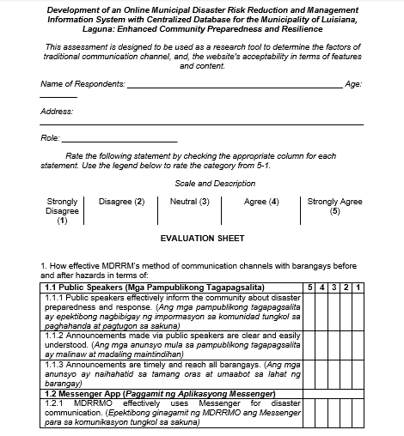
Questionnaire
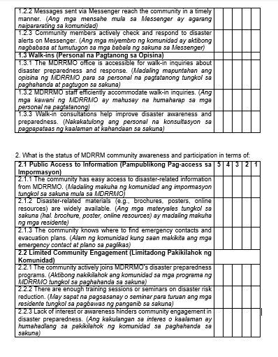

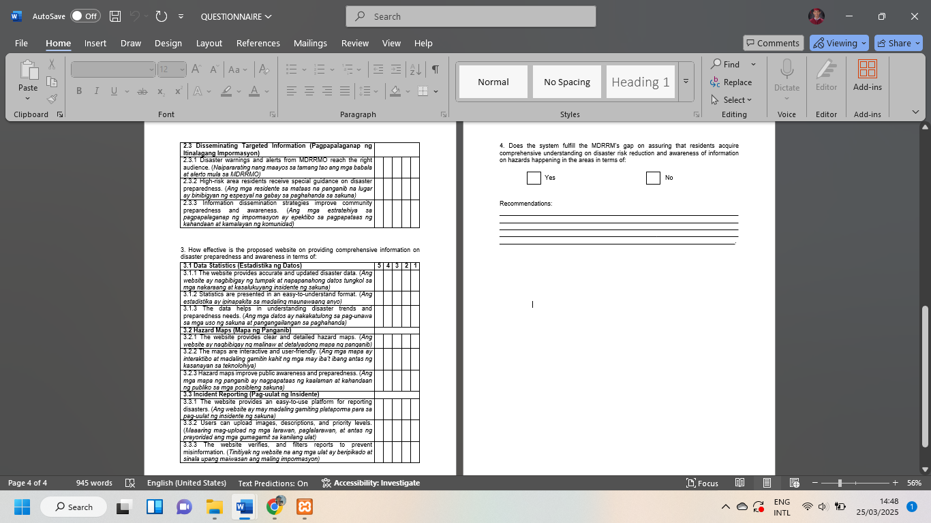

APPENDIX ‘B’


PHINMA EDUCATION
PHINMA UNION COLLEGE OF LAGUNA
Province of Laguna
College of Management and Accountancy

LETTER OF AGREEMENT

PHINMA EDUCATION
PHINMA Union College of Laguna
Province of Laguna
College of Management and Accountancy

March 20, 2025

Hon. Mayor Jomapher Alvarez
Municipal Mayor
Mayor’s Office
Luisiana, Laguna, Philippines 4032

Thru:
Ms. Joveña R. Esperanza
Head of MDRRM Office
Municipal Disaster Risk Reduction and Management Office
Luisiana, Laguna, Philippines 4032

Subject: Agreement on the Development of the Online Municipal Disaster Risk Reduction and Management Information System with Centralized Database.

Dear Ms. Esperanza
Warm greetings in the name of the Lord.
We are pleased to formally present this letter of Agreement between the office of the Municipal Disaster Risk Reduction and Management (MDRRM) and the research team consisting of James Izel P. Gallardo, Leo A. Custodio, Jhester M. Aquino, Lian Rovic C. Manjares.
This agreement outlines the commitment of the researchers to develop the Online Municipal Disaster Risk Reduction and Management Information System with Centralized Database as part of their capstone project.
The research team is dedicated to ensuring the successful development of the system by employing their skills, knowledge, and best efforts. The project will be undertaken from January 6, 2025, to March 29, 2025, and will encompass the following scope and limitations:
- User Management
  - View, search, download, report incidents, and upload comments.
- Barangay Management
  - Manage documents (View, search, locate, download, and upload documents, report, images and comments).
- Office Administrator
  - Manage data and documents (upload, update, delete, download, search, and clear all the uploaded data and documents).
  - Monitor and check audit logs.
  - Manage users (add, edit, or delete users)

If the terms and conditions outlined above are acceptable, we kindly request your signature to signify approval and formalize this agreement.
We appreciate the opportunity to collaborate with your esteemed office and look forward to a productive partnership.

Sincerely,
Researchers:
____________________
James Izel P. Gallardo
____________________
Jhester M. Aquino
____________________
Leo A. Custodio
____________________
Lian Rovic C. Manjares

Approved by,
____________________
Hon. Mayor Jomapher Alvarez
Municipal Mayor
Province of Laguna

____________________
Joveña R. Esperanza
Head of MDRRM Office
Province of Laguna

Noted by:
____________________
Dr. LEE D. SAMONTE, DPA, CpE
I.T. Professor
PHINMA-UCL College of Management and Accountancy

____________________
MICHAEL STEVE M. CRUZ
Dean of College of Management and Accountancy
APPENDIX ‘C’
PHINMA Union College of Laguna


PHINMA Union College
- Mabini St., Brgy. Pob. III, Santa Cruz, Laguna, 4009

COLLEGE OF MANAGEMENT AND ACCOUNTANCY

MS. JOVEÑA R. ESPERANZA
Head of MDRRM Office
Municipal Disaster Risk Reduction and Management Office
Luisiana, Laguna, Philippines 4032
March 20, 2025

Subject: System Acceptance and Approval

Dear Ms. Joveña Esperanza,
Warm Greetings in the Name of the Lord.
We are pleased to formally present the completed development of an Online Municipal Disaster Risk Reduction and Management Information System with Centralized Database for the Municipality of Luisiana, Laguna, developed as part of the ITE 310 Capstone Project II at PHINMA Union College of Laguna. This system has been designed and implemented based on your requirements and feedback, ensuring it aligns with your operational needs and expectations.
As part of the final review, we kindly ask for your confirmation of the system’s acceptance and satisfaction with its functionality, performance, and usability. Your approval signifies that the system meets the agreed-upon specifications and is ready for deployment in your organization.
Should there be any final adjustments or concerns, please let us know so that we can address them promptly. We greatly appreciate your collaboration and support throughout the development process.
Kindly sign below to indicate your acceptance of the system.

Acknowledgment and Acceptance:
I, Joveña Esperanza, hereby confirm that I have reviewed and tested the Online Municipal Disaster Risk Reduction and Management Information System with Centralized Database for the Municipality of Luisiana, Laguna and find it to be satisfactory and in accordance with the agreed specifications. I accept the system as delivered.
_________________________
JOVEÑA R. ESPERANZA
Date: _________________________

Thank you for your trust and partnership. We look forward to your continued support and feedback.
Sincerely,

Dr. LEE D. SAMONTE, DPA, CpE
Associate Professor II / Part-time
PHINMA-Union College of Laguna
College of Management and Accountancy

