The Game

Gameplay
The player tries to throw pieces into/onto a container or platform. The area the player can affect is highlighted green. In this area pieces float and are not affected by gravity. Outside this area gravity works normally, and the player cannot directly affect pieces.
This game will use physics to determine the outcome of players actions. If things fall of the bottom of the play area they are gone and the players pays the cost for them. Once all the pieces have been thrown and settle any pieces that remain will be be sold and the player will get the value for those pieces.
The player wants to make as much money as possible, so ideally the player will not lose any pieces, but the size, shape, and pieces they are given to work with will make this more difficult. To advance to the next level the player will have to accomplish a certain goal, usually to make so much money this level, but it could be anything. We will leave the goal for each level open ended so that we can change the nature of the puzzle, potentially allow for tutorials or new mindbenders.

Game Details
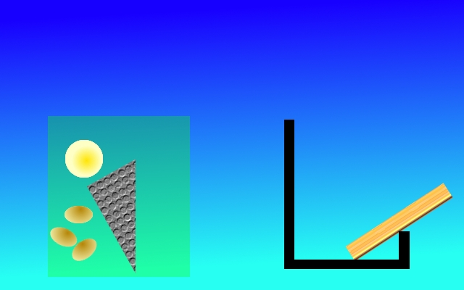Illustration 1: mocklevel1.xcf
The game can take place in a variety of different levels. Mocklevel1.xcf is a good example level.
In this example the background is a sky blue gradient, the black L shape on the right is the level platform. The wooden rectangle started in the greenish starting area, and is a potential position that a player may have thrown it to. There is a lump of gold, three oblong lumps of clay, and an largish metal triangle.

Any pieces that fall off the bottom
throw playing pieces in a container(Vase)
Different kind of materials and shape for pieces
5
Material Name | Value (what we gain) | Cost (what we lose) | How much does it bounce  (percent of momentum preserved) | Other interactions | Weight  per square CM | Color | Ferrous
Gold | 10 | 1 | 10 |  | 1 | Shiny Yellow | 0
iron | 5 | 3 | 30 |  | 1 | grey | 1
north magnet | 3 | 8 | 30 | attracts south magnet  repels north magnet  attracts ferrous materials | 1 | Black light blue  Radiating lines | 2
south magnet | 3 | 8 | 30 | attracts ferrous materials  attracts north magnet  repels south magnet | 1 | Black light blue  Radiating lines | 2
clay | 1 | 10 | 0 | sticky | 1 | Brown | 0
uranium | 10 | 10 | 30 | Explodes when colliding with another piece of  uranium if over a certain amount of momentum is transfered | 2 | Neon Green | 0
rubber | 3 | 7 | 180 |  | 1 | pink | 0
Lead | 3 | 5 | 20 | Very heavy likely to moves things about | 3 | Black | 0
Iron Clay | 1 | 10 | 0 | sticky, has iron in it | 1 | brown with red spots | 1
Pyrite | -5(with gold)  3 on its own | 10 | 30 |  | 1 | Shiny yellow  Black spots | 1
styrafom
Shapes of pieces
When two objects collide Half of the initiating objects momentum should be transfered. The bounciness determined with what speed the initiator flies back with 200% equals preserving all the bounce and transferring that much energy to hit object. So if dropped on a flat surface a Rubber ball in our game will return to 90% of its height. Assume all measurements are on typical screens 72dpi.
Round - a round ball appearing about 1 CM in diameter on typical screens in game weight is 1 KG for most objects
Cube - a square cube around 1 CM in height and width, on typical screens
Line - A long thin block, about 1 CM thick and about 5 long
U Shape - 3 cm by 3 cm, with a 2 cm by 2.3 cm section removed from the center of one edge.such t it is consistently .5 cm thick
Octogon- each side of the octagon is 1/8 cm long
What happens here

Pyrite is magnetic, prehaps we could include that.
Uranium explosions
Do not damage the vase, but destroys balls with ___ radius and gives player money equal the 1/2 of what would have been earned otherwise.
Project Resources

