Note from the author: The original documentation provided by FiiO was entirely in Chinese. Since I do not speak Chinese, this manual has been translated into English using AI to help the community. Please excuse any minor translation quirks!

ECHO Series Firmware Upgrade Guide

1. Download the upgrade tool, drivers, and firmware
First, make sure you have the correct firmware for your device. See the repository README for the exact filenames for ECHO, Echo Mini 8GB, Echo Mini 512MB, and Echo Nano.

2. Install the driver
Install the driver on the computer. Right-click "My Computer" -> select "Properties" -> select "Device Manager" -> expand "Other devices" and find the item with a yellow exclamation mark -> click "Update driver." Follow the prompts, select manual installation location, and choose the Driver folder under the tool directory. Select the corresponding driver based on your system parameters. Installation is now complete.
Note: If it does not work on a win10 computer, you can also try win8. On "My Computer," it is located in the area shown in the image.
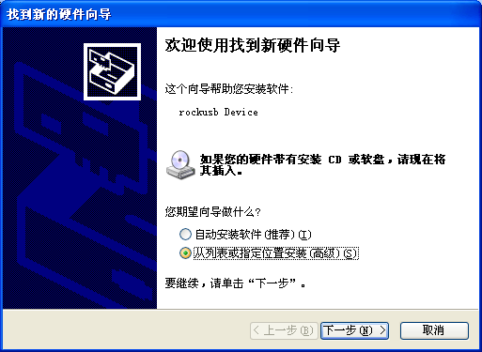

3. Open the RKDevelopTool program and re-flash
For international users: open the config.ini file and change "Selected=1" to "Selected=2", as indicated by the arrow in the image. This will make the RKDevelopTool display in English. (Note: This has already been done for you in this repository).
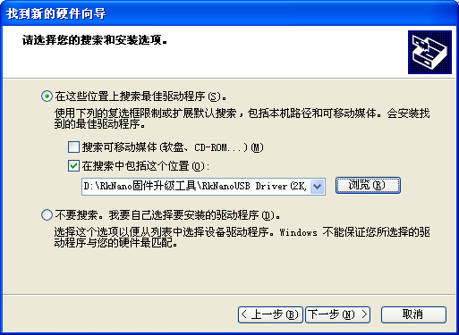
Load the firmware using the button. After completing this step, the following will appear:
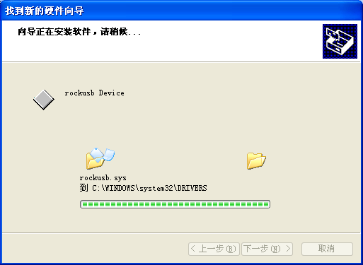
Then, pay attention to the lower-left corner of the image. When the computer connects to the device, it may display "Found one MSC device." Click the Switch button. If the driver is installed successfully, this area will then display "Found one MASKROM device" or "Found one Loader device".
If the first two steps are completed without any issues, then you can proceed to follow the remaining steps shown in the figure (Erase system block, then Upgrade). The final interface will appear as shown in the image:
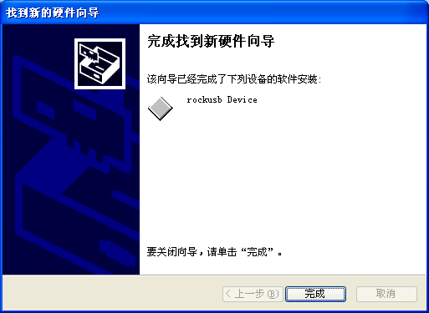
Once the loading is complete, the following will appear in the log:
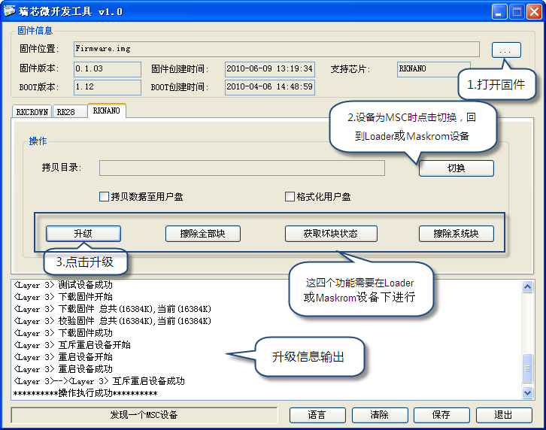
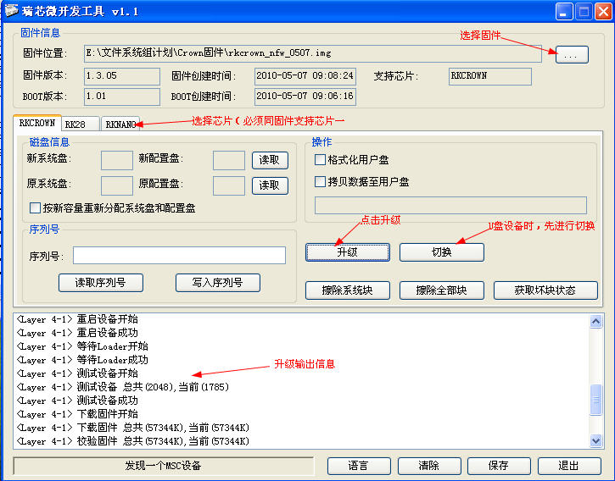

4. Error Message Description
• "Failed to load configuration information" — Error loading Config.ini file. Usually caused by Chinese characters in the folder path.
• "Failed to load firmware" — Verify that the firmware file is correct.
• "Another operation is in progress, please wait!" — Please wait for it to finish.
• "No device found" — Verify that the device is connected and in Rockusb state.
• "Unsupported device type" — Please confirm that the device has entered Rockusb state. If it is in USB mass storage mode, click Switch first.

5. Important Notes
• If the process gets stuck at "Download Boot Start," please disconnect the device and restart the upgrade process.
• On Vista or Windows 7 systems, the program must be run with administrator privileges.

