

A Comprehensive Comparison of Butterworth and Chebyshev IIR Filters: Design from Standard Analog Prototypes and Python Simulation
Group Members:
Hoang Trung Hải - SS204779
Mai Đình Tuấn - SE204186
Bùi Lê Văn Khoa - SE203529
CourseName: DGT302
Lecturer:Hoàng Thu Hà
October 28, 2026

Abstract
This report compares two lowpass IIR filter families, Butterworth and Chebyshev Type I, through Python simulation. The digital filters are designed from normalized analog prototypes using frequency scaling (lp2lp), frequency prewarping, and the bilinear transform, with order N = 5, cutoff frequency 1000 Hz, sampling frequency 8000 Hz, and 1 dB Chebyshev ripple. Their characteristics are assessed through magnitude response, phase response, group delay, step response, and pole-zero plots. At the same order, the Chebyshev filter reaches −54.5 dB attenuation at 2000 Hz versus −38.3 dB for the Butterworth filter, but it shows 1 dB passband ripple and a group delay variation of 13.44 samples versus 3.26 samples. Both filters are stable, with largest pole radii of 0.8008 and 0.9385, respectively. An illustrative application with four increasingly demanding requirement sets (labeled 2G, 3G, 4G, and 5G) shows that the minimum Butterworth order grows from 5 to 49, while the Chebyshev order grows from 4 to 15, and that Chebyshev group delay distortion is always larger. The results confirm that choosing between the two families is a trade-off between selectivity and filter order on one side and magnitude flatness and phase linearity on the other.
Keywords: IIR filter, Butterworth, Chebyshev, bilinear transform, pole-zero plot, group delay
Table of Contents
Abstract 2
List of Abbreviations 4
List of Symbols 4
Overview 5
Theoretical Background 5
Objectives and Scope 6
System Architecture 6
Workflow 7
Program 1: Digital IIR Design 7
Program 2: Illustrative Application 8
Results and Discussion 9
Magnitude Response 9
Phase Response and Group Delay 11
Step Response 11
Poles, Zeros, and Stability 12
Illustrative Application: 2G to 5G Scenarios 12
Limitations 15
Conclusion 15
References 17

List of Abbreviations
Abbreviation | Meaning
2G, 3G, 4G, 5G | Scenario labels of the four requirement sets used in the illustrative application (simulation assumptions, not standard specifications)
dB | Decibel
FIR | Finite impulse response
IIR | Infinite impulse response
SOS | Second-order sections
ZPK | Zero-pole-gain representation
B/C | Ratio of Butterworth order to Chebyshev order

List of Symbols
Symbol | Meaning
A_{s} | Minimum stopband attenuation (dB)
ε | Ripple parameter of the Chebyshev Type I response
f_{c} | Cutoff frequency (Hz)
f_{p} | Passband edge frequency (Hz)
f_{s} | Sampling frequency (Hz)
f_{st} | Stopband edge frequency (Hz)
H(z) | Digital filter transfer function
H_{a}(jΩ) | Analog filter frequency response
N | Filter order
R_{p} | Maximum passband ripple (dB)
T_{N} | Chebyshev polynomial of order N
Ω | Analog angular frequency (rad/s)
Ω_{c}, Ω_{p} | Analog cutoff and passband edge frequencies (rad/s)
A Comprehensive Comparison of Butterworth and Chebyshev IIR Filters: Design from Standard Analog Prototypes and Python Simulation

Overview

Theoretical Background
A digital filter with an infinite impulse response (IIR) is described by a rational transfer function H(z) = B(z)/A(z) and implemented by a recursive difference equation. Compared with an FIR filter meeting the same magnitude requirements, an IIR filter usually needs a lower order, at the cost of a nonlinear phase and the need to verify stability, that is, all poles inside the unit circle (Oppenheim & Schafer, 2010; Proakis & Manolakis, 2007).
A common way to design an IIR filter is to start from a known analog filter and map it to the z-domain. This approach reuses the magnitude approximations of analog filter theory, of which the Butterworth and Chebyshev approximations are two classical examples (Oppenheim & Schafer, 2010; Proakis & Manolakis, 2007). The squared magnitude response of an Nth-order Butterworth lowpass filter is
|H_{a}(jΩ)|² = 1 / [1 + (Ω/Ω_{c})^{2N}] (1)
It is maximally flat in the passband, decreases monotonically with frequency, and has 3 dB attenuation at the cutoff frequency Ω_{c}; its poles are equally spaced on a circle in the left half of the s-plane. The Chebyshev Type I response of order N is
|H_{a}(jΩ)|² = 1 / [1 + ε²T_{N}²(Ω/Ω_{p})], ε = √(10^{Rp/10} − 1) (2)
where T_{N} is the Chebyshev polynomial of order N and R_{p} is the allowed passband ripple in dB. This filter is equiripple in the passband, decreases monotonically in the stopband, and has poles on an ellipse; for the same order, its transition is steeper than that of the Butterworth filter (Oppenheim & Schafer, 2010; Proakis & Manolakis, 2007).

Objectives and Scope
The report has three objectives: (a) to design Butterworth and Chebyshev Type I IIR filters from standard analog prototypes; (b) to plot and compare the magnitude response, phase response, and pole-zero diagram of the two filters; and (c) to illustrate, through an application with changing requirements, how the two families differ in practice. The scope is limited to lowpass filters, Chebyshev Type I, and the parameters given in the Workflow section.

System Architecture
The simulation consists of two independent Python programs that follow the same five-layer processing chain summarized in Table 1. Program 1 (so_sanh_butterworth_chebyshev.py) performs the complete digital IIR design for one fixed parameter set. Program 2 (ung_dung_2G_5G.py) finds the minimum order of each filter family for each requirement set and compares the resulting metrics.
Table 1
Layers of the Simulation Architecture
Layer | Function | Functions used
Input parameters | Declare f_{s}, f_{c}, N, R_{p} (Program 1); f_{p}, f_{st}, R_{p}, A_{s} (Program 2) | Variables in code
Analog prototype | Create the zero-pole-gain form of the lowpass prototype with a 1 rad/s cutoff | buttap, cheb1ap; buttord, cheb1ord
Transformation | Frequency prewarping, frequency scaling, bilinear transform | lp2lp_zpk, bilinear_zpk
Analysis | Convert to second-order sections; compute frequency response, group delay, step response | zpk2sos, sosfreqz, group_delay, sosfilt, freqs_zpk
Display and measurement | Plot figures and extract quantitative metrics | Matplotlib, NumPy
Note. Program 1 designs the digital filters; Program 2 uses normalized analog filters to find the minimum orders.
Two architectural choices deserve mention. First, each filter is held in zero-pole-gain (ZPK) form and converted to second-order sections (SOS) for computation, because a cascade of second-order sections is less sensitive to coefficient errors than the direct form (Oppenheim & Schafer, 2010). Second, Program 2 designs the filters on a frequency axis normalized to f_{p} (so that f_{p} corresponds to 1 rad/s), because computing with real frequencies at high orders (49 for Butterworth in the 5G case) makes the power terms overflow.

Workflow

Program 1: Digital IIR Design
The simulation parameters are given in Table 2. The procedure has the following steps.
Table 2
Simulation Parameters of Program 1
Parameter | Value
Sampling frequency f_{s} | 8000 Hz
Cutoff frequency f_{c} | 1000 Hz
Filter order N | 5
Chebyshev ripple R_{p} | 1 dB
Number of frequency points | 4096 points in [0, f_{s}/2]
Step response length | 64 samples

- Create the normalized analog lowpass prototype (1 rad/s cutoff) with buttap and cheb1ap.
- Prewarp the cutoff frequency to compensate for the distortion of the bilinear transform:
Ω_{c} = 2f_{s}·tan(πf_{c}/f_{s}) (3)
- Scale the frequency with lp2lp_zpk to move the cutoff from 1 rad/s to Ω_{c}.
- Apply the bilinear transform with bilinear_zpk:
s = 2f_{s}(z − 1)/(z + 1) (4)
- Convert to SOS and compute the magnitude response, phase response, group delay, step response, and pole-zero locations.
- Extract the metrics: ripple over 0 to f_{c}, attenuation at 2000 Hz, largest pole radius, and the mean and variation of group delay in the passband.
The two families use different cutoff definitions: the Butterworth filter has 3 dB attenuation at f_{c}, whereas for the Chebyshev Type I filter f_{c} is the passband edge, where the response still lies within the ripple band R_{p}.

Program 2: Illustrative Application
Program 2 uses four requirement sets labeled 2G, 3G, 4G, and 5G (Table 3). The labels are only scenario names; what they share is a stopband edge that moves ever closer to the passband edge, an increasing attenuation requirement, and a shrinking ripple allowance.
Table 3
Specifications of the Illustrative Scenarios
Scenario | f_{p} | f_{st} | R_{p} (dB) | A_{s} (dB)
2G | 100 kHz | 300 kHz | 3.00 | 40
3G | 1.92 MHz | 3.6 MHz | 1.00 | 45
4G | 9 MHz | 11.5 MHz | 0.50 | 50
5G | 49.5 MHz | 58 MHz | 0.25 | 55
Note. f_{p}: passband edge; f_{st}: stopband edge; R_{p}: maximum passband ripple; A_{s}: minimum stopband attenuation. These are assumed simulation parameters.
- For each scenario, use buttord and cheb1ord to find the minimum order that meets the specification.
- Build the corresponding analog filter and compute its magnitude response and group delay.
- Compute the passband ripple or droop and the group delay distortion, defined as the difference between the largest and smallest group delay in the passband, normalized by 1/f_{p} so that scenarios can be compared fairly.
- Plot the magnitude response with the requirement regions, the normalized group delay, and summary bar charts.

Results and Discussion

Magnitude Response
Figure 1 (top row) and Table 4 present the magnitude responses. The Butterworth filter decreases monotonically and is flat over most of the passband, with a droop of 2.993 dB over 0 to f_{c}. The Chebyshev filter ripples evenly by exactly 1.000 dB in the passband but falls faster: at 2000 Hz its attenuation is −54.5 dB versus −38.3 dB for the Butterworth filter, a difference of 16.2 dB at the same order N = 5. This agrees with the theory that passband ripple is traded for a steeper transition.
Figure 1
Comparison of Butterworth and Chebyshev Type I Filters (N = 5, f_{c} = 1000 Hz, f_{s} = 8000 Hz)
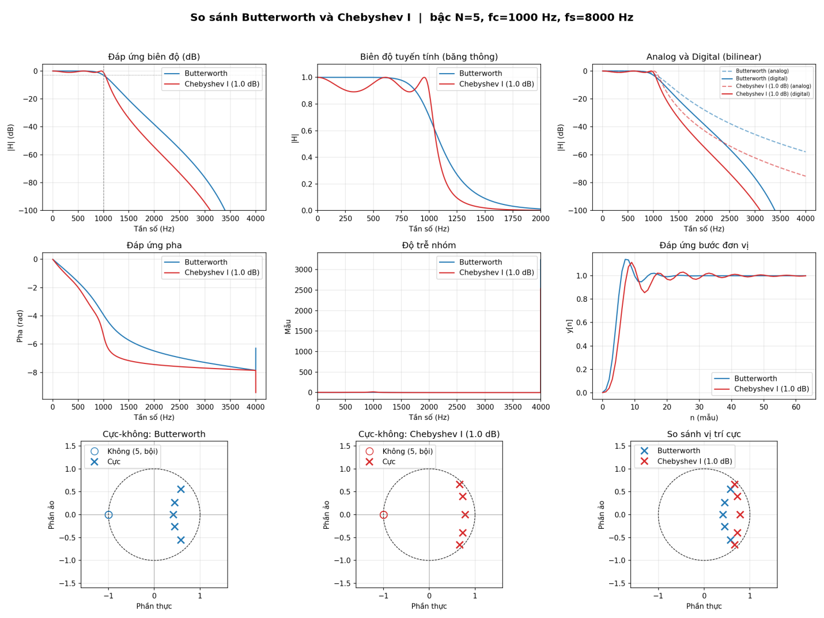
Note. Row 1: magnitude in dB, linear magnitude in the passband, and analog versus digital comparison. Row 2: phase, group delay, and unit step response. Row 3: pole-zero diagrams of the Butterworth and Chebyshev Type I filters and a comparison of pole locations. Figure generated by Program 1; axis labels appear as generated by the program.
The analog versus digital panel of Figure 1 shows that the digital response falls faster than the analog response at high frequencies. This results from the frequency warping of the bilinear transform, which compresses the whole analog frequency axis into the range 0 to π of the digital domain (Oppenheim & Schafer, 2010); prewarping ensures that only the cutoff frequency matches the intended value.
Table 4
Metrics of the Two Filters (N = 5)
Metric | Butterworth | Chebyshev I
Passband ripple or droop (dB) | 2.993 | 1.000
Attenuation at 2000 Hz (dB) | −38.3 | −54.5
Largest pole radius | 0.8008 | 0.9385
Mean group delay (samples) | 5.00 | 6.85
Group delay variation (samples) | 3.26 | 13.44
Step response peak | 1.140 (n = 7) | 1.114 (n = 9)
Minimum after the peak | 0.948 | 0.855
Stable | Yes | Yes
Note. Ripple or droop is measured over 0 to f_{c}. Group delay is measured in the passband.

Phase Response and Group Delay
The phase response of both filters decreases monotonically with frequency, but the Chebyshev phase changes faster around the passband edge (Figure 1, middle row). The mean group delay in the passband is 5.00 samples for the Butterworth filter and 6.85 samples for the Chebyshev filter; more importantly, the group delay varies by 13.44 samples for the Chebyshev filter versus 3.26 samples for the Butterworth filter. An uneven group delay means that different frequency components are delayed by different amounts, that is, larger phase distortion (Proakis & Manolakis, 2007). In the group delay panel of Figure 1, the spike at the Nyquist frequency dominates the scale; it is caused by the zero on the unit circle at z = −1, where the phase changes abruptly and group delay loses its meaning, so the values in Table 4 are computed in the passband only.

Step Response
The step response of both filters converges to 1. The Butterworth filter has a slightly higher overshoot peak (1.140 versus 1.114) but its oscillation dies out faster: its minimum after the peak is 0.948. The Chebyshev filter has a lower peak but dips deeper after it (0.855) and rings for longer. The advantage in peak overshoot therefore does not come with an advantage in settling behavior.

Poles, Zeros, and Stability
Both filters have five poles inside the unit circle and are therefore stable, and both have a fifth-order zero at z = −1, because the bilinear transform maps the zeros at infinity of the analog filter to this point (Figure 1, bottom row). The Chebyshev poles lie closer to the unit circle (largest radius 0.9385 versus 0.8008), that is, closer to the stability boundary. The closer a pole is to the unit circle, the sharper the frequency response near the corresponding frequency, which explains both the steeper transition and the larger ripple and group delay variation of the Chebyshev filter.
The coefficients of both filters are listed in Table 5 so that the results can be reproduced.
Table 5
Coefficients of the Transfer Function H(z) = B(z)/A(z)
k | b_{k} (Butterworth) | a_{k} (Butterworth) | b_{k} (Chebyshev) | a_{k} (Chebyshev)
0 | 0.003279 | 1.000000 | 0.000848 | 1.000000
1 | 0.016396 | −2.474416 | 0.004241 | −3.582782
2 | 0.032792 | 2.811006 | 0.008482 | 5.724424
3 | 0.032792 | −1.703772 | 0.008482 | −4.985236
4 | 0.016396 | 0.544433 | 0.004241 | 2.351050
5 | 0.003279 | −0.072316 | 0.000848 | −0.480312

Illustrative Application: 2G to 5G Scenarios
This section answers the question of how the difference between the two families shows up when the requirements change. The results of Program 2 are shown in Figure 2 and Table 6.
Figure 2
Butterworth and Chebyshev Type I Filters Across the 2G to 5G Scenarios
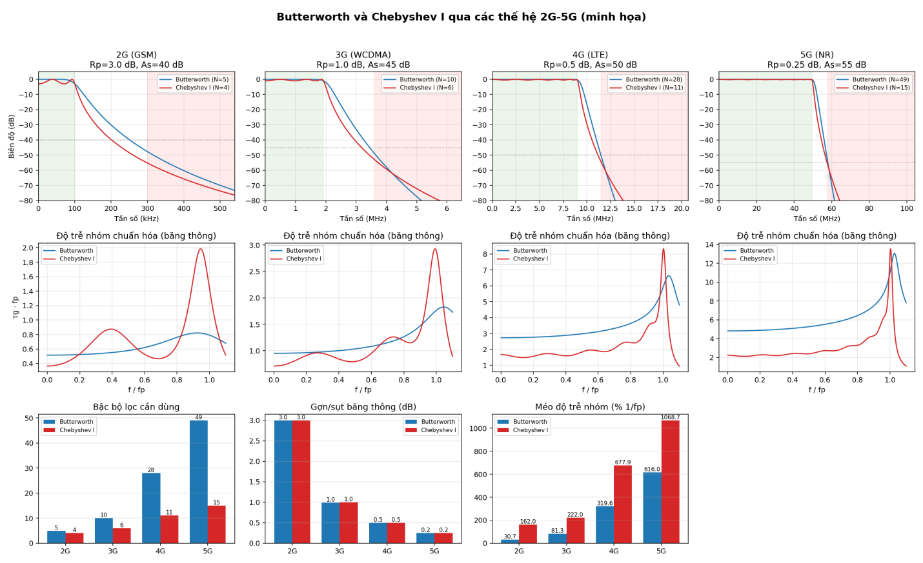
Note. Row 1: magnitude response with the passband (green) and stopband (red) regions. Row 2: normalized group delay in the passband. Row 3: filter order, passband ripple or droop, and group delay distortion. Figure generated by Program 2; axis labels appear as generated by the program.
Table 6
Minimum Order and Quality Metrics for Each Scenario
Scenario | Filter | Order | Ripple or droop (dB) | Group delay distortion (% of 1/f_{p}) | Order ratio B/C
2G | Butterworth | 5 | 3.00 | 30.7 | 1.25
 | Chebyshev I | 4 | 3.00 | 162.0
3G | Butterworth | 10 | 0.99 | 81.3 | 1.67
 | Chebyshev I | 6 | 1.00 | 222.0
4G | Butterworth | 28 | 0.50 | 319.6 | 2.55
 | Chebyshev I | 11 | 0.50 | 677.9
5G | Butterworth | 49 | 0.25 | 616.0 | 3.27
 | Chebyshev I | 15 | 0.25 | 1068.7
Note. The order ratio B/C is the Butterworth order divided by the Chebyshev order. Group delay distortion is the difference between the largest and smallest group delay in the passband, normalized by 1/f_{p}.
In the least demanding scenario (f_{st}/f_{p} = 3), the two filters differ by one order only (5 and 4). As the transition band narrows, this ratio falls to 1.875, 1.278, and then 1.172, and the Butterworth order rises very quickly to 10, 28, and 49, while the Chebyshev order rises only to 6, 11, and 15. The order ratio B/C therefore grows from 1.25 to 3.27. A higher order means more filter sections, more computation, and more delay, so for demanding requirements the Chebyshev filter has a clear advantage in implementation cost.
This advantage is paid for with phase distortion. In every scenario the group delay distortion of the Chebyshev filter exceeds that of the Butterworth filter, by factors of 5.28, 2.73, 2.12, and 1.73 from 2G to 5G. Figure 2 (middle row) shows that the Butterworth group delay rises slowly with a low peak, whereas the Chebyshev group delay has a sharp peak near f/f_{p} = 1. Consequently, if an application is sensitive to magnitude and phase distortion, the Butterworth filter is more suitable provided a high order is acceptable; if saving hardware is the priority, a Chebyshev filter with small ripple is a reasonable choice, possibly with phase compensation (Proakis & Manolakis, 2007).

Limitations
The results of Program 1 correspond to a single parameter set (N = 5, R_{p} = 1 dB); changing these parameters would change the metrics quantitatively, although the trends would remain. The scenarios of Program 2 use assumed parameters and analog filters that have not been passed through the bilinear transform. The report also considers only lowpass Chebyshev Type I filters.

Conclusion
This report designed Butterworth and Chebyshev Type I IIR filters from standard analog prototypes through lp2lp scaling, frequency prewarping, and the bilinear transform, and compared them through magnitude response, phase response, group delay, step response, and pole-zero diagrams. At the same order N = 5, the Chebyshev filter is steeper (−54.5 dB versus −38.3 dB at 2000 Hz) but ripples by 1 dB in the passband and has a larger group delay variation (13.44 versus 3.26 samples). The Butterworth filter is flat and has better phase behavior but a gentler slope. Both are stable, and the closeness of the Chebyshev poles to the unit circle (0.9385 versus 0.8008) is the common cause of both its steeper slope and its stronger oscillation.
The illustrative application showed that as the requirements become more demanding, the Butterworth order rises from 5 to 49 while the Chebyshev order rises only from 4 to 15, yet the Chebyshev filter always has the larger group delay distortion. The choice between the two families is therefore a trade-off governed by the application: choose Butterworth when magnitude flatness and phase linearity matter most, and Chebyshev when selectivity and implementation cost matter most. Natural extensions are to study other values of N and R_{p} and other families such as Chebyshev Type II and elliptic filters.

References
Oppenheim, A. V., & Schafer, R. W. (2010). Discrete-time signal processing (3rd ed.). Pearson.
Proakis, J. G., & Manolakis, D. G. (2007). Digital signal processing (4th ed.). Pearson Prentice Hall.

