**AZURE DEVOPS BUILD PIPELINE**

**WHAT IS CI/CD?**

**CI (Continuous Integration):**

CI process is an automation process that keeps building, testing, feeding back new code written/ changed by one of the developers to the team. CI process can be done by using automation tools.

Advantages:

* Reduce merge conflict
* Testable build

**CD process (Continuous Delivery):**

CD is process which automatically change new codes into a software, test the software with automation testing then have other tests before being approved then become a product for the end-users.

**Deployment pool:**

A deployment pool is a set of target servers available to the organization. When you create a new deployment pool for projects in your organization, a corresponding deployment group is automatically provisioned for each project.

**Agent pool:**

A set of services that runs the jobs defined in the pipeline (self-hosted agent, Microsoft-hosted agents).

**Build CI Pipeline with React**

1. **Click on Pipeline section**

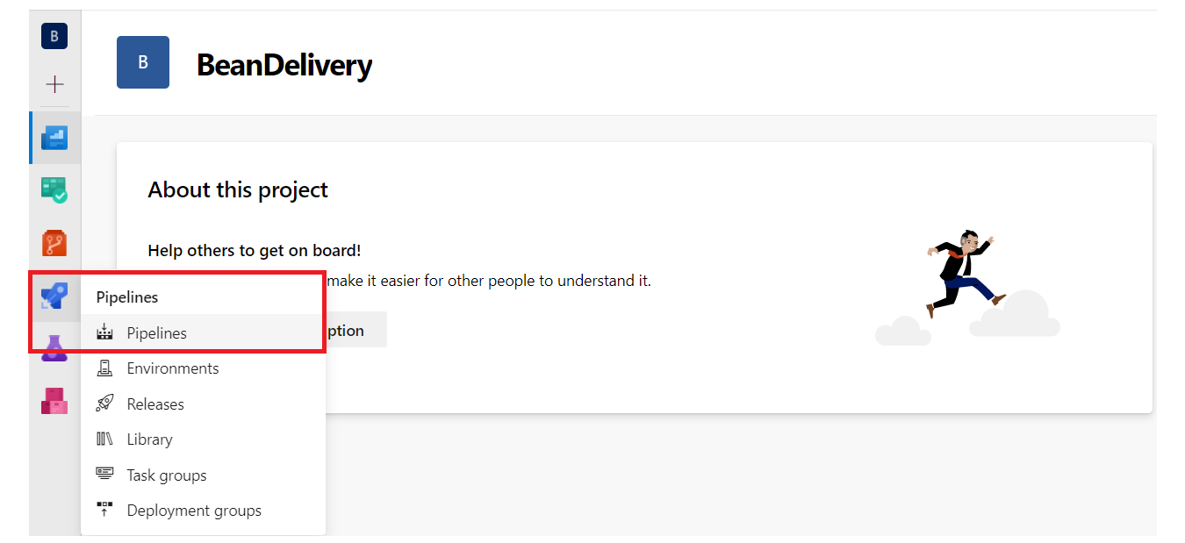

**and click create pipeline button to create a new pipeline**

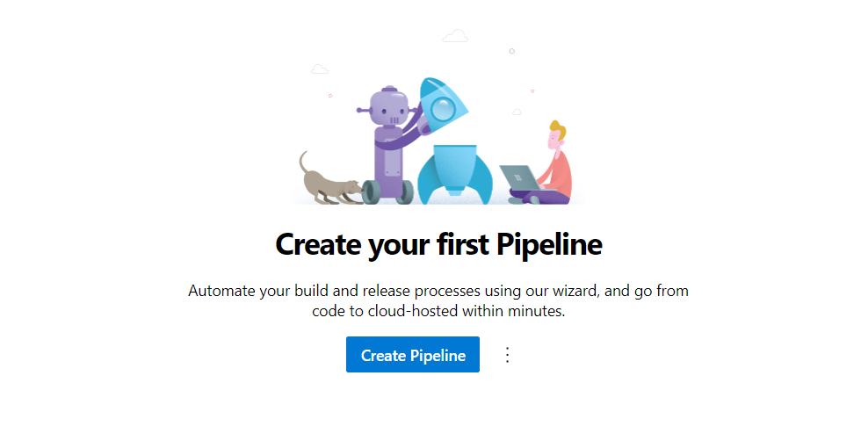

**Then,**

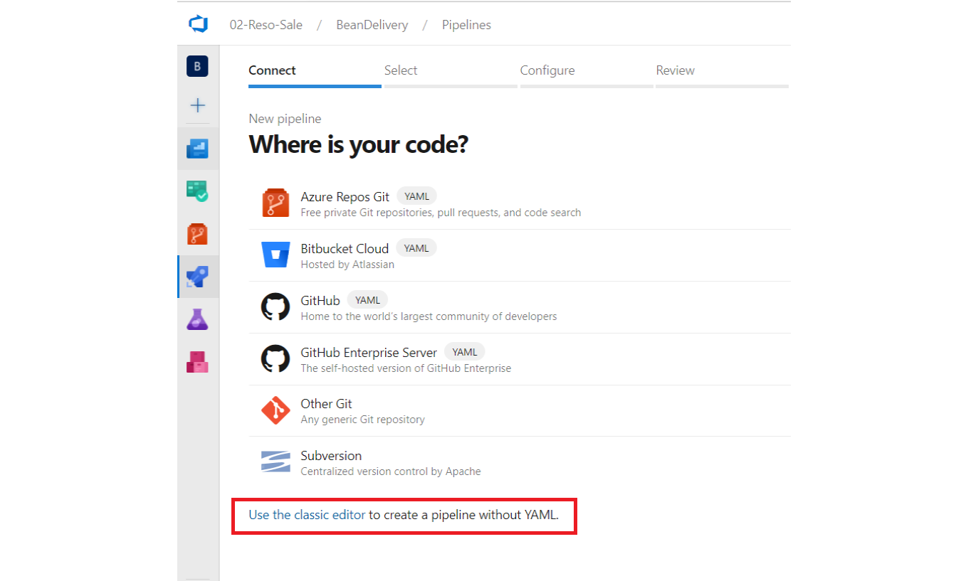

1. **After that, you select your repository which need to be built in pipeline**

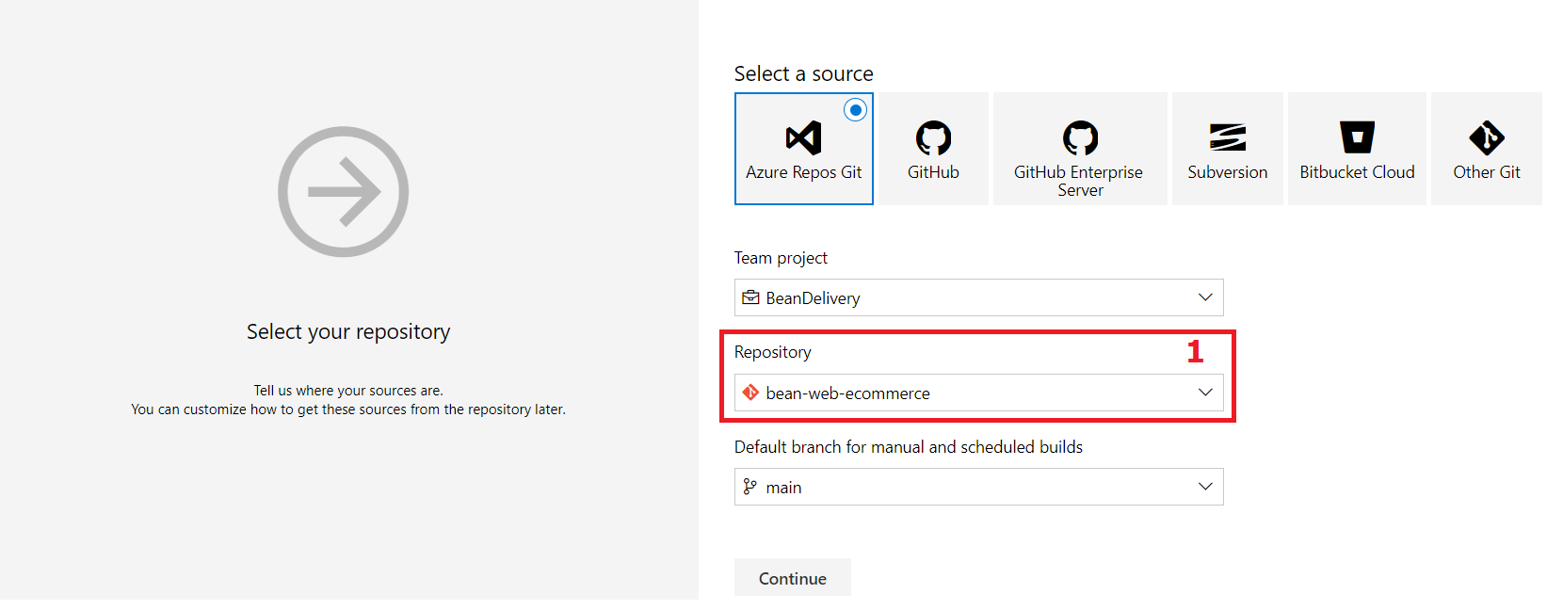

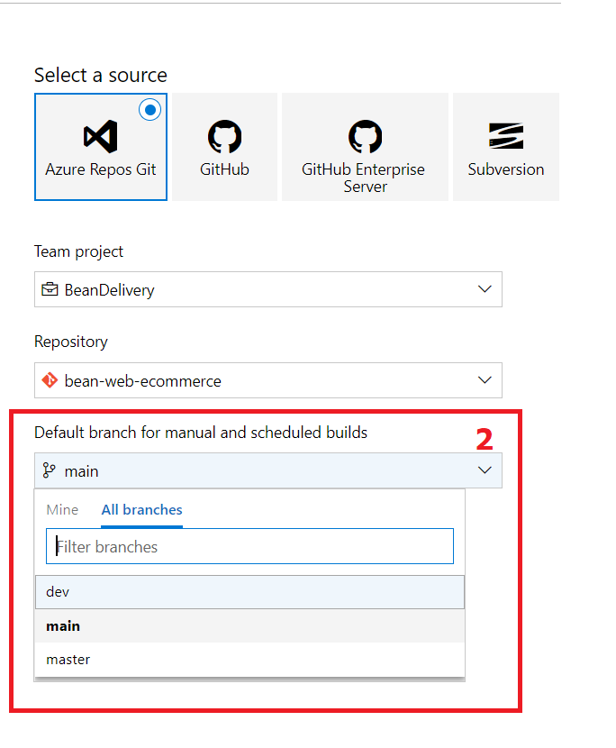

* Depend on environment pick a right branch.

1. **Then you have configured the pipeline. We have the react app so choose Node.JS with React**

* Search with keyword “*Node*” to use the template was created by Azure

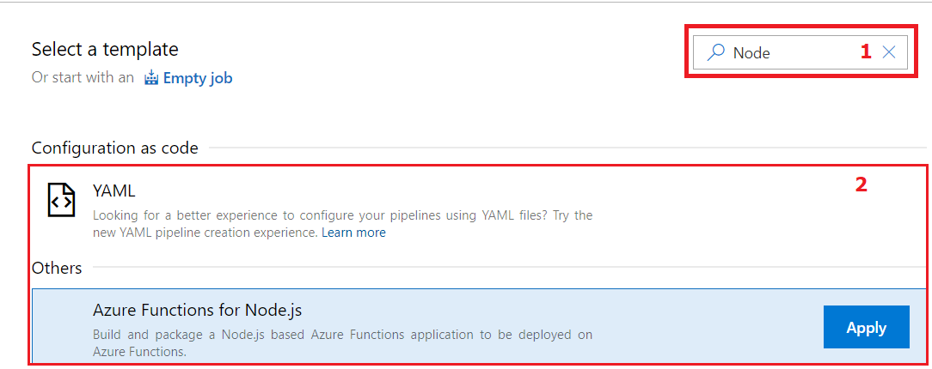

* Using the template that was created by Azure to shorten the configuration time. It has most used tasks that we have to implement into our pipeline.

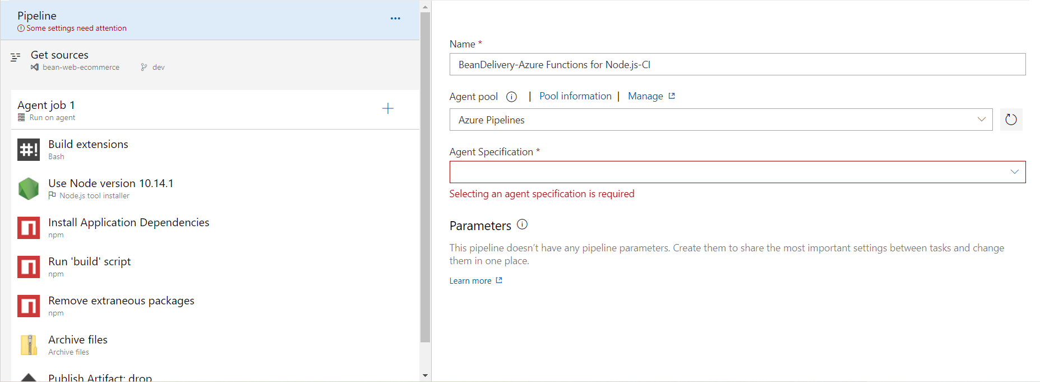

First, notice that we need to select *Agent Specification. (this Agent will be talked in another Article)*

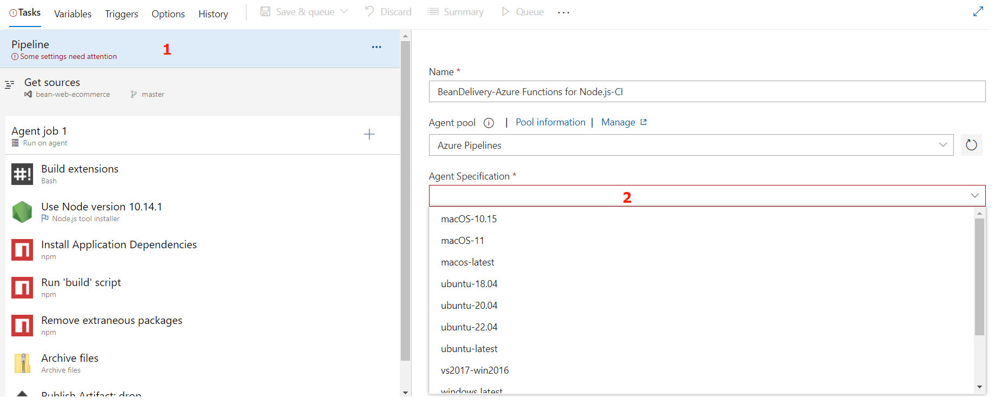

After removing/disable, I recommend using *Yarn* to execute the installation and building Node JS project (you’re able to use *npm*, if you want to).

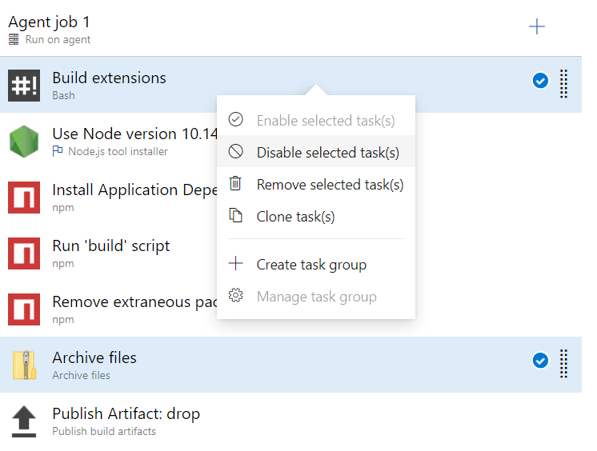

By adding these *Yarn* task, we continue to configure the important values.

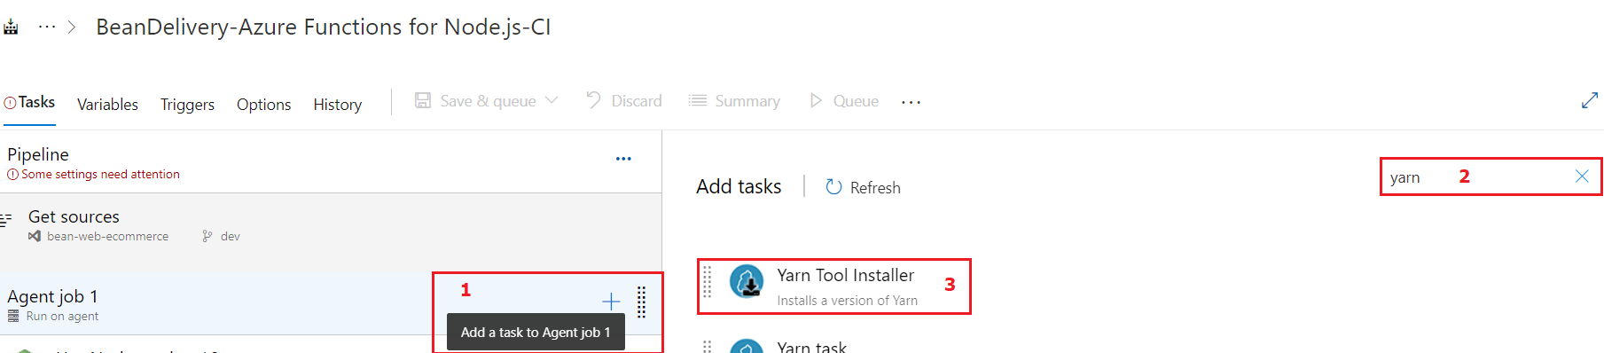

1. Node JS version: discuss this version to Team Dev. I suggest using Node JS version 16. This is currently a stable version of Node JS.

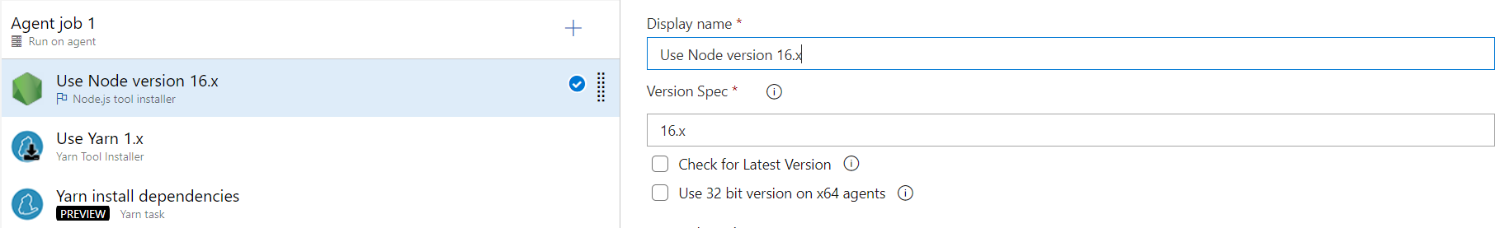

1. Use *Yarn* Task: using the latest version of it.

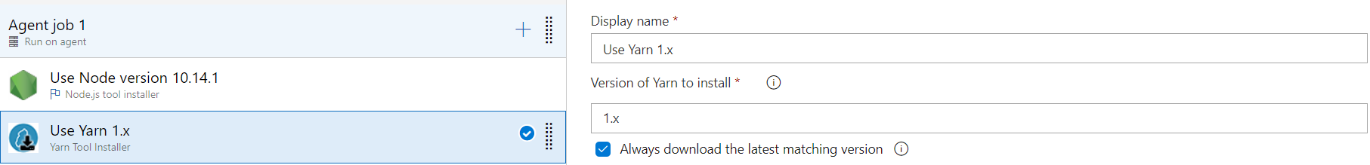

1. *Yarn* installation dependencies: this task requires you to locate the *package.json* file so that, the field *Project Directory* it should be the exact path to the file I early mentioned.

Use command “install” to fill in the *Argument* section. This means you use the command “*yarn install*” in order to install all dependencies were used in React Web App.

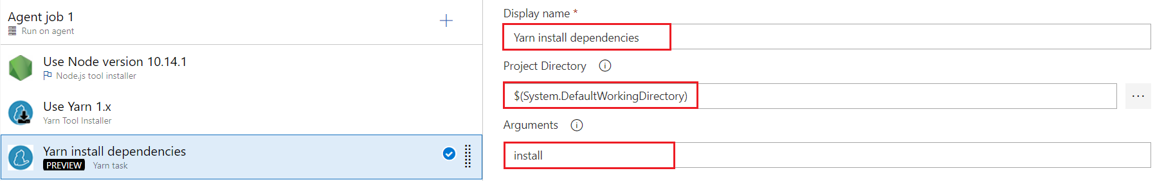

1. *Yarn* build {env} – it might be staging or production: the field *Project Directory* the same values with the previous task.

Use command “*run build*” to fill in the *Argument* section. This means you use the command “*yarn run build*” in order to build React Web App with env.staging file.

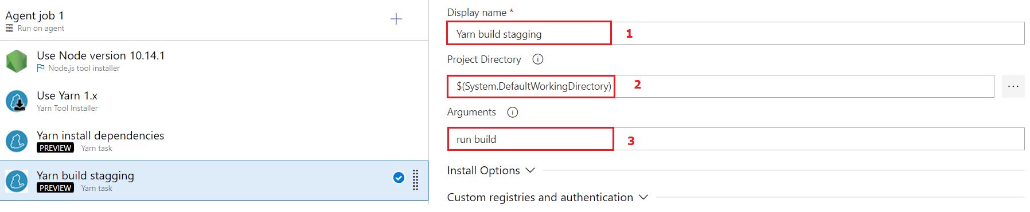

1. Next, add *Copy files* task for copying all the contents inside the *build* (it could be different to yours in this docs) folder to the publish artifact

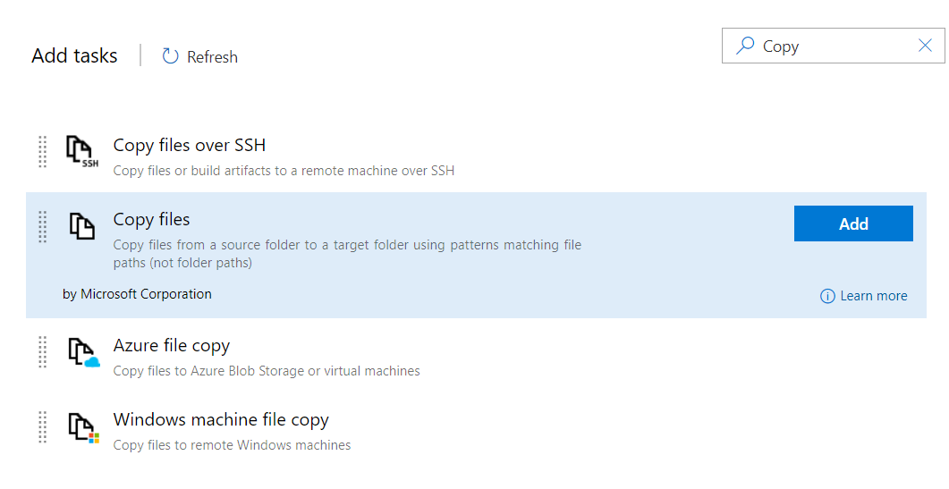

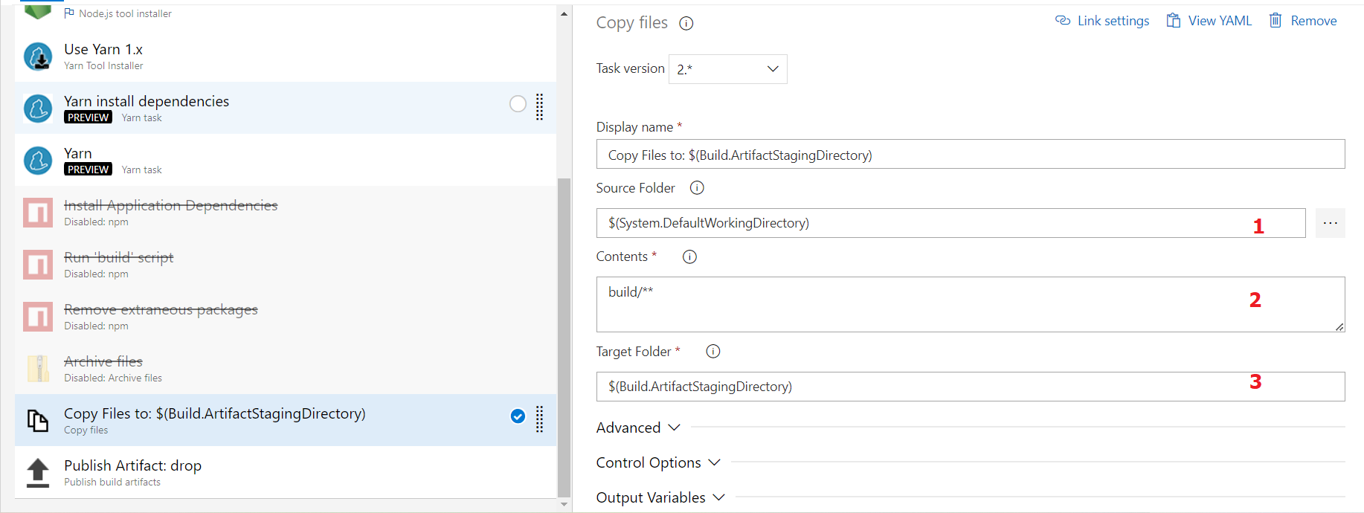

Then save it.

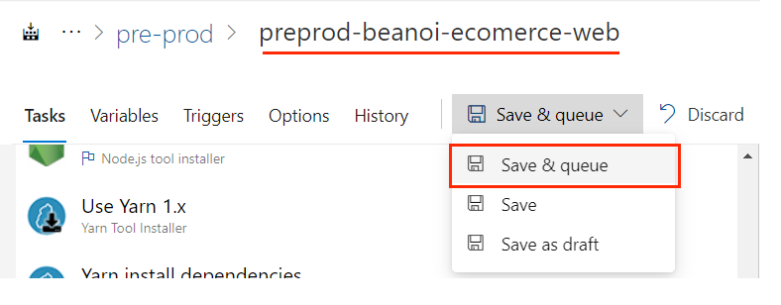

Notice that, the name of pipeline always following the format:

*{env}-{project-name}-{repo-name}-CI-pipeline*

Then, you just need to wait for the result of the CI pipeline and fix bug (**if have**).

**SO, THAT’S ALL FOR BUILDING CI PIPELINE FOR NODE JS (REACT JS WEB APP)**

**Build CI Pipeline with .NET Core**

Repeat Step1 & Step2 from above

After choosing the Repo and the specific branch to build pipeline

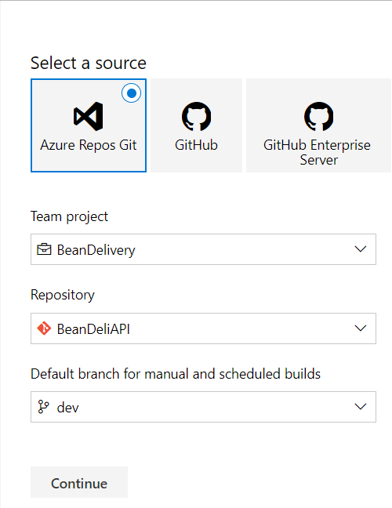

Continue to pick a build template for **.NET Core** project

