BOI Mule Account Detection System
Solution Proposal, System Architecture & Results
BOI PSB Cybersecurity, Fraud & AI Hackathon

1. Executive Summary
Financial institutions face a growing threat from mule accounts—bank accounts used by fraud networks to receive, move, and launder illicit funds. Traditional rule-based systems struggle to detect novel typologies such as dormant accounts that suddenly activate, large-value movers, and instant pass-through mule patterns.
This proposal presents an end-to-end machine learning solution built for the Bank of India (BOI) PSB Cybersecurity, Fraud & AI Hackathon. The system combines a multi-algorithm model zoo (LightGBM, XGBoost, Random Forest, Extra Trees, MLP, and stacking ensemble), unsupervised anomaly detection (Isolation Forest), rule-based typology tagging, four-level suspicion scoring, and SHAP-based explainability—delivered through a FastAPI backend and investigator web UI.
On a held-out evaluation set (1817 accounts, 16 positives), the auto-selected production model (XGBoost) achieves holdout PR-AUC 0.888, precision 0.778 at recall 0.875, and recall @ 1% FPR of 1.000. The solution is demo-ready via Docker with batch scoring up to 200,000 accounts per request.

2. Problem Statement
Mule accounts enable fraud typologies including money laundering, scam proceeds collection, and rapid fund pass-through. Investigators need more than a binary fraud label—they require actionable decisions (BLOCK, CHALLENGE, REVIEW, APPROVE), behavioural typology tags, and transparent feature explanations to support regulatory and operational workflows.
Key challenges addressed by this solution include:
- Severe class imbalance (~1% fraud rate) requiring careful holdout validation and precision-focused thresholds.
- Label leakage risk in high-dimensional feature sets (feature F3912 excluded after audit).
- Train/serve skew if feature engineering differs between training notebooks and production API.
- Silent mules and large amount movers that evade generic supervised models without typology-aware signals.

3. Proposed Solution

The proposed solution is an explainable hybrid machine learning system for detecting mule accounts in banking data. It classifies accounts as legitimate or mule/suspicious by analyzing transaction velocity, fund-flow asymmetry, account activity, channel behavior, device/terminal usage, and deviation from normal customer patterns. The system is designed for high-dimensional anonymized banking data with rare mule labels.

The first step is data cleaning and leakage control. Features that directly reveal the target, such as highly correlated leakage variables, must be removed before training. Missing values are handled using median imputation, extreme values are clipped, and skewed amount-related features are transformed using log1p. This improves model stability and reduces overfitting.

The second step is behavior-based feature engineering. Important derived features include outbound-to-inbound transaction ratio, short-window to long-window amount ratio, net fund flow, burst velocity, dormancy activation, channel asymmetry, terminal instability, and peer-cluster distance. These features convert raw anonymized variables into meaningful fraud signals.

The core model should use a supervised classifier, preferably XGBoost, because it performs well on tabular, imbalanced fraud data. Other models such as LightGBM, Random Forest, Extra Trees, Logistic Regression, and stacking ensembles can be tested, but the final model should be selected using PR-AUC, recall, precision, and Recall@FPR 1%.

Since mule accounts are rare, the system should not depend on accuracy. It should use class-weighted learning and optimize for high recall at low false-positive rate. This ensures the model catches suspicious accounts without overwhelming investigators with too many false alerts.

To detect unknown mule behavior, an Isolation Forest anomaly model should be trained only on legitimate accounts. This learns normal account behavior and flags accounts that strongly deviate from it. The final risk score combines supervised probability and anomaly score:

Final Risk Score = 0.70 × ML Mule Probability +0.30 × Anomaly Score + Typology Boost

A typology rule engine should classify suspicious accounts into meaningful fraud patterns such as Instant Mule, Sleeper Mule, Large Amount Mover, Aggregator Hub, or Device-Risk Mule. These labels make the alert easier for fraud analysts to understand and investigate.

The adjusted risk score should be converted into action levels: Low accounts are allowed, Medium accounts go to manual review, High accounts are challenged or held, and Critical accounts are blocked and escalated. This makes the system operationally useful, not just predictive.

Every alert should include SHAP explanations showing the top features responsible for prediction. The alert should contain the risk score, suspicion level, typology, key feature values, explanation, and recommended action. This makes the model transparent, auditable, and investigator friendly.

3.1 Multi-Model Zoo & Auto-Selection
Eight candidate models are trained on the same engineered feature set with 5-fold stratified cross-validation. Holdout PR-AUC selects the production winner, saved as models/best_model.pkl. The current winner is XGBoost (single model).

3.2 Score Fusion & Typology Boost
For each account, the API accepts 18 bank key features (F115–F3894). A serialized FeaturePipeline computes 266 engineered features. Supervised probability and Isolation Forest anomaly scores are fused (70% / 30%). The TypologyEngine detects flags (silent_account, large_amount_mover, instant_mule, aggregator_hub) and applies a capped boost (+0.05 per flag, max +0.10) to produce adjusted_fused_risk_score.

3.3 Suspicion Levels & Decisions
Level | Label | Score Range (Balanced Policy)
1 | LOW | < REVIEW threshold (0.45)
2 | MEDIUM | REVIEW to CHALLENGE (0.45 – 0.65)
3 | HIGH | CHALLENGE to BLOCK (0.65 – 0.85)
4 | CRITICAL | >= BLOCK threshold (0.85)

3.4 Explainability & Investigator Controls
SHAP TreeExplainer provides per-account feature contributions via GET /explain/{id}. Investigators can switch decision policy presets (strict / balanced / loose), apply manual overrides with audit reasons, filter by suspicion level and typology, and export a Suspicion List CSV from the web UI.

4. System Architecture
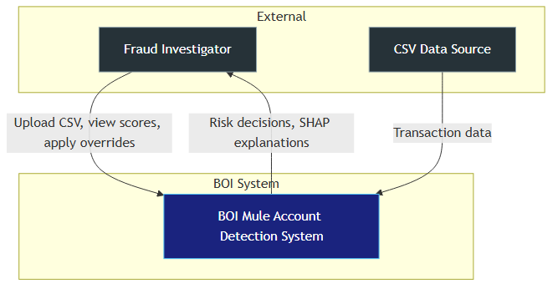
The following figures illustrate the system from external context through deployment. Each diagram is accompanied by an explanation of components, data flows, and operational relevance.
Figure 1: C4 System Context

Figure 1 shows the BOI Mule Account Detection System in its operational context. Fraud investigators interact with the system to upload transaction CSV files, review scored accounts, apply manual overrides, and retrieve SHAP explanations.
The system consumes account-level feature data and returns risk decisions, suspicion levels, typology flags, and explainability output. This boundary defines the scope of the hackathon deliverable: a self-contained ML serving application with investigator UI.

Figure 2: C4 Container Architecture
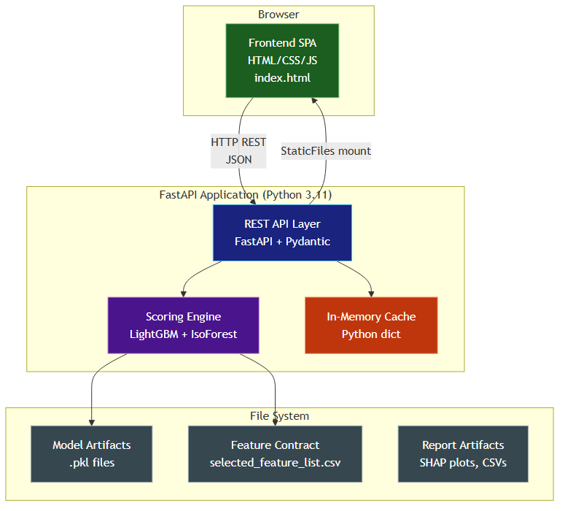
Figure 2 decomposes the system into containers. The Frontend SPA (HTML/CSS/JS) communicates with the FastAPI REST API over JSON. The Scoring Engine loads best_model.pkl (currently XGBoost), Isolation Forest, the serialized FeaturePipeline, and TypologyEngine thresholds.
An in-memory cache stores recent scoring results for SHAP explanations and the /alerts/suspicious-list endpoint. Model artifacts reside on the file system under models/, ensuring train/serve parity via the same feature_pipeline.pkl used in training notebooks.
Unlike a hard-coded single-model deployment, this container design supports swapping the production model after retraining without code changes—only best_model.pkl and metadata update.
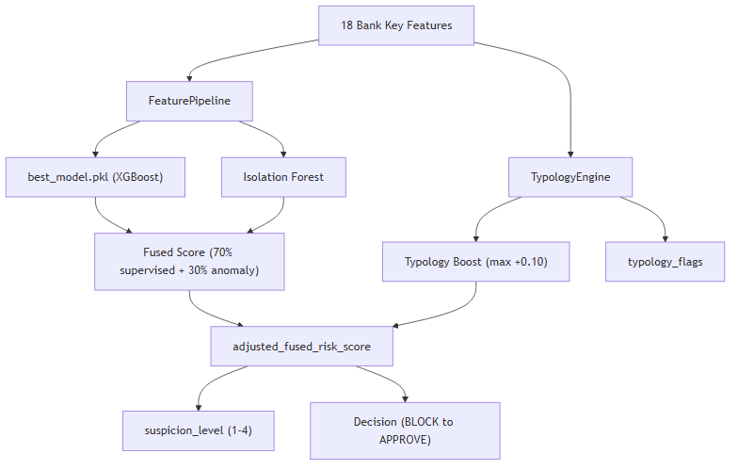
Figure 3: End-to-End Scoring Pipeline with Typology and Suspicion Levels

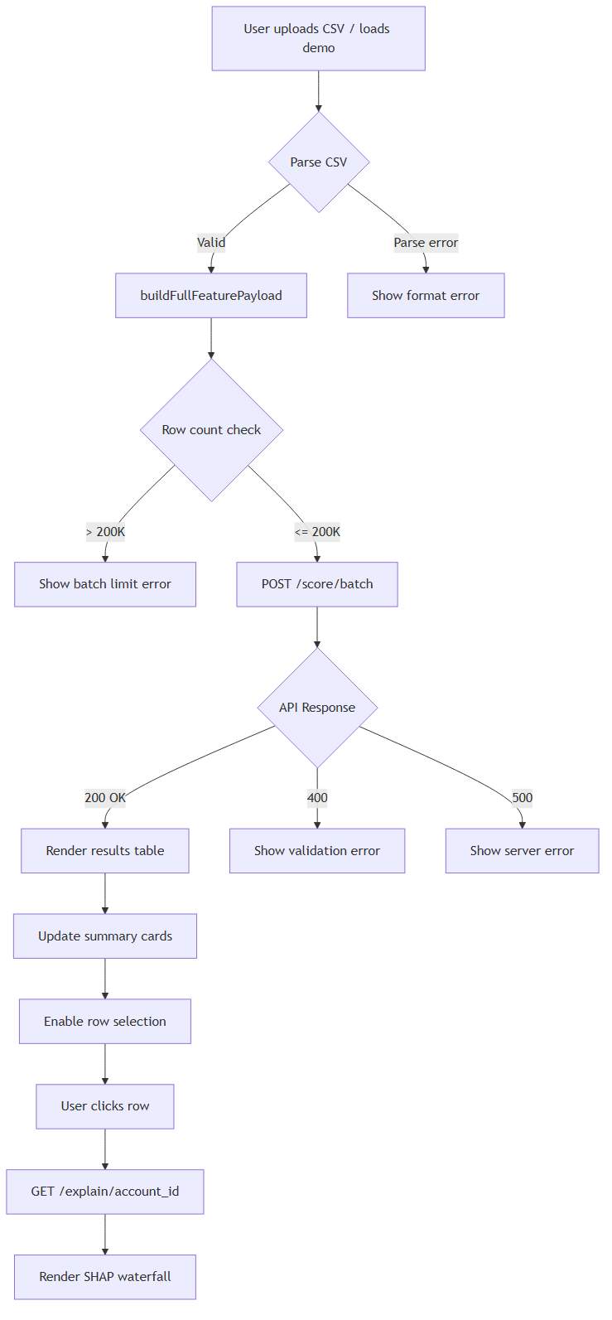
Figure 3 is the core scoring pipeline implemented in serving/app.py. Eighteen bank key features enter the FeaturePipeline, which produces the full engineered vector for supervised inference and anomaly detection in parallel.
Supervised probability (from best_model.pkl) and Isolation Forest anomaly scores are weighted into a fused risk score. Separately, TypologyEngine evaluates raw bank keys against train-fitted percentile thresholds to produce typology_flags and a typology boost.
The adjusted fused score drives both the four-tier decision (BLOCK / CHALLENGE / REVIEW / APPROVE) and suspicion_level (1–4). This dual output gives investigators both an operational action and a graded suspicion signal for watch-list prioritisation.

Figure 4: Batch Scoring Flow

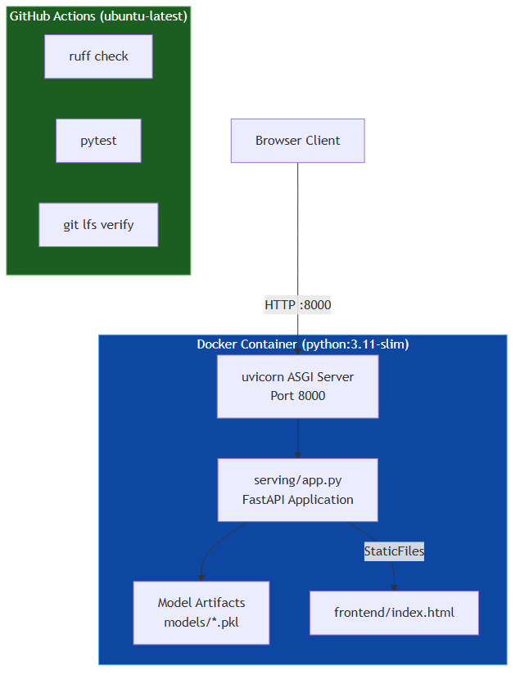
Figure 4 illustrates batch scoring workflow. Investigators upload a CSV via the web UI or call POST /score/batch directly. For batches exceeding 100 accounts, the API uses a vectorised scoring path for performance, supporting up to 200,000 accounts per request.
Results populate the scored transactions grid with decision, suspicion level, and typology chips. Filters and the Download Suspicion List CSV export enable rapid triage without re-scoring.

Figure 5: Deployment Architecture

Figure 5 shows the deployment topology. The application runs in a Docker container (Python 3.11-slim) with uvicorn serving the FastAPI app on port 8000. At startup, model artifacts (.pkl), typology thresholds, and the feature pipeline are loaded into memory.
This single-container design is suitable for hackathon demonstration and can be extended to Kubernetes with horizontal scaling, external model registry, and authenticated API gateways in a production bank environment.

5. Results & Evaluation
All metrics below are computed on a stratified 80/20 holdout split (not training cross-validation) to provide honest generalisation estimates. Feature F3912 was excluded after leakage audit (|r| > 0.5).

5.1 Production Model — Holdout Evaluation
Metric | Value
Best model (auto-selected) | XGBoost (single)
Holdout PR-AUC | 0.888
Holdout ROC-AUC | 0.999
Precision @ optimal threshold | 0.778
Recall @ optimal threshold | 0.875
Recall @ FPR 1% | 1.000
Precision-optimal threshold | 0.10
Holdout samples / positives | 1817 / 16

5.2 Model Zoo Comparison (Top 5 by Holdout PR-AUC)
Model | Holdout PR-AUC | Holdout ROC-AUC | Precision | Recall | Recall@FPR 1%
XGBoost | 0.888 | 0.999 | 0.778 | 0.875 | 1.000
LightGBM | 0.870 | 0.997 | 0.857 | 0.750 | 0.938
Stacking Ensemble | 0.848 | 0.998 | 0.765 | 0.812 | 0.875
MLP | 0.815 | 0.997 | 0.684 | 0.812 | 0.938
ExtraTrees | 0.748 | 0.992 | 0.565 | 0.812 | 0.812

5.3 Typology Flags
Flag | Detection Logic
silent_account | Low baseline activity (F531 < p25) with sudden activation, OR high tenure with burst ratio > p90
large_amount_mover | High absolute flow (|F2678| + |F2737| > p95) OR high net flow magnitude > p95
instant_mule | Out/in count ratio > 0.9 (rapid pass-through pattern)
aggregator_hub | High inbound proxy (F531 > p90) with low outbound ratio (< 0.3)

5.4 Validation & Quality Assurance
Quality assurance includes leakage audit, serialized FeaturePipeline for train/serve parity, integration tests for scoring API and typology engine, and model artifact smoke tests. Current status: 33 pytest tests passing.

6. Demo & API Capabilities
Method | Endpoint | Description
GET | /health | Liveness probe
GET | /model/info | Model metadata, features, decision policy
POST | /score | Score single account (< 100 ms target)
POST | /score/batch | Batch score up to 200,000 accounts
GET | /explain/{id} | SHAP feature explanation for scored account
GET | /alerts/suspicious-list | Filter cached scores by suspicion / typology
POST | /decision/policy | Switch decision threshold preset
POST | /decision/override | Investigator manual override

Demo workflow: (1) Start server with uvicorn serving.app:app --host 0.0.0.0 --port 8000, (2) Open http://localhost:8000, (3) Load demo batch or upload CSV, (4) Review grid with suspicion levels and typology flags, (5) Select account for SHAP chart, (6) Export Suspicion List CSV.

7. Conclusion & Innovation Highlights
This solution delivers a production-oriented mule detection platform tailored for bank fraud investigation workflows. Key differentiators for the hackathon include:
- Multi-model zoo with automatic holdout-based model selection (not hard-coded LightGBM).
- Typology-aware scoring that tags silent accounts and large amount movers alongside ML predictions.
- Four-level suspicion scale complementing operational decisions for watch-list prioritisation.
- Real SHAP TreeExplainer explanations—not heuristic placeholders.
- Honest holdout metrics with leakage remediation and 33 automated tests.
- Investigator-ready UI with policy controls, overrides, filters, and CSV export.
Future enhancements include CatBoost integration (environment-dependent), PSI drift monitoring, MLflow model registry, and Kubernetes deployment with authenticated API access for production banking.

