Patient Management System
Project Report | CSC1106 Web Programming
University of Glasgow | July 2026
Team Members: Muhammad ‘Afif Bin Muhd Lotfi Jarhom, Dylan Ho Sheng Xue (3178143H), Hanzalah Bin Mohamad Hisam , Lennon Lim Le Rong, Muhammad Raees Irfan Bin Ishak

1. Introduction and Design Approach
The Patient Management System is a full-stack web application modeling the clinical administration workflow. The core system architecture delivers all required areas: patient registration, appointment scheduling, medical records, billing, doctor management, and prescription tracking. The central objective is absolute correctness under concurrent use, centered around a robust scheduling core backed by cooperating validation layers.
Leveraging Rust ensures memory safety and exhaustive compile-time error handling , while server-side rendering via the Tera template engine centralizes validation trust, keeping request flows straightforward and audit-safe. The implementation follows a strict validation-first pipeline: every write request verifies input data prior to SQL execution, and operations spanning multiple tables are wrapped inside database transactions to prevent partial writes. Incremental feature delivery alongside automated regression testing guarantees system stability across all operational paths.

2. System Architecture and OOP Design
The codebase is organised into one feature module per business area, supported by a shared foundation layer. Every feature module keeps the same internal shape, which is a route entry point, a models file for data and validation, a services file for business logic and queries, and a handlers file for HTTP. Thus, this makes it easy to update or test individual features without affecting the rest of the system
HTTP route → Form validation → Service and database transaction → Rendered page or redirect
Figure 1. Every write request follows the same validate-first pipeline, so invalid input never reaches the database.
Alongside the feature modules sits a small foundation layer that the whole system shares. It holds the authentication extractors and role guards, one unified error type, the four domain traits, the database pool and migration runner, and a few date and time helpers. Centralising these concerns means that security and error handling are written once and reused everywhere, rather than being repeated, and possibly done differently, inside each module.
Rust is not a class-based language, but it expresses the same object-oriented ideas through traits, structs with methods, and enums. We defined four shared traits so that unrelated types reuse one correct implementation of common behaviour instead of copying it. This is how the project achieves polymorphism and abstraction without classical inheritance.
Trait | Implemented by | OOP principle and purpose
TimeSlotted | Appointment, WaitlistEntry, DoctorAvailability, TimeWindow | Polymorphism. Overlap, containment, and duration logic shared by every time-based type.
StatusManaged | Appointment, Invoice, WaitlistEntry | Polymorphism. One status interface with type-specific active rules and badge colours.
Prioritized | Appointment, WaitlistEntry, PriorityItem | Abstraction. A single triage mapping from level 1 to 4 into a label and a colour.
Reportable | Appointment, Invoice, MedicalRecord, Prescription | Polymorphism. One readable summary method per type for reports and the audit trail.

Encapsulation is enforced by keeping sensitive fields private and exposing guarded methods. The User type hides its password hash and role string and only allows access through a verify method and a typed role accessor, so no caller can read a raw hash or compare roles as loose strings. In the same way the Appointment type only permits a cancellation or a reassignment while it is still scheduled, which makes an invalid state change impossible to express. Error handling is unified through a single application error type with eight variants that implements the framework ResponseError trait. Because every lower-level failure, whether from the database, the template engine, or the password library, converts into this one type, handlers can use the question-mark operator to pass errors upward cleanly, and the matching response code of 400, 401, 403, 404, or 500 is decided in one place.

3. Advanced Features and System Complexity
The scheduling engine carries most of the technical weight, and five algorithms work together inside it.
- Conflict detection uses the standard interval-overlap test, where two periods clash when one starts before the other ends and ends after the other starts, checked against the doctor or the assigned room, so a doctor moved into a different room for one visit still cannot be double-booked.
- Earliest-slot search treats a doctor's day as a list of booked intervals and walks the gaps to return the first opening long enough for the visit, using a small pure helper that is unit tested without any database.
- Priority scheduling lets an Emergency or Urgent case take a held slot, using a binary heap as a priority queue with a reversed ordering so the most urgent and oldest request is served first, giving logarithmic inserts and removals.
- Greedy reassignment moves a patient to another doctor when one becomes unavailable, ranking candidates by matching specialisation first for continuity of care and then by the lightest workload that day.
- Optimal batch reassignment handles a doctor’s whole day off at once instead of one appointment at a time, modelling every appointment against every colleague as a cost matrix and solving it with the Hungarian algorithm, so the redistribution is provably the least disruptive rather than whichever the greedy pass reaches first.
When a booking is made, the system confirms the time falls within the clinic's operating hours, checks availability rules, and looks for overlaps. If the slot is open, the system assigns a room and saves the booking inside a database transaction. If the slot is taken, a patient’s request is rejected with an alternative-slot suggestion, while staff bookings follow the priority decision rules in Figure 2:
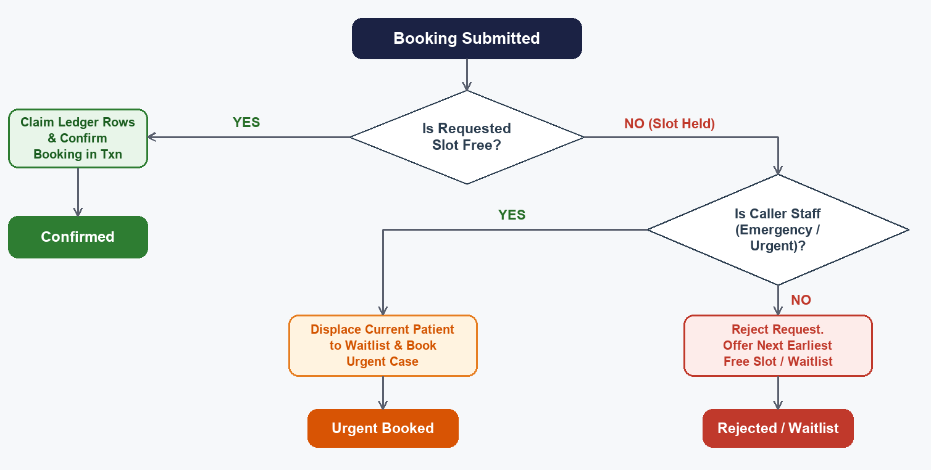
Figure 2. Priority booking decision. Only Emergency and Urgent cases may displace an existing patient.
The strongest piece of engineering is how the system prevents double booking. Rather than checking for a clash and then inserting, which leaves a race window between the two steps, every appointment is broken into one row per thirty-minute slot in an occupancy ledger. A unique database index on the doctor, date, and slot causes any double-booking attempt to fail immediately at the database layer, ensuring absolute data integrity under heavy usage. This pushes the correctness guarantee down into the storage layer, which is the approach used by production booking systems and is far safer than application-level checks.
The waitlist is a small state machine that keeps the schedule busy, shown in Figure 3. A cancellation frees a slot and auto‑promotes the most urgent waiter. A priority override instead searches the same doctor’s day for the next open gap and rebooks the displaced patient there, only falling back to waiting when the day is genuinely full. An entry whose requested time passes while still waiting is automatically swept to expired.
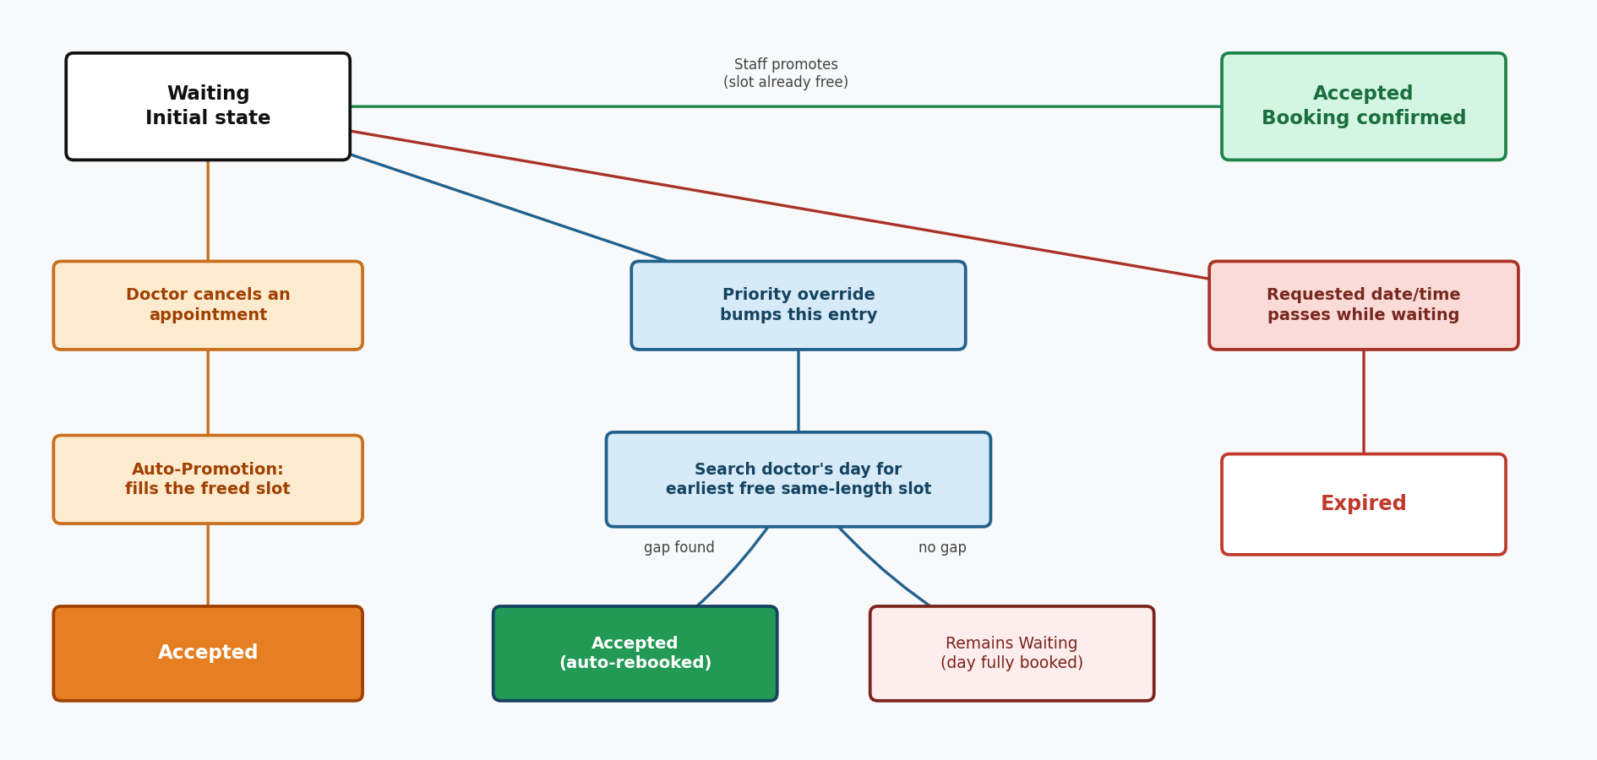
Figure 3. Waitlist lifecycle. A freed slot auto‑promotes the most urgent waiter, a priority‑override bump auto‑reschedules the displaced patient into the next free slot or leaves them waiting if none exists, and a stale request expires.
Two further features add breadth. Medical reports are exported to PDF entirely in Rust using the printpdf crate, with manual page layout, word wrapping, and automatic pagination, so no external program or font file is needed and the project runs unchanged on any machine. A patient timeline merges appointments, records, and prescriptions into one ordered history that gives a clinician the full picture of a patient at a glance. Running across all of these is an append-only audit trail that records every security and business action, such as a booking, a cancellation, a record change, or a report export, together with the user who performed it and the time it happened, giving the system a tamper-evident history that only administrators can view.
Several of these decisions follow well-established practice rather than being invented from scratch. The overlap test is the standard solution to the interval-scheduling problem, using a unique database constraint for concurrency control is a textbook alternative to application-level locking, the binary heap is the classic structure behind a priority queue, and the timing-safe login defends against the account-enumeration weakness described in common web-security guidance.

4. Database Design and Integration
The schema holds fifteen normalised tables defined across six migrations that run automatically the first time the server starts. Foreign keys, check constraints, and indexes enforce integrity inside the database rather than relying on application code alone, so the data stays valid even if a bug slips into a handler.
Domain | Tables and key relationships
Identity and roles | users, with patients and doctors as role-specific profile tables.
Scheduling | appointments and the appointment_slots occupancy ledger, plus doctor_availability, rooms, doctor_room_assignments, and waitlist.
Clinical | medical_records and prescriptions, each linked back to an appointment.
Billing | invoices with their invoice_items and payments.
Audit | audit_log, an append-only record of who did what and when.

The occupancy ledger is the centre of the design. Storing one row per slot instead of a single start and end time is what lets the unique index do the locking, because a clash becomes a duplicate key rather than a value comparison that two requests could pass at the same moment. Foreign keys with cascade rules keep the ledger and the appointment in step, so cancelling or moving an appointment deletes its slot rows and frees the time at once, which in turn lets the waitlist promote a waiting patient into the gap. SQLite was chosen so the application runs smoothly without complex external software setup

5. Frontend and Server-Side Rendering
The user interface is generated on the server using Tera templates with layout inheritance. A single layout file defines the main structure and navigation bars, allowing the 28 individual page templates to remain light and clean. We used the Bulma framework to make the layout fully responsive across mobile and desktop devices. The navigation menus adjust dynamically based on user roles, hiding restricted links from patients while displaying administrative management pages only to staff.

6. Security and Access Control
Security was treated as a first-class concern rather than an afterthought. Passwords are stored only as bcrypt hashes with a fixed work factor, sessions are held in signed cookies so their contents cannot be tampered with, and the signing key is generated once and reused across restarts so users are not logged out on every restart. Access is controlled on two levels. Role guards decide who may reach a route, so only staff can open billing management and only an administrator can see the dashboard and the audit trail. Ownership checks then decide who may see a specific record, so a patient can open only their own appointments, invoices, and medical reports, and an attempt to reach another patient data returns a forbidden response instead of leaking it. Together with the timing-safe login and the append-only audit trail, these measures give the system a realistic security posture for handling sensitive health information.

7. Technical Challenges and Reflection
Preventing double booking safely was our primary technical challenge. As detailed in our database architecture, enforcing concurrency via storage constraints completely bypassed the risks of application-level validation race windows. Managing multi-key criteria in the scheduling queue introduced algorithmic edge cases where naive sorting returned inverted patient priority rankings. Correcting the internal comparison logic resolved the issue, and a multi-priority regression test was added to guarantee future queue stability under high load. SQLite stores booleans as integers, which broke direct decoding into Rust boolean fields, so those columns are now read as integers behind small accessor methods. Finally, the priority override touches several tables at once, so the whole sequence runs inside a single transaction that rolls back completely on any failure, which keeps the data consistent even if a step fails midway. Each of these problems taught us to push guarantees toward the type system and the database, where they hold for every code path, rather than relying on careful handling in each handler.

8. Individual Contributions and Extended Features
Each member owned one feature module of the shared group system and delivered one or more individual extended features. Every entry below states the group contribution first, then explains the individual feature in enough depth to show why it is a genuinely hard piece of engineering rather than a simple addition.
Afif
Group Development Component:
- Built the users and auth modules, establishing the unified identity and authorization backbone that every other module depends on for secure session handling and profile management. The module also completes password self-service: a user can change their own password after confirming the current one, and an admin can reset another account’s password without knowing it.
Individual Extended Features & Technical Contributions:
- Type-Enforced Role-Based Access Control: Implemented access rules into the type system using an Actix request extractor. This makes it impossible to compile a code route that accidentally omits security verification.
- Fail-Safe Role Parsing: Modeled roles as a typed enum with fail-safe parsing, ensuring a tampered session value falls back to the least-privileged role rather than accidentally leaking access privileges.
- Advanced Ownership Guards: Developed secure request guards that verify user permissions, blocking patients from viewing other accounts by manually typing different IDs in the browser address bar.
- Anti-Enumeration Hardening: Closed a timing side-channel in login by always running a full password hash comparison even when the username does not exist, preventing response variations from revealing valid database accounts
Lennon
Group Development Component:
- Developed the appointments module, building the core calendar engine and booking database routes for the clinic application.
Individual Extended Features & Technical Contributions:
- Multi-Algorithmic Scheduling & Queue Logic: Implemented three cooperating algorithms to make the scheduling engine safe and fair under load. Applied the interval-overlap test for standard conflict detection.
- Pure Earliest-Slot Search: Built a search feature that analyzes a doctor’s booked day and returns the earliest open gap matching the required appointment length.
- Priority Sorting Queue: Built a custom triage queue using a binary heap, adjusting the key sorting so that urgent cases and older entries rise to the top of the queue correctly.
- Automated Lifecycle Promotion: Integrated an automatic waitlist promotion that automatically fills a freed slot with the most urgent waiting patient the moment a booking is cancelled.
Dylan
Group Development Component:
- Built the availability module and doctor management tables, establishing the core structural boundaries for the clinic schedule .
Individual Extended Features & Technical Contributions:
- Three-Rule Availability Gate: Checks every booking against three simple rules: blocked time such as leave or lunch breaks is rejected straight away, a slot must fit inside the doctor's own working hours if they have set any, and the clinic's default hours apply when they have not.
- Self-Service Schedule Management: Doctors set their own hours through a form with two modes, a recurring weekly pattern that can cover several days in one submit, or a single date for a one-off change such as leave. Every edit or deletion is checked against upcoming booked appointments first, so a doctor cannot narrow their hours out from under a patient who is already booked. They are pointed to reschedule or reassign those visits first.
- Reassignment Algorithms (Greedy and Hungarian): Built two ways to hand a patient to another doctor. A quick greedy algorithm reassigns one appointment at a time, picking the doctor with the closest matching specialty and the lightest workload. A more advanced Hungarian algorithm reassigns a doctor’s whole day at once when they go on leave, guaranteeing the least possible disruption instead of reassigning appointments one by one.
- Live Availability Booking: Connected the same availability gate to the booking form itself, so patients only ever see time slots that are genuinely free and allowed, instead of guessing a time and having it rejected.
- Race-Safe Room Allocation: Built a system that automatically gives each doctor a room for the day and safely handles two bookings trying to claim the same room at the same time, using database-level checks instead of manual assignment to prevent conflicts.
Raees
Group Development Component:
- Built the medical records and prescription tracking modules, establishing the database models and clinical storage paths.
Individual Extended Features & Technical Contributions:
- Unified Patient History Timeline: I created a consolidated timeline that normalizes appointments, records, prescriptions, and bills into a single history sorted by date. Utilized a typed kind enum to supply each event's icon and color so presentation details are never hardcoded at the call site.
- Pure-Rust PDF Engine: Wrote a standalone PDF report generator using the printpdf crate and the built-in Helvetica font, allowing the printable report to run with a single command on any machine with nothing extra to install.
- Manual Layout Math & Pagination: Solved the limitation of the underlying crate (which only draws text at fixed coordinates) by building a custom layout engine. Tracked a manual cursor that walks down the page and opens a fresh page when it runs out of room so that long records paginate cleanly.
- Glyph-Aware Greedy Word-Wrap: Designed a custom greedy word-wrap algorithm that estimates glyph width, respects existing line breaks, and hard-breaks over-long words on character boundaries to prevent accented multi-byte names from splitting in the middle of a letter.
Hanzalah
Group Development Component:
- Built the billing module, covering the core implementation of invoices, line items, and payments.
Individual Extended Features & Technical Contributions:
- Clinic Analytics Dashboard: Combined 12 real-time aggregation queries into a single data pass, providing summaries of patient counts, appointment states, and financial indicators.
- Derived Ratio Modeling: Designed the underlying model to derive cancellation rates, collection rates, and outstanding balances so administrators read actionable ratios rather than bare counts.
- System Audit Logging: Created an append-only log that notes the user, action type, and affected data row for all security events, designed to log data without interrupting active transactions.
- Billing State Machine: Enforced a strict state machine guarding how an invoice moves through pending, paid, and cancelled statuses. Implemented partial-payment support that tracks a running total against the balance and automatically triggers a settled state change once cleared. An admin can also void a pending invoice outright, closing the cancelled path of that same state machine, restricted to admins since it is an administrative action rather than something a patient does to their own bill.

9. Testing and Conclusion
The system is covered by 219 automated tests, made up of 161 integration tests that drive the real HTTP routes against an in-memory database and 58 unit tests for pure logic such as overlap maths, gap finding, and PDF word wrapping. Every test runs with no external setup, which made regression checking fast and reliable throughout development and gave us the confidence to refactor.
Our testing strategy leaned deliberately toward integration tests rather than mocks. A shared macro builds a complete Actix application in memory for each test, wired with every route, the session middleware, and stub templates, against a fresh in-memory SQLite database that is created and migrated from scratch. Two further macros either register and log in a user, or seed a full dataset and log in, so a test can start from a realistic signed-in state in a single line. Because the tests drive the real routes from end to end instead of calling functions in isolation, they exercise the same validation, transaction, and access-control paths that run in production, which is exactly what caught the priority-heap ordering bug and several authorisation gaps before they could reach the demo.
Test area | Tests | Main focus
Unit tests in src | 58 | Trait logic, gap-finding maths, enum round-trips, PDF word-wrap.
Scheduling algorithms | 45 | Conflict detection, earliest-slot, priority bumping, rescheduling.
Authentication | 25 | Registration, login, role guards, anti-enumeration, password change.
Appointments | 35 | Booking, priority booking, cancellation, and waitlist over HTTP, including the auto‑reschedule‑on‑bump and expiry lifecycle.
Extended features | 17 | Availability, reassignment, timeline, audit, dashboard.
Records and billing | 16 | Records and invoices, PDF export, payments, ownership, invoice cancellation.
Availability | 3 | Availability page, form submission, persistence.
Templates | 4 | Tera render checks for the batch-reassignment and live-availability booking pages.

Building the system reinforced one lesson: guarantees that last are the ones pushed into the type system or the database, not careful handler-level code where edge cases and races eventually slip through. That is true of the unique index that makes double booking impossible, the typed role enum that turns an unhandled privilege into a compile error, and the transaction that rolls back a half-finished priority override by itself. Extending the project with email notifications for waitlist offers or a calendar export would follow the same principle behind the existing service layer. In conclusion, the system delivers a clinic management portal built around a reliable scheduling engine, database-enforced concurrency, and distinct extended modules with real operational depth: reliable, easy to extend, and faithful to how a clinic actually operates.

