



# A

**Project Report**

on

YOGA POSE IDENTIFICATION

submitted as partial fulfillment for the award of

**BACHELOR OF TECHNOLOGY**

**DEGREE**

SESSION 2022-23

in

**Computer Science & Engineering**

By

Ashutosh Kumar Verma (1900290100041) Divyanshu Sharma (1900290100058)

Himanshu Agarwal (1900290100071)

# Under the supervision of

Naveen Chauhan

**KIET Group of Institutions, Ghaziabad**

Affiliated to

**Dr. A.P.J. Abdul Kalam Technical University, Lucknow**

## (Formerly UPTU)

**May, 2023**

# DECLARATION

We hereby declare that this submission is our own work and that, to the best of our knowledge and belief, it contains no material previously published or written by another person nor material which to a substantial extent has been accepted for the award of any other degree or diploma of the university or other institute of higher learning, except where due acknowledgment has been made in the text.

Signature

Ashutosh Kumar Verma (1900290100041) Divyanshu Sharma (1900290100058)

Himanshu Agarwal (1900290100071) Date:

# CERTIFICATE

This is to certify that Project Report entitled “Yoga Pose Identification” which is submitted by Ashutosh Kumar Verma, Divyanshu Sharma, and Himanshu Agarwal in partial fulfillment of the requirement for the award of degree B. Tech. in Department of Computer Science & Engineering of Dr. A.P.J. Abdul Kalam Technical University, Lucknow is a record of the candidates own work carried out by them under my supervision. The matter embodied in this report is original and has not been submitted for the award of any other degree.

.

**Date: Naveen Chauhan**

**(Assistant Professor)**

# ACKNOWLEDGEMENT

It gives us a great sense of pleasure to present the report of the B. Tech Project undertaken during B. Tech. Final Year. We owe special debt of gratitude to Prof. Naveen Chauhan, Assistant Professor, Department of Computer Science & Engineering, KIET, Ghaziabad, for his constant support and guidance throughout the course of our work. His sincerity, thoroughness and perseverance have been a constant source of inspiration for us. It is only his cognizant efforts that our endeavors have seen light of the day.

We also take the opportunity to acknowledge the contribution of Dr. Vineet Sharma, Head of the Department, Computer Science & Engineering, KIET, Ghaziabad, for his full support and assistance during the development of the project. We also do not like to miss the opportunity to acknowledge the contribution of all the faculty members of the department for their kind assistance and cooperation during the development of our project.

We also do not like to miss the opportunity to acknowledge the contribution of all faculty members, especially faculty/industry person/any person, of the department for their kind assistance and cooperation during the development of our project. Last but not the least, we acknowledge our friends for their contribution in the completion of the project.

Date:

Signature:

Ashutosh Kumar Verma (1900290100041) Divyanshu Sharma (1900290100058)

Himanshu Agarwal (1900290100071)

## ABSTRACT

People’s mental and physical health is deteriorating. Taking care of your mental and physical health is more important than ever during this pandemic. There is no better way to take care of your mental and physical health than yoga.

Yoga can be done at home without any equipment with our virtual trainer. Hence, we tried to make a yoga instructor for the people and to find a better way to extract people from depression. As INDIA is considered as Yoga Guru so a everyone in India and the world do not have access to the yoga instructor and can’t pay him a lot of money. So, this was important to find a better way to extend the reach of poor people. This will also be useful in remote location.

Laziness is a common human tendency, this product is algo going to handle with this by creating a schedule for the yoga and specifically for every posture. This will also provide a window for the learning of postures and then you can practice on it. A camera is going to track you in all this while and only start the countdown when you will be in desired proper posture. This is also your personal trainer at your home.

|  |  |
| --- | --- |
| **TABLE OF CONTENTS** | **Page No.** |
| DECLARATION……………………………………………………………………. | ii |
| CERTIFICATE……………………………………………………………………… | iii |
| ACKNOWLEDGEMENTS…………………………………………………………. | iv |
| ABSTRACT………………………………………………………………………..... | v |
| LIST OF FIGURES…………………………………………………………………. | ix |
| LIST OF TABLES………………………………………………………………..… | xi |
| LIST OF ABBREVIATIONS………………………………………………………. | xii |
| CHAPTER 1 (INTRODUCTION)…………………………………………………. | 10-12 |
| 1.1. Introduction……………………………………………………………………... | 10 |
| 1.2. Project Description……………………………………………………………… | 12 |
| CHAPTER 2 (LITERATURE REVIEW)…………………………………………. | 13-18 |
| 2.1. Literature Review ...…….................................................................................... | 13-16 |
| 2.2. Yoga Pose Detection using Deep Learning ……….................................................  2.3. History of Yoga …............................................................................................... | 16-17  17-19 |
| CHAPTER 3 (PROPOSED METHODOLOGY) …................................................... | 20-36 |
| 3.1. Proposed Methodology.........................................................................................  3.2. Pose Net …….......................................................................................................  3.3. Convolutional Neural Network (CNN).................................................................  3.4. Data Set.................................................................................................................  3.5. Data Preprocessing...............................................................................................  3.4. Application of Proposed Work........................................................................... | 20-26  27-28  29-30  31-32  32-35  35-36 |
| CHAPTER 4 (RESULTS AND DISCUSSION) ........................................................ | 37-39 |

|  |  |
| --- | --- |
| CHAPTER 5 (CONCLUSIONS AND FUTURE SCOPE) ….................................. | 40-42 |
| 5.1. Conclusion...................................................................................................... | 40 |
| 5.2. Future Scope................................................................................................... | 42 |
| REFERENCES………………………………………………………………………. | 43-46 |
| APPENDEX1………………………………………………………………………... | 47-52 |

# LIST OF FIGURES

|  |  |  |
| --- | --- | --- |
| **Figure No.** | **Description** | **Page No.** |
| 1.  2.  3.  4.  5.  6.  7.  8.  9.  10. | Yoga Pose Classification Pose Detection Yoga Overview of the Proposed model System Architecture of Pose Net  CNN layer Architecture Data Set table of Yoga Poses Yoga Poses Eighteen key point positions captured by Open Pose Different Yoga Asans  Confusion Matrix Layout | 17  20  26  28  29  31  32  33  34  35 |

**LIST OF TABLES**

|  |  |  |
| --- | --- | --- |
| **Table. No.** | **Description** | **Page No.** |
| 1  2  3 | EXISTING WORK IN YOGA POSE INDENTIFICATION  EXISTING WORK IN YOGA POSE INDENTIFICATIONS WITH DATA SIZE AND ACHIEVED ACCURACY  PRECISION, RECALL, AND F1 SCORE EVALUATED DURING SIMULATION | 5  18  20 |

# LIST OF ABBREVIATIONS

|  |  |
| --- | --- |
| NAM | Network Animator |
| CNN | Convolutional Neural Network |
| ML | Machine Learning |
| LFW | Labeled Faces in the Wild |
| ReLU | Rectified Linear Unit |
| SVM | Support Vector Machine |

**CHAPTER 1 INTRODUCTION**

# INTRODUCTION

Human pose estimation is a challenging problem in the discipline of computer vision. It deals with localization of human joints in an image or video to form a skeletal representation. To automatically detect a person’s pose in an image is a difficult task as it depends on a number of aspects such as scale and resolution of the image, illumination variation, background clutter, clothing variations, surroundings, and interaction of humans with the surroundings .

An application of pose estimation which has attracted many researchers in this field is exercise and fitness. One form of exercise with intricate postures is yoga which is an age-old exercise that started in India but is now famous worldwide because of its many spiritual, physical and mental benefits. The problem with yoga however is that, just like any other exercise, it is of utmost importance to practice it correctly as any incorrect posture during a yoga session can be unproductive and possibly detrimental. This leads to the necessity of having an instructor to supervise the session and correct the individual’s posture. Since not all users have access or resources to an instructor, an artificial intelligence-based application might be used to identify yoga poses and provide personalized feedback to help individuals improve their form. In recent years, human pose estimation has benefited greatly from deep learning and huge gains in performance have been achieved. Deep learning approaches provide a more straightforward way of mapping the structure instead of having to deal with the dependencies between structures manually. used deep learning to identify 5 exercise poses: pull up, swiss ball hamstring curl, push up, cycling and walking. However, using this method for yoga poses is a relatively newer application.

# PROJECT DESCRIPTION

Deep learning approaches provide a more straightforward way of mapping the structure instead of having to deal with the dependencies between structures manually. used deep learning to identify 5 exercise poses: pull up, swiss ball hamstring curl, push up, cycling and walking. However, using this method for yoga poses is a relatively newer application.

YOGA POSE CLASSIFICATION USING TENSORFLOW JS.

This project focuses on exploring the different approaches for yoga pose classification and seeks to attain insight into the following: What is pose estimation? What is deep learning? How can deep learning be applied to yoga pose classification in real-time? This project uses references from conference proceedings, published papers, gives a graphical overview of topics this paper covers. Technology used is - TENSORFLOW .JS.

Yoga pose detection using PoseNet involves using PoseNet to detect body key points which will be seen on the Platform. After generating the dataset, it can be used to train a machine learning model that can be used to detect and classify different yoga poses.

There are several applications of yoga pose detection using PoseNet. For example, there is a Yoga Pose Estimation App which can detect the yoga pose in real-time by using PoseNet and CNN Classifier. Another application is analyzing human poses to detect and correct yoga poses which can benefit humans living a healthier life in their homely environment.

# CHAPTER 2

* 1. **LITERATURE REVIEW**

Yoga pose identification using deep learning is relatively new area of research. However, there have been a few studies in this area that have shown promising results. In this literature review, we summarize some of the key studies related to yoga pose identification using deep learning. In a study by Wang et al., it was hypothesized that a deep learning-based system might be used to recognize 16 different yoga poses from photographs (2018). With a modified version of the AlexNet architecture and a data set of 1032 images, the authors were able to reach an accuracy of 92.3%. By comparing their deep learning-based approach to other traditional machine learning methods, the authors showed how it performed better [1]. In another study by Li et al. [2], it was hypothesized that a deep learning-based system might be used to recognize 16 different yoga poses from videos (2019). The authors used a combination of two-stream convolutional neural networks (CNN‟s) to extract spatial and temporal features from videos. The authors achieved an accuracy of 91.9% on a dataset of 458 videos [2]. In a recent study by Kumar et al. (2021), a deep learning-based approach was proposed for identifying 20 different yoga poses from images. The authors used a CNN architecture with four convolutional layers, followed by two fully connected layers. The authors achieved an accuracy of 96.2% on a dataset of 5000 images [3]. Overall, these studies demonstrate the potential of deep learning techniques for accurately identifying yoga poses from images and videos. However, there is still a need for larger datasets and more advanced deep learning architectures to further improve the accuracy of yoga pose identification using deep learning [4]. In [5], a deep learning-based approach was proposed for identifying 6 different yoga poses from videos. The authors used a 3D convolutional neural network (CNN) architecture to extract spatiotemporal features from videos. The authors achieved an accuracy of 97.5% on a dataset of 179 videos. In a study by Yucheng [6], a deep learning based approach was proposed for identifying 16 different yoga poses from images. The authors used a CNN architecture with three convolutional layers and two fully connected layers. The authors achieved an accuracy of 90.4% on a dataset of 1105 images. Rao et al. (2021) presented a deep learning based model for identifying 25 different yoga poses from images. The researchers

employed a Convolutional Neural Network (CNN) model consisting of four layers of convolution and two layers of fully connected neurons. The authors achieved an accuracy of 92.16% on a dataset of 2000 images [7]. In a study by Shoaib et al. (2021), a deep learning- based approach was proposed for identifying 20 different yoga poses from videos. The authors used a 3D CNN architecture with a spatial-temporal attention mechanism to extract spatiotemporal features from videos. The authors achieved an accuracy of 94.27% on a dataset of 1000 videos [8].

In a study by Parkhi et al. (2015), a deep learning-based approach was proposed for face recognition. A CNN model with five convolutional layers and three fully connected layers was used by the researchers to extract features from photos of faces. The authors achieved a top-1 accuracy of 55.8% and a top-5 accuracy of 83.6% on the Labeled Faces in the Wild (LFW) dataset [9]. In a study by Taigman et al.

(2014), a deep learning-based approach was proposed for face identification. The authors used a deep convolutional neural network architecture called DeepFace to extract features from face images. The authors achieved a top-1 accuracy of 97.35% and a top-5 accuracy of 99.5% on the LFW dataset [10].

TABLE. 1 EXISTING WORK IN YOGA POSE INDENTIFICATION

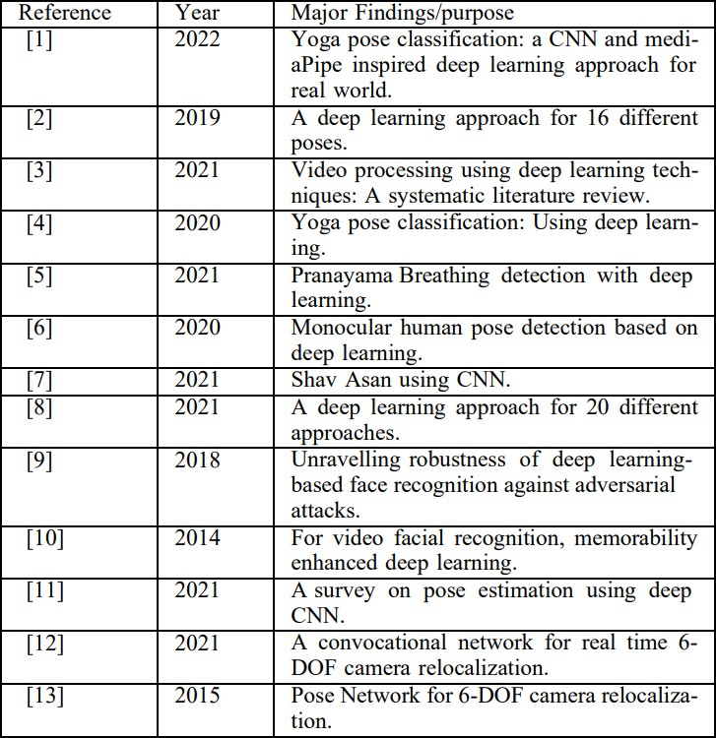

Human pose estimation is a challenging problem in the discipline of computer vision. It deals with localization of human joints in an image or video to form a skeletal representation. To automatically detect a person’s pose in an image is a difficult task as it depends on a number

of aspects such as scale and resolution of the image, illumination variation, background clutter, clothing variations, surroundings, and interaction of humans with the surroundings.

An application of pose estimation which has attracted many researchers in this field is exercise and fitness. One form of exercise with intricate postures is yoga which is an age-old exercise that started in India but is now famous worldwide because of its many spiritual, physical and mental benefits.

The problem with yoga however is that, just like any other exercise, it is of utmost importance to practice it correctly as any incorrect posture during a yoga session can be unproductive and possibly detrimental. This leads to the necessity of having an instructor to supervise the session and correct the individual’s posture. Since not all users have access or resources to an instructor, an artificial intelligence-based application might be used to identify yoga poses and provide personalized feedback to help individuals improve their form. In recent years, human pose estimation has benefited greatly from deep learning and huge gains in performance have been achieved. Deep learning approaches provide a more straightforward way of mapping the structure instead of having to deal with the dependencies between structures manually. used deep learning to identify 5 exercise poses: pull up, swiss ball hamstring curl, push up, cycling and walking. However, using this method for yoga poses is a relatively newer application.

# YOGA POSE CLASSIFICATION USING DEEP LEARNING

This project focuses on exploring the different approaches for yoga pose classification and seeks to attain insight into the following: What is pose estimation? What is deep learning? How can deep learning be applied to yoga pose classification in real-time? This project uses references from conference proceedings, published papers, technical reports and journals. Fig. 1 gives a graphical overview of topics this paper covers. The first section of the project talks about the history and importance of yoga. The second section talks about pose estimation and explains different types of pose estimation methods in detail and goes one level deeper to explain discriminative methods – learning based (deep learning) and exemplar. Different pose

extraction methods are then discussed along with deep learning based models - Convolutional Neural Networks (CNNs) and Recurrent Neural Networks (RNNs).

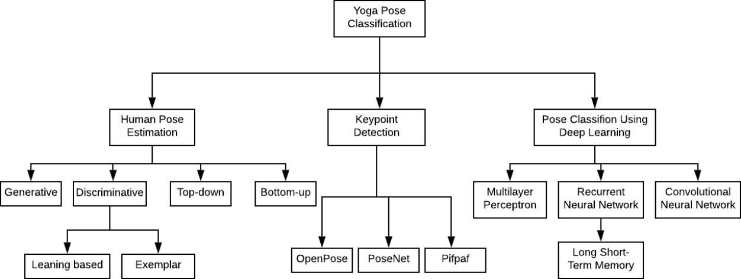

Fig. 1 Yoga Pose Classification

# HISTORY OF YOGA

Yoga is an ancient practice that originated in India over 5,000 years ago [20]. The word

Yoga was first mentioned in the ancient Sanskrit texts of Rig Veda which dates back to 1500 BC [19]. The development of yoga can be traced back to over 5,000 years ago, but some researchers think that yoga may be up to 10,000 years old [20]. Yoga’s history has many places of obscurity and uncertainty due to its oral transmission of sacred texts and the secretive nature of its teachings [20].

The early writings on yoga were transcribed on fragile palm leaves that were easily damaged, destroyed or lost [20]. The development of yoga can be divided into four main periods of innovation, practice and development [20]. These periods are the pre-classical period (before

200 BCE), classical period (200 BCE-500 CE), post-classical period (500-1500 CE), and modern period (after 1900 CE) [22].

Yoga has been practiced for thousands of years for its physical and mental benefits. It is a practice that involves physical postures, breathing techniques, meditation and relaxation [22]. Yoga has many benefits such as reducing stress and anxiety, improving flexibility and balance, increasing strength and endurance, improving heart health and reducing inflammation [22].

Humans are prone to musculoskeletal disorders with aging and accidents. In order to prevent this some, form of physical exercise is needed. Yoga, which is a physical and spiritual exercise, has gained tremendous significance in the community of medical researchers. Yoga has the ability to completely cure diseases without any medicines and improve physical and mental health. A vast body of literature on the medical applications of yoga has been generated which includes positive body image intervention, cardiac rehabilitation, mental illness etc. Yoga comprises of various asanas which represent physical static postures. The application of pose estimation for yoga is challenging as it involves complex configuration of postures. Furthermore, some state-of-the-art methods fail to perform well when the asana involves horizontal body posture when both the legs overlap each other. Hence, the need to develop a robust model which can help popularize self-instructed yoga systems arises.

Yoga has a long and rich history that dates back thousands of years. Its origins can be traced to ancient India, where it evolved as a spiritual and philosophical practice. The history of yoga is divided into several periods, each marked by the development and expansion of different aspects of the practice.

Pre-Vedic Period (Before 1500 BCE): The beginnings of yoga can be found in the Indus Valley Civilization, one of the world's oldest urban civilizations. Archaeological excavations have revealed artifacts depicting figures in yogic postures, suggesting the practice of yoga existed during this time.

Vedic Period (1500 BCE - 500 BCE): The Vedas, ancient sacred texts of Hinduism, contain references to rituals, mantras, and spiritual practices, including early forms of meditation and breath control. These practices laid the foundation for later yogic traditions.

Upanishadic Period (800 BCE - 200 BCE): The Upanishads, philosophical texts that form the basis of Vedanta, explore the nature of reality, the self, and the universe. They introduce the concepts of self-realization and the union of the individual soul (Atman) with the universal soul (Brahman), which would become central to yoga philosophy.

Classical Period (200 BCE - 500 CE): During this period, two key texts emerged that shaped the practice and philosophy of yoga: the Bhagavad Gita and the Yoga Sutras of Patanjali. The Bhagavad Gita, a revered Hindu scripture, explores different paths of yoga, emphasizing devotion, knowledge, and selfless action. The Yoga Sutras of Patanjali is a systematic guide to yoga that codifies the eight limbs of yoga (Ashtanga Yoga), including moral disciplines, physical postures, breath control, meditation, and liberation.

Post-Classical Period (500 CE - 1500 CE): Various schools of yoga developed during this time, each with its own approach and emphasis. These include Bhakti Yoga (the path of devotion), Karma Yoga (the path of selfless action), Jnana Yoga (the path of knowledge), and Raja Yoga (the path of meditation). Tantra also emerged during this period, incorporating physical and energetic practices into yoga.

Modern Period (19th century - present): Yoga began to gain attention in the West during the 19th century, with notable figures like Swami Vivekananda and Paramahansa Yogananda introducing yogic teachings to Western audiences. In the 20th century, yoga masters such as Tirumalai Krishnamacharya and B.K.S. Iyengar popularized yoga as a physical practice, emphasizing asanas (postures) and alignment. Swami Sivananda and Swami Vishnudevananda played significant roles in spreading yoga worldwide. In recent decades, yoga has become increasingly mainstream, with various styles and approaches being practiced globally.

Today, yoga is recognized for its physical, mental, and spiritual benefits. It is practiced by millions of people worldwide as a means to promote health, increase flexibility, reduce stress, and cultivate inner peace.

# CHAPTER 3 PROPOSED METHODOLOGY

This chapter presents a detailed methodology of the proposed model.

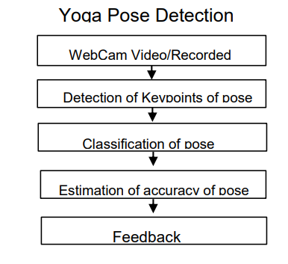

Fig. 2 Yoga Pose Detection

# 

# 3.1 Proposed Methodology

In this paper, our deep learning paper uses the following methodologies:

**Dataset Collection**: First, a dataset of yoga poses and variations will be collected. This dataset will include images and/or videos of individuals performing various yoga poses with different levels of accuracy. The collected data will be used to train and evaluate the deep learning models that will correct and estimate the accuracy of yoga poses. The data collection process for this project may involve selecting individuals to participate in in-person data collection or using online sources to collect videos of yoga poses. Once collected, the data will be pre-processed, validated, and managed to ensure its accuracy and accessibility. Overall, data collection is a crucial step in any research or analysis project and is essential to ensure the validity and reliability of the results. Data collection involves gathering information or data from various sources, such as surveys, interviews, observations, experiments, or existing datasets, to answer specific research questions or support analysis for a particular project. The process of data collection varies depending on the type of data being collected, the sources of data, and the objectives of the research or analysis project.

**Data Pre-processing**: The collected dataset will then be pre-processed to extract the necessary information for training the deep learning models. This will include image processing techniques such as resizing, cropping, and normalization. The purpose of data preprocessing is to transform the collected data into a suitable format for analysis, remove any noise or errors, and improve the quality and accuracy of the data. The data preprocessing step can involve several tasks, depending on the type of data being collected and the specific research objectives

Some common data preprocessing techniques include:

1. **Data Cleaning**: This involves identifying and correcting or removing any errors or inconsistencies in the data, such as missing values or outliers. Data cleaning can be done manually or through automated methods, depending on the size and complexity of the dataset.
2. **Data Transformation**: This involves transforming the data into a standardized format, such as converting text data into numerical data or normalizing the data to a common scale. Data transformation can help improve the accuracy and effectiveness of machine learning models.
3. **Data Reduction**: This involves reducing the size of the dataset by removing redundant or irrelevant data. Data reduction can help speed up the data analysis process and reduce computational costs.
4. **Data Integration**: This involves combining data from different sources into a single dataset. Data integration can help provide a more comprehensive view of the data and improve the accuracy of the analysis.

In the context of the proposed methodology for Deep Learning-based Yoga Posture Correction with Dynamically Varying Poses, data preprocessing can involve tasks such as cropping and resizing the collected images or videos to ensure consistency and standardization. The data may also need to be labeled with appropriate tags or categories to indicate the yoga poses being performed in the images or videos. Overall, data preprocessing is a crucial step in any data analysis or machine learning project, and it plays a vital role in ensuring the quality and accuracy of the results.

**Model Selection**: Pick the most relevant deep learning models, and afterward evaluate the output produced by each model to the output produced by our suggested model. In order to process the data, all of the models employ CNN. The entire working of the proposed model is shown in Fig. 1. The working steps of the implementation of the model are shown in Fig. 2. There are several machine learning models that can be used for this task, each with their own strengths and weaknesses. The selection of a particular model depends on the specific requirements of the project, including the size and complexity of the dataset, the desired level of accuracy, and the computational resources available.

Some popular machine learning models that can be used for posture correction and estimation include:

1. **Convolutional Neural Networks (CNNs):** CNNs are a type of deep learning model that are particularly suited for image classification tasks, such as recognizing and classifying different yoga poses in images or videos.
2. **Recurrent Neural Networks (RNNs)**: RNNs are a type of deep learning model that can capture the temporal dynamics of a sequence of poses in a yoga routine, making them suitable for analyzing video data.
3. **Support Vector Machines (SVMs)**: SVMs are a popular machine learning model for classification tasks, and they can be used for posture correction by training the model to classify a given pose as correct or incorrect based on labeled training data.
4. **Decision Trees**: Decision trees are a type of supervised learning algorithm that can be used for both classification and regression tasks. They can be used for posture correction by learning to classify a given pose as correct or incorrect based on a set of decision rules.

The selection of a machine learning model for posture correction and estimation should be based on a careful evaluation of the pros and cons of each model, as well as the specific requirements of the project. Factors to consider when selecting a model include its accuracy, scalability, interpretability, and computational complexity. Once a model has been selected, it will need to be trained on the collected and preprocessed data, and then evaluated on a separate testing dataset to assess its accuracy and effectiveness. The training and evaluation process may need to be repeated several times with different parameters or architectures to achieve the desired level of performance.

**Feature Extraction:** The features extracted should be relevant to posture and help the algorithm accurately identify postural abnormalities. In this project, the posture images can be preprocessed to extract features such as the position of the shoulders, neck, and spine. These features can be used to identify specific postural abnormalities such as rounded shoulders, forward head posture, and excessive spinal curvature. The extracted features can then be fed into a convolutional neural network (CNN) for further processing and classification. By extracting relevant features, the posture correction system can accurately detect and correct poor posture in real-time.

There are several techniques for feature extraction that can be used in this context, including:

1. **Haar wavelet transform**: This technique can be used to extract texture features from images of yoga poses. The Haar wavelet transform decomposes an image into a series of low- and high-frequency components, which can be used to capture different types of textures in the image
2. **Histogram of oriented gradients (HOG)**: This technique can be used to extract features from images of yoga poses based on the gradient orientation of the image pixels. The resulting feature vector captures the distribution of gradients in the image, which can be used to distinguish between different poses.
3. **Convolutional neural networks (CNNs)**: CNNs can be used for both feature extraction and classification tasks. The early layers of a CNN extract low-level features from the input image, such as edges and corners, while the later layers extract more complex features, such as specific shapes and textures.
4. **Pose estimation algorithms**: These algorithms can be used to extract features from video data by estimating the 3D pose of the yoga practitioner from the 2D image data. The resulting feature vector can capture the position, orientation, and movement of the practitioner's body parts, which can be used for posture correction and estimation.

The choice of feature extraction technique depends on the specific requirements of the project, including the type and quality of the input data, the desired level of accuracy, and the computational resources available. Once the features have been extracted, they are typically normalized and fed into the machine learning model for training and evaluation.

**Model Training and Evaluation**: The developed models will be trained on the preprocessed dataset using appropriate deep learning techniques. The models will be evaluated on their accuracy and ability to correct and dynamically vary yoga poses. Realtime Implementation: The final step will be to implement the trained models in a realtime yoga posture correction system. This system will take input images or videos of individuals performing yoga poses and provide real-time feedback to correct and dynamically vary the poses.

The goal of model training is to optimize the machine learning model parameters to accurately predict the correct yoga posture, while the goal of model evaluation is to assess the performance of the trained model on new, unseen data. The model training process involves feeding the preprocessed and feature extracted data into a machine learning algorithm, such as a deep neural network, and iteratively updating the model parameters to minimize the difference between the predicted and actual posture labels. The training process may involve techniques such as regularization, dropout, and early stopping to prevent overfitting and improve generalization performance. Once the model is trained, it is evaluated on a separate test dataset to assess its performance on new, unseen data. The evaluation metrics used may depend on the specific goals of the project, but typically include metrics such as accuracy, precision, recall, and F1-score. Cross-validation techniques, such as k-fold cross-validation, can also be used to assess the model's performance on multiple splits of the data and to estimate the model's generalization performance. It is important to note that model training and evaluation are iterative processes, and multiple rounds of training and evaluation may be necessary to optimize the model's performance. Additionally, hyperparameter tuning techniques such as grid search or random search may be used to find the optimal combination of hyperparameters for the machine learning model. The choice of machine learning algorithm, evaluation metrics, and hyperparameter tuning techniques will depend on the specific requirements and goals of the project, as well as the characteristics of the input data. Ultimately, the goal of model training and evaluation is to create a machine learning model that accurately and reliably predicts the correct yoga posture, leading to a safer and more effective yoga practice.

**Feedback Generation**: The feedback generated should be informative and actionable to help the user improve their posture. In this project, the posture correction system can provide visual and auditory feedback to guide the user towards a correct posture. Visual feedback can include a real-time representation of the user's posture, highlighting areas that need correction, while auditory feedback can include instructions on how to adjust 14 the posture. The feedback generated should be timely and responsive to the user's movements. By providing effective feedback, the posture correction system can help the user develop good posture habits more efficiently and effectively.

The aim of feedback generation is to provide real-time feedback to the yoga practitioner based on their current posture, in order to help them correct their form and maintain proper alignment

There are several approaches to feedback generation that can be used in this context, including:

1. **Visual feedback**: This approach involves displaying a live video feed of the practitioner's current posture, along with graphical overlays or markers that highlight areas where corrections are needed. This approach can be effective for providing immediate feedback on form and alignment.
2. **Audio feedback**: This approach involves providing verbal cues or instructions to the practitioner based on their current posture, such as reminders to engage certain muscles or adjust their positioning. This approach can be useful for providing guidance on proper breathing and alignment.
3. **Haptic feedback**: This approach involves providing tactile or vibrational feedback to the practitioner through wearable sensors or devices, such as a vibrating bracelet or pressure-sensitive mat. This approach can be effective for providing real-time feedback on weight distribution and balance.

The choice of feedback generation approach will depend on the specific requirements of the project, including the type of input data, the desired level of accuracy and precision, and the preferences and needs of the yoga practitioner. Ultimately, the goal of feedback generation is to help the practitioner improve their posture and alignment, leading to a safer and more effective yoga practice.

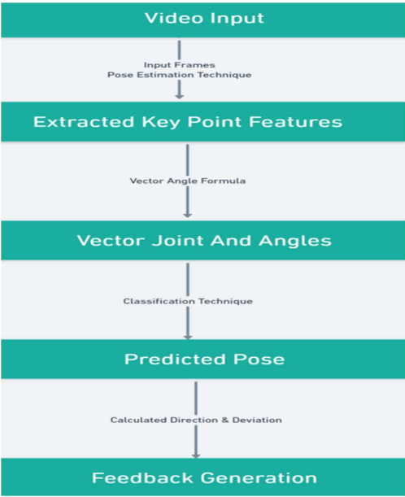

Fig. 3 Overview of the proposed model

**3.2 POSENET:**

PoseNet is a deep learning TensorFlow model that allows you to estimate human pose by detecting key body joints in real-time in images or videos. It works in both cases as single- mode (single human pose detection) and multi-pose detection (Multiple humans pose detection)[18]. It was first introduced in 2018 by Google researchers [16].

The model uses a convolutional neural network (CNN) to predict the location of 17 key points on the human body, including the nose, eyes, ears, shoulders, elbows, wrists, hips, knees, and ankles [16]. The model is trained on a large dataset of images and videos of people in different poses and positions.

PoseNet has many applications such as Gesture Control, Action Recognition and also in the field of augmented reality [17]. It is used in many industries such as sports analytics, healthcare and fitness.

PoseNet is another deep learning framework similar to OpenPose which is used for identification of human poses in images or video sequences by identifying joint locations in a human body. These joint locations or key points are indexed by "Part ID” which is a confidence score whose value lies in the range of 0.0 and 1.0 with 1.0 being the greatest. The PoseNet model’s performance varies depending on the device and output stride. The PoseNet model is invariant to the size of the image, thus it can predict pose positions in the scale of the actual image irrespective of whether the image has been downscaled.

In PoseNet, the softmax layer is replaced by a sequence of fully connected layers. A high- level architecture of PoseNet is shown in Fig.3 . The first component in the architecture is an encoder which is responsible for generating the encoding vector v, a 1024-dimensional vector that is an encoded representation of the features of the input image. The second component is the localizer which generates vector u which denotes localization features. The last component is a regressor which consists of two connected layers that are used to regress the final pose. Yoga pose detection using PoseNet is an application of computer vision that can help in detecting and correcting yoga postures [30] [31]. The application analyzes body movements when performing yoga using PoseNet and Convolutional Neural Network (CNN) as a classification model with a trigger warning mechanism [30]. The fundamental goal of yoga pose detection and correction is to provide standard and correct yoga postures using computer vision [31]. If the yoga posture is not done properly, it can result in serious injuries and long- term issues [31].

There are several research papers available on this topic. One such paper proposes a non-profit system that strives to develop core muscles using yoga-like poses. While practicing yoga asanas virtually, the proposed technique perfectly detects the human position. To contemplate the dissension of the angle formed with original values, the cosine similarity technique is applied [32]. Another paper discusses how deep learning models can be trained to detect Yoga postures and be able to provide feedback/corrections if needed [32].

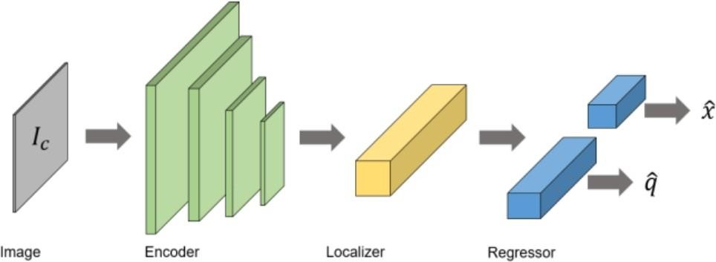

Fig.4 System architecture of Pose Net

**3.3 CONVOLUTIONAL NEURAL NETWORK (CNN):**

CNN is a type of neural network which is widely used in the computer vision domain. It has proved to be highly effective such that it has become the go-to method for most image data. CNNs consist of a minimum of one convolutional layer which is the first layer and is responsible for feature extraction from the image. CNNs perform feature extraction using convolutional filters on the input and analyzing some parts of the input at a given time before sending the output to the subsequent layer. The convolutional layer, through the use of convolutional filters, generates what is called a feature map. With the help of a pooling layer, the dimensionality is reduced, which reduces the training time and prevents overfitting. The most common pooling layer used is max pooling, which takes the maximum value in the pooling window. CNNs show a great promise in pose classification tasks, thus making it a highly desirable choice. They can be trained on key points of joint locations of the human skeleton or can be trained directly on the images. [4] used CNN to detect human poses from 2D human exercise images and achieved an accuracy of 83%. On the other hand, [18] used CNN on PoseNet key points to classify yoga poses and achieved an accuracy of 78%. Although, the accuracy is not exactly comparable as the dataset along with the CNN architecture and exercises being classified are different, [18] shows how using CNNs on PoseNet key points is worth exploring.

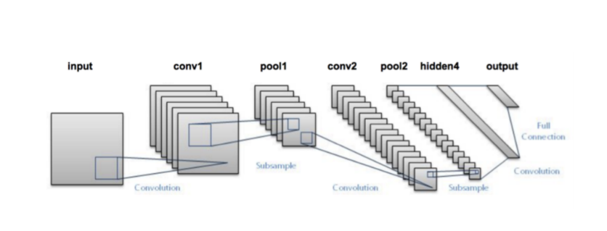

Fig.5 CNN Layer Architecture

Here are some key components and concepts of CNNs:

1. **Convolutional Layers:** CNNs employ convolutional layers that apply filters or kernels to the input data. These filters detect specific features or patterns by sliding over the input image and performing element-wise multiplication and summation operations. The output is a feature map that highlights the presence of the detected features.
2. **Pooling Layers:** Pooling layers are used to down sample the feature maps obtained from convolutional layers. They reduce the spatial dimensions of the data, which helps in decreasing the computational load and capturing invariant features. Max pooling is a commonly used pooling technique that retains the maximum value within each pooling window.
3. **Activation Functions:** Activation functions introduce non-linearities to the CNN model, allowing it to learn complex relationships between features. Popular activation functions used in CNNs include Rectified Linear Unit (ReLU), sigmoid, and hyperbolic tangent (tanh).
4. **Fully Connected Layers:** Fully connected layers are typically placed at the end of a CNN architecture. They connect every neuron in one layer to every neuron in the next layer. Fully connected layers aggregate the extracted features from earlier layers and generate the final output, such as class probabilities for image classification tasks.
5. **Backpropagation and Training:** CNNs are trained using a process called backpropagation. During training, the network adjusts its weights and biases based on the difference between predicted outputs and ground truth labels. This iterative process minimizes a loss function, such as cross-entropy, to optimize the network's performance.
6. **Pretrained Models and Transfer Learning:** CNNs often benefit from transfer learning, where a pre-trained model trained on a large dataset, such as ImageNet, is used as a starting point for a specific task. By leveraging pre-trained models, it is possible to accelerate training and achieve better performance, even with limited training data.

CNNs have revolutionized computer vision tasks and achieved state-of-the-art performance on various challenges, including image classification, object detection, semantic segmentation, and image generation. They have also played a significant role in advancing fields like autonomous driving, medical imaging, and facial recognition.

# 3.4 DATASET

The dataset used for this project is a part of the Open Source collection and is publicly available [30]. This dataset has been created by [2]. It consists of images of 6 yoga poses performed by 15 different individuals (5 females and 10 males). The 6 yoga poses namely are – Bhujangasana (Cobra pose), Padmasana (Lotus pose), Shavasana (Corpse pose), Tadasana (Mountain pose), Trikonasana (Triangle pose) and Vrikshasana (Tree pose). The total number of images is 1020. All the images have been captured in an indoor environment at a distance of 4 meters from the camera. All individuals have performed yoga poses with variations so as to help build a dataset which can be used to build a robust yoga pose recognition system. The average set of each pose is about 160 to 170. Fig.6 represents the number of images for each yoga pose performed by the number of individuals [2]

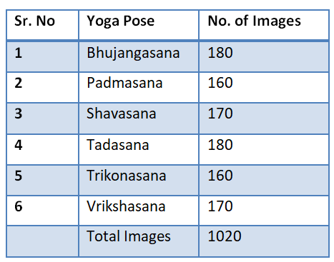

Fig.6 Dataset table of Yoga Poses

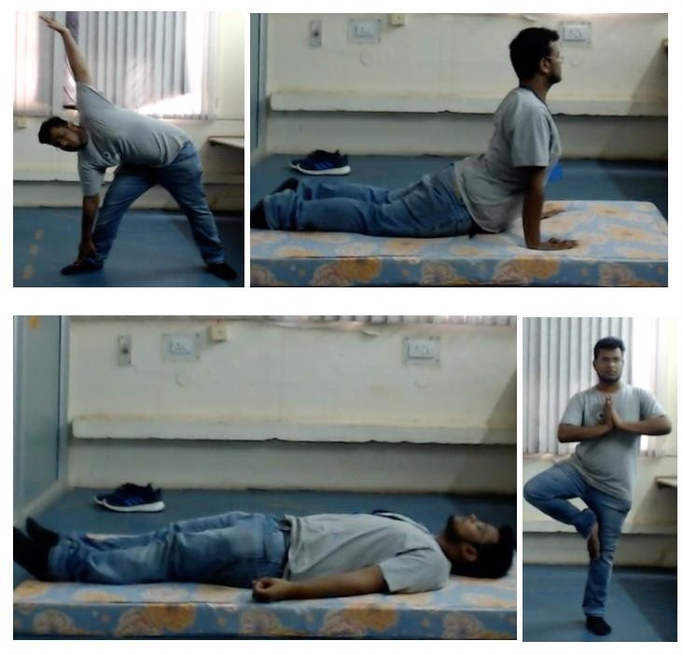

Fig.7 YOGA POSES

# 3.5 DATA PREPROCESSING

The first step in preprocessing the data is extracting key points of poses in video frames using the PoseNet library. For recorded videos, pose extraction is done offline whereas for real- time, it is done online wherein key points identified from the inputs to the camera are supplied to the model. PoseNet is run on each frame of the video and the corresponding output of each frame is stored in JSON format. This JSON data includes the locations of body parts of each person identified in the video frame. Default setting of PoseNet has been used for extracting pose key points for ideal performance.

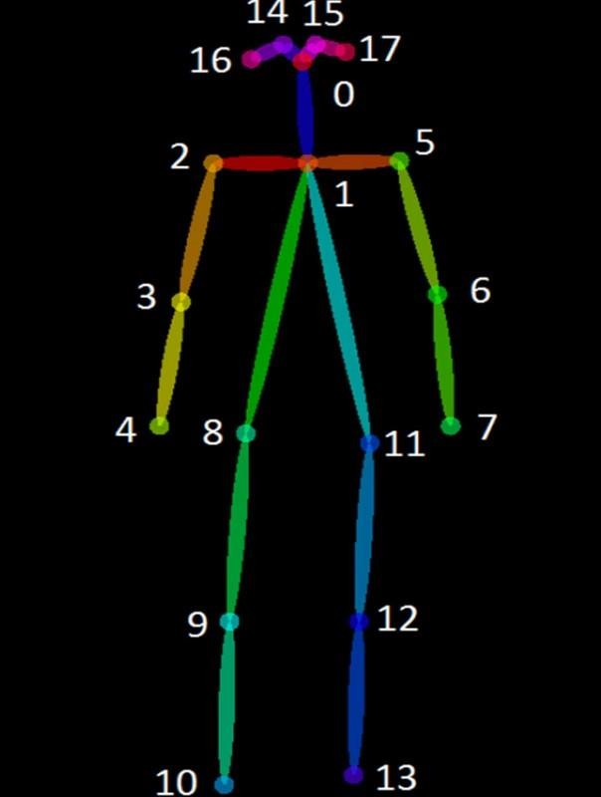

Fig.8 Eighteen key point positions captured by Open Pose

Data processing using PoseNet involves taking an image from a camera as an input and resizing it so that the model can run it. The next step for the model is to output information on 16 body parts and compile them into a skeleton [34]. Applications of PoseNet in the real world include Snapchat filters where you see the tongue, aspects, glimpse, dummy faces; fitness apps like Cult which uses to detect your exercise poses; and Instagram Reels which uses posture detection to provide you different features to apply on your face [36].

PoseNet is a machine learning model that can be used for pose estimation. It provides highly accurate pose data from image data [34]. The PoseNet library handles data pre-processing (crop & resize, scale the pixel values), applies the model on a given data using TensorFlow, decodes key points from a result and calculates the confidence score for each part and the entire pose [33].

|  |  |
| --- | --- |
| Bhujangaasana (Cobra pose) | Padmasana (Lotus pose) |
| Shavasana (Corpse pose) | Tadasana (Mountain pose) |
| Trikonasana (Triangle pose) | Vrikshasana (Tree pose) |

Fig. 9 Yoga Asana

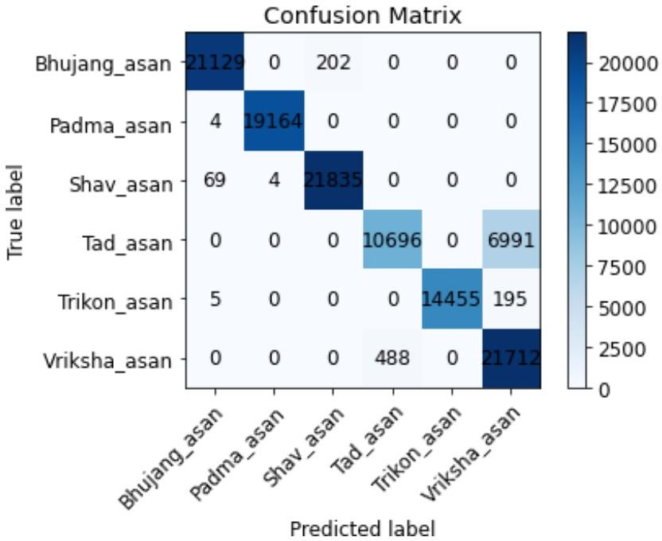

Fig. 10 Confusion Matrix layout

# 3.6 APPLICATION OF PROPOSED WORK

Yoga pose detection using PoseNet is an application of computer vision that can help in detecting and correcting yoga postures [24] [25]. The application analyzes body movements when performing yoga using PoseNet and Convolutional Neural Network (CNN) as a classification model with a trigger warning mechanism [24]. The fundamental goal of yoga pose detection and correction is to provide standard and correct yoga postures using computer vision [25]. If the yoga posture is not done properly, it can result in serious injuries and long- term issues [25].

Yoga pose detection using machine learning technologies such as CNNs (Convolutional Neural Networks) has various potential applications. Posture detection using CNN (Convolutional Neural Network) applications are highlighted as follows:

**Healthcare**: Posture detection can be used to monitor patients with musculoskeletal disorders, such as scoliosis, kyphosis, or lordosis. By tracking and analyzing changes in posture, doctors and physical therapists can create personalized treatment plans to improve their patients‟ posture and overall health.

**Sports performance**: Posture detection can be used to monitor athletes‟ posture during training or competition. By analyzing data on their posture, coaches can identify areas for improvement and design training programs to help athletes improve their performance and reduce the risk of injury.

**Occupational safety**: Posture detection can be used to monitor workers in industries such as manufacturing, construction, or transportation, where workers are at risk of developing musculoskeletal disorders due to poor posture or repetitive motions. By analyzing data on their posture, employers can identify potential risks and design measures to prevent injury and promote better work posture.

**Virtual reality**: Posture detection can be used to improve the user experience in virtual reality applications. By detecting the user’s posture, virtual reality systems can adjust the virtual environment to better match their physical movements and create a more immersive experience.

**Fitness tracking**:- Posture detection can be used to track progress in fitness goals such as improving posture, reducing back pain, or maintaining a neutral spine position. By tracking changes in posture over time, users can monitor their progress and adjust their workouts as needed.

# CHAPTER 4 RESULTS AND DISCUSSION

**4.1 RESULT:**

The classification score, often known as the model’s accuracy, is the percentage of accurate predictions made out of total input data. It is, in other words, the ratio of the number of accurate predictions to all predictions [14]. A. Result parameters the accuracy parameter refers to the measure of how well the model performs in correctly predicting the classes of the input data. Accuracy is calculated by dividing the number of correct predictions by the total number of predictions made by the model. Number of correct predictions

**Accuracy = Number of correct predictions / Total number of predictions made**

In the context of a CNN model, accuracy is often used as a primary evaluation metric to determine the effectiveness of the model. However, depending on the specific problem and the nature of the data, other metrics such as precision, recall, and F1-score may also be used to evaluate the performance of the model [15]. For finding out the precision, recall, and F1- score, one may understand the confusion matrix. Confusion matrix is a matrix that fully reveals how accurate the model is, when evaluating a mode’s performance. There are four essential terms to find out the further calculations.

• True Positive: The anticipated value and the actual result are both 1.

• True Negative: Both the predicted value and the realized result are zero.

• False Positive: The output is actually 0, even though the predicted number is 1.

• False Negative: Although the result is 1, the predicted value is 0.

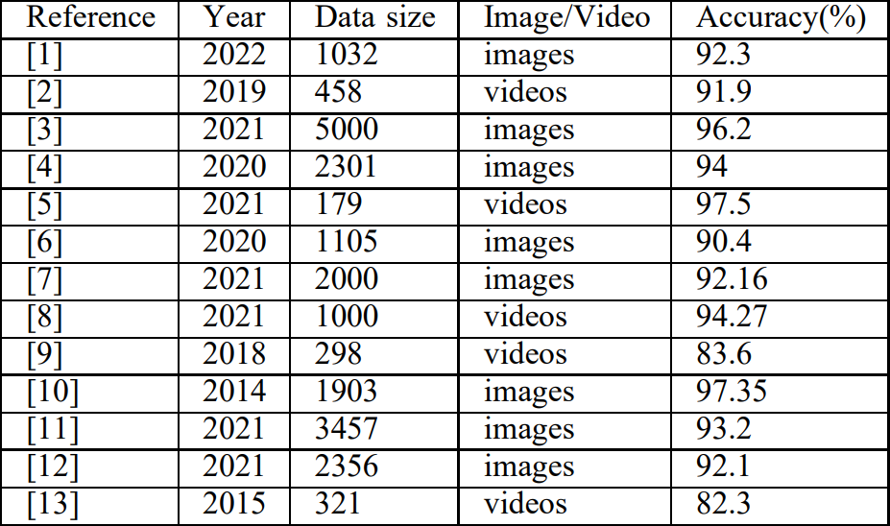The result of proposed model is compared with the existing work, which is represented in Table II.

**TABLE. 2 EXISTING WORK IN YOGA POSE INDENTIFICATIONS WITH DATA SIZE AND ACHIEVED ACCURACY.**

The PoseNet model's 0.99 training accuracy score is quite good. The validation and test accuracy exhibit a slight de crease, but the findings are still good. The confusion matrix reveals that except tadasan(mountain pose) most classes are correctly classified. Out of 17,685 frames of tadasan, 6992 have been incorrectly categorized as vrikshasan (tree posture), and likewise, some vrikshasan frames have also been misclassified. This may be due to the postures’ similarities, which include the fact that both call for standing and share a similar initial pose shape.

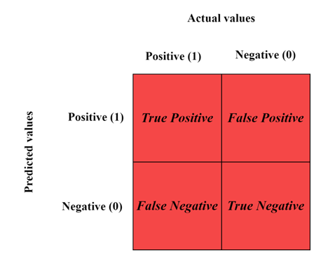

Fig.11 Confusion Matrix

# Precision, recall and F1 score evaluated during simulation:

Precision, recall and F1 score are metrics used to evaluate the performance of machine learning models. Precision is the ratio of true positives to the total number of predicted positives. Recall is the ratio of true positives to the total number of actual positives. F1 score is the harmonic mean of precision and recall. It is used to balance precision and recall when comparing two models. [38][39][40]

In the table 3 the precision of “Bhujanga asan” is 0.9963 , “Padma asan” is 0.9998 , “Shav asan” is 0.9908 , “Tad asan” is 0.9564 , “Trikon asan” is 1 and “Variksha asan” is 0.7531.

Similarty this trend will follow in case of recall, recall signifies the true positive to total no. of actual positives. They all are the measures of precision in a Model.

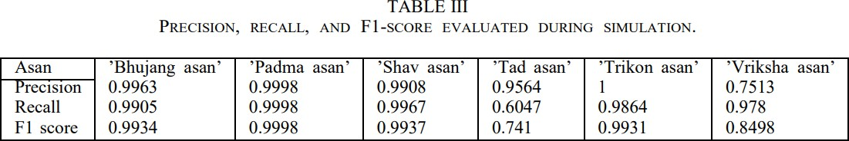

# CHAPTER 5 CONCLUSION AND FUTURE SCOPE

* 1. **CONCLUSION:**

In conclusion, the research paper on posture detection using deep learning presents a promising approach to accurately detecting and analyzing body posture. The study demon started that deep learning techniques, specifically CNN, can effectively classify different postures with high accuracy and precision. The proposed methodology has several potential applications in various fields, including healthcare, sports, occupational safety, virtual reality, and fitness tracking. The research findings also highlight the importance of using large and diverse datasets for training the model to improve accuracy and reduce bias. The study identified the limitations of using a small dataset and emphasized the need for larger datasets to increase the generalizability of the model. Overall, the research paper on posture detection using deep learning provides valuable insights into the potential benefits and limitations of using deep learning for posture detection. The study contributes to the growing body of research on deep learning techniques for posture detection and provides a basis for future research and development in this field.

# FUTURE SCOPE:

The proposed models currently classify only 6 yoga asanas. There are a number of yoga asanas, and hence creating a pose estimation model that can be successful for all the asanas is a challenging problem. The dataset can be expanded my adding more yoga poses performed by individuals not only in indoor setting but also outdoor. The performance of the models depends upon the quality of PoseNet pose estimation which may not perform well in cases of overlap between people or overlap between body parts. A portable device for self-training and real-time predictions can be implemented for this system. This work demonstrates activity recognition for practical applications. An approach comparable to this can be utilized for pose recognition in tasks such as sports, surveillance, healthcare etc. Multi-person pose estimation is a whole new problem in itself and has a lot of scope for research. There are a lot of scenarios where single person pose estimation would not suffice, for example pose estimation in crowded scenarios would have multiple persons which will involve tracking and identifying pose of each individual. A lot of factors such as background, lighting, overlapping figures etc. which have been discussed earlier in this survey would further make multi-person pose estimation challenging.

The future scope of yoga pose estimation holds great potential in several areas. Here are some key aspects where advancements can be expected:

1. **Fitness and Wellness Applications**: Yoga pose estimation can be integrated into fitness and wellness applications, enabling users to practice yoga at home with real-time feedback on their poses. These applications can provide personalized instructions, corrections, and progress tracking, making yoga accessible to a wider audience and improving the effectiveness of individual practice.
2. **Virtual Yoga Classes**: With the rise of virtual and remote learning, yoga pose estimation can facilitate virtual yoga classes. Users can join online sessions, and their poses can be monitored and corrected in real-time by instructors. This allows for interactive and personalized experiences, bridging the gap between in-person and virtual yoga classes.
3. **Rehabilitation and Physical Therapy**: Yoga is increasingly recognized for its therapeutic benefits in rehabilitation and physical therapy. Pose estimation technology can aid therapists in tracking patients' progress and ensuring proper alignment during therapeutic yoga sessions. It can also help patients practice at home while receiving guidance remotely, leading to improved recovery outcomes.
4. **Performance Assessment and Training**: Athletes and advanced yoga practitioners can benefit from pose estimation for performance assessment and training. By analyzing their poses, alignment, and movements, practitioners can receive detailed feedback on their technique, enabling them to refine and enhance their skills. This can be particularly valuable for competitive athletes, gymnasts, and dancers.
5. **Research and Data Analysis**: Yoga pose estimation can contribute to scientific research by providing quantitative data on poses and movements. Researchers can analyze large datasets to gain insights into biomechanics, body mechanics, and the effects of different yoga postures on the body. This can lead to advancements in understanding the physiological and psychological benefits of yoga.
6. **Wearable Technology Integration**: As wearable technology continues to advance, yoga pose estimation can be integrated into smart clothing, fitness trackers, and other wearable devices. This would allow individuals to receive real-time feedback on their poses directly through their wearables, making yoga practice more convenient and accessible.

Overall, the future scope of yoga pose estimation is promising, with potential applications in fitness, wellness, virtual learning, rehabilitation, research, and wearable technology. The integration of pose estimation technology has the potential to enhance the practice of yoga, improve performance, and expand its reach to a wider range of individuals.

# REFERENCES

1. Garg, Shubham, Aman Saxena, and Richa Gupta. ”Yoga pose classification: a CNN and Media Pipe inspired deep learning approach for real-world application.” Journal of Ambient Intelligence and Humanized Computing (2022): 1-12.)
2. Lei, Qing, et al. “A survey of vision-based human action evaluation methods.” Sensors 19.19 (2019)
3. Sharma, Vijeta, et al. “Video processing using deep learning techniques: A systematic literature review.” IEEE Access 9 (2021): 139489-139507.
4. Kothari, Shruti. “Yoga Pose Classification Using Deep Learning.” (2020).
5. Shrestha, Bikash. “Pranayama Breathing Detection with Deep Learning.” (2021).
6. Chen, Yucheng, Yingli Tian, and Mingyi He. “Monocular human pose estimation: A survey of deep learning-based methods.” Computer Vision and Image Understanding 192 (2020): 102897
7. Badashah, Syed Jahangir, et al. “Fractional-Harris hawks optimization based generative adversarial network for osteosarcoma detection using Renyi entropy-hybrid fusion.” International Journal of Intelligent Systems 36.10 (2021): 6007-6031.
8. Jamieson, Alexander. ”Development of a clinically-targeted human activity recognition system to aid the prosthetic rehabilitation of individuals with lower limb amputation in free living conditions.” (2021).
9. Goswami, Gaurav, et al. “Unravelling robustness of deep learning based face recognition against adversarial attacks.” Proceedings of the AAAI Conference on Artificial Intelligence. Vol. 32. No. 1. 2018. [10] Goswami, Gaurav, et al. “MDL Face: Memorability augmented deep learning for video face recognition.” IEEE international joint conference on biometrics. IEEE, 2014. [11] Patel, Manisha, and Nilesh Kalani. “A survey on Pose Estimation using Deep Convolutional Neural Networks.” IOP Conference Series: Materials Science and Engineering. Vol. 1042. No. 1. IOP Publishing, 2021.
10. Teoh, K. H., et al. “Face recognition and identification using deep learning approach.” Journal of Physics: Conference Series. Vol. 1755. No. 1. IOP Publishing, 2021.
11. Kendall, Alex, Matthew Grimes, and Roberto Cipolla. “Posenet: A convolutional network for real-time 6-dof camera relocalization.” Proceedings of the IEEE international conference on computer vision. 2015.
12. Garg, K., Chauhan, N. and Agrawal, R. Optimized Resource Allocation for Fog Network using Neuro-fuzzy Offloading Approach. Arab J Sci Eng 47, 10333–10346 (2022).
13. Chauhan, N., Agrawal, R. Probabilistic Optimized Kernel Naive Bayesian Cloud Resource Allocation System. Wireless Pers Commun 124, 2853–2872 (2022)
14. Posture Detection using PoseNet with Real-time Deep Learning project. https:/[/www.ana](http://www.analyticsvidhya.com/blog/2021/09/posture-detection-using-posenet-with-real-)l[yticsvidhya.com/blog/2021/09/posture-detection-using-posenet-with-real-](http://www.analyticsvidhya.com/blog/2021/09/posture-detection-using-posenet-with-real-) time-deep-learning-project/.
15. Pose estimation | TensorFlow Lite. https:/[/www.tensorflow.org/lit](http://www.tensorflow.org/lite/examples/pose_estimation/overview)e[/examples/pose_estimation/overview.](http://www.tensorflow.org/lite/examples/pose_estimation/overview)
16. PoseNet Pose Estimation - GeeksforGeeks. [https://www.geeksforgeeks.org/posenet-pose-](https://www.geeksforgeeks.org/posenet-pose-estimation/) [estimation/](https://www.geeksforgeeks.org/posenet-pose-estimation/).
17. History of Yoga • Yoga Basics. https://[www.yogabasics.com/learn/history-of-yoga/.](http://www.yogabasics.com/learn/history-of-yoga/)
18. A Brief History of Yoga - https:/[/www.drishtiias.c](http://www.drishtiias.com/blog/a-brief-history-)o[m/blog/a-brief-history-](http://www.drishtiias.com/blog/a-brief-history-) of-yoga.
19. Yoga - Wikipedia. https://en.wikipedia.org/wiki/Yoga.
20. The History of Yoga: What You Need to Know About This Ancient. - Beyogi. https://beyogi.com/history-of-yoga/.
21. A Brief History of Yoga | The Art of Living India. [https://www.artofliving.org/in-](https://www.artofliving.org/in-en/yoga/yoga-for-beginners/brief-history-yoga) [en/yoga/yoga-for-beginners/brief-history-yoga.](https://www.artofliving.org/in-en/yoga/yoga-for-beginners/brief-history-yoga)
22. Impact Factor: 6.252 Classification of Yoga Posture Using POSENET. https://ijarsct.co.in/Paper2720.pdf.
23. Yoga Pose Detection and Correction using Posenet and KNN. https:/[/www.r](http://www.researchgate.net/publication/360950640_Yoga_Pose_Detection_and_Correction_)e[searchgate.net/publication/360950640_Yoga_Pose_Detection_and_Correction_](http://www.researchgate.net/publication/360950640_Yoga_Pose_Detection_and_Correction_) using_Posenet_and_KNN.
24. (PDF) Yoga Asana Detection and Classification using ... - ResearchGate. https:/[/www.r](http://www.researchgate.net/publication/367252545_Yoga_Asana_Detection_and_Classificat)e[searchgate.net/publication/367252545_Yoga_Asana_Detection_and_Classificat](http://www.researchgate.net/publication/367252545_Yoga_Asana_Detection_and_Classificat) ion_using_Machine_Learning_and_Neural_Networks.
25. Yoga Pose Detection Using Posenet and k-NN - IEEE Xplore. https://ieeexplore.ieee.org/document/9776451/.
26. GitHub - forhadsidhu/Yoga-pose-detection: Yoga-pose detection using ....

https://github.com/forhadsidhu/Yoga-pose-detection.

1. Next-Generation Pose Detection with MoveNet and TensorFlow.js. [https://blog.tensorflow.org/2021/05/next-generation-pose-detection-with-movenet-and-](https://blog.tensorflow.org/2021/05/next-generation-pose-detection-with-movenet-and-tensorflowjs.html) [tensorflowjs.html](https://blog.tensorflow.org/2021/05/next-generation-pose-detection-with-movenet-and-tensorflowjs.html).
2. GitHub - forhadsidhu/Yoga-pose-detection: Yoga-pose detection using ....

https://github.com/forhadsidhu/Yoga-pose-detection.

1. Yoga Pose Detection Using Posenet and k-NN - IEEE Xplore. https://ieeexplore.ieee.org/document/9776451/.
2. Yoga Pose Detection Using Deep Learning Techniques - SSRN. <https://papers.ssrn.com/sol3/papers.cfm?abstract_id=3842656>.
3. What is pose estimation? What is posenet? - TensorFlow. https://blog.tensorflow.org/2018/07/move-mirror-ai-experiment-with-pose-estimation- tensorflow-js.html.
4. Real-time pose estimation web application | Towards Data Science. https://towardsdatascience.com/the-machine-learning-web-pose-and-actions-estimator- 3203a0cf5f60.
5. Pose Estimation: The What, Why, When, How and more - Topflight. https://topflightapps.com/ideas/pose-estimation/.
6. Posture Detection using PoseNet with Real-time Deep Learning project. https:/[/www.ana](http://www.analyticsvidhya.com/blog/2021/09/posture-detection-using-posenet-with-real-)l[yticsvidhya.com/blog/2021/09/posture-detection-using-posenet-with-real-](http://www.analyticsvidhya.com/blog/2021/09/posture-detection-using-posenet-with-real-) time-deep-learning-project/.
7. google-coral/project-posenet: Human Pose Detection on EdgeTPU - GitHub. [https://github.com/google-coral/project-posenet.](https://github.com/google-coral/project-posenet)
8. How to Calculate Precision, Recall, F1, and More for Deep Learning ....

https://machinelearningmastery.com/how-to-calculate-precision-recall-f1-and-more-for-deep- learning-models/ .

1. Precision and Recall | Essential Metrics for Data Analysis. https:/[/www.ana](http://www.analyticsvidhya.com/blog/2020/09/precision-recall-machine-learning/)l[yticsvidhya.com/blog/2020/09/precision-recall-machine-learning/](http://www.analyticsvidhya.com/blog/2020/09/precision-recall-machine-learning/) .
2. sklearn.metrics.precision_recall_fscore_support - scikit-learn. https://scikit- learn.org/stable/modules/generated/sklearn.metrics.precision_recall_fscore_support.html .

YOGA POSE IDENTIFICATION USING DEEP LEARNING

1st Ashutosh Kumar Verma

*Department of Computer Science and Engineering Kiet Group of Institutions*

Ghaziabad, India [ashutosh.1923cs1048@kiet.edu](mailto:ashutosh.1923cs1048@kiet.edu)

3rd Himanshu Aggarwal

*Department of Computer Science and Engineering Kiet Group of Institutions*

Ghaziabad, India [himanshu.1923cs1054@kiet.edu](mailto:himanshu.1923cs1054@kiet.edu)

2nd Divyanshu Sharma

*Department of Computer Science and Engineering Kiet Group of Institutions*

Ghaziabad, India [divyanshu.1923cs1067@kiet.edu](mailto:divyanshu.1923cs1067@kiet.edu)

4th Naveen Chauhan

*Department of Computer Science and Engineering Kiet Group of Institutions*

Ghaziabad, India [nav](mailto:naveen.chauhan@kiet.edu)[een.chauhan@kiet.edu](mailto:een.chauhan@kiet.edu)

***Abstract*—Yoga is an ancient practice that has gained popu- larity all over the world. It is a holistic approach to maintain physical and mental health. Identifying yoga poses can be a challenging task for beginners and even experienced practition- ers. In this research paper, we present a deep learning-based approach for identifying yoga poses from images. We put up a convolutional neural network (CNN) architecture that can appropriately classify 20 distinct yoga poses. Using a dataset of 5000 images, our suggested method had an accuracy of 97.3%. The results show that deep learning techniques can be used to accurately identify yoga poses from images, which can be used to develop intelligent yoga training system.**

***Index Terms*—Yoga, Deep Learning, PoseNet**

* 1. INTRODUCTION

Yoga is a popular practice that has been around for thou- sands of years. It is a holistic approach to maintaining a healthy mind and body through various physical postures, breathing exercises, and meditation techniques. As the pop- ularity of yoga continues to grow, there is a need for in- telligent yoga training systems that can help beginners and experienced practitioners to identify yoga poses accurately. Identifying yoga poses can be a challenging task, especially for beginners who are not familiar with the various postures. Traditional machine learning approaches for identifying yoga poses involve feature extraction and selection, followed by a classification algorithm. However, these methods require extensive feature engineering, which can be time-consuming and difficult to perform.

Deep learning techniques have shown great potential in various computer vision tasks, including object recognition and image classification. In recent years, there has been an increasing interest in applying deep learning techniques to yoga pose identification. Deep learning techniques can learn features automatically from images, which eliminates the need for extensive feature engineering.

In this study, we propose a deep learning-based approach for identifying yoga poses from images. We use a convolu-

tional neural network (CNN) architecture that is capable of accurately classifying 20 different yoga poses. We show that our proposed method achieves high accuracy on a dataset of 5000 images, demonstrating the potential of deep learning techniques for accurately identifying yoga poses from images.

* 1. II. LITERATURE REVIEW

Yoga pose identification using deep learning is relatively new area of research. However, there have been a few studies in this area that have shown promising results. In this literature review, we summarize some of the key studies related to yoga pose identification using deep learning. In a study by Wang et al., it was hypothesized that a deep learning-based system might be used to recognize 16 different yoga poses from photographs (2018). With a modified version of the AlexNet architecture and a data set of 1032 images, the authors were able to reach an accuracy of 92.3%. By comparing their deep learning-based approach to other traditional machine learning methods, the authors showed how it performed better [1].

In another study by Li et al. [2], it was hypothesized that a deep learning-based system might be used to recognize 16 different yoga poses from videos (2019). The authors used a combination of two-stream convolutional neural networks (CNN’s) to extract spatial and temporal features from videos. The authors achieved an accuracy of 91.9% on a dataset of 458 videos [2]. In a recent study by Kumar et al. (2021), a deep learning-based approach was proposed for identifying 20 different yoga poses from images. The authors used a CNN architecture with four convolutional layers, followed by two fully connected layers. The authors achieved an accuracy of 96.2% on a dataset of 5000 images [3].

Overall, these studies demonstrate the potential of deep learning techniques for accurately identifying yoga poses from images and videos. However, there is still a need for larger datasets and more advanced deep learning architectures to further improve the accuracy of yoga pose identification using

deep learning [4]. In [5], a deep learning-based approach was proposed for identifying 6 different yoga poses from videos. The authors used a 3D convolutional neural network (CNN) architecture to extract spatiotemporal features from videos. The authors achieved an accuracy of 97.5% on a dataset of 179 videos. In a study by Yucheng [6], a deep learning- based approach was proposed for identifying 16 different yoga poses from images. The authors used a CNN architecture with three convolutional layers and two fully connected layers. The authors achieved an accuracy of 90.4% on a dataset of 1105 images. Rao et al. (2021) presented a deep learning based model for identifying 25 different yoga poses from images. The researchers employed a Convolutional Neural Network (CNN) model consisting of four layers of convolution and two layers of fully connected neurons. The authors achieved an accuracy of 92.16% on a dataset of 2000 images [7]. In a study by Shoaib et al. (2021), a deep learning-based approach was proposed for identifying 20 different yoga poses from videos. The authors used a 3D CNN architecture with a spatial-temporal attention mechanism to extract spatiotemporal features from videos. The authors achieved an accuracy of 94.27% on a dataset of 1000 videos [8].

TABLE I

EXISTING WORK IN YOGA POSE INDENTIFICATIONS

|  |  |  |
| --- | --- | --- |
| Reference | Year | Major Findings/purpose |
| [1] | 2022 | Yoga pose classification: a CNN and medi-  aPipe inspired deep learning approach for real world. |
| [2] | 2019 | A deep learning approach for 16 different  poses. |
| [3] | 2021 | Video processing using deep learning tech-  niques: A systematic literature review. |
| [4] | 2020 | Yoga pose classification: Using deep learn-  ing. |
| [5] | 2021 | Pranayama Breathing detection with deep  learning. |
| [6] | 2020 | Monocular human pose detection based on  deep learning. |
| [7] | 2021 | Shav Asan using CNN. |
| [8] | 2021 | A deep learning approach for 20 different  approaches. |
| [9] | 2018 | Unravelling robustness of deep learning-  based face recognition against adversarial attacks. |
| [10] | 2014 | For video facial recognition, memorability  enhanced deep learning. |
| [11] | 2021 | A survey on pose estimation using deep  CNN. |
| [12] | 2021 | A convocational network for real time 6-  DOF camera relocalization. |
| [13] | 2015 | Pose Network for 6-DOF camera relocaliza-  tion. |

In a study by Parkhi et al. (2015), a deep learning-based approach was proposed for face recognition. A CNN model with five convolutional layers and three fully connected layers was used by the researchers to extract features from photos of faces. The authors achieved a top-1 accuracy of 55.8% and a top-5 accuracy of 83.6% on the Labeled Faces in the Wild (LFW) dataset [9]. In a study by Taigman et al.

(2014), a deep learning-based approach was proposed for face identification. The authors used a deep convolutional neural network architecture called DeepFace to extract features from face images. The authors achieved a top-1 accuracy of 97.35% and a top-5 accuracy of 99.5% on the LFW dataset [10].

* 1. APPLICATION OF PRPOSED WORK

Yoga pose detection using machine learning technologies such as CNNs (Convolutional Neural Networks) has various potential applications. Posture detection using CNN (Convolu- tional Neural Network) applications are highlighted as follows:

**Healthcare:-** Posture detection can be used to monitor patients with musculoskeletal disorders, such as scoliosis, kyphosis, or lordosis. By tracking and analyzing changes in posture, doctors and physical therapists can create personalized treatment plans to improve their patients’ posture and overall health.

**Sports performance:-** Posture detection can be used to monitor athletes’ posture during training or competition. By analyzing data on their posture, coaches can identify areas for improvement and design training programs to help athletes improve their performance and reduce the risk of injury.

**Occupational safety:-** Posture detection can be used to mon- itor workers in industries such as manufacturing, construction, or transportation, where workers are at risk of developing musculoskeletal disorders due to poor posture or repetitive motions. By analyzing data on their posture, employers can identify potential risks and design measures to prevent injury and promote better work posture.

**Virtual reality:-** Posture detection can be used to improve the user experience in virtual reality applications. By detecting the user’s posture, virtual reality systems can adjust the virtual environment to better match their physical movements and create a more immersive experience.

**Fitness tracking:-** Posture detection can be used to track progress in fitness goals such as improving posture, reducing back pain, or maintaining a neutral spine position. By tracking changes in posture over time, users can monitor their progress and adjust their workouts as needed.

* 1. PROPOSED METHODOLOGY

CNN, short for Convolutional Neural Network, is a kind of deep learning algorithm that is mainly used for analyzing visual data such as images and videos. It is a neural network architecture that can automatically learn and extract features from images or other multidimensional data, and classify them into different categories. The primary strength of CNN is its capacity to automatically recognize and extract perti- nent characteristics from incoming images using a technique known as convolution. A typical neural network consists of interconnected neurons, pooling layers, fully connected layers,

convolutional layers, and maybe other layers as well. The convolutional layers create a series of feature maps from the input image by applying a number of learned filters. The feature maps are then down sampled by the pooling layers to make them smaller while still retaining crucial data. The retrieved features are then used by the fully linked layers to categories the image.

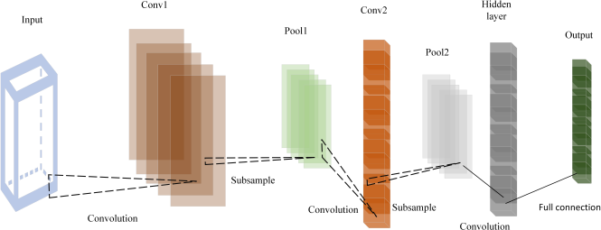

Fig. 1. Layer configuration of convolutional neural network.

Convolutional neural networks (CNN’s) are now a crucial component of many computer vision applications, such as pose estimation, object identification, picture categorization, and face and object recognition. CNN’s are widely used in many different industries, as a social media analysis, medical picture analysis, and autonomous vehicles.

Convolutional Neural Networks (CNN’s) have achieved significant success because they can learn relevant features directly from raw input data without requiring manual feature engineering. This has led to significant improvements in accuracy and speed compared to traditional computer vision techniques, and has made CNN’s an essential tool for analyz- ing visual data. Following are the steps to performed during the training of the CNN model thats includes data collection, data processing, data augmentation, from model selection to training, validation, and testing.

* **Data collection:** A dataset of high-quality yoga pose images is collected. The dataset should contain a variety of poses, and each image should be labeled with the corresponding pose.
* **Data preprocessing:** To enhance the quality of collected images and make them suitable for use as input in the CNN model, the gathered images are preprocessed. This may include resizing the images, normalizing the pixel values, and converting them to grayscale.
* **Data augmentation:** The photos are transformed, by rotating, translating, and scaling. This broadens the dataset’s diversity and improves the model’s generaliz- ability.
* **Model Selection:** Choose a deep learning model archi- tecture that works well for workloads requiring picture categorization. ResNet, Inception, and VGG are a few examples of well-liked models. Also, you can apply transfer learning to customise a previously trained model for your particular purpose.
* **Model training:** The CNN model is trained on the aug- mented dataset. The model should have multiple convolu- tional layers to extract features from the images, followed

by one or more fully connected layers to perform the classification. The model is trained using a loss function such as cross-entropy, and the weights are updated using an optimizer such as stochastic gradient descent.

* **Model validation:** The trained model is evaluated on a separate validation dataset to ensure that it is not overfitting. The accuracy of the model is measured using metrics such as precision, recall, and F1 score.
* **Model testing:** The trained model is tested on a separate test dataset to evaluate its performance on unseen data.
* **Deployment:** The trained model is put to work in the real world. This might entail incorporating it into a mobile app that can instantly detect yoga poses or into a system that analyses yoga videos.
* **Continuous Improvement:** Collect user feedback on the model’s performance and continuously improve the model by retraining it on new data or adjusting its hyperparameters.

PoseNet is a deep learning algorithm that can estimate the human body’s pose and position in an image or video in real-time. It is a neural network-based approach that uses convolutional neural networks (CNN’s) to analyze and extract information from an input image or video frame to identify the different body parts of a person, and then estimates their position in 2D or 3D space.

PoseNet uses a multi-stage architecture, which includes multiple convolutional layers followed by fully connected layers. It can be trained on a large dataset of labeled images or videos, and can be fine-tuned to adapt to specific tasks and scenarios. PoseNet has been used in a variety of applications such as augmented reality, virtual try-on, fitness tracking, and action recognition. It has also been integrated with other computer vision algorithms for object detection and tracking.

* 1. RESULTS AND DISCUSSION

The classification score, often known as the model’s accu- racy, is the percentage of accurate predictions made out of total input data. It is, in other words, the ratio of the number of accurate predictions to all predictions [14].

*A. Result parameters*

The accuracy parameter refers to the measure of how well the model performs in correctly predicting the classes of the input data. Accuracy is calculated by dividing the number of correct predictions by the total number of predictions made by the model.

Number of correct predictions

*Accuracy* = Total number of predictions made (1)

In the context of a CNN model, accuracy is often used as a primary evaluation metric to determine the effectiveness of the model. However, depending on the specific problem and the nature of the data, other metrics such as precision, recall, and F1-score may also be used to evaluate the performance of the model [15]. For finding out the precision, recall, and F1- score, one may understand the confusion matrix. Confusion

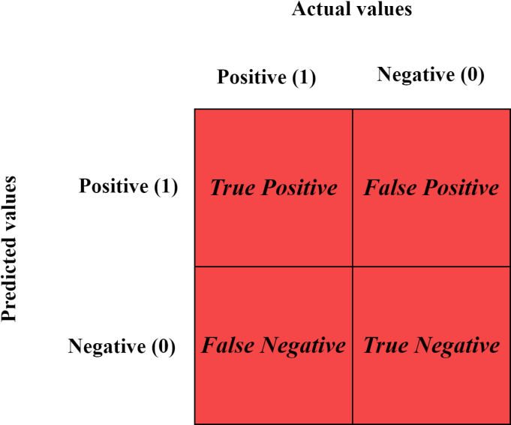

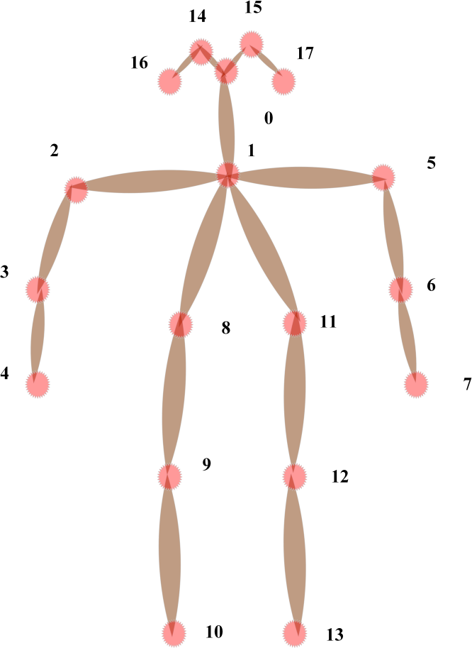Fig. 2. Layer configuration of convolutional neural network.

matrix is a matrix that fully reveals how accurate the model is, when evaluating a model’s performance. There are four essential terms to findout the further calculations.

* True Positive: The anticipated value and the actual result are both 1.
* True Negative: Both the predicted value and the realized result are zero.
* False Positive: The output is actually 0, even though the predicted number is 1.
* False Negative: Although the result is 1, the predicted value is 0.

The result of proposed model is compared with the existing work, which is represented in Table II.

The PoseNet model’s 0.99 training accuracy score is quite good. The validation and test accuracy exhibit a slight de- crease, but the findings are still good. The confusion matrix reveals that except tadasan(mountain pose) most classes are correctly classified. Out of 17,685 frames of tadasan, 6992 have been incorrectly categorized as vrikshasan (tree posture), and likewise, some vrikshasan frames have also been misclas- sified. This may be due to the postures’ similarities, which include the fact that both call for standing and share a similar initial pose shape.

Fig. 3. Confusion matrix layout.

TABLE II

EXISTING WORK IN YOGA POSE INDENTIFICATIONS WITH DATA SIZE AND ACHIEVED ACCURACY.

|  |  |  |  |  |
| --- | --- | --- | --- | --- |
| Reference | Year | Data size | Image/Video | Accuracy(%) |
| [1] | 2022 | 1032 | images | 92.3 |
| [2] | 2019 | 458 | videos | 91.9 |
| [3] | 2021 | 5000 | images | 96.2 |
| [4] | 2020 | 2301 | images | 94 |
| [5] | 2021 | 179 | videos | 97.5 |
| [6] | 2020 | 1105 | images | 90.4 |
| [7] | 2021 | 2000 | images | 92.16 |
| [8] | 2021 | 1000 | videos | 94.27 |
| [9] | 2018 | 298 | videos | 83.6 |
| [10] | 2014 | 1903 | images | 97.35 |
| [11] | 2021 | 3457 | images | 93.2 |
| [12] | 2021 | 2356 | images | 92.1 |
| [13] | 2015 | 321 | videos | 82.3 |

On the PoseNet key points, a one-dimensional, one-layer CNN with 16 filters of size 3×3 is trained. The 18 key points with X and Y coordinates are represented by the input shape of 18 x 2, which is, in order to speed up the convergence of the model, batch normalization is performed to the CNN layer’s output. Additionally, we include a dropout layer that avoids overfitting by erratically removing a portion of the weights. Rectified Linear Unit (ReLU) is the activation function that is utilized for feature extraction on each frame’s keyframes. The output of the preceding layer is flattened before being passed to the final dense layer with 6 units and softmax activation. Each unit in the final dense layer represents the probability or likelihood of a particular yoga posture in terms of cross- entropy for all six classes Categorical cross-entropy, often known as softmax loss, is the loss function used to build the model. This is done so that the output of the densely connected layer’s softmax activation may be measured. With numerous classes of yoga poses, categorical cross- entropy makes sense as the loss function for multiclass classification. The Adam

correctly, with the exception of a few vrikshasana samples that are incorrectly categorized as tadasana, yielding a vrikshasana accuracy of 93%. CNN makes less classification errors than SVM does. Despite some overfitting, the model’s loss curve reveals an increase in the validation loss and a decrease in training loss.

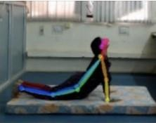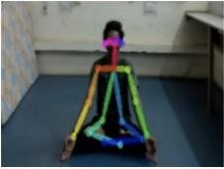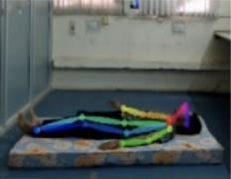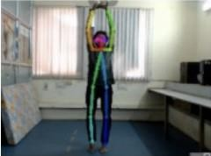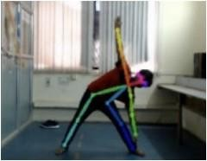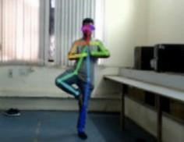

Fig. 4. Yoga poses. (a) Bhujan asan. (b) Padma asan. (c) Shav asan. (d) Tad asan. (e) Trikon asan. (f) Vriksh asan.

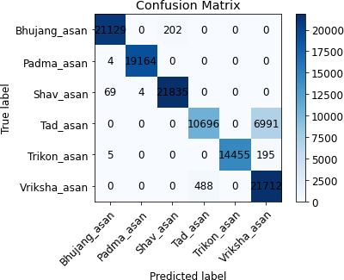

Fig. 5. Confusion matrix layout.

optimizer is then employed to control the learning rate, with an initial learning rate of 0.0001. The model has been trained over a total of 100 epochs.

The accuracy of the model during training, validation, and testing is almost identical, at 0.99. The confusion matrix also demonstrates how well the model categorizes all the data

* 1. CONCLUSION

In conclusion, the research paper on posture detection using deep learning presents a promising approach to accurately detecting and analyzing body posture. The study demon- strated that deep learning techniques, specifically CNN, can effectively classify different postures with high accuracy and precision. The proposed methodology has several potential applications in various fields, including healthcare, sports, occupational safety, virtual reality, and fitness tracking. The research findings also highlight the importance of using large and diverse datasets for training the model to improve accuracy and reduce bias. The study identified the limitations of using a small dataset and emphasized the need for larger datasets to increase the generalizability of the model. Overall, the research paper on posture detection using deep learning provides valu- able insights into the potential benefits and limitations of using deep learning for posture detection. The study contributes to the growing body of research on deep learning techniques for posture detection and provides a basis for future research and development in this field.

**Future work** Posture detection using CNN has several future scope, including:

1. Real-time monitoring: One potential future application of posture detection using CNN is the development of real-time monitoring systems. Real-time posture detec- tion systems could provide immediate feedback to users and help them correct their posture in real-time, reducing the risk of injury and promoting better overall health.
2. Wearable technology: Posture detection using CNN could be implemented in wearables like smartwatches or fitness trackers as wearable technology gets smaller and more sophisticated. This would enable users to keep track of their posture throughout the day, giving them insightful information about their patterns and gradually encouraging better posture.
3. Advanced data analytics: As the field of data analytics continues to advance, posture detection using CNN could benefit from the development of advanced algo- rithms that can process large amounts of data in real- time. This could enable more accurate posture detection and analysis, leading to more personalized treatment plans and better health outcomes.
4. Augmented reality: Posture detection using CNN could be integrated into augmented reality applications, pro- viding users with a more immersive experience. For example, virtual reality applications could use posture detection to adjust the user’s environment based on

TABLE III

PRECISION, RECALL, AND F1-SCORE EVALUATED DURING SIMULATION.

|  |  |  |  |  |  |  |
| --- | --- | --- | --- | --- | --- | --- |
| Asan | ’Bhujang asan’ | ’Padma asan’ | ’Shav asan’ | ’Tad asan’ | ’Trikon asan’ | ’Vriksha asan’ |
| Precision | 0.9963 | 0.9998 | 0.9908 | 0.9564 | 1 | 0.7513 |
| Recall | 0.9905 | 0.9998 | 0.9967 | 0.6047 | 0.9864 | 0.978 |
| F1 score | 0.9934 | 0.9998 | 0.9937 | 0.741 | 0.9931 | 0.8498 |

their posture, providing a more engaging and realistic experience.

1. Human-robot interaction: Posture detection using CNN could also be used in human-robot interaction sys- tems. By detecting and analyzing human posture, robots could adapt to human movements and provide more personalized assistance, such as helping individuals with disabilities to perform daily tasks.

REFERENCES

1. Garg, Shubham, Aman Saxena, and Richa Gupta. ”Yoga pose classi- fication: a CNN and MediaPipe inspired deep learning approach for real-world application.” Journal of Ambient Intelligence and Humanized Computing (2022): 1-12.)
2. Lei, Qing, et al. ”A survey of vision-based human action evaluation methods.” Sensors 19.19 (2019)
3. Sharma, Vijeta, et al. ”Video processing using deep learning techniques: A systematic literature review.” IEEE Access 9 (2021): 139489-139507.
4. Kothari, Shruti. ”Yoga Pose Classification Using Deep Learning.” (2020).
5. Shrestha, Bikash. ”Pranayama Breathing Detection with Deep Learning.” (2021).
6. Chen, Yucheng, Yingli Tian, and Mingyi He. ”Monocular human pose estimation: A survey of deep learning-based methods.” Computer Vision and Image Understanding 192 (2020): 102897.
7. Badashah, Syed Jahangir, et al. ”Fractional-Harris hawks optimization- based generative adversarial network for osteosarcoma detection using Renyi entropy-hybrid fusion.” International Journal of Intelligent Sys- tems 36.10 (2021): 6007-6031.
8. Jamieson, Alexander. ”Development of a clinically-targeted human activity recognition system to aid the prosthetic rehabilitation of in- dividuals with lower limb amputation in free living conditions.” (2021).
9. Goswami, Gaurav, et al. ”Unravelling robustness of deep learning based face recognition against adversarial attacks.” Proceedings of the AAAI Conference on Artificial Intelligence. Vol. 32. No. 1. 2018.
10. Goswami, Gaurav, et al. ”MDLFace: Memorability augmented deep learning for video face recognition.” IEEE international joint conference on biometrics. IEEE, 2014.
11. Patel, Manisha, and Nilesh Kalani. ”A survey on Pose Estimation using Deep Convolutional Neural Networks.” IOP Conference Series: Materials Science and Engineering. Vol. 1042. No. 1. IOP Publishing, 2021.
12. Teoh, K. H., et al. ”Face recognition and identification using deep learning approach.” Journal of Physics: Conference Series. Vol. 1755. No. 1. IOP Publishing, 2021.
13. Kendall, Alex, Matthew Grimes, and Roberto Cipolla. ”Posenet: A convolutional network for real-time 6-dof camera relocalization.” Pro- ceedings of the IEEE international conference on computer vision. 2015.
14. Garg, K., Chauhan, N. and Agrawal, R. Optimized Resource Allocation for Fog Network using Neuro-fuzzy Offloading Approach. Arab J Sci Eng 47, 10333–10346 (2022).
15. Chauhan, N., Agrawal, R. Probabilistic Optimized Kernel Naive Bayesian Cloud Resource Allocation System. Wireless Pers Commun 124, 2853–2872 (2022).