**Domination – Install DB HowTo**

This simple readme is based on the free mysql DB mariadb.

**1**. Download the needed files:

- mariadb from <https://mariadb.org/>

- extDB3 from <https://github.com/SteezCram/extDB3>

**2**. Install mariadb (and don’t forget to install the HeidiSQL tool from mariadb too) and install @extDB3 into your Arma 3 server folder (don’t forget to copy the tbbmalloc dll files, both, from your extDB3 download to the A3 server folder or A3 game folder for a host).

**3**. Once mariaDB is installed open HeidiSQL and connect as root to the database (root password is set during mariaDB installation).

Choose File->Execute SQL and select the Domination.sql file which you can find inside the Domination 7z File (I hope it is File->Execute SQL as I only have the german version of HeidiSQL)

This should create the Domination database.

Now open the user management in Tools (still HeidiSQL) and create a new user. It’s up to you how you name this new user. Just make sure that you add the Domination object (green button on the right, new object?) and give the user the following rights:

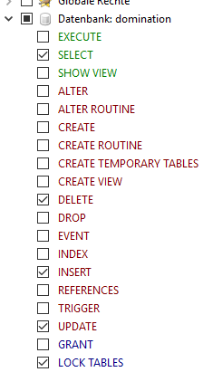

**4**. Copy the domination-custom.ini file from the Domination 7z download @extDB3\sql_custom folder to the @extDB3\sql_custom folder in your Arma 3 directory.

**5.** Do the same with the extDB3-conf.ini file from the Domination 7z download @extDB3 folder. Copy it to the @extDB3 folder in your Arma 3 server directory.

**6.** Open extdb3-conf.ini in the Arma 3 @extDB3 folder with a text editor and add the Domination user and the password for the Domination user (the ones from mariaDB that you set with HeidiSQL. Don’t use your root user and password.

**7**. Now start your server with -servermod=@extDB3 and DB support should work as soon as you start the mission.

The first run of the mission will add all available Params from the mission to the dom_params2 table. You are now able to change all params directly in the database dom_params2 table. Please don’t forget that the values in dom_params2 table will always overwrite the params a logged in admin may choose in the server lobby or changes you’ve made to description.ext!!!

P.S.: I’m a programmer not a documentation writer ☺