**“Community voting screenshots shared in a few selected telegram channels”**

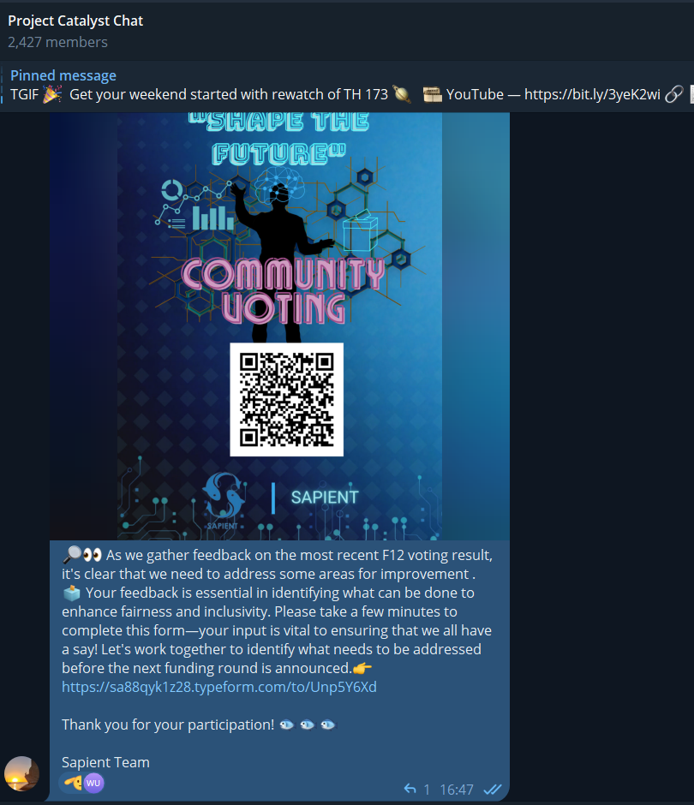

**“Our team's liaison and communication efforts with the Catalyst team”**

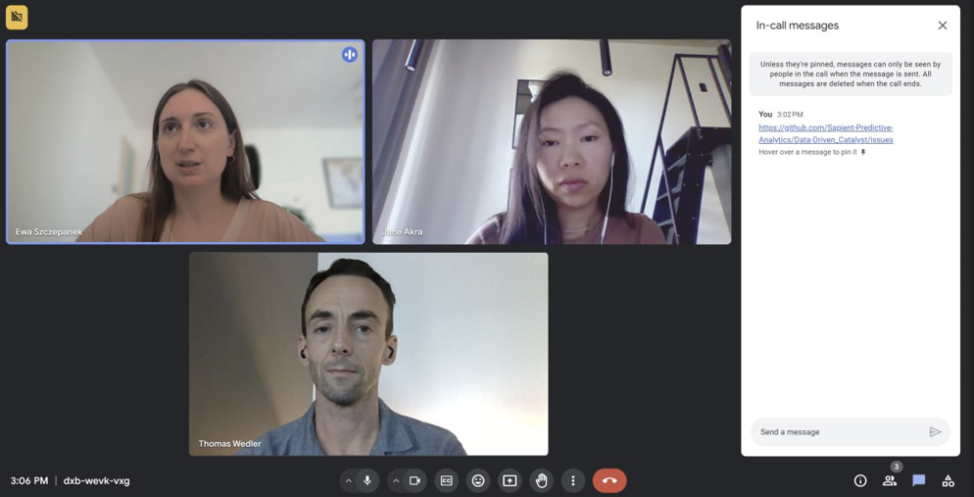

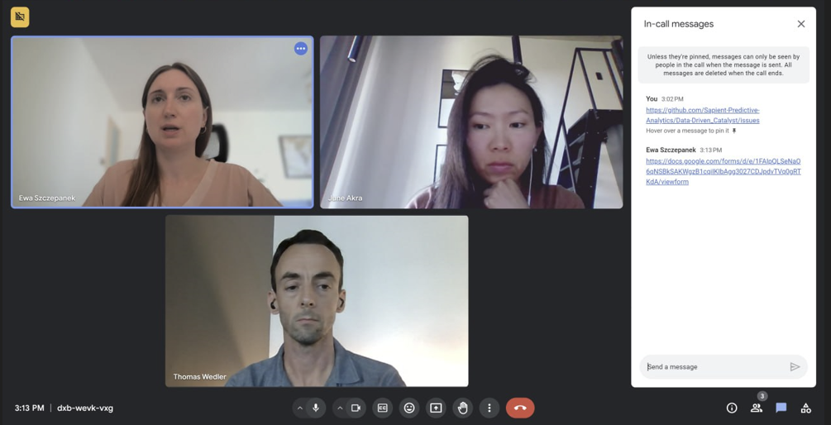

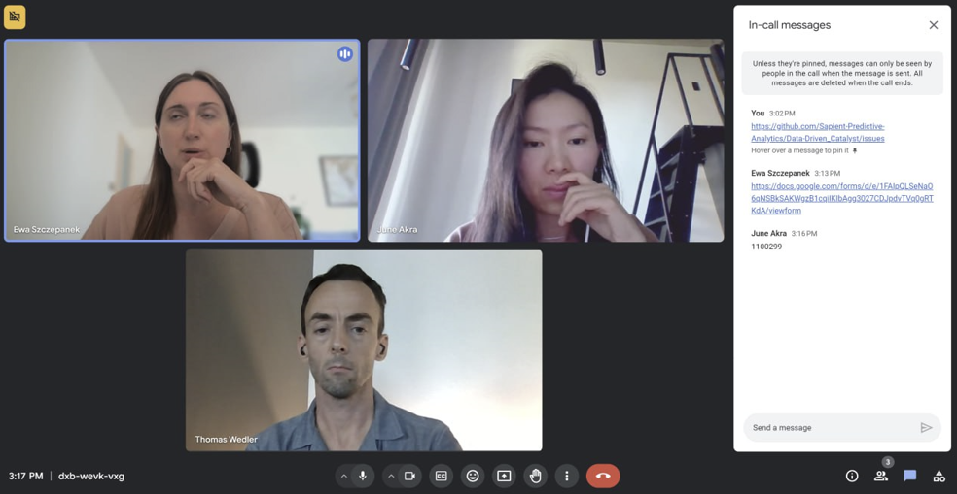

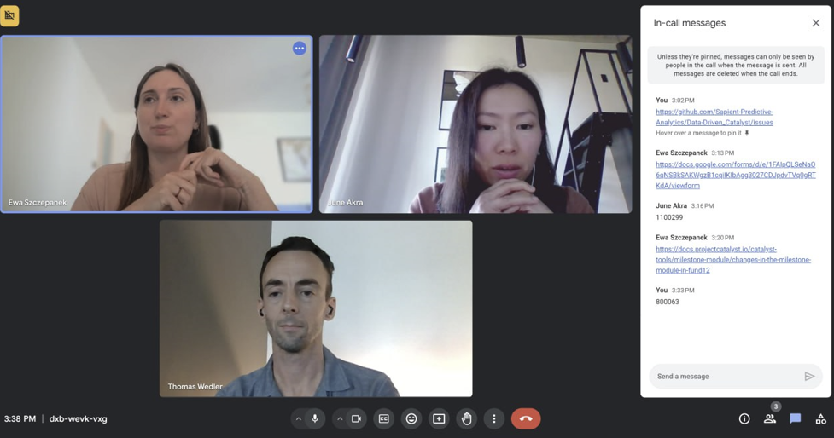

**“Data-Processing of Milestone Module: Reading as JSON, tokenization, insight (requested by Yuta)”**

