The given code is a simple calculator program using the Tkinter library in Python. It creates a GUI calculator with buttons for numeric digits, operators, and functions. The calculator allows users to input mathematical expressions and displays the result.
Here is the sequence diagram for the calculator program:
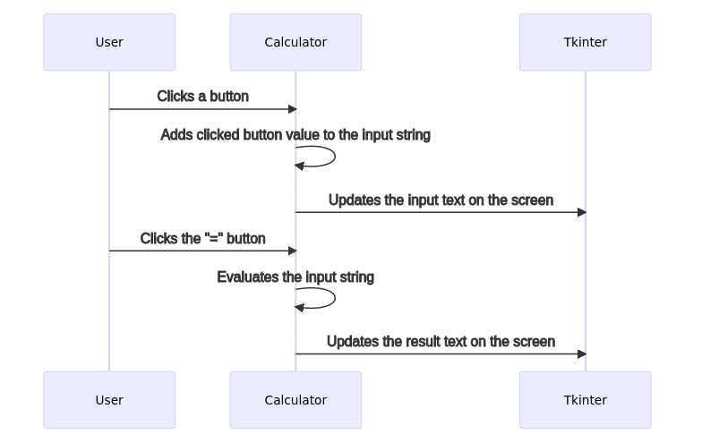

And here is the flowchart for the calculator program:
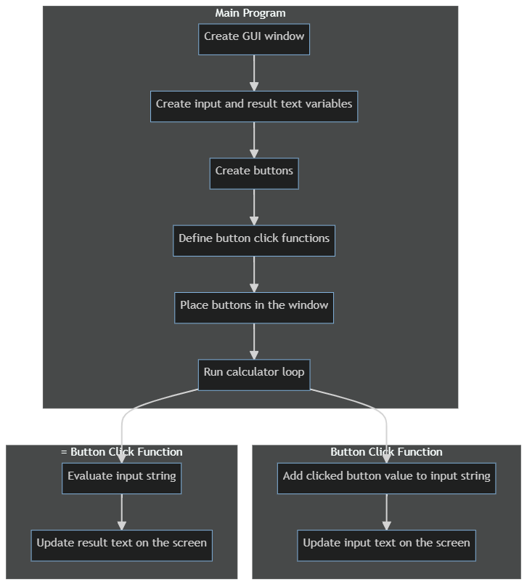

This is the documentation for the given calculator program. It uses the Tkinter library to create a GUI calculator with buttons for input and calculation. The program allows users to input mathematical expressions and displays the result on the screen. The calculator has buttons for numeric digits, operators, and functions such as square root and logarithm. Users can click the buttons to enter the desired input and click the “=” button to perform the calculation. The program handles any errors in the input and displays an error message if necessary. Users can also click the “C” button to clear the input and result. The calculator program is designed to be user-friendly and easy to use.

