How EU ETS and CBAM Can Strengthen Europe's Long-Term Green Manufacturing Economy: The Case of Germany
Iron and Steel Supply for German Manufacturing
Submitted by
Kanokphan Sirithienthong 6610750092
Phurin Meechanchuang 6610754250
Nathorn Apichaikriengkrai 6610750190
Monprach Pattamakeansai 6610750459
Presented to
Assoc. Prof. Attasuda Lerskullawat, Ph.D.
International Trade Policy 01101441
Department of Economics, Faculty of Economics
Kasetsart University
First Semester, Academic Year 2026

Abstract
This report describes how the European Union Emissions Trading System (EU ETS) and Carbon Border Adjustment Mechanism (CBAM) can influence cleaner steel supply for German manufacturing. It explains policy design and relates international trade theory to observed manufacturing, production and trade indicators. The main analysis uses Eurostat manufacturing data for 1995 to 2025, matched direct extra-EU trade for 1999 to 2025, German Steel Federation statistics and company announcements. Selected origin-based, energy-cost, emissions-proxy and provisional 2026 indicators are drawn from the sources listed in Section 1.3, with their source boundaries identified. Policy information is assessed as of 2 November 2026.
The evidence shows adjustment pressures alongside commitments to lower-emission production. Direct extra-EU Chapter 72 import tonnage fell 56.2% between 2019 and 2025, while export tonnage also declined. Germany's rolled-steel market supply fell from 40.8 million tonnes in 2017 to 29.1 million tonnes in 2025, although it increased from 2024. These outcomes do not establish that carbon policy caused the changes or that a demand curve shifted. Company agreements demonstrate procurement and investment commitments, with commissioning, financing and hydrogen availability remaining important conditions.
The policies can improve carbon-cost alignment and incentives for cleaner production, but the report does not establish a net German GDP or welfare gain. It recommends retaining a predictable framework while improving emissions verification, clean-energy infrastructure, additionality of public support and monitoring of downstream and regional outcomes. Any slower withdrawal of free allocation should be conditional and reviewed. Theoretical illustrations, observed graphs, full data tables and calculation rules are provided to make the reported outcomes traceable.

Table of Contents
Chapter 1 Introduction and Details of the Policy 5
1.1 Background and significance 5
1.2 Objectives 5
1.3 Scope, data and method 6
1.4 EU ETS: legal framework and operation 6
1.5 CBAM: coverage, obligations and pricing 7
1.6 Policy timeline and related measures 8
1.7 Economic rationale and supporting policies 10
Chapter 2 Economic Evidence and Discussion 12
2.1 Theoretical channels and interpretation of graphs 12
2.2 German manufacturing trends 15
2.3 Steel production and market use 16
2.4 Exports, imports and trade balances 18
2.5 Cleaner-material investment and company cases 21
2.6 GDP components, fiscal revenue and employment 24
2.7 Overall assessment and limitations 26
Chapter 3 Conclusion and Suggestions 28
3.1 Conclusion 28
3.2 Suggestions 28
3.3 Monitoring and future assessment 30
References 32
Appendix A Manufacturing Data 36
Appendix B Matched Trade Data and Calculations 38
Appendix C Chart Generating Code 40
List of Figures
Figure 2.1 Negative production externality and carbon pricing (illustration) 12
Figure 2.2 Carbon-related import cost and partial pass-through (illustration) 13
Figure 2.3 German manufacturing real GVA and production, 1995 to 2025 15
Figure 2.4 German crude-steel production and rolled-steel market supply, 2012 to 2025 16
Figure 2.5 Direct extra-EU Chapter 72 exports and imports, 1999 to 2025 18
Figure 2.6 Direct extra-EU Chapter 72 trade values and unit value, 2017 to 2025 19

Chapter 1

Introduction and Details of the Policy

1.1 Background and significance
Germany is an important manufacturing location within the European Union, and steel connects its upstream industrial base with automotive production, machinery, construction and other activities. Manufacturing accounted for 19.9% of German gross value added (GVA) in 2024 and 19.4% in 2025; the comparable EU27 share was 15.9% in 2024. These are shares of GVA, not GDP. On a different measure, Germany generated 26% of the EU's value of sold industrial production in 2025, the largest national share. The sold-production measure is not interchangeable with manufacturing GVA (Eurostat, 2026a, 2026e).
The importance of steel does not mean that all manufacturing outcomes can be explained by steel policy. Germany produced 34.1 million tonnes of crude steel in 2025 in the German Steel Federation's 2026 publication. Steel producers face changing energy costs, demand and international competition while investing in lower-emission processes. The same carbon policies can support cleaner upstream production and impose adjustment costs on importers or downstream users. This makes Germany a useful country case for examining environmental protection and international trade together (Wirtschaftsvereinigung Stahl, 2026).
The title's phrase 'can strengthen' is conditional. The report describes mechanisms and observed evidence relevant to a long-term green manufacturing economy. It does not assume that a positive net effect has already occurred. Germany remains the country case and iron and steel remain the product focus. Other EU countries are discussed as supplier locations and company examples, not as additional national case studies.

1.2 Objectives
The objectives are to explain the two policies, describe production and trade developments, compare theoretical mechanisms with observed indicators, and propose practical conditions for future implementation.
The report addresses exports (X), imports (M), net exports (NX), the balance of payments (BOP), quantity (Q), price (P), GDP, fiscal revenue, consumption (C), investment (I) and government expenditure (G). It uses steel-specific observations where available and clearly labels whole-economy context or data gaps elsewhere. It does not treat a national indicator as a measured steel-policy effect.

1.3 Scope, data and method
The analysis is descriptive. The main manufacturing series covers 1995 to 2025, beginning before the ETS launch in 2005, and the matched annual trade series covers 1999 to 2025. A separate 2026 update compares the same months of 2025 and 2026 and retains provisional status; it is not spliced into the full-year graphs. Policy and company developments are included up to 2 November 2026. No regression or estimated treatment effect is produced.
Eurostat provides real manufacturing GVA, the industrial production index, GVA shares and national-accounts expenditure growth. The trade dataset is Comext DS-045409: Germany as reporter, HS Chapter 72, both imports and exports, and the fixed extra-EU27 (2020 composition) partner aggregate. Monetary values and net mass are kept separate. The German Steel Federation supplies crude-steel output, rolled-steel market supply and steel-mill-product trade with all partners. These series have different product and partner boundaries and are not combined into one balance (Eurostat, 2026a to d; Wirtschaftsvereinigung Stahl, 2026).
Three supplementary indicators come from sources other than the Eurostat and WV Stahl extracts: an origin-based Chapter 72 compilation (Destatis, n.d.), selected SMARD industrial electricity prices (Bundesnetzagentur, 2026) and an ETS-derived emissions-intensity proxy (UBA/DEHSt, 2026). Each is shown with its stated period and definition. Directly recorded extra-EU flows are reproduced from Eurostat (2026c).
For each graph, the report identifies the dataset, definition, period and calculation. Policy dates are annotations. A change in quantity, price or trade value is treated as an observation, while a shift of demand or supply cannot be read from quantities alone. The complete manufacturing and matched trade observations appear in Appendices A and B.

1.4 EU ETS: legal framework and operation
The EU ETS began in 2005 and operates through a declining emissions cap and tradable allowances. Covered installations must monitor emissions and surrender allowances. Firms can reduce emissions, acquire allowances or use eligible holdings. The allowance price is determined in the carbon market, including auctions and trading; it is not a fixed German steel tax. The first pilot period relied predominantly on free allocation, and later phases changed the system's design (European Commission, n.d.-a).
Free allocation is important for trade-exposed activities, but it is not an exemption from monitoring or surrender obligations. Allocation is linked to rules and benchmarks, not to an unrestricted reimbursement of every firm's emissions. It reduces net allowance-purchase requirements while allowances retain a market value. An installation may therefore still benefit from saving emissions and retaining or selling allowances. An industry-level allocation-to-emissions ratio cannot be interpreted as the percentage of marginal carbon incentive that has disappeared (European Commission, n.d.-a, n.d.-b).
ETS and steel-output decisions must also be distinguished. The system constrains covered emissions; it does not set a quota on tonnes of steel. A plant can respond through efficiency, changes in fuel or material inputs, lower output, investment, or a combination of these. The output response depends on demand, technology and competing suppliers, so the report does not infer a particular German supply-curve shift from the existence of the policy alone.
By 2024, emissions from the electricity and heat-generation and industrial-manufacturing installations covered by EU ETS were about 50% below their adjusted 2005 level. This is an EU-wide, covered-sector emissions result, not a 50% reduction in Germany's steel emissions or proof of a manufacturing-output effect. It provides the wider environmental context for the German case (European Commission, 2025).

1.5 CBAM: coverage, obligations and pricing
CBAM complements domestic carbon pricing by addressing the emissions embedded in covered imports into the EU. Its climate objective is to reduce carbon leakage, including replacement of EU production by more emissions-intensive imports. Coverage is defined by listed customs codes and rules, not simply by a product being called steel. Germany applies the EU framework and does not set an independent national CBAM tariff (European Commission, n.d.-c; European Union, 2023/2025).
Transitional reporting ran from 1 October 2023 through 2025. The definitive regime applies from 1 January 2026. For relevant importers, financial obligations relate to 2026 imports even though certificate purchases begin in February 2027; the first declaration and surrender are due by 30 September 2027. Delayed cash settlement does not establish that firms could not change pricing or sourcing earlier (European Commission, n.d.-d, n.d.-e).
Certificate prices are linked to EU ETS auction prices: quarterly averages for 2026 and weekly prices from 2027. The official 2026 prices available on 2 November are EUR 75.36, 75.28 and 82.32 per tonne of CO2-equivalent for the first three quarters respectively. The fourth-quarter price is scheduled for publication on 4 January 2027. These are prices per tonne of emissions, not a uniform charge per tonne of steel (European Commission, n.d.-e).
The certificate requirement depends on embedded emissions and applicable adjustments, including treatment corresponding to EU free allocation and a recognised carbon price paid abroad. For iron and steel, the applicable calculation boundaries must be used instead of replacing them with a supplier's entire life-cycle footprint. Verified lower emissions may reduce liability, but there is no general exemption merely because a product is marketed as green steel. The mass-based exemption threshold and origin exemptions also mean that aggregate customs tonnage is not the legally liable base (European Commission, n.d.-d, n.d.-f; European Union, 2023/2025).
Table 1.1 Distinguishing the policy instruments.

Instrument | Immediate mechanism | Relevant distinction
EU ETS | Cap and trade for covered emissions | Domestic carbon incentive; allowance price is market determined.
CBAM | Certificates linked to covered import emissions | Import-side complement; not a fixed ad valorem tariff.
Green-production support | Grants or other conditional support | May address financing or cost gaps; not CBAM itself.
Steel trade measure | Tariff-rate quota and out-of-quota duty | Trade defence against overcapacity; separate from carbon accounting.

1.6 Policy timeline and related measures
Table 1.2 Main dates and their interpretation.

Date | Development | Interpretation
2005 | EU ETS launched | Beginning of domestic emissions trading, not a uniform charge on all manufacturers.
July 2021 | CBAM proposed | Expectations may influence decisions before implementation.
October 2023 | CBAM transitional reporting began | Reporting stage; not the definitive certificate-settlement stage.
January 2026 | CBAM definitive regime began | Obligations cover relevant 2026 imports.
July 2026 | Separate steel trade measure applied | Quota and duty changes must not be attributed to CBAM.
February / September 2027 | Certificate sales / first surrender | Purchases and surrender cover the 2026 import year.
2034 / proposed 2038 | Current-law phase-out / proposed extension | Keep adopted law separate from a proposal under negotiation.

Under current law, the CBAM factor for the relevant benchmark-based free allocation is 97.5% in 2026, 51.5% in 2030 and zero in 2034. These are selected milestones, not import-tax rates. The Commission's proposal of 17 July 2026 would slow withdrawal, retaining 15% in 2034 to 2037 and completing it in 2038. The existing schedule and proposed schedule must remain distinguished because the latter is still under legislative consideration (European Parliament, 2026a; Government Offices of Sweden, 2026).
The separate steel trade measure applied from 1 July 2026 and provides an annual duty-free quota of about 18.3 million tonnes, approximately 47% below the 2024 safeguard quotas, with a 50% out-of-quota duty. These trade-defence parameters are not CBAM provisions. Anti-dumping measures, sanctions and other restrictions can also affect sourcing. Low prices or a supplier's nationality do not by themselves establish dumping, low quality or high emissions (Council of the European Union, 2026).
State-aid milestones are separate from the ETS and CBAM start dates. The Commission approved support for Salzgitter on 4 October 2022 and for Thyssenkrupp on 20 July 2023. These dates describe EU approval of German support, not plant commissioning or proof that the full approved amount had already been spent (European Commission, 2022, 2023).

1.7 Economic rationale and supporting policies
The lecture's negative-production-externality framework distinguishes private marginal cost from social marginal cost. Pollution can make the latter higher. A carbon price seeks to bring the environmental cost into firms' decisions, while international trade raises a further question: whether production and emissions move to locations facing weaker constraints. CBAM addresses that import-side comparison. The environmental justification therefore concerns emissions and leakage, not merely reducing imports or protecting a particular producer (Lerskullawat, n.d.-b).
Producer support addresses a different problem. Grants, infrastructure or conditional operating support may help finance new capacity and close a transition cost gap. The production-subsidy model in the lecture can explain a supply response under its assumptions, but an actual capital grant is not automatically equivalent to a uniform per-unit subsidy. Public expenditure should be assessed against additional investment, emissions reductions and opportunity cost, and not treated as a benefit simply because it is large (Lerskullawat, n.d.-a).

Chapter 2

Economic Evidence and Discussion

2.1 Theoretical channels and interpretation of graphs
The two illustrations below connect the lecture framework to carbon policy. Figure 2.1 explains the environmental rationale for intervention, while Figure 2.2 examines the interaction between import prices and domestic production costs. Their equations and assumptions are stated so that the curve positions and calculations can be checked.

2.1.1 Negative production externality and carbon pricing
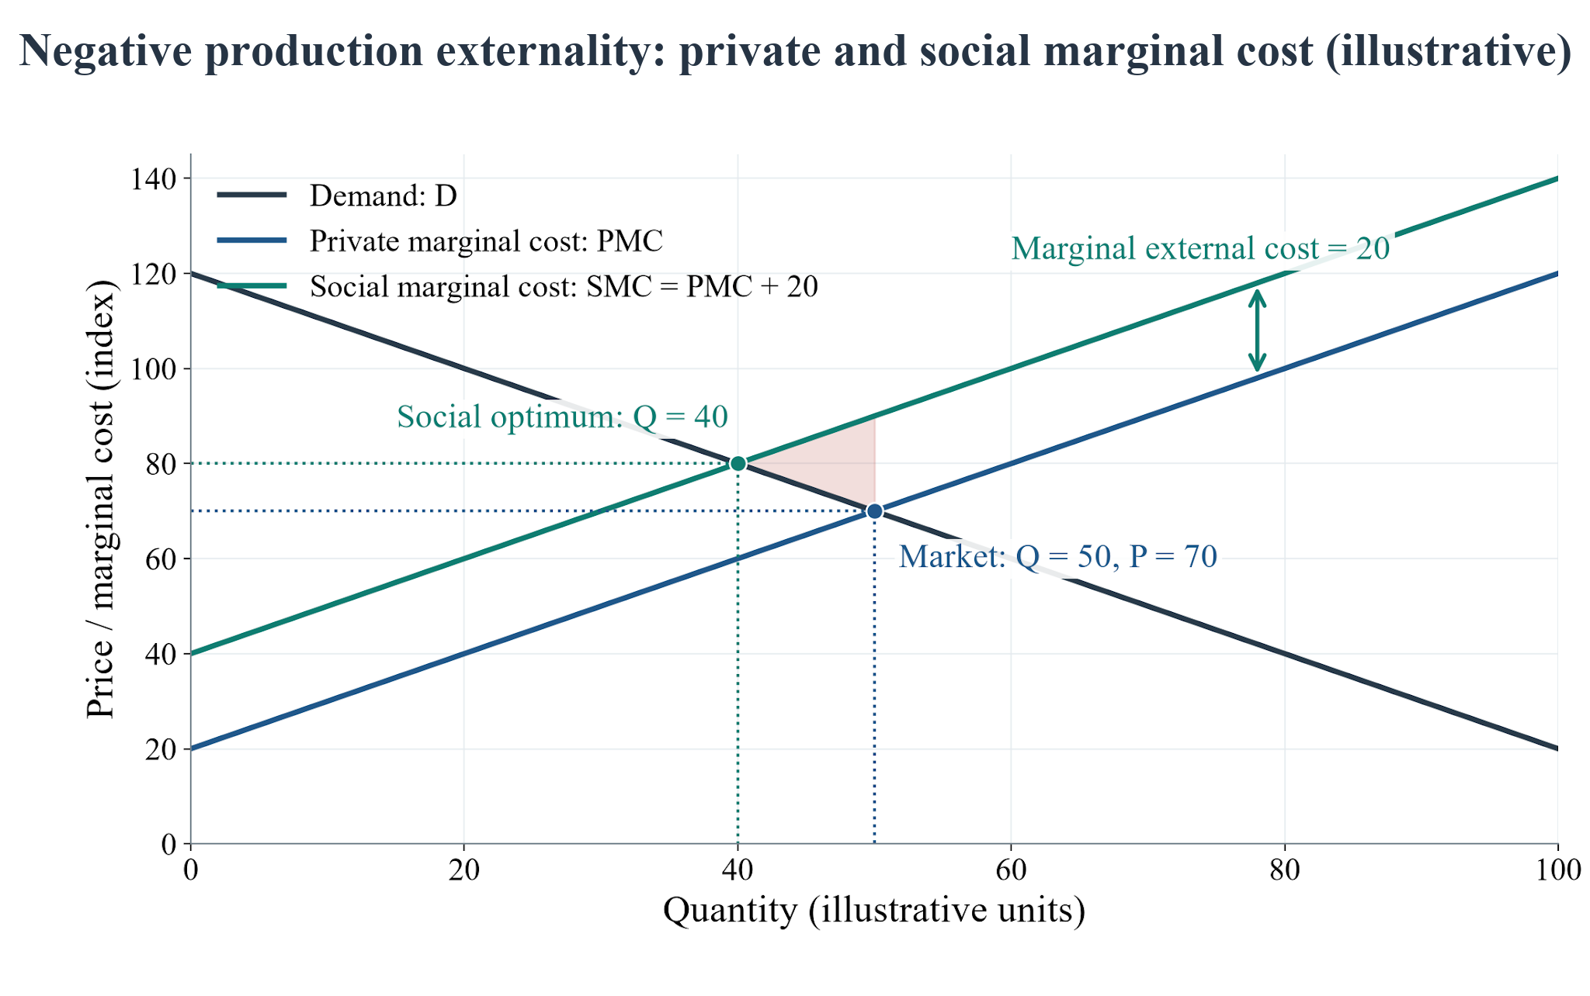
Figure 2.1 Negative production externality: private and social marginal costs. Source: authors' numerical illustration of the externality framework in Lerskullawat (n.d.-b), pp. 15–17. All values are invented; the curves are not estimated from German data.
Suppose inverse demand is P = 120 − Q and private marginal cost is PMC = 20 + Q. The uncorrected market equilibrium satisfies demand = PMC, giving Q = 50 and P = 70. If each additional unit creates an external cost of 20, social marginal cost is SMC = 40 + Q. The social optimum satisfies demand = SMC, giving Q = 40 and a marginal social value of 80. The shaded triangle identifies the excess social cost of units between Q = 40 and Q = 50 in this model.
An ideal corrective charge of 20 would make buyers pay 80 while producers receive 60 at Q = 40. This is an upward cost wedge, with movement along an unchanged demand curve; it is not a leftward demand shift. The figure explains why environmental costs can justify intervention. It does not establish that reducing German steel output is itself desirable: cleaner technology can reduce emissions per tonne without requiring the same output reduction.
EU ETS is a cap-and-trade system; the fixed corrective charge in this illustration is a simplification. Its allowance price is market-determined, and the external damage per tonne has not been estimated here. The illustrative 20 is therefore neither an observed allowance price nor an estimated optimal German carbon tax. Free allocation and the relationship between marginal emissions and production also affect the application to actual firms, as discussed in Chapter 1.

2.1.2 Carbon costs on imports and partial price pass-through
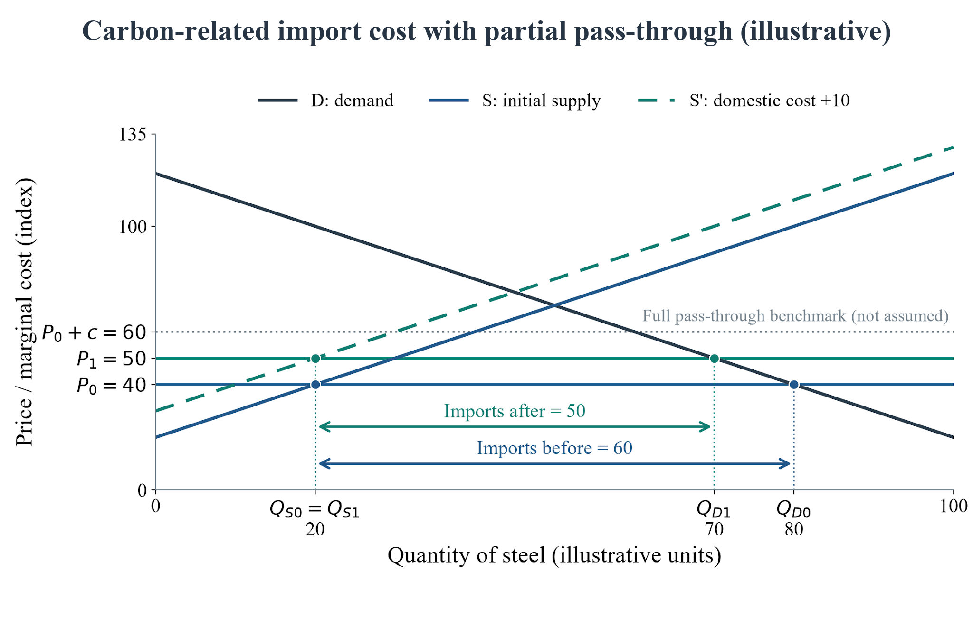
Figure 2.2 Carbon-related import cost with partial price pass-through and a domestic cost increase. Source: authors' simulation using the assumptions stated below. S′ represents the separate domestic-cost assumption. All values are illustrative, not observed German outcomes.
Consider a simplified importing market with inverse demand P = 120 − Q and initial domestic supply P = 20 + Q. At a delivered import price P0 = 40, domestic supply is Qs0 = 20 and use is Qd0 = 80, so imports equal 60. Assume a gross carbon-related import cost c = 20, but only half is reflected in the delivered market price: P1 = P0 + 0.5c = 50. The dotted P0 + c = 60 line is the full-pass-through benchmark, not the outcome assumed. This pass-through rate is imposed for illustration, not estimated from a foreign export-supply model.
The dashed S′ curve additionally assumes that domestic marginal costs rise by 10, giving P = 30 + Q. This could illustrate domestic carbon or energy-cost pressure; CBAM's import charge alone does not cause this domestic supply shift. At P1 = 50, supply remains Qs1 = 20, use falls to Qd1 = 70 and imports fall to 50. The smaller import gap therefore does not imply higher domestic output in this joint scenario. If domestic supply instead remained unchanged, the same P1 would produce Qs1 = 30 and imports of 40. A larger domestic cost increase could lower domestic output.
The diagram separates movement along demand from a shift in supply. Demand itself is held fixed: use falls because the assumed price rises. The imported carbon-cost wedge, domestic cost increase and pass-through rate are model inputs, not measured CBAM effects. Actual certificate liability also requires the legal adjustments described in Chapter 1. The observed trade and production series in Sections 2.2–2.4 are used to assess real developments, . The illustration's arrows are not evidence that those exact changes occurred in Germany.

2.1.3 Relating the models to observed evidence
Carbon pricing changes relative costs. A cleaner route may become more attractive when a more emissions-intensive route faces a larger carbon cost per unit, even without a change in technical product quality. A simple gross-cost relation is carbon price multiplied by emissions per unit of output; actual CBAM calculations require the legal adjustments described in Chapter 1. Relative competitiveness still depends on energy, capital, transport, quality and reliability.
A lower observed quantity could reflect a price change, weaker final demand, inventory adjustment or supply disruption. A future cleaner-steel contract demonstrates a commitment but does not estimate an aggregate demand curve. Figures 2.1–2.2 are therefore theoretical comparisons with explicit assumptions; Figures 2.3–2.6 plot observed indicators. The two forms of graph serve complementary purposes, and a time-series change is not by itself proof of a structural curve shift.
Long-run investment may expand capacity, spread fixed costs or improve technology. However, demand growth for cleaner materials can initially raise their prices if supply is constrained. Hydrogen-based primary steel, scrap-based electric-arc production and conventional blast-furnace production face different input and capital requirements. Scale economies alone do not guarantee cost parity. The offshoring framework also reminds us that higher imported-input costs can reduce benefits for downstream manufacturers even when upstream suppliers gain (Lerskullawat, n.d.-c; International Energy Agency, 2025).

2.2 German manufacturing trends
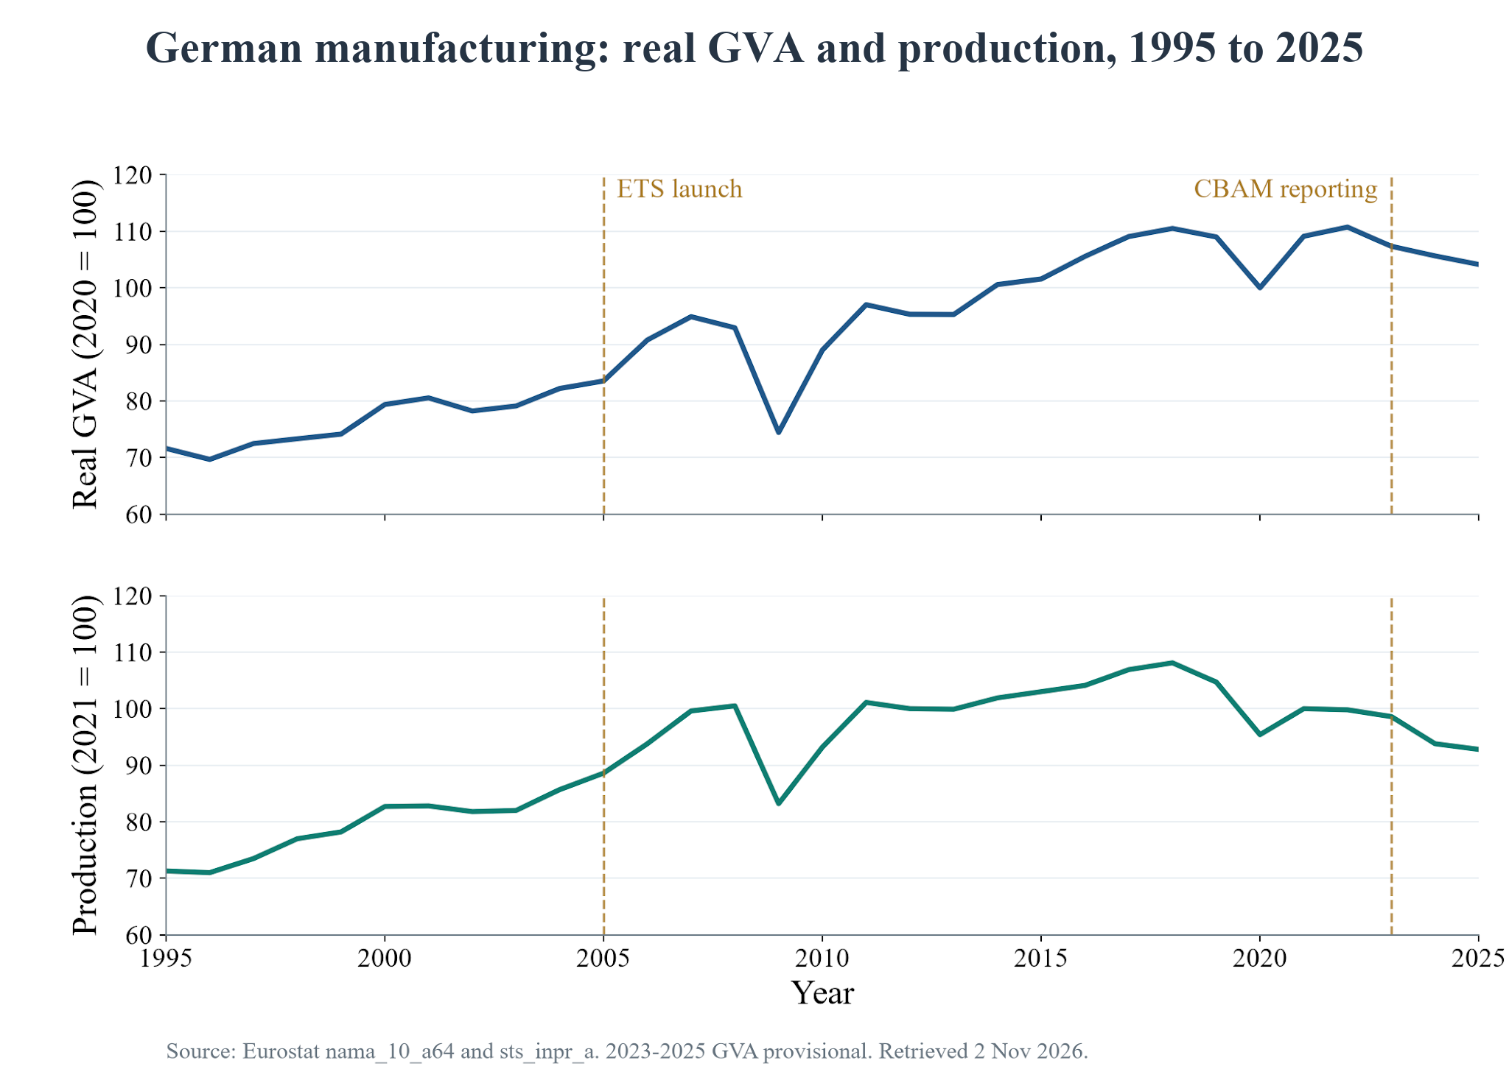
Figure 2.3 German manufacturing real GVA and production, 1995 to 2025. Sources: Eurostat (2026a, 2026b). The two panels have different base years; 2023 to 2025 GVA is provisional. Dashed lines identify policy dates, not causal effects.
Figure 2.3 shows expansion as well as substantial interruptions. Real manufacturing GVA rose from 82.21 in 2004 to 83.54 in 2005, while the production index rose from 85.7 to 88.6. Thus, the launch year does not display an aggregate manufacturing collapse. It also does not prove that ETS had no costs or that it caused growth. The financial crisis in 2009 and pandemic disruption in 2020 are visible examples of other events within the long observation period.
More recently, real GVA declined from 110.74 in 2022 to 104.13 in 2025, approximately 6.0%, and production from 99.8 to 92.8, approximately 7.0%. Manufacturing's current-price share of total GVA fell from 22.3% in 1995 to 19.4% in 2025. A share can change because of prices and developments in other sectors as well as real manufacturing output, so it should not be read as a volume index. Neither series isolates the contribution of ETS or CBAM (Eurostat, 2026a, 2026b).

2.3 Steel production and market use
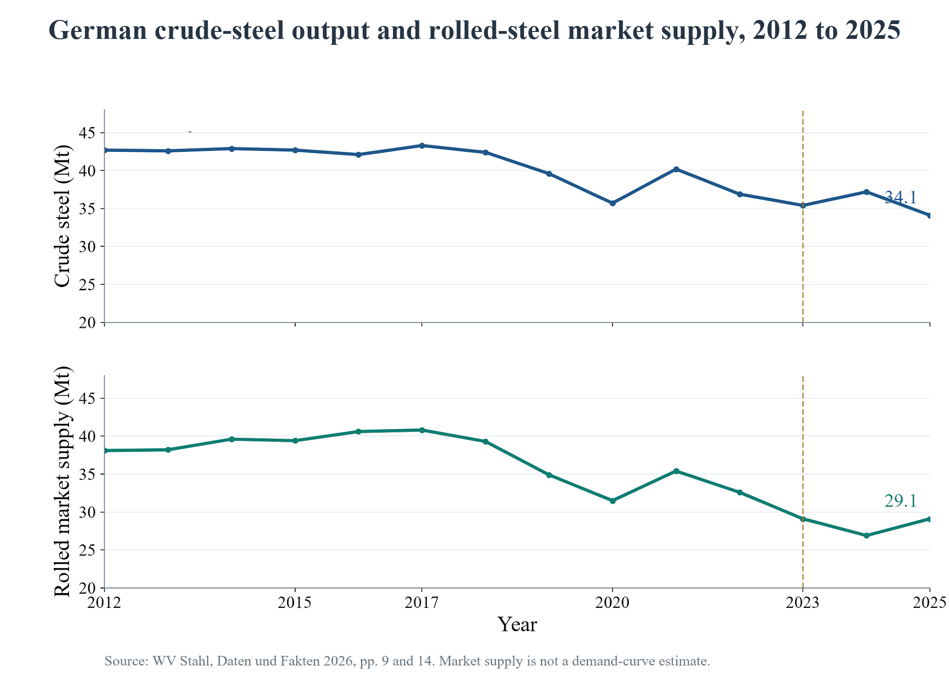
Figure 2.4 German crude-steel production and rolled-steel market supply, 2012 to 2025. Source: Wirtschaftsvereinigung Stahl (2026), pp. 9 and 14. These are different product measures and must not be subtracted to construct a trade balance.
Steel-specific observations show that the broader transition takes place in a weak market. Crude-steel output fell from 43.3 million tonnes in 2017 to 34.1 million tonnes in 2025, a decline of 21.2%. Rolled-steel market supply fell from 40.8 to 29.1 million tonnes over the same period, a decline of 28.7%. However, rolled-steel market supply increased 8.2% between 2024 and 2025, from 26.9 to 29.1 million tonnes. It would therefore be incorrect to describe every recent year as a continued fall (Wirtschaftsvereinigung Stahl, 2026).
Market supply is an observed market-quantity indicator relevant to apparent use, not a direct measure of the position of the demand curve. It can be affected by stocking and destocking as well as final users' activity. The data substantiate the statement that the market was substantially smaller in 2025 than in 2017. They do not establish that CBAM shifted demand left, that ETS caused the contraction, or that buyers rejected German steel because of one particular cost.
The Federation also reports crude-steel energy-related CO2 intensity of 1.59 tonnes per tonne in 1990 and 1.39 in 2025, a reduction of about 12.6% between those endpoints. This indicator includes purchased-electricity emissions and excludes coke ovens in the stated boundary. It is neither an annual post-2005 causal series nor an installation-specific CBAM factor. The two endpoints show long-run improvement in that defined measure, without assigning the improvement to either policy (Wirtschaftsvereinigung Stahl, 2026, p. 20).
A different indicator is an ETS-derived proxy of 0.84 t CO2 per tonne of crude steel in 2013, 0.90 in 2019 and 0.88 in 2025. These selected observations do not show a sustained decline over that period. The 2025 value is reproducible approximately as 30.0 million tonnes of iron-and-steel-sector emissions in the UBA/DEHSt ETS table divided by 34.1 million tonnes of crude steel, giving 0.880. It is a sector-emissions/output proxy, not a product-level embedded-emissions factor. The earlier proxy values come from the same UBA/DEHSt and WV Stahl series; their numerator and output boundaries must be retained before extending the series (UBA/DEHSt, 2026).
The ETS-derived proxy and the Federation's 1.59-to-1.39 measure are not interchangeable. The latter covers a longer period and includes purchased-electricity emissions in its stated energy-related boundary. Long-run improvement between 1990 and 2025 can therefore coexist with the absence of a sustained decline in the selected post-2013 proxy. Neither comparison alone establishes the causal emissions-intensity effect of CBAM.

2.4 Exports, imports and trade balances

2.4.1 Matched direct extra-EU iron-and-steel trade
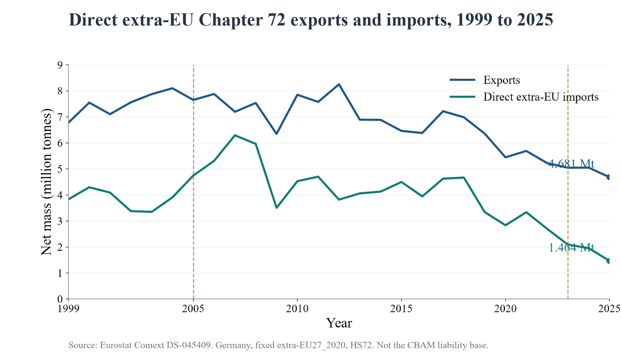
Figure 2.5 Germany: direct extra-EU Chapter 72 exports and imports, 1999 to 2025. Source: Eurostat (2026c). Both flows use the same reporter, product, fixed partner aggregate and net-mass unit. Chapter 72 includes scrap and does not equal CBAM coverage.
Direct extra-EU Chapter 72 imports were 3.342 million tonnes in 2019 and 1.464 million tonnes in 2025, a decrease of 56.2%. Exports to the same partner aggregate also declined, by 26.4%, over that interval. In 2025, exports were 4.681 million tonnes and imports 1.464 million tonnes, giving a physical balance of approximately +3.218 million tonnes. This is a product-specific customs balance and not a measure of national-accounts NX (Eurostat, 2026c).
Exports and imports must be considered together. A positive physical balance can arise while domestic output and both trade flows are weak. It can also reflect changes in customs recording routes or product composition. The import series reached a higher level after the ETS launch, including a 2007 peak, so the long record does not support a simple claim that ETS steadily reduced imports. Annual observations end before the definitive 2026 import year and cannot measure its realised certificate costs.
The fixed extra-EU27 aggregate keeps the partner classification consistent across years; it is not the membership of the EU at each historical date. Direct extra-EU imports also omit non-EU-origin steel first cleared in another Member State and then supplied to Germany. An origin-based series would answer a different question. The direct series must therefore not be presented as all foreign-origin steel used in Germany or as the tonnage on which CBAM certificates are actually owed (Eurostat, n.d.).
The origin-based Chapter 72 compilation (Destatis, n.d.) records non-EU-origin imports of about 6,933 kt in 2017, 4,704 kt in 2022, 4,156 kt in 2024 and 3,919 kt in 2025. Its 2019 starting point is 5,050 kt, implying a decline of approximately 22.4% by 2025, compared with 56.2% for the direct series. Direct extra-EU imports were 8.1% of all import tonnes in 2024 and 6.1% in 2025. These are separate shares and source compilations, not the fraction of German steel use legally liable for CBAM. The smaller origin-based decline shows why the direct series alone does not describe every non-EU-origin supply route (Destatis, n.d.; Eurostat, 2026c).

2.4.2 Trade value and price interpretation
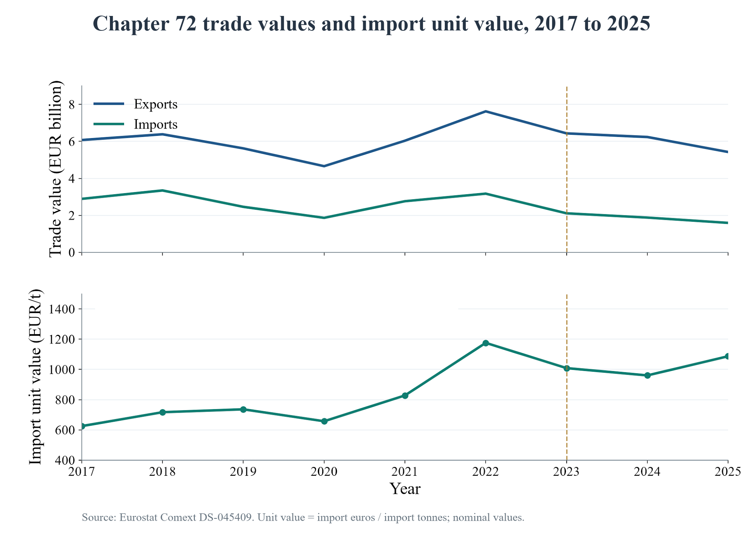
Figure 2.6 Direct extra-EU Chapter 72 nominal trade values and import unit value, 2017 to 2025. Source: Eurostat (2026c). Unit value is total import euros divided by net tonnes, not a fixed-product steel price index.
In 2025 the matched nominal series records exports of EUR 5.428 billion and imports of EUR 1.591 billion, producing a nominal product-specific balance of +EUR 3.837 billion. Import value fell 35.3% between 2019 and 2025, less than the decline in physical imports. The import unit value rose from approximately EUR 736 per tonne in 2019 to EUR 1,176 in 2022 and EUR 1,087 in 2025 (Eurostat, 2026c).
These observations illustrate why nominal value, physical volume and price should be kept distinct. A different mix of scrap, alloy steel, semi-finished goods and flat products can change the average unit value even when comparable product prices do not move proportionately. The report therefore does not interpret the difference between import-value and import-volume growth as a measured CBAM price effect. Comparable product specifications and a suitable price index would be needed for that assessment.

2.4.3 Other trade definitions and the balance of payments
For steel-mill products with all partners, the Federation publishes 2025 exports of 22.4 million tonnes, imports of 20.5 million tonnes and a physical balance of +1.9 million tonnes. The published balance narrowed from +4.2 million tonnes in 2024. These observations are consistent with the wider steel-trade context but differ from the direct extra-EU Chapter 72 figures because both the product and partner boundaries differ. Published balances may also differ slightly from subtraction of rounded components (Wirtschaftsvereinigung Stahl, 2026, p. 30).
Using the rounded origin-based import figure of 3.919 million tonnes and the 4.681 million-tonne Chapter 72 export figure gives approximately +0.762 million tonnes, or +0.8 million tonnes. This gives the origin-based balance alongside the direct-recorded balance of about +3.2 million tonnes. The two are alternative trade-recording views; their difference must not be interpreted as a policy gain or combined with the +1.9 million-tonne steel-mill-products balance (Destatis, n.d.; Eurostat, 2026c).
The balance of payments records more than merchandise trade. Its current account includes goods, services and primary and secondary income. Germany's current-account surplus of about EUR 203 billion in 2025 is whole-economy context, not the steel trade balance or a measured CBAM outcome. Similarly, the GDP identity uses exports and imports of goods and services on national-accounts definitions. Neither the +3.218 million-tonne direct balance nor the +1.9 million-tonne all-partner balance can be inserted into that identity as a euro value (Deutsche Bundesbank, 2026).

2.4.4 Provisional 2026 trade and electricity-cost context
For January–August, directly recorded extra-EU Chapter 72 imports increased from 1,028.426 kt in 2025 to 1,108.089 kt in 2026, or 7.7%, while import value declined about 0.7%. Export tonnage fell from 3,371.594 kt to 2,821.872 kt, or approximately 16.3%. These monthly observations match the rounded direct-trade totals in the Eurostat extract. The import rebound is relevant counter-context to the longer annual decline; it does not identify the effect of the definitive CBAM regime (Eurostat, 2026c, monthly extract updated 16 October 2026).
Relative to the same months of 2025, the origin-based series shows a 6.1% increase in imports for January–July 2026 and, for January–August, increases of approximately 5% in all-partner export tonnes and 2% in all-partner import tonnes. These are provisional observations with different partner definitions and, for the origin series, a different end month. They are kept separate from the reproduced direct Eurostat totals and from full-year 2025 comparisons (Destatis, n.d.; Eurostat, 2026c).
The SMARD industrial electricity-price series is 17.1 ct/kWh in 2020 and 35.9 ct/kWh in 2022, followed by 16.1 in 2024 and 16.5 in 2025; it shows 17.3 ct/kWh for January–September 2026. This provides the energy-cost context for this section. Because SMARD does not state the consumption band, contract population or tax treatment, these figures are attributed to SMARD (Bundesnetzagentur, 2026) and not treated as a verified price paid by every steel plant. Neither their movement nor the trade changes isolate an ETS or CBAM price effect

2.5 Cleaner-material investment and company cases

2.5.1 Thyssenkrupp Steel and Volkswagen
Volkswagen and Thyssenkrupp Steel announced a memorandum of understanding on 22 October 2024 for planned lower-carbon steel supply. That announcement envisaged plant commissioning from 2027 and supplies from 2028, initially with natural gas before a progressive transition toward hydrogen. These dates describe the announcement's plan, not verified commissioning or deliveries. The case demonstrates a buyer-producer commitment to a different primary-steel route without proving that CBAM alone caused it (Volkswagen Group, 2024).
Product terminology also matters. Thyssenkrupp's bluemint family includes routes involving specially processed scrap; it should not all be described as hydrogen-based DRI steel. Current lower-emission products, planned hydrogen-capable capacity and fully realised near-zero-emission output are different stages of the transition. A future-supply agreement cannot establish cost parity or the volume actually delivered (Thyssenkrupp Steel, 2021).
The scale of financing is substantial. In July 2023, the Commission approved a EUR 550 million direct grant and a conditional payment mechanism of up to EUR 1.45 billion for Thyssenkrupp, together up to EUR 2 billion. Thyssenkrupp's April 2024 announcement described investment of around EUR 3 billion in the Duisburg direct-reduction plant. The aid ceiling and announced project investment are different quantities and are not evidence that those amounts had already been paid or that current costs are unchanged (European Commission, 2023; Thyssenkrupp AG, 2024).

2.5.2 Salzgitter SALCOS and EWE
Salzgitter's SALCOS programme combines direct reduction and electric-arc processing. Its current programme page schedules the new route for the first half of 2027, while the Group already offers lower-carbon products from existing electric-arc production. The report therefore does not claim that all low-carbon steel capacity begins only in 2027 (Salzgitter AG, n.d.).
On 9 June 2026 Salzgitter and EWE announced a green-hydrogen supply contract for about 10,000 tonnes annually, initially for seven years and covering around 6.5% of SALCOS hydrogen requirements. Crucially, the announcement schedules these EWE deliveries from 2030 through the hydrogen core network. The steel project's planned 2027 start and the EWE supply date are not the same milestone. The contract is evidence of infrastructure and procurement planning, with much of the programme's hydrogen requirement still requiring other supply arrangements (Salzgitter AG, 2026).
Public support is a separate part of the investment setting. The German federal and Lower Saxony governments increased first-stage SALCOS support by approximately EUR 322 million in February 2026, bringing the announced total to about EUR 1.322 billion. A commitment is not the same as expenditure already paid, additional investment caused by the support or a realised emissions reduction (Federal Ministry for Economic Affairs and Energy, 2026).

2.5.3 Stegra and automotive customers
Mercedes-Benz announced a 2023 agreement for approximately 50,000 tonnes of lower-carbon steel annually, and BMW announced a hydrogen-steel sourcing agreement in October 2021. Stegra, formerly H2 Green Steel, is the producer, while the automotive companies are buyers. The original expectations of supply dates and volumes should not be converted into verified delivery figures (Mercedes-Benz Group, n.d.; BMW Group, 2021).
Stegra's review of 30 September 2026 stated that more capital was needed to complete the Boden project while commitments to customers and suppliers remained. The release did not provide a new calendar start date. Thus, the careful conclusion is that deliveries to those customers are not verified in the cited evidence, . The evidence does not show that none occurred. Financing and project execution remain conditions for the announced transition (Stegra, 2026).

2.5.4 What the cases establish
The wider supplier set also includes SSAB–Volvo and Outokumpu. SSAB reported collaboration with Volvo Group from 2021 and announced fossil-free-steel supplies for truck applications in 2022. Outokumpu represents the scrap-based stainless-steel route, reporting approximately 97% recycled material content in 2025. These examples show that some lower-emission products already exist, while the three main project cases concern particular future supply and capacity milestones. Stainless and carbon steels must still be compared within their technical specifications (SSAB, 2022; Outokumpu, n.d.).
A counterexample is ArcelorMittal's announcement of 19 June 2025 that it could not proceed with its previously announced DRI–EAF plans in Bremen and Eisenhüttenstadt. The company cited market, policy and energy conditions and the economics of low-carbon steel; the associated German support contract involved EUR 1.3 billion and a construction-start deadline. It continued planning for a possible phased EAF route. The case demonstrates that an announced transition and public support do not guarantee implementation; it does not identify CBAM as the single cause of withdrawal (ArcelorMittal, 2025).
The cases show different stages of the transition: procurement commitments, announced capacity, financing needs, existing commercial products and projects that did not proceed as planned. They do not identify an aggregate demand-curve shift or distinguish the effects of ETS, expected CBAM costs, public aid, technology and companies' own climate targets. The German project agreements largely pre-date certificate purchases, so anticipation and complementary measures form part of the relevant policy environment.
Material alternatives also have technical boundaries. Scrap-based electric-arc steel can reduce the need for ore reduction, but scrap quality, residual elements and electricity matter. Natural-gas DRI is not automatically fossil-free, and hydrogen-based production depends on the source of hydrogen and power. Aluminium and composites may substitute in particular components but are not interchangeable with all steel grades. Procurement should compare materials meeting the same performance requirement, using verified emissions boundaries and delivered cost, not a nationality label or a price per tonne alone.

2.6 GDP components, fiscal revenue and employment
GDP = C + I + G + NX provides an accounting framework, not an estimate of the policies' effects. In this section C denotes household and non-profit-institution consumption, G denotes government final consumption and I denotes gross capital formation, including inventory changes. Gross fixed capital formation is a useful narrower indicator and is identified separately. The real-growth figures for 2025 are provisional and are national aggregates (Eurostat, 2026d).
Table 2.1 Required variables: observed indicators and interpretation.

Variable | Observed indicator | Interpretation
X | Direct extra-EU HS72: 4.681 Mt; EUR 5.428 bn, 2025 | Steel-specific customs exports; not all German exports.
M | Direct extra-EU HS72: 1.464 Mt; EUR 1.591 bn, 2025 | Narrow direct-import scope; not the CBAM liability base.
NX | Same-scope balance: +EUR 3.837 bn, 2025 | Product-specific balance; national-accounts NX covers goods and services.
BOP | Current account about EUR 203 bn, 2025 | Whole-economy context, including income and services.
Q | Crude steel 34.1 Mt; rolled market supply 29.1 Mt, 2025 | Different product measures; neither identifies a demand-curve shift.
P | HS72 import unit value about EUR 1,087/t, 2025 | Product-mix-sensitive unit value, not a fixed-product price index.
GDP | Real GDP growth +0.2%, 2025 | Whole-economy context, not a policy-effect estimate.
Tax / fiscal revenue | EU ETS auction receipts about EUR 5.4 bn, 2025 | All covered sectors; distinct from national ETS and CBAM receipts.
C | Private consumption +1.3% in real terms, 2025 | Purchasing power and final prices are possible channels.
I | Gross capital formation +3.0%; fixed formation −0.6%, 2025 | Inventory changes help explain why total and fixed investment differ.
G | Government final consumption +1.7% in real terms, 2025 | Subsidy transfers are not automatically government consumption.

Sources: Eurostat (2026c, 2026d), Deutsche Bundesbank (2026), German Environment Agency (2026), and Wirtschaftsvereinigung Stahl (2026). Growth rates are observed national context, not causal steel-policy effects.
The distinction within investment is material: fixed capital formation fell 0.6% in 2025, while gross capital formation rose 3.0%. Calling both measures simply 'investment' would imply contradictory conclusions. Company investment announcements provide another form of evidence, but their value cannot be added mechanically to national growth rates or treated as additional investment caused by carbon policy.
Germany received approximately EUR 5.4 billion from EU ETS auctions in 2025. The combined European and national emissions-trading receipts were about EUR 21.4 billion, so the two totals must not be confused. These are carbon-market receipts across covered activities, not steel-sector tax payments. CBAM certificate receipts are a further distinct flow beginning with purchases in 2027. Corporate, payroll and consumption-tax effects depend on actual profits, employment and spending; they are not measured by the auction total (German Environment Agency, 2026).
Government support can influence investment and infrastructure, but transfer payments are not automatically included in G as final consumption. Public capital projects, subsidies, grants and carbon receipts require their own accounting treatment. A gross revenue figure is also not a net fiscal gain after administration, support and other expenditure. The report therefore discusses fiscal channels without manufacturing a German CBAM revenue estimate.
Employment adjustment can be uneven across companies and regions. Thyssenkrupp's November 2024 restructuring plan distinguished approximately 5,000 job reductions by 2030 from about 6,000 positions connected to transfers or business sales. The headline total should not become 11,000 completed dismissals caused by CBAM. Retraining and regional support are relevant because aggregate stability can coexist with substantial local disruption (Thyssenkrupp Steel, 2024).

2.7 Overall assessment and limitations
The evidence supports three findings. First, the market and production quantities relevant to German steel were weaker in 2025 than in 2017, although recent movements are not uniformly downward. Second, the direct extra-EU import contraction does not itself establish successful regional sourcing, because exports also fell and direct customs flows do not capture every origin route. Third, company commitments demonstrate a developing cleaner-material market, with execution, finance and energy supply still conditioning delivery.
Earlier studies offer separate evidence about ETS. An OECD account of a European-wide study reports an emissions reduction of approximately 10% during 2005 to 2012 without an adverse employment effect in its studied regulated firms. This supports the possibility that emissions pricing and economic activity can coexist. It concerns earlier ETS phases. It is not a regression estimated in this report, a Germany-only steel estimate or evidence about CBAM's 2026 effects (OECD, 2023).
These observations are consistent with a transition under pressure, not a completed policy success or failure. Energy costs, final-demand conditions, COVID disruption, sanctions, trade-defence measures and inventories overlap with carbon policy. The production, trade and company datasets also describe different units and boundaries. Their differences are economically informative but prevent treating them as one clean before-and-after experiment.
There are additional limits. The main annual graphs end in 2025, while the 2026 update uses explicitly matched part-year windows. Verified installation-level import emissions are unavailable, and the effects of subsidies and anticipated rules cannot be isolated. Some supplementary origin, electricity and early intensity observations come from the sources named in Section 1.3. No national demand curve or annual intensity path interpolated from two endpoints is estimated. Outcome statements retain the definitions and evidential limits of each source.

Chapter 3

Conclusion and Suggestions

3.1 Conclusion
EU ETS and CBAM can strengthen the incentives for a cleaner manufacturing economy by bringing carbon costs into production and sourcing decisions and reducing differences between covered EU and imported goods. The German steel case shows why that opportunity must be considered together with production, trade and transition costs. A framework supporting cleaner investment is not equivalent to proof that current output, employment or national welfare has increased.
Observed data show weaker German manufacturing since 2022, a smaller steel market than in 2017, and a long-run fall in both direct extra-EU imports and exports. The origin-based import decline is smaller, and the provisional 2026 direct-import rebound shows that the latest movement is not uniformly downward. Company agreements indicate cleaner-material commitments, while the ArcelorMittal withdrawal, SALCOS timing and Stegra financing needs show implementation risks. The record does not establish universal cost parity, aggregate delivered volumes or a net German GDP gain caused by ETS and CBAM.
The policy conclusion is to retain a predictable ETS–CBAM framework while improving its implementation and complementary conditions. Success should be assessed through verified emissions reductions, commercially workable cleaner capacity, domestic value added and downstream competitiveness. A fall in import tonnes, an allowance allocation or a subsidy commitment is not sufficient on its own to establish success.

3.2 Suggestions

Suggestion 1: Continue the framework with predictable rules and transparent review
EU institutions should maintain a credible emissions-pricing and leakage-prevention framework while making implementation easier to verify. Frequent uncertainty can delay long-lived plant and infrastructure decisions. Reviews should examine global emissions and leakage as well as the position of EU producers. Climate-policy objectives should remain distinct from the separate response to dumping or excess steel capacity.

Suggestion 2: Link transition support to additional investment and operating results
German support should address demonstrable financing or infrastructure gaps and require evidence of implementation. Published milestones should distinguish approval, commitment, payment, construction, commissioning, actual output and verified emissions. Support should reward additional outcomes, not expenditure that would have occurred anyway. Existing production-substitution theory provides a reason to consider public costs and distortions alongside producer gains.
The report supports the proposed slower free-allocation phase-out as a conditional transition measure: retain 15% in 2034 to 2037 and complete withdrawal in 2038, while keeping the proposed 2031 investment-plan link. This is a recommendation concerning the July 2026 proposal; current law still completes withdrawal in 2034. The extension should depend on credible low-carbon investment and verified deployment, not preserve protection without new capacity. Its trade-off is a smaller border adjustment for longer and potentially lower auction receipts. The evidence here supports conditional implementation and review, not a claim that 2038 is an empirically optimal date.

Suggestion 3: Coordinate clean power, hydrogen, scrap and procurement
New primary-steel routes require more than a completed steel plant. Clean-power availability, suitable hydrogen supply, network connections and high-quality scrap are complementary inputs. Policy should coordinate these schedules and make procurement commitments technically and financially credible. The different 2027 SALCOS plant milestone and 2030 EWE supply milestone illustrate why announced projects should be checked as an integrated chain, not as separate headlines.

Suggestion 4: Improve emissions data and monitor downstream competitiveness
Importers and producers need workable verification, transparent calculation boundaries and practical supplier data. Monitoring should distinguish lower-emission goods from claims based only on origin or branding. Downstream steel users should be examined for input-cost pass-through, export exposure and compliance burdens. Any extension to further downstream products should be evaluated on its own evidence and legal status, and not presented as already in force.

Suggestion 5: Support workers and evaluate outcomes at the appropriate level
Retraining, regional adjustment and information on realised jobs should accompany plant restructuring. Evaluation should separate jobs removed, transferred and created, and examine local conditions and not infer them from a national average. Similarly, government should publish a consistent evidence base for policy reviews so that quantity changes are not mistaken for identified demand shifts or emissions improvements caused solely by regulation.
Carbon receipts should support the transition through transparent budgets for clean infrastructure, additional investment and worker adjustment. Reporting should distinguish funds received, amounts committed, payments made and realised results. This makes the recommendation to retain carbon receipts for the transition assessable without treating gross receipts as a net national welfare gain.

3.3 Monitoring and future assessment
Table 3.1 Monitoring priorities and evidence required.

Priority | What should be measured | Decision relevance
Cleaner capacity | Commissioning, delivered tonnes, utilisation, verified emissions | Whether commitments become operating lower-emission production.
Trade and downstream users | Matched X/M, product prices, input-cost pass-through, value added | Whether competitiveness and leakage outcomes support the framework.
Energy and infrastructure | Actual hydrogen and electricity delivery, prices and network availability | Whether complementary inputs arrive on the required schedule.
Fiscal support | Payments, additional investment, cost per verified outcome | Whether public resources add value and support remains proportionate.
People and regions | Realised employment, transfers, skills and retraining outcomes | Whether adjustment is manageable and assistance reaches affected groups.

The framework or its supporting measures should be revised if evidence shows carbon leakage or resource shuffling, downstream or regional losses exceeding environmental and economic benefits, no sustained improvement in a consistently defined emissions-intensity measure from the 2025 baseline, or a slower free-allocation withdrawal without additional low-carbon capacity. These are monitoring triggers, not outcomes already demonstrated. Any decision to retain, change or discontinue a measure should use verified evidence and account for the consequences of the available alternatives.
Future assessment should compare like-for-like products, origins, periods and emissions boundaries. Where figures are provisional or rules remain proposed, that status should be retained until revised evidence is available. The absence of a visible aggregate change is not proof of no effect, while a movement following a policy date is not proof of causation. The practical test is whether the observed outcomes match the policy's stated environmental and economic objectives at an acceptable social cost.

References
ArcelorMittal. (2025, June 19). ArcelorMittal Europe urges faster implementation of Steel and Metals Action Plan.
BMW Group. (2021, October 20). BMW Group secures CO2-reduced steel from H2 Green Steel.
BMW Group. (2021, October 20). BMW Group secures CO2-reduced steel from H2 Green Steel.Bundesnetzagentur. (2026). SMARD industrial electricity prices: data series behind the electricity-price observations [Data set]. Retrieved October 22, 2026.
Council of the European Union. (2026, June 8). Steel overcapacity: Council greenlights new rules to protect the EU steel market from global overcapacity.
Destatis. (n.d.). GENESIS-Online table 51000-0007: Foreign trade by commodity classification and countries of origin/destination [Data table]. Retrieved November 2, 2026.
Deutsche Bundesbank. (2026, March). German balance of payments in 2025. Monthly Report.
European Commission. (2022, October 4). State aid: Commission approves EUR 1 billion German measure to support Salzgitter decarbonise its steel production by using hydrogen.
European Commission. (2023, July 20). State aid: Commission approves German direct grant and conditional payment mechanism to support ThyssenKrupp Steel Europe.
European Commission. (2025). EU Climate Action Progress Report 2025: Chapter 2, The EU Emission Trading System.
European Commission. (n.d.-a). About the EU Emissions Trading System. Retrieved November 2, 2026.
European Commission. (n.d.-b). Carbon leakage and free allocation. Retrieved November 2, 2026.
European Commission. (n.d.-c). Carbon Border Adjustment Mechanism. Retrieved November 2, 2026.
European Commission. (n.d.-d). CBAM definitive regime. Retrieved November 2, 2026.
European Commission. (n.d.-e). Price of CBAM certificates. Retrieved November 2, 2026.
European Commission. (n.d.-f). CBAM legislation and guidance. Retrieved November 2, 2026.
European Parliament. (2026a). EU ETS revision: Procedure 2026/0212(COD). Legislative Observatory. Retrieved November 2, 2026.
European Parliament. (2026b). CBAM downstream extension and anti-circumvention: Procedure 2025/0419(COD). Legislative Observatory. Retrieved November 2, 2026.
European Union. (2023/2025). Regulation (EU) 2023/956 establishing a carbon border adjustment mechanism, consolidated text of 20 October 2025.
Eurostat. (2026a). Gross value added and income by detailed industry (nama_10_a64) [Data set]. Retrieved November 2, 2026.
Eurostat. (2026b). Production in industry, annual data (sts_inpr_a) [Data set]. Retrieved November 2, 2026.
Eurostat. (2026c). EU trade by HS/CN (Comext DS-045409) [Data set]. Retrieved November 2, 2026.
Eurostat. (2026d). GDP and main components, annual data (nama_10_gdp) [Data set]. Retrieved November 2, 2026.
Eurostat. (2026e). Industrial production statistics: Value of sold production in 2025. Retrieved November 2, 2026.
Eurostat. (n.d.). International trade in goods: Detailed data methodology. Retrieved November 2, 2026.
Federal Ministry for Economic Affairs and Energy. (2026, February 23). Planungssicherheit fuer zentrales Zukunftsvorhaben der Stahlproduktion SALCOS [Funding increase for SALCOS].
German Environment Agency. (2026). Emissionshandel: 21 Milliarden Euro fliessen in den Klima- und Transformationsfonds [Emissions-trading receipts for the Climate and Transformation Fund].
Government Offices of Sweden. (2026). Oeversyn av EU:s system foer handel med utslaeppsraetter: COM(2026) 616 [Government memorandum on the EU ETS review].
International Energy Agency. (2025). Demand and supply measures for the steel and cement transition: Executive summary.
Lerskullawat, A. (n.d.-a). Export policy [Course lecture slides, International Trade Policy]. Kasetsart University.
Lerskullawat, A. (n.d.-b). Reason for domestic protection [Course lecture slides, International Trade Policy]. Kasetsart University.
Lerskullawat, A. (n.d.-c). Offshoring of goods and services [Course lecture slides, International Trade Policy]. Kasetsart University.
Mercedes-Benz Group. (n.d.). Company history: 2023. Retrieved November 2, 2026.
OECD. (2023). What are the economic and environmental effects of the European Union Emissions Trading Scheme?
Outokumpu. (n.d.). Environmental responsibility. Retrieved November 2, 2026.
Salzgitter AG. (2026, June 9). Salzgitter AG and EWE finalize contract for the supply of green hydrogen.
Salzgitter AG. (n.d.). SALCOS: Salzgitter Low CO2 Steelmaking. Retrieved November 2, 2026.
SSAB. (2022). SSAB to deliver fossil-free steel to Volvo Trucks.
Stegra. (2026, September 30). Stegra implements changes following 100-day review under new owners; Hakan Buskhe appointed CEO.
Thyssenkrupp AG. (2024, April 26). Thyssenkrupp and EP Corporate Group enter into strategic partnership.
Thyssenkrupp Steel. (2021). bluemint Steel: Premium steels with an environmental benefit.
Thyssenkrupp Steel. (2024, November 25). Thyssenkrupp Steel presents key points for future industrial concept.
UBA/DEHSt. (2026). Emissionen der Anlagen in Deutschland nach Branchen (EU-ETS-1-Abgrenzung), updated September 24, 2026 [Sector emissions table].
Volkswagen Group. (2024, October 22). Green steel for sustainable mobility: Thyssenkrupp Steel and Volkswagen Group collaboration.
Wirtschaftsvereinigung Stahl. (2026). Daten und Fakten zur Stahlindustrie in Deutschland 2026 [Facts and figures on the German steel industry], pp. 9, 14, 20 and 30.

Appendix A

Manufacturing Data
Table A1 contains the annual observations behind Figure 2.3. Germany, NACE Rev. 2 Section C. Real GVA is a chain-linked volume index with 2020 = 100; production is an annual unadjusted index with 2021 = 100; the share is current-price manufacturing GVA divided by total GVA. GVA observations for 2023 to 2025 are provisional. Sources: Eurostat (2026a, 2026b), retrieved 2 November 2026.
Table A1 Germany manufacturing, 1995 to 2025.

Year | Real GVA  2020 = 100 | Production  2021 = 100 | GVA share  % of total
1995 | 71.61 | 71.3 | 22.3
1996 | 69.67 | 71.0 | 21.8
1997 | 72.47 | 73.5 | 22.0
1998 | 73.31 | 77.0 | 22.2
1999 | 74.13 | 78.2 | 21.9
2000 | 79.37 | 82.7 | 22.6
2001 | 80.54 | 82.8 | 22.3
2002 | 78.23 | 81.8 | 21.6
2003 | 79.11 | 82.0 | 21.7
2004 | 82.21 | 85.7 | 21.9
2005 | 83.54 | 88.6 | 21.9
2006 | 90.78 | 93.8 | 22.6
2007 | 94.89 | 99.6 | 22.9
2008 | 92.93 | 100.5 | 22.1
2009 | 74.42 | 83.2 | 19.4
2010 | 89.00 | 93.2 | 21.7
2011 | 97.02 | 101.1 | 22.5
2012 | 95.32 | 100.0 | 22.4
2013 | 95.28 | 99.9 | 22.1
2014 | 100.57 | 101.9 | 22.5
2015 | 101.56 | 103.0 | 22.5
2016 | 105.55 | 104.1 | 22.8
2017 | 109.07 | 106.9 | 22.4
2018 | 110.50 | 108.1 | 22.0
2019 | 109.00 | 104.7 | 21.5
2020 | 100.00 | 95.4 | 20.5
2021 | 109.12 | 100.0 | 20.6
2022 | 110.74 | 99.8 | 20.3
2023 | 107.34 | 98.6 | 20.4*
2024 | 105.64 | 93.8 | 19.9*
2025 | 104.13 | 92.8 | 19.4*

* Provisional GVA. Replication: nama_10_a64, freq=A, geo=DE, nace_r2=C, na_item=B1G, unit=CLV_I20 and PC_TOT, 1995 to 2025. Production: sts_inpr_a, freq=A, indic_bt=PRD, nace_r2=C, s_adj=NSA, unit=I21, geo=DE. The EU comparison uses geo=EU27_2020. Source updates are 29 October 2026 for GVA and 31 October 2026 for production.

Appendix B

Matched Trade Data and Calculations
Table B1 gives the annual observations for Germany and the fixed extra-EU27_2020 partner aggregate, HS Chapter 72. Import and export net mass is in thousand tonnes (kt); values are EUR million. Missing pre-1999 observations were not replaced by zero. The source is Eurostat Comext DS-045409, updated 16 October 2026 and retrieved 2 November 2026.
Table B1 Matched direct extra-EU Chapter 72 trade.

Year | M  kt | X  kt | M  EUR m | X  EUR m
1999 | 3,831.234 | 6,776.462 | 1,482.39 | 3,131.38
2000 | 4,295.632 | 7,546.310 | 2,034.78 | 3,889.23
2001 | 4,089.448 | 7,102.944 | 1,898.66 | 3,891.18
2002 | 3,376.958 | 7,557.096 | 1,606.13 | 3,888.79
2003 | 3,349.149 | 7,872.322 | 1,661.37 | 4,127.43
2004 | 3,906.312 | 8,097.727 | 2,476.91 | 4,880.71
2005 | 4,744.265 | 7,649.805 | 3,363.02 | 5,789.13
2006 | 5,309.471 | 7,877.491 | 4,092.56 | 6,585.31
2007 | 6,290.766 | 7,193.944 | 5,660.36 | 6,946.14
2008 | 5,961.801 | 7,533.651 | 5,608.14 | 7,364.23
2009 | 3,503.051 | 6,344.685 | 2,465.29 | 4,940.95
2010 | 4,527.308 | 7,849.061 | 4,135.50 | 6,218.54
2011 | 4,701.021 | 7,573.437 | 4,746.92 | 7,047.14
2012 | 3,819.073 | 8,250.915 | 3,617.15 | 7,193.39
2013 | 4,058.370 | 6,889.558 | 3,231.84 | 5,895.62
2014 | 4,126.034 | 6,884.890 | 3,020.44 | 5,760.42
2015 | 4,497.485 | 6,459.870 | 2,942.12 | 5,632.02
2016 | 3,943.931 | 6,378.344 | 2,342.15 | 5,001.31
2017 | 4,623.534 | 7,217.115 | 2,890.06 | 6,073.50
2018 | 4,666.280 | 6,982.635 | 3,345.39 | 6,387.35
2019 | 3,341.970 | 6,356.387 | 2,459.48 | 5,623.46
2020 | 2,833.772 | 5,444.719 | 1,862.49 | 4,659.39
2021 | 3,337.390 | 5,689.501 | 2,762.68 | 6,036.45
2022 | 2,697.169 | 5,221.795 | 3,171.16 | 7,628.12
2023 | 2,088.770 | 5,044.062 | 2,106.93 | 6,435.51
2024 | 1,954.627 | 5,048.327 | 1,876.92 | 6,238.26
2025 | 1,463.589 | 4,681.188 | 1,590.95 | 5,427.93

Replication: freq=A; reporter=DE; partner=EXT_EU27_2020; product=72; flow=1 for imports and 2 for exports; indicators=VALUE_IN_EUROS and QUANTITY_IN_100KG. Divide the latter by 10 to obtain tonnes, and by 10,000 to obtain thousand tonnes. Unit value = euros / tonnes. Physical balance = export net mass − import net mass. Nominal balance = export euros − import euros. Percentage change = (later observation / earlier observation − 1) × 100. Calculations use unrounded observations, so displayed rounded values can create small differences.
Example: 2025 imports are 1,463.589 kt and exports 4,681.188 kt, giving approximately +3,217.599 kt. Imports valued at EUR 1,590.952 million and exports at EUR 5,427.926 million give approximately +EUR 3,836.974 million. This matched balance must not be combined with the all-partner steel-mill-products balance. Direct customs flows, origin-based imports and intra-EU supply answer different questions.
Appendix C
Chart Generating Code
The code below produces the figures of Chapter 2. Each script reads the sample data named in its header, from the repository paths shown there, and writes its PNG to report/chart-materials/figures-rebuilt/. Figures 2.3 and 2.5 are drawn with gnuplot 6.0.5; the rest use Python with matplotlib 3.
Figure 2.1: negative production externality
Source file: report/chart-materials/scripts/fig21_externality.py
"""Figure 2.1: negative production externality, private and social marginal cost (illustrative).

Invented values, not German data. Demand P = 120 - Q; private marginal cost PMC = 20 + Q;
external cost per unit = 20, so social marginal cost SMC = PMC + 20 = 40 + Q.
Run from the repository root: python -I -X utf8 report/chart-materials/scripts/fig21_externality.py
Output: report/chart-materials/figures-rebuilt/fig21_externality.png
"""
import os

import matplotlib
matplotlib.use('Agg')
import matplotlib.pyplot as plt
import numpy as np

plt.rcParams.update({'font.family': 'serif', 'font.serif': ['Times New Roman', 'DejaVu Serif'], 'font.size': 15})
OUT = 'report/chart-materials/figures-rebuilt'
os.makedirs(OUT, exist_ok=True)

DEMAND, PMC_INTERCEPT, EXTERNAL = 120.0, 20.0, 20.0
q = np.linspace(0, 100, 401)
demand = DEMAND - q
pmc = PMC_INTERCEPT + q
smc = pmc + EXTERNAL

q_market = (DEMAND - PMC_INTERCEPT) / 2 # demand = PMC: Q = 50
p_market = DEMAND - q_market # P = 70
q_social = (DEMAND - PMC_INTERCEPT - EXTERNAL) / 2 # demand = SMC: Q = 40
p_social = DEMAND - q_social # P = 80

fig, ax = plt.subplots(figsize=(12.8, 6.0), dpi=150)
ax.plot(q, demand, color='#263444', lw=2.6, label='Demand: D')
ax.plot(q, pmc, color='#2B5C98', lw=2.6, label='Private marginal cost: PMC')
ax.plot(q, smc, color='#167A67', lw=2.6, label='Social marginal cost: SMC = PMC + 20')
ax.fill_between(q, pmc, smc, where=(q >= q_social) & (q <= q_market), color='#E8B4B4', alpha=0.6, lw=0)
ax.plot([q_social, q_social], [0, p_social], ':', color='#167A67')
ax.plot([q_market, q_market], [0, p_market], ':', color='#2B5C98')
ax.plot([0, q_social], [p_social, p_social], ':', color='#167A67')
ax.plot([0, q_market], [p_market, p_market], ':', color='#2B5C98')
ax.scatter([q_social, q_market], [p_social, p_market], color=['#167A67', '#2B5C98'], zorder=5)
ax.annotate('Social optimum: Q = 40', (q_social, p_social), (12, 92), color='#167A67')
ax.annotate('Market: Q = 50, P = 70', (q_market, p_market), (56, 52), color='#2B5C98')
ax.annotate('Marginal external cost = 20', (78, 110), (55, 128), color='#167A67')
ax.set_xlim(0, 100)
ax.set_ylim(0, 145)
ax.set_xlabel('Quantity (illustrative units)')
ax.set_ylabel('Price / marginal cost (index)')
ax.legend(loc='upper right', frameon=False)
ax.grid(alpha=0.25)
fig.tight_layout()
fig.savefig(os.path.join(OUT, 'fig21_externality.png'))
print('wrote fig21_externality.png; market Q, P =', q_market, p_market, '; social Q, P =', q_social, p_social)

Figure 2.2: carbon-related import cost
Source file: report/chart-materials/scripts/fig22_import_cost.py
"""Figure 2.2: carbon-related import cost with partial pass-through and a domestic cost increase (illustrative).

Invented values, not German data. Demand P = 120 - Q; domestic supply S: P = 20 + Q;
domestic supply after a 10-unit cost rise S': P = 30 + Q; delivered import price P0 = 40 before the carbon cost;
the carbon cost c = 20 would give 60 at full pass-through (dotted benchmark, not assumed); with partial pass-through
the delivered price rises to P1 = 50.
Run from the repository root: python -I -X utf8 report/chart-materials/scripts/fig22_import_cost.py
Output: report/chart-materials/figures-rebuilt/fig22_import_cost.png
"""
import os

import matplotlib
matplotlib.use('Agg')
import matplotlib.pyplot as plt
import numpy as np

plt.rcParams.update({'font.family': 'serif', 'font.serif': ['Times New Roman', 'DejaVu Serif'], 'font.size': 15})
OUT = 'report/chart-materials/figures-rebuilt'
os.makedirs(OUT, exist_ok=True)

q = np.linspace(0, 100, 401)
demand = 120 - q
supply = 20 + q
supply_cost = 30 + q
P0, P1, FULL = 40.0, 50.0, 60.0
q_s0 = P0 - 20 # supply at P0: Q = 20
q_s1 = P1 - 30 # S' at P1: Q = 20 (the domestic cost rise offsets the price rise at this point)
q_d1 = 120 - P1 # demand at P1: Q = 70
q_d0 = 120 - P0 # demand at P0: Q = 80

fig, ax = plt.subplots(figsize=(12.8, 6.4), dpi=150)
ax.plot(q, demand, color='#263444', lw=2.6, label='D: demand')
ax.plot(q, supply, color='#2B5C98', lw=2.6, label='S: initial supply')
ax.plot(q, supply_cost, color='#167A67', lw=2.6, ls='--', label="S': domestic cost +10")
ax.axhline(FULL, color='#78828C', ls=':', lw=1.4)
ax.text(100, FULL + 2, 'Full pass-through benchmark (not assumed)', ha='right', color='#78828C')
ax.axhline(P1, color='#167A67', lw=1.6)
ax.axhline(P0, color='#2B5C98', lw=1.6)
ax.scatter([q_s0, q_s1, q_d0, q_d1], [P0, P1, P0, P1], color=['#2B5C98', '#167A67', '#2B5C98', '#167A67'], zorder=5)
ax.annotate('', (q_d1, 30), (q_s1, 30), arrowprops=dict(arrowstyle='<->', color='#167A67'))
ax.text((q_s1 + q_d1) / 2, 33, 'Imports after = 50', ha='center', color='#167A67')
ax.annotate('', (q_d0, 22), (q_s0, 22), arrowprops=dict(arrowstyle='<->', color='#2B5C98'))
ax.text((q_s0 + q_d0) / 2, 25, 'Imports before = 60', ha='center', color='#2B5C98')
ax.set_xlim(0, 100)
ax.set_ylim(0, 140)
ax.set_xlabel('Quantity of steel (illustrative units)')
ax.set_ylabel('Price / marginal cost (index)')
ax.legend(loc='upper right', frameon=False)
ax.grid(alpha=0.25)
fig.tight_layout()
fig.savefig(os.path.join(OUT, 'fig22_import_cost.png'))
print('wrote fig22_import_cost.png; imports before =', q_d0 - q_s0, '; after =', q_d1 - q_s1)

Figure 2.3: German manufacturing real GVA and production (GNUplot)
Source file: report/chart-materials/scripts/s6_manufacturing.gp
# Slide 6: German manufacturing 1995-2025, two stacked panels (separate y axes, never combined).
# Data: data/workbook/de_manufacturing_1995_2025.csv (update tab 4.1; Eurostat nama_10_a64, sts_inpr_a). Run from repo root:
# gnuplot -c graphs/gnuplot/s6_manufacturing.gp
data = ARGC >= 1 ? ARG1 : 'data/workbook/de_manufacturing_1995_2025.csv'
set terminal pngcairo size 1700,1000 font 'TH Sarabun New,22'
set output 'graphs/out/s6_manufacturing.png'
blue = '#2B5C98' ; green = '#167A67' ; dark = '#263444' ; grey = '#78828C' ; band = '#EEF0F2' ; amber = '#B26A00'
set datafile separator ','
set border 3 lw 2 lc rgb grey
set tics nomirror textcolor rgb dark
unset key
set xrange [1995:2026.2]
set xtics 5 ; set mxtics 5
set grid ytics lc rgb '#E3E6E9' lw 1

set multiplot
# title and axis names as screen-positioned labels (TH Sarabun New metrics push set title/ylabel/xlabel off the canvas)
set label 40 'German manufacturing (NACE C), annual, 1995-2025' at screen 0.5,0.965 center font 'TH Sarabun New,28' textcolor rgb dark
set label 41 'Real GVA (2020 = 100)' at screen 0.018,0.71 center rotate by 90 textcolor rgb dark
set label 42 'Production (2021 = 100)' at screen 0.018,0.30 center rotate by 90 textcolor rgb dark
set label 43 'GVA index and share for 2023-25 carry Eurostat flag p (provisional), checked 22 Oct 2026; the production index is not flagged.' at screen 0.08,0.025 noenhanced textcolor rgb grey font 'TH Sarabun New,19'

# helper markers shared by both panels
set object 1 rect from 2008.5,graph 0 to 2009.5,graph 1 fc rgb band fs solid noborder behind
set object 2 rect from 2019.5,graph 0 to 2020.5,graph 1 fc rgb band fs solid noborder behind
set arrow 1 from 2005,graph 0 to 2005,graph 1 nohead dt 2 lw 2 lc rgb amber
set arrow 2 from 2023.75,graph 0 to 2023.75,graph 1 nohead dt 2 lw 2 lc rgb amber

# panel A
set lmargin at screen 0.08 ; set rmargin at screen 0.97
set tmargin at screen 0.89 ; set bmargin at screen 0.53
set format x ''
set yrange [60:120]
set label 1 'ETS launch 2005' at 2005.2,116 left textcolor rgb amber
set label 2 'CBAM reporting Oct 2023' at 2023.5,116 right textcolor rgb amber
set label 3 '2009' at first 2009, graph 0.07 center textcolor rgb grey
set label 4 '2020' at first 2020, graph 0.07 center textcolor rgb grey
plot data skip 1 using 1:2 w l lw 4 lc rgb blue

# panel B
unset label 1 ; unset label 2 ; unset label 3 ; unset label 4
set tmargin at screen 0.47 ; set bmargin at screen 0.13
set format x '%g'
set yrange [60:120]
plot data skip 1 using 1:3 w l lw 4 lc rgb green
unset multiplot

Figure 2.4: crude steel and rolled market supply
Source file: report/chart-materials/scripts/fig24_steel_output_supply.py
"""Figure 2.4: German crude-steel production and rolled-steel market supply, 2012 to 2025.

Sources: crude steel from data/steel_route/chart_data_cleaner_steel_indicators.csv (WV Stahl, latest revision);
market supply of rolled steel from data/german_sources/wv_stahl/marktversorgung_walzstahl_by_edition_2010_2025.csv,
using the latest edition available for each year.
The two series are different product measures and must not be subtracted.
Run from the repository root: python -I -X utf8 report/chart-materials/scripts/fig24_steel_output_supply.py
Output: report/chart-materials/figures-rebuilt/fig24_steel_output_supply.png
"""
import csv
import os

import matplotlib
matplotlib.use('Agg')
import matplotlib.pyplot as plt

plt.rcParams.update({'font.family': 'serif', 'font.serif': ['Times New Roman', 'DejaVu Serif'], 'font.size': 14})
OUT = 'report/chart-materials/figures-rebuilt'
os.makedirs(OUT, exist_ok=True)
YEARS = range(2012, 2026)

crude = {}
for r in csv.DictReader(open('data/steel_route/chart_data_cleaner_steel_indicators.csv', encoding='utf-8')):
if r['crude_steel_Mt'] and int(r['year']) in YEARS:
crude[int(r['year'])] = float(r['crude_steel_Mt'])

market = {}
edition_rank = {}
for r in csv.DictReader(open('data/german_sources/wv_stahl/marktversorgung_walzstahl_by_edition_2010_2025.csv', encoding='utf-8')):
y = int(r['year'])
if y in YEARS and r['market_supply_rolled_steel_mt']:
rank = r['edition'][:4] # latest edition year wins
if y not in edition_rank or rank > edition_rank[y]:
edition_rank[y] = rank
market[y] = float(r['market_supply_rolled_steel_mt'])

fig, (top, bottom) = plt.subplots(2, 1, figsize=(12.8, 8.0), dpi=150, sharex=True)
top.plot(list(YEARS), [crude[y] for y in YEARS], color='#2B5C98', marker='o', ms=4, lw=2.2)
top.set_ylabel('Crude steel (Mt)')
top.axvline(2023, color='#B26A00', ls='--', lw=1.2)
top.text(2025, crude[2025], f' {crude[2025]:.1f}', color='#2B5C98', va='center')
top.grid(alpha=0.25)
bottom.plot(list(YEARS), [market[y] for y in YEARS], color='#167A67', marker='o', ms=4, lw=2.2)
bottom.set_ylabel('Rolled market supply (Mt)')
bottom.axvline(2023, color='#B26A00', ls='--', lw=1.2)
bottom.text(2025, market[2025], f' {market[2025]:.1f}', color='#167A67', va='center')
bottom.set_xlabel('Year')
bottom.grid(alpha=0.25)
fig.tight_layout()
fig.savefig(os.path.join(OUT, 'fig24_steel_output_supply.png'))
print('wrote fig24; crude 2025 =', crude[2025], '; market 2025 =', market[2025])

Figure 2.5: direct extra-EU Chapter 72 exports and imports (GNUplot)
Source file: report/chart-materials/scripts/s7_extra_eu_imports.gp
# Slide 7: German steel (HS Chapter 72) imports from outside the EU, 1999-2025, two stacked panels.
# Panel A: direct imports (Comext DS-045409, partner EXT_EU27_2020, vintage 2026-10-16; col 6 kt) and imports by ORIGIN (Destatis GENESIS 51000-0007, 2008-2025).
# Panel B: direct import value, EUR million nominal (Comext; col 3).
# Run from the repo root: gnuplot -c graphs/gnuplot/s7_extra_eu_imports.gp
load 'graphs/gnuplot/common.gp'
direct = 'data/comext_exports/ch72_extra_eu_balance_1999_2025.csv'
origin = 'data/german_sources/destatis/trade_ch72_eu27_vs_noneu_annual_2008_2025.csv'
set terminal pngcairo size 1700,1000 font fnt
set output 'graphs/out/s7_extra_eu_imports.png'
set datafile separator ','
set xrange [1999:2026.4]
set xtics 2 ; set mxtics 2

set multiplot
set label 40 'German steel imports from outside the EU, HS Chapter 72 (incl. scrap), 1999-2025' at screen 0.5,0.965 center font fntT textcolor rgb dark
set label 41 'Net mass (thousand tonnes)' at screen 0.018,0.71 center rotate by 90 textcolor rgb dark
set label 42 'Value (EUR million, nominal)' at screen 0.018,0.28 center rotate by 90 textcolor rgb dark
set label 43 'Direct = cleared at German customs (Comext). By origin = all channels, incl. non-EU steel via other EU states (Destatis).' at screen 0.085,0.062 noenhanced textcolor rgb grey font fntS
set label 44 'Not the CBAM base. No 2026 point on this axis (Jan-Aug 2026 is compared with Jan-Aug 2025 on the slide).' at screen 0.085,0.025 noenhanced textcolor rgb grey font fntS

# markers: ETS 2005, crisis 2009, COVID 2020, energy shock 2022, CBAM reporting Oct 2023
set object 1 rect from 2008.5,graph 0 to 2009.5,graph 1 fc rgb band fs solid noborder behind
set object 2 rect from 2019.5,graph 0 to 2020.5,graph 1 fc rgb band fs solid noborder behind
set object 3 rect from 2021.5,graph 0 to 2022.5,graph 1 fc rgb band fs solid noborder behind
set arrow 1 from 2005,graph 0 to 2005,graph 1 nohead dt 2 lw 2 lc rgb amber
set arrow 2 from 2023.75,graph 0 to 2023.75,graph 1 nohead dt 2 lw 2 lc rgb amber

set lmargin at screen 0.085 ; set rmargin at screen 0.97
set tmargin at screen 0.89 ; set bmargin at screen 0.53
set format x ''
set yrange [0:9000] ; set ytics 1000
set label 1 'ETS launch 2005' at 2004.8,8600 right textcolor rgb amber
set label 2 'CBAM reporting Oct 2023' at 2023.55,8600 right textcolor rgb amber
set label 3 'crisis' at 2009,350 center textcolor rgb grey
set label 4 'COVID' at 2020,350 center textcolor rgb grey
set label 5 'energy shock' at 2022,1000 center textcolor rgb grey
set label 6 'Direct (Comext), 2019-25: -56%' at 1999.4,2550 left front boxed bs 1 textcolor rgb blue
set label 7 'By origin (Destatis), 2019-25: -22%' at 1999.4,1500 left front boxed bs 1 textcolor rgb amber
plot direct skip 1 using 1:6 w l lw 4 lc rgb blue, origin skip 1 using 1:5 w l lw 4 lc rgb amber

unset label 1 ; unset label 2 ; unset label 3 ; unset label 4 ; unset label 5 ; unset label 6 ; unset label 7
set tmargin at screen 0.47 ; set bmargin at screen 0.15
set format x '%g'
set yrange [0:6500] ; set ytics 1000
set label 8 'EUR 5,660 m (2007)' at 2007.4,6200 left textcolor rgb dark
set label 9 'EUR 1,591 m (2025)' at 2023.3,600 right textcolor rgb dark
plot direct skip 1 using 1:3 w l lw 4 lc rgb green
unset multiplot

Figure 2.6: Chapter 72 trade values and import unit value
Source file: report/chart-materials/scripts/fig26_trade_unit_value.py
"""Figure 2.6: direct extra-EU Chapter 72 nominal trade values and import unit value, 2017 to 2025.

Sources: Eurostat Comext DS-045409 (reporter DE, partner EXT_EU27_2020, HS Chapter 72, nominal EUR).
Values from data/comext_exports/slide_table_2017_2025.csv (extra-EU Chapter 72 trade, EUR million);
unit value (EUR per net tonne) from data/comext_exports/ch72_extra_eu_imports_1999_2025.csv.
Unit value is total import euros divided by net tonnes; it reflects product mix and is not a fixed-product price index.
Run from the repository root: python -I -X utf8 report/chart-materials/scripts/fig26_trade_unit_value.py
Output: report/chart-materials/figures-rebuilt/fig26_trade_unit_value.png
"""
import csv
import os

import matplotlib
matplotlib.use('Agg')
import matplotlib.pyplot as plt

plt.rcParams.update({'font.family': 'serif', 'font.serif': ['Times New Roman', 'DejaVu Serif'], 'font.size': 14})
OUT = 'report/chart-materials/figures-rebuilt'
os.makedirs(OUT, exist_ok=True)
YEARS = range(2017, 2026)

exports, imports = {}, {}
for r in csv.DictReader(open('data/comext_exports/slide_table_2017_2025.csv', encoding='utf-8')):
y = int(r['year'])
if y in YEARS:
exports[y] = float(r['extra_eu_ch72_exports_eur_m']) / 1000
imports[y] = float(r['extra_eu_ch72_imports_eur_m']) / 1000

unit = {}
for r in csv.DictReader(open('data/comext_exports/ch72_extra_eu_imports_1999_2025.csv', encoding='utf-8')):
y = int(r['year'])
if y in YEARS:
unit[y] = float(r['unit_value_eur_per_t'])

fig, (top, bottom) = plt.subplots(2, 1, figsize=(12.8, 8.0), dpi=150, sharex=True)
top.plot(list(YEARS), [exports[y] for y in YEARS], color='#2B5C98', lw=2.2, label='Exports')
top.plot(list(YEARS), [imports[y] for y in YEARS], color='#167A67', lw=2.2, label='Imports')
top.set_ylabel('Trade value (EUR billion)')
top.axvline(2023, color='#B26A00', ls='--', lw=1.2)
top.legend(loc='upper left', frameon=False)
top.grid(alpha=0.25)
bottom.plot(list(YEARS), [unit[y] for y in YEARS], color='#167A67', marker='o', lw=2.2)
bottom.set_ylabel('Import unit value (EUR/t)')
bottom.axvline(2023, color='#B26A00', ls='--', lw=1.2)
bottom.set_xlabel('Year')
bottom.grid(alpha=0.25)
fig.tight_layout()
fig.savefig(os.path.join(OUT, 'fig26_trade_unit_value.png'))
print('wrote fig26; 2025 exports EUR bn =', round(exports[2025], 3), 'imports =', round(imports[2025], 3), 'unit =', unit[2025])

