PORTFOLIO PROJECT – MEPS SURVEY
BMI : SMOKING ANALYSIS
By: Chris S Blackman
Course: MIS-500 Foundations of Data Analytics
Option 2 – Running SAS code on Dataset Provided by
U. S. Department of Health & Human Services
CSU Global Campus
Instructor: Eric Straw
June 30, 2019

Analysis of BMI of smokers vs BMI of non-smokers

Introduction
The Medical Expenditure Panel Survey (MEPS) provides nationally representative estimates of health care use, expenditures, sources of payment, and health insurance coverage for the U.S. civilian noninstitutionalized population (Agency for Healthcare Research and Quality ,2016). This survey also provides a number of demographic and socio-economic data that can be studied.
I have focused on the data pertaining to Body Mass Index (BMI) and the frequency of smoking self-reported by respondents. BMI is calculated with data from other fields by the originators of the survey, and I do not recalculate it for my purposes. The smoking frequency is captured in the dataset by 4 possible values: 1-The respondent smoked every day during the year covered by the study, 2-The respondent smoked some days during the year covered by the survey, 3-the respondent did not smoke at all during the year covered by the survey and a value of -9 is reported for respondents that did not provide an answer.
I wanted to use this data to determine if there was a relationship between frequent smoking and the BMI. My initial thought was that BMI would be higher for frequent smokers. However, according to one article I found, BMI is actually lower than usually reported for non-smokers (Kaufman, et. al., 2011). To test this, I will perform a two-sample t-test on the 2 samples of every day smokers, and those who did not smoke at all using a 95% confidence level.
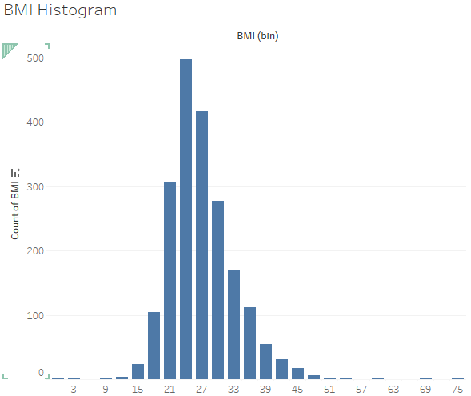
Figure 1. BMI Histogram – Tableau.
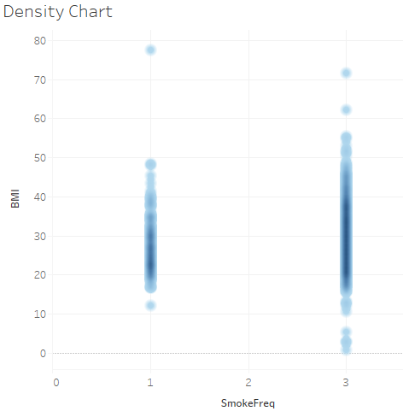
Figure 2. BMI Density Chart – Tableau.

Setup
In order to ensure I was working with solid data, I removed rows that showed a -9 for either the Smoking Frequency or BMI. A -9 indicates that no data was collected for that person on the survey indicating that the answer could not be read or was not provided.
I also removed the data for those who answered smoking some days’ which is demonstrated by a value of 2 in that column. These rows on constituted inconsistent data as ‘some days’ could mean anything from once in a week to almost every day. For best results of my analysis, I decided that ‘some days’ was not a suitable answer for analysis and eliminated it from the data.
In addition, I modified the file to be an excel worksheet and added column labels to import it into SAS.

Code
I did all my own coding. I created the code using the wizard interface offered by SAS. First is the import code to get the data into SAS (Figure 3).
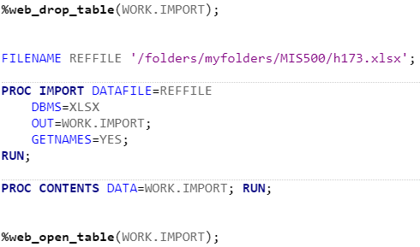
Figure 3. Code to import the Health Survey data into SAS.
Next, I produced the summary statistics for the data (Figure 4).
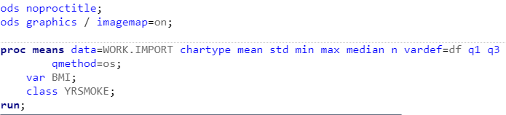
Figure 4. SAS Code to produce the summary statistics.
Finally, I did a two-sample t-test (Figure 5).
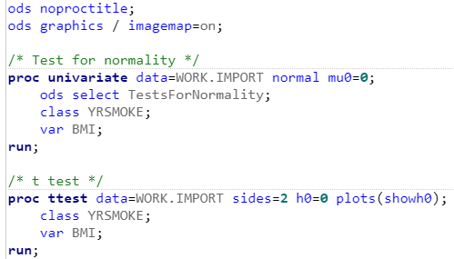
Figure 5. SAS Code for a 2-sample t-test.

Execution
The import code executed without error. Below is the result of the import as a table produces by SAS (Figure 6).
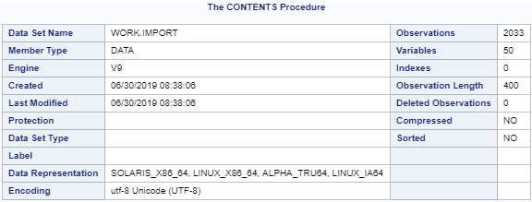
Figure 6. SAS Import Contents Table.
SAS Produced summary statistics in a table (Figure 7).
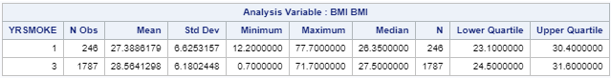
Figure 7. SAS Summary Statistics table.
SAS also produced a set of tables for the t-test (Figure 8) and some histograms and a box chart (Figure 9).
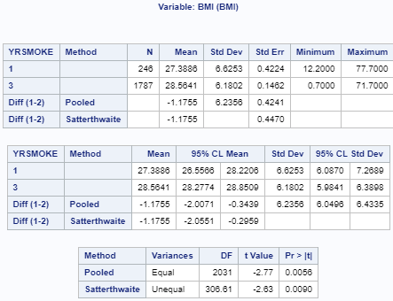
Figure 8. SAS Tables produced for the t-test.
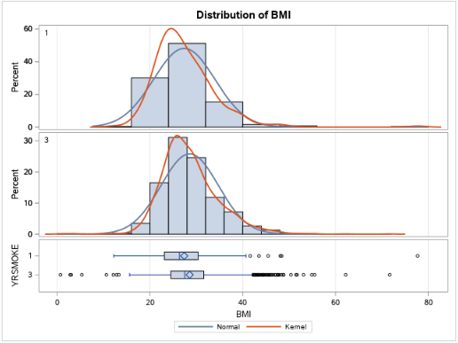
Figure 9. SAS Histograms and Box Chart produced by t-test code.

Analysis
My goal is to determine if there is any relationship at all between the samples so this will be a two-tailed t-test. My hypotheses are:
H₀: There is not a statistically significant difference between a smokers BMI and a non-smokers BMI.
H_{a}: There is a statistically significant difference between a smokers BMI and a non-smokers BMI, based on these samples.
Based on the previously stated 95% confidence level, and the t-test calculation provided in Figure 8, I conclude that there is a statistically significant difference between the average BMI of a non-smoker and the average BMI of a smoker. Based on the box charts in Figure 9 and the density chart in Figure 2, it appears that the difference is in favor of smokers’ BMI being less on average than a non-smokers.
References
SAS Institute, Inc. (2018), SAS University Edition [Software]. Available from www.sas.com/en_us/software/university-edition.html.
Agency for Healthcare Research and Quality (2016) 2014 Full Year Clinical Preventive Care Services Self-Administered Questionnaire. Retreived from https://meps.ahrq.gov/data_stats/download_data/pufs/h173/h173doc.shtml
Tableau Software (2018) Tableau [Software]. Available from http://www.tableau.com

Annette Kaufman, Erik M. Augustson, and Heather Patrick (2011) Unraveling the Relationship between Smoking and Weight: The Role of Sedentary Behavior. Retrieved from https://www.hindawi.com/journals/jobe/2012/735465/

