I downloaded UMlet dirtectly to my desktop 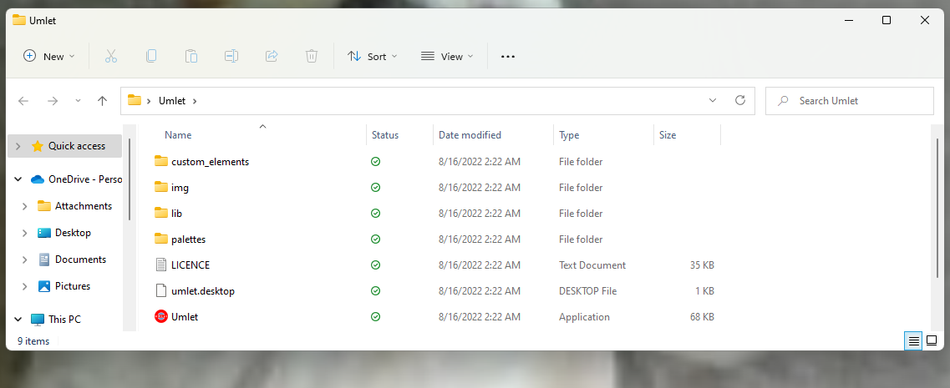

Umlet running in background.

