Object relational diagram

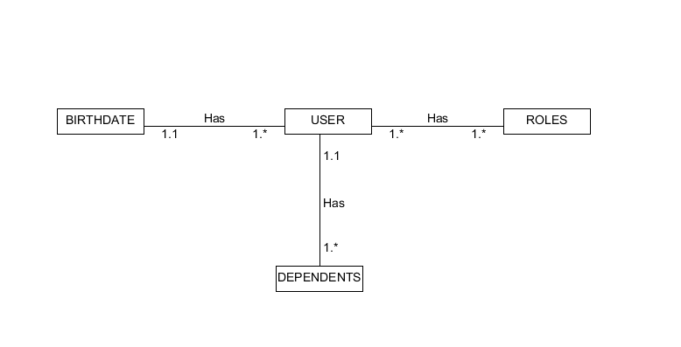

RDMBS

