Showing Drop statements

Table created

Select function used

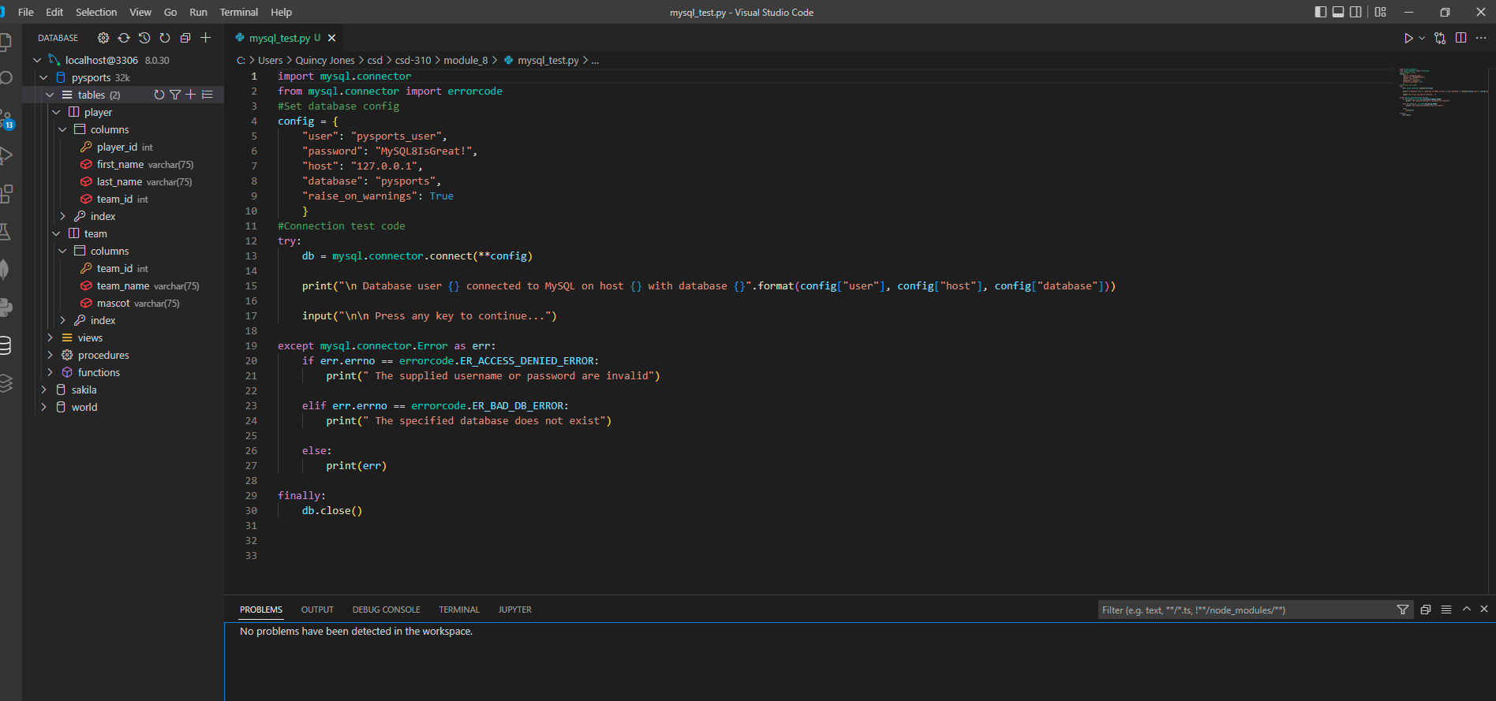

Final vscode image