Product Requirements Document
Submission 1 Specification

[Alphecca]
SWEN90007 SM2 2021 Project

[大家的名字：

Haimo Lu, 1053789]


*This page refers to the document template. It must be discarded and replaced by yours (next page).

Revision History (this template’s)
Date | Version | Description | Author
08/08/2022 | 01.00-D01 | Initial draft | Haimo Lu

Revision History
<students must use this table to track individuals’ contributions to this document.
Every time you change this document, add the date you changed it, a description of your performed task and your name. For the version, please adopt the following format:
01.00-D<number> for draft versions related to Part 1 (any version before the final submission is considered draft). When your document is reviewed and finally ready to be submitted, change it to 01.00. For Part2, start with 02.00-D<number> and so on. This document should always be kept on GitHub>

Date | Version | Description | Author
08-08-2022 | 01.00-D01 | Add the domain model and its descriptions for the domain model | Haimo Lu

Contents
1. Introduction 6
1.1 Proposal 6
1.2 Target Users 6
1.3 Conventions, terms and abbreviations 6
2. Actors 6
3. Use Cases 7
3.1 <students to add info here> Use Case 1: Student Undertakes Examination 7
4. Domain Model 7
4.1 Domain Model Diagram 7
4.2 Domain Model Description 8
4.2.1 Object 8
4.2.2 Inheritance 9
4.3 Domain Model Diagram 11

Introduction

Proposal
This document specifies the SWEN90007 project use cases, actors to be implemented, and the system’s domain model.

Target Users
This document is mainly intended for SWEN90007 students and teaching team.

Conventions, terms and abbreviations
This section explains the concept of some important terms that will be used throughout this document. These terms are detailed alphabetically in the following table.
Term | Description
LMS | Learning Management System
HBS | Hotel Booking System

Actors

Actor | Description
Lecturer | <students to add info here>
Student | <students to add info here>
<students to add info here> | <students to add info here>

Use Cases

<students to add info here> Use Case 1: Student Undertakes Examination
Actors
- Student
Basic Flow
On Wednesdays, students of SWEN900XX log into the Online Examination Application to undertake a written examination. After logging in, they select the subject from their list of enrolled subjects. Then they select the examination corresponding to that Wednesday. They commence the exam, entering an answer or skipping each question in the examination. Once they have provided a response to each question, they submit the examination for marking.

Domain Model

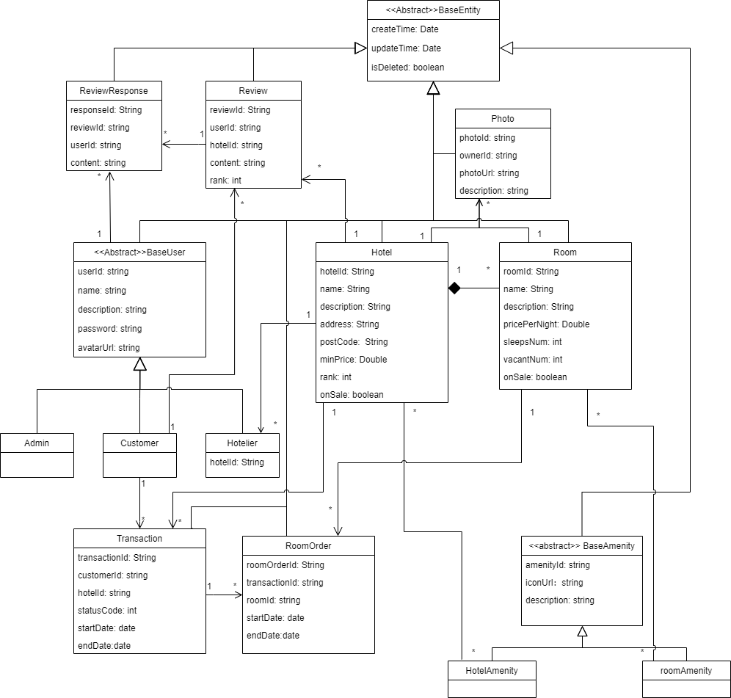
Domain Model Diagram

Domain Model Description

Object

Object Type: | Format:
Concrete Class | Bolded
Abstract Class | Non-Bolded
Interface | Italicized

Object | Description
BaseEntity | # Descriptions for abstract objects are in the next table
ReviewResponse | While only customer can create a review, reviewResponse can be created by all users.
Review | When Customer write a review, a review object is then created.
BaseUser | # Descriptions for abstract objects are in the next table
Admin | Admin is one role of the system, they are the HBS provider that aggregate all hotels created in the system, they can also view all users and stays users have booked.
Customer | Customer is another role of the system, they can book hotels, view, and manage their bookings.
Hotelier | Hotelier is also a role of the system; they can register and manage their hotels with different configurations in the system and can manage bookings they received from customers.
Transaction | Transactions are created when customers book stays, transactions are owned by the customers and also the respective hotel.
RoomOrder | RoomOrders are recorded in transations, they are also included in each respective room.
Photo | A photo is associated with a hotel are a room, one hotel/room can have many photos while one photo can only have one hotel/room.
Hotel | Hotels are created by a hotelier, the hotel has one to many hotelier(s), room(s).
Room | Room cannot exist without with a hotel.
BaseAmenity | # Descriptions for abstract objects are in the next table
HotelAmenity | HotelAmenity describes facilities or amenities a hotel has in public area.
RoomAmenity | RoomAmenity describes facilities or amenities a room has.

Inheritance

Super Class | Sub Class | Description
BaseEntity | ReviewResponse | BaseEntity class provides concrete/abstract methods such as createTime(): Date, and attributes like isDeleted: boolean, which are useful for the HBS management.
BaseEntity | Review
BaseEntity | BaseUser
BaseEntity | Hotel
BaseEntity | Photo
BaseEntity | Room
BaseEntity | BaseAmenity
BaseUser | Admin | Three types of roles are all user of the HBS, they have some common attributes such as userId or name.
BaseUser | Customer
BaseUser | Hotelier
BaseAmenity | HotelAmenity | All types of Amenities have common attributes such as description.
BaseAmenity | RoomAmenity

Xiaotian麻烦看一下4.2.2，我觉得description这边的解释不确定和你当初设计时是否有出入，可以改一下，4.2.1最后可以把一些行的顺序调换，这样不会出现还没有介绍的object已经出现在了另一个object的介绍里，这边没有立刻调换是因为不确定diagram是否还要改

另外有些一对多的关系我觉得可以改成0对多，比如一个新酒店可以没有transaction和review。

