vgrfbfb

# set the repo root path before importing data!!!

setwd("C:/simone_robamia/unifi/datamining-class-homework/")

students <- read.csv("res/TRE ANNI IMMATRICOLATI 2010-2013 PER STUDENTI.csv")

# gather some info about the imported dataset

str(students)

# ADJUST DATA ATTRIBUTES

# convert "coorte" to nominal by making it a factor

students[, c(1)] <- sapply(students[, c(1)], factor)

# ok, let's take a look at it now

str(students)

summary(students)

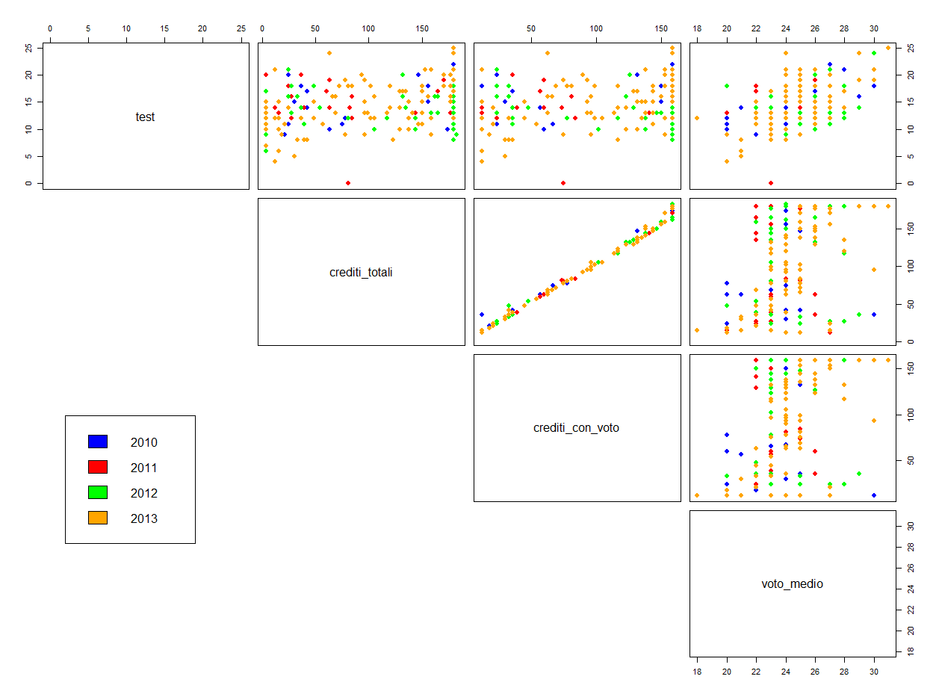

#################

# SCATTER PLOTS #

#################

colors <- c("blue","red", "green", "orange")

coorte_labels <- students[,1]

coorte_colors <- colors[as.numeric(coorte_labels)]

# general attributes

students_subset1 <- students[,-c(1, 6 : 45)]

pairs(students_subset1, col = coorte_colors,lower.panel = NULL,cex.labelsiris=2, pch=19, cex = 1.2)

par(xpd = TRUE)

legend(x = 0.05, y = 0.4, cex = 1,legend = as.character(levels(coorte_labels)),fill = unique(coorte_colors))

par(xpd = NA)

# test / avg mark detail

test_score <- students[,2]

avg_mark <- students[,5]

plot(jitter(test_score), jitter(avg_mark), col = coorte_colors, pch=19, cex = 1, xlab="Entry Test Score", ylab="Avg. Exam Score")

legend(x="topleft", legend = levels(students[,1]), col=colors, pch=19)

# cfu / avg mark detail

cfu <- students[,4]

plot(jitter(cfu), jitter(avg_mark), col = coorte_colors, pch=19, cex = 1, xlab="Total Marked CFUs", ylab="Avg. Exam Score")

legend(x="bottomright", legend = levels(students[,1]), col=colors, pch=19)

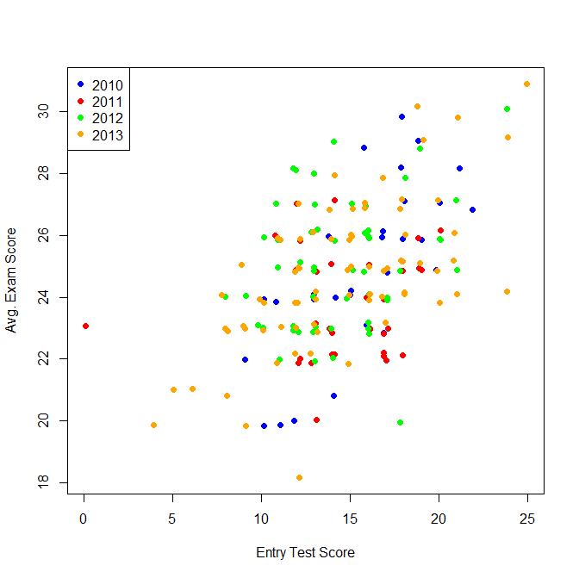

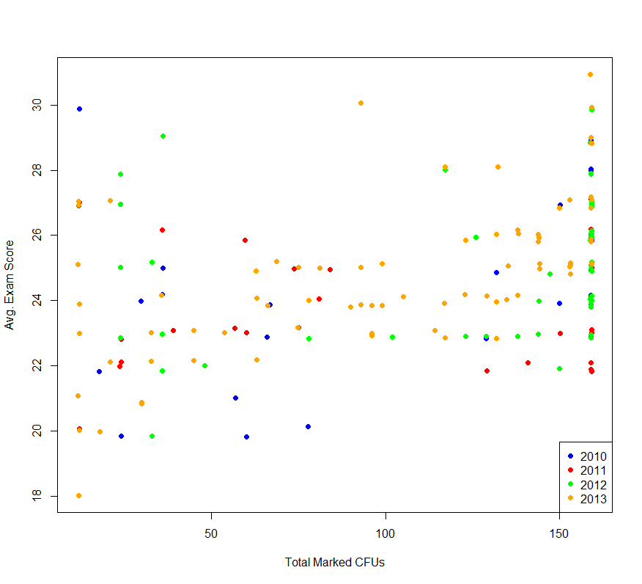

# general first year exams performances

students_subset2 <- students[,-c(1 : 5, 7, 9, 11, 13, 15 : 45)]

pairs(students_subset2, col = coorte_colors,lower.panel = NULL,cex.labelsiris=2, pch=19, cex = 1.2)

par(xpd = TRUE)

legend(x = 0.05, y = 0.4, cex = 1,legend = as.character(levels(coorte_labels)),fill = unique(coorte_colors))

par(xpd = NA))

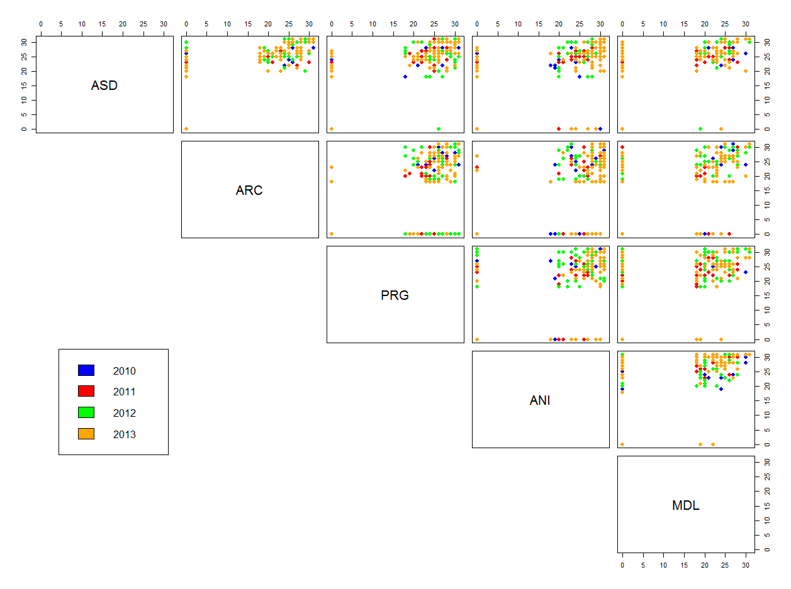

È possibile notare una caratteristica interessante degli esami del primo anno:

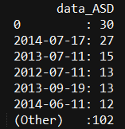 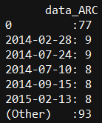 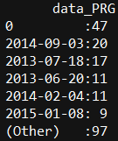 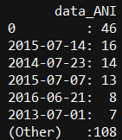 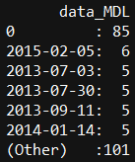

Gli esami meno disputati con successo sono (piuttosto comprensibilmente) Architetture degli Elaboratori e Matematica Discreta e Logica.

Guardiamo in che modo il non superare questi esami ha influito sulla produttività totale:

# first year "difficult" exams / total cfu detail

mdl <- students[,14]

plot(jitter(mdl), jitter(cfu), col = coorte_colors, pch=19, cex = 1, xlab="M.D.L. Exam Score", ylab="Total Marked CFUs")

legend(x="bottomright", legend = levels(students[,1]), col=colors, pch=19)

ade <- students[,8]

plot(jitter(ade), jitter(cfu), col = coorte_colors, pch=19, cex = 1, xlab="Computers Architecture Exam Score", ylab="Total Marked CFUs")

legend(x="bottomright", legend = levels(students[,1]), col=colors, pch=19)

﻿

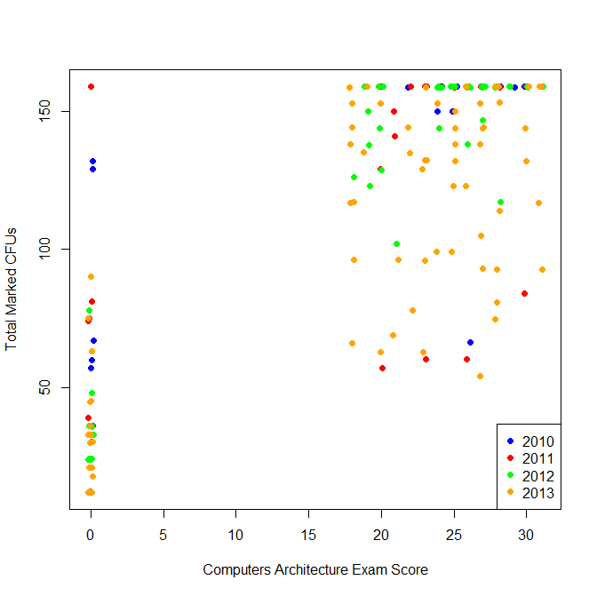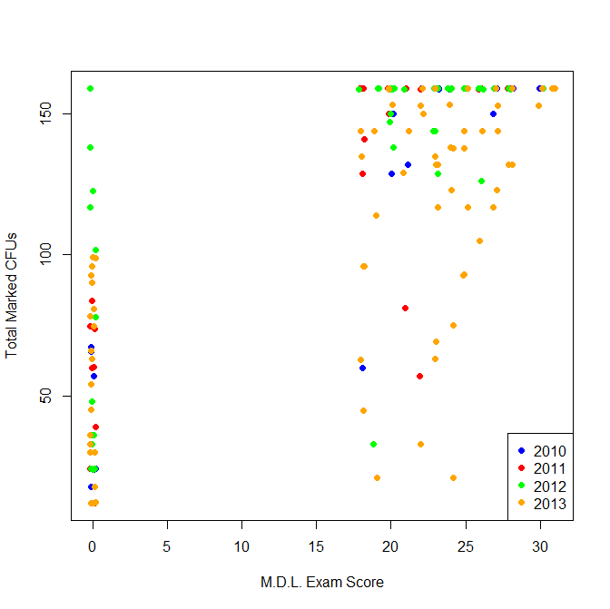

# computer science exams performances

students_subset3 <- students[,c(6,8,10,22,24,26,32,36,42)]

pairs(students_subset3, col = coorte_colors,lower.panel = NULL,cex.labelsiris=2, pch=19, cex = 0.8)

par(xpd = TRUE)

legend(x = 0.05, y = 0.4, cex = 1,legend = as.character(levels(coorte_labels)),fill = unique(coorte_colors))

par(xpd = NA)

# general mathy exams performances

students_subset4 <- students[,c(12,14,18,20,28,30,34)]

pairs(students_subset4, col = coorte_colors,lower.panel = NULL,cex.labelsiris=2, pch=19, cex = 0.8)

par(xpd = TRUE)

legend(x = 0.05, y = 0.4, cex = 1,legend = as.character(levels(coorte_labels)),fill = unique(coorte_colors))

par(xpd = NA)

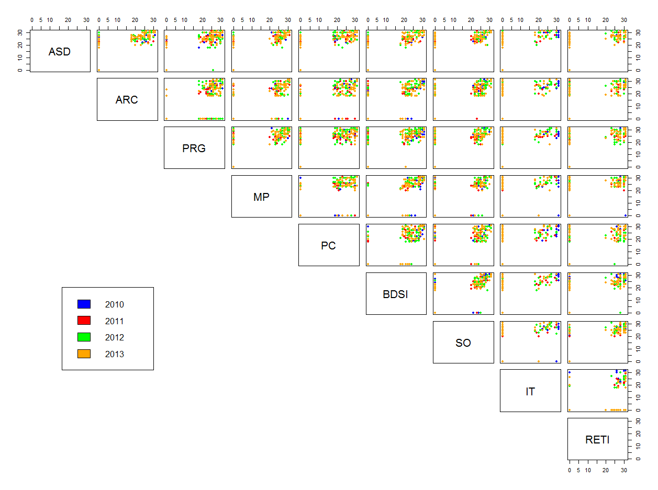

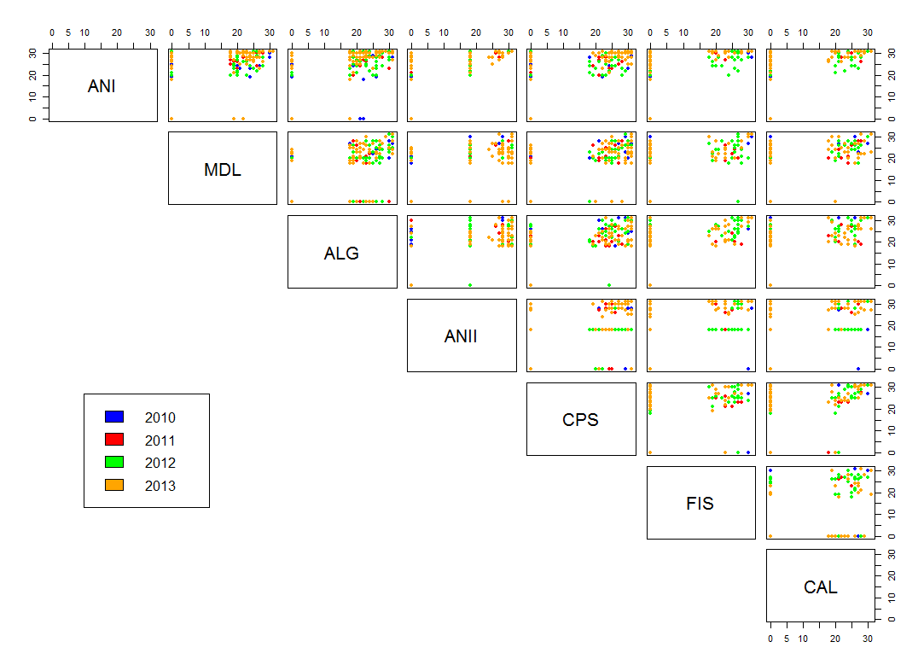

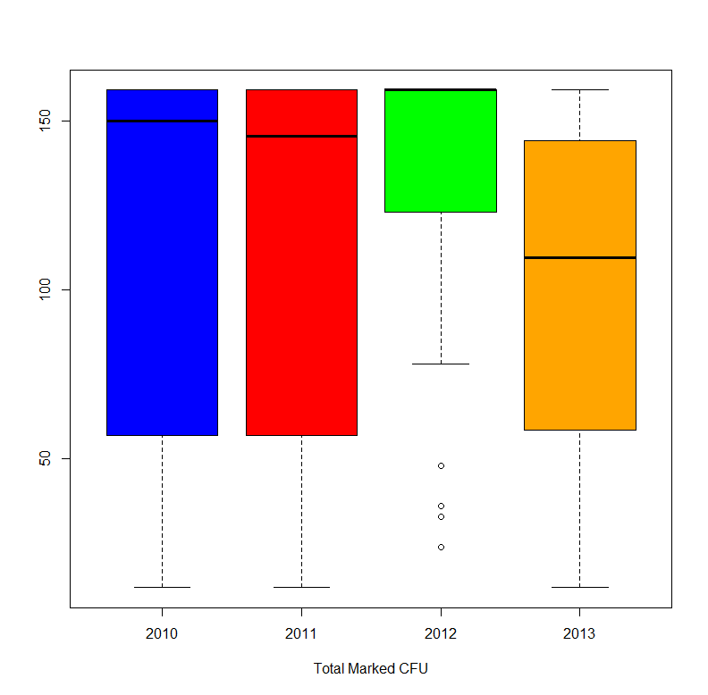

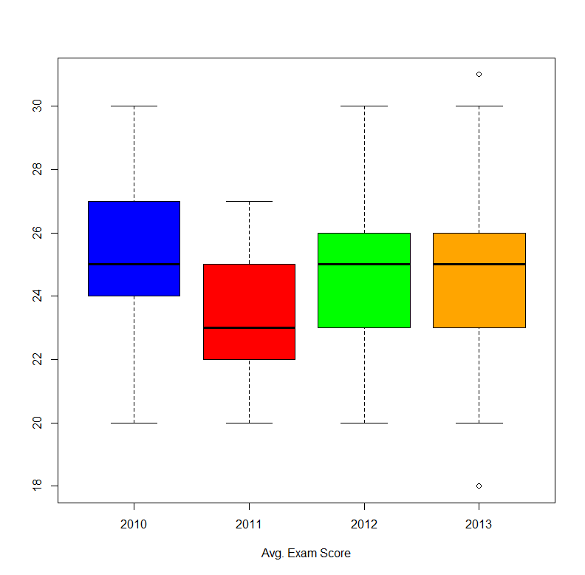

descriva le caratteristiche del dataset

con calcolo di misure di similarità per vedere se tra i dati esistono particolari correlazioni

tecniche di visualizzazione (in tal caso

preprocessing

algoritmi di clustering che userete.

postprocessing

*Ovviamente tutte queste fasi dovranno essere descritte nella relazione, inserendo i grafici che ritenete più interessanti e commentando i risultati.*

analisi dei risultati