Methods
Preliminary clustering analysis of sentence embeddings
Before implementing explicit extraction pipelines, a preliminary clustering analysis was conducted to assess whether sentence embeddings exhibit natural grouping structures related to the target schema fields. The purpose of this stage was exploratory rather than predictive: the analysis was designed to test whether participant-, intervention-, and outcome-related sentences are naturally separable in embedding space, and whether such structure could inform subsequent pipeline design.
Data preparation
The analysis firstly starts from the token-level annotations provided in EBM-NLP. In order to simplified the original hierarchy into a representation better suited to exploratory sentence-level analysis, the original hierarchical labels were converted into flat “BIO” tags, where “O” denotes tokens outside an entity span, “B” marks the beginning of a span, and “I” marks tokens inside a span.
Tokens in each abstract were then grouped into sentence-level units using a punctuation-based segmentation rule, where sentence boundaries were triggered by “.”, “!”, or “?”. In this way, the produced sentence texts while preserving alignment with token-level annotations.
Sentence-level label construction
Because clustering was performed at sentence level, approximate sentence-level labels were derived from token-level BIO annotations. For each target field, a sentence was labelled as “field-related” if it contained at least a minimum number of positive BIO tokens (B or I) for that field, otherwise it was labelled as “other”. This procedure was applied separately to participants, interventions, and outcomes, and created three binary datasets: “participants vs other”, “interventions vs other” and “outcomes vs other”. These sentence-level labels are more likely to be heuristic approximations rather than definitive extraction gold labels, since individual sentences may contain information from multiple schema fields.
Sentence embeddings
Each sentence was encoded using the pretrained sentence-transformer model all-MiniLM-L6-v2, producing dense sentence embeddings for all clustering experiments.
Clustering methods
Two unsupervised clustering methods were used:
- K-means clustering, evaluated with multiple values of $k$(2, 3, 4, and 5) for the binary field-vs-other experiments and with $k=3$for the combined P/I/O experiment.
- Hierarchical agglomerative clustering (HAC), used as a second clustering method to test whether observed patterns were robust across clustering algorithms.
Cluster composition was evaluated by comparing cluster assignments with the sentence-level field labels. To be specific, the proportion of field-related sentences within each cluster was used as the main indicator of whether natural clusters corresponded to schema fields.
Dimensionality reduction and visualisation
To visualise the embedding space, sentence embeddings were projected into two dimensions using Principal Component Analysis (PCA). For each experiment, two complementary plots were generated: embeddings coloured by sentence-level gold labels and embeddings coloured by cluster assignments.
The first plot showed whether the target field appeared naturally separated in embedding space, while the second showed how the clustering algorithm partitioned the same space.
Supplementary combined P/I/O analysis
In addition to the field-vs-other analyses, a supplementary combined P/I/O analysis was constructed. For each sentence, the numbers of positive BIO tokens for participants, interventions, and outcomes were counted separately. The sentence was then assigned to the field with the highest count. Sentences with tied highest counts were labelled as mixed, while sentences with no positive field tokens were labelled as other. For the main three-way comparison, mixed and other were excluded so that the analysis focused only on dominant participants, interventions, and outcomes sentences.
This supplementary experiment was intended to test whether multiple schema fields could be jointly recovered from the natural clustering structure of sentence embeddings.

Experimental evaluation
Preliminary clustering results
Participants vs other
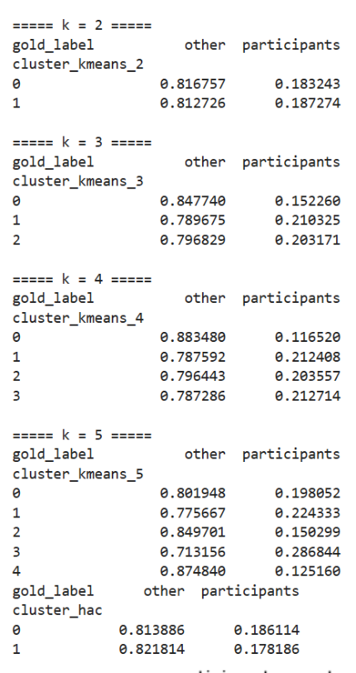
The participant-related clustering analysis showed only weak correspondence between natural clusters and the participant field. In the k=2 k-means solution, the two clusters were almost indistinguishable in label composition: cluster 0 contained 18.3% participant-labelled sentences and 81.7% other sentences, while cluster 1 contained 18.7% participant-labelled sentences and 81.3% other sentences. This indicates that the clustering algorithm was partitioning the embedding space geometrically, but not in a way that meaningfully recovered the participant field. Increasing the number of clusters produced only modest changes. At k=3, the proportion of participant-labelled sentences ranged from 15.2% to 21.0% across clusters. At k=4, the range was 11.7% to 21.3%. At k=5, the most participant-enriched cluster reached 28.7%, but the remaining clusters still remained strongly mixed rather than participant-dominant. HAC showed a similar pattern: one cluster contained 18.6% participant-labelled sentences and the other 17.8%. Overall, the participant field showed only weak natural clustering structure.
Figure 1. Participants K-means & HAC Results
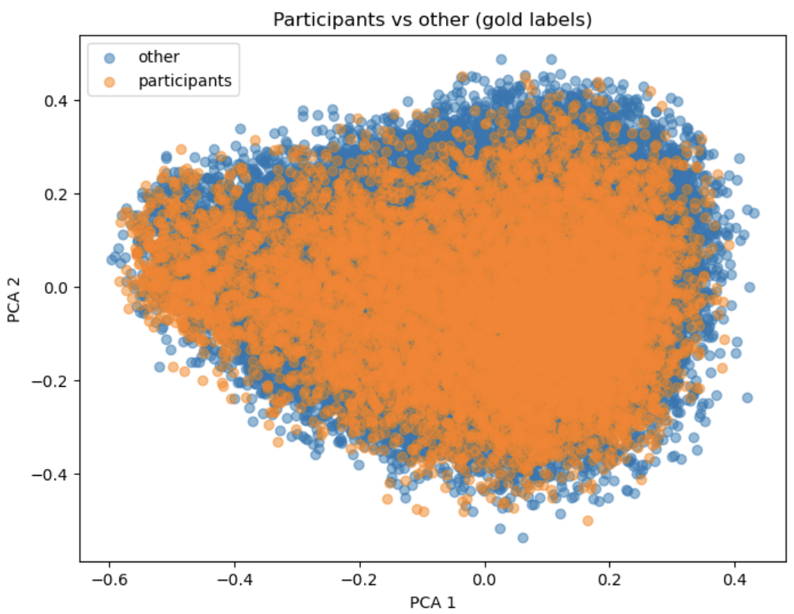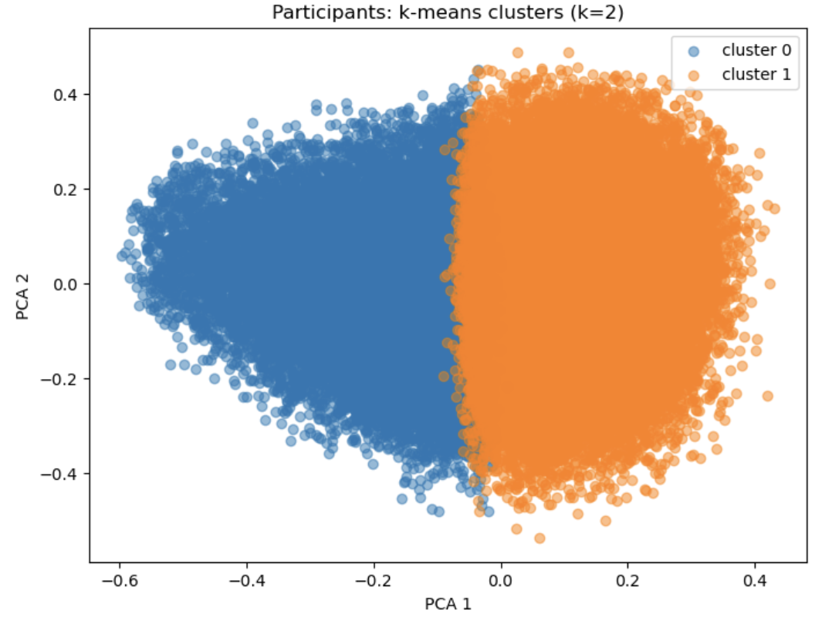
Figure 2. Participants PCA results
In the PCA results, when coloured by gold labels, participant and other sentences overlapped heavily across almost the entire projected space, with no clearly isolated participant-rich region. When coloured by cluster assignments, the embedding space was cleanly partitioned into geometric regions, but these regions did not align strongly with participant labels. This suggests that participant-related information is not naturally well separated in sentence embedding space.
Interventions vs other
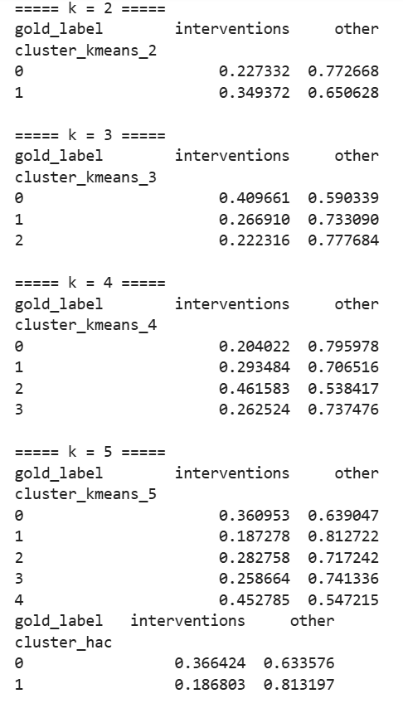
The intervention-related analysis showed a clearer clustering tendency than the participant-related analysis. The sentence-level label distribution consisted of 15,440 intervention-labelled sentences and 35,430 other sentences, indicating a substantial amount of intervention-related content in the dataset.
At $k=2$, k-means already showed a noticeable difference between clusters: one cluster contained 34.9% intervention-labelled sentences, while the other contained 22.7%. At $k=3$, the difference became larger: the most intervention-enriched cluster contained 41.0% intervention-labelled sentences, compared with 22.2% in the least enriched cluster. At $k=4$, one cluster reached 46.2% intervention-labelled sentences, whereas another contained only 20.4%. At $k=5$, the most enriched cluster still contained 45.3% intervention-labelled sentences, while the least enriched cluster contained only 18.7%. These results indicate that intervention-related sentences occupy more field-specific local structure in the embedding space than participant-related sentences.
In HAC, one cluster contained 36.6% intervention-labelled sentences, while the other contained only 18.7%, nearly a twofold difference. This also supported the same interpretation of that the tendency for intervention-related sentences to form more concentrated local groupings, and proves that it was not specific to k-means.
Figure 3. Interventions K-means & HAC result
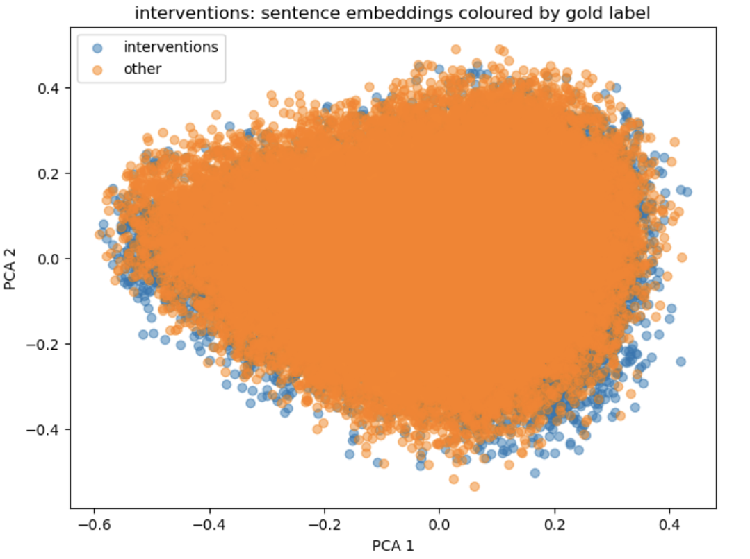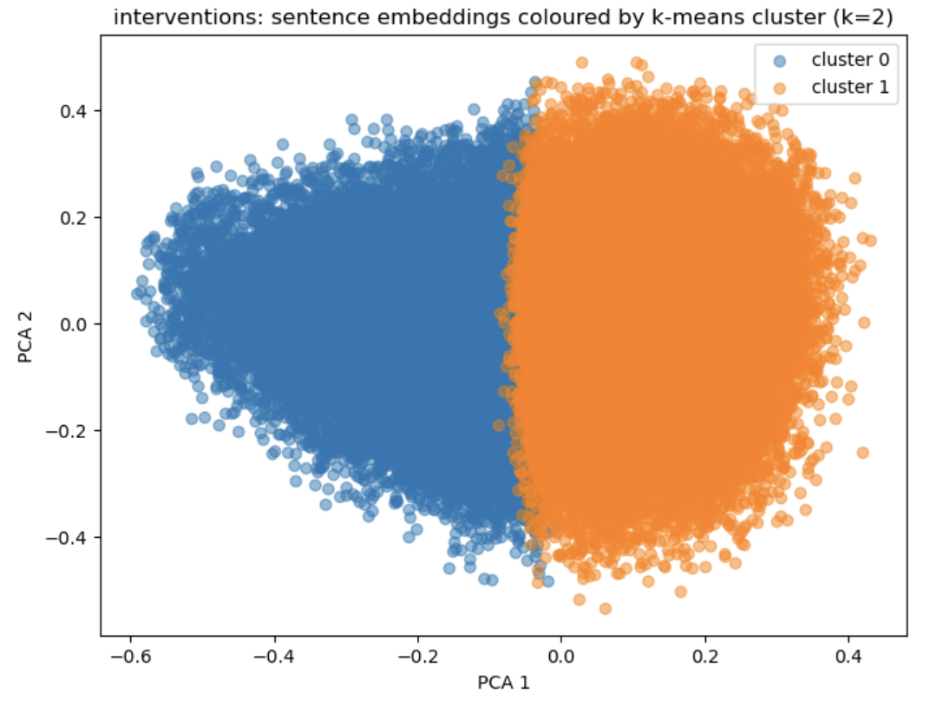
Figure 4. Interventions PCA results
The PCA plots show that intervention and other sentences still overlap substantially, so the intervention field is not cleanly separable in a strict sense. However, the intervention labels are less uniformly distributed than participant labels, and the clustering methods identify regions that are more strongly enriched for intervention-related sentences. In short, the intervention field shows a clearer natural clustering structure than the participant field, although the separation remains incomplete.
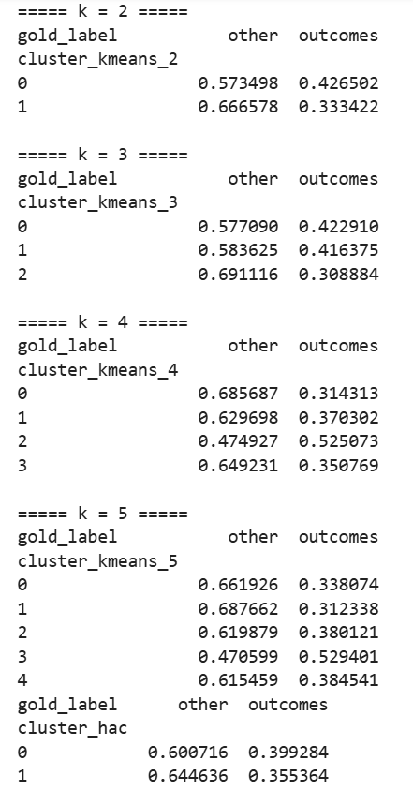
Outcomes vs other
The outcome-related analysis showed a stronger clustering tendency than participants and a moderately clearer pattern than interventions in some settings. The sentence-level label distribution consisted of 19,769 outcome-labelled sentences and 30,697 other sentences, making outcomes the most frequent field in the binary field-vs-other comparisons.
At $k=2$, one k-means cluster contained 42.7% outcome-labelled sentences, while the other contained 33.3%. At $k=3$, two clusters remained similar, with 42.3% and 41.6% outcome-labelled sentences, while the third was less enriched at 30.9%. At $k=4$, the most outcome-enriched cluster reached 52.5%, meaning that outcome-labelled sentences formed the majority in that cluster; by contrast, the least enriched cluster contained only 31.4% outcome-labelled sentences. At $k=5$, the most enriched cluster again reached 52.9%, while the least enriched contained 31.2%. This indicates that, for outcomes, some local regions of the embedding space are substantially more field-specific than those observed for participants, and in some cases more concentrated than those observed for interventions.
Figure 5. Outcomes K-means & HAC result
HAC also showed a modest but consistent difference: one cluster contained 39.9% outcome-labelled sentences, while the other contained 35.5%. This contrast was smaller than that observed for interventions under HAC, but still indicated some degree of field-related structure.
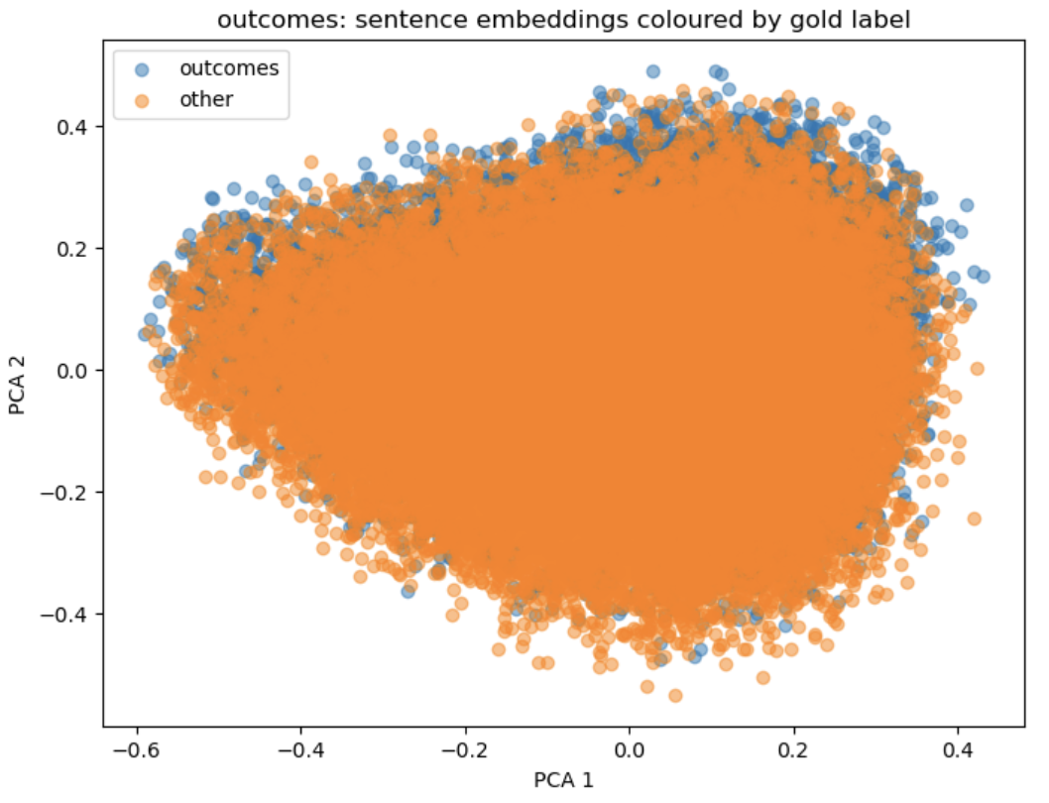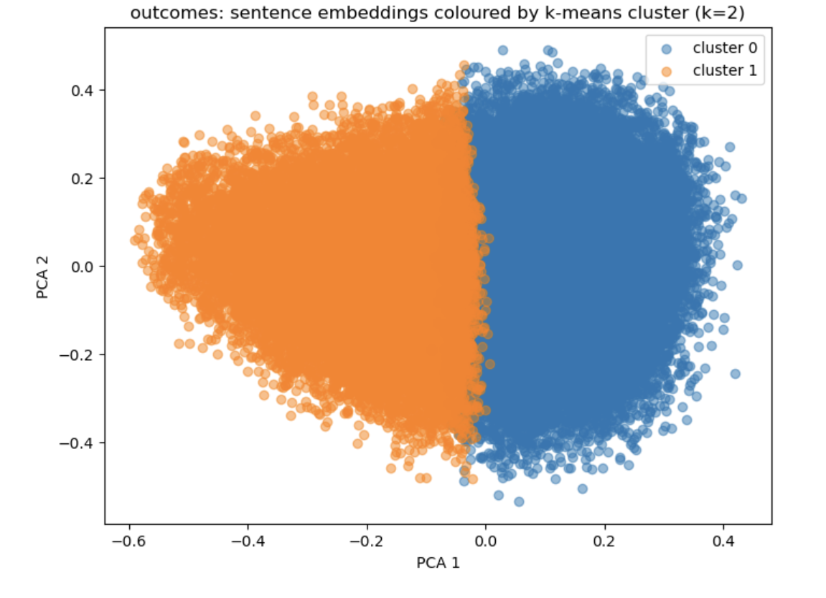
Figure 6. Outcomes PCA results
The PCA visualisations show that outcome and other sentences still overlap heavily across the projected space. Nevertheless, the quantitative cluster composition suggests that certain parts of the embedding space are more strongly associated with outcome-related content than with participant-related content. Therefore, outcome-related information appears to contribute more strongly to the natural embedding structure than participant-related information, although it still does not form a cleanly isolated field.
Combined P/I/O analysis
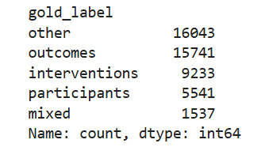
In order to examine whether multiple schema fields could be jointly recovered from natural clustering structure, a combined P/I/O analysis was added. Before filtering, the sentence-level distribution was:
Figure 7. Original P/I/O Sentence-level distribution
The mixed class accounted for approximately 3.2% of all sentences, indicating that the dominant-label heuristic produced a usable simplified label space for exploratory analysis. After excluding mixed and other, the remaining three-way dataset contained 15,741 outcome-labelled sentences, 9,233 intervention-labelled sentences, and 5,541 participant-labelled sentences.
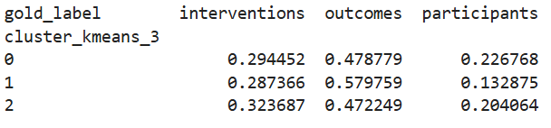
Figure 8. Original P/I/O K-means result
In the $k=3$ k-means experiment, the three clusters were geometrically well separated in PCA space, indicating strong unsupervised structure in the sentence embeddings. However, cluster composition showed only weak correspondence to the P/I/O fields. Cluster 0 contained 47.9% outcomes, 29.4% interventions, and 22.7% participants. Cluster 1 contained 58.0% outcomes, 28.7% interventions, and 13.3% participants. Cluster 2 contained 47.2% outcomes, 32.4% interventions, and 20.4% participants. Thus, all three clusters remained mixtures of the three fields, with outcomes dominating each cluster and participants consistently underrepresented.
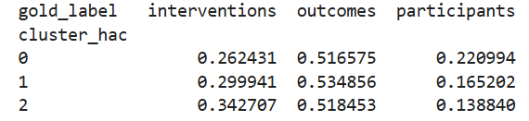
Figure 9. Original P/I/O HAC result
In the three HAC clusters, outcomes remained the largest class in every case, ranging from 51.7% to 53.5%. Interventions ranged from 26.2% to 34.3%, while participants ranged from 13.9% to 22.1%. Again, no cluster aligned cleanly with a single schema field.
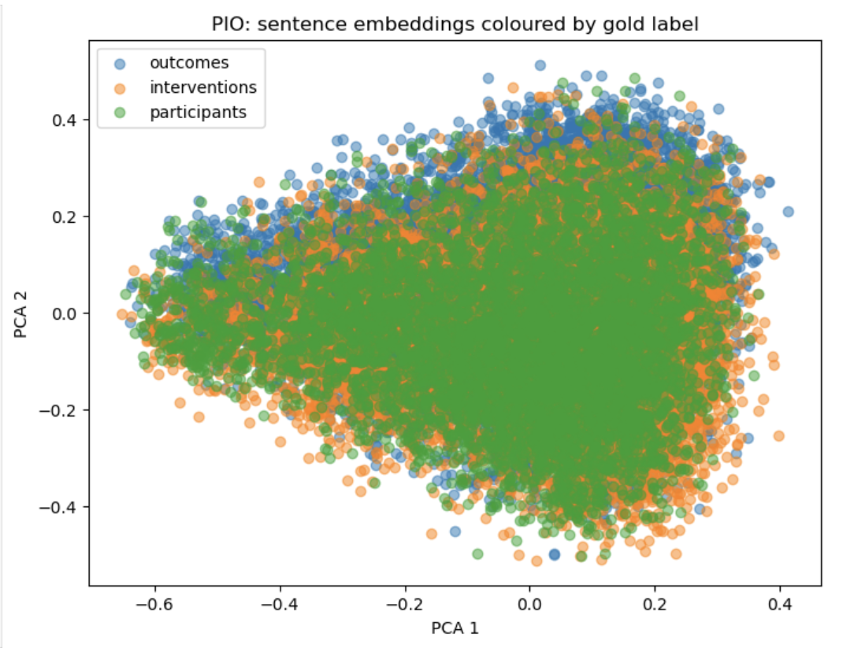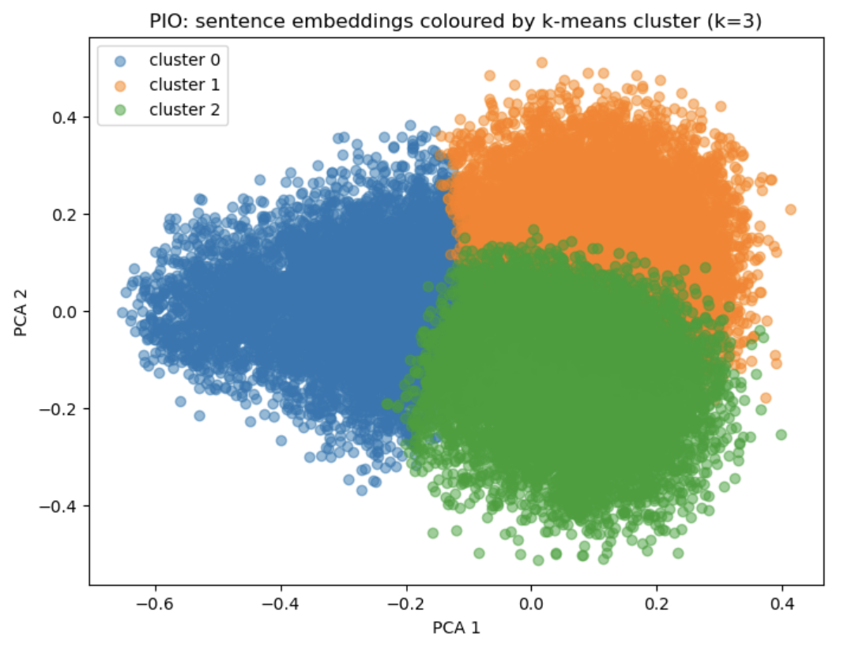
Figure 9. Original P/I/O PCA result
The PCA plots shows that when coloured by gold P/I/O labels, the three fields overlapped extensively, showing no clear field-specific regions. When coloured by k-means cluster assignments, the same space was partitioned into three visually distinct geometric blocks. This contrast is important: the embedding space clearly contains stable unsupervised geometric structure, but that structure only weakly corresponds to the schema fields themselves.
Overall interpretation
Across the preliminary clustering experiments, sentence embeddings consistently exhibited meaningful geometric structure. Both k-means and HAC were able to find stable partitions, and PCA projections showed visually coherent embedding regions. However, the correspondence between these natural clusters and the target schema fields was limited.
The participant field showed the weakest clustering signal, with only small changes in participant enrichment across clusters. The intervention field showed a more informative pattern, with some clusters containing substantially higher proportions of intervention-related sentences. Outcome-related sentences also showed relatively strong local enrichment, with some k-means clusters exceeding 50% outcome content. However, even in the strongest cases, none of the fields formed clean, field-pure clusters.
The combined P/I/O analysis further demonstrated that the strongest geometric structure in the embedding space does not map cleanly onto the schema fields. Clear cluster boundaries were visible in PCA space, but the corresponding cluster compositions remained mixed, with outcomes dominating all three clusters and participants consistently the smallest class.
Taken together, sentence embeddings contain stable latent structure, yet this structure does not map cleanly enough onto schema fields to recover them reliably without explicit extraction methods. On the one hand, the presence of some field-related local structure, especially for interventions and outcomes, suggests that sentence-level information is still useful and may support decomposed approaches such as sentence selection followed by field extraction. On the other hand, the weak overall alignment between clusters and schema fields shows that unsupervised grouping cannot substitute for explicit extraction methods. In this sense, the clustering analysis provides an empirical justification for moving to more directed pipelines, including rule-based and LLM-based extraction methods.
Limitations of the clustering analysis
This analysis has several limitations. First, the sentence-level labels were heuristically derived from token-level BIO annotations rather than provided directly as sentence-level gold labels. Second, individual sentences may contain multiple schema fields, so any dominant-label assignment inevitably introduces noise and information loss. Third, PCA is only a two-dimensional approximation of a much higher-dimensional embedding space, and therefore may not fully reflect the underlying geometry.
Although there are limitations, the clustering stage provides a useful empirical starting point for pipeline design. In particular, the weak alignment between natural clusters and schema fields motivates the transition to explicit extraction pipelines in the next stage.

