

Course Name: WEB FUNDAMENTAL

Student name: DA-NZI MBOUMBA Junior Judicael

Student ID : PUIT/24210155

Project: SRC Sports Academy Web Platform: Testing & Evaluation Report

1. Project Overview
The goal of this project was to build a modern, responsive web solution for the SRC Sports Academy. The platform was designed to help students engage with sports, simplify the registration process, and provide a clear booking system for training sessions. The final result is a multi-page site built using semantic HTML5, CSS3, and JavaScript.
2. Technical Implementation & Successes
I used a mobile-first design approach to ensure student-athletes can easily check academy info on their phones or tablets. Some of the technical highlights include:
- Responsive Navigation: I built a dynamic hamburger menu with JavaScript so navigation stays clean on small screens.
- Modern UI Components: By using CSS Flexbox and Grid, I was able to align the “Sport Cards” professionally, using box-shadows and rounded corners for a modern look.
- Form Validation: Both the Registration and Booking pages use HTML5 validation and a CAPTCHA-style check to stop spam, keeping things secure and functional.
3. Testing and Validation
To make sure everything hit industry standards, I ran the site through some pretty rigorous testing:
3.1. W3C Validation
I ran the HTML and CSS through the W3C Markup Validation Service.
- Initial Findings: At first, the CSS had some syntax errors (like missing brackets) because of how I nested media queries and a few typos.
- Correction: I fixed these by cleaning up the stylesheet, moving media queries to the bottom, and strictly following CSS3 standards. The final versions passed with zero critical errors.
3.2. Cross-Browser & Device Testing
I tested the platform on **Google Chrome, Microsoft Edge, and Safari**. I used a universal CSS reset to keep the look consistent across all of them. I also checked responsiveness for screen widths ranging from 360px to 1920px, making sure the menu switches to the hamburger icon exactly at 1024px.
3.3. Accessibility (WCAG Compliance)
Making the site usable for everyone was a priority:
Semantic HTML: I used tags like <nav>, <main>, and <footer> so screen readers can navigate easily.
ARIA Labels: I added aria-label to icons and aria-required to form fields for better clarity.
- Color Contrast: I chose a high-contrast palette (Navy Blue #1a237e and Gold #ffab00) to help users with visual impairments.
4. Challenges and Problem Solving
One of the biggest hurdles was keeping the layout consistent across all 7 pages while using a single external stylesheet. Originally, the forms on the Book Online and Register pages were stacking horizontally and looked messy. I solved this by creating specific. input-group CSS classes to force them to stack vertically with better padding, which really improved the user experience.

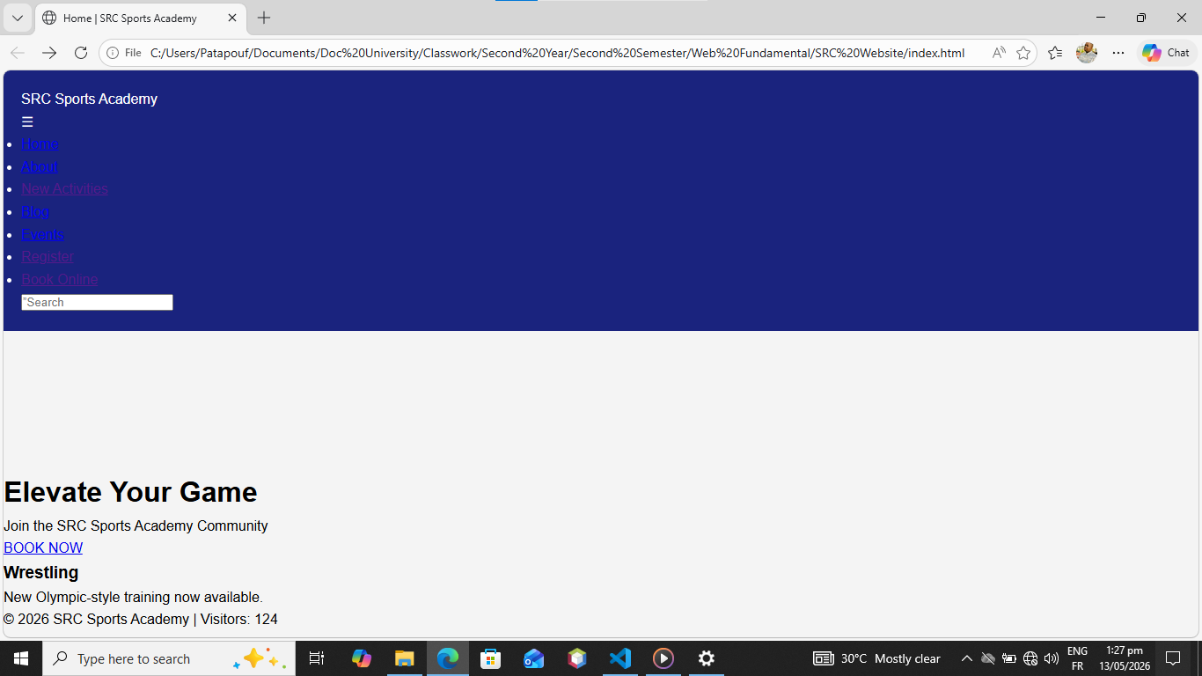
Picture: an example of a challenges faced is the link between the html pages and the css and javascript pages leading to some design troubles.

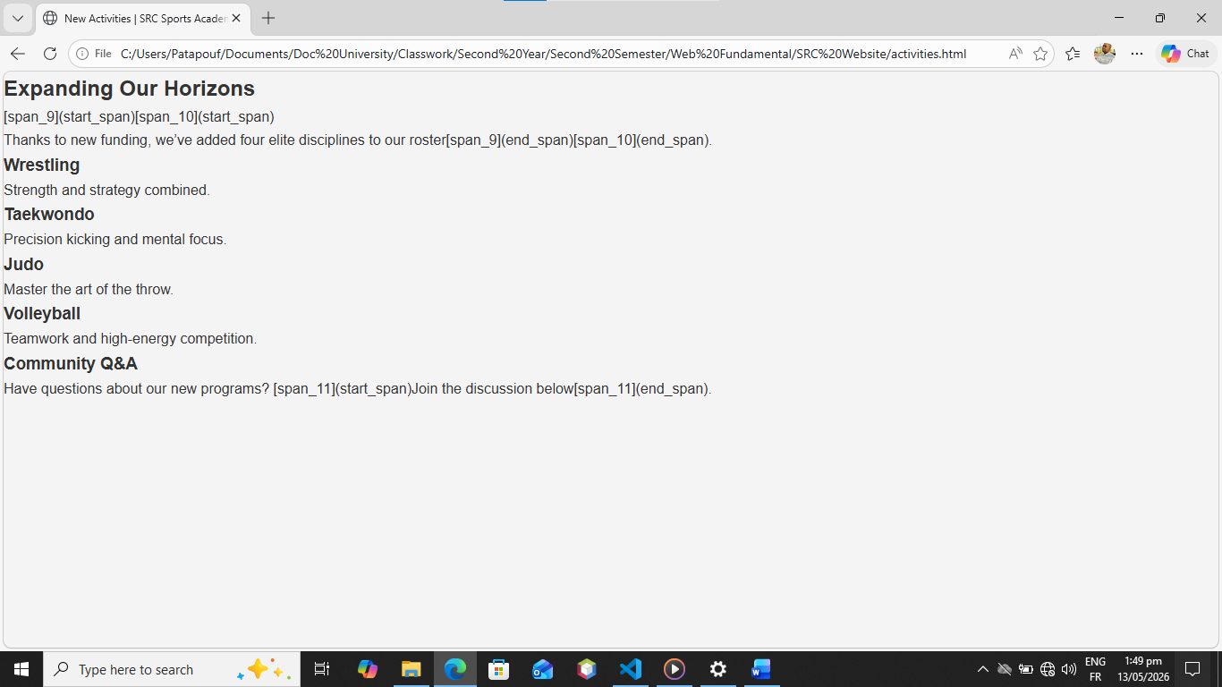
Picture: apart from the from the javascript problem, another one was the the css code, specially when this one tried to use the mobile code for computers.

5. Critical Evaluation & Future Upgrades
The final platform meets all the requirements for Task 1 and Task 2. It’s a functional, engaging, and responsive site, but there’s always room to grow. For future versions.

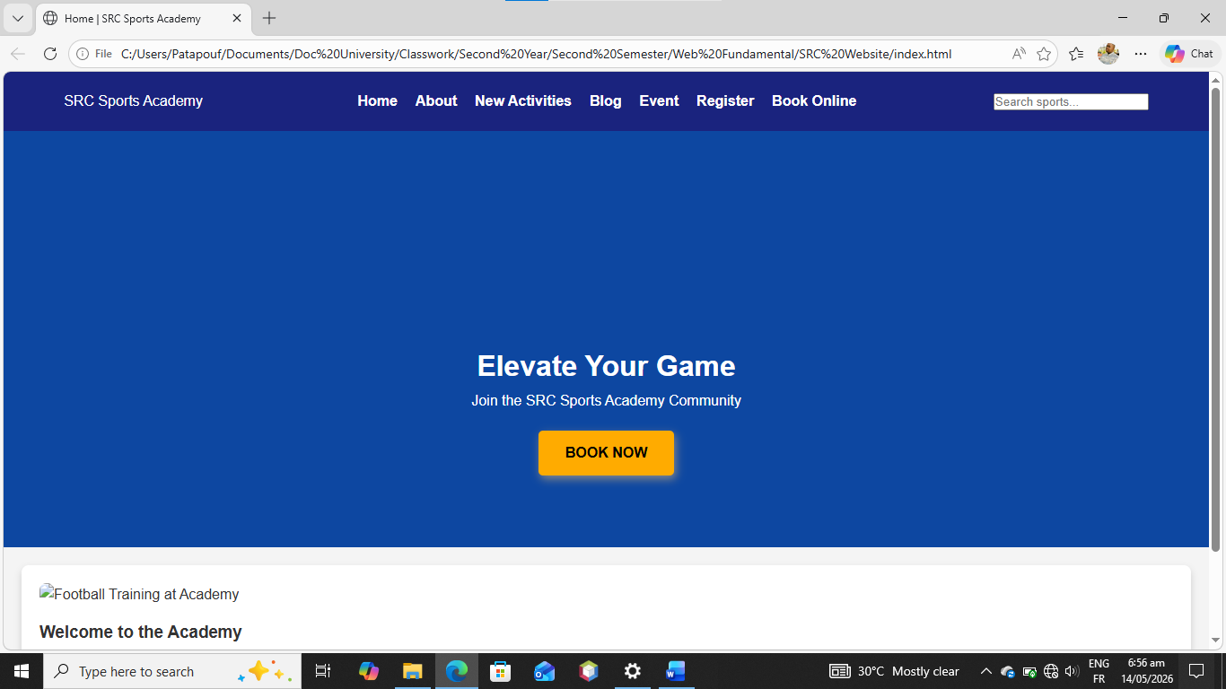
Picture: a screenshot of my homepage (index.html)
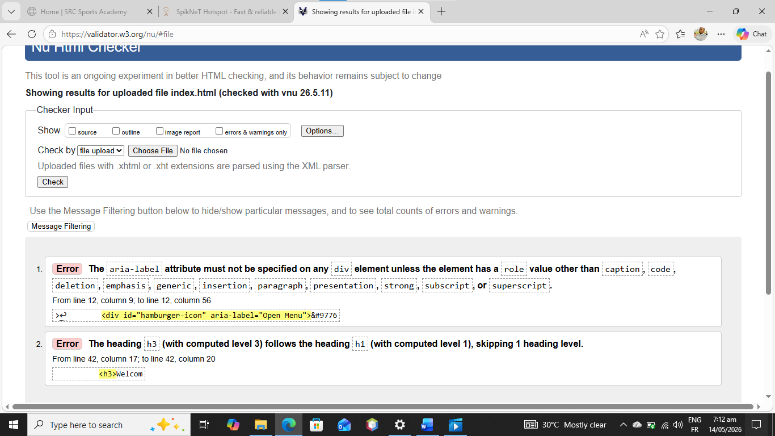
Picture: Screenshot of my index page getting checked by w3c

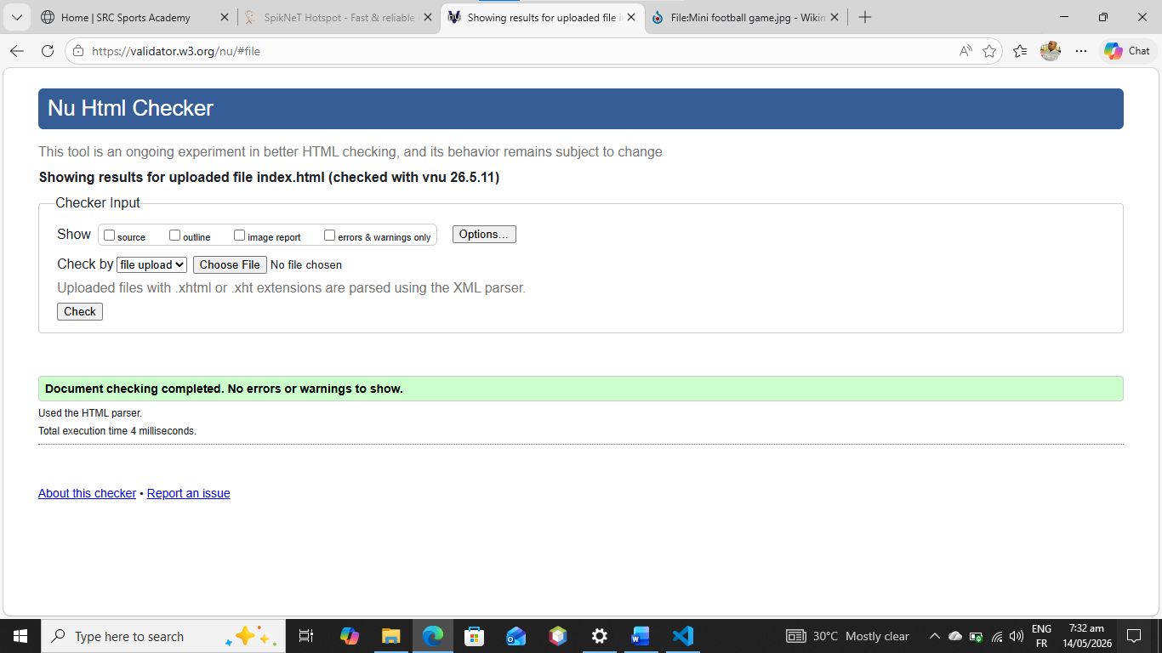
Picture: Validation of my page by W3C

